Table of Contents

Variable 1373: Research Wishes 1

Variable 18: Further Comments and Suggestions 1

Variable 6: Primary Working Area 2

Variable 11: Years of Experience 3

Variable 16: Class of System 4

Variable 19: Industry Sector 5

Variable 8345 et seq: Positive Reasoning 6

Variable 8780 et seq: Negative Reasoning 7

Paper Mapping: What? 8

Paper Mapping: How? 9

Paper Mapping: With Whom? 10

# Variable 1373: Research Wishes

To Be Done

# Variable 18: Further Comments and Suggestions

To Be Done

# Variable 6: Primary Working Area

Answers to Code: 29

Variable Type: List-Supplementing Short Text (for Variable 5)

Variable Question: Which of the following roles describes your primary working area best?  
 (Respondent answered “Other (please specify)” on Variable 5)

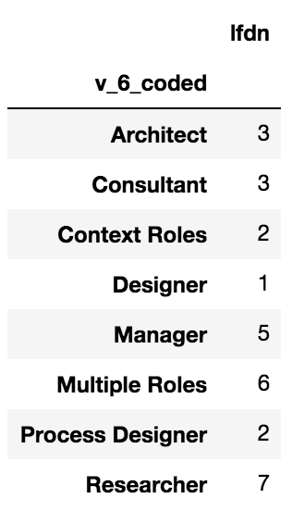Options shown for Variable 5: Summary of “Other (please specify)” after algorithmic coding:

* Requirements Engineer
* Business Analyst
* Architect
* Tester / Test Manager
* Project Manager
* Developer
* Product Owner
* Designer
* Other (please specify)

Code used to produce this result:

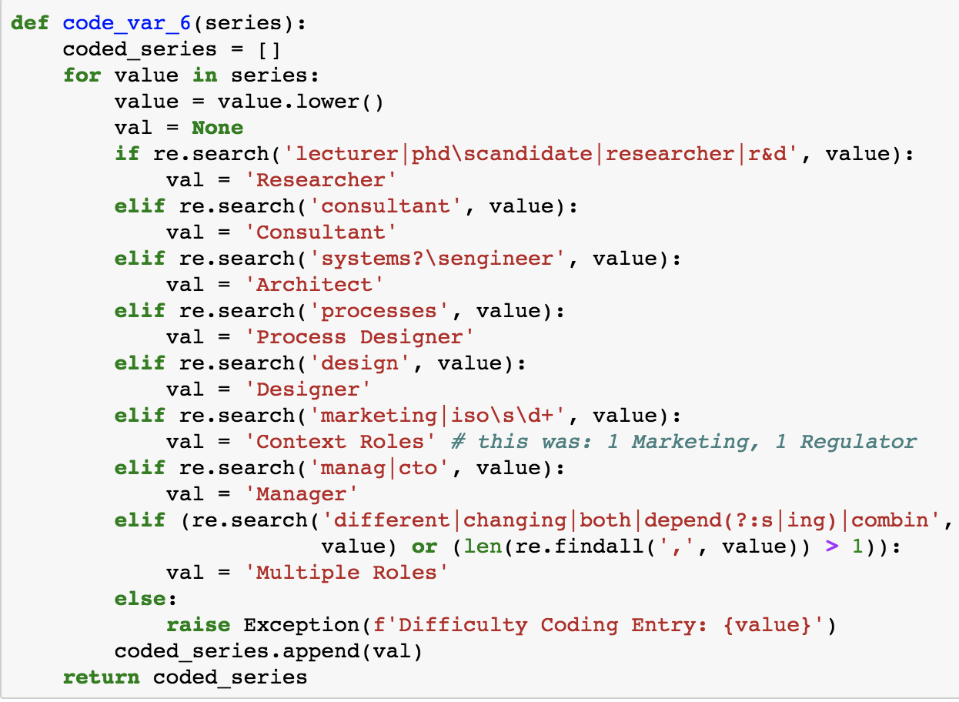

# Variable 11: Years of Experience

Answers to Code: 154

Variable Type: List-Supplanting Short Text

Variable Question: How many years are you working in your primary working area?

Visual summary of responses after algorithmic coding:

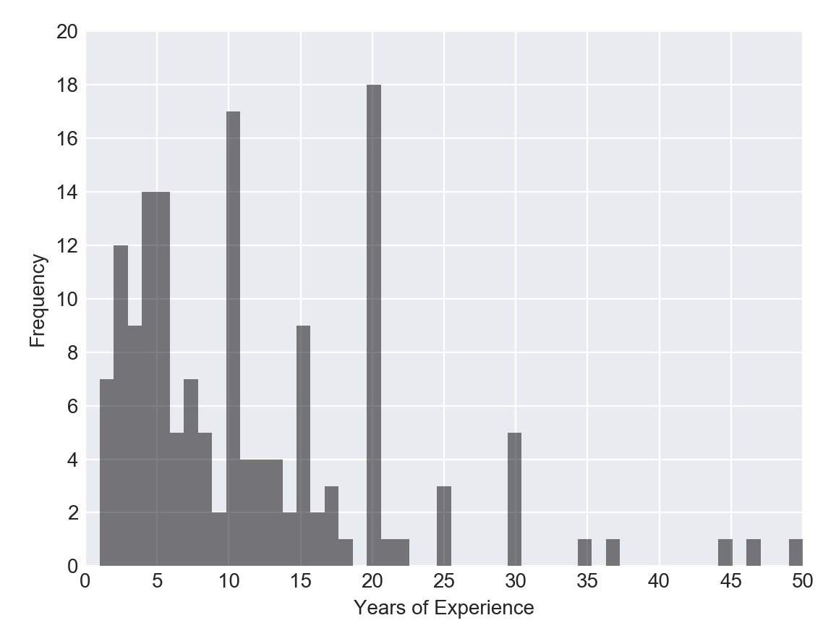

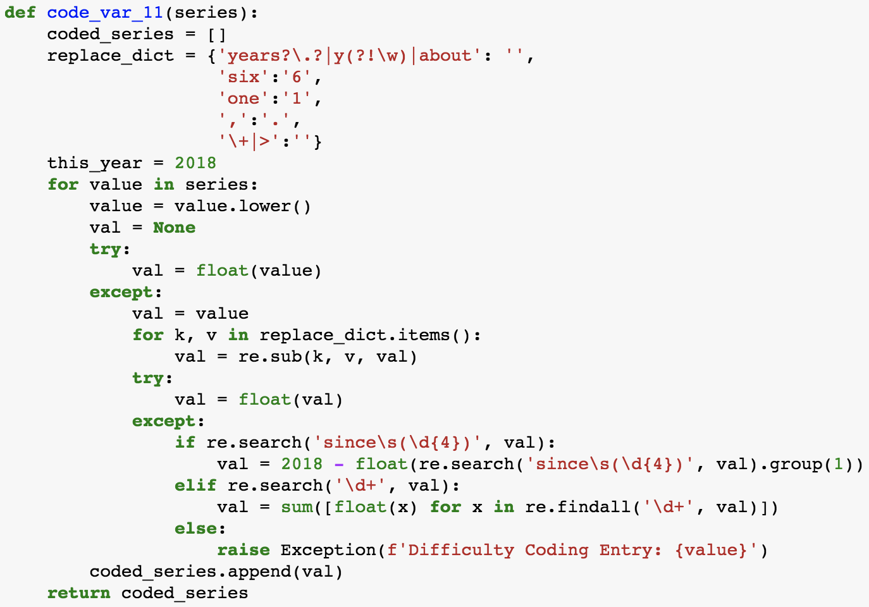Code used to produce this result:

# Variable 16: Class of System

Answers to Code: 12

Variable Type: List-Supplementing Short Text (for Variable 15)

Variable Question: What class of systems is in scope of your project(s)?   
 (Respondent answered “Other (please specify)” on Variable 15)

Options shown for Variable 15 were:

* Software-intensive embedded systems
* (Business) information systems
* Hybrid / mix of embedded systems and information systems
* Other (please specify)

Summary of “Other (please specify)” after algorithmic coding:

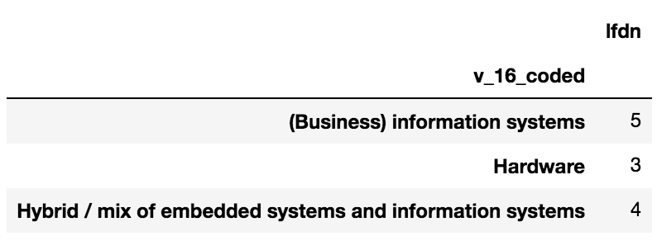

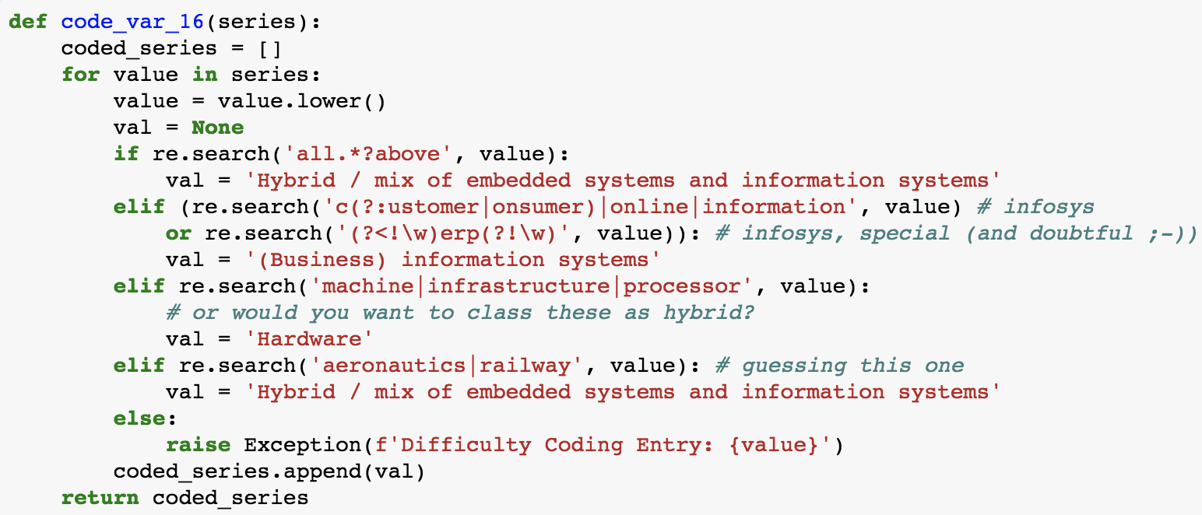Code used to produce this result:

# Variable 19: Industry Sector

Answers to Code: 154

Variable Type: List-Supplanting Short Text

Variable Question: What is the industry sector in which you are most frequently involved?

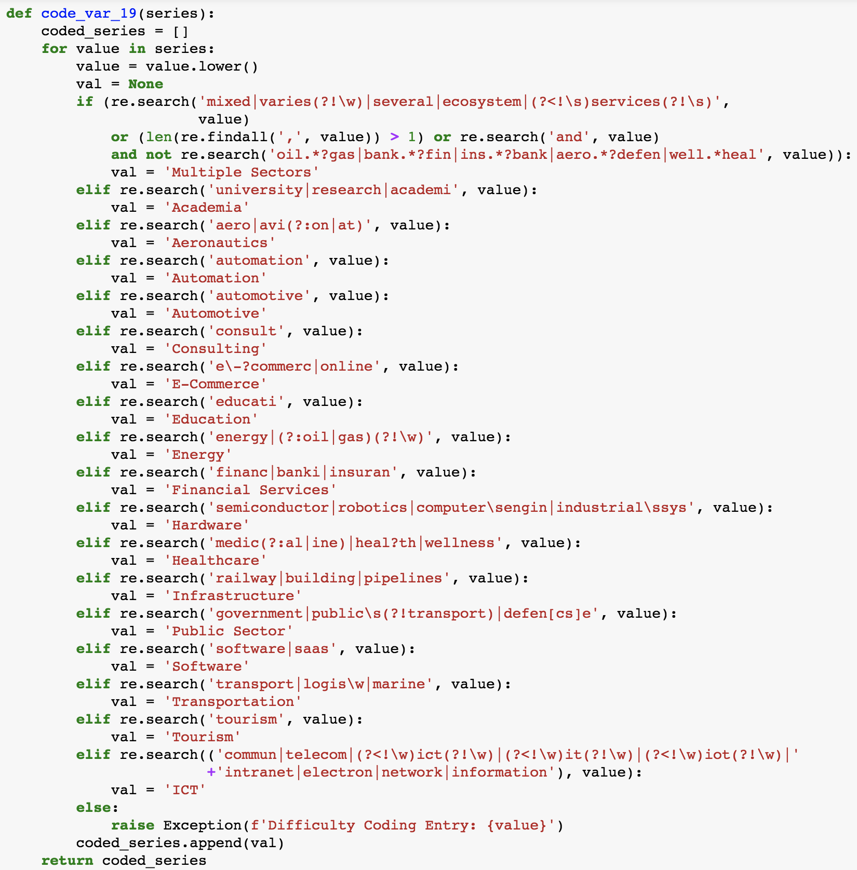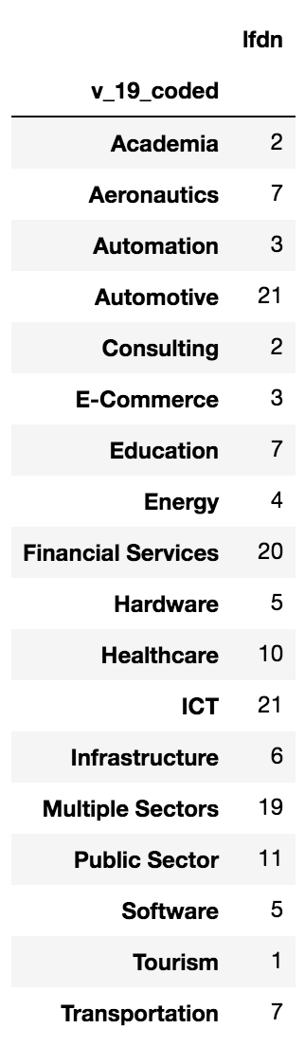Summary of responses after coding: Code used to produce this result:

# Variable 8345 et seq: Positive Reasoning

While performing the validation, please watch for responses we might quote in our publications.

Summary of responses after algorithmic coding:

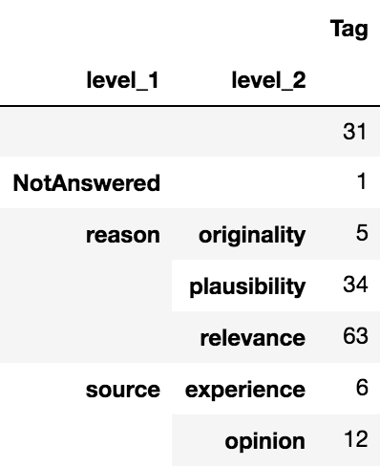

Regular expressions used to produce this result:

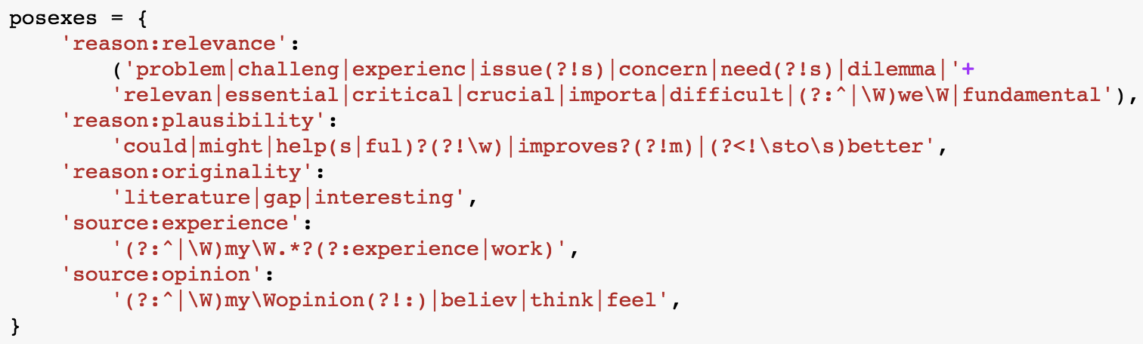

# Variable 8780 et seq: Negative Reasoning

While performing the validation, please watch for responses we might quote in our publications.

Summary of responses after algorithmic coding:

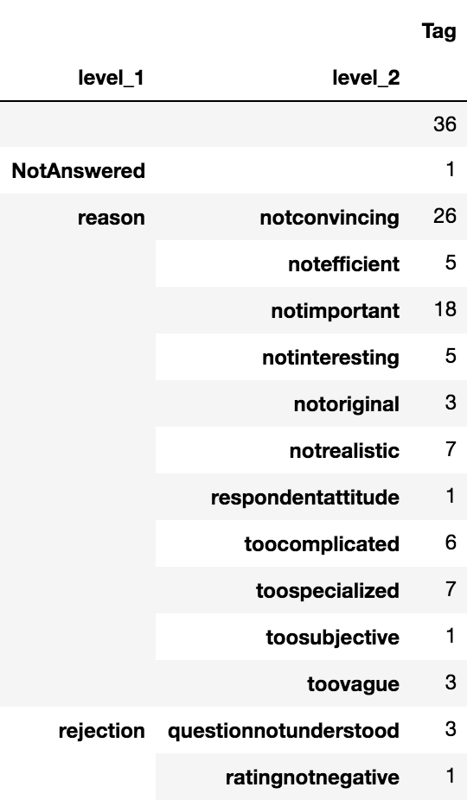

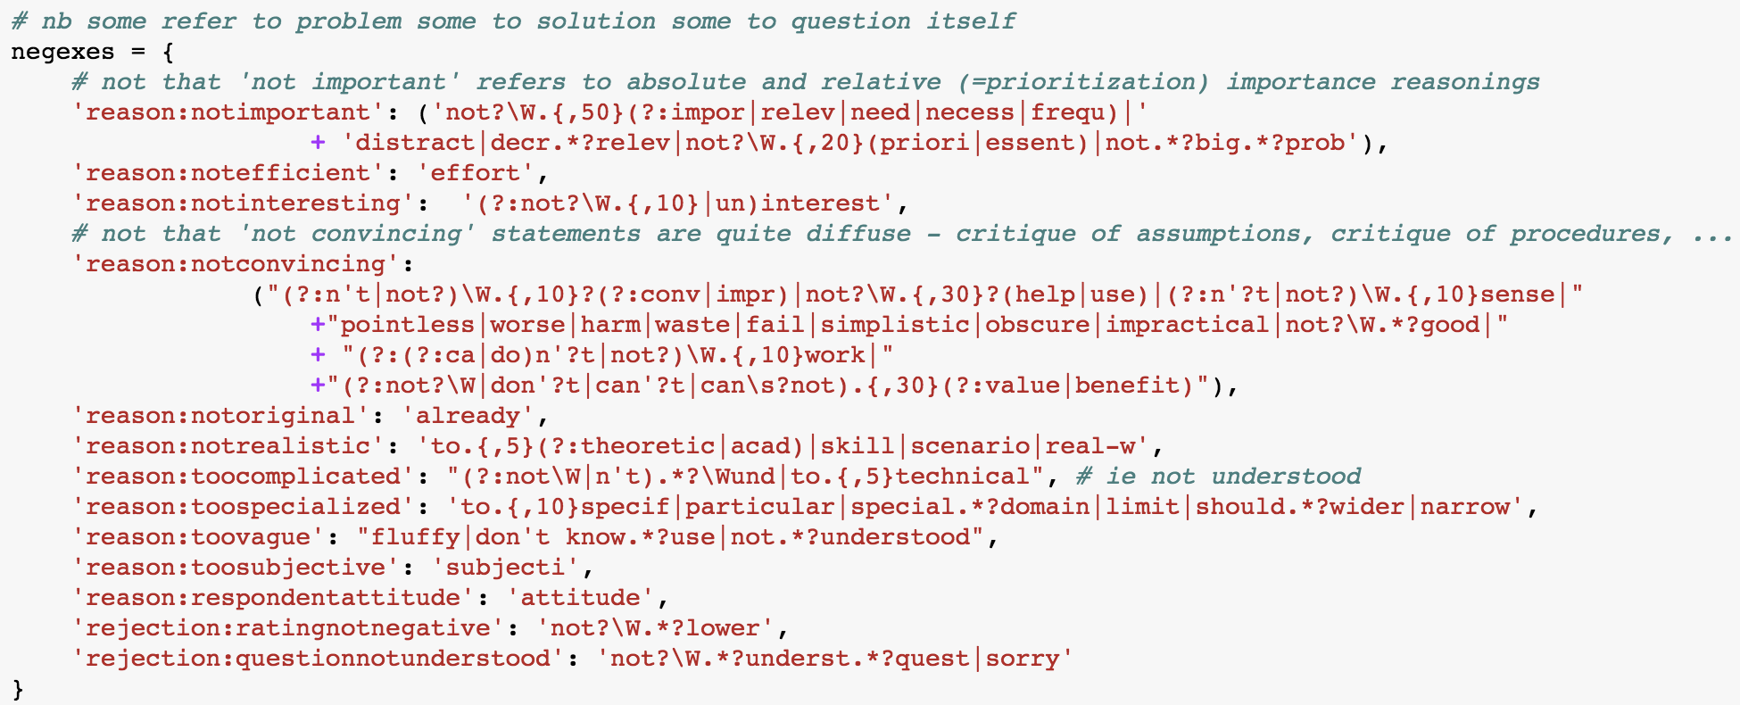Regular expressions used to produce this result:

# Screen%20Shot%202018-04-05%20at%2013.29.45.pngPaper Mapping: What?

Summary of papers after algorithmic coding:

As the code used to produce this result is quite   
voluminous, please see the Jupyter Notebook HTML  
for details regarding the rules used and the rationales  
behind individual facets or tags.

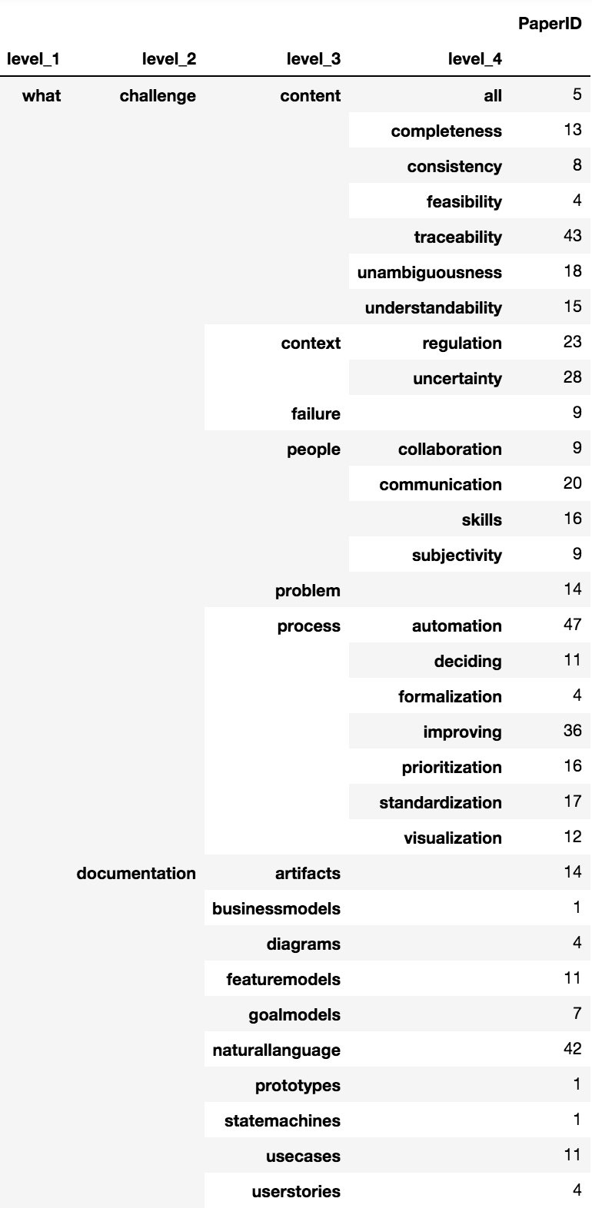

# Paper Mapping: How?

Please validate “How?” in conjunction with “With Whom?”. The validation file contains entries for both questions, and at least one row per paper.

Summary of papers after algorithmic coding:

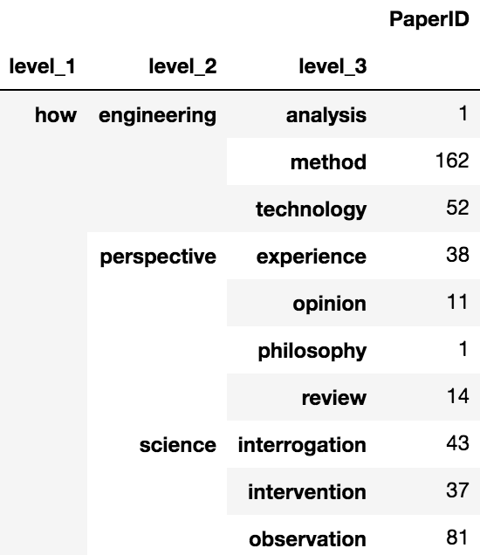

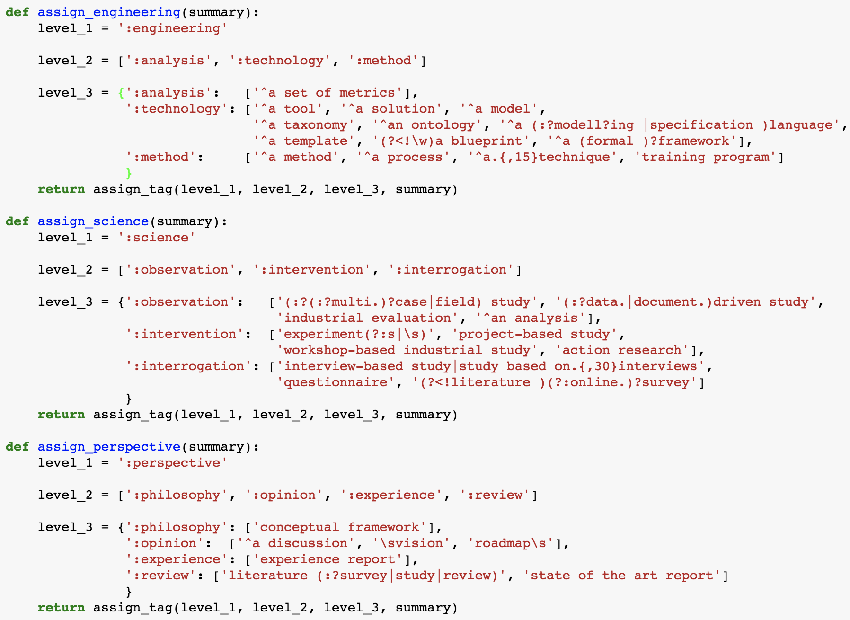Code used to produce this result:

# Paper Mapping: With Whom?

Please validate “With Whom?” in conjunction with “How?”. The validation file contains entries for both questions, and at least one row per paper.

Summary of papers after algorithmic coding:

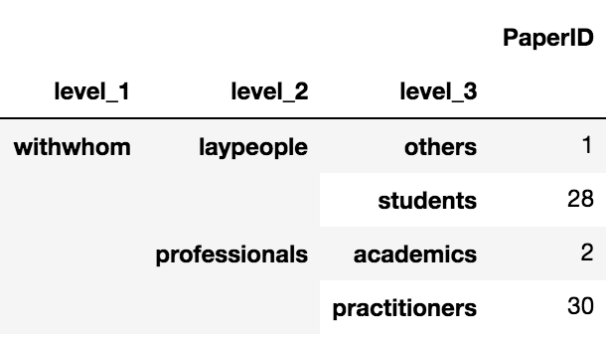

Code used to produce this result:

