**Nishant Mendiratta**

**009994387**

**CMPE 280 (Assignment 3) - AJAX_and_RegistrationPage_with_CAPTCH**

# To run project:

# Download project

# Run on terminal – “npm install” from project folder (used for installing dependencies”

# Run “node server.js” after npm installs. node server will start on port 3000

# From browser open “localhost:3000”

# Fill in all details and it will be stored on mongo lab( mongo db cloud services)

1. Empty Screen

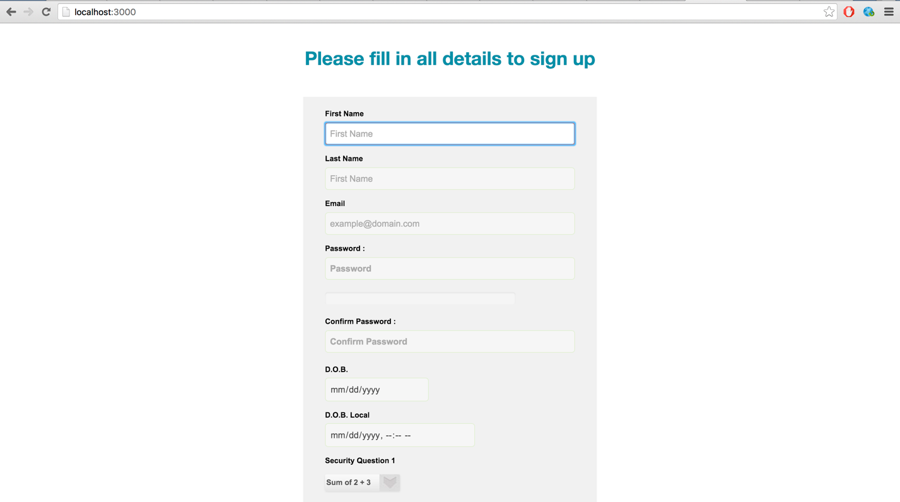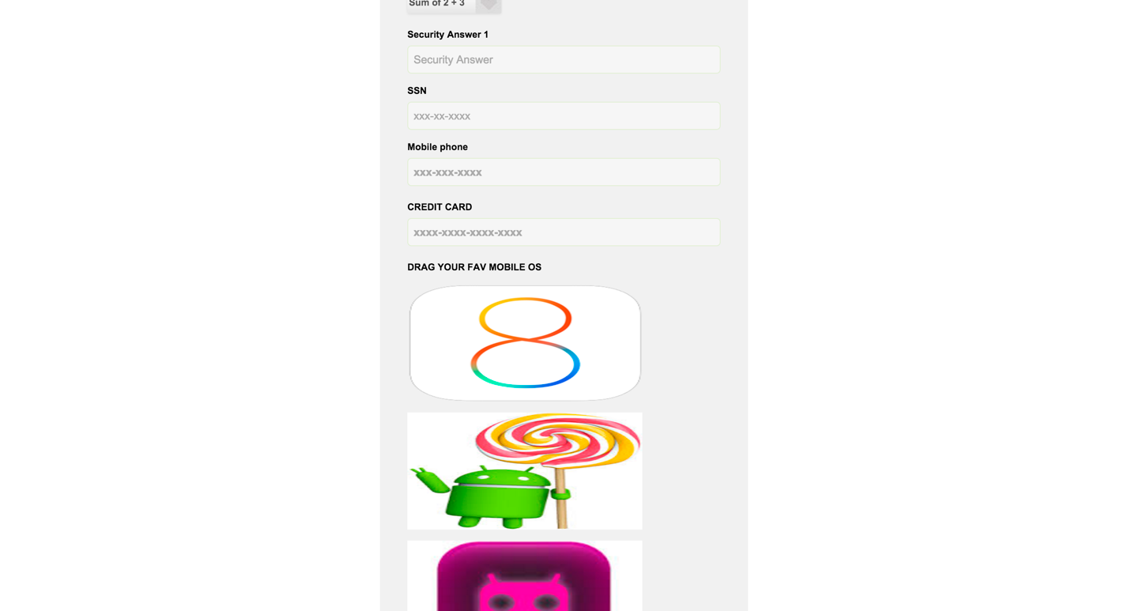

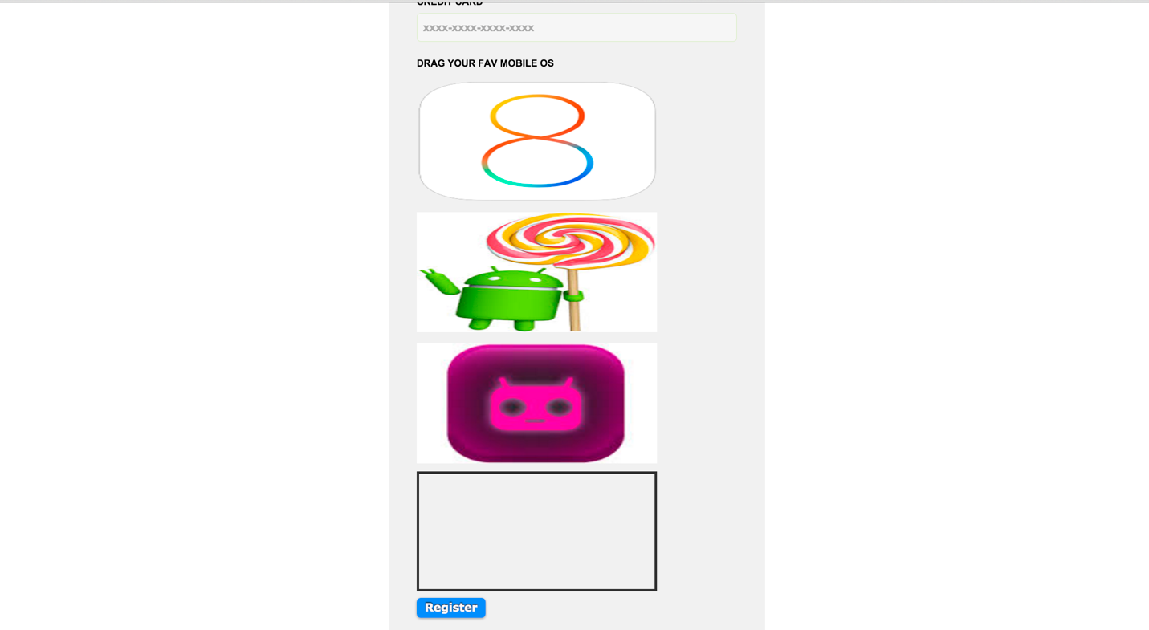

1. Filled Details and Saved into MongoDB

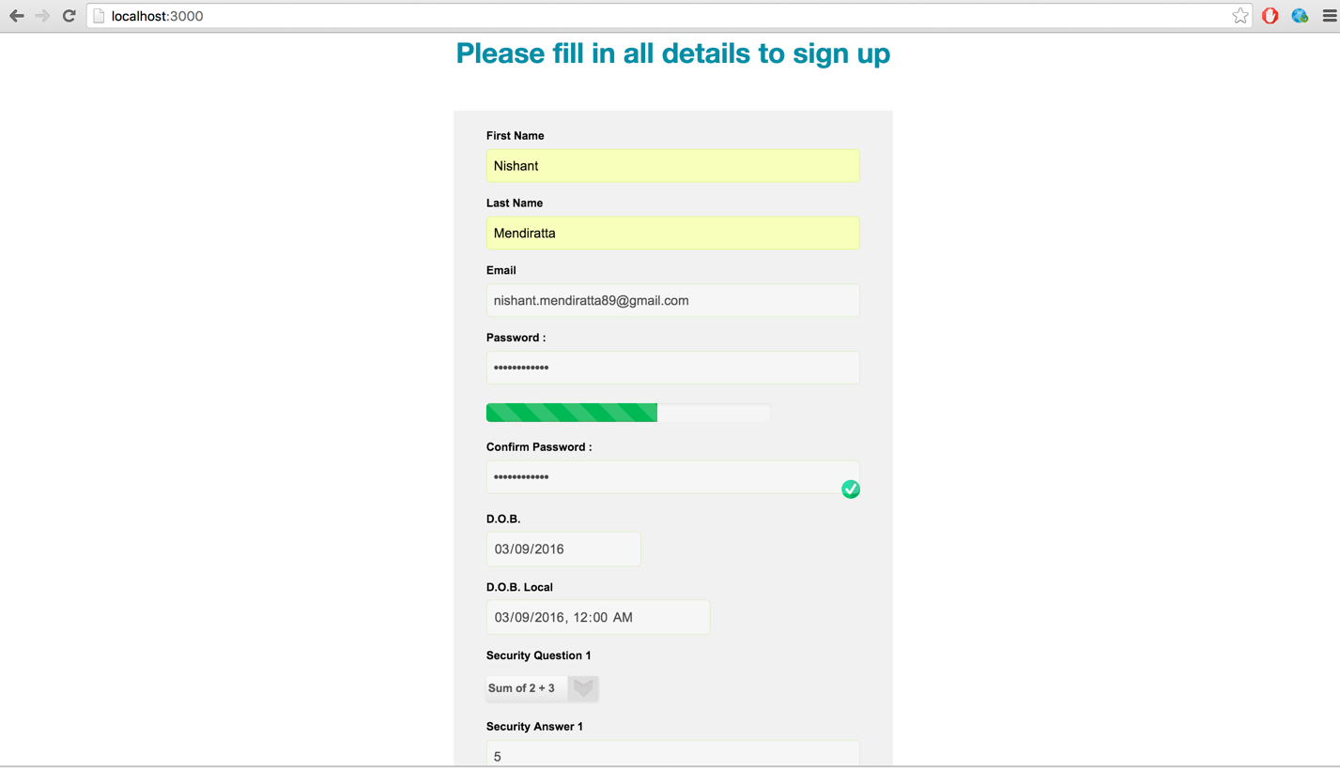

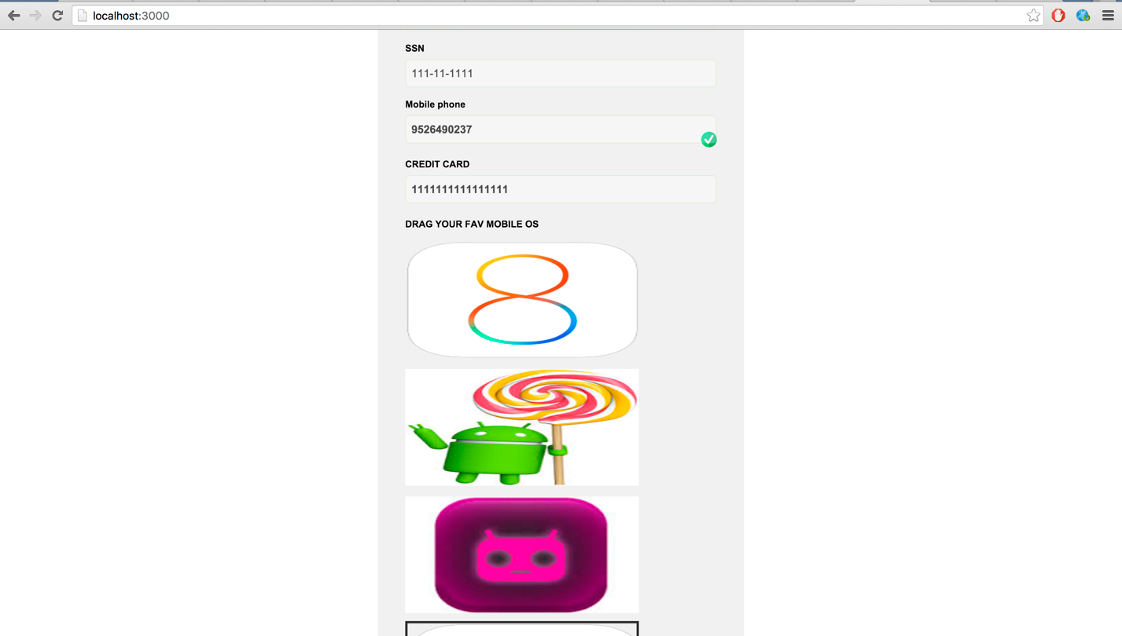

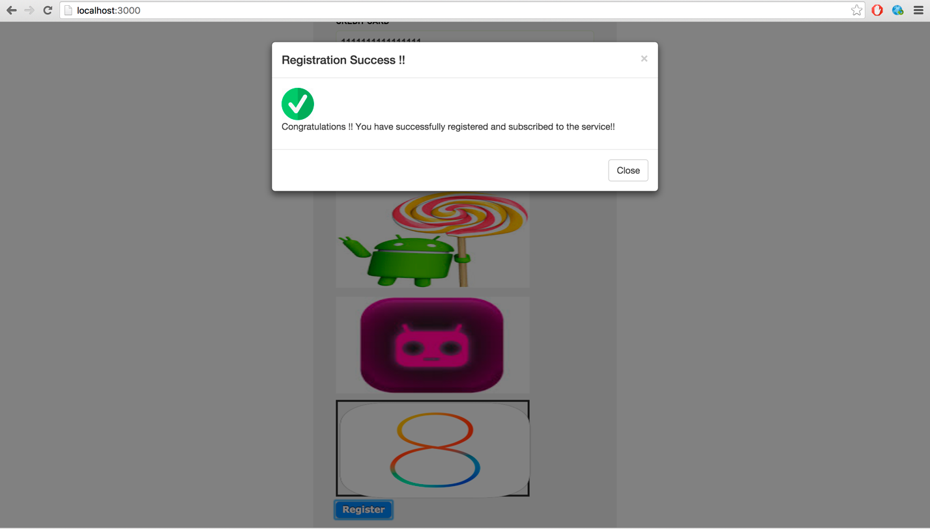

Screenshot of Terminal to state object gets stored

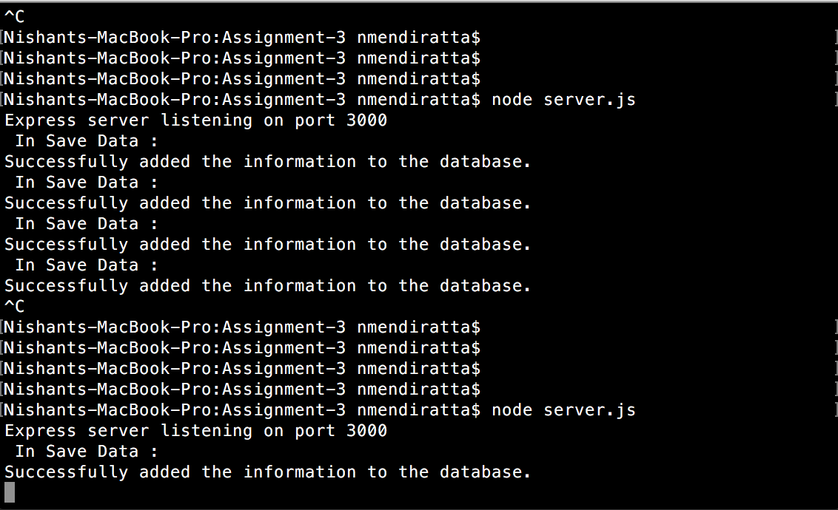

Mongo Lab Screenshot

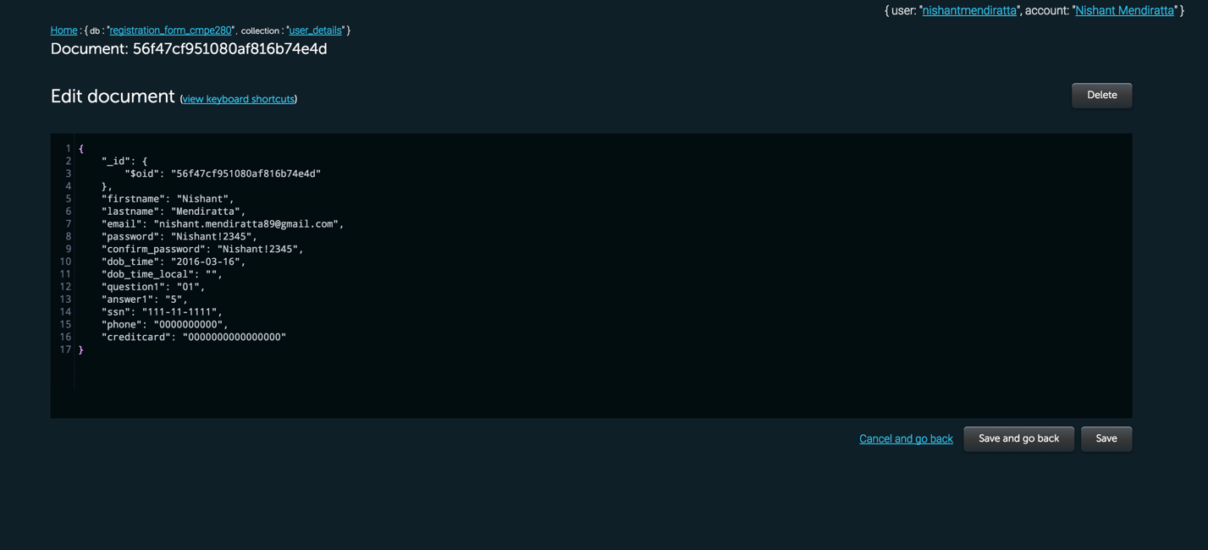

1. Failed Registration

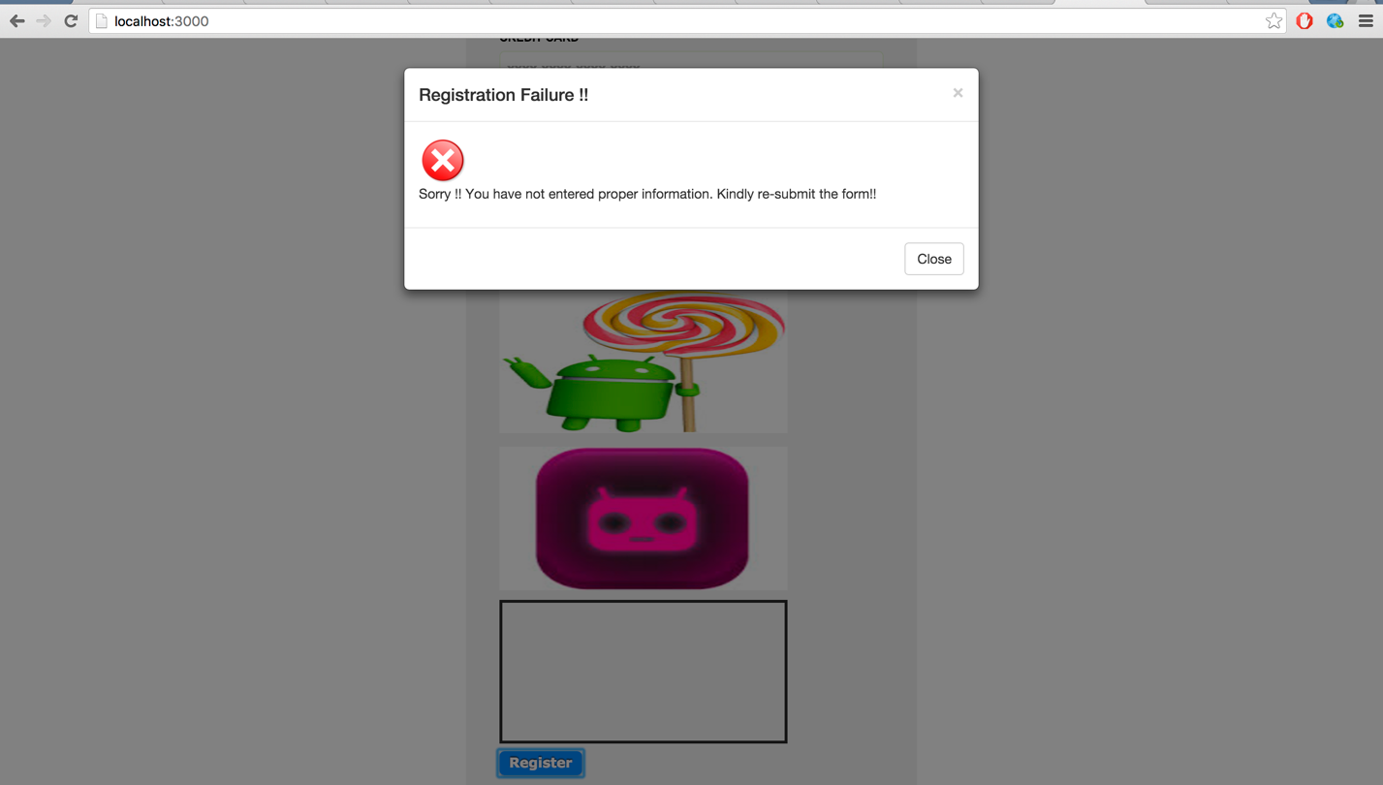

Thank you!