5 Signs You're Not Ready to Retire — YouTube Packaging
Title Options
Search = how closely the title matches what a retirement viewer actually types into YouTube (1–10). Len = character count; green stays visible on mobile.

# | Title | Search | Len | Pattern
1 | 5 Signs You're Not Ready to Retire | 10 | 34 | Warning / loss
2 | You Can Afford to Retire. You're Still Not Ready. | 4 | 49 | Contrarian pushback
3 | The 5-Question Retirement Readiness Check | 7 | 41 | Authority / framework
Thumbnail Concepts
  Recommended — "ARE YOU READY?" |   Alt — "ONLY 2 ARE ABOUT MONEY"
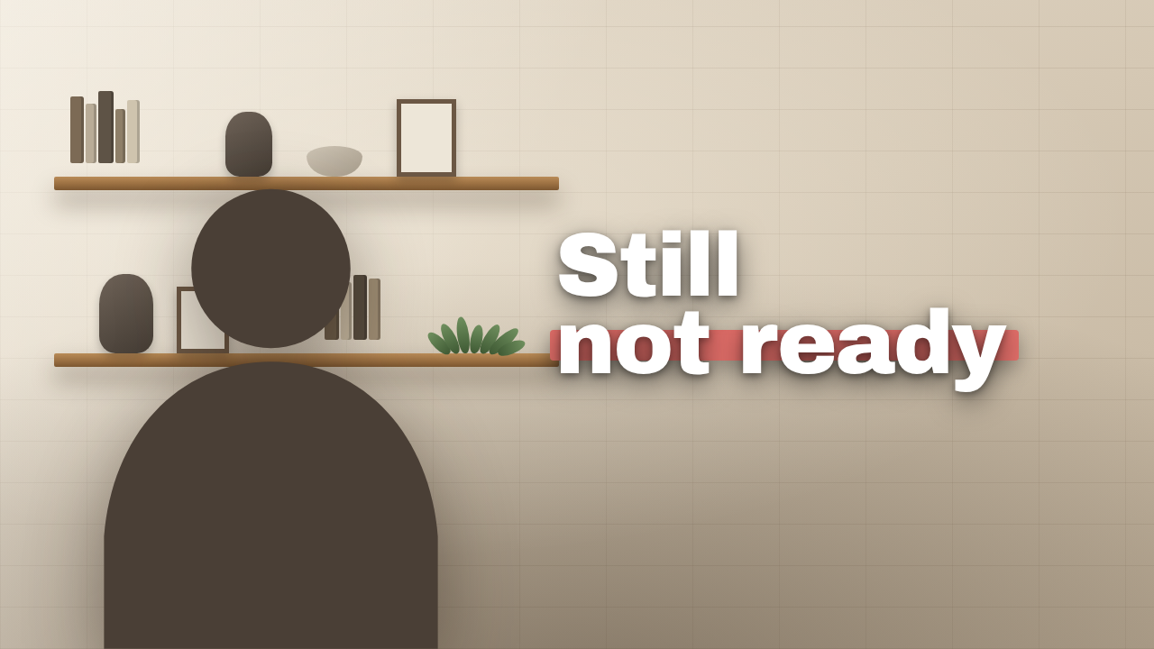  Alt — "STILL NOT READY" |   Alt — "THE 3 NOBODY PLANS FOR"

Video Description
You can have the money and still not be ready to retire.
After nearly 15 years as a CFP®, Aaron Christopherson breaks down the five warning signs he sees most often in the years before retirement — and why only two of them are actually about your money.
• Why a guessed spending number breaks the whole plan
• Shifting a portfolio from accumulation to retirement income
• Knowing what you're retiring to, not just what you're retiring from
• Getting on the same page as your spouse before you retire
More at thinkpinnacle.com
DISCLAIMER: Advisory services are offered through Pinnacle Wealth Advisors, LLC, an SEC-registered investment adviser. This content is intended for informational and educational purposes only and should not be considered personalized investment, tax, or legal advice. Viewing this content does not create an advisory relationship. We do not provide tax preparation or legal services. Always consult an investment, tax or legal professional regarding your specific situation. The strategies, case studies, and examples discussed may not be suitable for everyone. They are hypothetical and for illustrative and educational purposes only. They do not reflect actual client results and are not guarantees of future performance. All investments involve risk, including the potential loss of principal. Comments reflect the views of individual users and do not necessarily represent the views of Pinnacle Wealth Advisors. They are not verified, may not be accurate, and should not be considered testimonials or endorsements Advisory services are offered only under a written agreement with Pinnacle Wealth Advisors.
Tags
20 tags · 496 / 500 chars
5 signs you're not ready to retire, not ready to retire, am i ready to retire, retirement readiness, signs you are not ready to retire, how do i know if i can retire, when can i retire, retirement planning, sequence of returns risk, retirement income planning, how much do i need to retire, retirement spending, retiring in 5 years, retirement checklist, what to do before you retire, retirement mistakes, certified financial planner, Aaron Christopherson, Pinnacle Wealth Advisors, thinkpinnacle

