5 Questions Before You Retire — YouTube Packaging
Title Options
Search = how closely the title matches what a retirement viewer actually types into YouTube (1–10). Len = character count; green stays visible on mobile.

# | Title | Search | Len | Pattern
1 | 5 Questions to Answer Before You Retire | 9 | 39 | Authority / framework
2 | How to Know If You Can Afford to Retire | 9 | 39 | Judgment / question
3 | You Could Probably Retire Sooner Than You Think | 5 | 47 | Contrarian pushback
Thumbnail Concepts
  Recommended — "RETIRE TODAY?" |   Alt — "You can't make more time"
  Alt — "DON'T WAIT FOR 65" | 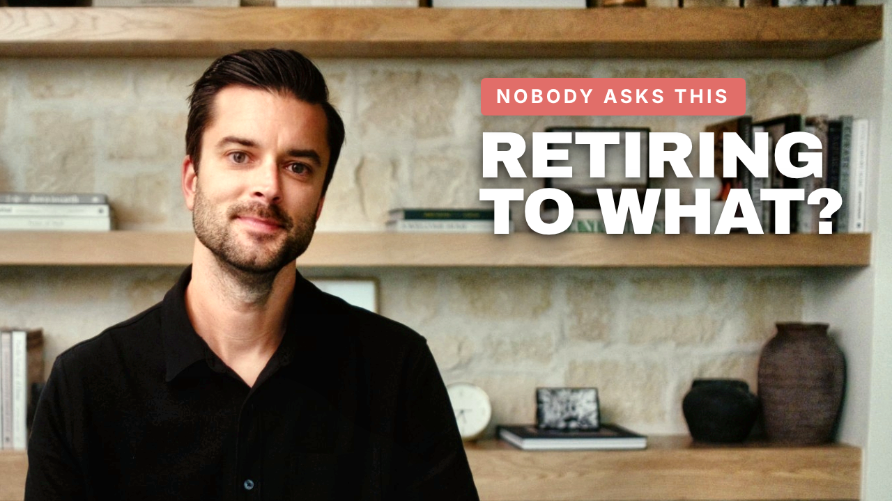  Alt — "RETIRING TO WHAT?"

Video Description
You might be closer to retirement than you think — or overlooking something that puts it at risk.
Aaron Christopherson, CFP®, walks through the five questions he wants answered before anyone retires, and why the people who retire confidently aren't always the ones with the most money.
• Building your retirement number from your lifestyle, not your salary
• Why a portfolio built for accumulation can fail in a down market
• What health insurance before 65 really costs, and why it isn't a reason to keep working
• Having something meaningful to retire to
• Whether your spouse would be financially okay without you
Schedule a conversation with our team at thinkpinnacle.com
DISCLAIMER: Advisory services are offered through Pinnacle Wealth Advisors, LLC, an SEC-registered investment adviser. This content is intended for informational and educational purposes only and should not be considered personalized investment, tax, or legal advice. Viewing this content does not create an advisory relationship. We do not provide tax preparation or legal services. Always consult an investment, tax or legal professional regarding your specific situation. The strategies, case studies, and examples discussed may not be suitable for everyone. They are hypothetical and for illustrative and educational purposes only. They do not reflect actual client results and are not guarantees of future performance. All investments involve risk, including the potential loss of principal. Comments reflect the views of individual users and do not necessarily represent the views of Pinnacle Wealth Advisors. They are not verified, may not be accurate, and should not be considered testimonials or endorsements Advisory services are offered only under a written agreement with Pinnacle Wealth Advisors.
Tags
18 tags · 487 / 500 chars
can i afford to retire, am i ready to retire, questions to ask before retiring, how much do i need to retire, retirement readiness, sequence of returns risk, retiring before 65 health insurance, health insurance before medicare, retirement income planning, retirement portfolio allocation, when can i retire, surviving spouse retirement planning, certified financial planner, fiduciary financial advisor, retirement planning, Aaron Christopherson, Pinnacle Wealth Advisors, thinkpinnacle

