**Readme File for RSA project.**

***Setup Steps:***

Please ensure python is installed on the Operating System running the program. No additional module/package needs to be installed to run the program.

***RSA program:***

Script written in python for the RSA challenge.

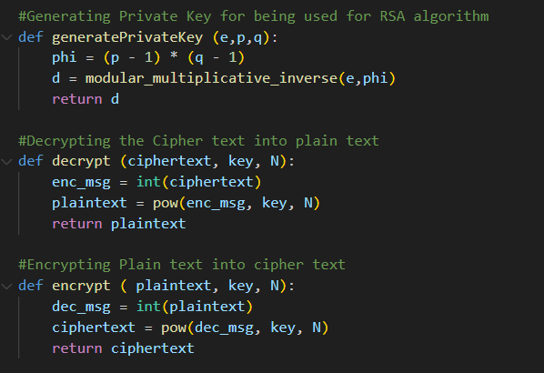

Screenshot showing RSA.py python script for required functions.



***Input parameters***

Following input parameters are supplied to the program (according to example provided in the question prompt):

pe = 254

pc = 1223

qe = 251

qc = 1339

ee = 17

ec = 65535

c = 66536047120374145538916787981868004206438539248910734713495276883724693574434582104900978079701174539167102706725422582788481727619546235440508214694579

d = 1756026041

Note: Input parameters are passed as a single string to the program:

254 1223 251 1339 17 65535 66536047120374145538916787981868004206438539248910734713495276883724693574434582104900978079701174539167102706725422582788481727619546235440508214694579 1756026041



Screenshot showing input values.

***Running the program***

The program can be run with the help of the following command:

**python RSA.py 254 1223 251 1339 17 65535 66536047120374145538916787981868004206438539248910734713495276883724693574434582104900978079701174539167102706725422582788481727619546235440508214694579 1756026041**

(Note: Please ensure that you are in the same directory as the RSA.py file.)



Screenshot showing running the program.

Please note I am using PowerShell as the CLI a windows machine and have provided the full path to the python executable as well as the RSA.py file. It can be replaced by “python” and “RSA.py” if you are in the same directory as the RSA.py file and python is installed on your OS.

***Output***

Following is the output received after running the program:

1756026041,665360471203741455389167879818680042064385392489107347134952 7688372469357443458210490097807970117453916710270672542258278848172761 9546235440508214694579

Here 1756026041 is the decrypted plaintext.

Here 665360471203741455389167879818680042064385392489107347134952 7688372469357443458210490097807970117453916710270672542258278848172761 9546235440508214694579 is the encrypted ciphertext.

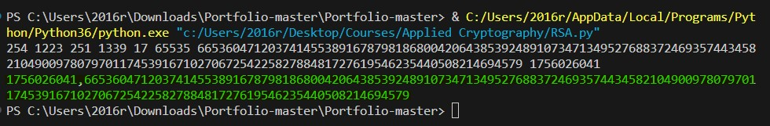

Screenshot showing the output highlighted in green color.