**Date Submitted: 12.11.2019**

**Task 01:** Building and loading the collector example

**Youtube Link:**

Collector built and loaded

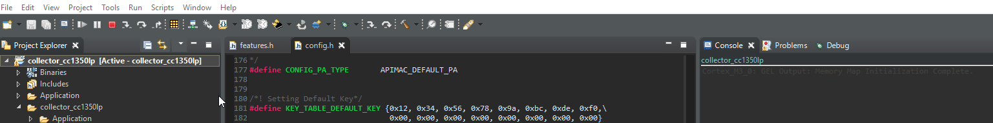

**Task 02:** Building and loading the sensor example

**Youtube Link:**

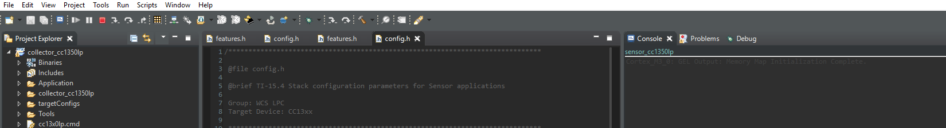

**Task 03:** Using the Collector and Sensor

**Youtube Link:**

**Working with Itzel berecill we were able to use both builds**

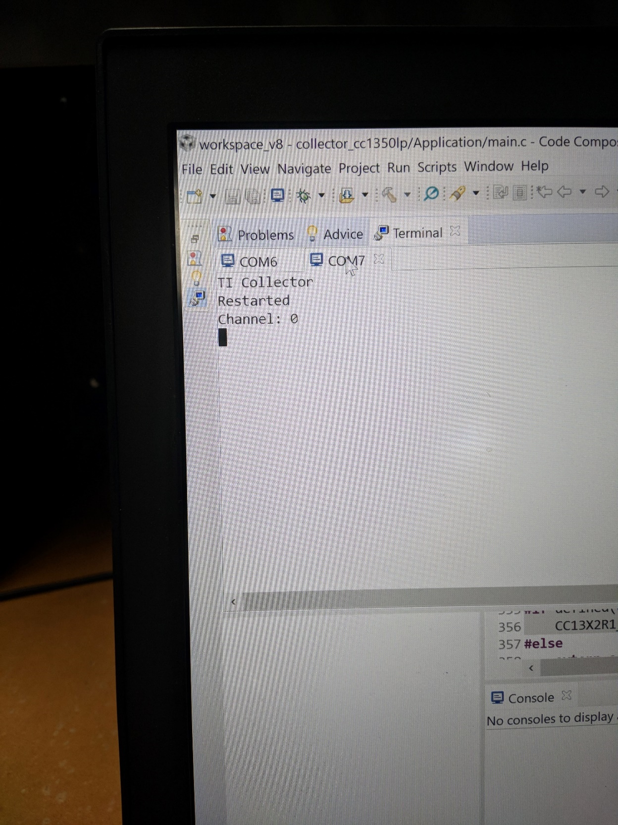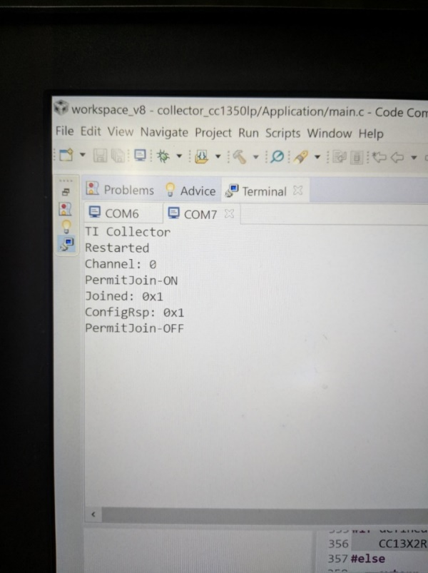

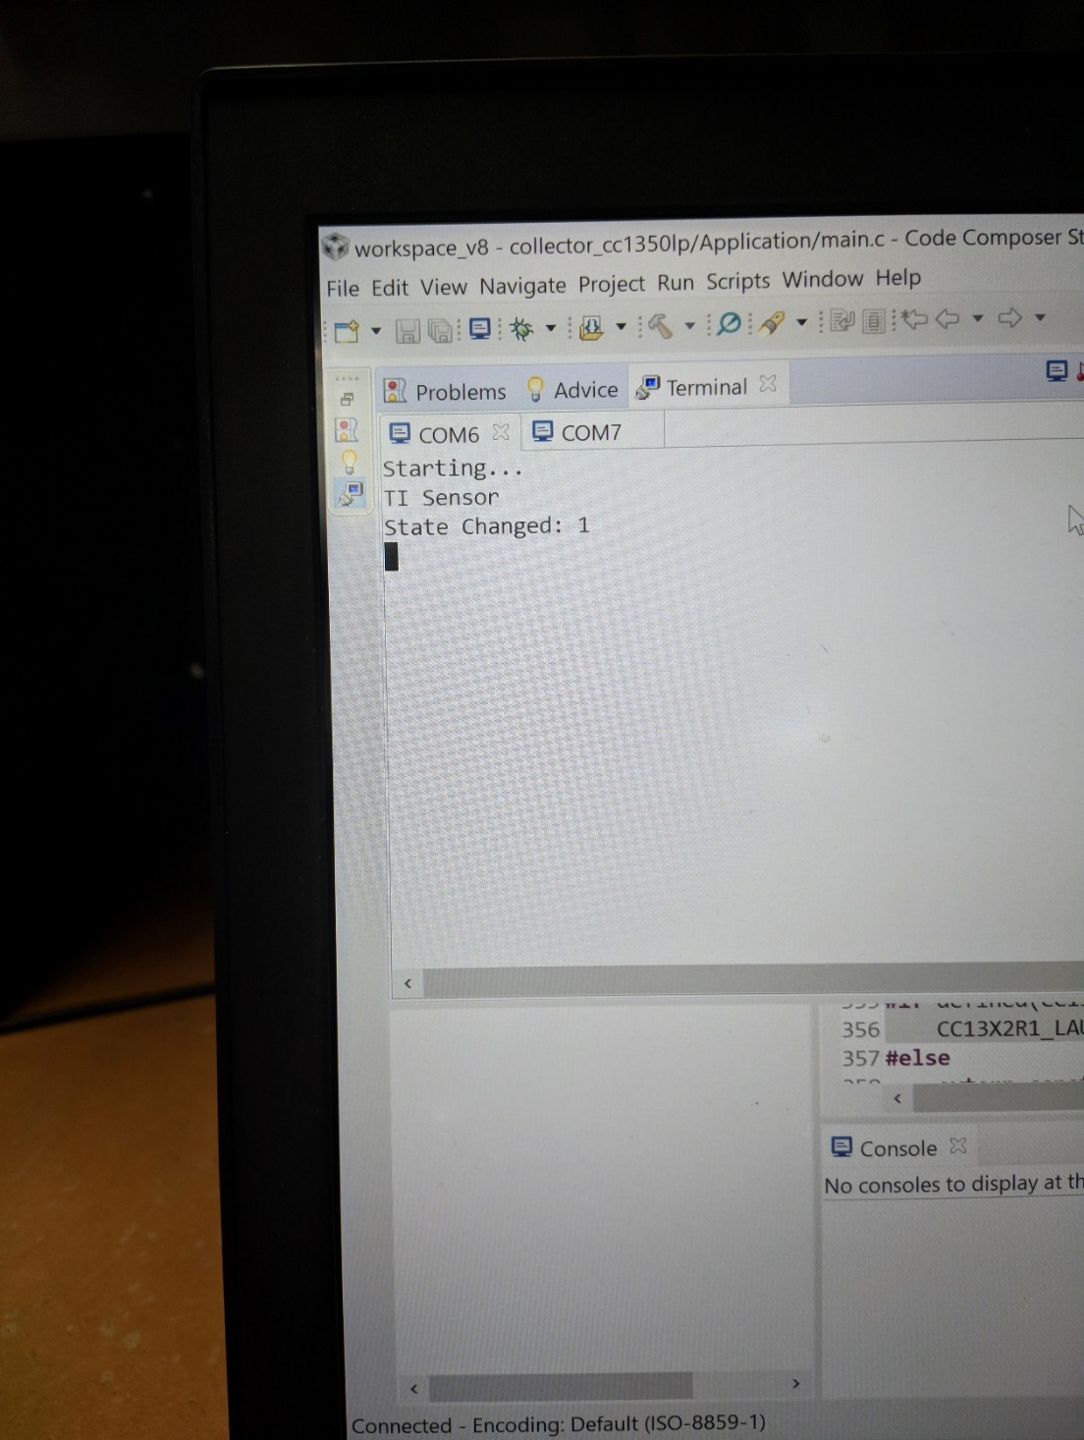

**Task 04:** Updating the sensor's reporting rate

**Youtube Link:**

