**Date Submitted: 10/10/2019**

**Task 00: Execute provided code**

**Youtube Link:**

<https://www.youtube.com/watch?v=WD3YLFheLXM>

**------------------------------------------------------------------------------------**

**Task 01:**

Graph:

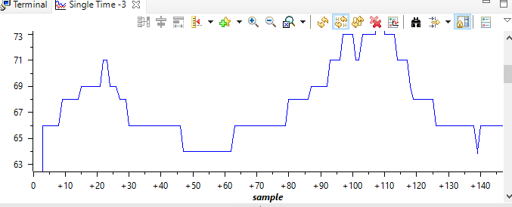

Youtube Link:

<https://www.youtube.com/watch?v=9LCvm5uinTg>

**Modified Schematic (if applicable):**

**Modified Code:**

**#include** <stdint.h>

**#include** <stdbool.h>

**#include** "inc/hw_memmap.h"

**#include** "inc/hw_types.h"

**#include** "driverlib/debug.h"

**#include** "driverlib/sysctl.h"

**#include** "driverlib/adc.h"

**#include** "driverlib/gpio.h"

**int** **main**(**void**){

uint32_t ui32ADC0Value[4];

**volatile** uint32_t ui32TempAvg;

**volatile** uint32_t ui32TempValueC;

**volatile** uint32_t ui32TempValueF;

**SysCtlClockSet**(SYSCTL_SYSDIV_5|SYSCTL_USE_PLL|SYSCTL_OSC_MAIN|SYSCTL_XTAL_16MZ);

**SysCtlPeripheralEnable**(SYSCTL_PERIPH_ADC0);

**ADCSequenceConfigure**(ADC0_BASE, 2, ADC_TRIGGER_PROCESSOR, 0); // Sequencer 2

**ADCSequenceStepConfigure**(ADC0_BASE, 2, 0, ADC_CTL_TS);

**ADCSequenceStepConfigure**(ADC0_BASE, 2, 1, ADC_CTL_TS);

**ADCSequenceStepConfigure**(ADC0_BASE, 2, 2, ADC_CTL_TS);

**ADCSequenceStepConfigure**(ADC0_BASE, 2, 3, ADC_CTL_TS|ADC_CTL_IE|ADC_CTL_END);

**ADCSequenceEnable**(ADC0_BASE, 2);

// Enable PF1 and PF2 LEDs

**SysCtlPeripheralEnable**(SYSCTL_PERIPH_GPIOF);

**GPIOPinTypeGPIOOutput**(GPIO_PORTF_BASE, GPIO_PIN_1|GPIO_PIN_2);

**while**(1){

**ADCIntClear**(ADC0_BASE, 2);

**ADCProcessorTrigger**(ADC0_BASE, 2);

**while**(!**ADCIntStatus**(ADC0_BASE, 2, **false**)){}

**ADCSequenceDataGet**(ADC0_BASE, 2, ui32ADC0Value);

ui32TempAvg = (ui32ADC0Value[0] + ui32ADC0Value[1] + ui32ADC0Value[2] + ui32ADC0Value[3] + 2)/4;

ui32TempValueC = (1475 - ((2475 * ui32TempAvg)) / 4096)/10;

ui32TempValueF = ((ui32TempValueC * 9) + 160) / 5;

// If greater than 68degF change to red, else blue.

**if** (ui32TempValueF > 68) {

**GPIOPinWrite**(GPIO_PORTF_BASE, GPIO_PIN_1|GPIO_PIN_2, 2);

}

**else** {

**GPIOPinWrite**(GPIO_PORTF_BASE, GPIO_PIN_1|GPIO_PIN_2, 4);

}

}

}

**------------------------------------------------------------------------------------**

**Task 02:**

Graph:

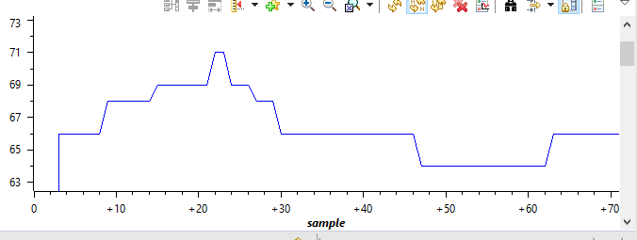

*Held down on processor at red marks to generate heat.

Verification of timer:



Youtube Link:

<https://www.youtube.com/watch?v=nnmxvSmT4kE>

**Modified Schematic (if applicable):**

**Modified Code:**

**#include** <stdint.h>

**#include** <stdbool.h>

**#include** "inc/hw_types.h"

**#include** "driverlib/debug.h"

**#include** "driverlib/sysctl.h"

**#include** "driverlib/adc.h"

**#include** "driverlib/gpio.h"

**#include** "inc/hw_memmap.h"

**#include** "inc/tm4c123gh6pm.h"

**#include** "driverlib/timer.h"

**#include** "driverlib/interrupt.h"

uint32_t ui32Period;

uint32_t ui32ADC0Value[4];

**volatile** uint32_t ui32TempAvg;

**volatile** uint32_t ui32TempValueC;

**volatile** uint32_t ui32TempValueF;

**int** **main**(**void**){

**SysCtlClockSet**(SYSCTL_SYSDIV_5|SYSCTL_USE_PLL|SYSCTL_OSC_MAIN|SYSCTL_XTAL_16MHZ);

**SysCtlPeripheralEnable**(SYSCTL_PERIPH_ADC0);

**ADCHardwareOversampleConfigure**(ADC0_BASE, 32); // Hardware Averaging of 32 Samples

**ADCSequenceConfigure**(ADC0_BASE, 2, ADC_TRIGGER_PROCESSOR, 0); // Sequencer 2

**ADCSequenceStepConfigure**(ADC0_BASE, 2, 0, ADC_CTL_TS);

**ADCSequenceStepConfigure**(ADC0_BASE, 2, 1, ADC_CTL_TS);

**ADCSequenceStepConfigure**(ADC0_BASE, 2, 2, ADC_CTL_TS);

**ADCSequenceStepConfigure**(ADC0_BASE, 2, 3, ADC_CTL_TS|ADC_CTL_IE|ADC_CTL_END);

**SysCtlPeripheralEnable**(SYSCTL_PERIPH_GPIOF);

**GPIOPinTypeGPIOOutput**(GPIO_PORTF_BASE, GPIO_PIN_1|GPIO_PIN_2);

**SysCtlPeripheralEnable**(SYSCTL_PERIPH_TIMER1);

**TimerConfigure**(TIMER1_BASE, TIMER_CFG_PERIODIC);

ui32Period = **SysCtlClockGet**() / 2;

**TimerLoadSet**(TIMER1_BASE, TIMER_A, ui32Period-1);

**IntEnable**(INT_TIMER1A);

**TimerIntEnable**(TIMER1_BASE, TIMER_TIMA_TIMEOUT);

**IntMasterEnable**();

**TimerEnable**(TIMER1_BASE, TIMER_A);

**ADCSequenceEnable**(ADC0_BASE, 2); // 128 samples

**ADCIntEnable**(ADC0_BASE, 2);

**while**(1) {}

}

**void** **Timer1AIntHandler**(**void**){

**TimerIntClear**(TIMER1_BASE, TIMER_A);

**ADCIntClear**(ADC0_BASE, 2);

**ADCProcessorTrigger**(ADC0_BASE, 2);

**while**(!**ADCIntStatus**(ADC0_BASE, 2, **false**)){}

**ADCSequenceDataGet**(ADC0_BASE, 2, ui32ADC0Value);

ui32TempAvg = (ui32ADC0Value[0] + ui32ADC0Value[1] + ui32ADC0Value[2] + ui32ADC0Value[3] + 2)/4;

ui32TempValueC = (1475 - ((2475 * ui32TempAvg)) / 4096)/10;

ui32TempValueF = ((ui32TempValueC * 9) + 160) / 5;

// If greater than 68degF change to blue, else red.

**if** (ui32TempValueF > 68){

**GPIOPinWrite**(GPIO_PORTF_BASE, GPIO_PIN_1|GPIO_PIN_2, 2);

}

**else**{

**GPIOPinWrite**(GPIO_PORTF_BASE, GPIO_PIN_1|GPIO_PIN_2, 4);

}

}