CPE301 – SPRING 2019

Design Assignment 4B

Student Name: Saul Alejandro Mendoza Guzman

Student #: 2000540481

Student Email: mendos1@unlv.nevada.edu

Primary Github address: <https://github.com/mendos1/subnission_da>

Directory: DA4B

Submit the following for all Labs:

1. In the document, for each task submit the modified or included code (only) with highlights and justifications of the modifications. Also, include the comments.
2. Use the previously create a Github repository with a random name (no CPE/301, Lastname, Firstname). Place all labs under the root folder ESD301/DA, sub-folder named LABXX, with one document and one video link file for each lab, place modified asm/c files named as LabXX-TYY.asm/c.
3. If multiple asm/c files or other libraries are used, create a folder LabXX-TYY and place these files inside the folder.
4. The folder should have a) Word document (see template), b) source code file(s) and other include files, c) text file with youtube video links (see template).

1. **COMPONENTS LIST AND CONNECTION BLOCK DIAGRAM w/ PINS**

* Atmega328p Xplained MINI
* Usb cable
* External power supply
* Jumper wires
* Potentiometer
* Servo motor
* Sepper mtor
* Atmel studio 7

1. **INITIAL/MODIFIED/DEVELOPED CODE OF TASK 1/B**

#define F_CPU 16000000UL

#include <avr/io.h>

#include <util/delay.h>

#include <avr/interrupt.h>

void adc_int(void);

void timer_init(void);

volatile unsigned int speed; // Value of delay AKA speed

volatile int stop = 0; // Variable used to stop operation

int main(void)

{

DDRB = 0x0F; // Set PD0 - PD3 as outputs for stepper motor

adc_int(); // Initialize ADC

TCCR1B = 0x0D; // Set CTC mode and 1024 prescaler

while(1){

while((ADCSRA&(1<<ADIF))==0); // wait for ADC conversion

if (ADC <= 4) {stop = 0; speed = 1;}

if (ADC <= 85) {stop = 0; speed = 2;}

if (ADC <= 170) {stop = 0; speed = 3;}

if (ADC <= 255) {stop = 0; speed = 4;}

if (ADC <= 340) {stop = 0; speed = 5;}

if (ADC <= 425) {stop = 0; speed = 6;}

if (ADC <= 510) {stop = 0; speed = 7;}

if (ADC <= 595) {stop = 0; speed = 8;}

if (ADC <= 680) {stop = 0; speed = 9;}

if (ADC <= 765) {stop = 0; speed = 10;}

if (ADC <= 850) {stop = 0; speed = 11;}

if (ADC <= 935) {stop = 0; speed = 12;}

if (ADC <= 1015) {stop = 0; speed = 13;}

if (ADC >= 1016) {stop = 1;}

OCR1A = speed; // set OCR1A to the determined speed

TCNT1 = 0x00; // reset the clock

if(stop == 0){

// If the ADC value is not at its MAX value then step with desired delay

while((TIFR1 & 0x2) != 0x2);

PORTB = 0x09;

TIFR1 |= (1<<OCF1A);

while((TIFR1 & 0x2) != 0x2);

PORTB = 0x08;

TIFR1 |= (1<<OCF1A);

while((TIFR1 & 0x2) != 0x2);

PORTB = 0X0C;

TIFR1 |= (1<<OCF1A);

while((TIFR1 & 0x2) != 0x2);

PORTB = 0X04;

TIFR1 |= (1<<OCF1A);

while((TIFR1 & 0x2) != 0x2);

PORTB = 0x06;

TIFR1 |= (1<<OCF1A);

while((TIFR1 & 0x2) != 0x2);

PORTB = 0x02 ;

TIFR1 |= (1<<OCF1A);

while((TIFR1 & 0x2) != 0x2);

PORTB = 0X03;

TIFR1 |= (1<<OCF1A);

while((TIFR1 & 0x2) != 0x2);

PORTB = 0X01;

TIFR1 |= (1<<OCF1A);

}

}

}

void adc_int(void){

ADMUX = (0<<REFS1)| // Reference Selection Bits

(1<<REFS0)| // AVcc-external cap at AREF

(0<<ADLAR)| // ADC Left Adjust Result

(0<<MUX3) |

(0<<MUX2) | // ANalogChannel Selection Bits

(0<<MUX1) | // ADC0 (PC0)

(0<<MUX0);

ADCSRA = (1<<ADEN)| // ADC ENable

(1<<ADSC) | // ADC Start Conversion

(1<<ADATE)| // ADC Auto Trigger Enable

(0<<ADIF) | // ADC Interrupt Flag

(1<<ADIE) | // ADC Interrupt Enable

(1<<ADPS2)| // ADC PrescalerSelect Bits

(1<<ADPS1)|

(1<<ADPS0);

}

1. **DEVELOPED CODE OF TASK 2/B**

Insert only the modified sections here

#define F_CPU 16000000UL

#include <avr/io.h>

#include <util/delay.h>

#include <avr/interrupt.h>

int check = 0;

int main(void)

{

DDRB = 0xFF; //DDRB as an output

DDRD = 0xFF;

TCCR1B |= (1<<WGM13) | (1<<WGM12) | (1<<CS11) | (1<<CS10);

TCCR1A |= (1<<COM1A1) | (1<<COM1B1) | (1<<WGM11);

ICR1=4999;

ADMUX = 0x60;

ADCSRA = 0xA6;

while (1)

{

ADCSRA |= ( 1 << ADSC); //start conversion

while((ADCSRA & (1 << ADIF))== 0);

check = ADCH; //temp value

if(check == 0) // minimum value

{

OCR1A = 0; //turn 0 deg

_delay_ms(500);

}

if(check == 255) // maximum pot value

{

//PORTB = ( 1 << PORTB2);

OCR1A = 535; //turn 180

_delay_ms(500);

}

}

}

1. **SCHEMATICS**

Use fritzing.org

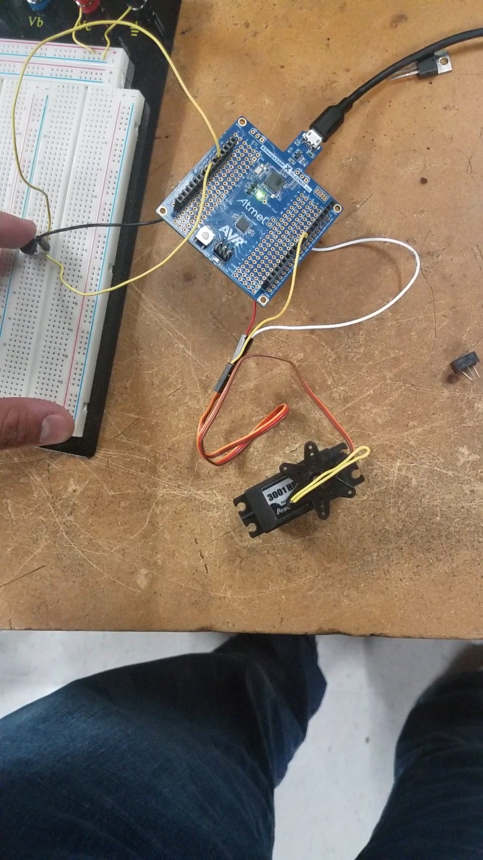

1. **SCREENSHOTS OF EACH TASK OUTPUT (ATMEL STUDIO OUTPUT)**

None for this assignment

1. **SCREENSHOT OF EACH DEMO (BOARD SETUP)**



1. **VIDEO LINKS OF EACH DEMO**

STEPPER: <https://www.youtube.com/watch?v=uRQB7bCZkSw>

SERVO: <https://www.youtube.com/watch?v=eugV6I61uaw>

1. **GITHUB LINK OF THIS DA**

<https://github.com/mendos1/subnission_da/tree/master/DA4B>

**Student Academic Misconduct Policy**

<http://studentconduct.unlv.edu/misconduct/policy.html>

“This assignment submission is my own, original work”.

NAME OF THE STUDENT