Whitewater Rafting Site Plan

# Purpose

The purpose of establishing an online presence for this rafting business is to expand and connect with an audience of adventure enthusiasts. Through our website and social media platforms, we aim to showcase the experiences we can offer. Through our team we intend to attract more customers, increase bookings, and enhance customer engagement. Ultimately, our online presence will serve as a powerful tool for promoting our business, sharing our passion for outdoor adventure, and building lasting relationships with our clients.

## Goals

* Provide information
* Online visibility
* Increase sales

# Target Audience

We welcome people of all ages and backgrounds who share a passion for exploration, adrenaline-pumping activities, and connecting with nature's beauty while enjoying safe and thrilling rafting experiences. Whether beginners looking to try water-rafting for the first time or an experienced rafter seeking challenging rapids, our website caters to individuals, families, and teams seeking exciting rafting adventures.

* **Who are the target customers?**

Adventure seekers, outdoor enthusiasts, thrill-seekers, nature lovers, and anyone looking for unforgettable experiences in the great outdoors.

* **What do they want?**

Our audience want adrenaline-pumping activities, connection with nature, thrill experiences.

* **How will my audience usually access my site (desktop, laptop, mobile device)?**

They will access through a variety of devices, including desktop computers, laptops, and mobile devices such as smartphones and tablets. It is important to note that that accessing trough mobile devices is more and more common.

# Site Map

# Branding

## Logo

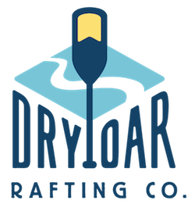

## Style Guide

### Color Schema

Color palette URL: <https://coolors.co/134266-f7f7f7-79c5d7-fbe072>

* **Primary Color:** Indigo Dye #134266
* **Secondary Color:** Seasalt #F7F7F7
* **Accent 1 Color:** Sky Blue #79c5d7
* **Accent 2 Color:** Jasmine #FCE172

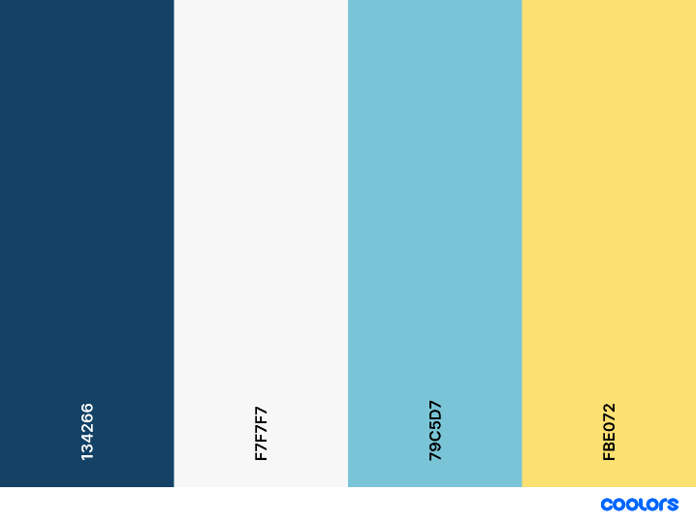

**Accent 1**

**Accent 2**

**Secondaryyyy**

**Primary**

### Typography

Campaign Heading: Kaushan Script, 800

Heading h1: **Montserrat Bold, 700**

Heading h2: **Montserrat Bold, 600**

Heading h3: **Montserrat Bold, 500**

Heading h4: **Montserrat Bold, 400**

Heading h5: **Montserrat Bold, 300**

Paragraphs: Montserrat Regular, 300

## Wireframes

### Homepage

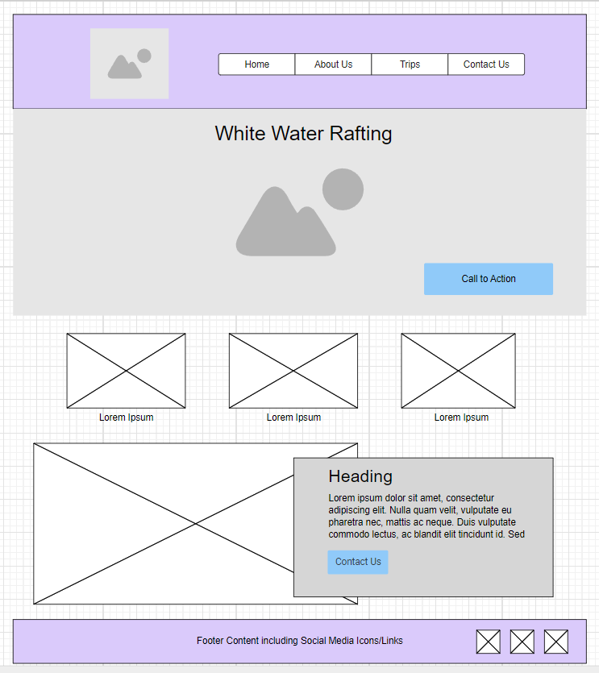

### About us

