**DATA WRANGLING & VISUALIZATION**

**MICRO PROJECT**

**TITLE**

**CREATE A VIZ ON CRICKET STADIUM**

**(IPL DATA ANALYSIS 2008-2020)**

**ABSTRACT**

The Indian Premier League (IPL) is a Twenty20 cricket league tournament held in India during April and May of every year where top players from all over the world take part. The idea is to analyze the IPL data hosted by Kaggle.I have used many charts for doing this analysis.The project utilizes the IPL datasets that allows analyst to incorporate functions that are used by IPL application to fetch and view information.

**INTRODUCTION**

The Indian Premier League (IPL) is a Twenty20 cricket league tournament held in India.The IPL is the most-attended cricket league in the world and ranks sixth among all sports leagues.IPL was started in the year of 2008 still it is continuously running in the every year.Generally IPL mainly involves who is title winner,orange cap winner,purple cap winner etc. As part of this project we can able to fetch this type of information along with we can also fetch the matches win based on the toss decision and matches win percentage based on the toss decision.we have created many charts for all the functionalities. Finally we combine all the sheets and placed in the dashboard.It is easy to get all the information whatever we want by simply changing the filter parameters.

**SOFTWARE REQUIREMENTS**

* By using TABLEAU DESKTOP software we have implemented the project

**DESIGN AND IMPLEMENTATION**

IPL data analysis involves many things like Title winner,Orange cap winner,Purple cap winner,Tournament sixes,Tournament fours,matches win based on the toss decision and matches win percentage based on the toss decision.We have used separate chart for each module.

**Title winner:** Winner. The context is filtered on Date Year, which keeps 13 of 13 members. The data is filtered on MAXDATE, which keeps True. Based on the selecting filter we can able to see the title winner accordingly.

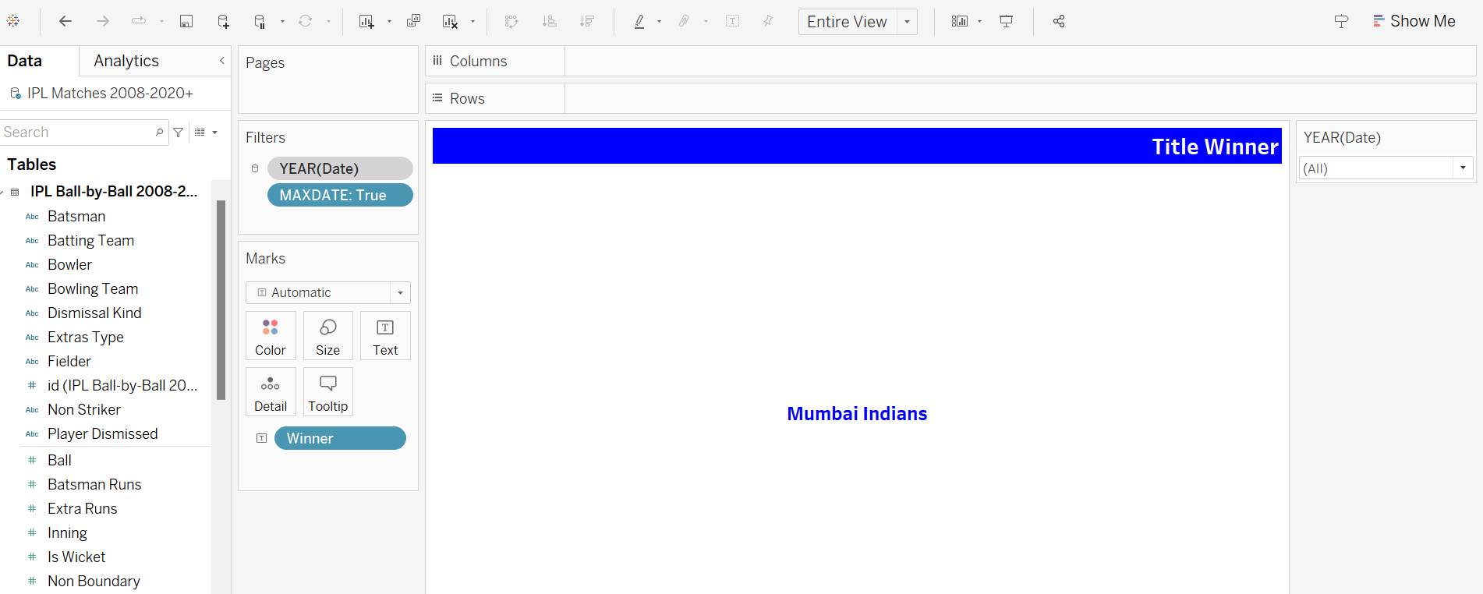

**Team Image:** Title winner we need to get the team image.Shape shows details about Winner. The context is filtered on Date Year, which keeps 13 of 13 members. The data is filtered on MAXDATE, which keeps True.

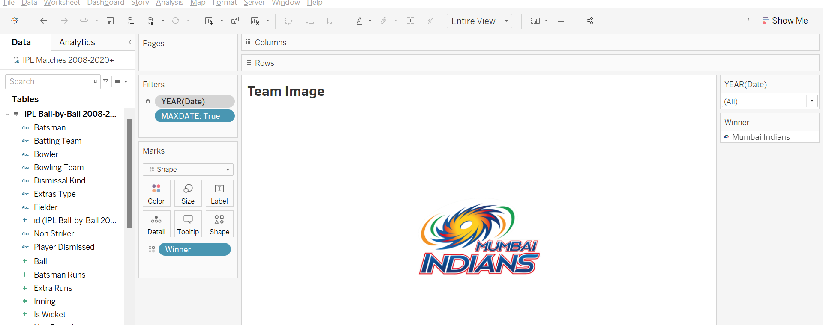

**Orange Cap Winner:**Batsman and sum of Batsman Runs. The context is filtered on Date Year, which keeps 13 of 13 members. The view is filtered on Batsman, which has multiple members selected.

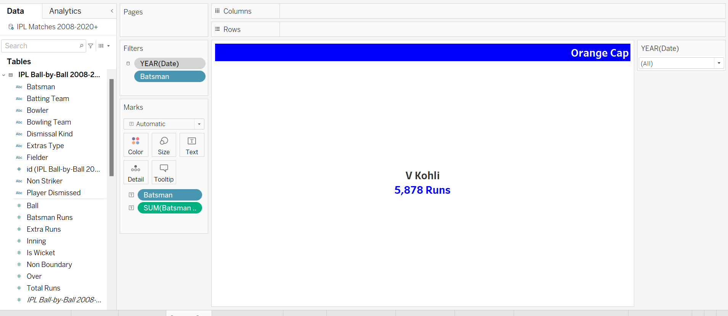

**Orange Cap image:**Shape shows details about Batsman. The context is filtered on Date Year, which keeps 13 of 13 members. The view is filtered on Batsman, which has multiple members selected.

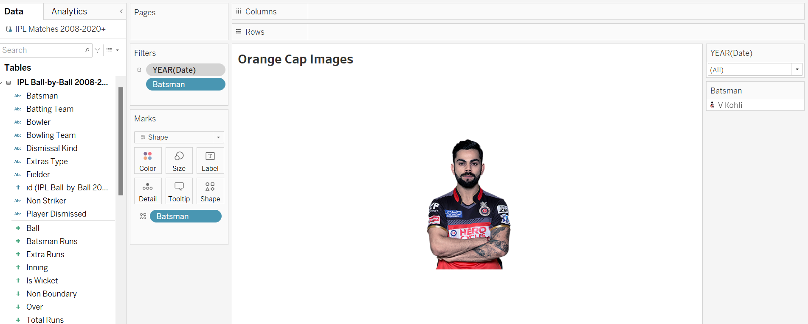

**Purple Cap Winner:**Sum of Is Wicket and Bowler. The context is filtered on Date Year, which keeps 13 of 13 members. The data is filtered on Dismissal Kind, which excludes NA, obstructing the field, retired hurt, run out and Null. The view is filtered on Bowler, which has multiple members selected.

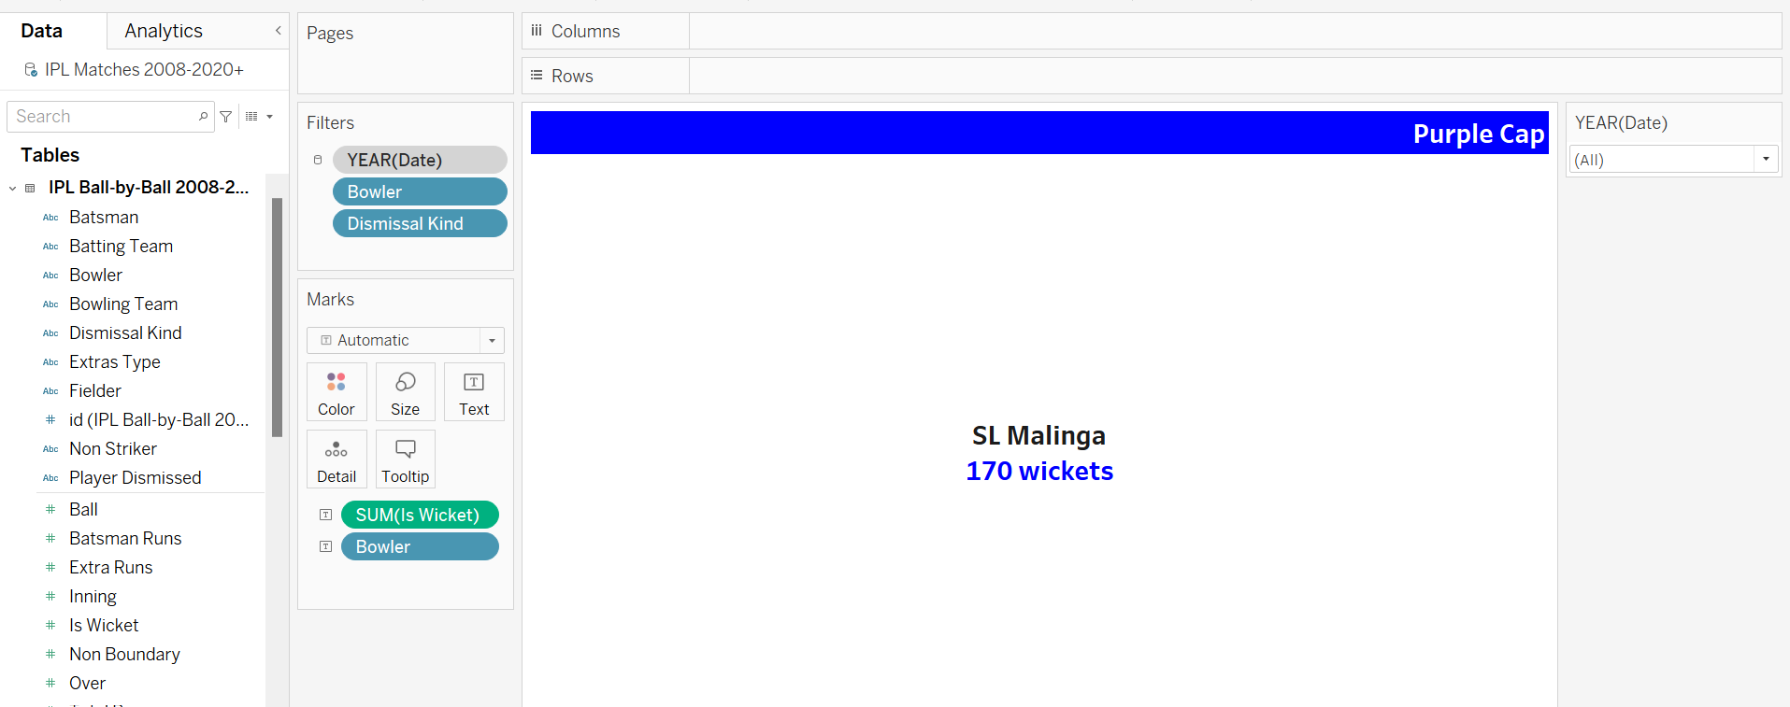

**Purple Cap Image:**Shape shows details about Bowler. The context is filtered on Date Year, which keeps 13 of 13 members. The data is filtered on Dismissal Kind, which excludes NA, obstructing the field, retired hurt, run out and Null. The view is filtered on Bowler, which has multiple members selected.

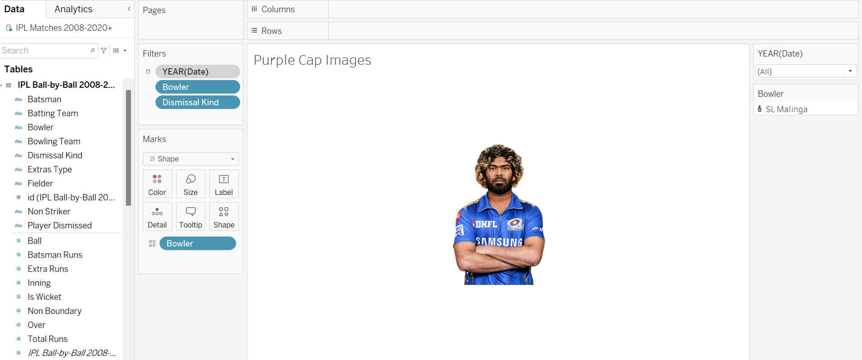

**Tournament 6’s:** Count of Batsman Runs. The context is filtered on Date Year, which keeps 13 of 13 members. The data is filtered on Batsman Runs, which ranges from 6 to 6.

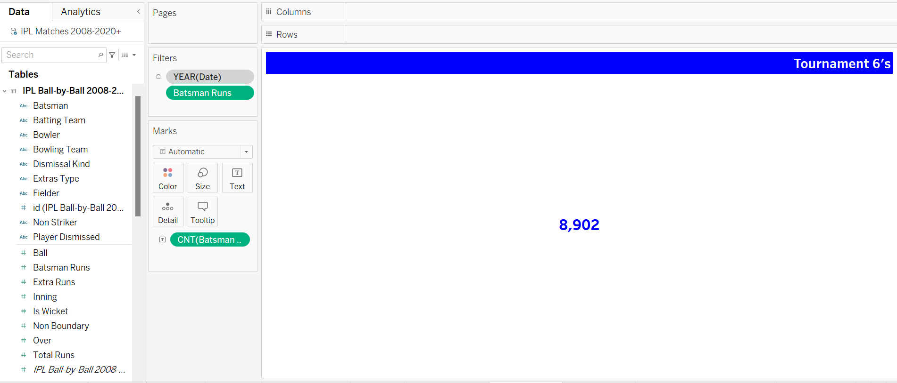

**Tournament 4’s:**Count of Batsman Runs. The context is filtered on Date Year, which keeps 13 of 13 members. The data is filtered on Batsman Runs, which ranges from 4 to 4.

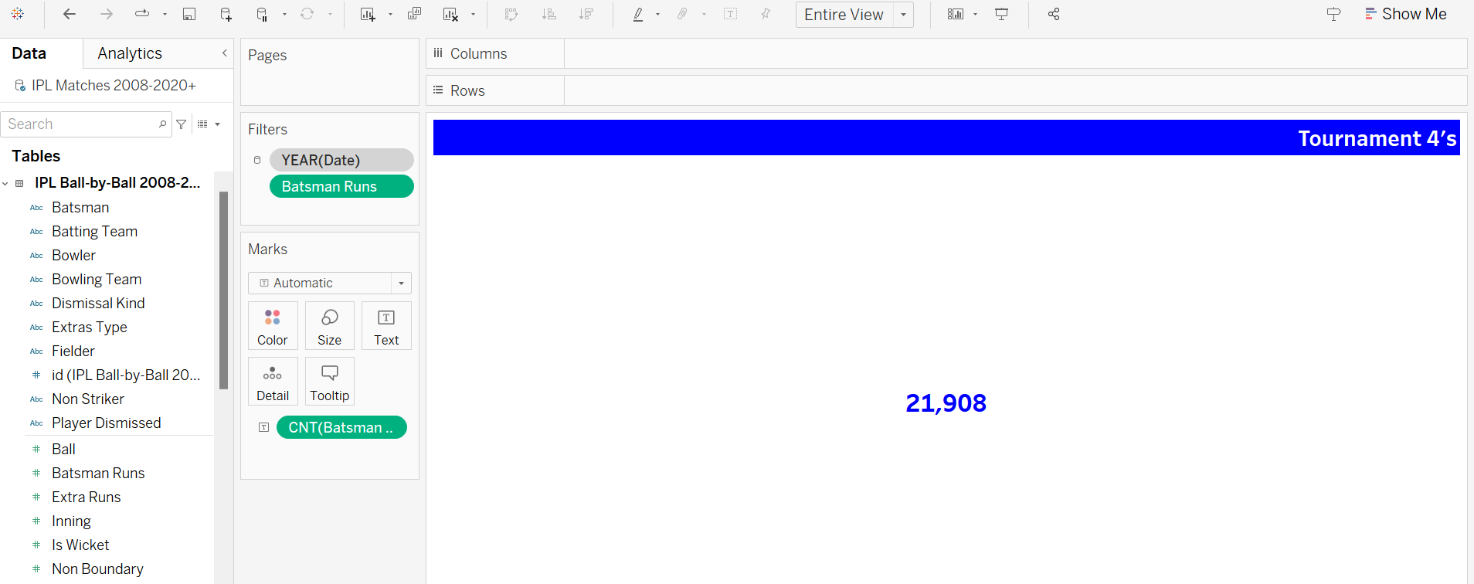

**Matches Win Based On Toss Decision:** Count of Winner for each Winner (group). Color shows details about Toss Decision. The context is filtered on Date Year, which keeps 2013.

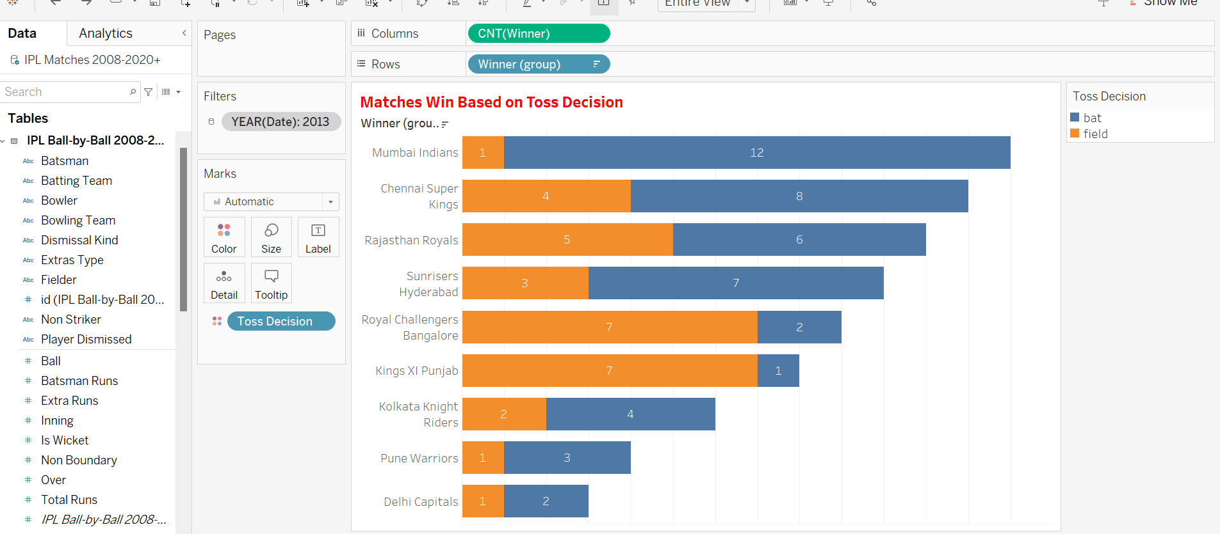

**Toss Decision Based On Winning Percentage:**

Avg(0) and AVG(0). For pane Avg(0): Color shows details about Toss Decision. The marks are labeled by % of Total Count of Winner and Toss Decision. The context is filtered on Date Year, which keeps 2013.

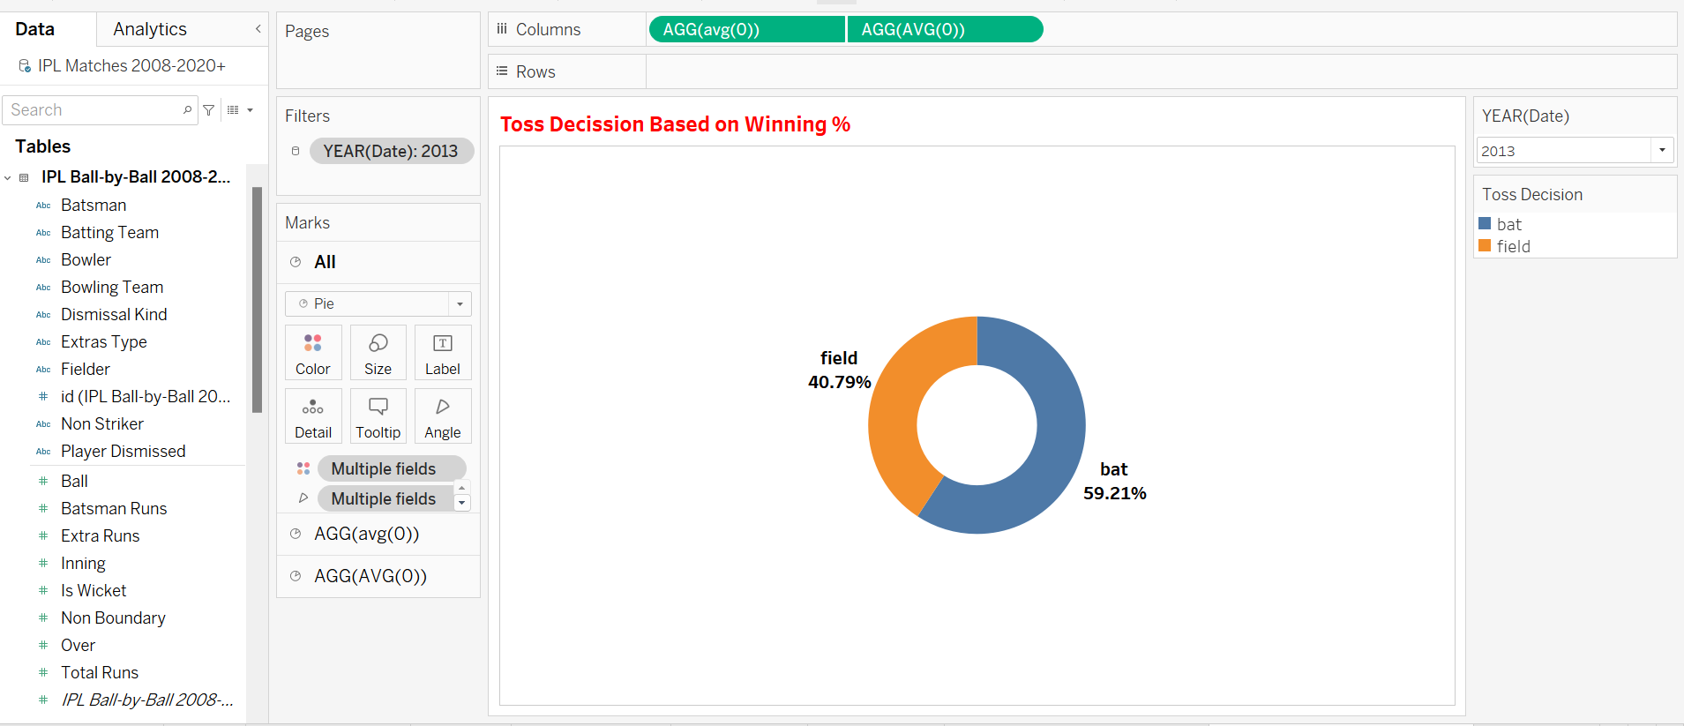

**DASHBOARD:** Finally we have combined all the charts and placed in the dashboard in the proper manner. Place the corresponding images in the dashboard like team images. By changing the select season filter we can able to see the respective year of data results.

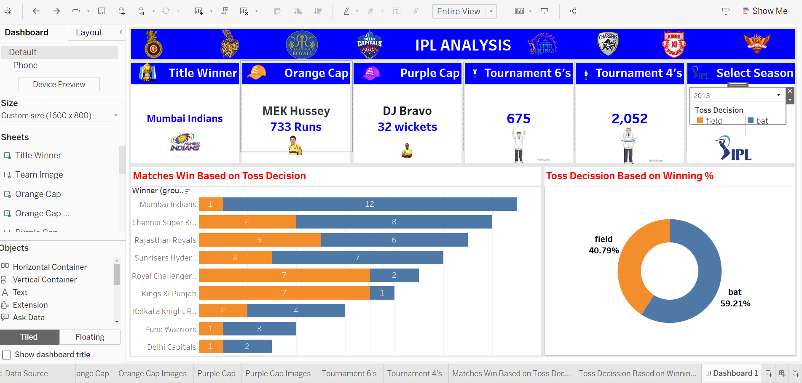

**CONCLUSION**

IPL data analysis dashboard project we can achieve the year wise Title winner, Orange cap winner,Purple cap winner,Tournament 6’s,Tournament 4’s , Matches win based on the toss decision and Matches win percentage based on the toss decision.Everyone can easily understand the data analysis by using this dashboard.

**REFERENCES**

* Collecting the dataset information from kaggle**(**[IPL Complete Dataset (2008-2020) (kaggle.com)](https://www.kaggle.com/datasets/patrickb1912/ipl-complete-dataset-20082020))