**Bachelor of Software Engineering**

**Centre for IT Education (CITES)**

**Department of Electrical and Computer Engineering**

**The Open University of Sri Lanka**

**EEX 4189 – Software Design in Groups**

**2024 - 06 - 22**

**FINGERPRINT VOTING SYSTEM**

**Project proposal**

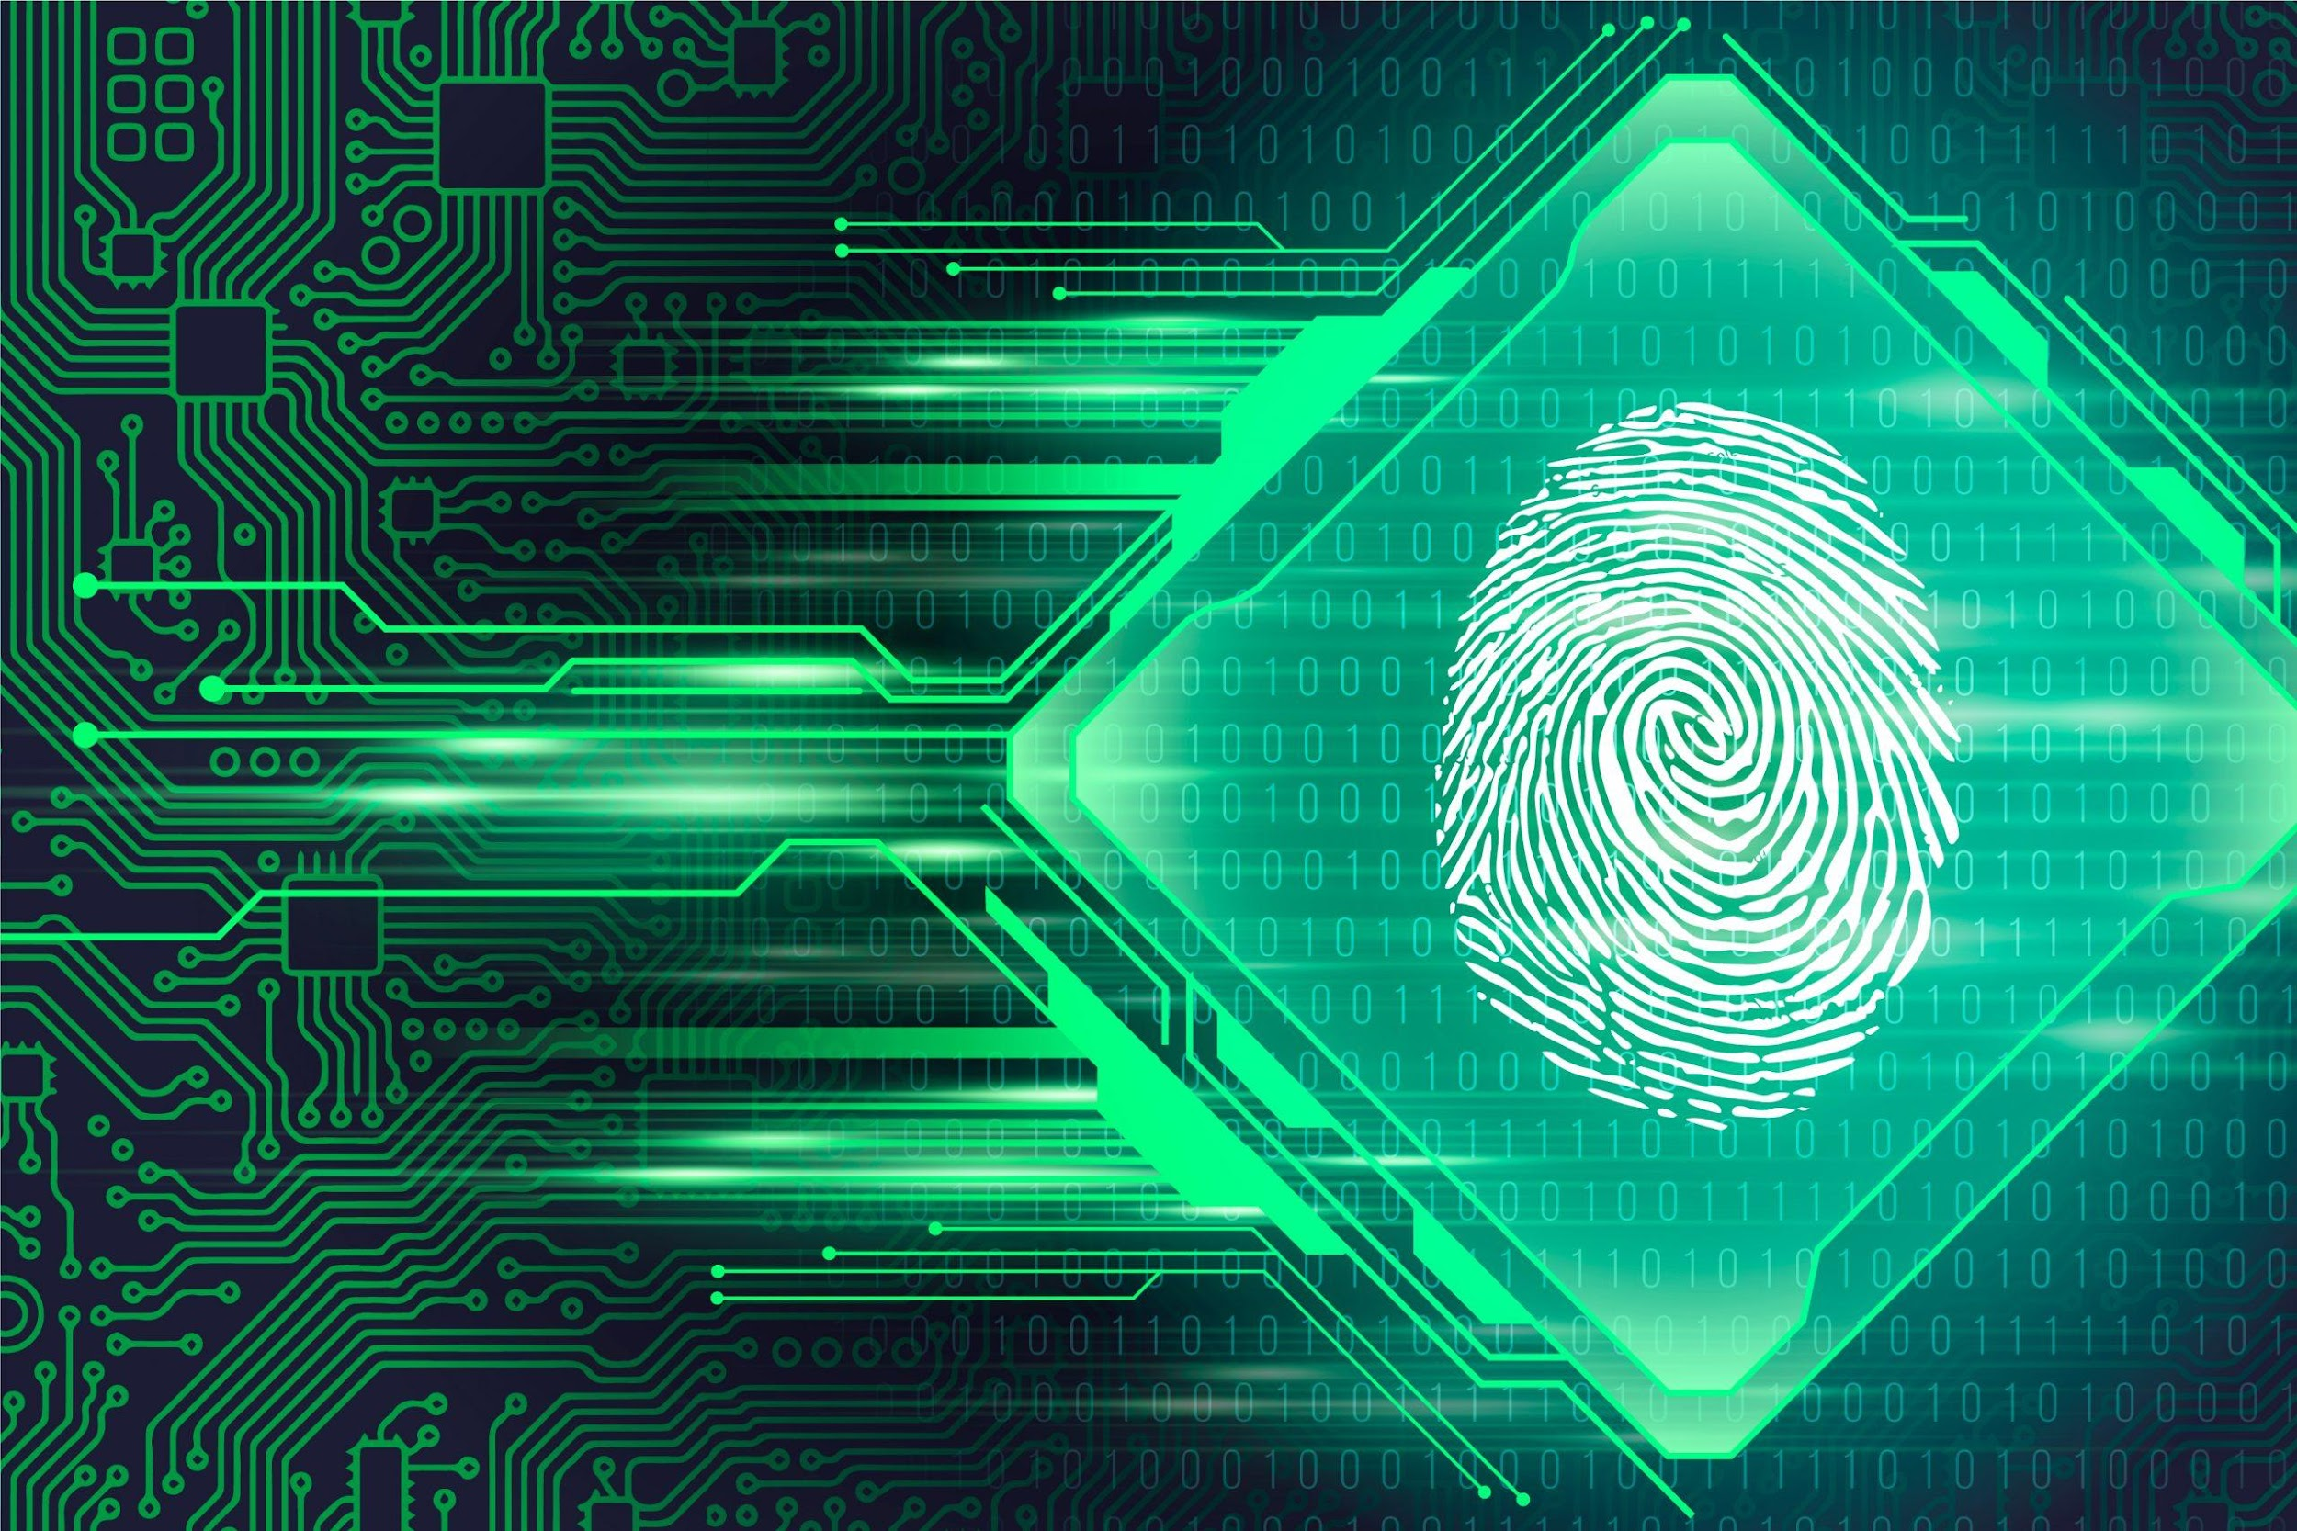

| **Group Members:**  **D.A.T.M Abenayaka - 219213375 - s19004189**  **P.M Abeyrathna - 221426574 - s92066574**  **G.D.D Senath - 222515500 - s22009991**  **N. W. L. U. R. D. Nanayakkara - 321424374 - s92064374** |
| --- |

# Table of Contents

**Introduction 2**

**Background** 2

**Problem Statement 2**

● Vote Fraud 3

● Logistical Challenges 3

● Accessibility 3

**Project Objectives 3**

Enhance Voting Security and Prevent Fraud 3

Improve Efficiency and Accessibility of the Voting Process 3

**Stakeholders / Components 4**

**Tech stack 4**

**High level use-case diagram 5**

**Introduction to Similar Systems 6**

Similar Products in the Market 6

Biometric Voting Systems 6

Other Biometric Systems 6

**Project Timeline 7**

**Conclusion 7**

# Introduction

Voting is a fundamental part of democratic societies, ensuring that the voice of the populace is heard and represented in governance. However, voting extends beyond governmental elections and includes various other scenarios such as corporate board elections, student council elections, and community decision-making processes. Traditional voting systems, whether paper-based or electronic, have faced numerous challenges, including voter fraud, multiple voting, and unauthorized access. To address these issues and enhance the integrity, efficiency, and accessibility of the voting process, this project proposes the development and implementation of a Fingerprint Voting System (FVS).

The FVS leverages biometric authentication technology to uniquely identify voters based on their fingerprints, ensuring that each individual can vote only once and that their vote is securely recorded. This system aims to provide a seamless, user-friendly voting experience while significantly reducing the risks associated with traditional voting methods in any voting situation, from national elections to corporate boardrooms and educational institutions.

# Background

Biometric recognition technology, which identifies individuals based on unique physiological traits, offers a robust solution to these challenges. Fingerprint recognition, in particular, is widely recognized for its reliability, uniqueness, and ease of use. Key advantages including:

* Uniqueness: Fingerprints are unique to each individual, making it nearly impossible for one person to impersonate another.
* Permanence: Fingerprint patterns remain largely unchanged throughout an individual's life, providing a stable basis for identification.
* Convenience: Modern fingerprint scanners are quick and easy to use, enhancing the user experience.

The Fingerprint Voting System represents a forward-thinking solution to the challenges faced by contemporary voting systems across various contexts. By integrating advanced biometric technology, this system has the potential to revolutionize the way elections are conducted, ensuring a secure, efficient, and inclusive democratic process in governmental, corporate, educational, and community settings.

# Problem Statement

Voting integrity is a critical concern in various contexts, ranging from national elections to corporate board decisions and academic institution elections. Traditional voting systems, both paper-based and electronic, face several persistent issues that compromise the fairness, efficiency, and accessibility of the voting process. The primary problems associated with these systems include:

### Vote Fraud

Instances of voter impersonation, multiple voting, and fraudulent voter registrations have been reported constantly, undermining the credibility of elections. In governmental elections, these issues can lead to contested results and decreased public trust. Similarly, in corporate and academic settings, voter fraud can skew results, impacting decision-making processes and organizational governance.

## Logistical Challenges

Traditional paper-based voting systems are logistically complex, involving the distribution, collection, and manual counting of ballots. This process is time-consuming, prone to human error, and costly. Delays in vote counting can lead to uncertainty and mistrust in the process. Electronic voting systems, while faster, are not immune to issues such as hacking and technical malfunctions.

### Accessibility

Ensuring that all eligible voters can participate in elections is a significant challenge. Traditional voting methods often fail to accommodate voters with disabilities, those living in remote areas, or individuals unable to attend polling stations due to various reasons.

To address these issues, there is a need for a robust, secure, and accessible voting system that can be reliably implemented across different voting scenarios. The Fingerprint Voting System (FVS) offers a solution by using biometric technology to enhance the integrity and efficiency of the voting process.

# Project Objectives

## Enhance Voting Security and Prevent Fraud

The primary objective of the Fingerprint Voting System is to significantly enhance the security of the voting process. By using fingerprint biometric authentication, the system ensures that each voter is uniquely identified and authenticated, eliminating the possibility of voter impersonation and multiple voting. The FVS will create a secure voter database, encrypted to prevent unauthorized access and ensure the confidentiality of voter information. This objective aims to restore and bolster voter confidence in the integrity of the electoral process across various contexts, including governmental, corporate, and academic elections.

## Improve Efficiency and Accessibility of the Voting Process

The second objective is to streamline the voting process, making it more efficient and accessible for all eligible voters. The Fingerprint Voting System will reduce the administrative burden associated with traditional voting methods by automating voter identification and vote counting. This automation will minimize human errors, reduce the time required to tally votes, and provide instant, accurate results. Additionally, the FVS aims to make voting more accessible to individuals with disabilities and those in remote locations by offering user-friendly interfaces and mobile voting options. This inclusivity ensures that every eligible voter can participate in the electoral process, upholding the democratic principle of universal suffrage.

# Stakeholders / Components

* Election Administrators
  + They register potential voters
* Fingerprint Scanner device (mobile app, dedicated device, etc.)
  + Device(or device feature) or application that registers the vote
* Eligible Voter
  + Registered voter
* Voter Tabulation System (Automated Server, etc.)
  + Backend system that collects and analyzes the voting data
* IT Support/Administration
  + Support on breakdowns, etc.

# Tech stack

* Fingerprint technology: an ultrasonic or optical sensor located on a mobile device.
  + Biometric api exposed through a Javascript wrapper will be used to interact with the sensor.
  + The proposal is to register the user with authentication provided by the Biometric API of android/iOS. This will then be used when voting to authenticate the user.
* Client Application / UI (Frontend)
  + Mobile
    - React Native through Expo SDK to create a universal voting application.
  + Web
    - ReactJS
      * UI Libraries like Material React to create the UI for the vote tabulation system (count and analyze votes).
      * Tailwind Css to style the website
    - NextJS
      * Server side rendering and serving the website on the Vercel free tier
    - Analysis and Data Visualisation using ChartsJS
    - Two-way encryption for the transmitted data using CryptoES
* Vote Tabulation System (Backend)
  + Non-relational data saved using Firestore (NoSQL database)
  + ExpressJS to serve endpoints for the vote tabulation system
* Design tools
  + Figma for wireframing and high-fidelity UI design
* Project Management Tool
  + Jira Kanban
  + Git for version controlling

# High level use-case diagram

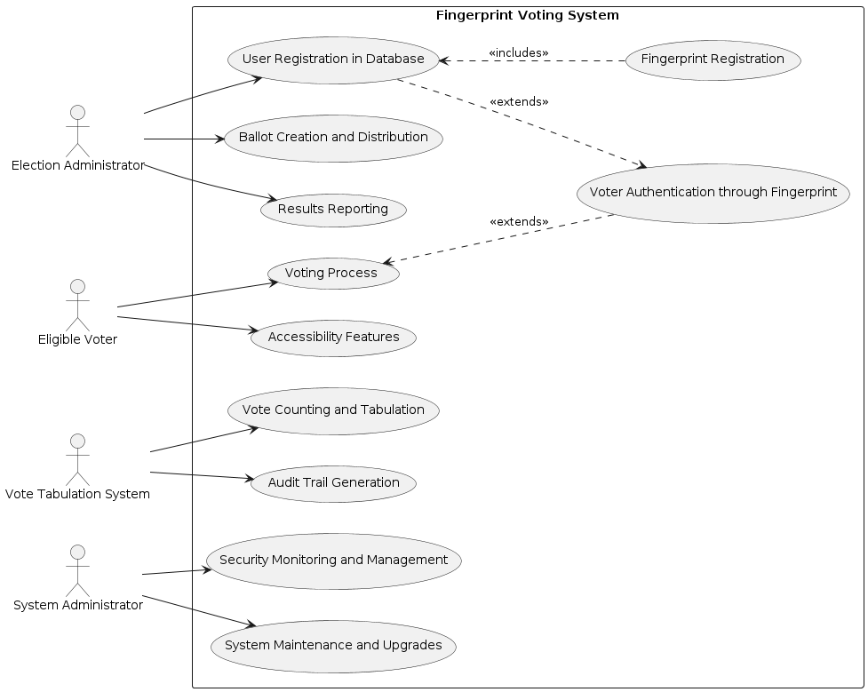

# Introduction to Similar Systems

In the market, there are several systems that utilize the same technology and procedures as fingerprint voting systems. These systems employ biometric data to verify the authentication of information inputted. Below are some examples of similar products that use biometrics for verification purposes.

## Similar Products in the Market

### Biometric Voting Systems

Some countries have adopted biometric voting systems alongside traditional physical evidence methods to enhance voter verification and prevent fraud.

* **India's Aadhaar-based Voting System**:

India has been piloting a voting system linked to Aadhaar, a unique biometric ID system. This system uses fingerprints for voter verification.

* **Belgium's Biometric Voting System**:

Belgium has implemented a biometric voting system that includes fingerprint verification to prevent voter fraud and ensure that each person votes only once.

* **Bangladesh Biometric Based Voting System**:

Bangladesh has been using a Biometric Based Voting system Since 2010. For Municipal elections But Bangladesh reverted to ballot box for the 2023 General Election after opposition led by BNP

Other than Biometric Voting Systems there are Similar Systems that use the Same Principles and Technology as Biometric Voting Systems.

### Other Biometric Systems

Other than the systems described above, the following systems use some features of biometric authentication:

* **ZKTeco Biometric Systems**
* **uAttend**
* **Fingerprint Door Locks**
* **Apple Pay and Google Pay**

# Project Timeline

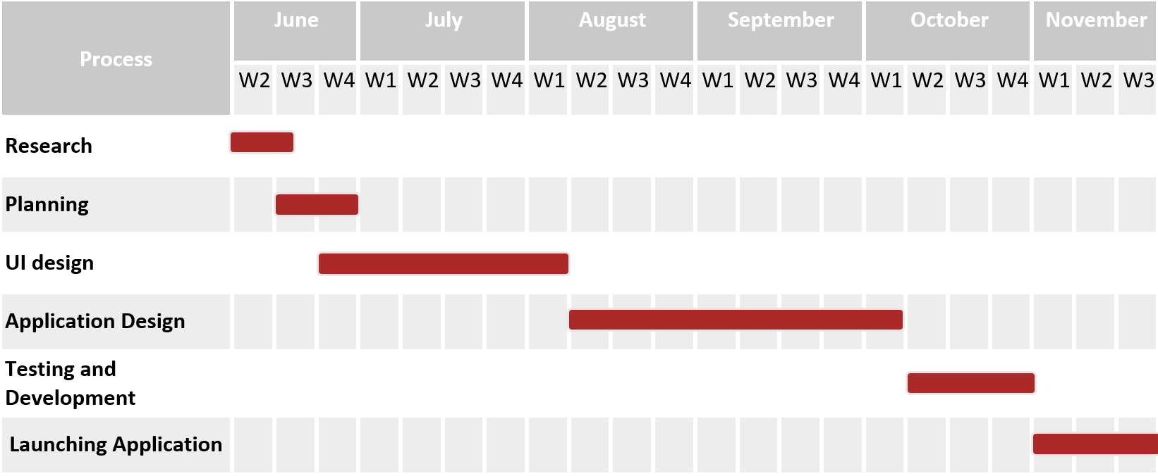

**Tasks**:

1. **Research** (Second week and third week of June): Gather information, conduct market analysis on existing fingerprint systems, define project requirements.
2. **Planning** (Third week of June within Fourth week of June): Outline project goals, scope, and deliverables; allocate resources
3. **UI Design** (Between the fourth week of June and the first week of August): Create the user interface (UI) for the mobile application.
4. **Application Design** (During the second week of August and the First week of October): Develop the back-end structure of the mobile application
5. **Testing and Development** (Between the Second week of October and the Fourth week of October): Integrate UI design with back-end functionality; coding, testing, and debugging.
6. **Launching Application** (During the first week of November and the Third week of November): Deploy the mobile application to the production environment; configure servers and conduct final checks.

# Conclusion

The fingerprint voting system brings out a transformative approach to addressing the persistent challenges faced by traditional voting methods.

* Utilizes fingerprint authentication to uniquely identify each voter.
* Eliminates possibilities of voter impersonation and multiple voting.
* Creates a secure, encrypted voter database to prevent unauthorized access.
* Minimizes human error possibilities and provide instant, accurate results
* Ensures voting is accessible to individuals with disabilities and those in remote areas.
* Offers user-friendly interfaces and mobile voting options.
* Enhances security and transparency of the voting process.
* Addresses core issues like security and accessibility in traditional voting systems.