# Dashboard index.html

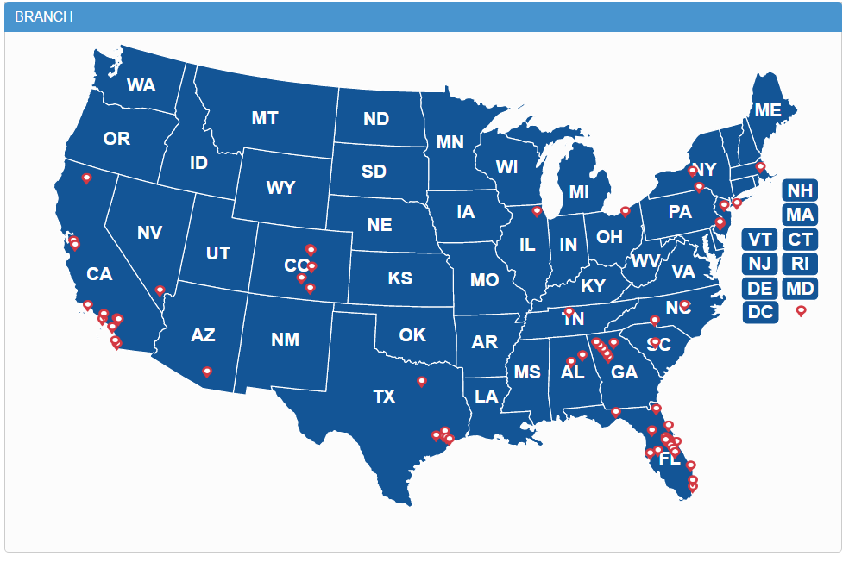  
**Branch**The branch section is a launching pad to branch-visit.html, which displays the department visits based on the branch that is selected.

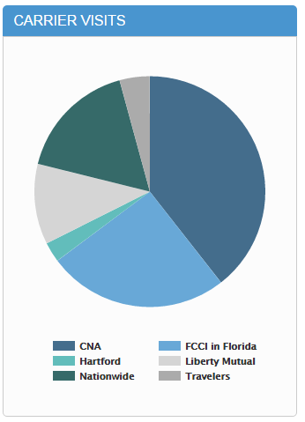**Carrier Visits**The carrier section is a launching pad to carrier-visit.html, which displays the carrier visits for **all** locations.

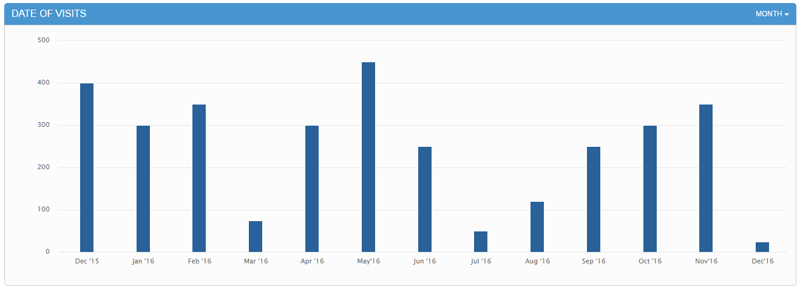**Date of Visits**

This section on the dashboard, displays the date of visits for **all** location, based on the filtered option selected.

# Department Visit department-visit.html

Once the user selects a branch from the dashboard, this is the page that they are redirected to. This page displays all of the results for the branch selected.

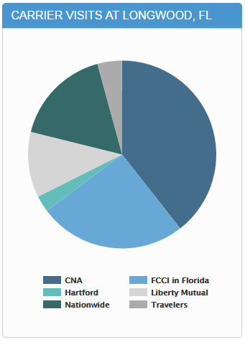 **Carrier Visits at Longwood, FL**  
This section on this page, is a launching pad to /carrier-visit-results-longwood.html, which displays the department visits for the selected carrier in the already selected location.

# Carrier Visit carrier-visit.html

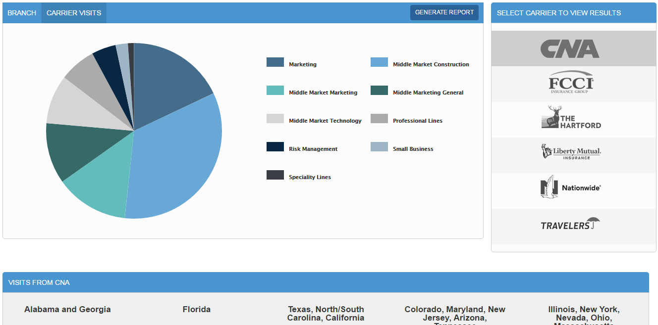

This page displays all of the carrier visits from **all** locations. With the option of selecting the location at the bottom of the page, and updating the report.