B-196

Blue Bell

B-194 Maroon

B-197
I Heavan

Reflection

Dhooresvilla

Park

Roof

B-171
Rose
Dhilbahaarumaage

Vathan

Nooraani

Mosque

Faskuri

Arolhimaage

Morning House

Snow

Leaf

Light Corner

Reem Marine House
Ice Blue
Vision

B-195

Aaru

Hĳura

B-172

Amsi

Bloom
Lilek
Theem

Fiyanoomaage

Green Night
Town B-1Hith7i 3

Fehikokaa

Everest

Fahidhoo

Day Light

Good Look

B-89

B-94

Mammage B-02

Dolphin

Nivaas

Bonthi

Little Wood Blue Moon
B-174

Roaz

Etheredhoo

JAKS Cafe’

Shurooq (B-01)

(Naailu Menge) B-04
Village B-03

Ridha B-07

Anaa

Aavaas B-06

Aahe B-05

B-09

B-08

B-12
B-13

B-10
B-163 Hevan

B-143

Fanaaru

Feliz

B-93

B-11

Zikura (B-15)
Minaara B-14

B-16

B-165

Themaage
Hudhumuthee

LOZANO
Havali

Hamathi

B-91
Hanidhoadhi
Fehiroalhi

Palace

Zenith

Rikaz

Silk

Moon Light

Iris

New Sea B-92

Ranthari

Oak Land

Vilaady Rose

B-162
B-19

Ever Beach (B-20)

B-18

Aviroalhi B-17

Licious

Minson
B-87

Seesan Villa

Anbumaa

Beauty Flower

ILM

V Jamiyya

Roadhi
New Beach Villa B-161 Normal

B-148
Lansimoo

By Heart
B-127

B-81

Mariyam Manzil

Waadu Gaadiyaa

Hawks

Naira

West Light

B-65

Earth

Haveeru

Zefir

Pizca Fullmoon

Mahal
Aula

Hudhufas

Kalaanee

Maimoo

Ihuru

Axis

B-75

Visit

B-160

Ali Abdulla

B-146
Fonadhoo Police

Shiman
Fehigasdhoshuge

Fehivilaage

Fenvilla
B-147

Dhilaavaruge
Bashimaage

Randhoadhi

Shaaz
Hiriyaa B-80 Ehandhaan

Life

NIshaan

Jupiter

Shaahil

Naares

Fehiali

Zembase

B-70
Star Light New Half

B-61
Aabaadhu
Nooran

Scarlet

B-170

B-185

3Mah Store
Shanamee Gudhan

Ibrahim Mahir Ibrahim Anees

Dhiyaanaa Ibrahim Rasheed

Abdurraheem Abdulla

Ranfaiy

Maavani

B-01

Silver Villa

Kudheenaage
Anbugasdhoshuge

Hattrick

B-02
Hiyaleege
Hiyaafehi

Saayaa Manzil

Marvelous

B-69
Red Rose

Faith

B-58
Acacia

Vist

Golden Rose

B-126

Meruit

Andharey

Fonadhoo Harbor

STO

B-96
B-95

Escape

Ever Last

Lovely RosBe -63

Kiriyaa

Ever Blue

Pink Rose

Lagoon

Chaaruchaandhu
B-08

Huvandhumaage

Jazz
CableTV

Kenereege

Esjehige
Shanamee Restaurant

Dhunfinige
Maduroalhi

Venus

Fehivina
Regina House

Jazeera
B-57

Niyaama

Fehi Aabaadhu

Maafahi

Red House

Ali Nooru

B-125

Thaureef

Ali Didi
Ali Khaleel

L.Fonadhoo Council

Farukan
Mahmaa Village

Red Girl
Manzil

Faahi

Barru Pre-School
Guraafehi

Annaarugasdhoshuge

Alhivilaage
Gultharujamaage

Finivaage
B-03

Handhuvarudheyge
Dheydharuge

Bilehkafaage

Marble
Violet Rose

B-71
Dhaaruhsalaam
Knox Ville
B-159

B-97

Saalihaa Studio

Guleyseemuge

Ever Shine

Finiroalhi

Daisy Villa

Sea Weed
Saavan

Blue Bird

B-62
Diamond Villa

Sun Side

Fennaaru

B-07
Fathangumaage
Masjidul Shaheed Ali
Finimaizaan

Heenaamaage

Chanbeyleege

Keerange
B-04
Furuhmaage
Dhilabahaaruge
Seesange

B-05
Thiyaramaage

Guraha

B-169

Ferry Terminal

Dhidha Maizaan

B-98
Fonadhoo Market

Shabnamee Livin Noovill

Vilares

Meynaage

B-64

Soanazameen

Shine
Olhuthereyge

B-12
Bageechaage

Alimasge
B-11

Madufehige

Finihiyaage

Annaarumaage

Asurumaage Wanted

Hudhuvillaage

Fathaha
B-06

Nooraaneevilla

The JAM Kitchen

BML Fonadhoo Branch

Fonadhoo Court

Skyline
Memory

B-74
Wamco Office Moorithi

Beaking

Manzaruvilla

Hoaravilla

Asseyri

B-44

Petro Star

Rihiali

Bahaaruaage
B-13

Maabageechaage

Narugisvilla B-15

B-09
Nedhunge

Guldhasthaage

Unimaage
Irumatheege

BDhe-kun9u Pa9rk

Beach Spot

Maavani

B-66
Boahiyaa

Cornus

Finivai

Ranfaru

Aahiyaa

B-49 Fenthila Helangeli

Rosevilla

IF Villa

Fehifarudhaage
Suvaasaage

Ocean Reed

Dream B-17
Dhunnikamaage

Harumaluge

Ihraamge

Gandhakoalhimaage
Lillymaage B-10

Nasruhsabaa

Bank

AGRO

B-55

Cinema

B-56

Nooraane Fehi

Fenfoahmaage

Vaadheege

Muringu
B-21 Ablaqeege Kudhiraiymaage

Kanmatheege

Randhelige

Alamaage

Mirusge

Sithaaraa

Rabeeumanzil

Mercury

Leykokaage
B-16

Daisymaage

Women's Center
Outdoor Gym
B-145

Laamu Atoll Council

Post Office

NIyaa

Gurimpiya

Dhanbuge

Satharuge

B-22

Guldhamge
Arinagaage

Beach Heaven
Fakkaage

B-20
Vaimatheege

Sana

Happy Guard

Muniyaage

B-19
Kudhilunboamaage Sweet Flower

Uthuruge
White Rose

Driving Track

Laamu Atoll Education Centre

B-45

Atholhuge

Orchid

Afzaa
Dhoalhanbuge B-24

Gumreege

Dhilkushaage

Moonimaage
B-25
Sabdheliyaage

Faransaage

Manzaruge

B-23

Hiyaavahi

Andhaleebuvilla

Husnoovilla
B-60

Saimaage
Vaagali
B-18

Feyrumaage

Bottling Plant

Siyara Water Plantation

Green Area
Park

Masjidul Ulaa

B-31

Malaz
B-27

Asareege

Roshanvilla
Sharaaz
Gulhaaruge

Aagadhage

Onufeenige
Chaandhaneevilla

B-14
Viluveli

Green Leaf

Araairu

Beach House

B-184
Laamu Atoll Bahuge
Khidhumayydhey Marukazu

Fonadhoo Court

B-151

JJU

Nalahiyaa

Gaburusthaanu

B-39
Cable TV Hut

Old Mosque

Farudhaabageechaage

B-33
Dhilshaadhuge
B-32

RayByhath-aa29
Youth Centre
Chaandhaneemaage

Fonadhoo Ijuthimaee Marukazu

Slipway
Mainaavilla
Mainaage

Binmatheege

Lainoofarumaage
B-26

Chaandhaneege

Kosheege

Naseeb

Hura
B-68

Arafa Pre-School

Family and Children's Service Centre

Merry Corner
ElpasoB-43

Ginamaage

Udharesge

Dhonfayybageechaage

Darbell

B-36
Sosunvilla

Edhuruge

Kaamineege

Banafsaage

Rayyvillaage
Blue Star

Dhanbufashuvige Foolhumaige

B-28

Dhoores

Kunnaarumaage
B-30
Nala

Dhivili

Fenaka Cooporation Fonadhoo Branch

Villa Roalhi

Giriteege

Fusthulhaage
Alivaage B-34

Shabnameege

Janbumaage
Dearest

B-72
Cherry Park

Ever PBeace -54

Aroma

B-52

Muthee

Hulhanguge

B-42
Loobiyaa

Kasthooreege

Tharika

Sosunge

Gulalaage
Thirige

Everense

B-37

Maajehige
Jeeza

Orchidmaage

Andhaleebuge
Janburoalugasdhoshuge

Husnooge

Bulbulaage

Thiburoazuge

Kinbi
Mazaara

Lotus

Conenta Villa
Velivaru

Aafathis

Hazaarumaage

Kaneeruge B-41
Dharuma

Bilehmaage

Niyandhurumaage

Hudhuma
Fenthashi

Dheyliyaage

Ooredoo Antena

Sun Shine

B-73
Orbit Villa

Nashaa

Chelsea

Sun Beam
B-53

Araakuri

Maluvilu

Merry Rose

B-50

Rihiali

Snowpy

Hithahfinivaage

Musthareege

Gulfaamuge

B-38Shaadheevilla

Karankaage
Meerange

Themaa

Dhirimaage
B-35

Thundiveli

Zamaaneevilla

Dhonfehige

B-67

Nalamala

Asif
B-78

Fashuivilla

Eleena

B-51

Alithari

Sandhubarakaamaage

Ambaraa

Heena

B-40

Merry Meet

B-142

Vehi
Munaaz

Merry Weather

Lotus

Noomuthi

Kinaara

Fathishandhuvaru

Dhilaashaage

Fazaa

Endherimaage
Dhekunuge

Athamaage

Health Centre

Red Sea
B-76

Basheereehiyaa
MilahanBdhuva-ru 77 Malas

Fine Beach
Beach Villa

B-46

Matharesmaage

B-86

Futsal Pitch

Wind Screen

Saimal
Paris

Aalam

B-59

Usha

Boaganvilla

Fahi

Eveylaa

Kethi
Lemeena

Haulath

Public Works

B-47

Sky Lark

B-82

Sky Blue

Dharukan

Bushraa

Siraajuhdheen Preschool

Volley Court

Medhuvashu Kulheybin

B-100

Love Nest

Cherry Vaadhee
B-79

Hasrath

Irushaad

Iyaan

Nahid

Fayaz

Madheeh

B-88

Nizaar

Growing

Fayaz
B-128
Nahid

B-150
B-149

B-200

Mosque

Marlin

B-83

Amaaz

Onasahtha

Vaadhee
Sky Ross

LIverpool

Aaveli

Vina

B-129

Melban

VInavi

B-90

Shemrock

Coral Reef

Nadheem
Nooma

B-152

B-201

B-84
Dream Home

Manfaa

Firudhoas

Heydhakuri

Sathaha

Unique

B-130
Zoom

The Lodge

Hungaanu

Naaru
Sun View

Marvel Doric Aruz
B-131

B-133
Mariyam Zeena
B-199
Isham Aroma
B-198

Heeraa

The Holys

B-135
B-134

Asifaa

Kurigam Park

B-123

Breeze

Kurigam Kulheybin

B-141

Rihithari

Shabnam

Dolphin House

B-85

Need

Cherry

Park Road

Hiyaa Park

B-136

B-138

Ahmed

Sodhaa

Ibrahim Rasheed

B-122

Rose Flower

Ummeedhu
Kurigam Ijuthimaaee

B-118
Niru

Fini

Faruma

B-132

Nuzuhaa

Razzaaq

Shehez
B-166 Faaiq Hassan Ziyad

Alihandhuvaru

HIyaa
Athagasdhoshuge

Rasfiya
Marukazu

B-137
B-139

Sifaanaa

Snow White

B-113
Kurigam Gaburusthaan

Park Avenue

Thousand Flower

Silver Sand

Uraha

Nookuri

Night Star
B-119

Kudhimaa
Haveyli

Enboomaage

Sirumeelaa

Vesca

Aavehi

Heeron

B-105

Thuhufaa

B-114
Ameenaamanzil

Havana

Beauty Garden

Nooruhsabaah

B-117
Vaifilaamaage
Maagasdhoshuge

Sweet Dream

Shady Corner

Rose Mead

Jumanamanzil

B-167

Bright Nine

Liyo

Zindhagee

Thuthiyaage

B-106
vaĳeheyge

Penzeemaage
Dheriyaa
Gasdhoshuge

ID Villa

Pre-School B-101

Fehimala
Masjidul Furqaan
Nasam

Sidney

Beauty Villa

Paradise

Sahara

Meera

Dhunifaru

Udharesvilla

Ala

Fehi

Madhoshi

Seetmaage

Tharaha

Sun Flower

Aakuri

B-153

Dheelathi
Aafaaq

B-140

B-168

Dream House
B-175
Vila

Hudhuveli
B-108 B-106

Javaahirumaage

Fenfiyaazuge

Asrafeege
Masjidul Falaah

Gulshankinaaraa

B-111

Thoonis

B-120

Tharividhaage

Meylaa

Keveli

Red Star

Rooh

Hiya
Irudheymaage

Vesnooge

B-107
Kandholhumaage

B-104
Ebuhareege Nooraaneege

Valukafage
Javaahiruvaadhee

Boduruhdhashuge
Raazdhaan

Glory

B-156

B-17H9iyaalee

Maza

New New Moon

Bina

Rihi
B-17Fit6huroanumaage
Bimhaa
Diamond

Ufaa
Isthafaage

B-109
Finifenmaage

B-107
Feeroazuvilla

Rankokaage
Feeroazuge

Fehibageechaage

B-102

Yasnew

B-121

Align

B-154

(K- 85/32 )
B-180

Ithaa
Green Garden
Pedition (K- 85/25)

Blue Ocean

iLaa

Sepal

Violet Rose
Lunboamaage
Raanivilla

Beach Side

Fahiali (K - 85/41)
(K-85/33)

Autumn Villa

Autumn

Fisheman
B-177Light Star Roam

Ever Green

Gold Rose

Kashimaage

Meenaaz

Chilhiyaage

B-103
Vinares

Haveereenaaz

Hawai

B-115

Miracle

B-124
Marshal

B-157

Ihaa
B-18I1ramaage

Kurunees

B-110
Asseyri House

Red Bee

Falhoamaage

B-178

Handhuvareegulshan
Handhuvareenaaz

Golden Pearl
Nagazaki

B-158
Herosheema
B-164

Ali

Reehussaba
B-182Fazaa Thari Fehinala
Ruhun

K-01

Mosque

B-202

B-116

Blue House

B-112

K-02 K-07

K-03
B-189K-05

K-04

K-08
K-09 B-187

K-13

K-06

K-11

K-10

K-16

K-15
K-14

K-19

B-186
B-144

K-12
B-1K9-17 0
Holiday K-18

K-22

K-21

K-27
K-20

B-188
K-26

K-25

K-24

K-23

B-191 K-28 K-29

K-30

B-192

B-193

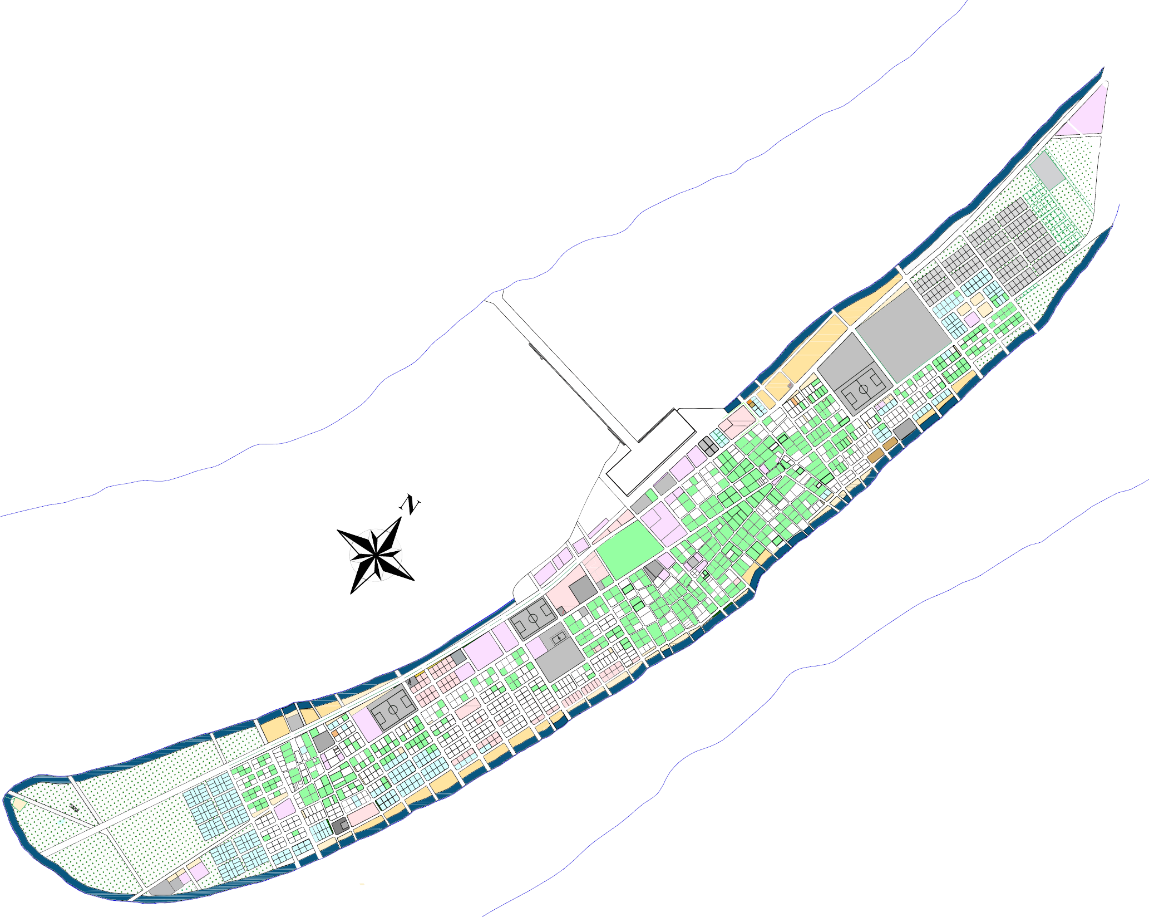











Waste Management Center

B-155

