Twin KMS
QA Test Plan & Outsourcing Pack
Operator console — user stories, user flows, and screen-by-screen test scripts
for E2E automation and manual (offshore) testing

Version 1.0 · 2026-06-26 · CONFIDENTIAL
Scope: lightrag_webui_twin (React 19 operator console) + /twin/api overlay

Table of Contents
Right-click and choose “Update Field” to build the table of contents.

1. Purpose & how to use this document
This document is the single source of truth for outsourced QA of the Twin KMS operator console. It maps the product's user stories and user flows to concrete, executable test cases, and splits them across two delivery streams:
- Stream A — E2E automation. Automated end-to-end (E2E) regression of operator journeys against a deterministic, mocked backend (and a real backend variant). Owned by the test-automation vendor.
- Stream B — Manual (offshore). Human, exploratory and judgement-based testing: visual fidelity, real-document ingestion, answer quality, cross-browser behaviour, and role-based access. Owned by the offshore manual QA team.
Each test case below is tagged with its stream and the maximum severity to assign if it fails. The automation vendor implements / extends the E2E suite; the manual team executes the Manual cases and reports defects using the template in §3.5.
Read §4 (Known limitations) BEFORE testing.
• Several behaviours look like bugs but are documented, accepted product limitations of the 1.0.0 release. Reporting them wastes triage time. They are listed in §4 with the audit reference.

2. Test environments & access
Two builds exist. Choose the build that matches the test's intent.

2.1 Mocked build (MSW) — default for UI / flow / visual testing
The console ships with an in-browser mock backend (Mock Service Worker). All screens render realistic, deterministic data with no database, no LLM and no network dependency. This is the correct environment for Stream A regression and for most Stream B screen/flow testing.
- Boot: cd lightrag_webui_twin && bun install && bun run dev
- Identity: The dev user is an administrator, so every admin-gated control is visible.
- Caveat: LLM answers are mock strings ("Mock retrieval response for: …") and retrieval sources are fixtures. Answer quality cannot be judged here.

2.2 Real-backend build — for ingestion & retrieval-quality testing
A full runtime (Memgraph + LightRAG + LLM credentials) is required to test document ingestion, classification, real retrieval/answer quality and folder data isolation. The integration environment URL and credentials are provided separately by the Twincore team. Stream B uses this build only for the cases explicitly marked "Real backend".

2.3 Roles & permissions
Access is tiered. Many controls are hidden or rejected based on the operator's role. Stream B must verify gating with each role where a real/IdP-configured environment is available.
Role / tier | Can do | Cannot do
Reader (Tier 1) | Read documents, tags, graph, activity; run retrieval queries. | Approve/reject docs; create/edit/delete tags; mutate graph; manage folders or API keys.
Steward / Contributor (Tier 2) | Everything a Reader can, plus approve/reject documents and suggest tag edits (queued for review). | In-place tag edit/delete; folder CRUD (unless granted admin:folders).
Admin (Tier 3) | Full CRUD on tags, graph entities/relations, folders (with admin:folders scope), API keys, tag categories; clear activity. | —

Folder administration specifically requires the admin:folders gateway scope. In a mocked build the dev user holds it; in a real build it is granted when the user's IdP groups intersect the configured admin groups.

3. Methodology

3.1 Identifier scheme
Prefix | Meaning | Example
US-xx | User story (epic-grouped) | US-DOC-03
TC-xxx | Test case (executed by a tester) | TC-DOC-12
E2E | Already covered by an automated Playwright spec | documents.spec.ts

3.2 Test case types
- E2E (automated): the journey is already automated; the manual team performs a one-pass smoke confirmation only, and the automation vendor maintains the spec.
- E2E (to build): an automated journey that does not yet exist and is recommended for the vendor to build.
- Manual: requires human judgement (visual, semantic, real data, cross-browser) — owned by the offshore team.

3.3 Severity scale
Use this scale for every defect. It mirrors the project's internal audit scale (bloquant / sérieux / modéré / info).
Severity | Label | Definition | Internal equivalent
S1 | Blocker | A core operator flow is impossible; data loss/corruption; security or access-control bypass. Stop-ship. | bloquant
S2 | Critical | A major feature is broken with no reasonable workaround, or wrong data is presented as authoritative. | sérieux
S3 | Major | Feature degraded but a workaround exists; significant UX or layout defect. | modéré
S4 | Minor | Cosmetic, copy, or minor visual issue; no functional impact. | info

3.4 Definition of done for a test pass
- Every Manual TC executed on the agreed browser matrix (§7.2) with a recorded verdict.
- Each defect has: screenshot/video, exact steps, expected vs actual, severity, environment.
- No defect filed for any item listed in §4 (Known limitations).

3.5 Defect report template (Stream B)
Field | Content
ID | BUG-<area>-<n> (e.g. BUG-DOC-07)
Title | One line: screen + symptom
Screen / TC | e.g. Documents / TC-DOC-12
Environment | Mocked or Real backend; browser + version; OS; viewport
Role | Reader / Steward / Admin
Preconditions | State required before step 1
Steps | Numbered, reproducible
Expected | What should happen (cite the TC)
Actual | What happened
Severity | S1–S4 per §3.3
Evidence | Screenshot / screen recording attached

4. Known limitations — DO NOT report these as defects
The following behaviours are documented, accepted limitations of the 1.0.0 release, traced to the internal interaction audit (2026-06-13). They are expected. Do not raise defects for them. If a test step appears to contradict one of these, follow the limitation, not your intuition.
# | Behaviour you will observe | Why it is expected | Ref
1 | On the Retrieval tab, adding a Source-tag filter does NOT narrow the answer. The answer can still cite material outside the selected tags. | LightRAG 1.4.9.11 has no tag_filter at retrieval time; the /query path rejects it. The filter is only honoured on the structured /query/data route. | C1
2 | The Retrieval "Sources" panel may list chunks that are not exactly what the model grounded its answer on. | Sources are reconstructed by a secondary retrieval, not yet the model's own references. Treat them as candidate sources, not citations. | C0/C3
3 | The Knowledge Graph may show demo entities even when the real KB is empty. | A seed fallback keeps the demo/pre-ingestion path renderable. In the mocked build ALL graph data is fixture data by design. | C5
4 | "Read source" / indexed-chunks preview may show placeholder text rather than the real extracted document text. | Real extracted-text view is a later backend phase; the modal is a contract placeholder. | C6
5 | "View raw" in the document detail panel opens a notice instead of downloading. | The raw-download endpoint is backend phase 2; the button is intentionally a notice gate. | —
6 | Folders filter the WebUI governance surface but do not create separate KB instances; graph reads are membership-scoped, not physically isolated. | By design — one physical namespace, folders are a logical many-to-many membership layer. | C4

5. User-story catalogue
Stories are grouped by epic. Each maps to the screen section (§6) where its flows are tested.
US | As a… I want… so that… | Tested in
US-AUTH-01 | operator, I sign in with my credentials so that only authorised staff reach the KB. | §6.1
US-AUTH-02 | operator, I sign out and have my local session/threads cleared. | §6.1 / §6.10
US-NAV-01 | operator, I switch between the active folders I am entitled to. | §6.2
US-NAV-02 | operator, I see and triage my notifications from any screen. | §6.2
US-DOC-01 | operator, I browse, search and filter the document inventory by status, tag and source. | §6.3
US-DOC-02 | operator, I inspect a document's chunks, lineage and audit trail. | §6.3
US-DOC-03 | steward, I approve or reject newly submitted / modified sources. | §6.3
US-DOC-04 | operator, I retag one or many documents and see the impact before applying. | §6.3
US-DOC-05 | operator, I delete a document (single or bulk) with a confirmation guard and undo. | §6.3
US-DOC-06 | operator, I reprocess failed documents. | §6.3
US-UPL-01 | operator, I upload files (or add URLs), assign tags, and set a sensitivity class. | §6.4
US-UPL-02 | operator, files above the allowed sensitivity ceiling are refused, not indexed. | §6.4
US-TAG-01 | operator, I request a new tag for review. | §6.5
US-TAG-02 | admin, I edit, deprecate, manage synonyms of, or delete a tag (with migration). | §6.5
US-TAG-03 | admin, I approve / reject pending tag requests. | §6.5
US-TAG-04 | admin, I manage the tag-category taxonomy (add, import, template). | §6.5
US-RET-01 | operator, I ask a question and receive an answer with a sources panel. | §6.6
US-RET-02 | operator, I tune retrieval parameters (mode, top-k, rerank, filters). | §6.6
US-RET-03 | operator, my conversation threads persist locally across reloads. | §6.6
US-GRAPH-01 | operator, I explore the knowledge graph and filter by type / tag / document. | §6.7
US-GRAPH-02 | operator, I inspect an entity and its relations and pin it. | §6.7
US-GRAPH-03 | admin, I create / edit / delete entities and relations. | §6.7
US-ACT-01 | operator, I review the audit feed and filter by time, kind, severity, actor. | §6.8
US-ACT-02 | operator, I open an event and drill down to its source document. | §6.8
US-SET-01 | operator, I view my profile, identity provider and gateway scopes. | §6.9
US-SET-02 | operator, I browse the live API surface. | §6.9
US-SET-03 | admin, I mint, reveal-once, and revoke per-operator API keys. | §6.9
US-SET-04 | admin, I create / edit / delete runtime folders within the cap. | §6.9

6. Screen-by-screen test scripts
Each subsection: a screenshot, what the screen does, the stories it covers, then the test cases. Cases marked E2E (automated) already have Playwright coverage — the manual team runs them once as a smoke check.

6.1 Login & session
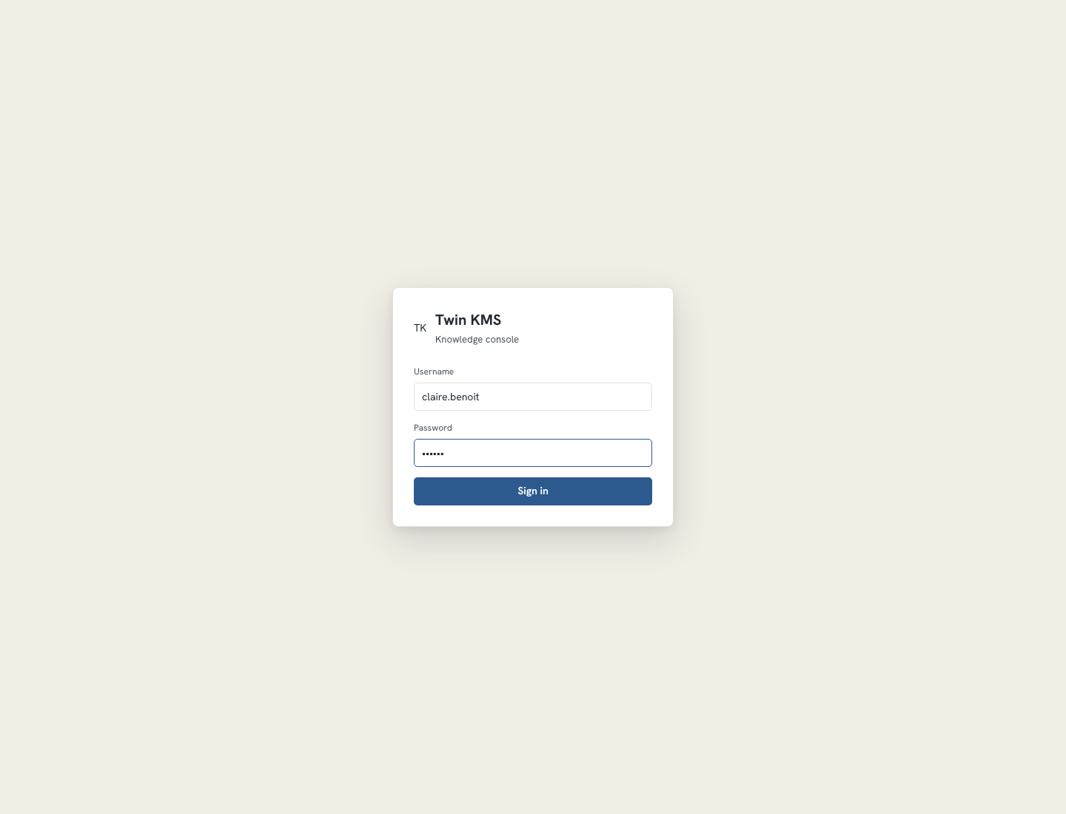
Figure — Auth gate (shown when an authentication backend is configured).
The login gate appears only when the deployment configures an auth backend (API key, local JWT, or IdP). In the open-access default it is skipped. Local login issues an HttpOnly session cookie; sign-out clears it and purges local conversation threads.
Reach: First screen on load when auth is enabled; sign-out from Settings › Profile returns here.
Stories: US-AUTH-01, US-AUTH-02
TC-AUTH-01 — Submit is disabled until both fields are filled
Type: E2E (automated) Max severity if it fails: S3
Preconditions: Auth gate enabled; login screen shown.
Steps:
- Observe the Sign-in button is disabled.
- Type a username only — button stays disabled.
- Type a password — button becomes enabled.
Expected result: Sign-in enables only when both username and password are non-empty; the app shell is not visible behind the gate.
TC-AUTH-02 — Bad credentials show an error and keep the gate
Type: E2E (automated) Max severity if it fails: S2
Preconditions: Login screen shown.
Steps:
- Enter a valid username and a wrong password.
- Click Sign in.
Expected result: An inline error appears; the login screen remains; no app content leaks.
TC-AUTH-03 — Valid credentials enter the app and survive reload
Type: E2E (automated) Max severity if it fails: S1
Preconditions: Login screen shown.
Steps:
- Enter valid credentials and click Sign in.
- Confirm the Documents screen loads.
- Reload the page.
Expected result: The session persists across reload; the operator stays signed in.
TC-AUTH-04 — Sign-out returns to the gate and clears local threads
Type: E2E (automated) Max severity if it fails: S2
Preconditions: Signed in.
Steps:
- Go to Settings › Profile.
- Click Sign out.
- Inspect browser localStorage for twin-rag.* keys.
Expected result: The login gate returns and all twin-rag.* local keys are removed.
TC-AUTH-05 — Session expiry forces re-authentication
Type: Manual Max severity if it fails: S2
Preconditions: Real backend with a short token TTL, signed in.
Steps:
- Stay idle until the token expires.
- Trigger any authenticated action (e.g. open Documents).
Expected result: The operator is challenged to re-authenticate; no stale data is shown as live.
Note: Real-backend only; the mocked build does not expire tokens.

6.2 Topbar — navigation, folders, notifications
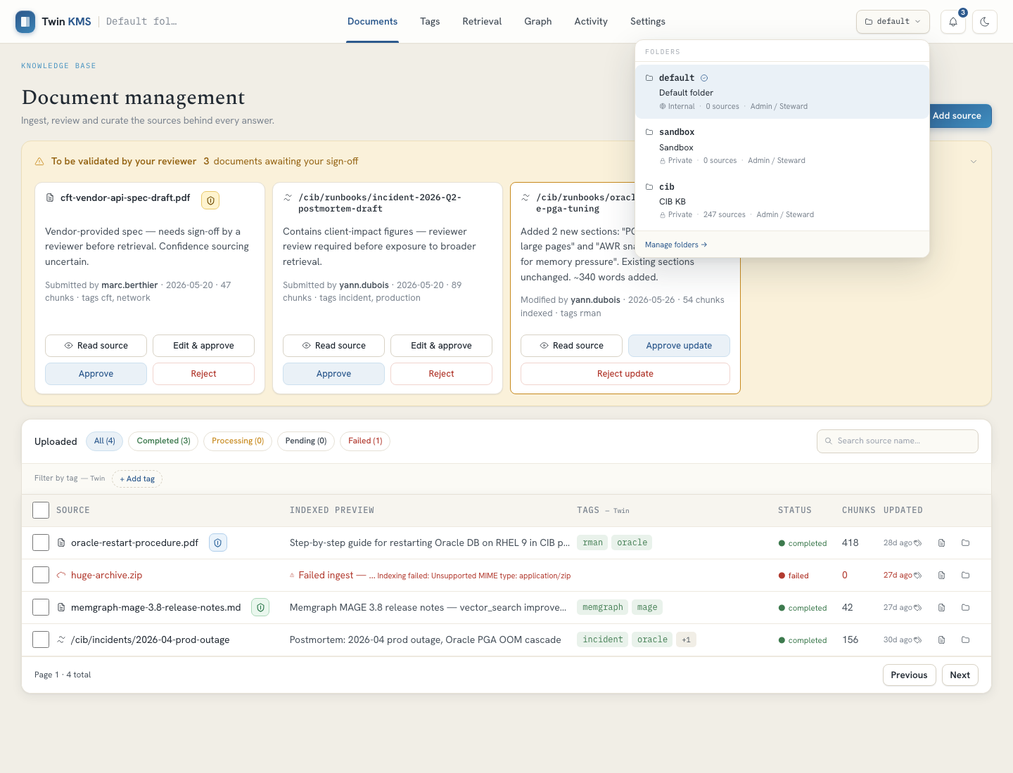
Figure — Folder switcher menu open in the topbar.
The persistent topbar carries: brand (returns to Documents), the six tab buttons, the folder switcher, the notifications bell with an unread badge, and the theme toggle. The folder switcher lists only folders the operator is entitled to; switching propagates an X-Twin-Folder header on subsequent requests and resets document filters.
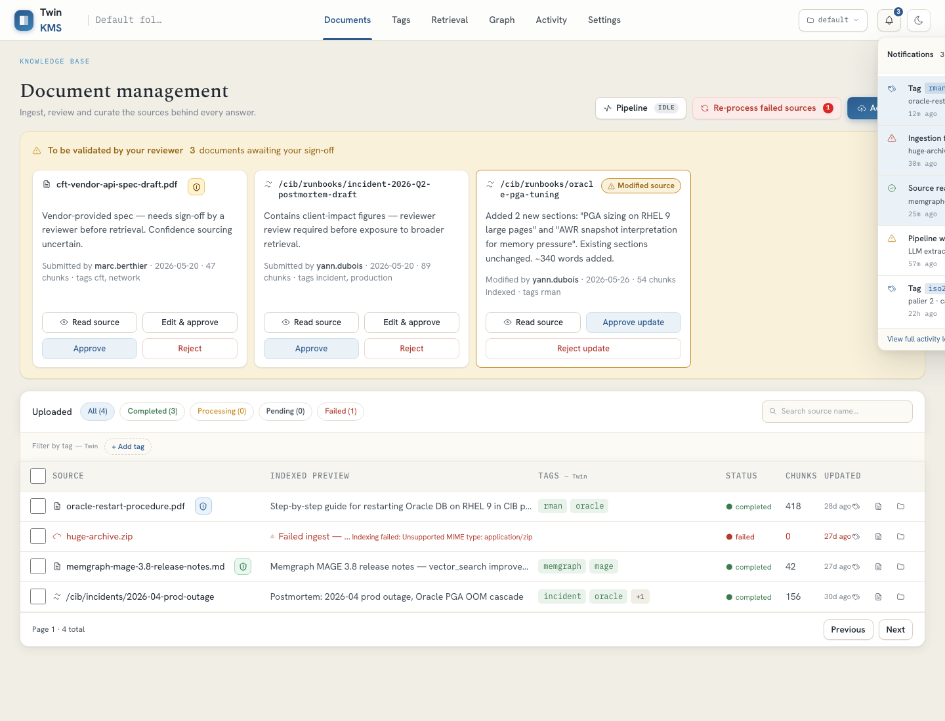
Figure — Notifications popover with unread items and quick actions.
Reach: Always visible once authenticated.
Stories: US-NAV-01, US-NAV-02
TC-NAV-01 — Tab navigation reaches all six tabs
Type: E2E (automated) Max severity if it fails: S2
Preconditions: Signed in.
Steps:
- Click each tab: Documents, Tags, Retrieval, Graph, Activity, Settings.
Expected result: Each tab renders its primary heading with no console errors.
TC-NAV-02 — Folder switch changes scope and resets filters
Type: E2E (automated) Max severity if it fails: S2
Preconditions: More than one folder available.
Steps:
- Open the folder switcher.
- Select a different folder.
- Observe the Documents list and any active filters.
Expected result: The active folder updates, the document list refreshes for the new folder, and local filters are cleared.
TC-NAV-03 — Empty-folder state shows the Twincore guidance
Type: Manual Max severity if it fails: S3
Preconditions: A deployment with no folder provisioned.
Steps:
- Load the console with no folder available.
Expected result: The message "No folder available for this KB. Please contact Twincore Team." is shown.
TC-NAV-04 — Notifications popover: mark-all-read and clear
Type: E2E (automated) Max severity if it fails: S3
Preconditions: At least one unread notification.
Steps:
- Click the bell.
- Click Mark all read.
- Re-open and click Clear all.
Expected result: The unread badge clears after mark-all-read; the list empties after clear; "View full activity log" navigates to Activity.
TC-NAV-05 — Theme toggle persists across reload
Type: Manual Max severity if it fails: S4
Preconditions: Signed in.
Steps:
- Toggle to dark mode.
- Reload.
Expected result: Dark mode persists; every screen remains legible with adequate contrast.
Note: Pair with the dark-mode visual charter in §7.2.

6.3 Documents
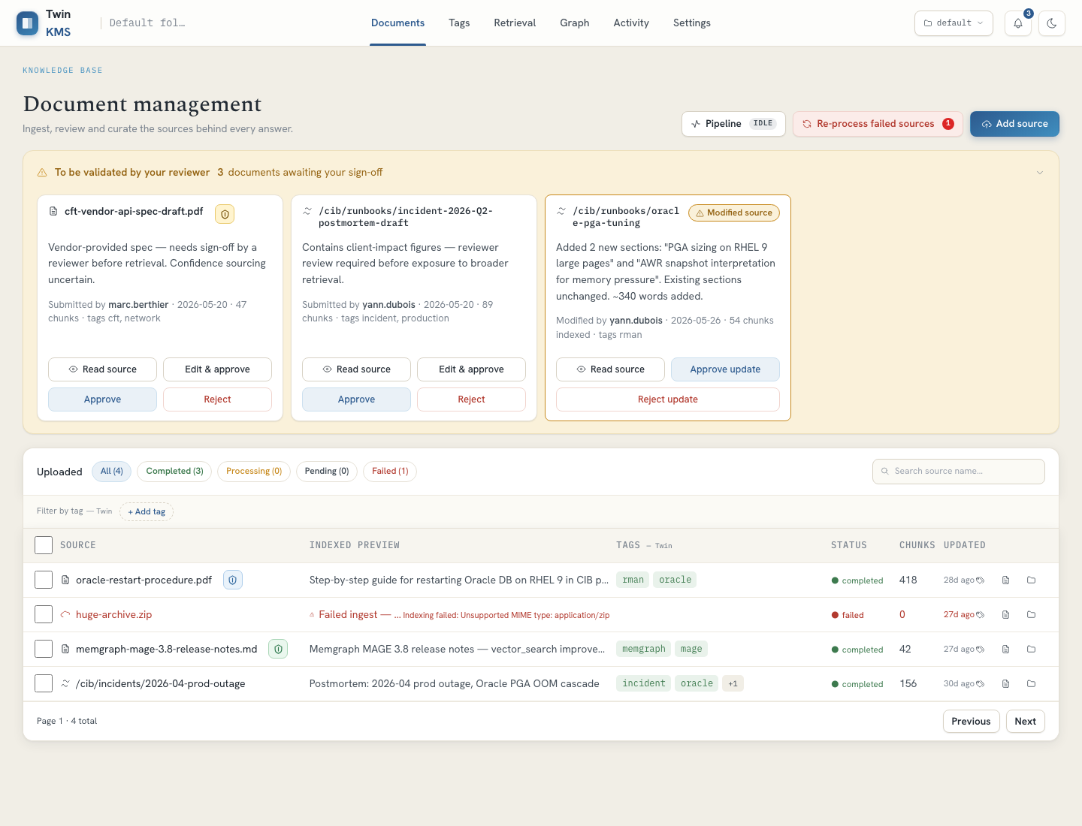
Figure — Documents tab: pending-review cards above the filterable inventory table.
The operator's main workspace. A pending-review band surfaces newly submitted or upstream-modified sources for approval; below it, a filterable, paginated inventory with status, classification badge, tags, chunk count and per-row actions. A pipeline popover shows ingestion status and a Retry-failed control.
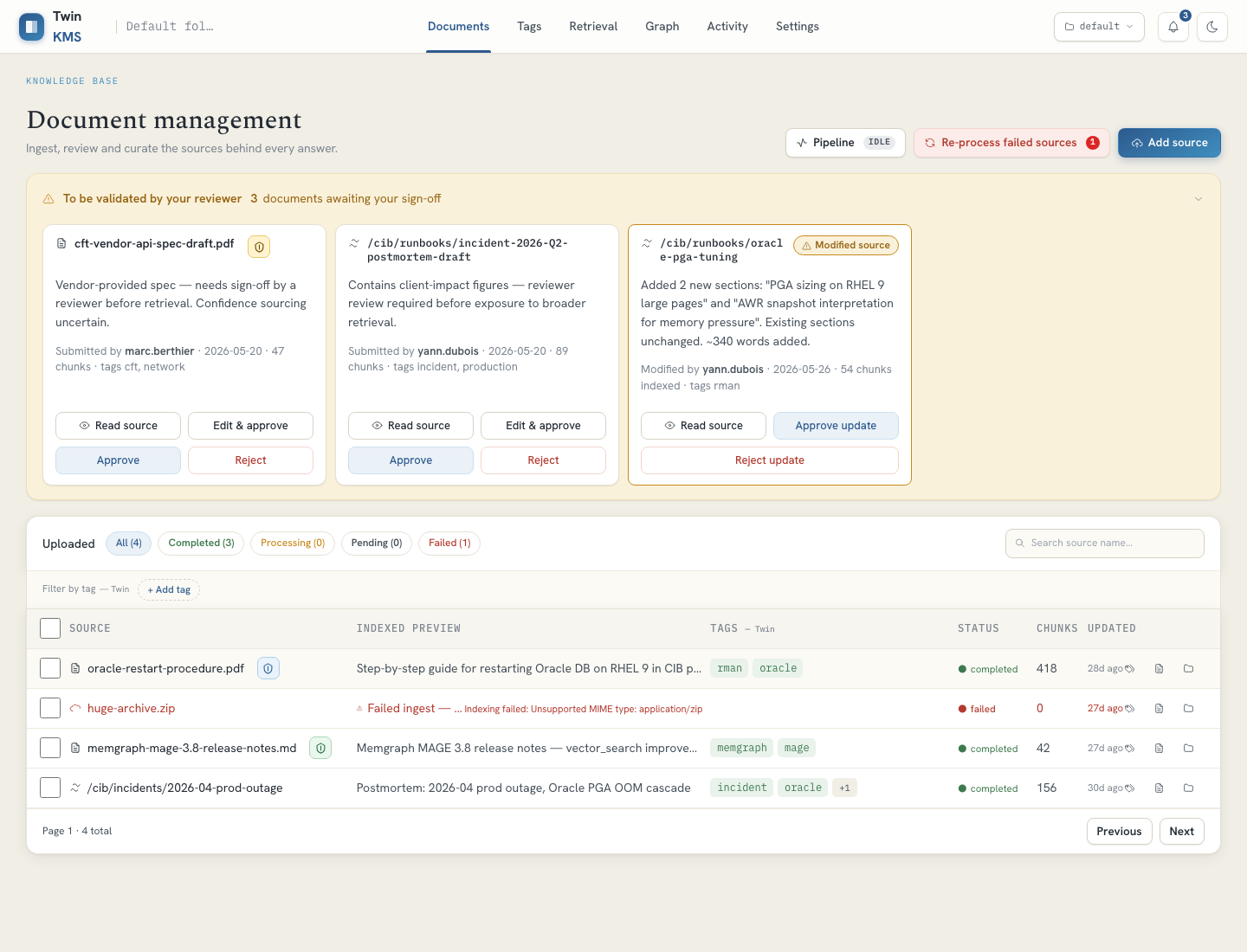
Figure — Document detail panel: chunks, lineage and audit tabs.
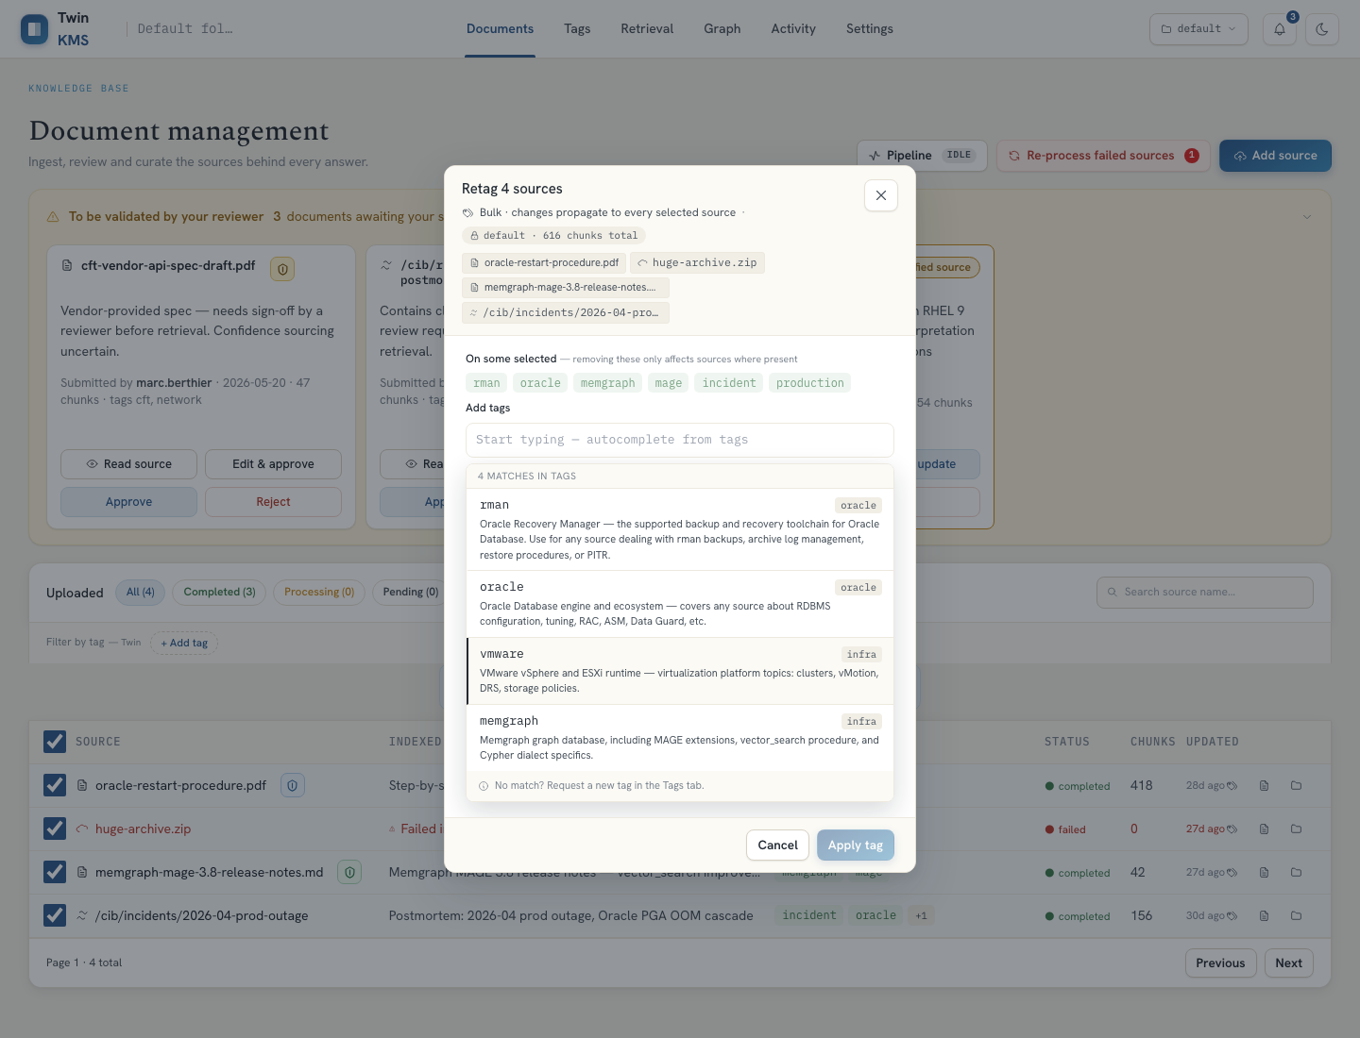
Figure — Retag modal with current tags and an impact preview.
Reach: Default tab after login; brand button returns here.
Stories: US-DOC-01, US-DOC-02, US-DOC-03, US-DOC-04, US-DOC-05, US-DOC-06
TC-DOC-01 — Search and status filter narrow the list
Type: E2E (automated) Max severity if it fails: S3
Preconditions: Several documents across statuses.
Steps:
- Type a filename fragment in search.
- Click the Failed status pill.
- Clear filters.
Expected result: The table shows only matching rows; status pills reflect backend counts; clearing restores all.
TC-DOC-02 — Tag and source filters combine
Type: E2E (automated) Max severity if it fails: S3
Preconditions: Documents carrying tags.
Steps:
- Open the tag filter, add a tag.
- Add a source filter.
Expected result: Only documents matching all active filters remain; filter chips are removable.
TC-DOC-03 — Open the document detail panel
Type: E2E (automated) Max severity if it fails: S3
Preconditions: At least one document.
Steps:
- Click a document row.
- Inspect the Chunks, Lineage and Audit tabs.
Expected result: The side panel shows chunk content, metadata (created/updated, folder, tags, classification) and related audit events.
TC-DOC-04 — Approve a pending (newly submitted) source
Type: E2E (automated) Max severity if it fails: S2
Preconditions: A card in the "Requested" pending state; Steward+ role.
Steps:
- Click Read source to preview indexed chunks.
- Click Approve.
Expected result: The source leaves the pending band; an approval activity event is recorded; focus returns to a sensible element.
TC-DOC-05 — Reject a pending source with a reason
Type: E2E (automated) Max severity if it fails: S2
Preconditions: A pending card; Steward+ role.
Steps:
- Click Reject.
- Confirm the reject button is disabled until a reason is typed.
- Enter a reason and submit.
Expected result: Rejection requires a reason; the card is removed; a rejection event is recorded.
TC-DOC-06 — Re-validate an upstream-modified source
Type: Manual Max severity if it fails: S2
Preconditions: A card in the "Modified" pending state.
Steps:
- Open the modified card.
- Review the change summary.
- Click Approve update or Reject update.
Expected result: The modified source is re-validated or rejected; the band updates accordingly.
TC-DOC-07 — Single-document retag with impact preview
Type: E2E (automated) Max severity if it fails: S3
Preconditions: A document open or row action available.
Steps:
- Open Retag for one document.
- Add a tag and remove one.
- Read the impact preview (chunks/docs affected).
- Apply.
Expected result: The preview reflects the change; on Apply the tags update optimistically and an undo toast appears.
TC-DOC-08 — Bulk retag across multiple selected documents
Type: E2E (automated) Max severity if it fails: S3
Preconditions: Two or more documents selectable.
Steps:
- Select multiple rows.
- Click Retag.
- Note shared vs partial tags.
- Add a tag and Apply.
Expected result: Shared and partial ("on some docs") tags are distinguished; the change applies to all selected documents.
TC-DOC-09 — Bulk retag failure rolls back optimistic tags
Type: E2E (automated) Max severity if it fails: S2
Preconditions: Inject a 500/413 on bulk retag (MSW scenario).
Steps:
- Bulk-retag a selection.
- Observe the failure handling.
Expected result: The optimistic tags roll back and an error is surfaced; no partial/incorrect state persists.
TC-DOC-10 — Delete (single and bulk) with confirm and undo
Type: E2E (automated) Max severity if it fails: S1
Preconditions: Deletable documents.
Steps:
- Delete a single document via the detail panel (two-click confirm).
- Select several and use bulk delete (double-confirm).
- Observe the deleting state and the undo toast.
Expected result: Deletion requires explicit confirmation; rows disappear; an undo path is offered; no accidental single-click deletion is possible.
TC-DOC-11 — Reprocess failed documents
Type: E2E (automated) Max severity if it fails: S3
Preconditions: At least one FAILED document.
Steps:
- Use Retry Failed (or Re-process in the detail panel on a FAILED doc).
- Try Re-process on a non-failed doc.
Expected result: Failed documents are re-queued; a non-failed doc reports honestly that reprocess does not apply.
TC-DOC-12 — Cascade: deleting a document updates the graph
Type: E2E (automated) Max severity if it fails: S2
Preconditions: A document whose entities appear on the Graph tab.
Steps:
- Delete the document.
- Open the Graph tab.
Expected result: Entities sourced only from the deleted document are no longer shown; the graph refetches rather than serving stale nodes.

6.4 Upload & classification
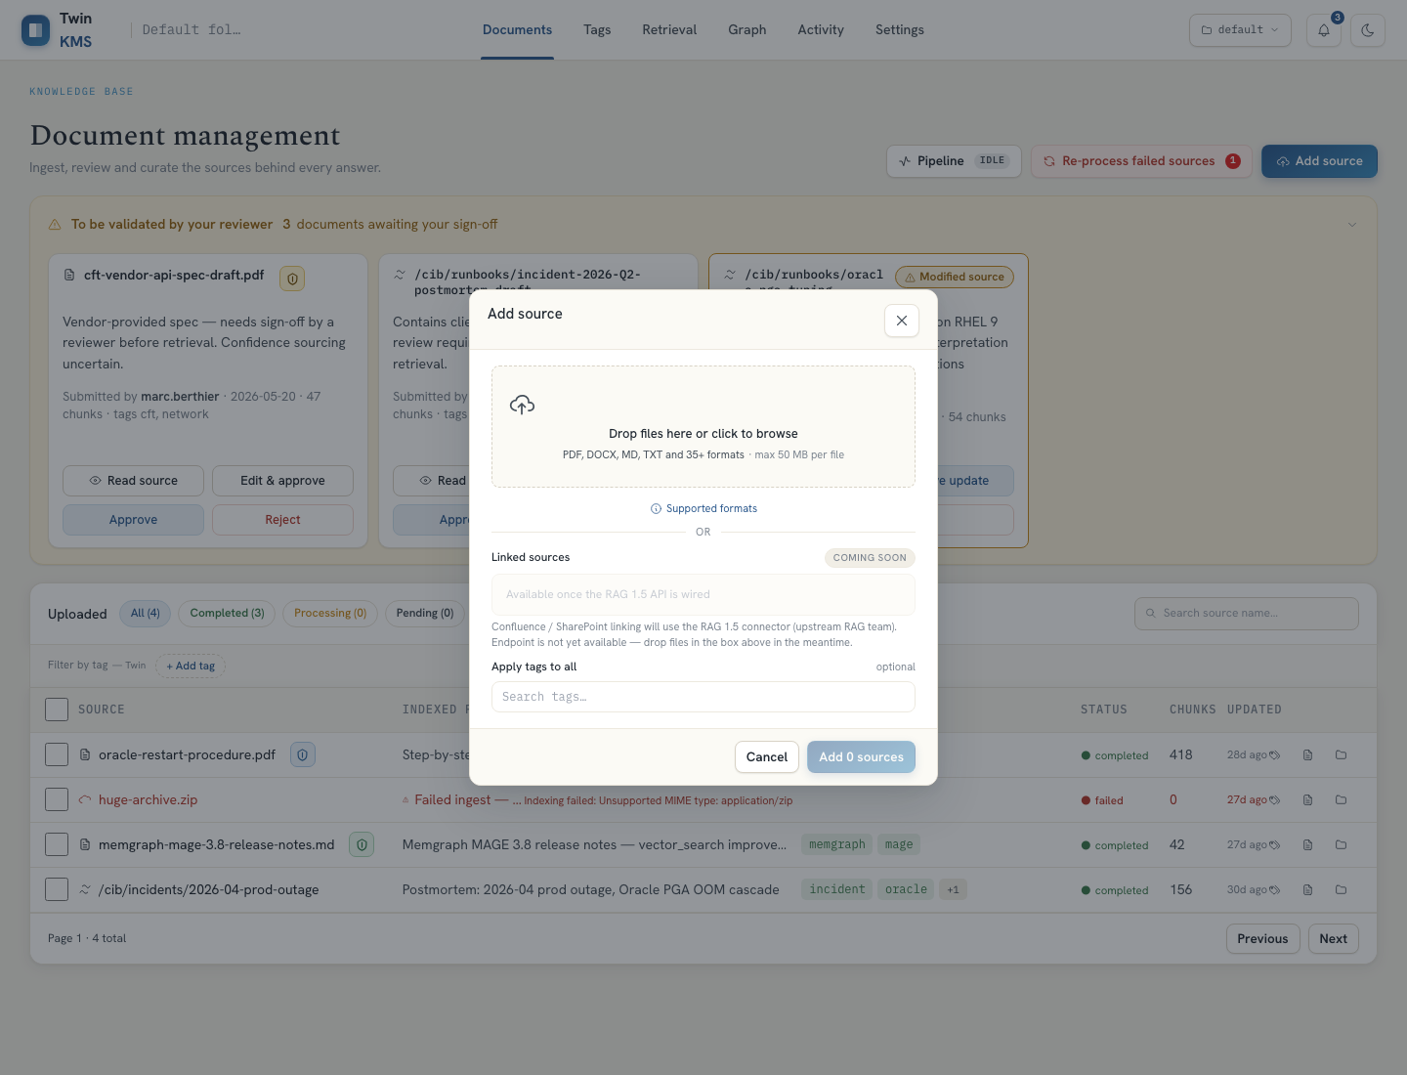
Figure — Add-source modal: file drop, tag assignment, and per-file sensitivity class.
Sources are added by file upload (drag-drop or picker, ≤50 MB) or by URL (Confluence/SharePoint). Each file can be tagged and assigned a MIP sensitivity class (C1 Public → C4 Secret). Files above the workspace ceiling are refused at ingestion and land FAILED rather than being indexed.
Reach: "Add source" button on the Documents tab.
Stories: US-UPL-01, US-UPL-02
TC-UPL-01 — Add a valid file and submit
Type: E2E (automated) Max severity if it fails: S2
Preconditions: Add-source modal open.
Steps:
- Select a supported file under 50 MB.
- Wait for it to validate.
- Click Add 1 source.
Expected result: The file validates, the submit button enables, and the source is accepted for ingestion.
TC-UPL-02 — File type / size validation
Type: Manual Max severity if it fails: S3
Preconditions: Add-source modal open.
Steps:
- Add an unsupported type.
- Add a file over 50 MB.
Expected result: Each invalid file shows a clear per-file error and cannot be submitted; valid files still submit.
TC-UPL-03 — Multi-file: only valid files submit
Type: E2E (automated) Max severity if it fails: S3
Preconditions: Add-source modal open.
Steps:
- Add a mix of one valid and one invalid file.
- Submit.
Expected result: Counts are accurate; only the valid file is submitted; the failure is reported truthfully.
TC-UPL-04 — Assign initial tags on upload
Type: E2E (automated) Max severity if it fails: S3
Preconditions: Add-source modal open.
Steps:
- Add a file.
- Search and select a tag from the catalog.
- Submit.
Expected result: The uploaded source carries the chosen tag once ingested (with manual-retag guidance if tag propagation times out).
TC-UPL-05 — Set a per-file sensitivity class
Type: Manual Max severity if it fails: S3
Preconditions: Add-source modal open; real backend.
Steps:
- Add a file.
- Pick a class (e.g. C2 · Internal).
- Submit and inspect the document badge.
Expected result: The classification badge on the resulting document matches the chosen class (or the label detected from the file).
TC-UPL-06 — Over-ceiling file is rejected, not indexed
Type: Manual Max severity if it fails: S1
Preconditions: Real backend with TWIN_MIP_MAX_CLASSIFICATION set (e.g. C2); a C3/C4-labelled file.
Steps:
- Upload the over-ceiling file.
- Open Documents.
- Open Activity.
Expected result: The document appears FAILED with a classification-rejected reason, is never indexed (no chunks, not retrievable), and a classification-rejected warning event is logged.
Note: This is the core compliance guarantee — verify it cannot be bypassed.

6.5 Tags governance
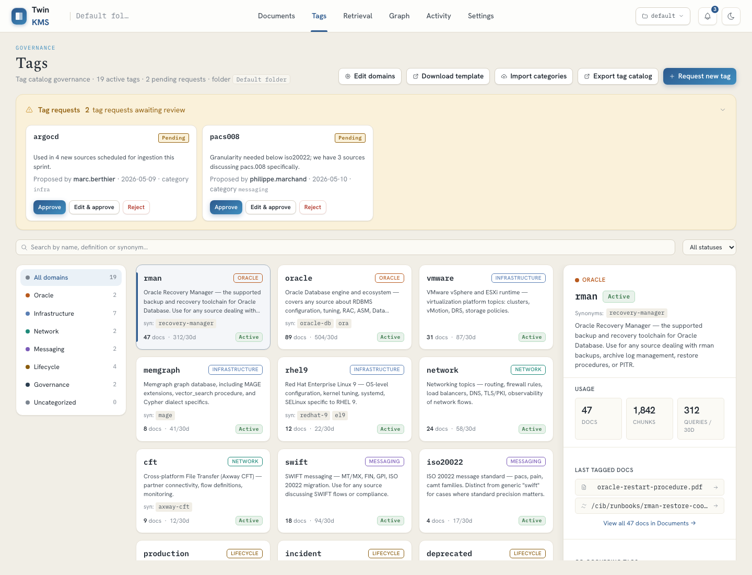
Figure — Tags tab: category rail, status filters, tag cards and detail panel.
Governs the controlled vocabulary. Operators can request new tags; admins edit, deprecate, manage synonyms, delete (with migration), and approve/reject pending requests. The tag-category taxonomy is admin-editable and importable from JSON. Tag actions cascade to the chunks/documents that carry them.
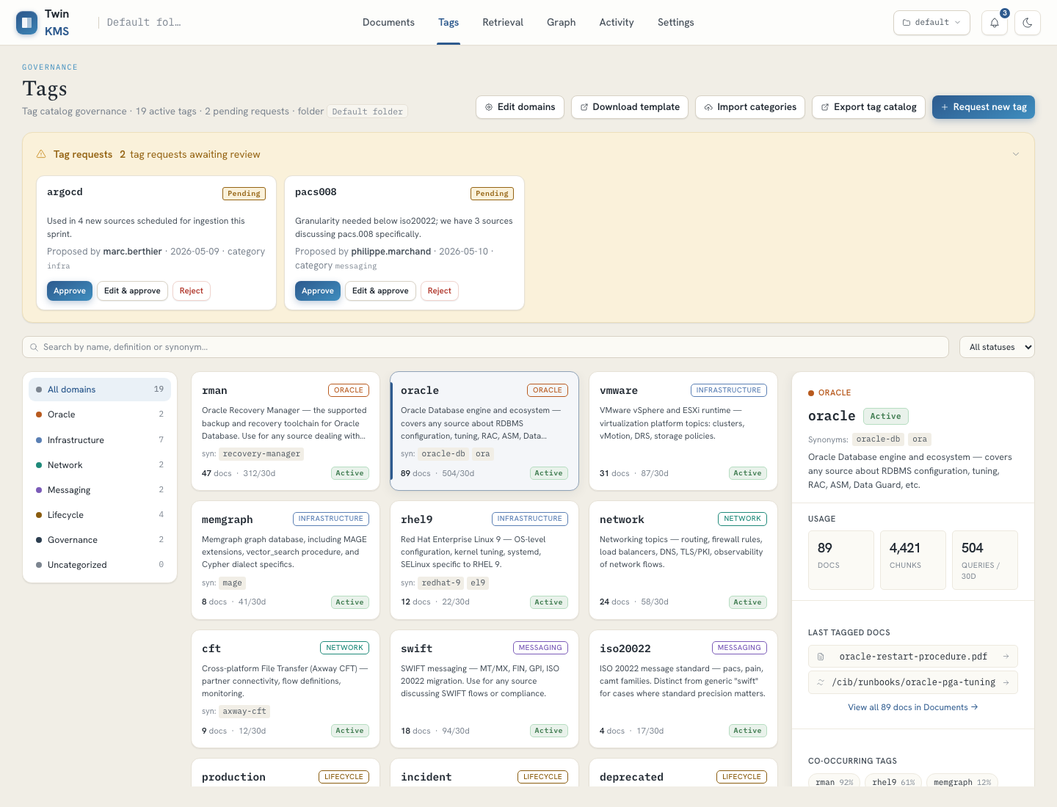
Figure — Tag selected: definition, tier/status and usage counts.
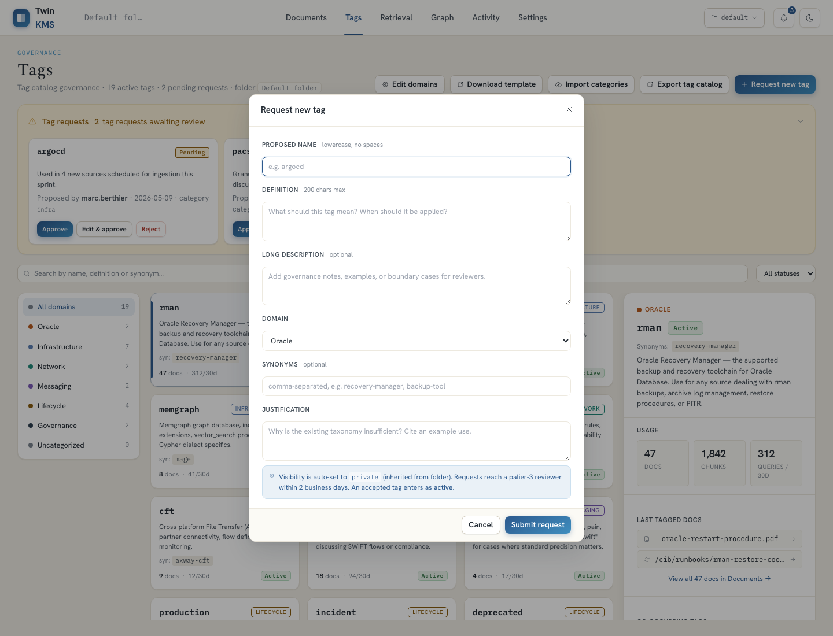
Figure — Request-new-tag modal.
Reach: Tags tab.
Stories: US-TAG-01, US-TAG-02, US-TAG-03, US-TAG-04
TC-TAG-01 — Request a new tag and see it pending
Type: E2E (automated) Max severity if it fails: S3
Preconditions: Tags tab open.
Steps:
- Click Request new tag.
- Fill name, definition, domain, justification.
- Submit request.
- Leave and return to Tags.
Expected result: The requested tag appears in the pending/requested section and persists across navigation.
TC-TAG-02 — Edit a tag definition (admin)
Type: E2E (automated) Max severity if it fails: S3
Preconditions: Admin; an existing tag.
Steps:
- Select a tag card.
- Click Edit.
- Change the definition.
- Save.
Expected result: The new definition is shown on the card and survives reload.
TC-TAG-03 — Approve / reject a pending request (admin)
Type: E2E (automated) Max severity if it fails: S2
Preconditions: Admin; a pending request.
Steps:
- Reject one request — confirm the button is disabled until a reason is entered.
- Approve another (optionally with edits).
Expected result: Rejected tags show a Rejected status; approved ones become active; both emit activity events.
TC-TAG-04 — Manage synonyms (admin)
Type: E2E (automated) Max severity if it fails: S3
Preconditions: Admin; a tag selected.
Steps:
- Open the synonyms action.
- Add and remove aliases.
- Save.
Expected result: The alias list updates and persists.
TC-TAG-05 — Deprecate a tag
Type: E2E (automated) Max severity if it fails: S3
Preconditions: Admin; an active tag.
Steps:
- Open the deprecate action.
- Confirm.
Expected result: The tag is flagged deprecated and is excluded from default retrieval surfaces.
TC-TAG-06 — Delete a tag with migration to a replacement
Type: E2E (automated) Max severity if it fails: S2
Preconditions: Admin; a tag used by documents.
Steps:
- Open Delete.
- Choose Migrate and pick a target tag (required).
- Confirm.
Expected result: Deletion requires a migration target (or explicit untag); affected chunks/docs are migrated; the operation is auditable.
TC-TAG-07 — Edit the category taxonomy (admin)
Type: E2E (automated) Max severity if it fails: S3
Preconditions: Admin; domain editor available.
Steps:
- Open the domain editor.
- Add a domain (id, label, colour).
- Try an invalid id and an empty label.
- Save.
Expected result: Validation blocks invalid ids/labels/colours and duplicates; valid taxonomy saves.
TC-TAG-08 — Import categories from JSON
Type: Manual Max severity if it fails: S3
Preconditions: Admin; a categories JSON (use Download template as a base).
Steps:
- Download the template.
- Import a valid JSON.
- Import a malformed JSON.
Expected result: Valid JSON replaces the taxonomy; malformed JSON is rejected with a clear error.

6.6 Retrieval
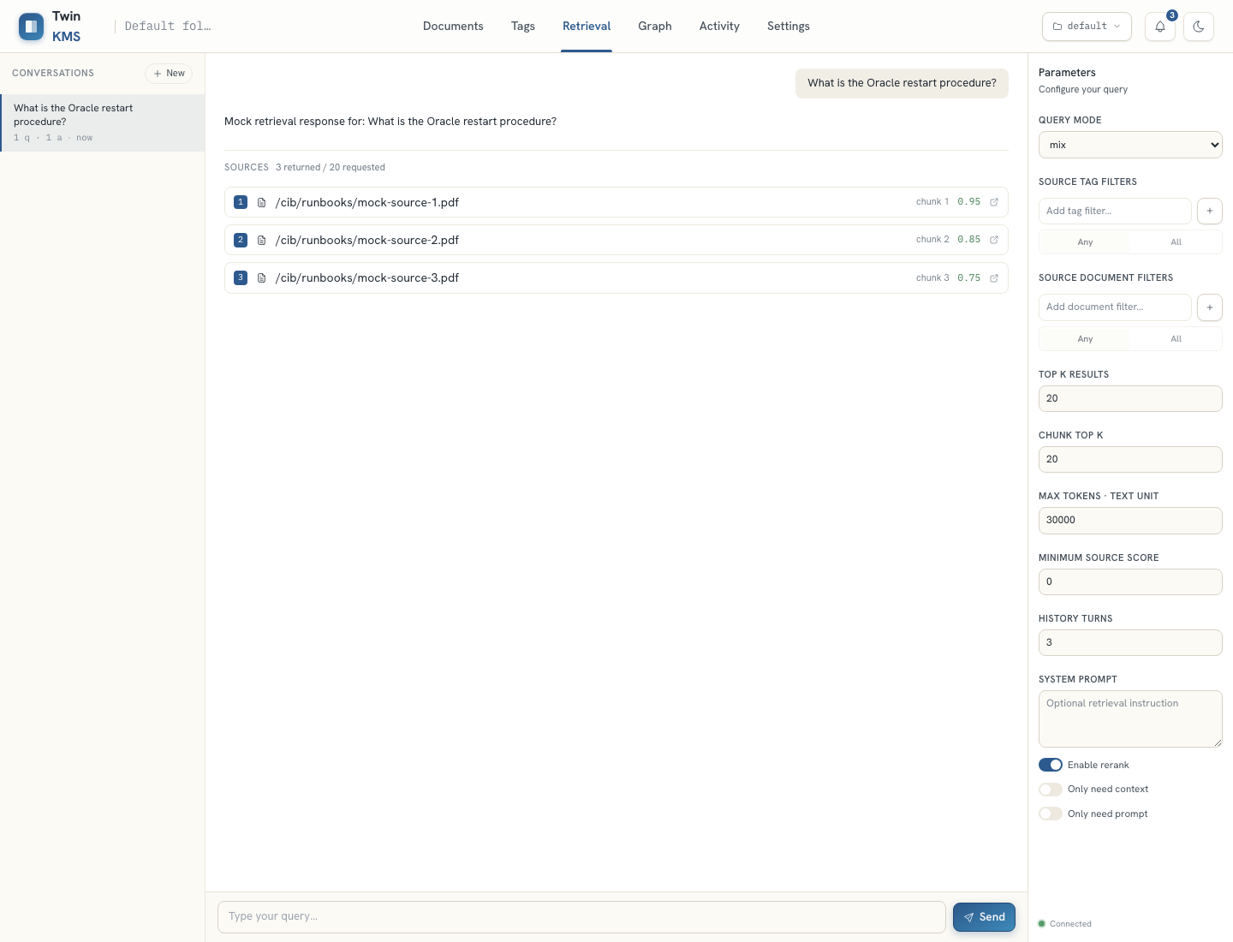
Figure — Retrieval tab: answer with a sources panel and the query-parameter rail.
The question-answering surface. The operator asks a question and receives a streamed answer with a sources panel; a parameter rail tunes query mode, top-k, rerank, token budget, history turns and tag/document filters. Conversation threads persist in the browser.
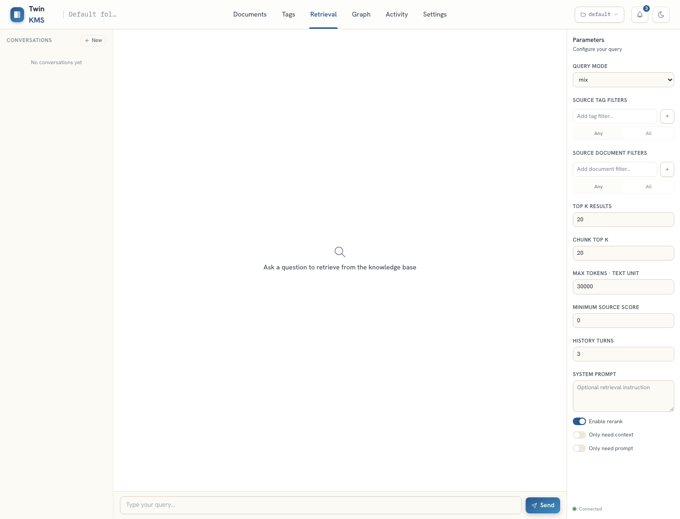
Figure — Empty thread with the full query-parameter rail.
Reach: Retrieval tab.
Stories: US-RET-01, US-RET-02, US-RET-03
TC-RET-01 — Ask a question and receive an answer + sources
Type: E2E (automated) Max severity if it fails: S2
Preconditions: Retrieval tab open.
Steps:
- Click New.
- Type a question in the query input.
- Click Send.
Expected result: An answer renders and a Sources panel lists the returned sources with scores.
TC-RET-02 — Threads persist across reload
Type: E2E (automated) Max severity if it fails: S3
Preconditions: At least one thread with a message.
Steps:
- Create two threads with questions.
- Switch between them.
- Reload.
Expected result: Both threads and their histories survive the reload; switching shows the right history.
TC-RET-03 — Delete a thread
Type: E2E (automated) Max severity if it fails: S3
Preconditions: A thread exists.
Steps:
- Delete a thread via its control.
Expected result: The thread is removed from the list and from local storage.
TC-RET-04 — Parameters change retrieval breadth
Type: E2E (automated) Max severity if it fails: S3
Preconditions: Retrieval tab open.
Steps:
- Set top-k to 1.
- Ask a question.
Expected result: Fewer sources are returned than with a higher top-k (contract-level check on the mock).
TC-RET-05 — Tag filter does NOT narrow the answer (known limitation)
Type: Manual Max severity if it fails: S4
Preconditions: Retrieval tab; a tag selected in Source-tag filters.
Steps:
- Add a tag filter.
- Ask a question that has answers outside that tag.
Expected result: The answer may include out-of-tag material — this is expected (§4 item 1). Only file a defect if the UI claims the filter is applied to the answer.
Note: Do NOT report the no-op itself. See §4 / audit C1.
TC-RET-06 — Citation link drills to the document
Type: E2E (to build) Max severity if it fails: S3
Preconditions: An answer with an inline citation marker.
Steps:
- Click an inline [n] citation or a source row.
Expected result: Navigates to / highlights the corresponding source document.
Note: Currently skipped in automation; recommended new E2E and a manual pass.
TC-RET-07 — Answer quality and honest no-answer (real backend)
Type: Manual Max severity if it fails: S2
Preconditions: Real backend with a populated KB.
Steps:
- Ask 10–15 in-domain questions.
- Ask 3 deliberately out-of-scope questions.
Expected result: In-domain answers are grounded with relevant sources; out-of-scope questions return "insufficient information" with no fabricated grounding.
Note: Mocked build returns canned text — judge quality on real backend only.

6.7 Knowledge graph
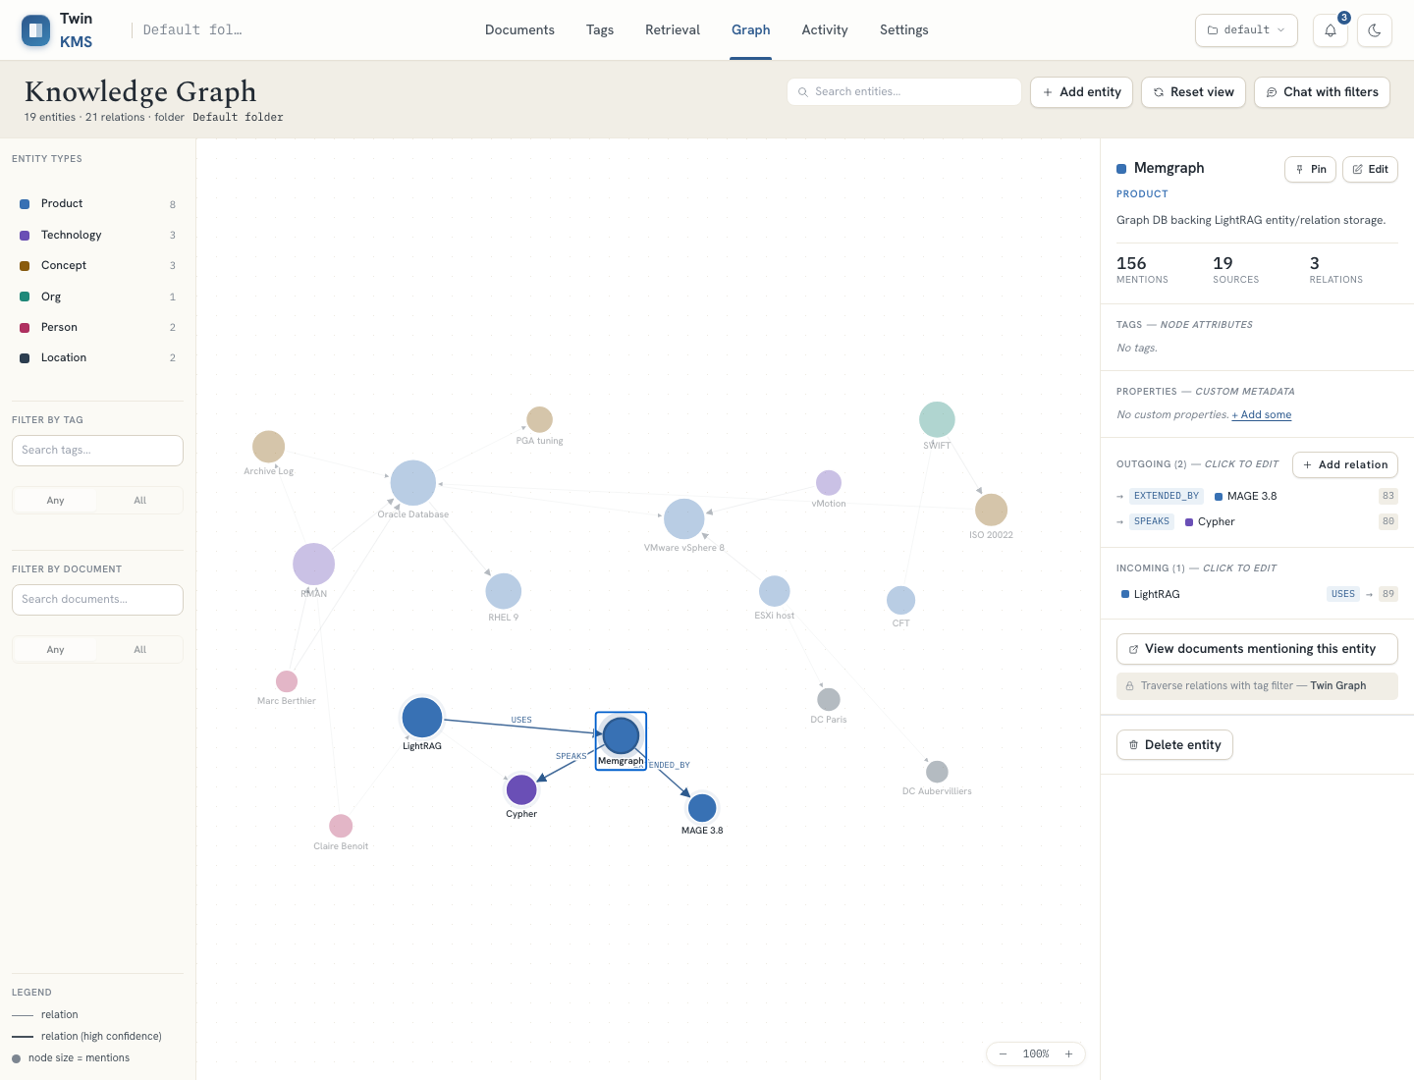
Figure — Graph tab: canvas with an entity selected and its inspector open.
A live projection of the knowledge graph. Operators filter by entity type, tag and document, select nodes/edges to inspect, and pin nodes. Admins create, edit and delete entities and relations; mutations emit activity and refetch the graph.
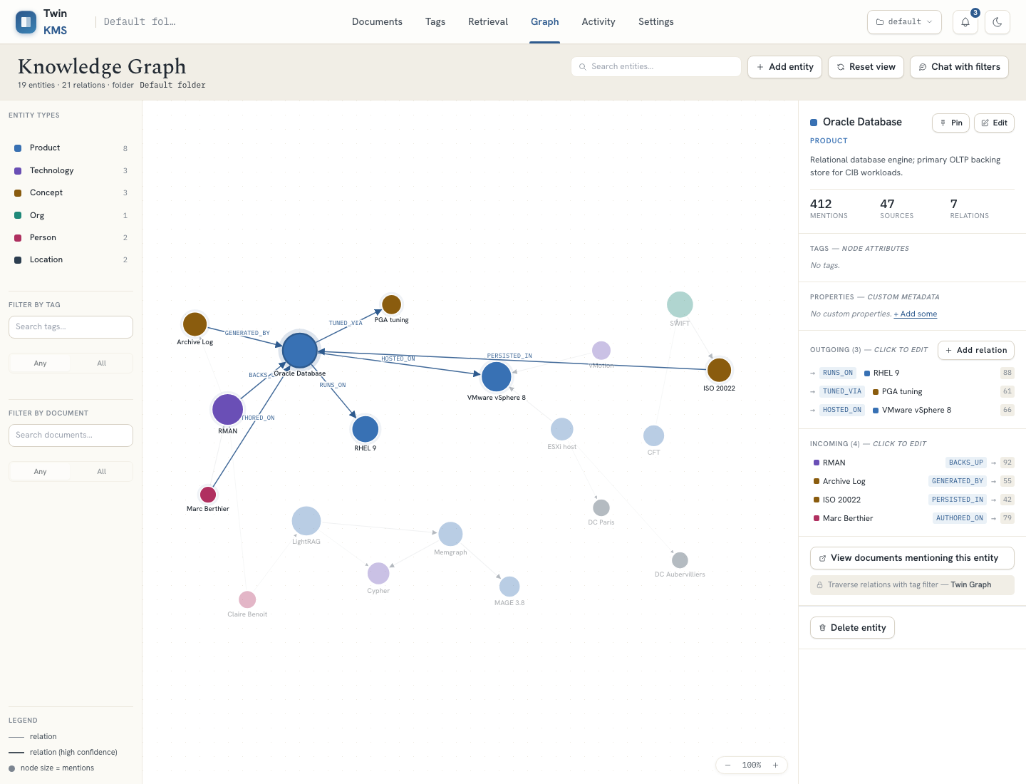
Figure — Graph canvas with the type/tag/document filter rail.
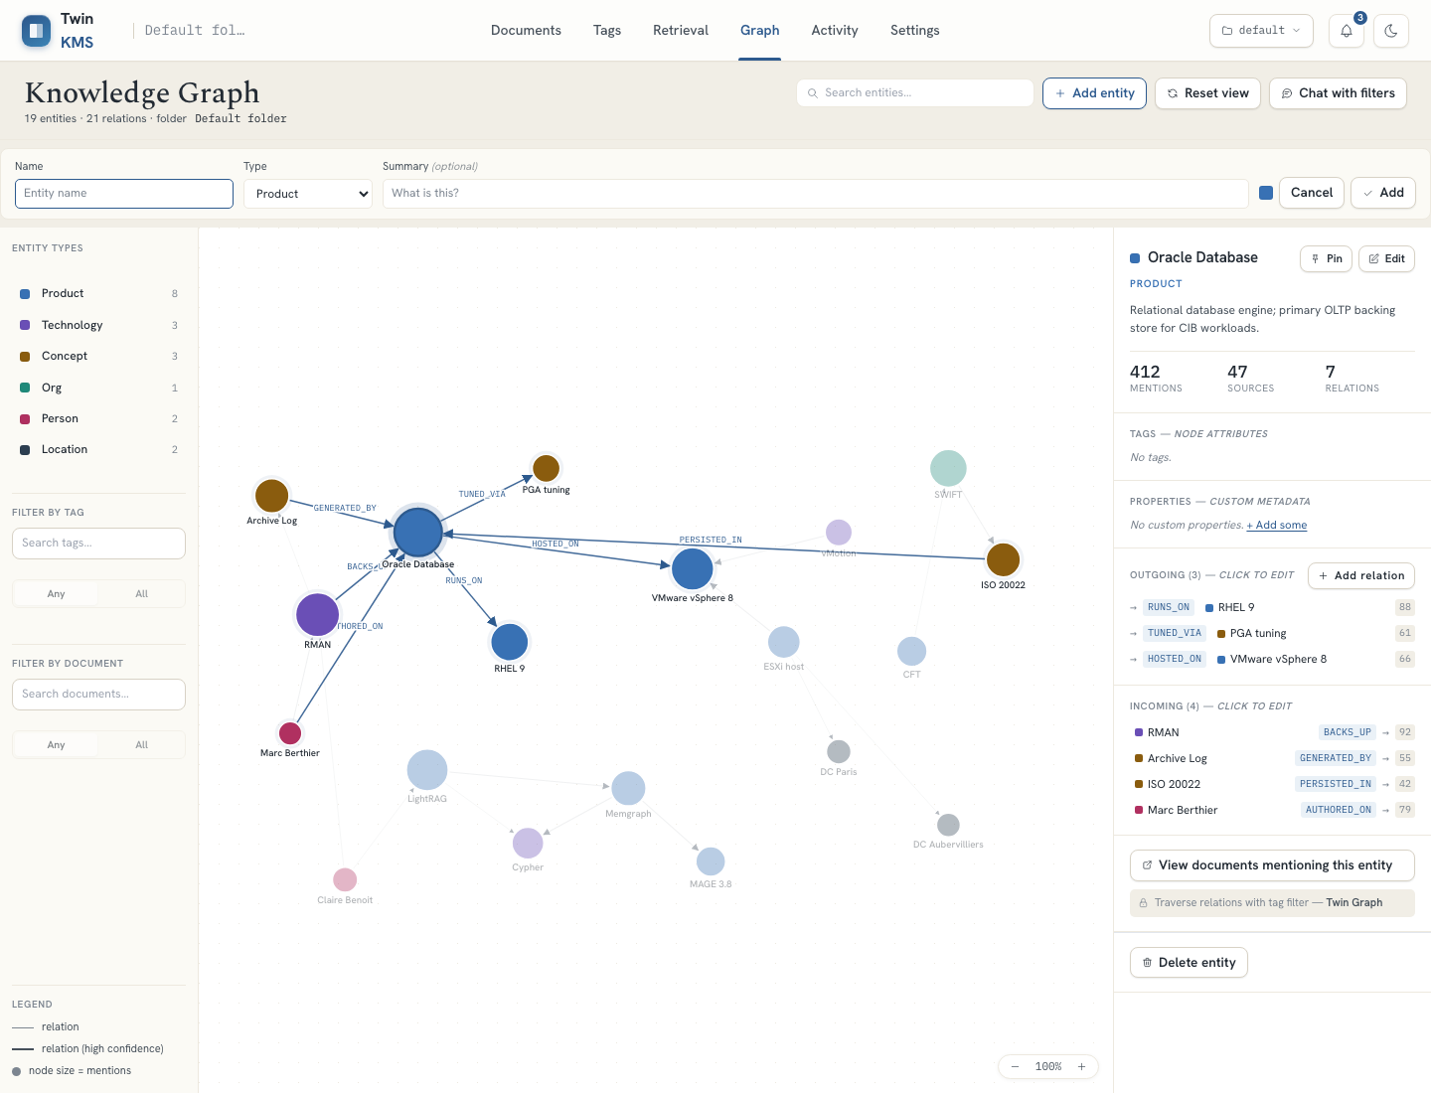
Figure — Admin add-entity form.
Reach: Graph tab.
Stories: US-GRAPH-01, US-GRAPH-02, US-GRAPH-03
TC-GR-01 — Filter by entity type updates canvas and counts
Type: E2E (automated) Max severity if it fails: S3
Preconditions: Graph tab open.
Steps:
- Toggle entity-type filters.
- Observe nodes and the per-type counters.
Expected result: The canvas and counters track the active type filters.
TC-GR-02 — Search an entity by name
Type: E2E (automated) Max severity if it fails: S3
Preconditions: Graph tab open.
Steps:
- Type an entity name in search.
Expected result: Only matching nodes remain emphasised/visible.
TC-GR-03 — Select an entity and read its inspector
Type: E2E (automated) Max severity if it fails: S3
Preconditions: Graph has nodes.
Steps:
- Click a node.
- Read summary, type, tags, source documents and relations.
Expected result: The inspector shows the entity's details and its incoming/outgoing relations.
TC-GR-04 — Pin an entity; pin persists
Type: E2E (automated) Max severity if it fails: S4
Preconditions: A node selected.
Steps:
- Click Pin.
- Reload and reselect the node.
Expected result: The node is pinned and remains pinned after reload.
TC-GR-05 — Create an entity (admin)
Type: E2E (automated) Max severity if it fails: S3
Preconditions: Admin; Graph tab.
Steps:
- Click Add entity.
- Confirm submit is disabled until name + type are set.
- Fill required fields and create.
Expected result: A new entity is created, appears on the canvas, and an activity event is recorded.
TC-GR-06 — Create a relation with duplicate guard (admin)
Type: E2E (automated) Max severity if it fails: S3
Preconditions: Admin; an entity selected.
Steps:
- Add a relation to another entity.
- Try to add the same edge again.
Expected result: The relation is created; a duplicate edge is prevented.
TC-GR-07 — Delete an entity / relation (admin, two-click)
Type: E2E (automated) Max severity if it fails: S2
Preconditions: Admin; an entity or relation selected.
Steps:
- Click Delete.
- Confirm on the second click.
Expected result: Deletion requires the second confirm; the element disappears; an event is recorded.
TC-GR-08 — Drill from an entity to its documents
Type: E2E (automated) Max severity if it fails: S3
Preconditions: An entity with source documents.
Steps:
- Use "View documents mentioning this entity".
Expected result: Navigates to Documents pre-filtered by that entity.

6.8 Activity
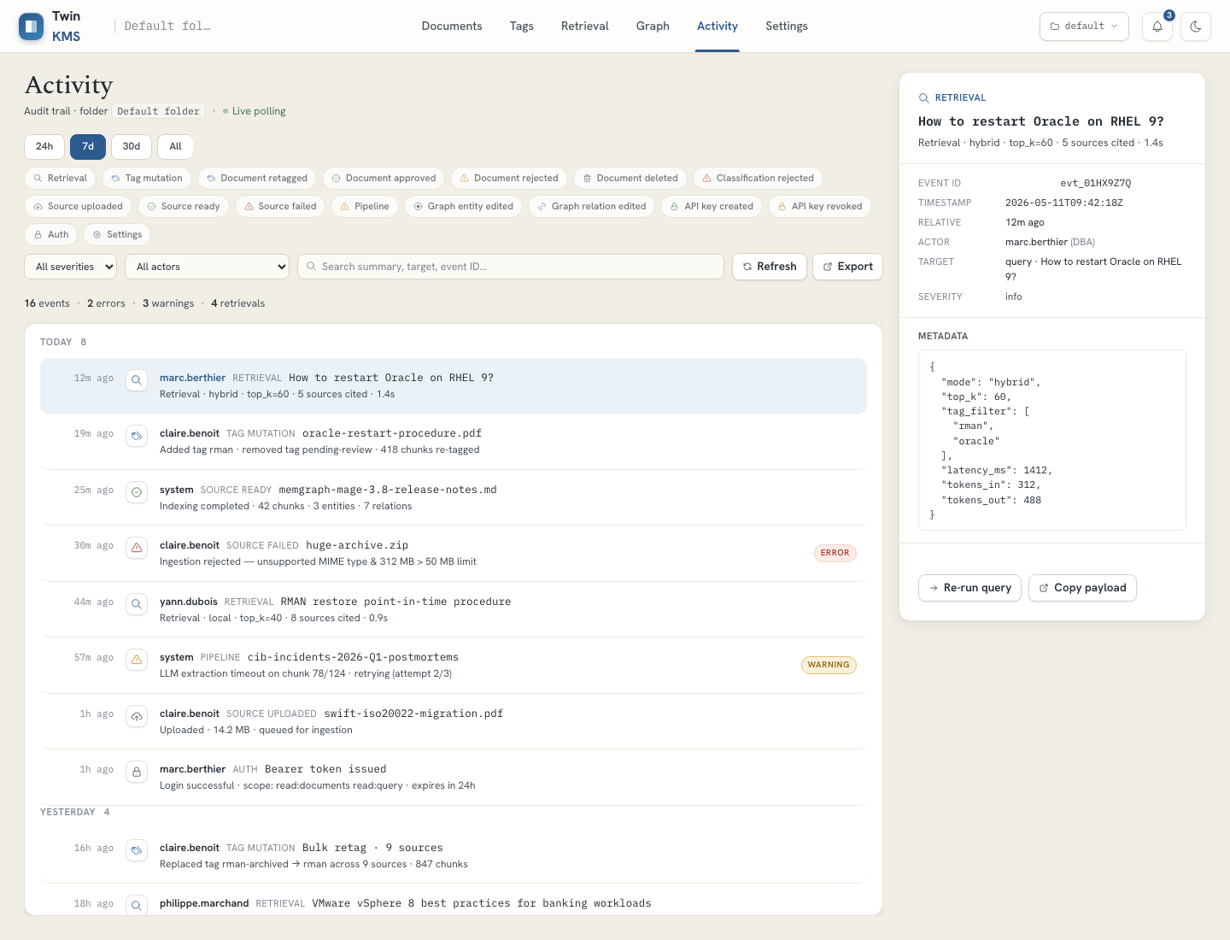
Figure — Activity tab: filtered timeline with an event detail panel.
The audit feed. Every governance action (upload, approve/reject, tag change, graph mutation, key minting, classification rejection…) is recorded. Filter by time range, kind, severity, actor and free text; open an event to drill into its target. Admins can clear activity.
Reach: Activity tab.
Stories: US-ACT-01, US-ACT-02
TC-ACT-01 — Severity filter narrows the timeline
Type: E2E (automated) Max severity if it fails: S3
Preconditions: Events of mixed severity.
Steps:
- Set Severity filter to error.
- Reset to any.
Expected result: Only error rows show under the error filter; all return on reset; the stats count tracks the filter.
TC-ACT-02 — Kind and text filters
Type: E2E (automated) Max severity if it fails: S3
Preconditions: Events of mixed kinds.
Steps:
- Toggle one or more event kinds.
- Search a text fragment.
Expected result: The list reflects the combined kind + text filters.
TC-ACT-03 — Time-range tabs
Type: E2E (automated) Max severity if it fails: S4
Preconditions: Activity tab open.
Steps:
- Switch among 24h / 7d / 30d / All.
Expected result: The active range is highlighted and the timeline updates.
TC-ACT-04 — Open an event detail
Type: E2E (automated) Max severity if it fails: S3
Preconditions: At least one event.
Steps:
- Click an event row.
- Read the detail (Event ID, severity, actor, target, timestamp).
Expected result: The detail panel shows full metadata for the selected event.
TC-ACT-05 — Drill from an event to its source
Type: E2E (automated) Max severity if it fails: S3
Preconditions: A source-related event selected.
Steps:
- In the detail panel, click Open source (or Replay ingestion for a failed source).
Expected result: Navigates to the Documents tab on the right document (or replays ingestion).
TC-ACT-06 — Refresh pulls new events
Type: E2E (automated) Max severity if it fails: S4
Preconditions: Activity tab open.
Steps:
- Click Refresh after a new action elsewhere.
Expected result: Newly produced events appear.

6.9 Settings — profile, API, API keys, folders
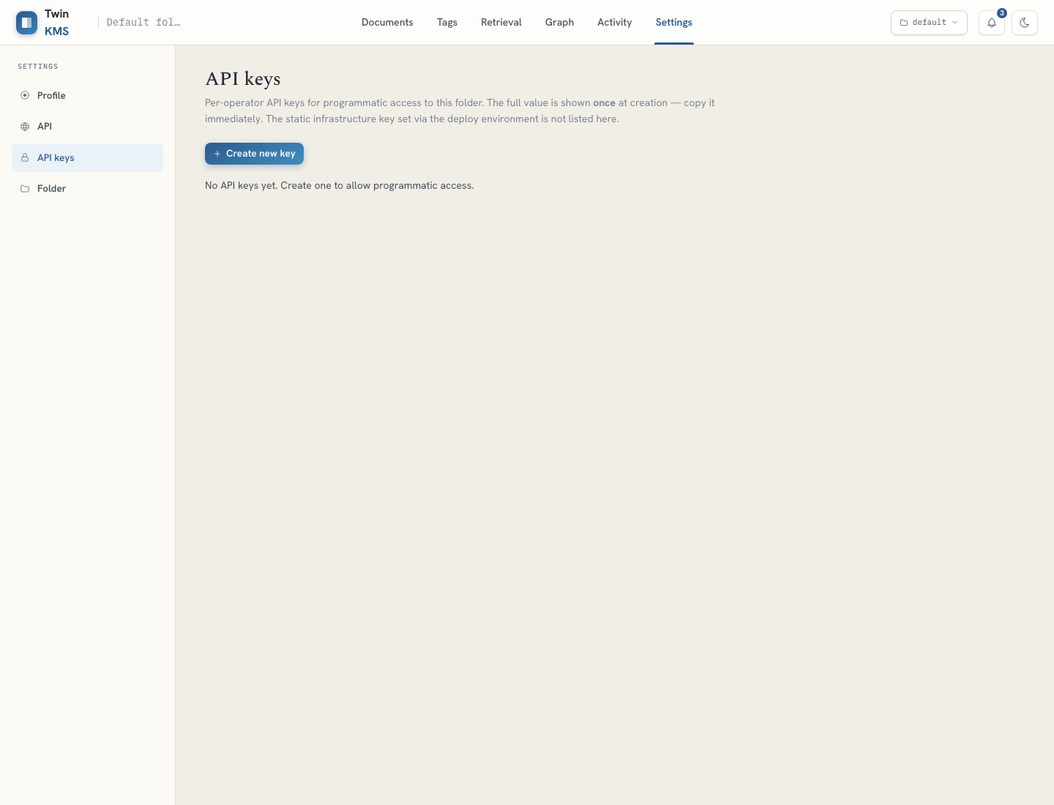
Figure — Settings › API keys: mint, one-time reveal, and revoke per-operator keys.
Four sections. Profile shows identity, IdP and gateway scopes (read-only). API browses the live OpenAPI surface. API keys lets admins mint a key (full value revealed exactly once), list prefixes, and revoke. Folders shows the env-controlled identity and, for admins, runtime folder CRUD within a five-folder cap.
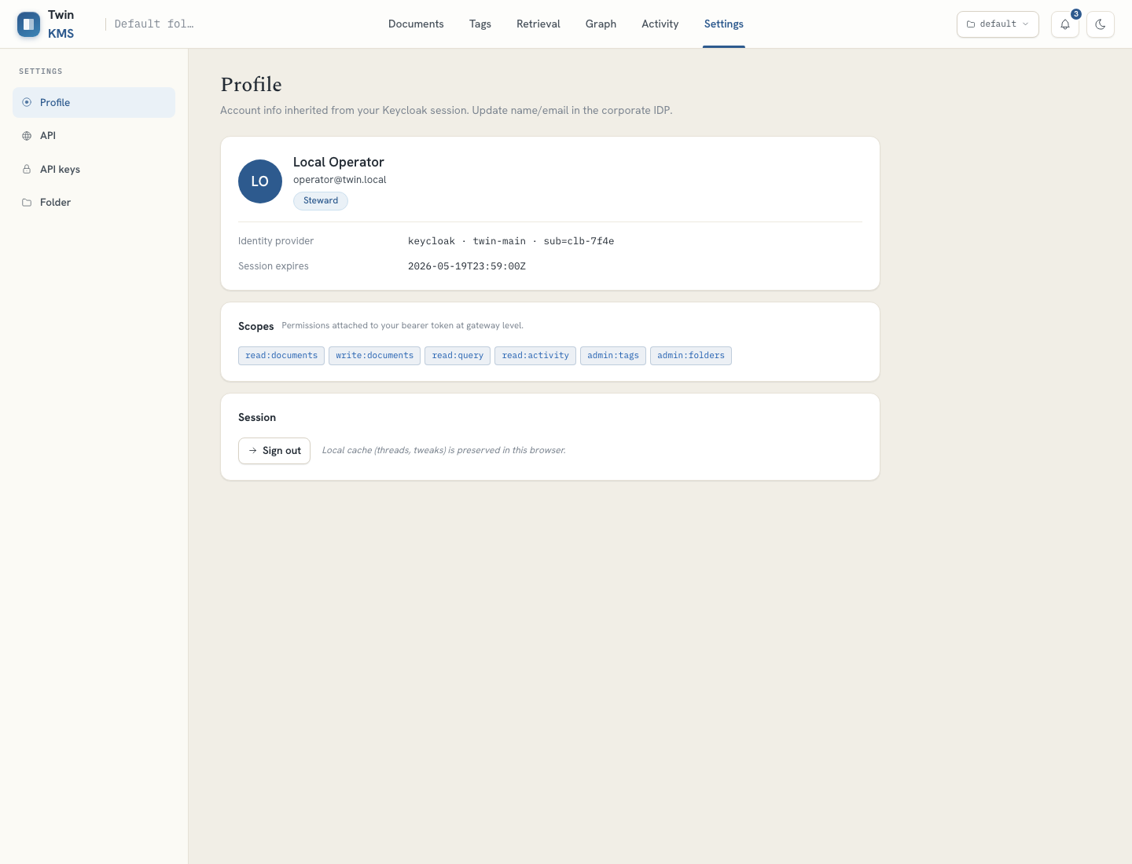
Figure — Profile: identity, IdP and gateway scopes (read-only).
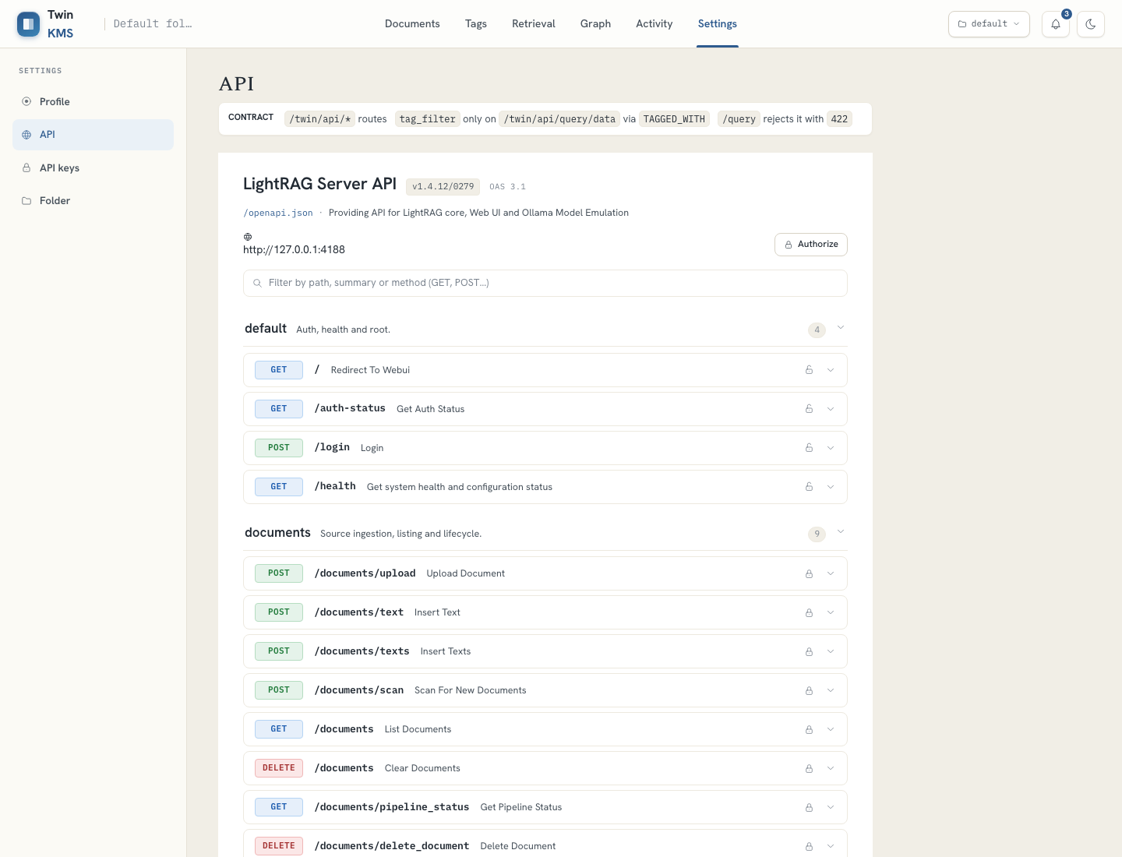
Figure — Live OpenAPI surface browser.
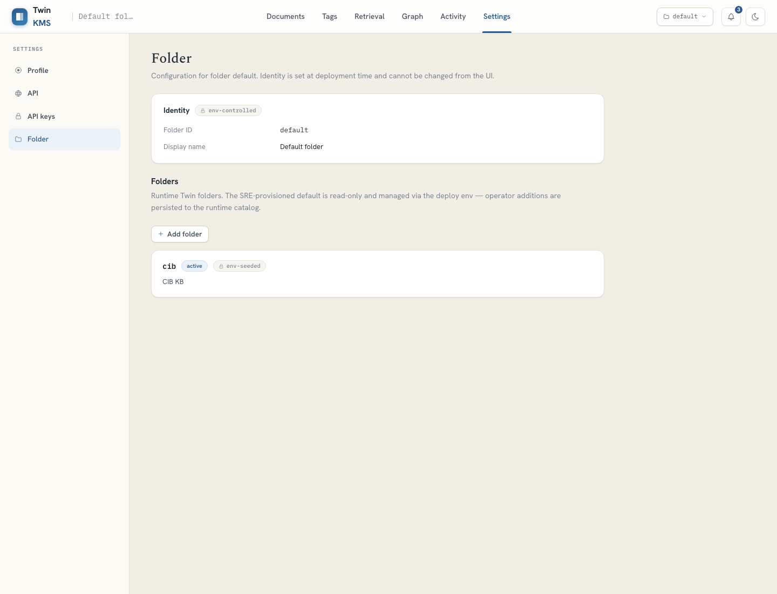
Figure — Runtime folder administration (admin:folders).
Reach: Settings tab; left-rail section switch.
Stories: US-SET-01, US-SET-02, US-SET-03, US-SET-04
TC-SET-01 — Profile shows identity and scopes
Type: E2E (automated) Max severity if it fails: S4
Preconditions: Signed in.
Steps:
- Open Settings › Profile.
Expected result: Name, email, role, IdP/realm/subject and gateway-scope chips are shown; an open-access note appears when no auth backend is configured.
TC-SET-02 — API explorer loads and authorises
Type: E2E (automated) Max severity if it fails: S3
Preconditions: Settings open.
Steps:
- Open the API rail.
- Authorize with a token, then revoke it.
Expected result: The OpenAPI surface lists endpoints; Authorize toggles to Authorized and back on revoke.
TC-SET-03 — Mint an API key with one-time reveal (admin)
Type: E2E (automated) Max severity if it fails: S2
Preconditions: Admin; API keys rail.
Steps:
- Create a key with a name.
- Copy the revealed full value.
- Dismiss the reveal.
Expected result: The full value is shown once with a copy control and a "never shown again" warning; afterwards only the prefix is listed.
TC-SET-04 — Revoke an API key (admin, two-click)
Type: E2E (automated) Max severity if it fails: S2
Preconditions: Admin; an active key.
Steps:
- Click Revoke.
- Confirm on the second click.
Expected result: The key becomes revoked (kept for audit) and can no longer authenticate.
TC-SET-05 — Folder identity is read-only
Type: Manual Max severity if it fails: S4
Preconditions: Settings › Folder.
Steps:
- Open the Folder section.
Expected result: Folder id and display name are shown as env-controlled and cannot be edited here.
TC-SET-06 — Create a runtime folder (admin)
Type: E2E (automated) Max severity if it fails: S3
Preconditions: Admin with admin:folders; under the 5-folder cap.
Steps:
- Click Add folder.
- Enter a valid id, name and visibility.
- Create.
Expected result: The folder is created and appears in the topbar switcher.
TC-SET-07 — Folder cap and id validation
Type: Manual Max severity if it fails: S3
Preconditions: Admin.
Steps:
- Try to create a 6th folder.
- Try an invalid id and a duplicate id.
Expected result: Add is blocked at the cap with an at-max indicator; invalid/duplicate ids are rejected with a clear error.
TC-SET-08 — Edit / delete a runtime folder; env folder is protected
Type: Manual Max severity if it fails: S2
Preconditions: Admin; one env-seeded and one runtime folder.
Steps:
- Edit the runtime folder.
- Delete an empty runtime folder (two-click).
- Attempt to edit/delete the env-seeded folder.
- Attempt to delete a folder that still has data.
Expected result: Runtime folders edit/delete; the env-seeded folder offers no edit/delete; deleting a folder with data is refused (409).
TC-SET-09 — Folder admin hidden for non-admins
Type: Manual Max severity if it fails: S1
Preconditions: Reader or Steward without admin:folders (real/IdP config).
Steps:
- Open Settings › Folder.
Expected result: Folder CRUD is read-only / hidden; the API rejects folder mutations with 403.
Note: Access-control case — a failure here is a security defect (S1).

7. Outsourcing scope by stream

7.1 Stream A — E2E automation vendor
The console already carries a substantial Playwright suite (18 specs) plus ~45 component tests. The vendor's job is to MAINTAIN these and CLOSE the gaps below — not to re-cover what exists. Existing coverage by area:
Area | Covered | Spec(s)
Login / auth gate / session | Yes | login.spec.ts
Documents CRUD, filter, bulk, pending review | Yes | documents.spec.ts, app.spec.ts
Upload + classification header | Yes | upload.spec.ts
Tag governance (request→approve→edit→migrate) | Yes | tags.spec.ts
Retrieval threads, params, filters | Partial | retrieval.spec.ts (citation link skipped)
Knowledge graph CRUD, pin, cascade | Yes | graph.spec.ts
Activity filters & detail drill-down | Yes | activity.spec.ts
Settings: API keys, profile, folders | Yes | settings.spec.ts
Notifications, topbar, theme, responsive | Yes | toasts-topbar / responsive-topbar
Modal accessibility (focus, escape) | Yes | modals-a11y.spec.ts
Runtime folders & X-Twin-Folder header | Yes | folders-runtime.spec.ts
Adversarial API surface (real backend) | Yes | api-coverage-real / -generated-key

Recently closed (2026-06-26 reinforcement pass):
- Citation drilldown — a Retrieval source now links to its real seeded document; the previously-skipped test is enabled (retrieval.spec.ts, with a one-source MSW handler tune).
- Role gating on folder administration — Reader (no admin:folders) sees a read-only badge and no Add-folder control; Admin sees the controls (role-gating.spec.ts).
- Document pagination boundary — 60 seeded docs force a second page; Next/Previous and the page label are asserted (documents-pagination.spec.ts).
Gaps still recommended for new automation (E2E to build):
- Real-backend ingestion: upload a real file → poll to COMPLETED → appears with chunks.
- Classification rejection end-to-end: a file above the ceiling lands FAILED + emits a classification-rejected activity event (MSW needs a classification-rejected seed knob).
- Folder membership: duplicate-to-share, add-to-folder, and last-folder removal physically deletes the document (endpoints are mocked; an admin UI path / contract test is needed).
- Quota-exceeded journey (QuotaBanner) — needs a /__e2e/quota knob to drive the over-limit state.
- Session-expiry re-auth (real backend / short token TTL).
Finding — Tags governance is NOT role-gated in the UI.
• TagsTab is wired to a hardcoded CURRENT_USER constant (palier 3 = admin/steward), not to the authenticated user. A Reader therefore still sees Edit/Delete/Deprecate tag controls. The MSW tag-mutation handlers are also not scope-checked. Net: tag-governance access control is currently enforced (if at all) only by the real backend, not the UI. Decide: wire CURRENT_USER → auth.user (so the UI reflects the role), or accept backend-only enforcement and document it. Until resolved, a UI role-gating test for tags would be vacuous — which is why role-gating.spec.ts covers folders only.

7.2 Stream B — manual (offshore) testing
Human judgement work that automation cannot meaningfully cover.
Browser / device matrix (minimum):
Browser | Versions | Viewports
Chrome | latest + latest-1 | 1440×900, 1280×800
Firefox | latest | 1440×900
Safari | latest (macOS) | 1440×900
Edge | latest | 1280×800
Responsive | Chrome | 1100px and 760px widths

Exploratory charters (time-boxed, 60–90 min each):
- Real-document ingestion: ingest 10 mixed real files (PDF, DOCX, XLSX, HTML) and verify they reach COMPLETED with sensible chunk counts and tags.
- Answer quality (real backend): ask 15 domain questions; judge whether the answer is grounded, whether sources are relevant, and whether a deliberately out-of-scope question honestly returns "insufficient information".
- Classification: upload files carrying MIP labels C1–C4 and confirm the badge shown and the ceiling-rejection behaviour.
- Visual fidelity & dark mode: every screen in light and dark theme; check contrast, truncation, overflow, and long filenames/tags.
- Role-based access: repeat the golden paths as Reader, Steward, Admin; confirm gated controls are correctly hidden/blocked.
- Resilience: slow network, mid-flight reloads, double-clicks on destructive actions, empty states, and error toasts (undo).

8. Traceability matrix (story → screen → cases → automation)
User story | Screen | Key test cases | Automated?
US-AUTH-01/02 | §6.1 Login | TC-AUTH-01..04 | Yes (login.spec)
US-NAV-01/02 | §6.2 Topbar | TC-NAV-01..05 | Yes (folders-runtime, toasts-topbar)
US-DOC-01..06 | §6.3 Documents | TC-DOC-01..12 | Mostly (documents.spec)
US-UPL-01/02 | §6.4 Upload | TC-UPL-01..06 | Partial (upload.spec; rejection manual)
US-TAG-01..04 | §6.5 Tags | TC-TAG-01..08 | Yes (tags.spec)
US-RET-01..03 | §6.6 Retrieval | TC-RET-01..07 | Partial (citation/quality manual)
US-GRAPH-01..03 | §6.7 Graph | TC-GR-01..08 | Yes (graph.spec)
US-ACT-01/02 | §6.8 Activity | TC-ACT-01..06 | Yes (activity.spec)
US-SET-01..04 | §6.9 Settings | TC-SET-01..09 | Yes (settings.spec)

End of document.

