ENGG 683 - Winter 2022

Assignment 2

March 4, 2022

Dr. Ghada Nafie

Allen Ndonwi Shu, Bhavyai Gupta, Drew Burritt, Michael Man Yin Lee, Thomas

Scott

# Table of Contents

**Q1. Describe the industry factors that were present when NIO was first founded.**

**PEST anal****ysis 2**

**Q2. Describe NIO’s business model using the business model canvas attached as Appendix ‘A’ to this assignment document (also shared in Mural).** **4**

**Q3. Innovations in NIO’s business model? What were the advantages of NIO in comparison to Tesla?** **5**

Battery Swapping vs Charging 5

Direct to customer model 5

Wider user base than Tesla 5

R&D centers in multiple countries attracting world-class industry talents. 6

**Q4. SWOT analysis (strengths, weaknesses, opportunities, and threats) on NIO’s power swap** **7**

**Q5. Describe two major challenges NIO are faced with?** **9**

Intense competition 9

Profit problem 9

**Q6. What would you recommend NIO do to adjust its business model to enhance market competitiveness?** **10**

**Additional items (Done out of our own group’s interest)** **11**

# Q1. Describe the industry factors that were present when NIO was first founded. You should focus on political, economic, social, and technical factors, the PEST analytical tool.

When NIO was first founded, the country from which NIO is situated (China, which is now one of the world’s largest automotive markets), provided generous subsidies to EV purchases as well as tax credits for local manufacturers. Furthermore, China, at the time, saw a rapid growth in its middle class through its National Poverty Reduction Program, which means that there is a growing market for the adoption of vehicles. China also had a very strong economy with moderate interest and inflation rates.

Couple with cheap labor and national initiative to focus on climate change (ie. the joint climate announcement between the United States and China), this has created an excellent ecosystem for NIO’s business to grow. Social media usage in China is experiencing rapid growth at this time with new platforms such as Weibo just founded in 2009, which means that Nio’s social focused marketing is in the right direction.

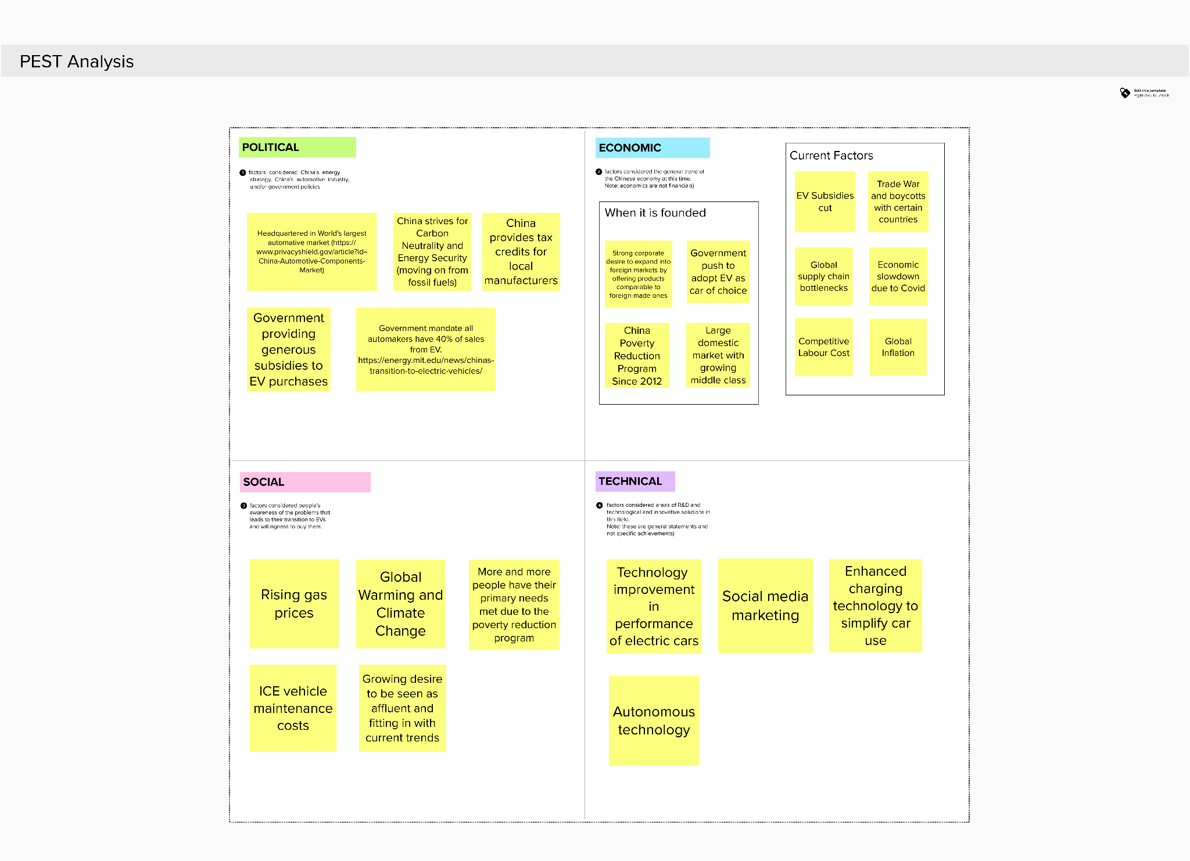

Please find the mural of the above PEST analysis [here](https://app.mural.co/t/ghadasroom9330/m/ghadasroom9330/1646157128196/b7a542439cbf299c019701ac68e02779b5a1e971?sender=u30c8daf8af50b7a86f155313).

# Q2. Describe NIO’s business model using the business model canvas attached as Appendix ‘A’ to this assignment document (also shared in Mural).

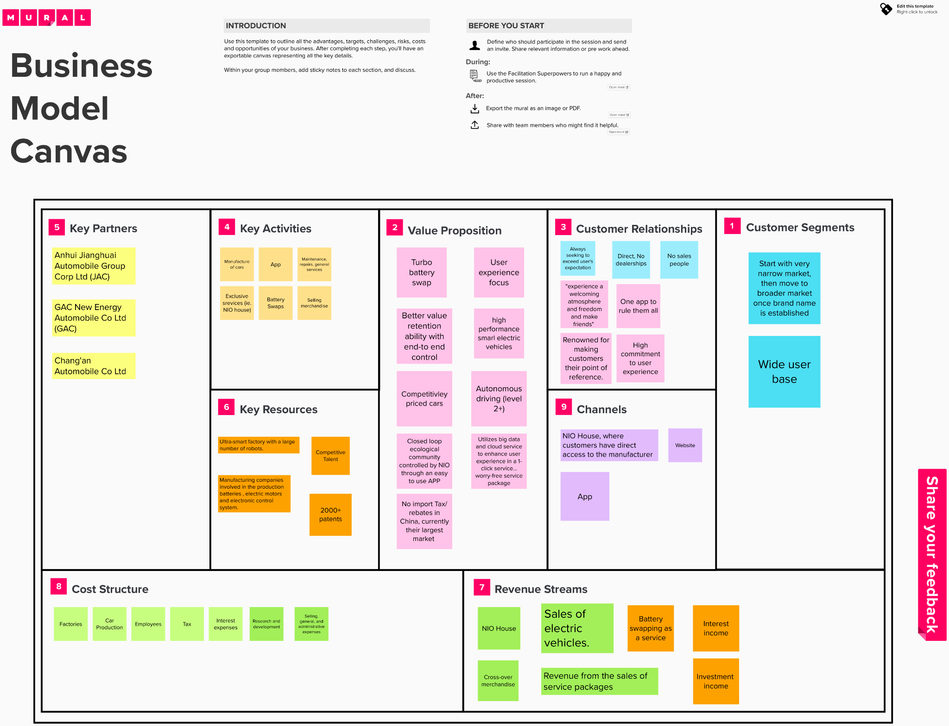

Please find the mural of the above Business Model Canvas [here](https://app.mural.co/t/ghadasroom9330/m/ghadasroom9330/1645689032940/ed267a5319872b1899bca66d765c39e3b7b81dd1?sender=u30c8daf8af50b7a86f155313).

# 

# Q3. What were the innovations in NIO’s business model? What were the advantages of NIO in comparison to Tesla? You should look at the differences related to value proposition, infrastructure, cost/revenue, and customer interface.

The top two innovations in NIO’s business model are: battery swapping, the infrastructure associated with it and the centralized app platform that helps NIO to re-enforce their branding.

## Battery Swapping vs Charging (NIO developing technology not yet proven by other companies)

Where Tesla has abandoned the idea of battery swapping, citing lack of interest from customers (Morris 2021), NIO focused on developing this technology that allows the price of the electric vehicle not only cheaper, but also introduces a new recurring income model in the form of Battery-as-a-service (BaaS). The reason for the decrease in price for the vehicle is because this allows NIO to sell their electric vehicles without a battery installed.

Furthermore, NIO’s technology has refined the battery swapping technology to a point that a battery swap can be done within minutes, which means that swapping batteries may actually be a faster method than charging the battery itself. This gives a unique competitive advantage over Tesla. (Baldwin 2020).

## Expanded and more robust direct to customer model with NIO offering more options at point of purchase

Although when people think of electric vehicles they would think of Tesla, Tesla does very little in marketing as it basically focuses on word-of-mouth(Reicheld 2019). NIO, on the other hand, focus on a brand community that takes care of the customer experience with a centralized app that functions as not only a vehicle maintenance platform but also a social media platform to re-enforce brand loyalty, NIO house which is an offline channel that fosters a community of NIO users as well as periodical cross-over merchandises with other famous brands to further promoting of NIO’s brand awareness (Shenvi 2021).

There are several factors of which NIO has advantages in comparison to Tesla of which we will analyze in detail below:

**We have also found the following to be the advantages of NIO in comparison to Tesla:**

## NIO targets a wider user base than Tesla:

Tesla currently emphasizes the luxury market, while NIO emphasizes the middle class market. In an article from August 16, 2021 (Leggett 2021), Nio has established a new market brand where there are more affordable models that will be available to middle income consumers. These models are aimed to have prices lower than Tesla.

On the other hand, if we were to look at a typical Tesla customer (“Tesla Owner Demographics by Age, Income, Gender, Home Value”, n.d.), they are usually male in their 50s who usually have high household income.

## NIO has developed R&D centers in multiple countries attracting world-class industry talents.

Although Tesla invests in R&D the most out of all the brands, they only have one R&D center outside of the United States by the end of 2021, which is in Shanghai (Randall 2021).

NIO focuses on attracting a wider range of talents with R&D centers not only in China, but also the United States, Germany and UK.

This allows NIO to react and adapt better to foreign markets due to their talent diversification.

In addition:

1. NIO has multiple streams of revenue, like NIO Power, NIO Life
2. Huge focus on customer experience, more so than Tesla
3. Stronger delivery growth than Tesla (revenue growth of 88% vs 28%) (Team 2021)
4. NIO offers an entire ecosystem during sales with the help of NIO House
5. Outsourced manufacturing to an established company vs Tesla’s in-house manufacturing

# 

# Q4. Conduct a SWOT analysis (strengths, weaknesses, opportunities, and threats) on NIO’s power swap. Fill out the Mural and discuss.

NIO’s power swap involves the physical changing of batteries at NIO stations. Here drained car batteries are exchanged for fully charged batteries, enabling faster turnaround which is comparable in time to traditional refueling of ICE vehicles at gas stations (< 5 minutes per swap).

**Strengths**: Fast alternative to charging, which eliminates key time issues confronting typical electric vehicles (recharging can take several hours). As NIO likewise owns the car batteries and restricts swapping to its own swapping stations, this service provides a source of recurring revenue as NIO users are charged a fee for each battery swap; NIO users remain able to charge batteries through standard recharging so swapping is not required for car use, therefore encouraging swapping as users remain in control of when to use the service. Since batteries can be easily swapped, it allows cars to be sold without a battery. This significantly reduces the upfront cost needed to purchase a car, the owner then rents a battery from NIO using the battery as a service model for a monthly fee. As car owners do not own the battery, they don’t have to worry about the battery wearing out over time, as is common in EVs. They can simply swap it for a new one and not worry about capacity.

**Weaknesses**: The technology is not yet proven on a large scale. For example Tesla has explored battery swapping, but later abandoned the technology due to implementation difficulty. Of concern is, battery swapping is very resource intensive with significant infrastructure requirements for large-scale use - i.e. need a major supply of excess car batteries ready for swapping at any time. Building swapping stations is also more expensive than just charging stations. As electric car batteries require heavy use of carbon-intensive materials (e.g. rare earth metals), battery swapping can theoretically enhance risk to the global climate out of proportion to current recharging technology.

**Opportunities**: One of the biggest opportunities for battery swapping is that there is very little competition for the use of this technology, as other EV brands have emphasized traditional battery charging technology. This means that if customers want a fast solution, NIO has a competitive advantage with its fast battery swapping technology. Furthermore, their battery-as-a-service concept provides a recurring revenue source as this service aforementioned enables the charging of fees on a per-swap basis (since NIO retains ownership of all batteries used and the facilities for swapping).

**Threats**: The biggest threat to the battery swapping technology are current and future environmental regulations which may impact mining of carbon-intensive materials; any inflation in battery costs will likewise affect the cost of operating battery swapping stations. As battery swapping increases carbon footprint due to its greater need for available batteries, additional carbon-intensive waste is naturally generated. Furthermore, battery swapping requires additional infrastructure for widespread use needing noticeable capital investment for both introduction and maintenance. Lastly, with the current condition of global supply chains and further development in rapid charging technology by NIO’s competitors, there is a major risk for NIO that battery swapping could be proven un-viable for the EV market in the near future.

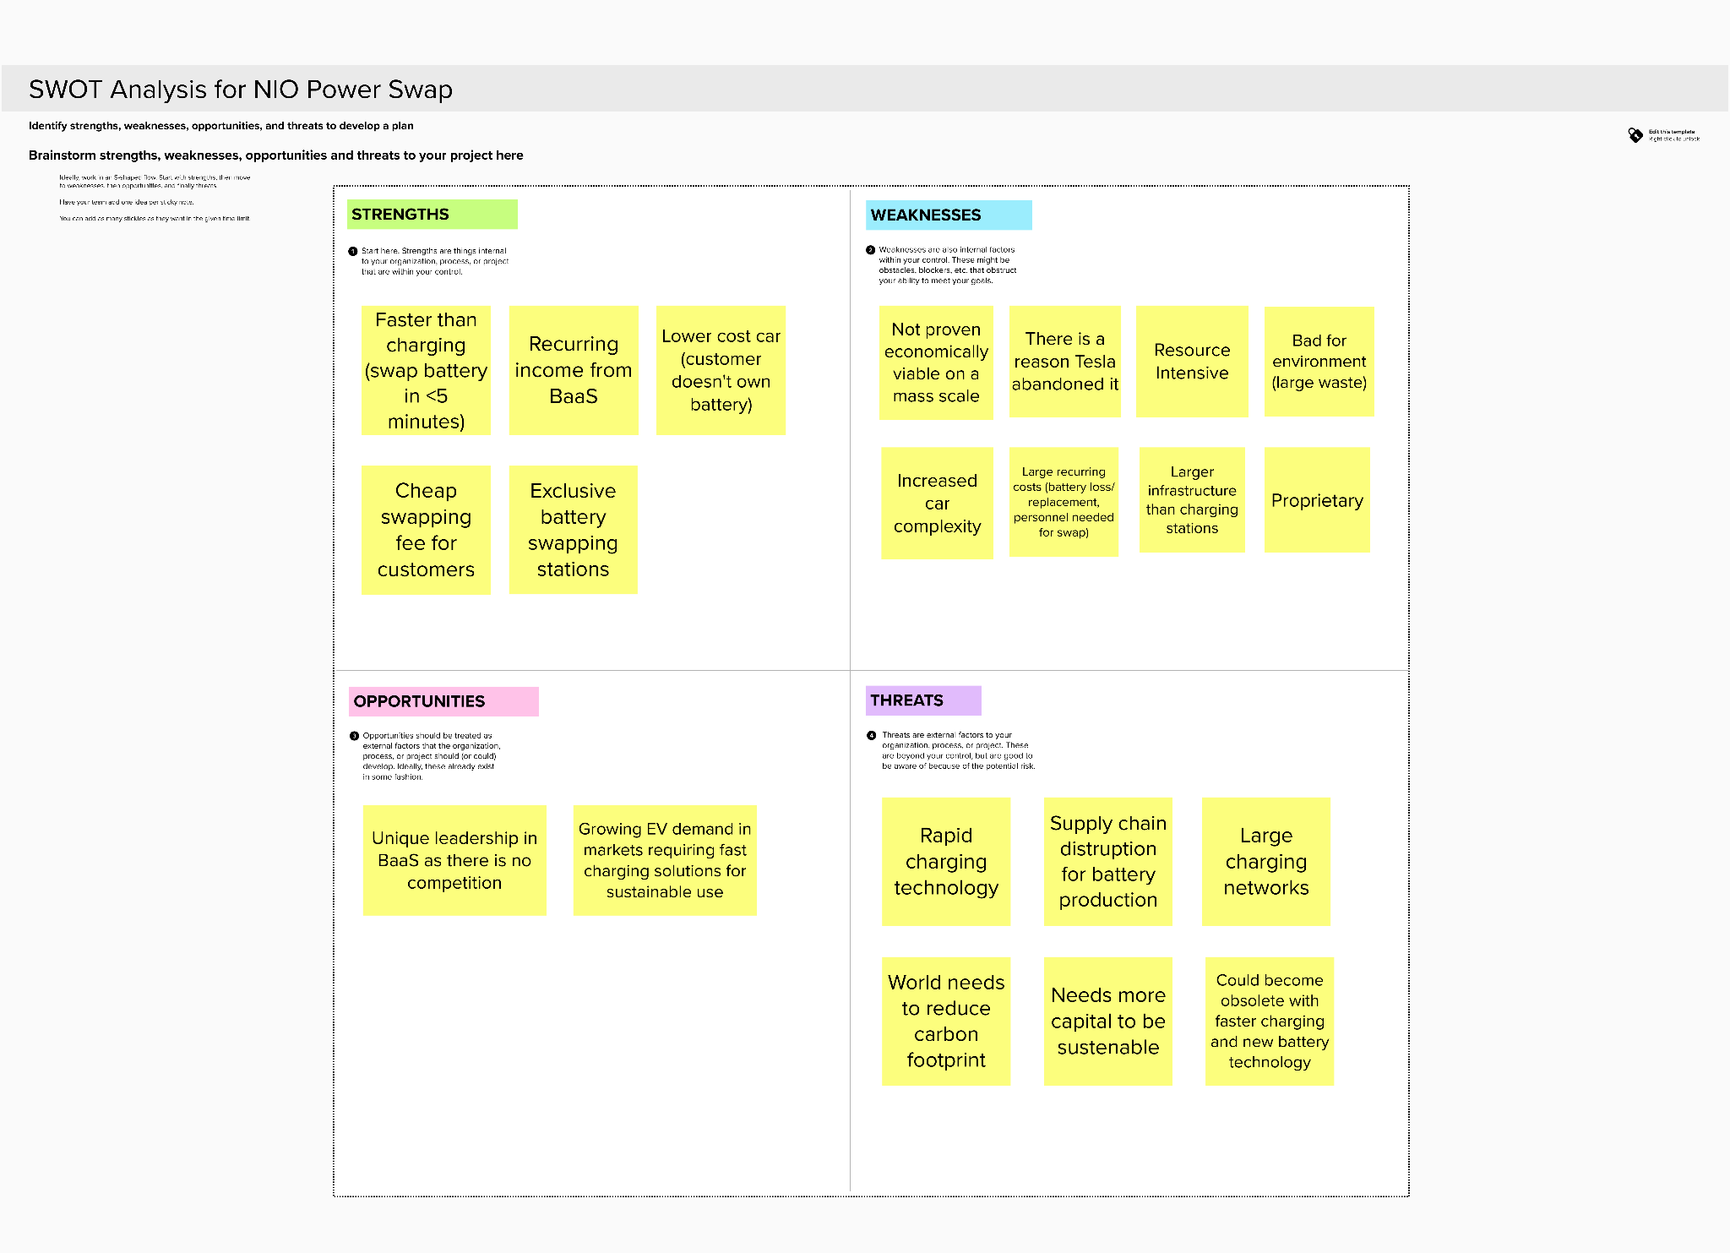

Please find the mural of the above SWOT analysis [here](https://app.mural.co/t/ghadasroom9330/m/ghadasroom9330/1645690366403/a79b6b822612cd33f4051b7f24b6ec770548a0b1?sender=u30c8daf8af50b7a86f155313).

# 

# Q5. Describe two major challenges NIO are faced with?

## Intense competition

NIO, still being a startup, faces intense competition from several well-established domestic and foreign Internet companies. The Android Auto by the Open Car Alliance aims to add infotainment capabilities to possibly any car. So, theoretically a car from any brand, which may or may not be electric, can add “smartness” using Android Auto, thereby improving user experience. This is in direct competition with NIO, which claims to be “providing smart vehicles and ultimate user experience”.

Waymo LLC also plans to enter the market by commercializing a driverless car in early December 2018.

Although Li often mentions that NIO is not the same as Tesla, yet Tesla is a direct competitor of NIO. Tesla has an edge over NIO simply because of its popularity and brand value, if not in terms of cost.

China’s domestic companies like Singulato, Xiaopeng Motors, CHJAutomotive, WMMotor, etc, had also started to invest, build factories, and launch Internet car products. SAIC has already adopted AliOS to create an Internet car and an industrial ecosystem.

The influx of many high-end players has made NIO’s market more competitive in a negative way. The entry of well-established local players like BAIC Group and BYD Auto Company Ltd into the market can be further detrimental to NIO, as they have years of careful planning, large network of dealers, and years of research on local consumers.

## Profit problem

Tesla, which is the world's most successful and well-known electric car company, has been in business for 15 years but has not been in any year yet (as of 2018).

Similarly, NIO hasn’t made any profits since its inception, and there are still doubts over it because of NIO’s comparison to Tesla. This is a challenge as it might affect the investors might turn pessimistic about NIO’s profitability in near future. To exacerbate this situation, Bin Li’s public speeches never gave a clear picture of the company’s profit model. Although NIO has already accumulated financing exceeding $2.2 billion, yet its requires more capital investment to address problems like mass-production capacity and independent production qualification.

Traditional car manufacturers were accelerating development, but NIO prioritized making a manufacturing platform first and then followed by value-added services. The company’s factories and mass production capacity couldn’t be established in the short term. Significant capital investment was needed to fix this issue in order to place NIO at a level where the market prospects will be brighter. Investing more capital will further affect the profit made and this affected the development of NIO.

In addition to this, the scheduled change in China’s policy for pure electric passenger vehicles will negatively affect the profits of NIO even further.

# Q6. What would you recommend NIO do to adjust its business model to enhance market competitiveness? Present at least two recommendations and explain.

**NIO should focus more on its core business**, which is making smart electric vehicles. As of now, apart from making smart electric cars, NIO tries to provide enhanced user purchasing experience with NIO House. In addition to this, NIO Life tries to take this one step further by designing products like backpacks, electric scooters, bottles, jackets, etc. They justify this by claiming to be a lifestyle company and not just an electric car manufacturer.

In our opinion, this shows lack of focus by the company. Their primary focus should remain building smart electric vehicles. Lifestyle items by NIO house and glorified showroom by NIO House can follow when the company has proved to be successful and profitable in the car business.

NIO should focus on releasing more vehicle models for different segments of the user base. By doing this, NIO can not only divert more attention towards its core product, but it can also hold its position in a market with rising competition and reach a wider user base.

**NIO should use its fund more appropriately.** As mentioned in the above proposed adjustment, NIO probably invests a lot of time and investor’s money in NIO House and NIO Life. A startup like NIO should use funds more appropriately in the core business which can drive it towards profitability. Rather, NIO continues to invest in NIO Power Swap even though its NIO’s supply chain needs significant capital infusion.

Power Swap, which is swapping battery instead of charging, has been historically a failure with companies like Tesla and Better Place. The CEO of a successful car company Renault had publicly declared that “power exchange mode has no future”. Yet, NIO plans to invest $300 million in power swapping.

We recommend NIO to ditch power swapping, and use these funds towards improving the company's independent product qualification and increasing factories and mass-production capacity to address supply-chain issues. This will help them address cost optimization, developing new products, and providing better subsequent services.

# 

# Additional items (done out of our own group’s interest)

Furthermore, we have created a SWOT out of our own interest for NIO’s current position in the market.

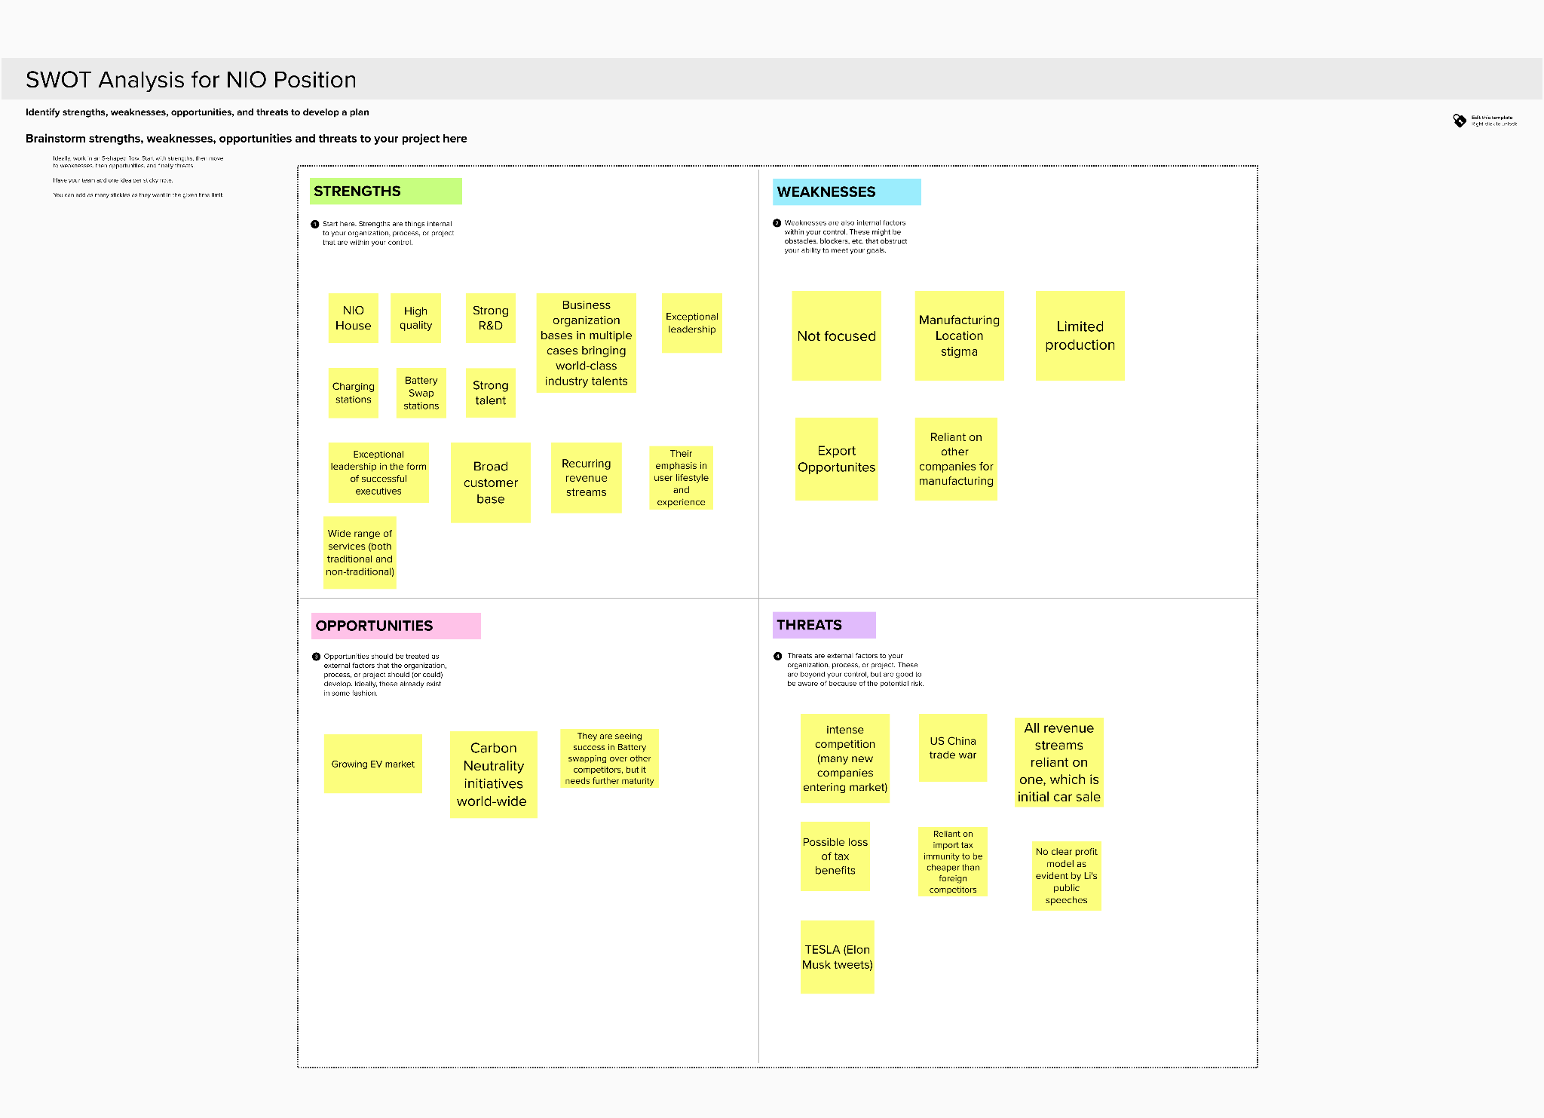

Please find the mural of the above SWOT analysis [here](https://app.mural.co/t/ghadasroom9330/m/ghadasroom9330/1646159763930/71c883008629e17a65086dfc5d44b716f1f38213?sender=u30c8daf8af50b7a86f155313).

**References**

Baldwin, R. (2020, August 21). *China's Nio Lets EV Drivers Swap Batteries in 5 Minutes, Hit the Road*. Car and Driver. Retrieved March 1, 2022, from https://www.caranddriver.com/news/a33670482/nio-swappable-batteries-lease/

Leggett, D. (2021, August 16). *Nio targets mass-market segment with new brand*. Just Auto. Retrieved March 1, 2022, from https://www.just-auto.com/news/nio-targets-mass-market-segment-with-new-brand/

Morris, C. (2021, June 8). *EV battery swapping: Better idea or big boondoggle?* https://chargedevs.com/newswire/ev-battery-swapping-better-idea-or-big-boondoggle/. https://chargedevs.com/newswire/ev-battery-swapping-better-idea-or-big-boondoggle/

Randall, C. (2021, October 26). *Tesla opens first R&D centre outside the USA in Shanghai*. electrive.com. Retrieved March 1, 2022, from https://www.electrive.com/2021/10/26/tesla-opens-first-rd-centre-outside-the-usa-in-shanghai/

Reicheld, F. (2019, September 5). *How Tesla Used a $0 Marketing Strategy To Dominate a Market*. Marketing Strategy. Retrieved March 1, 2022, from https://www.marketingstrategy.com/marketing-strategy-studies/how-tesla-used-a-0-marketing-strategy-to-dominate-a-market/

Shenvi, D. (2021, July 12). *NIO's business model & Ecosystem strategy*. The Strategy Story. Retrieved March 1, 2022, from https://thestrategystory.com/2021/07/12/nio-business-model-ecosystem-strategy/

Team, T. (2021, 12 3). *Should You Pick This Chinese EV Player Over Tesla?* Should You Pick This Chinese EV Player Over Tesla? https://www.forbes.com/sites/greatspeculations/2021/12/03/should-you-pick-this-chinese-ev-player-over-tesla/?sh=3c3a2e4614fd

*Tesla Owner Demographics by Age, Income, Gender, Home Value*. (n.d.). Hedges & Company. Retrieved March 1, 2022, from https://hedgescompany.com/blog/2018/11/tesla-owner-demographics/