ENGG 683 - Winter 2022

Final Project - EyeSea Analytics

April 3, 2022

Dr. Ghada Nafie

Allen Ndonwi Shu, Bhavyai Gupta, Drew Burritt, Michael Man Yin Lee, Thomas

Scott

# 

# **Table of Contents**

**1 - Social Media: the Problem & EyeSea’s Solution** **2**

**2 - Market Research** **3**

2.1 - Market Competitors 3

**3 - Surveying the Market: End User Profile** **4**

**4 - Quantifying Value Proposition** **6**

**5 - Competitive Advantage** **6**

5.1 - Technology Advantage 6

5.2 - Cost Advantage 7

5.3 - Time-Based Advantage 7

**6 - EyeSea Business Model** **7**

**7 - Key Business Model Assumptions & Risks** **8**

**8 - Minimum Viable Product** **9**

**9 - Financials** **12**

**10 - Conclusion** **14**

**11 - References** **16**

**12 - Appendix** **18**

12.1 - Survey Questions 18

12.2 - Interview Questions and Responses 18

12.2.1 - Interview Questions 18

12.2.2 - Interviews 19

12.3 - Value Proposition Mural Link 21

12.4 Business Model Mural Links 21

# **1 - Social Media: the Problem & EyeSea’s Solution**

Since its inception in the late 1980s and 1990s through the likes of IRC, MySpace, and Six Degrees, social media has become a ubiquitous and omnipresent part of the modern world. Everyone interacts with some form of social media on a daily (if not hourly) occurrence: media concerning friends and family is shared through posts and tweets; advertisement featuring social media links is produced for and seen via television and internet; and many stories of infamous individual escapades - particularly celebrity-centric - borne through social media material emerges everyday within the office, at school, or at the local get-together. Social media has become a key fixture of our lives, a presence whose impact can now be felt far beyond initial appearances.

The main challenge for many regarding current social media is its wide-ranging impact. Most social media users registered as teenagers or post-secondary students; personal pages and posts became the de facto method for communication otherwise done in person or over the phone, for discussing interests, airing grievances, and even engaging in acts of bullying or humiliation. Given social media’s digitization these records exist in near perpetuity, and since many of these social media users keep their personal pages and profiles public, their posting histories are available for anyone to search for and browse.

This can have serious consequences for many individuals, in both private and public. Secrets or regrets once kept hidden are now freely available for all to see, past involvements capable of being laid bare. While friendships falling apart over the reveal of such reputation damaging information is a concern for some, the larger threat is professional. As of 2018 over 70% of employers now actively screen a candidate’s social media history during their hiring process and nearly half of all companies actively screen their employees’ social media [1]. Should a candidate/employee make or display questionable and/or divisive material on their social media, it is not unlikely to see job opportunities squandered or careers ended due to lack of perceived professionalism. The personal nature of social media has therefore made it a complimentary check for companies after analyzing an individual’s resume and cover letters, a component of professional life which job seekers and career movers cannot reasonably ignore.

Given the significant impact of social media in the current job market, there is a strong need for it to be curated to maximize professional opportunities. Although easy to forego social media entirely, companies are increasingly basing hiring decisions on having social media presence, and links to deleted social media accounts can remain in search caches [2]; to lack it is to inhibit oneself in the job market. Yet paradoxically curating one’s social media can also be challenging - should an individual have an extensive online past it may prove impractical to personally comb through, find, and eliminate all potentially problematic material. A better, more efficient method is needed to help job hunters professionally curate their social media presence.

It is this need for better social media management where EyeSea comes into play. EyeSea will provide the management individuals may not be able (or have the time) to do. Through the use of automated software and machine learning AI it will identify all problematic or potentially damaging material across an individual’s entire social media presence. Such information will enable them to both know what a prospective employer can see and what they might consider removing to maximize their job opportunities. Furthermore, EyeSea will, if necessary, provide referrals to reputation management firms should an individual find the source of their troubles cannot be dealt with through their own accounts. Taken together EyeSea’s services will empower the average person to follow their dreams without the need to become their own social media guru.

# **2 - Market Research**

EyeSea’s main market segmentation focus is on young professionals (including students) who are active users of social media. As many as three times more users of social media are under the age of 40 than over, with many below the age of 40 also being the most active in terms of partying and clubbing [3, 4]. For these individuals social media has become a significant part of their lives, using it to express themselves and connect with others. The ubiquity of social media concomitantly induces pressure to conform. Younger users are often encouraged through peers to post material others will approve of, whether for friendship or affirmation. Transition from high school to post-secondary institutions especially promotes this behaviour, where otherwise inappropriate partying, drinking, and other “dumb” activities is commonplace and social media provides the vehicle through which to share and promote them [5].

While acceptable for individuals at the time, many employers are unlikely to view such material the same way during screening and interviews. The rise of social media use has seen employers increasingly conduct social media background checks, whether in-house or through the use of third party agencies [6]. Should a young job hunter’s social media history, either in direct posts or in tagged content, prove unsuitable to an employer’s desired persona, it could deprive the job hunter of potential job opportunities.

It is this particular market segment which EyeSea’s value proposition and business model will focus on. The current reputation management market (of which social media is a part) is estimated to be ~$240 USD, with the social media market likewise estimated to be $223 billion USD with a 23.7% compound annual growth rate [7, 8]. EyeSea will primarily compete within the reputation management market, and it is anticipated EyeSea will capture 0.1% of the market (~$240,000 USD) owing to its more cost-efficient, information-only service compared to contemporary reputation management services.

## **2.1 - Market Competitors**

Social media reputation management is one part of a larger reputation management market. Within this market fierce competition currently exists owing to the prevalence of online-based companies including Igniyte, Webimax, GuaranteedRemovals, NetReputation, ReputationManagement.com, and Reputation.ca. What defines these companies are their clientele. Current reputation management companies primarily service organizations, businesses, or high status individuals (e.g. politicians, celebrities); their services are intended to both identify and eliminate problematic information across all communication avenues. These companies also help in generating positive content along with search engine optimization to ensure favourable results outweigh any potentially problematic information.While these companies technically provide their services to individuals like young professionals, the associated costs are often prohibitive and thus limit their effective use. Given how these competitors have structured their operations and who they tailor them for, EyeSea has the opportunity to outcompete them in the young professional market segment by offering a broad, cost-effective means of reputation management.

# **3 - Surveying the Market: End User Profile**

To better gauge the market potential discovered from research and likely users of EyeSea, a dual survey-interview process was conducted to verify and/or adjust all aspects of the proposed social media service. The survey (refer to Appendix 12.1 for used questions) was circulated online via Reddit (r/Calgary and r/UCalgary) and professional Slack and WhatsApp channels used by each team member and conducted over two weeks. A total of 66 responses were obtained during this period. The people surveyed were mostly young adults in university or recent graduates. 60% percent of the people said they would use a service that compiled social media posts into one report. 65% of people said they would prefer a service that highlighted posts that are potentially problematic. Of people identifying willingness to pay for such a service, 65% said they would pay between $1-10 CAD per report, and 27% willing to pay $10-25 CAD. It was determined that the most popular social media platforms were (from most to least popular) Facebook, Instagram, LinkedIn, and Twitter. When people were asked to rate their awareness of their post history, only 24% said they know everything they have posted. When asked about other people's posts that they appear in, or that mention them, only 18% said they knew every post. 42% of people said that they never review their social media, and 9.1% said they only do it once a year. Only 24% said they do it once a month or more. However 91% said they post more than once a day.

When asked about what types of posts people remove when going through their social media, the most common ones were alcohol or drug related, controversial opinions, rants, and pictures of partying. Only 42% of people said they have never gone back and deleted a post because it could be seen poorly by someone else.

This market research demonstrates that there is a need for EyeSea. The majority of people have previously deleted posts because of their content. However people are often unaware of these posts and have forgotten about or do not know they remain. People post things in the moment and do not think about its effect, and also review such material very infrequently.

Additionally 15 individuals who participated in the survey were requested to be interviewed for further insight into market needs. Of these five individuals granted permission with all obtained responses (with publication permission) and interview questions contained in Appendix 12.2.

The totality of survey and interview data both led to the creation of the following end user profile:

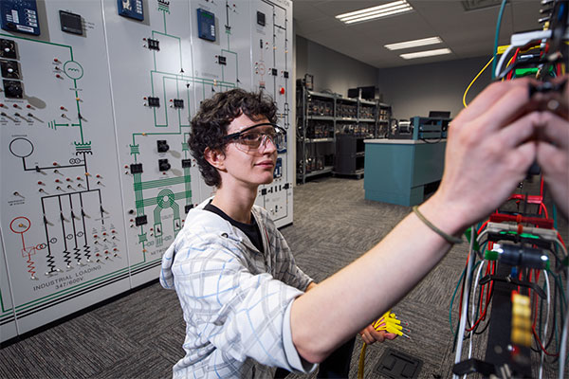[9]

Name: John Doe

Title: Electrical Engineer in Training

Age: 25 years old

Family: Parents, younger sibling

Education: Bachelors of Engineering (Electrical)

Personal & Professional Priorities

* Acquire enough experience to obtain Professional Engineer designation and licensure.
* Find a suitable, long-term job with good career advancement opportunities and benefits.
* Develop a professional CV and contact base appropriate for electrical engineers.
* Provide optimal and efficient electrical designs for company clients.

Needs & Pain Points

* Always stressed about how employers and industry leaders perceive his work.
* Hard-pressed to keep track of what all he has presented on various professional networking tools and apps.
* Works long hours, often with tight deadlines and demanding project requirements
* Has some trouble maintaining a proper work-life balance and separating his private life from his public life.

From this end user profile a general outline of potential EyeSea users is obtained. The average consumer is relatively young and professionally focused. They are hard workers with heavy demands, often having little time to devote to matters outside their immediate work schedules. Given their high-stress environment, these consumers are professionally conscious, aware of anything which may negatively affect them and concerned over potential surprises. They would therefore be most open to using EyeSea as it enables them to quickly and efficiently manage their social media presence without requiring major effort or learning a new technology.

# **4 - Quantifying Value Proposition**

The value proposition of EyeSea was formulated through an interactive Mural canvas identifying both its overall value and the value it provides to the consumer. Mural link to the canvas is found in Appendix 12.3 with summary as follows:

EyeSea’s customer segment is primarily young and professional. They are seeking well-paying jobs and are concerned about how their online presence can influence this desire. These customers want to know what their online presence is so they can effectively manage it. EyeSea answers this through its automated social media search engine. It analyzes social media through machine learning to identify problematic material and outputs a report specifying what such material exists and where it can be found. Such functionality will enable the customer to quickly manage any social media issues.

The primary customer pains are cost and anonymity. Being a junior professional the customer wants a cheap yet effective service, particularly in terms of time. Likewise they want to ensure their use of such service is known only to them and (ideally) as thorough as potential background checks. EyeSea relieves these pains by being automated and cost-effective. It requires minimal human involvement and outputs strictly to the customer, ensuring only the customer is aware of them ever using EyeSea. As EyeSea also leverages machine learning it provides as detailed an analysis of social media as any background check, ensuring nothing will be missed. Moreover, EyeSea is a tiered service, with users able to purchase one-time reports differing in degree of search (e.g. images) or subscribe for monthly reports if desired, further optimizing costs depending on exact customer need.

What the customer hopes to gain is security and confidence. They want to know their social media presence is clean and professional with no risk of surprise during interviews. EyeSea meets these gains by ensuring all problematic social media material is found and explicitly identifying where it is for the customer. Furthermore should the customer be unable to remove any problematic material themselves (or simply unwilling), EyeSea can offer recommended action plans via referrals to reputation management companies devoted to material takedown.

# **5 - Competitive Advantage**

As EyeSea is a reputation management service, its competitors are other reputation management companies. Based on the value proposition above, the competitive advantage EyeSea has compared to them can be organized into three categories: technology advantage, cost advantage, and time advantage. The specific advantages EyeSea has in these categories is described below using potential competitor Reputation.ca as a comparison [10].

## **5.1 - Technology Advantage**

Potential competitor Reputation.ca manually conducts all its services. It requires the user to manually find and report all search results found troublesome, with Reputation.ca then taking action to see those results removed. This approach relies on the content’s search engine optimization (SEO): if the content is not found in a manual search, it is likely missed.

EyeSea’s solution is automated. Using machine learning models all troublesome content is identified and reported with high accuracy, ensuring both that little is missed and that human intervention is not required. Furthermore, EyeSea uses automated signup and verification systems to verify all user documentation and provide user reports, ensuring the user can have their needs met as quickly as possible.

## **5.2 - Cost Advantage**

Owing to potential competitor Reputation.ca removing troublesome material, it charges $2500-5000 CAD to suppress each user-identified item. Users can choose how many items Reputation.ca acts to suppress, but suppression is inherently expensive.

EyeSea offers a significantly cost-effective solution. Given EyeSea’s automated nature, operating cost is lower due to minimal human involvement and human resource needs. Likewise as EyeSea primarily identifies troublesome material exclusively (with removal left to the user or affiliate partners) cost for use is further reduced, with EyeSea’s most cost-efficient tier being only $5 CAD.

## **5.3 - Time-Based Advantage**

Potential competitor Reputation.ca does not execute its services quickly. Owing to the need for actual content takedown (which may in certain instances involve lawsuits) Reputation.ca users may not see results for days or weeks. Moreover given Reputation.ca relies heavily on human resources extra time is also required to meet customer needs.

EyeSea, being fully automated, can provide its service quickly. Data analytics can read all necessary material within a workday, ensuring all EyeSea users receive their reports within 24 hours of purchase.

# **6 - EyeSea Business Model**

EyeSea’s business model was developed collaboratively via a Mural canvas (refer to Appendix 12.4 for business model and lean business model Mural links). The following summarizes the overall business model and structure:

EyeSea will deliver value through two key channels: mobile app and website. Given this service is concerned with social media, it was deemed essential that EyeSea be easily accessible from both phones and computers given their extensive use in reading and generating social media. The service will be primarily automated, with customers self-serving through automated search algorithms and report generation, and as specified is geared towards young professionals seeking quick and effective social media management solutions.

Costs associated with operation are therefore primarily hosting and development related. EyeSea will need sufficient server capacity to meet customer needs and also sufficient human support for any customer assistance when required. Likewise, EyeSea will see continued software evolution over its lifespan as search algorithms are improved, coding is rationalized, and social media information is acquired, requiring continual research and development.

To offset these costs EyeSea will employ three revenue streams. First will be one-time report sales whereby the customer can pay a one-time fee for use; this service will be tiered with higher costs yielding more search options. Second will be subscription whereby the customer can receive monthly reports, with similar tiered options yielding additional search options. Third option will be revenue sharing with affiliate partners in reputation management whereby EyeSea obtains revenue from forwarding potential clients to them.

Key components for EyeSea will be its affiliate partnerships and hosting/access allowances (e.g. cloud hosters, social media groups granting API access). Other specific key resources include a helpdesk and automated chatbot (for customer support). All listed requirements are necessary to meet EyeSea’s key activities of autonomous, data analytic-driven social media analysis and automatic report generation.

# **7 - Key Business Model Assumptions & Risks**

The two key assumptions regarding EyeSea’s proposed business model stem from the key partners involved. As EyeSea will search through a customer’s entire social media footprint, the service requires access to various social media platforms for effective searching. Although capable of searching through basic web scraping, such activity is often inefficient and (depending on website allowances) illegal. Application programming interface (API) frameworks are the conventional means for such searches, of which all social media platforms offer for free to varying degrees.

EyeSea’s first assumption is that its use of these APIs will be within their associated website’s established guidelines. Facebook for example provides a free API framework for querying information, images, and videos, however also restricts its use, limiting users to 200 API calls per hour per searched name. While not problematic at this stage, as EyeSea scales such restrictions could become onerous, especially for customers with extensive social media histories. This assumption can be freely tested in one of two ways, either through a simple stress test using sample social media accounts of varying history sizes, or streamlining API calls to minimize the total number of calls made (e.g. bundling data queries together to lower API usage). At worst EyeSea will require paid API access to ensure expected service is maintained.

The second key assumption is the willingness of reputation management companies to form affiliate partnerships with EyeSea. Given one revenue stream relies on affiliate partnership kickbacks through client forwarding, any refusal on the part of these companies will negatively affect both the financial viability of EyeSea and its ability to grow a customer base (as EyeSea begins without a dedicated base). This assumption can specifically be tested through generating a customer growth forecast. By approaching reputation management firms with this forecast and EyeSea’s business model an understanding of affiliate interest can be acquired, albeit slowly given time required to develop a proposal and contact potential partners. At worst EyeSea will not find any affiliate partnerships, requiring business model adjustments (e.g. tier pricing changes) to ensure profitability is maintained.

# **8 - Minimum Viable Product**

As part of this report a simplified website has been deployed as a minimum viable product (MVP) to show what EyeSea can look like in practice. The website can be found at [https://www.eyesea.ml](https://www.eyesea.ml/).

Website use is as follows:

To look at sample reports and the user panel, click register at the top of the homepage.

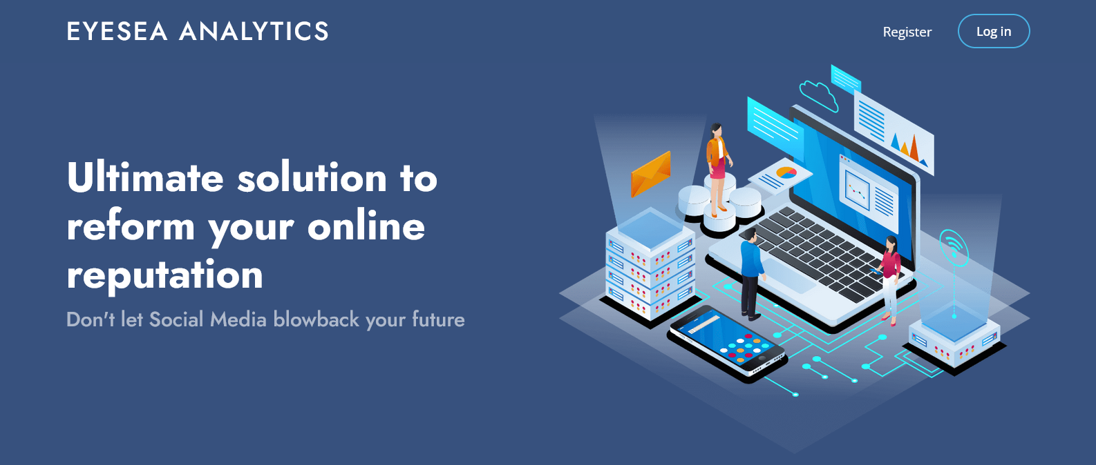

The user can then select one of three tier plans and register for an account. For the purpose of this MVP, fake or dummy information can be used:

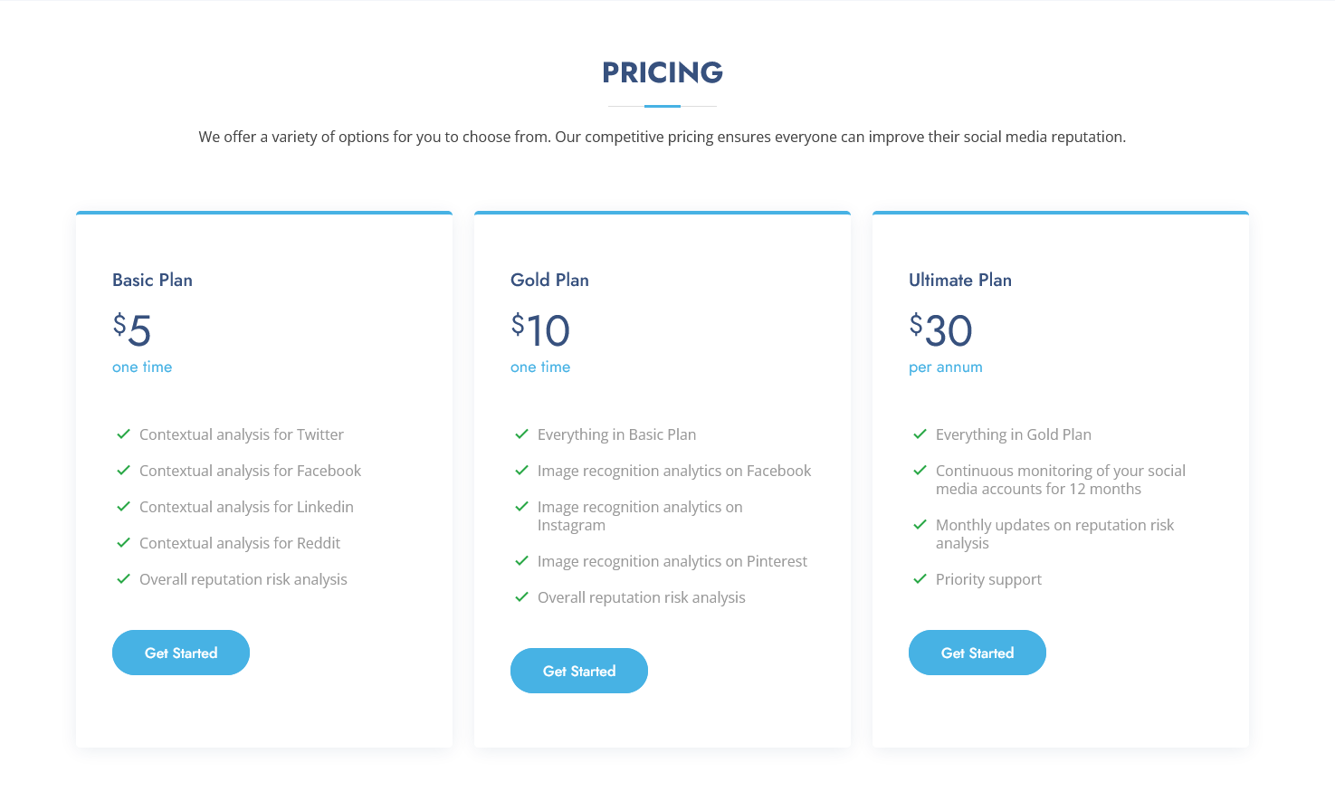

After successfully registering with the desired plan and logging in, the following options will be available for the user: “View Reports”, “Buy More Reports” (or “Top Up Account” if on the Ultimate Plan) and “Profile”:



“View Reports” contains a list of all purchased reports, either through one-time payments or through annual subscription. For this MVP one basic and one gold report are provided as samples. Report details can be viewed by clicking on the relevant report “Details” button:

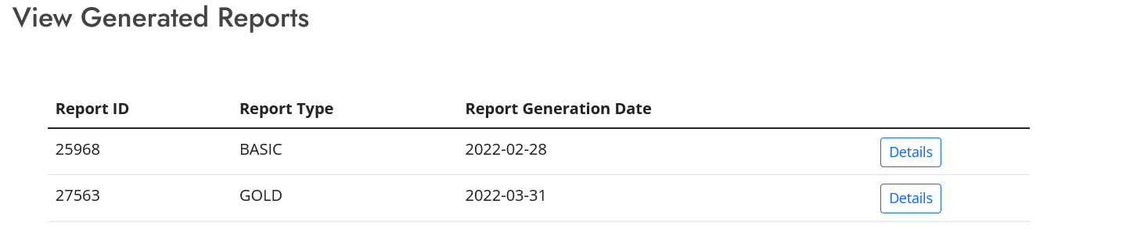

Viewing the sample basic report details will return the following:

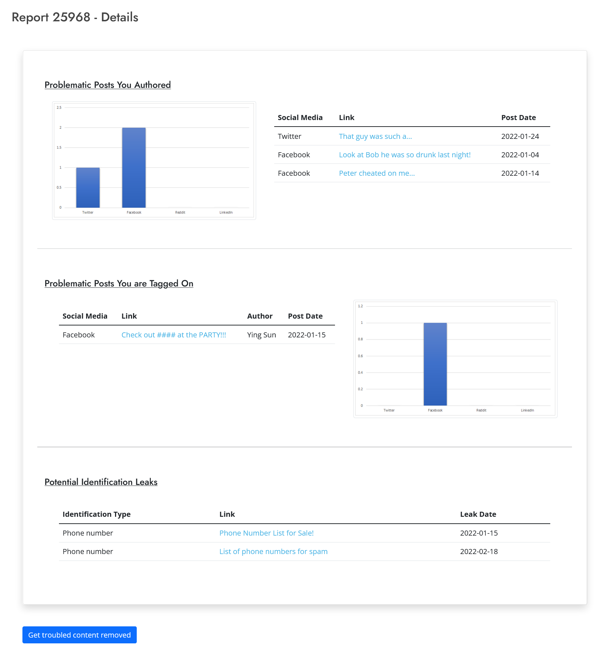

The user profile with all registered info can likewise be viewed by clicking on Profile in the top navigation bar:

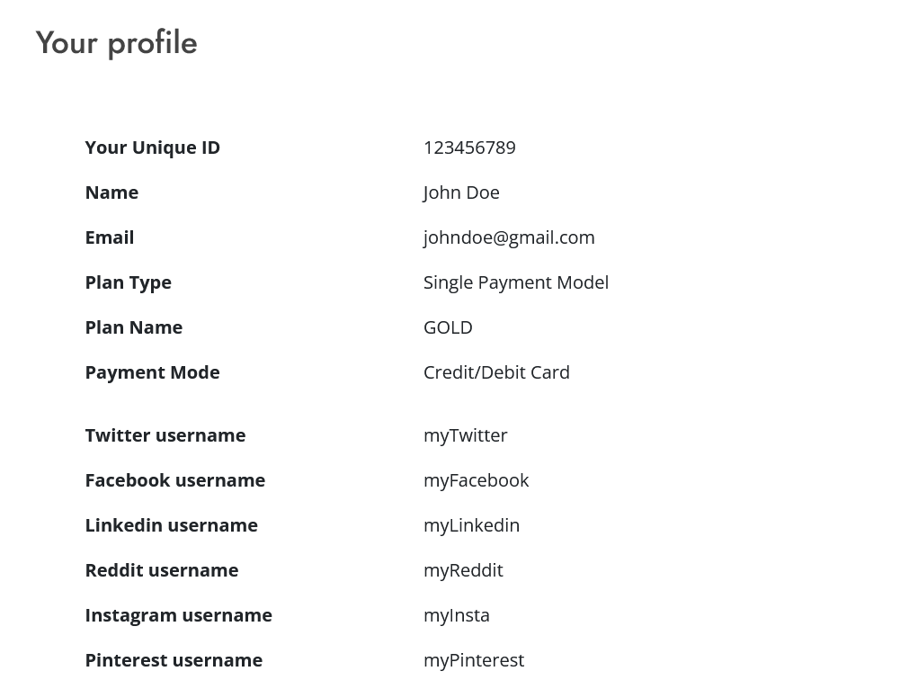

# **9 - Financials**

EyeSea’s financial projections initially assume 20,000 units of basic reports ($5 CAD each), 15,000 gold reports ($10 CAD each) and 1,000 subscriptions ($30 CAD per yearly subscription) are sold during the first year. It is further estimated that 1% of the report and subscription sales are converted into affiliate revenue under the assumption that 1% of the customers will pay for partnered reputation management services.

Owing to EyeSea’s framework, payment processing fees are the only cost of goods sold. This service will use Stripe as payment processor with cost of service being 2.9% of transaction amount, plus $0.30 CAD per transaction. Total cost for goods sold will therefore equate to $19,001.20 CAD.

Other operating expenses include hosting, general & administrative, advertising & marketing, and repair & maintenance. EyeSea’s platform (including both front end and analytics back end) will be hosted on Google Cloud using N2 Standard Machine Type (2 cores) costing $70 CAD per month ($838.59 CAD per year) [11]. Website domain cost will be $20 CAD per year [12], resulting in a total hosting cost of $860 CAD per year. It is anticipated more powerful hardware will be needed as user number increases, however Google allows for automatic scaling to workload, ensuring only the required amount of computational power is purchased.

General and administrative fees will consist of: $450 CAD business registration, $1,500 CAD corporate tax filing, $84 CAD for a virtual office with mailbox, $228 CAD for a business bank account, and $15 CAD per hour ($31,200 CAD per year) for a full-time virtual assistant, totalling $35,496 CAD per year [13, 14, 15, 16]. Basic social media management services will also be used for advertising and marketing, totalling $340 CAD per month ($4,080 CAD per year) [17]. Routine platform maintenance and bug-fixing will be funded through a $20,000 CAD compensation assignment to an EyeSea cofounder.

In terms of non-operating income, it is assumed EyeSea will successfully obtain $170,000 CAD in funding from the Industrial Research Assistance Program owing to this service’s unique commercialization of data-analytics technology advancing the reputation management industry [18]; it is assumed this funding will cover all business expenses including software development costing $100,000 CAD and an estimated business income tax rate of 38% [19].

The complete Profit and Loss Statement for first year of the business is provided below:

| **EyeSea Analytics** | | | | | |
| --- | --- | --- | --- | --- | --- |
| **Profit & Loss statement** | | | | | |
| *For one year ending April 1st, 2023* | | | | | |
|  | | | | | |
| **REVENUES** | | | | | |
| Basic Report Sales | | | | $100,000.00 |  |
| Gold Report Sales | | | | $150,000.00 |  |
| Subscription Sales | | | | $30,000.00 |  |
| Affiliate Revenue | | | | $2,800.00 |  |
| **Total revenues** | | | |  | **$282,800.00** |
|  | | | | | |
| **EXPENSES** | | | | | |
| **Cost of Goods Sold** | | | | | |
| Payment Processing | | | | $19,001.20 |  |
|  | | | |  | **$19,001.20** |
|  | | | | | |
| **Gross Profit** | | | |  | **$263,798.80** |
| Gross Margin (%) | | | |  | **93.28** |
|  | | | | | |
| **Operating expenses** | | | | | |
| Hosting | | | | $860.00 |  |
| General & administrative | | | | $35,496.00 |  |
| Advertising and marketing | | | | $4,080.00 |  |
| Repair and maintenance | | | | $20,000.00 |  |
| **Total operating expenses** | | | |  | **$60,436.00** |
|  | | | | | |
| **OPERATING INCOME** | | | | | **$203,362.80** |
|  | | | | | |
| **NON-OPERATING ITEMS** | | | | | |
| Non-operating income | | | | | $170,000.00 |
| Non-operating expenses | | | | | $100,000.00 |
|  | | | | | |
| **EARNINGS BEFORE TAXES** | | | | | **$273,363.00** |
|  | | | | | |
| **INCOME TAXES** | | | | | **$103,877.86** |
|  | | | | | |
| **NET INCOME** | | | | | **$169,484.94** |

# **10 - Conclusion**

Social media has become a common component of modern living. Thanks to the ability of social media to share and store any and all personal experiences, individuals often display information on it which can prove troublesome or otherwise unprofessional. As employers increasingly turn to social media to gain a better understanding of employee candidates, young professionals are rightfully concerned their pasts may unduly influence their job prospects. EyeSea offers the ideal solution for these individuals. By using cutting-edge data analytics technology to analyze social media histories efficiently and cost-effectively, EyeSea enables worried job hunters to quickly scan their digital pasts and identify any problematic material before their would-be employers do. With current reputation management firms focused more on high end clientele, EyeSea therefore provides an ideal service to the general public and helps bridge the gap between posting on social media and managing it.

EyeSea Analytics benefits investors by:

* Allowing investors to align with an innovative leadership team that are leaders in the data analytics and software engineering industry.
* Helping the new generation of young professionals job searching with confidence without the fear of being jeopardized by their social media history.

Together, the reputation management industry can be transformed with the new data analytics platform of EyeSea Analytics. If you share the vision of a better social media future, invest with EyeSea.

# **11 - References**

[1] CareerBuilder, “More Than Half of Employers Have Found Content on Social Media That Caused Them NOT to Hire a Candidate, According to Recent CareerBuilder Survey,” Prnewswire.com, Aug. 09, 2018.

https://www.prnewswire.com/news-releases/more-than-half-of-employers-have-found-content-on-social-media-that-caused-them-not-to-hire-a-candidate-according-to-recent-careerbuilder-survey-300694437.html [Accessed: 01-Apr-2022].

[2] S. Driver, “Social Media Screenings Increase for Job Seekers,” Business News Daily, Mar. 23, 2020. https://www.businessnewsdaily.com/2377-social-media-hiring.html [Accessed: 01-Apr-2022].

[3] “Social Media Infographic: How different age groups interact online: Alex White: Social Media Infographic, Social Web, online infographic,” Pinterest, Oct. 23, 2012. [Online]. Available: https://www.pinterest.ca/pin/33354853461641790/. [Accessed: 01-Apr-2022].

[4] Published by S. Lock and N. 19, “Pub, bar and club goers by age in England 2018,” Statista, Nov. 19,2020. [Online]. Available: https://www.statista.com/statistics/557584/going-to-pubs-bars-clubs-by-age-uk-england/. [Accessed: 01-Apr-2022].

[5] M. Anderson and J. Jiang, “Teens and their experiences on social media,” Pew Research Center: Internet, Science & Tech, Nov. 28, 2018. https://www.pewresearch.org/internet/2018/11/28/teens-and-their-experiences-on-social-media/ [Accessed: 01-Apr-2022].

[6] “Social Media Background Checks [A Guide],” www.screeningcanada.ca. https://www.screeningcanada.ca/blog/social-media-background-checks [Accessed: 01-Apr-2022].

[7] R. and M. ltd, “Online Reputation Management Services Market Research Report by Service Types, by End Users, by Region - Global Forecast to 2027 - Cumulative Impact of COVID-19,” www.researchandmarkets.com. https://www.researchandmarkets.com/reports/5234041/online-reputation-management-services-market [Accessed: 01-Apr-2022].

[8] “Social Media Market Analysis, Size And Trends Global Forecast To 2022-2030,” www.thebusinessresearchcompany.com. https://www.thebusinessresearchcompany.com/report/social-media-global-market-report#:~:text=The%20global%20social%20media%20market [Accessed: 01-Apr-2022].

[9] SAIT, “Electrical Engineering Technology,” www.sait.ca. https://www.sait.ca/programs-and-courses/diplomas/electrical-engineering-technology-daytime [Accessed: 01-Apr-2022].

[10] “Reputation Management Landing Page,” GuaranteedRemovals.com. https://guaranteedremovals.com/reputation-management-lp [Accessed: 01-Apr-2022].

[11]“All pricing | Compute Engine Documentation,” Google Cloud. https://cloud.google.com/compute/all-pricing [Accessed: 01-Apr-2022].

[12] Godaddy.com, 2022. https://ca.godaddy.com/domainsearch/find?checkAvail=1&domainToCheck=eyesea [Accessed: 01-Apr-2022].

[13] “How Much Does It Cost to Incorporate in Canada?” https://www.thebalancesmb.com/how-much-does-it-cost-to-incorporate-in-canada-2948228 [Accessed: 01-Apr-2022].

[14] “How Much Does an Accountant Cost? | Kinden CPA.” https://www.kindencpa.ca/outsourcing-accounting-operations-the-benefits-and-cost/ [Accessed: 01-Apr-2022].

[15] “Virtual Office.” https://www.anytimemailbox.com/offer/virtual-office [Accessed: 01-Apr-2022].

[16] “Every Day Business Bank Account Plans | TD Canada Trust.” https://www.td.com/ca/en/business-banking/small-business/bank-accounts/every-day-business-plan/ [Accessed: 01-Apr-2022].

[17] “Social Media Pricing | Social Media Marketing Costs - 2021”. [Online]. Available: https://www.bark.com/en/ca/social-media-marketing/cost-of-social-media-marketing/ [Accessed: 01-Apr-2022].

[18] “Top 5 Startup Grants in Canada | Liftoff Capital”. [Online]. Available: https://liftoffcapital.com/blog/startup-grants-for-canadian-businesses [Accessed: 01-Apr-2022].

‌[19] “Corporate Income Taxes in Canada: Revenue, Rates and Rationale ...”. [Online]. Available: https://hillnotes.ca/2021/11/02/corporate-income-taxes-in-canada-revenue-rates-and-rationale-2/ [Accessed: 01-Apr-2022].

# **12 - Appendix**

## **12.1 - Survey Questions**

1. Do you consider your social media when applying for jobs?
2. Do you have concerns about your past when applying for jobs? If so, what are they?
3. How often do you review your social media posts and what criteria do you use? How do you review them?
4. What do you consider before making posts on social media?
5. Would you show a potential/current employer your social media if requested?
6. Do you use multiple accounts on the same platform? If so, why? Do you post different things on each?
7. Would you use a service that compiled/tagged your posts? If so, would you prefer a service which compiled/tagged problematic or divisive posts?
8. How much would you pay for such a service?
9. How often do you review social media posts that your social media handle is tagged in?
10. How aware would you rate yourself on what other people are posting about you on social media?

## **12.2 - Interview Questions and Responses**

### **12.2.1 - Interview Questions**

1. When looking for a job or any other time someone might ask about your history, could you explain how you review your social media? Such as updating linkedin, cleaning up old posts.
2. How often do you go through your entire social media history, such as your Facebook timeline? Would you say you’re familiar with everything you may have posted, or could there be posts you may have forgotten about?
3. What information would help you the most in gauging your online reputation?
4. Do you apply to jobs using social media like Linkedin?
5. Has any of the employers asked you for your public social media handles, during job application form and/or during interviews?
6. Which social media handle was asked?
7. Do you feel comfortable in sharing your social media handles with potential employers?
8. If uncomfortable, then why? How can you mitigate that discomfort?
9. Do you check all the posts of your social media friends? Could there be some posts of concern about you?

### **12.2.2 - Interviews**

Interviewee 1 is a recent graduate from the Electrical Engineering program at the University of Calgary and is currently looking for an electrical engineering job.

Here are his responses:

1. Well, I will try to update Linkedin with my latest information and signal in my profile that I am looking for work.
2. I would say I never go through my social media history. I have LinkedIn, Facebook, Instagram…. You name it. I post content whenever I feel like it and I have a busy life. Life is short, I cannot possibly spend my time just reviewing the stuff that I post.
3. I guess flagging stuff that may get me in trouble would be a start. I just don't want to stare at my phone for hours just to look at old stuff.
4. Yes, I use Linkedin and Indeed for my job hunting.
5. Nope and if they do ask I will just refuse. To me it will be a red flag if they ask me such questions.
6. Nope, there might be posts about me, but I am not aware of those.

Interviewee 2 is a third year chemistry major at the University of Calgary. They are considering applying for a co-op position over the summer with an interest in post-grad research.

Here are his responses:

1. I don’t really consider my social media when applying for work, it has never come up before. Always thought employers never really considered it, though I guess they might since some people have their entire lives on it.
2. Not too often, I stay more involved with recent posts. I definitely have forgotten some stuff I posted in the past, especially high school!
3. Anything that would highlight or flag bad I have directly posted, maybe even a system which would do the same for other people’s posts; cannot imagine some people looking at my Twitter page would be thrilled seeing awkward or bad retweets.
4. Not right now, been focused a lot on the University’s career pages since the work I’m looking for posted there. I will probably consider LinkedIn more once I’m searching for post-doc positions.
5. Nope, no one in previous jobs has ever asked me for that. I would be alright with sharing my handles if asked, but no more - heard of some horror stories about employers asking for account passwords, would definitely not go that far.
6. Wouldn’t say I check all of them, but I stay up to date with what they’re doing. Also nothing they’ve posted has stood out to me in a bad way, but I cannot deny there probably was stuff in the past which I found troublesome and since forgot about.

Interviewee 3 is in the second last year of his 5 year bachelor’s program and is doing double major in software and finance at the University of Calgary. He is looking for a summer internship with a software development firm.

Here are his responses:

1. Yes I keep my LinkedIn profile updated when I am applying to any kind of position or roles. The updates I make on my LinkedIn profile are related to education, my previous internships, and my projects.
2. I have a Facebook account, but I don't use it anymore. Besides LinkedIn, I only use Instagram. However, I don’t remember what I had liked, commented, or shared on Facebook or on Instagram. I use Instagram quite often, so going through the entire social media history is impractical.
3. I think, knowing some of the controversial posts with which I interacted. Or maybe I unknowingly shared some news article that later turned out to be fake.
4. Yes, I use LinkedIn to apply for jobs.
5. Yes, many times I have been asked to share my Linkedin profile and GitHub profile with the employers. Some employers even ask to share my own portfolio website to gauge my technical skills.
   1. All my social media profiles like Linkedin, Instagram, (including now inactive Facebook) are public anyways, so anyone can search me on google and they might link to one or more of my social media profiles. So, I am comfortable sharing my social media profiles with employers. But yes, I don’t think that a software development company would ask for a social media handle other than LinkedIn. If they ask for any other social media handle other than LinkedIn, I would ask them why they need it. Anyways, I will be okay with sharing it with them.
6. I have a big friend circle and I have been tagged a lot by my friends. But I don’t think there is anything concerning about it.

Interviewee 4 is in the last year of her 4-year Bachelor program in business administration at SAIT. She has just started an internship in an HR position.

Here are her responses:

1. I Look through my public profiles and delete any unrelated or old posts. I also make sure LinkedIn is up to date.
2. I usually review it about once a year, there are definitely some old posts that I forgot about on sites like Facebook.
3. It would be nice to have everything in one place. It would also be nice to have an easy way to see what other people see on profiles, such as without hidden posts.
4. Yes, I use LinkedIn and Indeed when applying to jobs.
5. I have not been asked to share them; However I would share if asked but only public ones, like LinkedIn and Facebook. All my other accounts are private. While I would share them, it would make me uncomfortable. I think they should focus more on me and how I present myself and less on my social media. It would be better if I knew everything posted and knew there was nothing I had to worry about, such as an old post I forgot about.
6. No, I don’t as I have a lot of people on social media. I do check posts that I am tagged in. It's possible there may be some of me drinking with friends that could be concerning.

Interviewee 5 is a new Mount Royal University art student. They are unsure if they will remain in their program, but are confident they want to pursue work in the private sector following graduation.

Here are their responses:

1. I have never reviewed my social media when applying for a job, in fact I rarely review it at all! Only time I even consider deleting something is if I immediately regret posting it or someone mentions something, just a thing that doesn’t cross my mind.
2. As said I don’t really review my social media, I don’t see much point to go through it outside of reminiscing or looking up friends. Probably there is stuff in there I have forgotten about, but nothing I’m worried about!
3. Anything that indicates if what I’ve posted or liked is bad in some way. I don’t try to make or approve of such things, but you never know what some might consider offensive. Better safe than sorry.
4. Nope never have, never have had the need to. Probably will change in the future though as I know it’s what a lot of people use in place of a resume.
5. Nope never have, all the jobs I’ve had only required resumes. Wouldn’t be surprised if some companies do want them now though considering how much stuff you can find with it.
6. Well not all the posts, but definitely a good chunk of them. There has been stuff they’ve posted which I guess you could call concerning, but nothing I think is really bad, just jokes and what not. Probably the thing someone doesn’t like though so wouldn’t surprise me if it’s the sort of material that gets flagged.

## **12.3 - Value Proposition Mural Link**

Value Proposition Canvas Link:

<https://app.mural.co/t/ghadasroom9330/m/ghadasroom9330/1648884881622/724581894283dfaf60c8f6bf4118340a673a47cf?sender=u30c8daf8af50b7a86f155313>

## **12.4 Business Model Mural Links**

Business Model Canvas Link:

<https://app.mural.co/t/ghadasroom9330/m/zbhavyai3927/1648886158520/cdb54de94e933199aa782674316c952852535876?sender=u30c8daf8af50b7a86f155313>

Lean Model Canvas Link:

<https://app.mural.co/t/ghadasroom9330/m/ghadasroom9330/1648886893701/045d5b430f357433225a4d7907d72faeebee701e?sender=u30c8daf8af50b7a86f155313>