GHX Engineering
Is 25x–100x Faster
Product Development Real?
Validating the AI Productivity Narrative Against the Evidence
GHX Engineering | May 2026 | Internal Research
The Verdict  The 25x–100x claim is NOT SUPPORTED by any rigorous study at any scope level.  The best enterprise evidence shows gains of 1.08x–1.26x — real and worth pursuing, but 20–80x below the claimed range. | Evidence Base  - 5 randomized controlled trials evaluated  - 14 primary studies, including 400-company dataset  - Expert claims documented and source-assessed  - Scope attenuation modeled across 5 levels

1 Executive Summary: The Verdict
A common executive narrative holds that AI will enable 25x–100x faster product development. This report evaluates that claim against the best available evidence — including five randomized controlled trials, a 400-company observational dataset, and an analysis of where the claim originates. The verdict is unambiguous.

25x–100x faster product development (cycle time / throughput): FALSE
- No rigorous independent study documents 10x gains at any enterprise scope level — task, team, SDLC, or product.
- The largest real-world dataset (DX, 400+ companies, 135k developers) measured +7.76% median PR throughput gain despite 65% AI adoption increase.
- The gap between the claim (25–100x) and the enterprise evidence (1.08–1.26x) is 20–80x.
- The claim originates from executives and investors with financial incentives to project growth, not from controlled research.

Meaningful productivity gains are real and achievable: TRUE
- Task-level gains of 20–55% are documented in RCTs. These are real in controlled conditions.
- Enterprise business-metric gains of 8–26% are achievable with proper rollout and training investment.
- These gains are worth pursuing seriously — they translate to real capacity and delivery improvements.
- The realistic planning range for GHX: +10–25% at the team/PR level within 12 months with a well-run program.

25x+ gains will become possible at some future point: CONDITIONALLY TRUE — 5–10 year horizon, not 12 months
- Reaching 25x requires agentic AI automating requirements, architecture, coding, review, testing, and operations simultaneously.
- Today: only coding and test generation are partially automated. The other phases are either not addressed or unreliable.
- The conservative case: a 3–4x product cycle improvement may be achievable in 3–5 years with full agentic SDLC tooling — not 25x.
- The 25x scenario requires a technological discontinuity that is not on a predictable near-term roadmap.

1.1 Why the Claim Persists Despite the Evidence
Three mechanisms sustain the 25x–100x narrative in executive conversations:

- Scope conflation: The best-documented AI gains (55% faster on a single coding task) are real, but they are silently extrapolated to the product lifecycle as if coding were the only activity in product development. It is approximately 30%.
- Demo bias: 'Vibe coding' tools like Lovable and Bolt can generate a simple app prototype in hours. This is genuinely impressive — but these demos involve greenfield, simple, no-compliance, prototype-quality work. The gap between a demo prototype and an enterprise product in production is not visible in a 60-second video.
- Source bias: The loudest claims come from AI company CEOs (Amodei, Altman), venture capitalists (Andreessen), and vendors — all with financial incentives for market acceptance of high-multiplier narratives. Independent academic and observational research consistently shows much smaller gains.

1.2 What GHX Should Tell Its Executives
A factually grounded counter-narrative: AI can meaningfully accelerate software engineering — by 10–25% at the team level, with serious investment in tooling, training, and process. That is real value. The 25x–100x framing conflates isolated coding demos with product development reality, and no enterprise has published evidence of gains at that scale. Pursuing 'vibe coding for enterprise' without this context risks wasted investment and credibility loss when the results don't match expectations.

2 The Claim and Its Origins

2.1 What Executives Are Saying
The 25x–100x narrative takes several forms, often used interchangeably without acknowledging they imply different things:

Framing | What It Implies | Example Claim
Throughput | Same team produces 25x more features per quarter | "Our 10 engineers will do what 250 did"
Cycle time | Features that took 6 months will take days | "AI will 100x our dev speed"
Output/person | Each engineer produces 25x more code or features | "Every dev is now a 25x engineer"
Displacement | Engineering team can be cut 96% and AI fills the gap | "We'll replace engineers with AI"

These are not equivalent. A 25x throughput claim requires a 25x team output multiplier. A 25x cycle time claim requires compressing 18 months to 3 weeks. Both require full SDLC AI automation — which does not exist.

2.2 Primary Sources of the Claim

Source | Claim | Evidence Cited | Conflict of Interest
Marc Andreessen (a16z) | "20x" to "1,000x" more productive | None — directional assertion | a16z portfolio invests in AI coding tools
Dario Amodei (Anthropic) | "10–100x" speed (often misquoted); replace all SWE in 6–12 months | Anecdote from Anthropic engineers | Anthropic builds AI models; sells Claude Code
Sam Altman (OpenAI) | "100x reduction in cost of intelligence by 2027" | None — extrapolation from pricing trends | OpenAI sells AI models and tools
Vendor marketing | "100x faster" (unattributed) | None | Direct product revenue from AI tool sales
Demo culture / vibe coding | "I built this app in 2 hours" | Real — but for simple greenfield prototypes only | None — but sampling bias (demos of successes only)

2.3 The 'Token Speed' Confusion
One specific misquotation deserves attention. When Amodei describes AI as operating at '10–100x human speed,' he is often referring to inference token generation speed — how fast a large language model produces text compared to how fast a human types. A model generating 200 tokens per second is roughly 20–50x faster than human typing speed. This is not a developer productivity claim. Token generation speed and software engineering throughput are not the same thing, and conflating them is a common source of the 100x narrative.

3 What the Evidence Actually Shows

3.1 The Evidence Hierarchy
Every source in this analysis is classified by the strength of its evidence. The classification matters: the loudest voices in the 25x debate hold the weakest evidence type (opinion/assertion), while the studies that most rigorously measure actual gains show the smallest numbers.

 | Tier | Definition | Who Uses This Tier
 | HIGH — RCT | Randomized controlled trial; causally valid | METR, Accenture, Google, GitHub (lab)
 | MEDIUM — Large Survey / Obs. | Large sample, real data; possible bias | DX (400 cos), Faros, Jellyfish, McKinsey
 | LOW — Single Case / Vendor | One org or vendor-disclosed; not generalizable | Uplevel, Opsera, CodeRabbit
 | OPINION — Assertion | No data disclosed; personal claim | Andreessen, Amodei, Altman, Karpathy

3.2 Productivity Gains at Each Scope Level
The single most important insight: the scope at which you measure determines the number you get. Almost every headline gain was measured at the smallest scope (single task, lab conditions). Enterprise reality is measured at a much larger scope, and the numbers are much smaller.

Scope of Measurement | Gain Range | Multiplier | Evidence Quality | Source Example
Single coding task (lab, greenfield) | 20–55% | 1.20x–1.55x | Studied (RCT) | GitHub/MIT, Google RCT
PR / feature-level (enterprise) | 8–26% | 1.08x–1.26x | Studied | Accenture RCT, DX 400-co.
Sprint / team velocity | 8–20% | 1.08x–1.20x | Survey-based | Jellyfish, McKinsey
Full SDLC cycle time | 5–17% | 1.05x–1.17x | Estimated | Scope model (this report)
Product / business outcome | 4–12% | 1.04x–1.12x | Estimated | No direct study exists
Executive claims (25x–100x) | 2,400–9,900% | 25x–100x | Opinion — no data | Andreessen, Amodei

3.3 The Gap: Claimed vs. Evidenced
The chart below plots all primary sources on a log scale, separating executive claims from measured studies. The shaded band shows the range where most enterprise evidence sits. The gap between the shaded band and the claimed range is not a rounding error — it is structural.

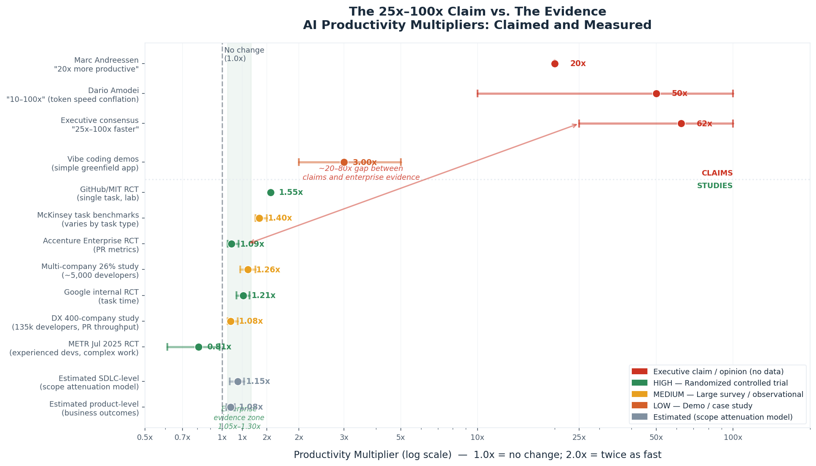
Figure 1: Claimed (red, above dividing line) vs. evidenced (below) AI productivity multipliers on a log scale. Note the 20–80x gap between claims and the enterprise evidence zone.

3.4 Studies Over Time
As AI tools have improved since 2023, measured gains have generally increased — but they remain in the 1.1x–1.6x range on tasks, not 25x. The METR negative result (July 2025) reversed to a positive within 6 months as models improved, confirming the landscape is changing — but on a trajectory that projects toward 2x on tasks, not 25x.

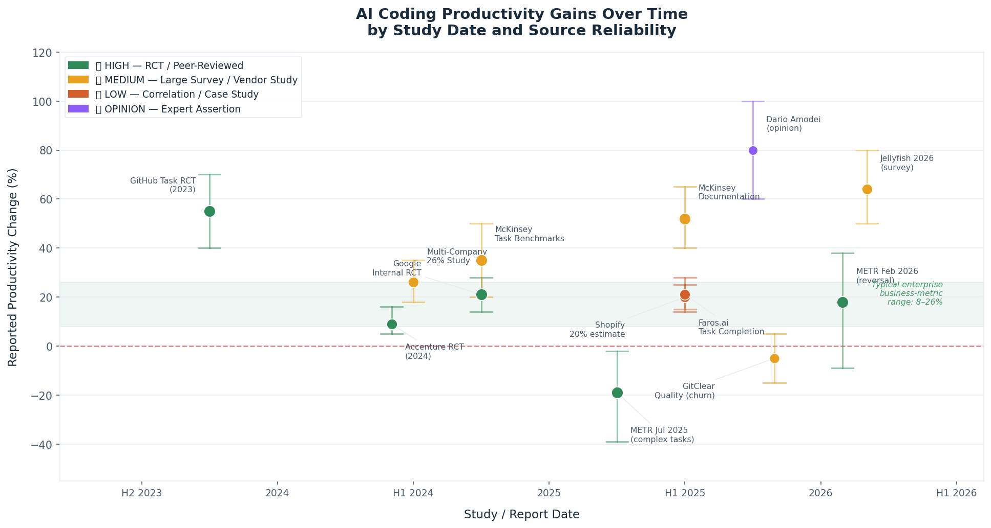
Figure 2: Reported productivity gains by study date and source reliability. Gains are trending up but remain far below the claimed range.

4 Why 25x Is Structurally Impossible Today

4.1 The SDLC Bottleneck Math
Even in a best-case scenario where coding is 100% automated and instantaneous, product development speed is bounded by all the other phases of the SDLC. This is not a technology limitation — it is a structural property of how software is built.

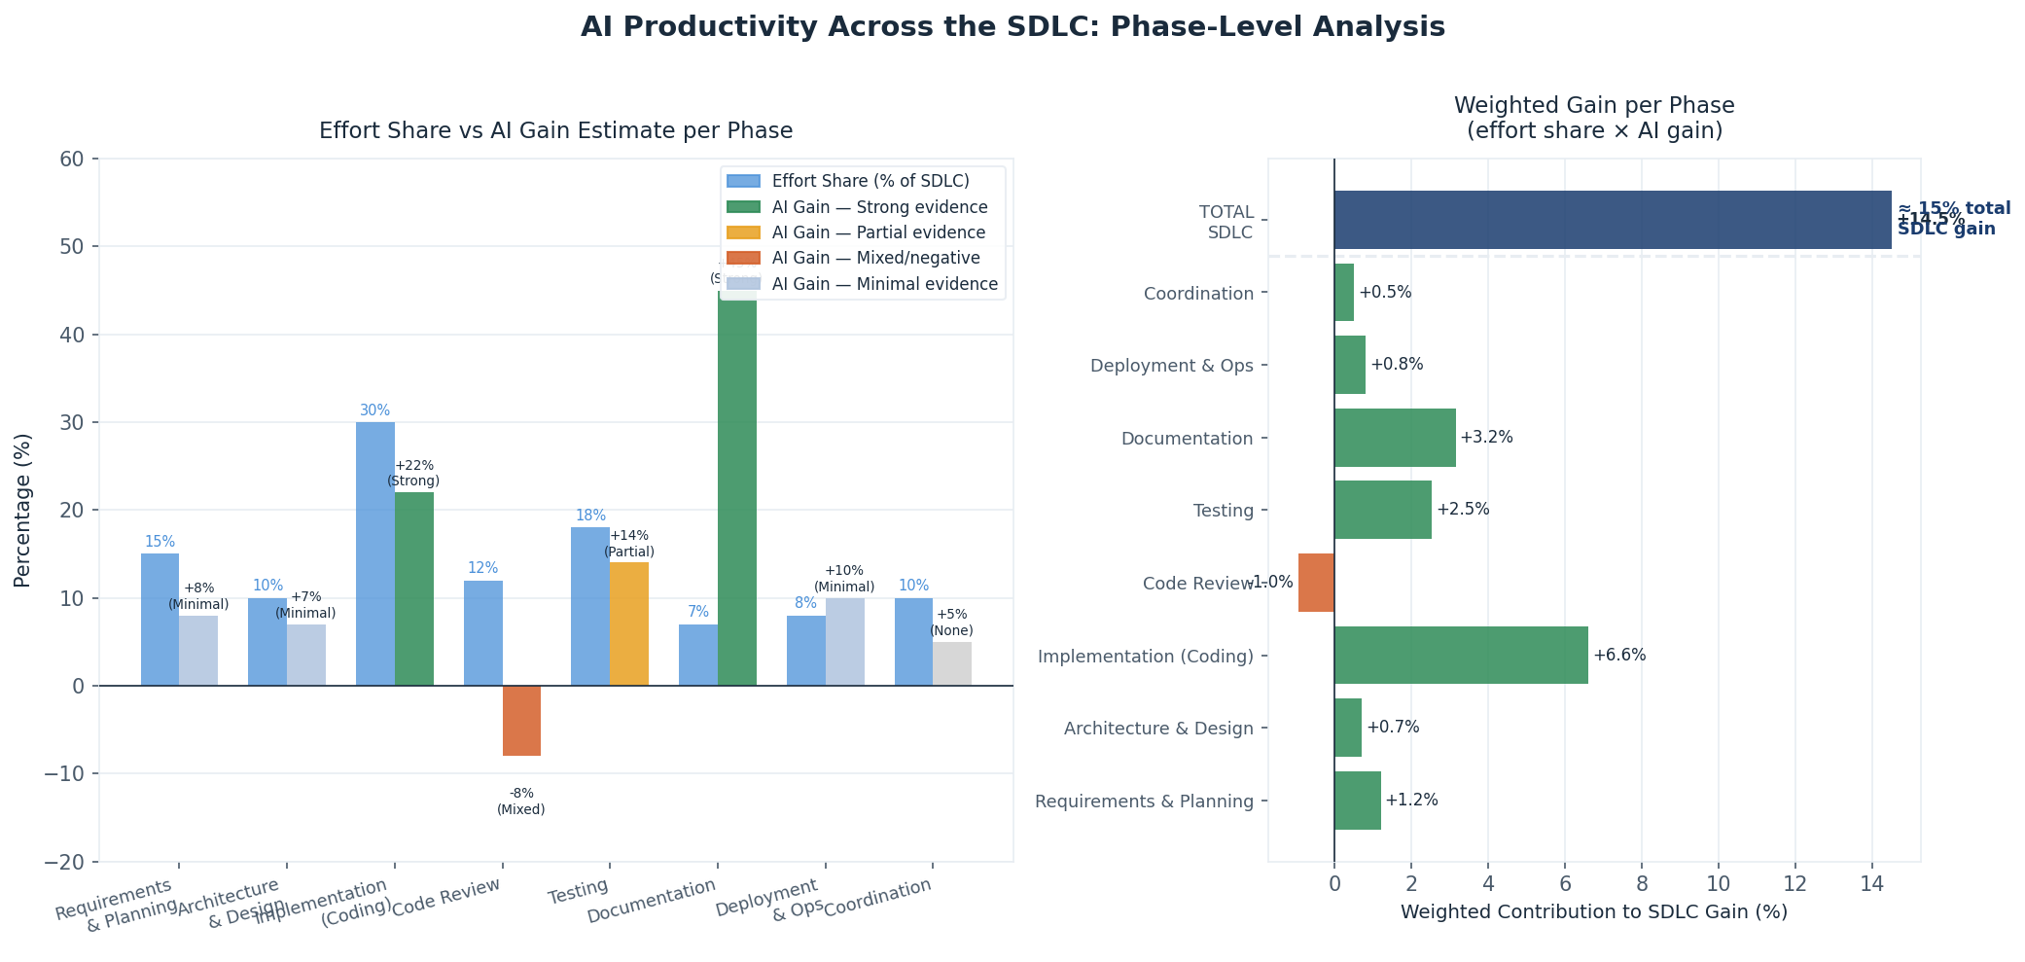
Figure 3: SDLC phase effort allocation and AI gain by phase. Coding (30% of effort) is the most AI-accelerated phase, but six other phases constrain total cycle time. Code review is currently a net drag due to bottleneck shifts.

The weighted SDLC estimate from this model: approximately +14.5% overall. For 25x (2,400%) total SDLC improvement, you would need every phase to be accelerated by roughly 24x simultaneously — including requirements, architecture, stakeholder communication, and operations, none of which AI currently addresses at enterprise scale.

4.2 The Bottleneck Shift Problem
Faster coding does not automatically mean faster delivery. Faros.ai's analysis of 67,000 developers found that high-AI-adoption teams merged 98% more pull requests — but experienced 91% longer PR review times. The bottleneck moved from coding to review. Product delivery speed did not scale proportionally.

This dynamic was predicted by the DORA research: AI amplifies what is already there. If the review process, QA pipeline, or requirements process is the constraint, accelerating coding makes the constraint worse, not better.

4.3 The Scope Attenuation Effect
Gains measured in labs on isolated tasks systematically overstate what happens at the product level. The compression is not a failure of AI — it is the mathematical consequence of applying a partial speedup to one component of a larger system.

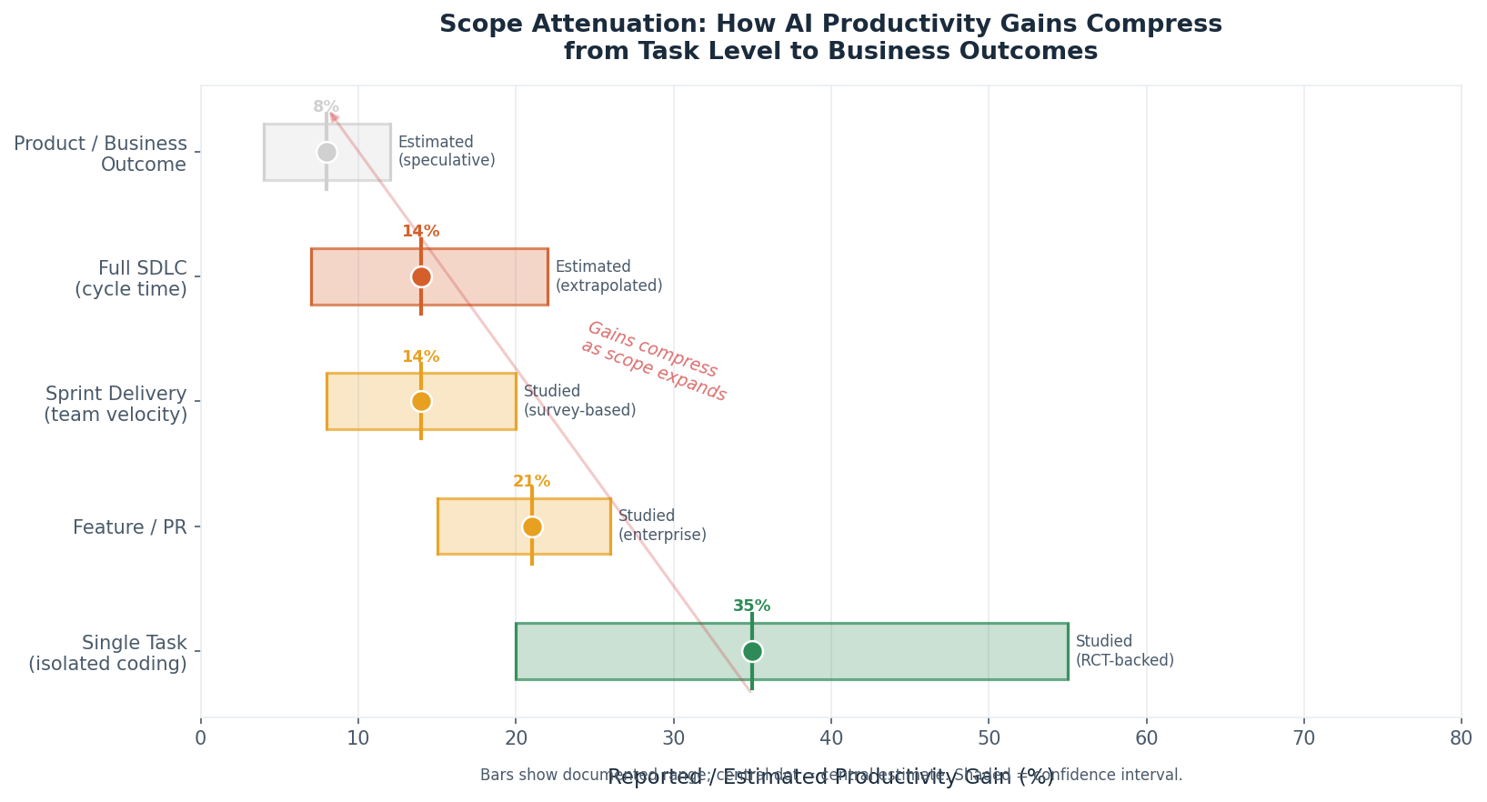
Figure 4: Scope attenuation — how gains compress from task level (~35%) to product/business outcome level (~8%). Gains above the dashed line are studied; below are estimated from the scope model.

4.4 What 25x Would Actually Require
For 25x product development speed to be real, the following would all need to be true simultaneously:

Requirement | Current Status | Gap
AI generates correct requirements from business intent | Not available at enterprise scale | Requires full business understanding, multi-stakeholder negotiation
AI produces trustworthy system architecture | Not available reliably | Enterprise architecture involves deep domain, legacy, and compliance constraints
AI coding at near-zero defect rate | Current AI code has 1.7–2.74x MORE defects | Quality gap must close completely
AI code review replaces human review | 49% of teams use AI-assisted review; not autonomous | Full autonomy requires human-level judgment on security, logic, integration
AI testing with complete coverage | Test generation available; autonomous design: partial | Test coverage strategy still requires human judgment
AI manages deployment, monitoring, incident response | Partially automated via IaC + AI monitoring | Incident response still requires human context
AI handles stakeholder communication and prioritization | Not available | Requires organizational authority, not just capability

Current state: Items 3 (coding) and 5 (partial test generation) are partially addressed. Items 1, 2, 4, 6, 7 are not production-ready at enterprise scale. 25x requires all seven to be solved simultaneously and reliably.

5 The Forward Trajectory: When Could Larger Gains Become Real?

5.1 What Is Actually Improving
The model capability trajectory is real and documented. METR's RCT reversed a negative finding in ~6 months as models improved. Jellyfish's 2026 survey found Claude Code overtook GitHub Copilot as the #1 tool within 12 months. The direction is clear — but the pace of improvement in complex enterprise tasks is not the same as improvement in isolated coding benchmarks.

Capability | Today | 12–24 Months | 5+ Years
Task-level coding acceleration | +20–55% on tasks | Improving; agents growing | Possible near-full task automation
PR / feature-level gains | +8–26% | +15–35% plausible | +30–50% with agentic tools
Full SDLC cycle time | +5–17% (estimated) | +10–25% with agentic workflows | Possibly 2–4x with full orchestration
Product / business outcomes | +4–12% (estimated) | +8–20% (estimated) | Unknown — no measurement exists
25x product speed | Not achievable | Not achievable | Theoretical — requires full AI SDLC automation

5.2 The Realistic Optimistic Scenario
If agentic AI continues improving at the observed pace, and if organizations invest seriously in the platform prerequisites (test coverage, review tooling, governance), the most optimistic well-supported projection for 5 years out is:

- Coding + testing substantially automated for well-scoped features: 3–5x faster on those tasks
- SDLC cycle time improvement for greenfield, well-defined work: 2–3x
- For complex legacy systems with compliance requirements: 1.5–2x
- Business outcome improvement (revenue, delivery of strategic features): 1.3–1.8x (the bottleneck shifts to requirements quality and strategic prioritization)

This is the scenario that leading companies like Stripe and Shopify are building toward. It is genuinely valuable. It is not 25x.

5.3 The Andreessen Scenario
The 25x–100x scenario requires the following technological discontinuity: AI agents that can take a business goal (not a technical specification) as input and produce a deployed, tested, compliant, maintainable software product as output — with no human involvement in requirements, architecture, code review, testing, or operations.

This is the 'AI as autonomous engineer' scenario. It is coherent — it is what Anthropic, OpenAI, and Google are working toward. But it is not a 12–24 month trajectory. Current AI success rates on complex multi-system regulated-industry workflows are 22.7%. Getting from 22.7% to >99% reliability (required for autonomous production deployment) is not a linear extrapolation from current trends.

6 Realistic Targets for GHX

6.1 GHX-Specific Context
GHX is a regulated enterprise B2B healthcare marketplace with legacy systems, HIPAA compliance requirements, and complex multi-stakeholder workflows. This context places GHX at the conservative end of the productivity gain distribution, for two reasons: (1) AI underperforms on complex legacy systems relative to greenfield work, and (2) regulated workflows have lower AI success rates (22.7% documented for complex multi-system healthcare scenarios).

Metric | Conservative Target | Realistic Target | Best Case (Conditions Met)
PR / sprint velocity (6–12 months) | +8–12% | +15–20% | +25–30%
Feature cycle time (12–18 months) | +5–10% | +10–20% | +20–30%
SDLC-level efficiency (12–24 months) | +5–10% | +10–15% | +15–25%
Business outcome improvement | +3–5% | +5–10% | +10–15%

Conditions for best case: internal developer platform investment, 3-month minimum training program, security tooling in CI/CD before rollout, code review process updated for higher PR volume, and baselines measured before rollout.

6.2 The Recommended Counter-Narrative for Leadership

What Executives Say | The Evidence-Based Response
"We need to be 25x faster with AI" | No enterprise has achieved this. The evidence ceiling for PR throughput is ~26%. The realistic SDLC-level gain is 10–25% with a well-run program — real and valuable, but not 25x.
"Our competitors are doing 100x with AI" | If true, they are not measuring at the product level. Task-level demos (building a simple app in hours) do not translate to product cycles. The largest independent study found 7.76% median gain across 400 companies.
"AI will replace our engineering team" | Junior employment is down 9–10%; senior roles are stable. The trajectory is role transformation over 2–5 years, not immediate displacement. Cutting the team now risks a 2028–2030 senior shortage with no pipeline.
"We should target 10x productivity in 2 years" | Set a 2-year target of 15–25% productivity gain at the team level with a structured program. That is achievable, measurable, and credible. 10x requires full SDLC AI automation that does not exist.

Appendix A GHX Operational Considerations
This section covers implementation patterns, security risks, and workforce implications specific to GHX. These are secondary considerations — the evidence on realistic gains above should anchor the strategy.

A.1 Rollout Approach
Phase 1 (Enthusiastic early adopters): Build internal proof points, surface real friction before broad rollout. Phase 2 (Core dev teams): High-visibility product teams; update code review guidelines before this phase, not after. Phase 3 (Extended teams): QA, DevOps, platform — tailor use cases. Phase 4 (Cross-functional): Data, security, product — unlocks net-new capacity.

Critical: Update code review processes before Phase 2. Faros.ai documented +91% review time in high-adoption teams. The bottleneck shift is predictable and preventable.

A.2 Training: The Primary Differentiator
McKinsey found top-performing AI adopters invested in hands-on coaching at 3x the rate of bottom performers. Training elements: prompt engineering for developers, recognizing AI failure modes in your specific tech stack, security awareness (AI code has 1.7–2.74x higher defect rates), when NOT to use AI (METR finding: experienced devs on complex familiar codebases may be slower), hands-on practice time before production expectations.

A.3 Security: Non-Negotiable
Three independent sources document elevated security risk from AI-generated code: Veracode (2.74x more vulnerabilities), Apiiro (10x more security findings), CodeRabbit (1.7x more major issues, 75% more misconfigurations). Required mitigations before broad rollout: automated SAST/DAST in CI/CD pipeline; explicit code review requirements for security-sensitive AI-generated code; developer security awareness training.

A.4 Quality Risks
GitClear's 211M-line longitudinal analysis shows AI-era codebases accumulating more churn (+44%), more duplication (8x increase in clones), and less refactoring (-60%). This is a technical debt pattern. Mitigation: maintain code review standards, require developers to understand AI suggestions, measure code churn alongside velocity metrics.

A.5 Workforce and Pipeline
Harvard workforce data: junior developer employment dropped 9–10% within 6 quarters of AI adoption. Senior roles: unchanged. The 3–5 year pipeline implication: organizations cutting junior hiring today will face a senior developer shortage in 2028–2030 when AI falls short of full automation. Recommendation: maintain junior hiring while peers cut. The asymmetric cost favors maintaining the pipeline.

A.6 Measurement Framework
Measure throughput metrics (PR velocity, task completion, deployment frequency), quality metrics (defect escape rate, review time, rework rate), and developer experience (satisfaction NPS, frustration with AI tools). Run baselines for 2–3 months before rollout; measure at 3 months and 6 months. Most important: track PR review time alongside PR volume — this is the first signal of bottleneck shift.

Appendix B Primary Source Reference
All sources are classified by the four-tier reliability framework used throughout this report.

Study / Source | Date | Key Metric | Tier | Notes
GitHub/MIT Task RCT | 2023-09 | 55% faster (1 task, lab) | HIGH | Greenfield, isolated; does not generalize to SDLC
Accenture Enterprise RCT | 2024-05 | +8.69% PRs; +84% builds | HIGH | Best enterprise-scale RCT available
Multi-Company 26% Study | 2024 | +26% developer productivity | MEDIUM | ~5,000 devs; methodology partially disclosed
Google Internal RCT | 2024-25 | ~21% faster (task) | HIGH | Google-caliber engineers; may not generalize
McKinsey Task Benchmarks | 2023-24 | 35–50% faster by task type | MEDIUM | Task-level; not peer-reviewed
METR Jul 2025 RCT | 2025-07 | -19% (19% SLOWER) | HIGH | Most rigorous real-world study; complex tasks
DORA Report 2025 | 2025 | 90% adoption; amplifies quality | MEDIUM | Annual longitudinal; platform quality is key
Stack Overflow Survey 2025 | 2025 | 52% positive; trust -11% | MEDIUM | Self-reported; sentiment, not measurement
DX 400-Company Study | 2025-Q4 | +7.76% median PR throughput | MEDIUM | Largest real-world observational dataset
GitClear 211M Lines | 2025-26 | Churn +44%; clones 8x | MEDIUM | Longitudinal code quality — most important quality signal
Jellyfish Eng Mgmt 2026 | 2026-05 | 64% report >25% velocity | MEDIUM | Survey; self-reported; Claude Code now #1 tool
METR Feb 2026 Follow-up | 2026-02 | ~18% speedup (reversal) | HIGH | Same RCT design; model improvement confirmed
Harvard Workforce Study | 2025 | Junior dev jobs -9-10% | MEDIUM | 62M workers; pipeline implication is key finding
CodeRabbit PR Analysis | 2025-12 | AI code: 1.7x more issues | LOW | Small sample; vendor source
Uplevel 800-Dev Study | 2024 | Zero gains; +41% more bugs | LOW | Pre-2025 models; lower confidence
O'Reilly 'The Other 80%' | 2025 | Coding = 20% of eng work | MEDIUM | Editorial synthesis; best framing of scope problem
CMR Berkeley Meta-Analysis | 2025-10 | No robust AI-productivity link | MEDIUM | Academic meta-analysis; covers productivity broadly
Faros.ai 67k Developers | 2026 | 2x incident divergence | LOW | Vendor; shows high variance across organizations

GHX Engineering Research | May 2026 | Confidential — Internal Use Only | Three sessions of primary research; 17+ sources evaluated

