GHX Engineering
AI-Assisted Development:
Realistic Productivity Gains
From Individual Tasks to the Full Product Lifecycle
Claude assisted by Marten Engblom | May 2026 | Internal Research
Research Scope  - 17 primary sources evaluated  - 5 randomized controlled trials  - 400-company observational dataset  - Expert projections with reliability ratings  - Current state and 12–24 month outlook | Key Findings at a Glance  - Single task: 20–55% faster — well-evidenced  - PR / sprint level: 8–26% gains — enterprise range  - Full SDLC: ~14% (estimated) — scope attenuation  - Gains amplify what is already working  - Code review is currently a bottleneck, not a gain

1 Executive Summary
AI coding assistants have reached near-universal adoption — 90% of professional developers use them at least monthly as of 2025. The productivity question is no longer whether AI has an impact, but how large that impact is, under what conditions, and at what scope of measurement. This report synthesises 17 primary sources — including five randomised controlled trials and a 400-company observational dataset — to establish realistic expectations across the full range, from individual developer tasks to product lifecycle outcomes.

What the Evidence Shows
The honest answer is a range, not a single number, and the range depends heavily on what you measure. Gains documented in controlled studies run from negative (experienced developers on complex, familiar codebases can be slower) to 55% faster on isolated greenfield tasks. Enterprise business-metric gains — the numbers that reflect actual team output — cluster in the 8–26% band. When gains are applied across the full software development lifecycle, scope attenuation and bottleneck shifts reduce the net effect to an estimated 10–15% improvement in overall cycle time.

Scope of Measurement | Low End | High End | Best Evidence | Confidence
Single coding task (lab / greenfield) | ~20% | 55% | RCT (GitHub, Google) | HIGH
PR / feature — enterprise teams | 8% | 26% | RCT (Accenture) | HIGH
Sprint / team velocity | 5% | 20% | Surveys (DX, Jellyfish) | MEDIUM
Full SDLC cycle time (estimated) | 5% | 17% | Scope model | MEDIUM
Product / business outcomes (estimated) | 3% | 12% | No direct study exists | LOW
Experienced devs — complex legacy work | -20% | +18% | RCT (METR x2) | HIGH

Critical Context for Interpreting These Numbers
Three structural factors consistently explain why enterprise gains fall below what controlled task studies suggest:

- Scope attenuation: Coding represents approximately 30% of SDLC effort. A 55% coding speedup, applied to 30% of the cycle, contributes roughly 16 percentage points to overall cycle time — before accounting for other phases.
- The bottleneck shift: Faster coding increases PR volume. Without scaling code review, review time becomes the constraint. Faros.ai documented +98% PR volume alongside +91% longer review times in high-adoption teams. Net delivery velocity gains were much smaller.
- Amplification, not transformation: DORA's longitudinal research finds that AI amplifies what is already working. Teams with strong engineering foundations, test coverage, and developer platforms capture 2–3x larger gains than teams without. AI is not a shortcut around weak processes — it magnifies them.

What Is Changing
Model capability is improving at a measurable pace. METR's rigorous RCT reversed a negative finding (−19%) to a positive one (+18%) within six months as AI tools improved. The productivity ceiling is not fixed — but the trajectory projects toward meaningful improvement in the 1.2x–1.5x range on team metrics over the next 12–24 months, not order-of-magnitude gains.

2 How to Read the Evidence
The range of claimed productivity gains in AI is unusually wide — from negative results to extraordinary multiples. The reason is straightforward: the numbers depend on what was measured, how, and at what scale. This section explains the reliability classification used throughout the report.

 | Tier | What It Means | Practical Use
 | HIGH — RCT / Peer-Reviewed | Randomised controlled trial or academic study with disclosed methodology. Isolates AI's causal contribution. | Set targets, make business cases, challenge vendor claims.
 | MEDIUM — Large Survey / Observational | Large-sample surveys or passive metrics collection. Real data but potential bias from self-selection or commercial interest. | Understand industry-wide trends, directional planning.
 | LOW — Single Case / Vendor Study | One organisation, undisclosed methodology, or vendor-published without independent validation. | Illustrative examples only; not generalizable.
 | OPINION — Expert Assertion | Statements from practitioners, executives, or investors. No underlying data disclosed. | Understand the range of credible beliefs; not a planning input.

A practical observation: the highest-reliability sources (RCTs) tend to produce the most conservative numbers. The lowest-reliability sources (vendor marketing, executive statements) tend to produce the largest numbers. This is not coincidence — rigorous measurement constrains what can be claimed.

3 Current State: What the Studies Show (2023–2026)

3.1 The Study Landscape
The body of evidence on AI coding productivity has grown significantly since 2023. The chart below plots all primary sources by date, with central estimates and confidence intervals where reported. Source reliability is colour-coded. The shaded band shows the enterprise business-metric range consistently supported across multiple studies.

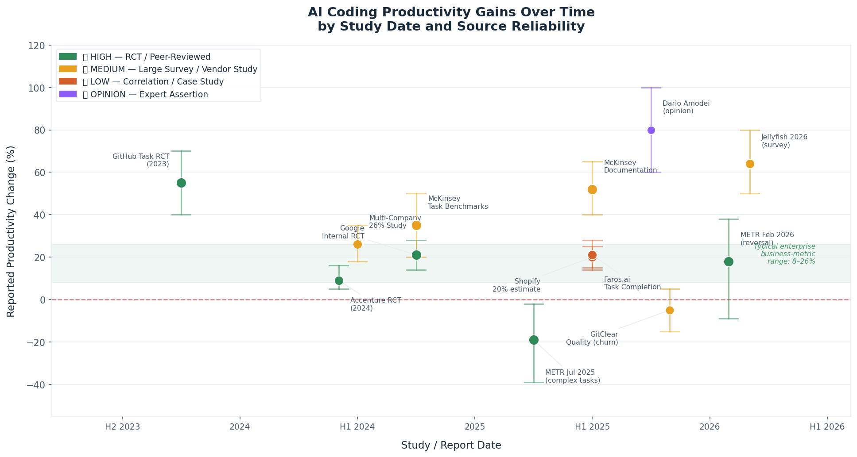
Figure 1: Reported AI productivity gains by study date. Colour = source reliability; vertical bars = confidence intervals. Shaded band = typical enterprise business-metric range (8–26%).

3.2 The Full Picture by Study

Study / Source | Date | Key Finding | Tier | Context & Limits
GitHub / MIT Task RCT | 2023-09 | 55% faster on single coding task | HIGH | Lab; greenfield; isolated task — not SDLC
Google Internal RCT | 2024-25 | ~21% faster (task completion time) | HIGH | Google-caliber engineers; strong upper bound
Accenture Enterprise RCT | 2024-05 | +8.69% PRs; +84% successful builds | HIGH | ~650 devs; consulting context; training required
METR Jul 2025 RCT | 2025-07 | −19% (19% SLOWER on complex tasks) | HIGH | 16 devs; complex real codebases; devs felt 20% faster
METR Feb 2026 Follow-up | 2026-02 | +18% speedup — reversal with new models | HIGH | Same design/cohort; model improvement in ~6 months
Multi-Company 26% Study | 2024 | +26% productivity across ~5,000 developers | MEDIUM | Microsoft, Accenture, Fortune 100; partial methodology
McKinsey Task Benchmarks | 2023-24 | 35–50% faster by task type | MEDIUM | Documentation highest; complex refactoring lowest
DX 400-Company Study | 2025-Q4 | +7.76% median PR throughput (+65% AI use) | MEDIUM | Largest observational dataset; 135,000+ developers
DORA 2025 | 2025 | 90% adoption; platform quality = ROI driver | MEDIUM | Longitudinal; 'amplification' finding is key insight
Jellyfish Eng Mgmt 2026 | 2026-05 | 64% report >25% velocity gain | MEDIUM | Survey; self-reported; Claude Code now #1 tool
Stack Overflow 2025 | 2025 | 52% positive effect; trust −11 points | MEDIUM | Sentiment, not measurement; 'almost right' problem
GitClear 211M Lines | 2025-26 | Code churn +44%; duplicate code 8× | MEDIUM | Best longitudinal quality signal; technical debt risk
Faros.ai 67k Developers | 2026 | 2× incident divergence across organisations | LOW | High variance — some orgs improve, some regress
CodeRabbit / Veracode | 2025 | AI code: 1.7–2.74× higher defect rates | LOW | Security risk signal; consistent across 3 sources
Uplevel 800 Developers | 2024 | Zero gains; 41% more bugs | LOW | Pre-2025 models; useful lower-bound data point

3.3 Patterns Across Studies
Synthesising across all 17 sources, six patterns emerge consistently:

- The perception gap is large and consistent. METR's RCT documented a 39-point gap between what developers believed (20% faster) and what was actually measured (19% slower). Self-reported productivity surveys likely overstate gains.
- The 'almost right' problem is a genuine drag. 66% of developers (Stack Overflow 2025) cite subtly incorrect AI output as their top frustration. Review and correction time partially offsets speed gains.
- AI amplifies existing strengths. Teams with strong CI/CD, clean codebases, and good test coverage see 2–3x larger gains than teams without. DORA calls this the 'amplification effect.'
- Training investment is the strongest predictor of outcome. McKinsey found top-performing adopters invested in hands-on coaching at nearly 3× the rate of bottom performers.
- Quality is diverging. GitClear's longitudinal data shows AI-era codebases accumulating more churn, more duplication, and less refactoring — consistent with a technical debt pattern. The Faros.ai 2× incident divergence confirms that outcomes are spreading, not converging.
- Model improvement is rapid. METR reversed a negative finding in approximately six months. Any benchmark from 12+ months ago is partially obsolete. The landscape will look materially different by end of 2026.

4 The Scope Question: From Tasks to the Product Lifecycle
The most significant gap in the research literature is the distance between how productivity is measured and how it is experienced by an engineering organisation. Nearly all published studies measure at the task or PR level — the smallest scopes. Business outcomes depend on the full product development lifecycle. Understanding how gains translate (or don't) across these levels is essential for setting credible expectations.

4.1 How Gains Are Distributed Across the SDLC
Coding is approximately 30% of total software development lifecycle effort. AI tools have strong evidence for accelerating this phase. Other phases have partial, minimal, or no evidence of AI-driven gains — and code review currently shows a net drag due to the bottleneck shift created by increased PR volume.

SDLC Phase | Effort Share | AI Gain Estimate | Evidence Quality | Weighted Contribution
Requirements & Planning | 15% | +8% | Minimal | +1.2%
Architecture & Design | 10% | +7% | Minimal | +0.7%
Implementation (Coding) | 30% | +22% | Strong (RCT-backed) | +6.6%
Code Review | 12% | −8% | Mixed / emerging | −1.0%
Testing | 18% | +14% | Partial | +2.5%
Documentation | 7% | +45% | Strong, consistent | +3.2%
Deployment & Ops | 8% | +10% | Minimal | +0.8%
Coordination & Comms | 10% | +5% | No direct evidence | +0.5%

TOTAL SDLC — weighted estimate | 100% |  |  | ≈ +14.5%

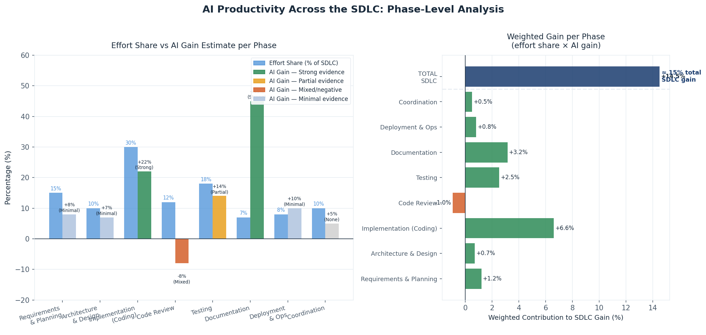
Figure 2: Left — effort share vs AI gain estimate per SDLC phase (blue = effort, coloured bars = AI gain). Right — each phase's weighted contribution to total SDLC efficiency gain. Code review is currently a net drag (−1.0%).

4.2 The Bottleneck Shift
Faster coding does not automatically produce faster delivery. When one stage of a production system accelerates while the stages downstream remain constant, the bottleneck shifts — and overall throughput is bounded by the new constraint, not the improved stage.

Faros.ai's analysis of 67,000 developers provides the most concrete evidence: high-AI-adoption teams merged 98% more pull requests but experienced 91% longer PR review times. The benefit of faster coding was partially consumed by the review backlog it created. This dynamic also explains DORA 2024's finding that AI adoption initially correlated with slightly lower delivery throughput for some organisations — the constraint moved before review processes adapted.

4.3 Scope Attenuation: How Gains Compress
Synthesising across the research, estimated productivity gains compress progressively as scope expands from individual task to business outcome. The compression has two causes: (1) non-coding phases are less affected by AI tools, and (2) bottleneck shifts absorb part of the coding gain at larger scopes.

Scope Level | Gain Range | Central Estimate | Evidence | Confidence
Single coding task | 20 – 55% | ~35% | RCT studies | HIGH
Feature / pull request | 8 – 26% | ~21% | Enterprise studies | HIGH
Sprint / team velocity | 5 – 20% | ~14% | Surveys | MEDIUM
Full SDLC cycle time | 5 – 17% | ~14% | Scope model (estimated) | MEDIUM
Product / business outcome | 3 – 12% | ~8% | No direct study | LOW

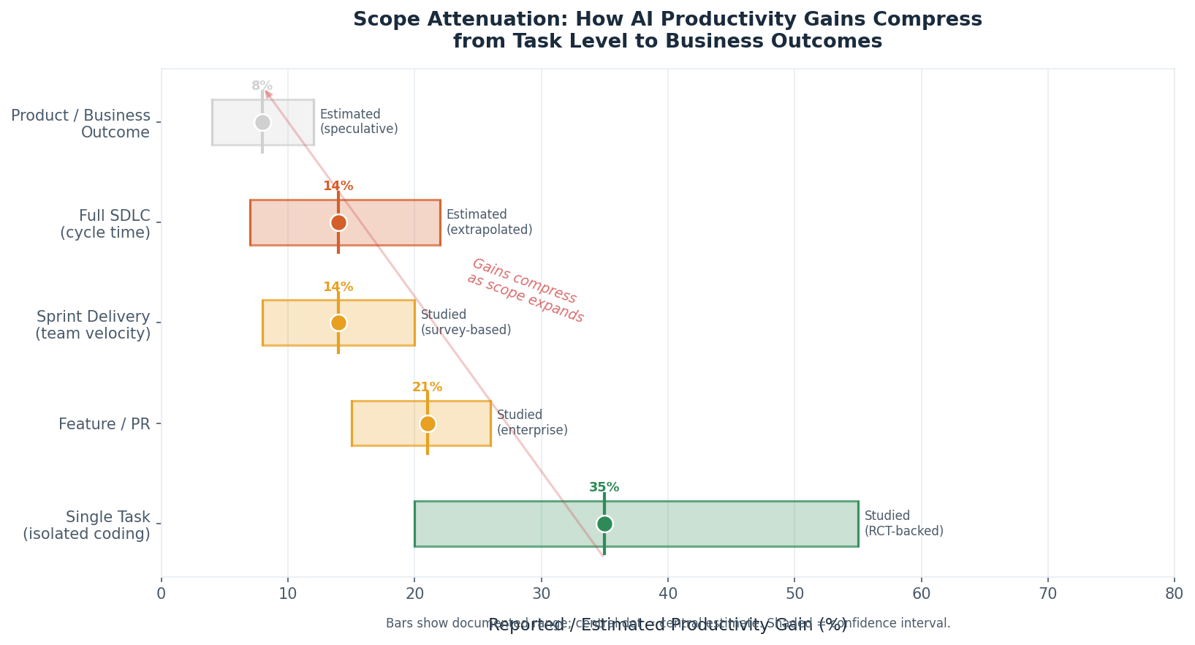
Figure 3: Scope attenuation — gains compress from ~35% at the task level to ~8% at the product / business outcome level. Green = studied directly; amber = estimated from scope model.

The gap between task-level studies (20–55%) and product-outcome estimates (3–12%) is not a measurement artefact — it is the structural consequence of applying a partial automation tool to one component of a larger, multi-phase system. Both numbers are correct within their respective scopes.

Key Insight for Setting Expectations
- Task-level gains (20–55%) are real and reproducible. Use them for developer experience and recruitment arguments.
- Business-metric gains (8–26%) are the right anchor for team-level planning and ROI models.
- SDLC-level gains (~14%) are the right anchor for cycle time and capacity projections.
- Product/business-outcome gains (~8%) are the honest number to use when connecting AI investment to delivery or revenue impact. No study has measured this directly — it is an estimated upper bound.

5 Future Outlook: 12–24 Months and Beyond

5.1 What Is Improving
The AI capability trajectory is real and measurable. METR's follow-up RCT reversed a negative finding in approximately six months as models improved. Jellyfish's 2026 survey found Claude Code overtook GitHub Copilot as the top-ranked tool within 12 months. Agentic tools — where AI executes multi-step tasks autonomously — are moving from research to production at companies including Stripe, Shopify, and Zapier.

The direction is clear. The rate-limiting factor for enterprise productivity is no longer primarily AI capability — it is organisational readiness: internal developer platform quality, governance frameworks, test coverage, and review process scalability.

5.2 Data-Grounded Projections

DORA 2026: Platform Maturity Compounds AI Returns
The most rigorous longitudinal study in software delivery (DORA) finds a direct correlation between internal developer platform quality and AI ROI. Organisations with mature CI/CD, quality practices, and developer tooling see compounding returns. Those without see AI adoption increase workload without proportional value. Platform investment is a prerequisite for the next tier of AI productivity — not a parallel track.

Agentic Workflows: 12–18 Month Horizon for Enterprise
Anthropic's 2026 Agentic Coding Trends Report draws on production deployments at Rakuten, TELUS, Zapier, and others to document eight structural shifts in software engineering: roles shifting from implementer to orchestrator; development cycles compressing from weeks to days for appropriate task types; multi-agent parallel systems handling discrete, well-scoped work. One notable finding: 27% of AI-assisted work consists of tasks that would not have been done otherwise — net new capacity, not only faster execution.

Enterprise-scale agentic deployment for complex, regulated work is a 12–24 month horizon, not an immediate capability.

METR's Rate-of-Improvement Signal
The reversal from −19% to +18% in six months, using the same RCT design and developer cohort, is the most quantified signal of model improvement pace available. It suggests the productivity ceiling is moving at approximately that cadence. Benchmarks from 12+ months ago should be treated as lower bounds, not current state.

Regulated Industries: 12–24 Month Lag
Healthcare and financial services are tracking 12–24 months behind consumer technology companies in capturing AI productivity gains, due to compliance requirements, audit trail needs, and legacy system complexity. Current AI success rates on complex multi-system regulated-industry workflows are documented at 22.7%. This creates a predictable roadmap: capabilities proven in consumer tech today are likely achievable in regulated enterprise contexts by 2027–2028.

5.3 Projection Summary

Scope | Today | 12–24 Months | 5+ Years (speculative)
Single task | 20–55% | 30–70% (models improving) | Possible near-full automation of isolated tasks
PR / feature | 8–26% | 15–35% (agentic review/codegen) | 30–50% with mature agentic tooling
SDLC cycle time | 5–17% | 10–25% (agentic workflows) | Possibly 2–4× with full SDLC orchestration
Business outcome | 3–12% | 8–20% (estimated) | Unclear — no measurement framework exists

Expert opinion spans a wide range. Andreessen projects 10–100× gains within 2–3 years (opinion, no data). Gergely Orosz (Pragmatic Engineer) and the DORA research team project meaningful but incremental improvement constrained by organisational prerequisites. The data-grounded view sits between these: acceleration already underway, with significant prerequisites that will rate-limit enterprise adoption.

5.4 The Junior Developer Pipeline
Harvard workforce data documents a 9–10% drop in junior developer employment within six quarters of AI adoption across 62 million workers. Senior roles are largely unchanged. If AI continues substituting for entry-level work, the apprenticeship pipeline that produces senior engineers could weaken — creating a medium-term supply shortage in 2028–2030. This is a planning consideration independent of near-term productivity gains.

6 Best-in-Class Benchmarks
The organisations below represent the leading edge of AI-assisted engineering in production. Their results define the upper range of what is achievable — and the organisational conditions required to get there.

Company | Tools | Results | What Made It Work | Scope
Accenture | GitHub Copilot | +8.69% PRs; +84% builds; +15% merge rate | Phased rollout; mandatory training nudge | Enterprise RCT
Shopify | Cursor + 'Roast' AI review | ~20% productivity gain; AI review on every PR | CEO mandate; AI embedded in mandatory workflow | Team estimate
Google | Internal Gemini tools | ~21% faster (RCT); >30% of code AI-generated | Large-scale RCT; strong eng culture | Task-level RCT
Stripe | 'Minions' agent system | Large-scale refactoring at speed; qualitative | Structured 'harness' around AI; not raw LLM | Agentic / infra
Healthcare orgs | Various assistants | 34–44% faster to PR (low confidence) | Methodology not disclosed | Low-confidence

What High Performers Have in Common
- Cultural mandate from leadership. The most effective implementations are not opt-in. Shopify's 'baseline expectation' model removed the social friction that kills adoption in other organisations.
- AI embedded in mandatory workflows. The highest-impact deployments put AI in the path developers are already walking (code review, PR creation, CI/CD gates) rather than offering it as an optional additional tool.
- Training investment at 3× the industry average. McKinsey's clearest finding: hands-on coaching is the strongest predictor of positive outcomes, at 57% adoption among top performers vs. 20% among bottom performers.
- Measurement from day one. Organisations that establish baselines before rollout can identify what works, catch regressions early, and make a credible business case for continued investment.
- Security as a parallel, non-negotiable track. Best-in-class organisations treat AI-generated code security as a separate, elevated risk — automated SAST/DAST in CI/CD and targeted code review for security-sensitive paths.

7 GHX Context: Realistic Targets and Considerations

7.1 GHX-Specific Modifiers
GHX operates as a regulated enterprise B2B healthcare marketplace with legacy systems, HIPAA compliance requirements, and complex multi-stakeholder workflows. These factors place GHX at the conservative end of the productivity distribution. AI success rates on complex multi-system regulated workflows are documented at 22.7%, versus 50–70%+ on greenfield tasks. Legacy system complexity is consistently associated with smaller gains across all sources.

Metric | Conservative | Realistic | Best Case (prerequisites met)
PR / sprint velocity (6–12 months) | +8–12% | +15–20% | +22–28%
Feature cycle time (12–18 months) | +5–10% | +10–18% | +18–28%
SDLC efficiency (12–24 months) | +4–8% | +8–15% | +15–22%
Business outcome improvement | +3–5% | +5–10% | +8–14%

Prerequisites for the best case: internal developer platform investment; 3-month minimum training programme; security tooling in CI/CD before rollout; code review processes updated before Phase 2 expansion; baselines measured before rollout begins.

7.2 Implementation Approach
A phased rollout model is consistently supported by the evidence. Phase 1 targets enthusiastic early adopters and builds internal proof points. Phase 2 expands to core product teams, with code review processes updated before this phase begins. Phase 3 extends to QA, DevOps, and platform engineering with tailored use cases. Phase 4 includes cross-functional teams (data, security, product), where the 27% net-new-capacity finding from agentic tooling is most likely to appear.

7.3 Security and Quality Risk
Three independent sources document elevated security risk from AI-generated code: Veracode (2.74× more vulnerabilities), Apiiro (10× more security findings), CodeRabbit (1.7× more major issues, 75% more misconfigurations). These risks are mitigatable — automated SAST/DAST in CI/CD, targeted security review for AI-assisted code, and developer security awareness training are the required countermeasures. They are not optional for a regulated enterprise.

GitClear's longitudinal data (code churn +44%, duplicate code 8×, refactoring −60%) suggests AI-era codebases are accumulating technical debt faster. Tracking code churn alongside velocity metrics is essential for catching this early.

7.4 Measurement
The single most common planning failure in AI rollouts is the absence of pre-rollout baselines. Without baselines, teams cannot measure impact, cannot identify the bottleneck shift, and cannot make the business case for continued investment. Recommended: run baseline measurements for 2–3 months before rollout; measure at 3 months and 6 months post-rollout. Track PR volume and PR review time together — the ratio between them is the earliest signal of bottleneck shift.

Appendix: Full Source Reference

Study / Source | Date | Key Metric | Tier | Notes / Limits
Jellyfish State of Eng Mgmt 2026 | 2026-05 | 64% report >25% velocity gain | MEDIUM | Survey; self-reported; Claude Code overtook Copilot as top tool
DORA 2026 | 2026-05 | Platform maturity compounds AI ROI | HIGH | Strongest longitudinal software delivery dataset; annual survey
Faros.ai 67k Developers | 2026-Q1 | 2× incident divergence across organisations | LOW | High-variance finding; org context matters more than tool choice
Anthropic Agentic Coding Report | 2026-Q1 | 27% net-new capacity; 8 SDLC shifts | MEDIUM | Customer deployment data; Anthropic has commercial interest
METR Feb 2026 Follow-up RCT | 2026-02 | +18% speedup — model improvement confirmed | HIGH | Same RCT design + cohort as Jul 2025; reversal in ~6 months
GitClear 211M-Line Analysis | 2025-26 | Churn +44%; duplicate code 8× | MEDIUM | Best longitudinal code quality signal; technical debt pattern
DX 400-Company Study | 2025-Q4 | +7.76% median PR throughput | MEDIUM | Largest real-world observational dataset; 135k+ devs; passive metrics
CMR Berkeley Meta-Analysis | 2025-10 | No robust AI–productivity relationship | MEDIUM | Academic meta-analysis; covers broad productivity, not SWE-specific
METR Jul 2025 RCT | 2025-07 | −19% (SLOWER on complex real-world tasks) | HIGH | Most rigorous real-world study; 16 devs; complex codebases
DORA 2025 | 2025 | Platform quality = AI ROI driver | MEDIUM | Annual survey; ‘amplification’ finding is central insight
Stack Overflow Dev Survey 2025 | 2025 | 52% positive effect; trust −11 pts | MEDIUM | Sentiment only; ‘almost right’ frustration is key finding
Harvard Workforce Study | 2025 | Junior dev employment −9–10% | MEDIUM | 62M workers; secondhand citation; pipeline implication for 2028–2030
CodeRabbit / Veracode / Apiiro | 2025 | AI code: 1.7–2.74× higher defect rates | LOW | Security risk; consistent signal across 3 independent sources
O’Reilly — The Other 80% | 2025 | Coding = ~20% of total engineering work | MEDIUM | Editorial synthesis; best framing of SDLC scope attenuation
Accenture Enterprise RCT | 2024-05 | +8.69% PRs; +84% successful builds | HIGH | ~650 devs; consulting context; training nudge was essential
Multi-Company 26% Study | 2024 | +26% across ~5,000 developers | MEDIUM | Microsoft, Accenture, Fortune 100; methodology partially disclosed
Uplevel 800-Developer Study | 2024 | Zero gains; 41% more bugs | LOW | Pre-2025 models; useful lower-bound; pre-dates current tooling
Google Internal RCT | 2024-25 | ~21% faster (task completion time) | HIGH | Google-caliber engineers; strong upper bound for skilled orgs
McKinsey Task Benchmarks | 2023-24 | 35–50% faster by task type | MEDIUM | Documentation highest; complex refactoring lowest; not peer-reviewed
GitHub / MIT Task RCT | 2023-09 | 55% faster — single greenfield coding task | HIGH | Lab conditions; isolated task; does not generalise to full SDLC

GHX Engineering Research | May 2026 | Confidential — Internal Use Only | 4 research sessions; 17 primary sources evaluated

