GHX Engineering
AI Productivity Research
Realistic, Data-Backed Expectations for AI-Driven
Productivity Gains in Software Engineering
May 2026
Prepared by: GHX Engineering Leadership | INTERNAL — DRAFT

Research Scope  - Current-state gains (2023–2026)  - 14 primary studies evaluated  - Future projections (12–24 months)  - Implementation patterns & pitfalls  - GHX-specific recommendations | Headline Findings  - Task-level gains: 20–55%  - Enterprise business-metric gains: 8–26%  - SDLC-level estimate: ~14% (weighted)  - One RCT found experienced devs 19% SLOWER  - Critical prerequisite: platform maturity

1 Executive Summary
As of mid-2026, AI coding assistants have achieved near-universal adoption among professional developers. However, the productivity story is far more nuanced than vendor claims suggest. This report synthesizes 14 primary studies — including five randomized controlled trials — alongside industry surveys, expert analysis, and practitioner perspectives, to establish realistic planning assumptions for GHX.

What the Evidence Actually Shows
Task-level productivity gains of 20–55% are real and reproducible in controlled conditions. However, when measured at the enterprise level — PR throughput, sprint velocity, cycle time — gains consistently fall in the 8–26% range. A critical counterpoint: one high-quality RCT (METR, July 2025) found that experienced developers on complex, real-world codebases were 19% slower with AI tools while believing they were 20% faster. That study was subsequently reversed within 6 months as models improved, underscoring a key theme: the landscape is changing faster than the research can track.

The Scope Problem
The single most important methodological gap in the research is that almost all studies measure at the wrong scope for business planning. Coding is approximately 30% of the SDLC. A 22% coding speedup, applied to 30% of the cycle, contributes roughly 6–7 percentage points to overall cycle time — before accounting for the bottleneck shift to code review (documented at +91% review time in high-adoption teams). The defensible SDLC-level estimate is approximately +14%, and the business-outcome-level estimate is approximately +8%. No peer-reviewed study has directly measured at the business-outcome level.

Key Findings for GHX

Current State (Data-Grounded)
- Enterprise productivity gains of 8–26% on business metrics are achievable with proper rollout and training.
- AI amplifies what is already working: teams with strong CI/CD, clean codebases, and good test coverage see 2–3x larger gains than teams without.
- Training investment is the single strongest predictor of outcomes: top performers invest in hands-on coaching at 3x the rate of bottom performers.
- Security risk is real: AI-generated code shows 1.7–2.74x higher vulnerability rates without active countermeasures.
- Code quality is diverging: GitClear's 211M-line longitudinal analysis shows churn +44%, clones 8x, and refactoring down 60%. High performers and poor performers are separating.

Future Outlook (12–24 Months)
- Agentic workflows (multi-step autonomous task execution) are operationally deployed at Stripe and Shopify; broader enterprise adoption is 12–18 months away.
- DORA 2026 confirms: platform maturity is a prerequisite for AI ROI — not a nice-to-have.
- Regulated industries (healthcare, finance) will capture gains 12–24 months behind consumer tech due to compliance requirements and legacy complexity.
- Models are improving rapidly: the METR follow-up reversed a negative finding in ~6 months. Reassess assumptions every 6 months, not annually.
- Junior developer employment has dropped 9–10% within 6 quarters of AI adoption; the 3–5 year pipeline implication is a strategic risk.

Recommendations for GHX
- Near-term (0–12 months): Target 15–25% productivity gains on appropriate task types. Establish baselines NOW — you cannot measure impact without pre-rollout data.
- Invest in the review infrastructure before increasing throughput. The bottleneck shift is predictable and preventable.
- Security tooling is non-negotiable: automated SAST/DAST in CI/CD pipeline before broad AI adoption.
- Medium-term (12–24 months): Invest in platform maturity and test coverage to unlock agentic gains. These are the long-lead-time items.
- Maintain junior developer hiring. The 3–5 year pipeline risk is asymmetric — the cost of maintaining hiring is low relative to the cost of a senior shortage in 2029.
- Get governance ahead of agentic adoption: shadow AI, IP leakage, and audit trail requirements are compliance exposures specific to GHX's regulated context.

2 Source Reliability Framework
This report uses a consistent four-tier reliability classification for every source. The classification reflects the strength of evidence — not the magnitude of the claimed gain. Use higher-reliability sources to set targets and make business cases; use lower-reliability sources to stress-test assumptions.

 | HIGH — RCT / Peer-Reviewed | Randomized controlled trial or peer-reviewed study. Strongest causal evidence. Use for targets and business cases.
 | MEDIUM — Large Survey / Vendor | Large-sample surveys or vendor studies. Real data, but potential selection bias or commercial incentive. Use for trends.
 | LOW — Correlation / Case Study | Single-org studies or analyses with undisclosed methodology. Directionally useful but not generalizable.
 | OPINION — Expert Perspective | Statements from practitioners or executives. No disclosed data. Useful for forward-looking framing, not benchmarks.

Reading advice: Use HIGH sources to set targets and make the business case. Use MEDIUM sources to understand industry-wide trends. Use LOW and OPINION sources to stress-test assumptions and get practitioner intuition — but do not cite them as hard evidence in executive presentations.

3 Current State: AI Productivity Gains (2023–2026)

3.1 Summary
Enterprise deployments consistently show productivity gains of 8–26% on business-level metrics (PR throughput, cycle time, task completion), with task-level gains of 25–55% achievable on well-defined, discrete work. AI has near-universal adoption (90%+) but trust is declining — 52% of developers report a positive effect, down from higher levels the prior year, with 66% citing subtly wrong AI output as their top frustration.

3.2 Study Overview
The table below summarizes the 14 primary sources evaluated, classified by reliability tier and scope of measurement. Sources are listed chronologically.

Study / Source | Date | Gain Metric | Confidence | Scope
GitHub Task RCT | 2023-09 | 55% faster (task completion) | HIGH | Task
Accenture Enterprise RCT | 2024-05 | +8.69% PRs; +84% builds | HIGH | PR/Repo
Multi-Company 26% Study | 2024 | +26% developer productivity | MEDIUM | PR/Repo
Google Internal RCT | 2024-25 | ~21% faster (task time) | HIGH | Task
McKinsey Task Benchmarks | 2023-24 | 35-50% faster (by task type) | MEDIUM | Task
METR Jul 2025 RCT | 2025-07 | -19% (19% SLOWER on complex) | HIGH | Task
DORA Report 2025 | 2025 | 90% adoption; amplifies quality | MEDIUM | Org-wide
Stack Overflow Survey 2025 | 2025 | 52% positive effect, trust -11% | MEDIUM | Org-wide
GitClear Longitudinal | 2025-26 | Churn +44%, clones 8x | MEDIUM | Repo-wide
Jellyfish Eng Mgmt 2026 | 2026-05 | 64% report >25% velocity gain | MEDIUM | PR/Repo
METR Feb 2026 Follow-up | 2026-02 | ~18% speedup (reversal) | HIGH | Task
Harvard Workforce Study | 2025 | Junior dev jobs -9-10% | MEDIUM | Org-wide
CodeRabbit PR Analysis | 2025-12 | AI code: 1.7x more major issues | LOW | PR
Faros.ai 67k Developers | 2026 | 2x incident divergence | LOW | Org-wide

3.3 Productivity Gains Over Time
The chart below plots all primary studies on a timeline, with central estimates and confidence intervals. Color encodes source reliability. The shaded band represents the typical enterprise business-metric range of 8–26%. Note the METR July 2025 outlier showing a negative result — and its subsequent reversal in February 2026.
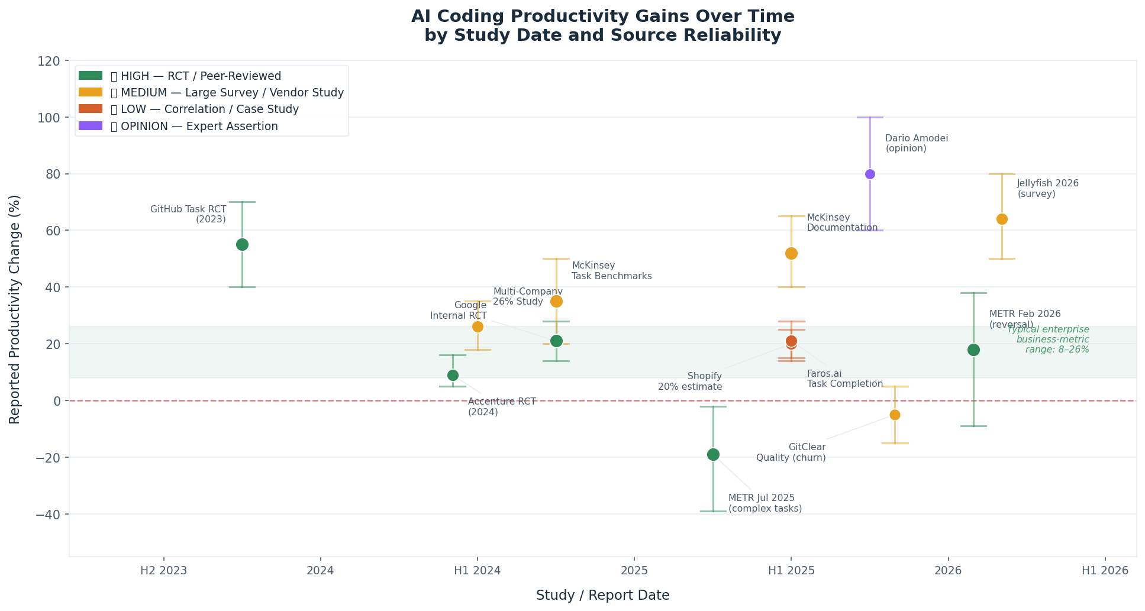
Figure 1: Reported AI productivity gains by study date. Color = source reliability; bars = confidence intervals.

3.4 Key Patterns
Synthesizing across all 14 sources, six patterns emerge:

- The perception gap is significant. METR documented a 39-point gap between perceived speed (+20%) and actual outcome (-19%). Self-reported surveys likely overstate gains by a meaningful margin.
- The 'almost right' problem is a real drag on productivity. 66% of developers (Stack Overflow 2025) cite subtly incorrect AI output as their top frustration. Review and correction time partially offsets speed gains — particularly for experienced developers on complex work.
- AI amplifies what is already working. Teams with strong CI/CD, clean codebases, and good test coverage consistently see larger gains. DORA calls this the 'amplification effect.'
- Training investment is the strongest predictor of outcomes. McKinsey found that top-performing AI adopters invested in hands-on coaching at nearly 3x the rate of bottom performers.
- Code quality is diverging. GitClear's 5-year longitudinal analysis shows AI-era codebases accumulating more churn, more duplication, and less refactoring — consistent with a technical debt build-up pattern.
- Model improvement is rapid. METR reversed a negative finding in approximately 6 months. Any benchmark from 12+ months ago should be treated as potentially obsolete.

4 The Scope Problem: Why Study Numbers Don't Translate Directly to ROI

4.1 The Core Issue
The most important methodological limitation in the entire research corpus is that almost all studies measure at the wrong scope for business planning. Task-level and PR-level gains tell you how fast a developer completes a coding task — not how quickly a feature ships, how often it breaks, or whether it delivers business value. Understanding this distinction is critical to setting realistic targets.

4.2 SDLC Phase Breakdown
Coding represents approximately 30% of total SDLC effort. When AI gains are applied only to the coding phase, the top-line productivity improvement is diluted by phases where AI has limited impact — and offset by phases where AI currently creates a net drag, particularly code review.

SDLC Phase | Effort Share | AI Gain Estimate | Evidence Quality | Weighted Contribution
Requirements & Planning | 15% | +8% | Minimal | +1.2%
Architecture & Design | 10% | +7% | Minimal | +0.7%
Implementation (Coding) | 30% | +22% | Strong (RCT) | +6.6%
Code Review | 12% | -8% | Mixed/emerging | -1.0%
Testing | 18% | +14% | Partial | +2.5%
Documentation | 7% | +45% | Strong | +3.2%
Deployment & Ops | 8% | +10% | Minimal | +0.8%
Coordination | 10% | +5% | None | +0.5%
TOTAL SDLC (weighted estimate) | 100% |  |  | ~+14.5%

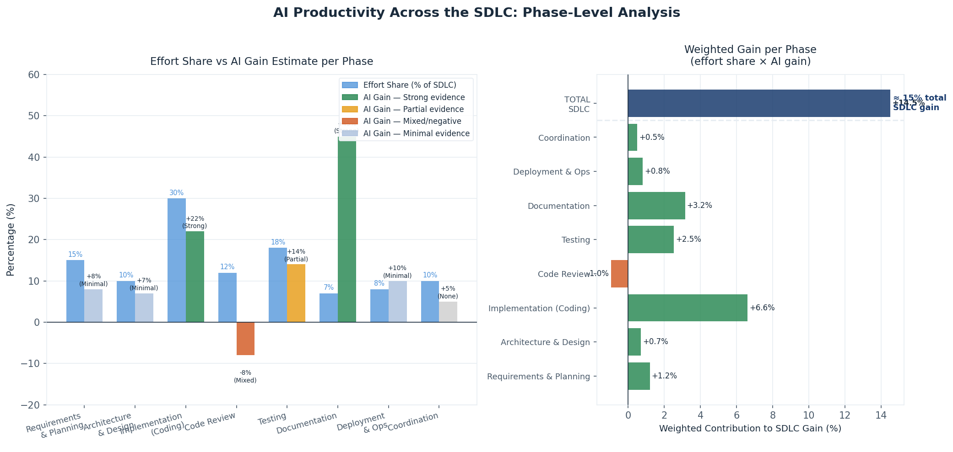
Figure 2: Left — effort share vs. AI gain estimate per SDLC phase. Right — weighted contribution of each phase to total SDLC gain.

4.3 The Bottleneck Shift
Faster coding does not automatically mean faster delivery. Faros.ai's analysis of 67,000 developers found that high-AI-adoption teams merged 98% more pull requests while experiencing 91% longer PR review times. This is the bottleneck shift: as coding accelerates, the constraint moves downstream to review, integration testing, and QA. Unless these phases scale in parallel, net delivery velocity may improve less than coding velocity suggests.

The DORA 2024 finding — that AI adoption initially correlated with slightly lower delivery throughput for some teams — is consistent with this dynamic. Review capacity was not scaled to match increased throughput.

4.4 Scope Attenuation by Level
Synthesizing the research, productivity gains compress significantly as measurement scope expands from task level to business outcomes.

Scope Level | Gain Range | Central Estimate | Confidence
Single Task (isolated coding) | 20 – 55% | ~35% | Studied (RCT-backed)
Feature / Pull Request | 15 – 26% | ~21% | Studied (enterprise)
Sprint Delivery (team velocity) | 8 – 20% | ~14% | Studied (survey-based)
Full SDLC (cycle time) | 7 – 22% | ~14% | Estimated (extrapolated)
Product / Business Outcome | 4 – 12% | ~8% | Estimated (speculative)

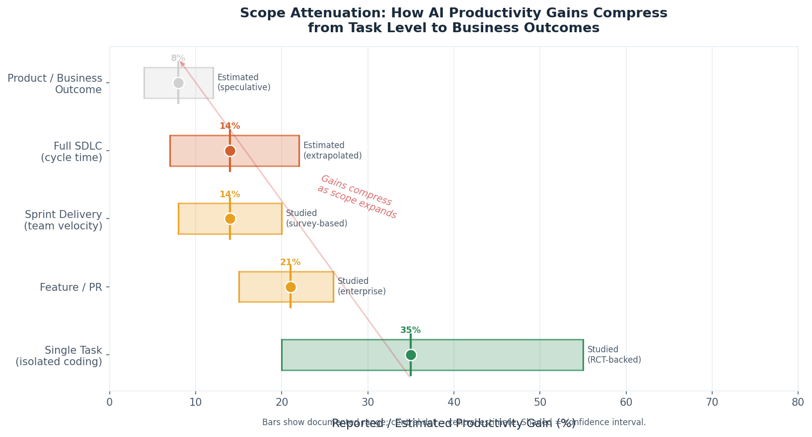
Figure 3: Gains compress from ~35% at task level to ~8% at product/business outcome level. Shading represents the documented or estimated range.

4.5 Implications for GHX

- Use task-level gains (20–55%) only for developer experience and recruitment arguments, not for business case projections.
- Use 8–20% as the realistic range for sprint velocity and PR throughput, with the lower end being the more defensible planning assumption given GHX's regulated enterprise context and legacy systems.
- For business cases involving headcount or cycle time, a conservatively estimated +10–15% SDLC efficiency is defensible. Claims above 25% at the SDLC level require extraordinary evidence.
- Instrument PR review time before rollout. Without this baseline, the bottleneck shift will be invisible — productivity will appear to improve (more PRs) while delivery velocity stagnates.
- The business-outcome level (4–12%) is the only number that connects to revenue, retention, or strategic execution. No peer-reviewed study has measured at this level. It remains an open research gap.

5 Future State: Credible Projections (12–24 Months)

5.1 Data-Grounded Projections
The direction of change is unambiguous: AI's role in software development is expanding, developer roles are shifting toward orchestration, and throughput metrics will continue to increase. The key divergence is not about direction, but about which organizations capture value and which plateau or regress.

DORA 2026: Platform Maturity is the Unlock
The most rigorous longitudinal data source (DORA) finds a direct correlation between internal developer platform quality and AI ROI. Organizations with mature CI/CD, strong quality practices, and good developer tooling see compounding returns on AI investment. Organizations without these foundations often see AI adoption increase workload (more PRs, more review burden) without proportional value. Platform investment is a prerequisite, not a nice-to-have.

Anthropic 2026 Agentic Coding Report
Drawing on production usage data from Rakuten, TELUS, Zapier, and others, this report identifies eight major shifts: engineer role from implementer to orchestrator; development cycles compressing from weeks to hours; multi-agent parallel systems replacing single-agent workflows; long-running agents with task horizons measured in days. The report also finds that 27% of AI-assisted work consists of tasks that would not have been done otherwise — net new capacity, not just faster execution.

METR Follow-Up: The 6-Month Model Improvement Signal
METR's February 2026 follow-up reversed their July 2025 negative finding (19% slower) to an 18% speedup, using the same methodology and developer cohort with updated AI tools. This is the clearest empirical signal that the productivity ceiling is not fixed. Treating any single data point as permanent is a planning error — reassess assumptions every six months.

Regulated Industries: 12–24 Month Lag
Healthcare and financial services will capture AI productivity gains 12–24 months behind consumer technology companies, constrained by compliance requirements, audit trail needs, and legacy system complexity. Current AI success rates in complex regulated-industry workflows are documented at 22.7%. This creates a structural lag but also a predictable roadmap: GHX can observe what is working in consumer tech today and plan for equivalent capabilities in 2027–2028.

5.2 Expert and Opinion-Based Projections
The following represent the range of credible beliefs among well-informed practitioners. These are not planning inputs, but they define the scenario space GHX should consider.

Source | Claim | Planning Implication
Dario Amodei (Anthropic) | AI could replace most software engineering within 6–12 months (Davos, Jan 2026). 'White collar bloodbath' prediction. | Low probability in that timeframe, but scenario-plan for substantial role transformation within 2–3 years.
Addy Osmani (Google) | Within 2 years, the dominant mode will be orchestration — defining intent, evaluating output, maintaining architectural coherence. | Begin reweighting hiring and training toward systems thinking, prompt engineering, and code review depth now.
Gergely Orosz (Pragmatic Engineer) | Junior developer drought in 2028–2030 as AI cuts entry-level hiring today, draining the pipeline to senior roles. | Maintaining junior hiring while peers cut may create a 3–5 year competitive advantage.
Sam Altman (OpenAI) | 100x reduction in cost of intelligence by end of 2027. | Even at 10x cost reduction, the ROI calculus for broad AI deployment changes substantially. Plan for declining license costs.

6 What Works: Implementation Patterns

6.1 Phased Rollout Model
Evidence strongly supports a phased adoption model. Organizations that see the best outcomes treat AI tooling like a platform launch — building internal advocates before expanding broadly.

Phase |  | Goal | Critical Action
1 | Early Adopters | Volunteers; build internal proof points | Identify friction before broad rollout
2 | Core Dev Teams | High-visibility product teams | Update code review guidelines first
3 | Extended Teams | QA, DevOps, platform engineering | Tailor use cases — not copy of dev rollout
4 | Cross-Functional | Data, product, security teams | Unlock net-new capacity (27% per Anthropic)

6.2 Training: The Strongest Lever
McKinsey found that top-performing AI adopters invested in hands-on workshops and coaching at nearly 3x the rate of bottom performers (57% vs. 20%). Training is not optional — it is the primary differentiator between organizations that capture gains and those that plateau.

- Prompt engineering for developers: decomposing tasks, specifying constraints, iterating on prompts.
- Recognizing AI failure modes: pattern recognition for common AI mistakes in your specific tech stack.
- Security-specific awareness: AI code has documented higher vulnerability rates — developers need to know what to scrutinize.
- When NOT to use AI: experienced developers on complex legacy systems may be faster without AI (METR data). This counterintuitive finding should be part of the training program.
- Hands-on practice time: structured experimentation without production pressure before expecting productive use.

6.3 Measurement Framework
Most easily measured metrics (lines of code, AI suggestion acceptance rate) are poor proxies for productivity. Use a balanced scorecard across four categories:

Throughput metrics (leading indicators): PR merge rate and velocity, task completion rate, time from code complete to deployment.
Quality metrics (lag indicators): defect escape rate, security vulnerability counts, PR review time, rework rate.
Business outcome metrics: feature delivery velocity, time to market, incident rate per feature shipped.
Developer experience metrics: developer satisfaction NPS, time spent on repetitive vs. novel work, frustration with AI tools.

Timing: run baselines for 2–3 months before introducing AI tools; measure impact at 3 months and 6 months. One month of data is insufficient to see through the learning curve.

6.4 Common Pitfalls

- 1. The Review Bottleneck: Throughput increases without scaling review create a bottleneck. Faros.ai documented +91% review time in high-adoption teams. Address proactively with automated review tooling and AI-assisted code review.
- 2. Security Regression: AI code has documented higher vulnerability rates (Veracode: 2.74x). Automated SAST/DAST in CI/CD pipeline is required before broad adoption.
- 3. False Productivity Confidence: Developers believe they are more productive than they are (METR 39-point perception gap). Build objective measurement into the rollout from day one.
- 4. Skill Atrophy: Developers using AI exhibit 'false sense of security' about code correctness. Maintain review standards and require developers to understand AI suggestions, not just accept them.
- 5. Big-Bang Rollout: Giving everyone access on day one without updating review processes, security workflows, or training typically results in 20–30% active usage and limited gains.
- 6. Over-Reliance in Regulated Domains: AI shows 22.7% success on complex regulated workflows. Start with lower-risk tasks (tests, docs, scripts) and prove quality before expanding to core business logic.
- 7. Neglecting the Internal Platform: DORA's clearest finding. Platform maturity is directly correlated with AI ROI. Invest in platform before AI — or simultaneously.

7 Best-in-Class Company Benchmarks
The following companies represent the leading edge of AI-assisted engineering deployment. Their results reflect both the ceiling of what is achievable and the specific organizational conditions required to achieve it.

Company | Tools | Key Results | Why It Worked | Relevance to GHX
Accenture | GitHub Copilot | +8.69% PRs; +84% build success; +15% merge rate | Phased rollout; training nudge; enterprise-scale RCT | Closest enterprise services analog; rollout model applicable
Shopify | Cursor, Claude + 'Roast' AI review | Est. 20% gain; AI review on every PR above size threshold | CEO mandate as baseline; AI embedded in mandatory workflow | Cultural mandate model; 'AI in the path' design principle
Google | Internal Gemini tools | ~21% faster (RCT); >30% of new code AI-generated | Large-scale RCT; Google-caliber engineering org | Most credible large-org benchmark; 21% is a realistic ceiling for a strong org
Stripe | Internal 'Minions' agents | Enterprise-grade agentic refactoring at scale | Structured scaffolding ('harness') around AI models | Blueprint for future agentic deployment at GHX
Healthcare Orgs | Various AI assistants | 34–44% faster to PR (vendor source; low confidence) | Not disclosed | Only regulated-industry benchmark; treat as upper bound, not target

7.1 What Best-in-Class Organizations Have in Common

- Cultural mandate from leadership. The most effective implementations are not opt-in. Shopify's 'baseline expectation' model removed the social friction that kills adoption in other organizations.
- AI embedded in mandatory workflows. The highest-impact deployments do not give developers a new tool to use — they put AI in the path developers are already walking (code review, PR creation, CI/CD gates).
- Training investment at 3x industry average. McKinsey's clearest finding. There is no shortcut.
- Measurement from day one. Baselines established before rollout enable organizations to identify what is working, catch regressions early, and make the business case for continued investment.
- Security as a non-negotiable parallel track. Best-in-class organizations treat AI-generated code security as a separate, escalated risk stream — not an afterthought.

8 Research Gaps and Confidence Assessment

8.1 Current Confidence Assessment

- Current-state task-level gains (20–55%): HIGH confidence — backed by multiple RCTs.
- Enterprise business-metric gains (8–26%): MEDIUM-HIGH confidence — backed by large-sample studies including an RCT.
- SDLC-level gain estimate (~14%): MEDIUM confidence — analytical synthesis; no direct measurement at this scope exists.
- Business-outcome-level gain (~8%): LOW confidence — extrapolated from scope attenuation model; not empirically validated.
- Security risk increase: HIGH confidence — corroborated by three independent sources (Veracode, Apiiro, CodeRabbit).
- Future agentic projections (12–24 months): LOW-MEDIUM — directionally credible but timeline-uncertain.

8.2 Key Research Gaps

- SDLC-level and business-outcome-level productivity studies — virtually none exist. If found, they would be the highest-priority additions to this research corpus.
- Peer-reviewed academic papers from arXiv/ACM on developer productivity with AI (not yet searched).
- ThoughtWorks Technology Radar assessment (not yet searched).
- ROI/business case frameworks with cost inputs: license cost, training investment, time-to-productivity curves.
- GHX-specific comparables: enterprise B2B healthcare marketplace, regulated SaaS with legacy systems.
- Longitudinal technical debt data beyond GitClear — is the churn increase stabilizing or accelerating?

Document prepared by GHX Engineering Research | May 2026 | GHX Confidential — Internal Use Only

