Registration:

If you use this model, please send your name, organisation and e-mail address to:

admire@foi.se

If you register as a user we will notify you of new releases via email. Bugs are usually reported to registered users as soon as we find out about them. We advise you to always use the latest version of the model. Some clues to what has happened with the model over time can be found if you use the menu item “Model Properties” in Simulink (mostly quite old info by now) and in this document (more recent info).
If there are any problems, any bugs in the software or you have any questions, please contact us at the same e-mail address.

Note:

From version 3.0 to 3.4c, ADMIRE contained Matlab, Saab and DASA phase compensating rate limiters for all control surfaces. If you want them we can send you Admire3.4c.
From version 3.0, the inputs from the stick are forces instead of displacements.

Files and folders:

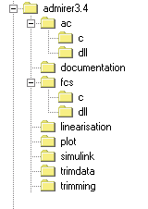 Figure 1: Directory tree

The zipped folder (..\admirer3.4h) contains the files shown in the table below (and a few more of lesser importance.)

Folder: | File: | Description:
..\admirer4.1 | Readme.doc | Readme-file.
 | Startup.m | Updates MATLAB’s search path.
..\admirer4.1\ac\c | act_pos_lim.c | Actuator and engine saturation c-file.
 | admire_aerotesthigh.c | For use with aerodemohigh.m
 | admire_data.h | Configuration data.
 | admire_main.c | Aircraft model c-file.
 | admire_main_5dof.c | Aircraft model c-file. Same thing but with speed derivatives hard-coded to zero.
 | admire_test.h | Envelope test.
 | admire_tvc.h | Thrust vectoring.
 | aerodata_asym_ext.h | Asymmetric aerodata. _ext means that data for AoA > 30 degrees has been added.
 | aerodata_high.h | Symmetric aerodata at high angles of attack.
 | aerodata_fuel01.h | Mass flow data for the engine without after-burner (AB).
 | aerodata_fuel02.h | Mass flow data for the engine with AB.
 | aerodata_sym.h | Symmetric aerodata.
 | aerodata_thrust01.h | Thrust data for the engine without AB.
 | aerodata_thrust02.h | Thrust data for the engine with AB.
 | calc_asym_coeff.h | Calculates the asymmetric aerodata force- and moment coefficients.
 | calc_sym_coeff.h | Calculates the symmetric aerodata force- and moment coefficients.
 | lip1.c | One-dimensional interpolation routine.
 | lip2.c | Two-dimensional interpolation routine.
 | lip3.c | Three-dimensional interpolation routine.
 | lip4.c | Four-dimensional interpolation routine.
 | setup_aerodata_asym.h | Interpolation routine setup for the asymmetric aerodata.
 | setup_aerodata_fuel01.h | Interpolation routine setup for the mass flow for the engine without AB.
 | setup_aerodata_fuel02.h | Interpolation routine setup for the mass flow for the engine with AB.
 | setup_aerodata_high.h | Interpolation routine setup for the symmetric aerodata at high angles of attack.
 | setup_aerodata_sym.h | Interpolation routine setup for the symmetric aerodata.
 | setup_aerodata_thrust01.h | Interpolation routine setup for the thrust data for the engine without AB.
 | setup_aerodata_thrust02.h | Interpolation routine setup for the thrust data for the engine without AB.
..\admirer4.1\ac\dll | act_pos_lim.dll | Actuator and engine saturation c-mex-file.
 | admire_main.dll | Aircraft model c-mex-file.
 | admire_main_5dof.dll | Aircraft model c-file. Same thing but with speed derivatives hard-coded to zero.
 | admire_aerotesthigh.dll | For use with aerodemohigh.m
..\admirer4.1\documentation | gen_dat_mod_3.ps | Original documentation of the Generic Aerodata Model (GAM) from Saab.
 | Software architecture of ADMIRE.doc | An overview of the software implementation and how the model can be incorporated in an existing simulator environment.
\admirer4.1\fcs\c | fcslateral.c | FCS Lateral gains interpolation. C-code. Flight Control System (FCS).
 | fcslateral.h | FCS Lateral gains data.
 | fcslongitudinal.c | FCS Longitudinal gains interpolation. C-code.
 | fcslongitudinal.h | FCS Longitudinal gains data.
 | fcsnz.c | FCS Load Factor gains interpolation. C-code.
 | fcsnz.h | FCS Load Factor gains data.
 | fcsselector.c | FCS Control selector interpolation. C-code.
 | fcsselector.h | FCS Control selector data.
 | fcsu0.c | FCS U0 interpolation. C-code.
 | fcsu0.h | FCS U0 data.
 | fcsx0.c | FCS X0 interpolation. C-code.
 | fcsx0.h | FCS X0 data.
 | machno.c | Mach No. C-code.
\admirer4.1\fcs\dll | fcslateral.dll | FCS Lateral gains interpolation c-mex-file. Is used in the admire_sim.mdl¹.
 | fcslongitudinal.dll | FCS Longitudinal gains interpolation c-mex-file. Is used in the admire_sim.mdl¹.
 | fcsnz.dll | FCS Load Factor gains interpolation c-mex-file. Is used in the admire_augmented.mdl¹.
 | fcsselector.dll | FCS Control selector interpolation c-mex-file. Is used in the admire_sim.mdl¹.
 | fcsu0.dll | FCS U0 interpolation c-mex-file. Is used in the admire_sim.mdl¹.
 | fcsx0.dll | FCS X0 interpolation c-mex-file. Is used in the admire_sim.mdl¹.
 | machno.dll | Mach No. c-mex-file. Is used in admire_sim.mdl¹.
..\admirer4.1\linearisation | adm_lin.m | Linearises the bare aircraft and the control system in two parts.
 | adm_lin_incl_cs.m | Linearises the bare aircraft and the control system including control selector in two parts.
 | linmod_nnt.m | A modified version of linmod.m.
 | adm_lin_p.m | Creates a linear system with a cut in the p command signal between the control system and the control selector. For single loop analysis.
 | adm_lin_q.m | Creates a linear system with a cut in the q command signal between the control system and the control selector.
 | adm_lin_beta.m | Creates a linear system with a cut in the beta command signal between the control system and the control selector.
 | admire_delay_actuators.m | This script might be useful if you want to analyse the full linear system with feedback signals in MATLAB
..\admirer4.1\plot | admire_sim_plot.m | Plot script. Used to plot a subset of the simulated outputs of admire_sim. mdl¹.
 | admire_linear_plot.m | Plot script. Used to plot a subset of the simulated outputs of admire_linear.mdl.
 | admire_test_plot.m | Plot script. Used to plot subsets of the simulated outputs of admire_linear.mdl and admire_sim.mdl for comparison
 | aerodemohigh.m | Runs aerotesthigh.mdl and plots a result. Can be used to see how force and moment coefficients depend on various parameters.
 | trimplot.m | Used to plot the first part of the simulation time history, to judge the quality of the trim condition.
..\admirer4.1\simulink | admire_sim.mdl | The ADMIRE in Simulink with FCS.
 | admire_sim_5dof.mdl | Same thing, but using admire_main_5dof.dll instead of admire_main.dll. Speed is fixed.
 | admire_sim_test.mdl | Version of admire_sim.mdl with stick inputs taken from Workspace.  (See the testinput files.)
 | admire_rtw.mdl | Admire_sim.mdl adapted for use with real-time workshop.
 | admire_rtw_wal.mdl | The same as admire_rtw.mdl, but without AoA limiter in the control system.
 | admire_complete_trim.mdl | For trimming of the aircraft including control system. Since the setting of the longitudinal control surfaces and the angle of attack usually vary together, little seems to be won by separating the control system and the bare aircraft for trimming.
 | admire_bare_lin.mdl | For linearisation of the bare aircraft.
 | admire_fcs_lin.mdl | For linearisation of the control system.
 | admire_fcs_lin_incl_cs.mdl | For linearisation of the control system including control selector.
 | admire_linear.mdl | ‘Linear’ simulink model that works well for trimmed straight and level cases.
 | admire_linear_cut.mdl | The only entirely linear Simulink model. With p, q, beta and feedback signals cut. For an example of how to use it, see the file adm_lin_beta.m. Adm_lin_p.m and adm_lin_q.m also use this file.
 | admire_linear_test.mdl | Version of admire_linear.mdl with stick inputs taken from Workspace.
 | admire_linear_test_lin_cs.mdl | Like admire_linear_test, but with the control selector included in the linearised control system.
 | admire_linear_xcs.mdl | Not useful for anything really, but contains examples of the Saab and DASA phase compensating rate limiters.
 | aerotesthigh.mdl | To check the aerodata. Put a ramp block on the input parameter you want to use. Run a simulation and then plot the columns of uin and yout you want.
 | get_x0u0.mdl | Gets the state and control settings for the bare aircraft. Used by admtrim_sl.m and admtrim_aoa.m.
 | get_x0u0unc.mdl | Gets the state and control settings for the bare aircraft with uncertainties in Mach No. and altitude. Used by admtrim_sl.m and admtrim_aoa.m.
 | testinput.mat | Recorded stick signals from a pilot performing a roll tracking task with another aircraft model. (Not ADMIRE).
 | testinput2.mdl | Generates sine signals for stick inputs in pitch and roll.
 | testinput3.mdl | Generates pulse signals for stick inputs.
..\admirer4.1\trimdata | setup_ratelims.m | M-file. Edit this file to set parameters for the control surface rate limiters.
 | uncertainty.m | Uncertainty data. M-file. Edit this file to add uncertainties.
\admirer4.1\trimming | admtrim_sl.m | Main program for trimming and linearisation of the bare aircraft and the control system for straight&level flight.
 | admtrim_states_aoa.m | Sets up the full state vector 'x0' by calculating all states except for the 12 bare aircraft states. (States 10 to 21).
 | admc_sub_sl.m | Called by admtrim_sl.m, calls admc_cost_sl.m.
 | admc_cost_sl.m | Cost function for trimming of the aircraft for straight&level flight.
 | admtrim_aoa.m | Main program for trimming and linearisation of the bare aircraft and the control system for pull-up with specified angle of attack.
 | admc_sub_aoa.m | Called by admtrim_aoa.m, calls admc_cost_aoa.m.
 | admc_cost_aoa.m | Cost function for trimming of the aircraft for pull-up with specified angle of attack.
 | atmosphere.m | Returns the speed for a given Mach number and altitude.
\admirer4.1\trimming_vt  NOTE: The files in this directory are not always reliable. | admtrim_sl_vt.m | Main program for trimming and linearisation of the bare aircraft and the control system for straight&level flight, with trimming of the speed controller also. Not entirely reliable.
 | admc_sub_sl_vt.m | Called by admtrim_sl_vt.m, calls admc_cost_sl_vt.m.
 | admc_cost_sl_vt.m | Cost function for trimming of the aircraft for straight&level flight, with trimming of the speed controller.
 | admtrim_aoa_vt.m | Main program for trimming and linearisation of the bare aircraft and the control system for pull-up with specified angle of attack, with trimming of the speed controller also. Not entirely reliable.
 | admc_sub_aoa_vt.m | Called by admtrim_aoa_vt.m, calls admc_cost_aoa_vt.m.
 | admc_cost_aoa_vt.m | Cost function for trimming of the aircraft for pull-up with specified angle of attack and trimming of the speed controller.
..\admirer4.1\animation |  | Files in this folder can be used to visualize recorded flights.
..\admirer4.1\convert |  | Files in this folder are used to convert .AER format aerodata files to Admire format.
¹ See admire_sim.mdl

Description of the model:

The model describes a small generic fighter aircraft with one engine. A bit larger than the JAS39 and with quite low wing loading. The model is implemented as several c-mex-files in order to fit into the Simulink environment. It is based on the GAM (Generic Aerodata Model) developed by Saab AB, Sweden.
The control system has been tuned at 30 design points as shown in the graph below. Between the design points the control system characteristics are given by linear interpolation.
The altitudes are 20 m, 3000 m and 6000 m. The Mach numbers are 0.2200, 0.3500, 0.4500, 0.5500, 0.8000, 0.9000, 0.9500, 1.0000, 1.0500, 1.1000 and 1.2000. Note that the choice of envelope for the control system is somewhat arbitrary and its shape is not what you would expect in a real aircraft.
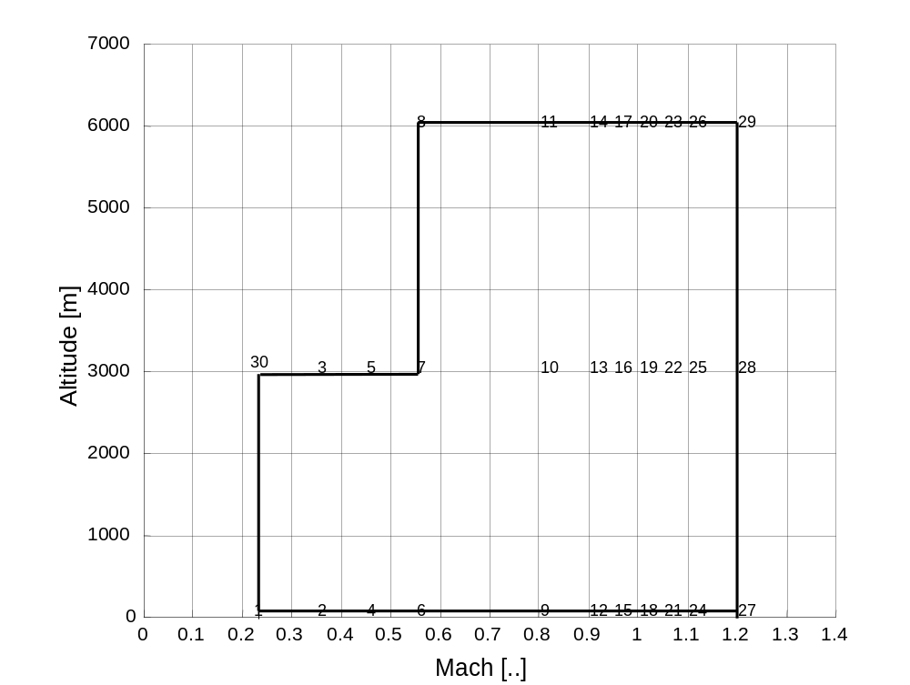
Figure 2: Control system design points.

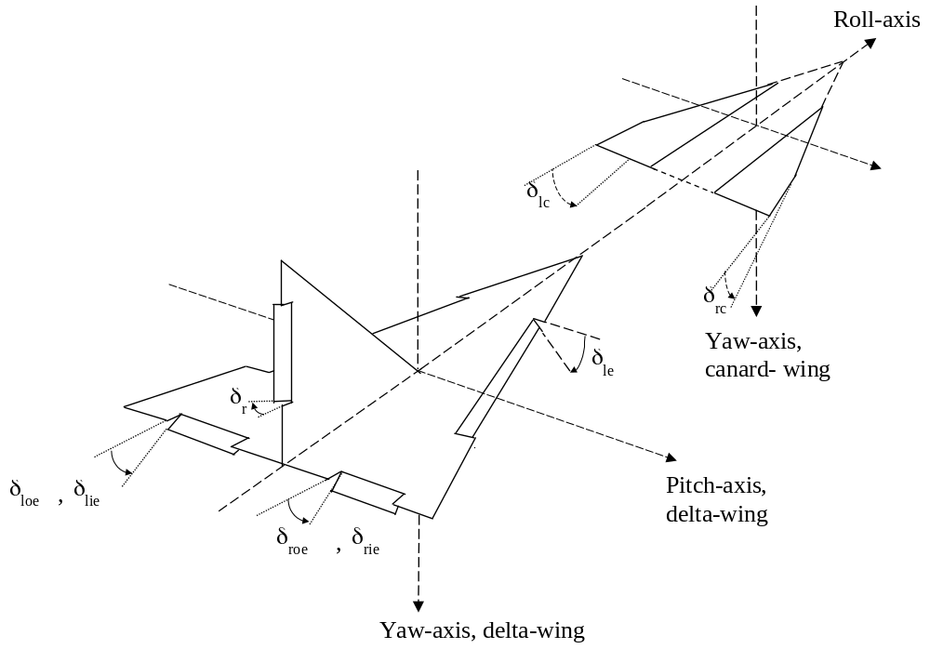
Figure 3. Definition of the control surface deflections

Software requirements:

Matlab/Simulink release 11 or 13. A C-compiler that Matlab supports. With MATLAB release 11, Microsoft Visual C/C++ 5.0 was used. The latest versions of admire_main.dll and admire_main_5dof.dll have been mexed in MATLABR13, see the files acmex.c and fcsmex.c.

Installation on a PC:

There are two ways you can use the ADMIRE:

1) Use the precompiled c-mex-files, i.e. the dll-files.

2) You can also mex your own “admire_main.c”. How to do this is described below. (This description is a bit old, the stages written in italics may be obsolete in MATLAB Release 13.)

In order to run the Simulink model on a PC, the c-file has to be compiled to a c-mex-file.

First you must configure the mex options in Matlab. Use the command

>>mex -setup

in Matlab Command Window (MCW). A DOS-environment will open and you just have to follow the instructions to setup the C-compiler.

Second, go to the folder ..\Admirer4.1\ac\c and type

>>acmex

This will hopefully create a number of .dll files, which are the compiled c-mex-files. Note that the .dll files will be stored in the actual folder. It should be pointed out that the originally precompiled c-mex-files in the dll folder should be erased or at least renamed if you choose to make your own c-mex-files. Otherwise a possible mix-up can take place.

Then go to the folder ..\Admirer4.1\fcs\c and type

>>fcsmex

This will create the .dll files needed for the control system.

NOTE! If you are planning to buy a compiler in order to compile your own mex file, DO NOT buy Watcom C/C++ because this compiler is unable to create stand-alone applications, i.e. c-mex-files.

On a UNIX system the mexing process is basically the same as on a PC.

The file startup.m, provided by David Bennet of BAE Systems, can be used to automatically update Matlab's search path to incorporate the below listed folders, i.e. the folders that contain the model and the supporting programs. When Matlab is started, Matlab automatically runs the startup.m file, if one exists in the directory from which Matlab is started.

..\Admirer4.1\ac
..\Admirer4.1\ac\c
..\Admirer4.1\ac\dll
..\Admirer4.1\fcs\c
..\Admirer4.1\fcs\dll
..\Admirer4.1\linearisation
..\Admirer4.1\plot
..\Admirer4.1\simulink
..\Admirer4.1\trimdata
..\Admirer4.1\trimming

Trimming:

The model must first be trimmed at the point in the envelope where you want to linearise it or start the simulation. This is done by running admtrim_sl.m or admtrim_aoa. For a list of the model states, se the file admtrim_states_aoa.m.
In this release of ADMIRE, trimming works only for straight and level flight or pull-ups with specified angle of attack, and only within the envelope shown in Figure 2.

CAUTION:
If the trimming is aborted while admire_complete_trim is compiled, you MUST terminate it in the following manner: admire_complete_trim([],[],[],’term’), possibly a number of times, before you proceed. Otherwise your following trimming results will be completely unreliable.

Uncertainty and rate-limiter data into Matlab workspace:
The programs admtrim_sl.m and admtrim_aoa make calls to the programs setup_ratelims.m and uncertainty.m. In Admire4.1 you always have the standard MATLAB rate limiters with the rlimit_* settings given in setup_ratelims.m.
As default, uncertainty.m does not add any uncertainty. You must edit it to add the characteristics you want.
You can run setup_ratelims.m and uncertainty.m separately if you like.
Edit uncertainty.m if you want to investigate the robustness of the aircraft control system.
Edit setup_ratelims.m to investigate the effects of rate limits on the control surfaces.

Linearisation:
If you want to use the linearised versions of the control system and aircraft characteristics you must linearise them at the trimmed condition.
The control system and the bare aircraft are linearised separately. Note that the control selector, computer time delays and the saturators, rate limiters and actuators blocks are not included in either part of the linearisation. These must be modelled or linearised separately. The file admire_linear.mdl shows one way of connecting the linearised control system and the linear aircraft.
To linearise:
First trim the model as described above, then type:
>>adm_lin
This yields the linearised control system and the linearised bare aircraft.
Note that you will not get the correct coupling between the lateral and longitudinal motion when you use the linear model.
(Note! If you want a linear version of the complete aircraft you can linearise the Simulink model admire_linear.mdl with linmod. You must first remove the memory block in the feedback path.)

Simulation:

After you have trimmed the model (and added rate limiter data and/or uncertainties), open the Simulink model admire_sim.mdl.

This is done by simply typing

>>admire_sim

Use the pull-down menus to run the simulation.

In admire_linear.mdl the time step for simulation is set to 0.008 s. Such a short time step is required for the padé approximations of the time delays to work properly.
The other simulink models use a time step of 0.01 s. You can experiment with longer time steps if you like.
To view a subset of the simulated outputs of admire_sim.mdl type

>>admire_sim_plot

A better plotting program for checking the trimmed condition is trimplot.m.

You can also simulate the model admire_linear.mdl and plot with admire_linear_plot.m. If you want to compare data between admire_sim.mdl and admire_linear.mdl, use admire_test_plot after you have run the simulations.

Automatic code generation:
This requires Real-Time Workshop, which is an add-on to Simulink. Admire_sim.mdl requires that dtz (thrust vectoring in pitch) is disconnected for some strange reason. See admire_rtw.mdl.

Bugs in ADMIRE 3.3 that have been fixed in ADMIRE 3.4

The funny looking stick gradients in 3.3 were actually adapted only to fit the response into the Gibson gain-phase template, and were quite useless for flying. They have been replaced with pure gains.
There was a sign error for the setting of the leading edge flaps during trimming in 3.3. This is gone because the trimming method has been altered.
Sign error for the initial state of the altitude sensor model has been corrected.

Improvements in ADMIRE 3.4 compared to ADMIRE 3.3

A number of changes have been made to improve the trimming:
The trimming problems in 3.3 were partly due to the last of the bugs mentioned above, and partly due to the interpolated control surface settings and states given by the S-functions fcsu0 and fcsx0. These S-functions use matrices of trimmed conditions for the control system design points. Between the design points, linear interpolation is performed.
The leading edge flaps and the angle of attack are now kept constant during trimming in order to agree with the values given by the S-functions fcsu0 and fcsx0. Only elevator, canards and throttle are moved to give correction terms for the settings given by fcsu0. At the design points, these correction terms are very small, but for points in the envelope far away from any design point significant corrections of the elevator, canard and throttle settings may be needed for a good trim condition.

The model has been divided into a control system part and a bare aircraft part that both can be linearised. Saturators, rate limiters, actuator models and computer time delays have been placed in their own blocks. The idea is that a simulation can be built out of mainly linear parts with a more detailed modelling of the time delays and interesting non-linearities. This saves CPU time compared to running the complete non-linear model.

Bug fixes in ADMIRE 3.4a
- A misplaced semicolon in the extrapolation part of lip4.c has been removed. This bug only affected calls to lip4 with the parameter look set to 0, and did not cause any problems with normal use of ADMIRE.
- Lateral control was not good below M = 0.35 @ 20 m, and below M = 0.45 @ 3000 m. There were even a couple of points where roll commands were reversed! To the best of our knowledge, this problem has now been removed by changes in fcsselector.h and fcslateral.h.
- In the block FCS_long_qVt_alim there is a lookup table named pw demand dead zone. The intended function of it was to keep AoA constant during the initial phase of rolling manoeuvres, but it caused severe pitch control problems if you made simultaneous pitch and roll inputs. The effect of it has now been removed entirely by opening the block named pw demand dead zone and setting the output vector to [0 0 0 0 0 0].

Other changes in ADMIRE 3.4a
- All C++ style comments in the source code have been removed.
- Output data has been changed. The matrices/vectors fes_newton and xout have been removed. FCS_Fas_in, FCS_Fes_in, FCS_Frp and FCS_Vt_in have been added. These are mainly intended for recording the pilot input during manned simulation.
- The cost function in admbare_cost.m has been changed to give smaller control surface deflections and lower drag in the straight and level trim conditions. The files fcsx0.h and fcsu0.h have been changed accordingly.
- The leading edge flap deflection has been set to 0 at all times. This seemed to be the most sensible thing to do since we didn’t get the optimisation of it to work well. If somebody else would like to have a go at it we would really appreciate to see the results.
- The Dutch roll mode has been speeded up a bit over the whole envelope, and the yaw damping has been improved. This is done by changes in fcslateral.h.
- Design point 30 has been added, M = 0.22, altitude 300 m.
- The Padé approximation of the Total Computer Delay is now used only in admire_linear.mdl. Admire_sim.mdl and admire_rtw.mdl have transport delay block instead.
- The Simulink model tasks.mdl can be incorporated in admire_rtw.mdl to provide output of pitch and roll tracking commands.
- The constant x0diff is calculated in admtrim.m and used in admire_sim.mdl and admire_rtw.mdl to improve the initial trim condition.

Bug fixes in ADMIRE 3.4b
- The bad lateral control characteristics in parts of the envelope can be traced back to errors in the linearised models used for the control system design. We blame this on peculiarities in Simulink. For ADMIRE 3.4b, new linearisations have been performed. The control selector has also been changed so that the canards are no longer used for lateral control, and yaw is controlled by the rudder only. This should improve lateral control characteristics.

Other changes in ADMIRE 3.4b
- New versions of fcsselector.h, fcslateral.h, fcsselector.dll and fcslateral.dll have been added.
- In Admire_rtw.mdl, a block for pitch and roll tracking tasks has been added. Also in Admire_rtw.mdl, a 1 Newton deadband has been added in the stick gradient blocks for both pitch and roll.

Changes in ADMIRE 3.4c
- New versions of fcslateral.h and fcslateral.dll have been added, in an attempt to cope with the annoying roll/yaw coupling at higher speeds. Not quite satisfactory. There may be both compressibility and aeroelastic effects here. Any info available on this, Saab?

Changes and bug fixes in ADMIRE 3.4d
- A new version of fcsnz.h and fcsnz.dll have been added in order to speed up the longitudinal control at Mach numbers above 0.6. There is still some annoying pitch disturbances when speed changes in the transonic region. This is because the trimmed settings of the canards change quite abruptly with speed here.
- The tracking task blocks in Admire_rtw.mdl have been changed a bit.
- The trimming has been changed to work with uncertainties in Vt, Mach and alpha. It also works fairly well with uncertainties in altitude. Errors in measured beta always affect the control system.
- Trimming can be made for pull-ups with specified angle of attack.
- The phase compensating rate limiters from ADMIRE3.4c have been removed. Pick them from ADMIRE3.4c if you need them. (Note that you also must edit admtrim_states_aoa.m).
- The number of iterations used in admc_cost_sl.m and admc_cost_aoa.m have been reduced slightly in order to make the trimming quicker.
- Correction of mixed-up axes of inertia in admire_main.c, found by ONERA Salon. The error had little impact on aircraft characteristics.
- The ‘linear’ simulink model has been changed to facilitate cutting for single loop analysis both before and after the control selector.
- Linearisation for pull-ups with specified angle of attack. Angular rates look pretty good, but Theta and Gamma are still not calculated well enough. The linear model should be OK to use for criteria that use the angular rates. (And roll angle). Use testinput.mat, admire_sim_test.mdl, admire_linear_test.mdl and admire_test_plot.m to see what we mean.

Bug fixes in ADMIRE 3.4e
- Bug fix: dalt_err and dMach_err have been included in admire_fcs_lin.mdl, admire_fcs_lin_incl_cs.mdl, admire_linear.mdl and admire_linear_test.mdl. The corrected files were e-mailed to registered ADMIRE users on April 19th, 2001.

Changes in ADMIRE 3.4e
- Admire will again be available on a web page: http://www.foi.se/admire/
- The trimming method we used in Admire3.4d can now be found in the directory trimming_vt. It works most of the time, as long as you don’t add uncertainties in the model or sensors. For trimming with uncertainties we have had serious problems with this trimming method, probably to a large extent due to the model’s very crude speed controller. For trimming with uncertainties you should use the files you find in the directory named trimming. There we have abandoned the trimming of speed, which means that when you trim for cases other than straight and level flight you will most of the time get a deceleration or acceleration. To some extent it can be compensated by an extra term added to the input into the speed controller. Note to AG-11 users: don’t tamper with the speed controller input, everybody must work with the same conditions.
- You now again have the choice to linearise the control system with the control selector included, see adm_lin_incl_cs.m, admire_fcs_lin_incl_cs.mdl and admire_linear_test_lin_cs.mdl.
- Use admire_linear_cut.mdl instead of admire_linear.mdl if you want to perform single loop analysis.
- Admire_delay_actuators.m has been added. This script might be useful if you want to analyse the full linear system with feedback signals in MATLAB.
- The number of iterations used in admc_cost_aoa.m is back to the original value for safety reasons.

Bug fixes in ADMIRE 3.4f
- The cost calculation in admc_cost_sl.m has been changed. The weighting for Ztot is now the same as for Mtot: 0.000001.
- Admire_delay_actuators.m has been modified. See comments in the file.

Changes in ADMIRE 3.4f
- The files admire_main_5dof.c admire_main_5dof.dll and admire_sim_5dof.mdl have been added. In these Vt_der and vtder are locked to zero, i.e. there is no change of speed.
- In admire_main.c and admire_main_5dof.c, a number of calls to ssSetErrorStatus have been replaced by calls to. This means that if you run batches of simulations, the script will not stop just because one simulation exceeds the envelope limits. If required, you must yourself perform the check if each simulation was completed or if it was stopped prematurely. E.g. by checking the last element in the tout vector.
- dMach_err is no longer used in the trimming programs. This means that the speed controller will no longer provide suitable thrust even for straight&level flight if you assign a non-zero value to dMach_err.
- The stick signal saturation and stick gain in pitch have been adjusted so that the commanded n_{z} from straight&level flight will stay in the range -3g to +9g.

Bug fixes in ADMIRE 3.4g
- Admire_main.c and admire_main_5dof.c now work with MATLAB 6.5, after some changes to the functions mdlOutputs and mdlUpdate.

Changes in ADMIRE 3.4g
- Aerodata has been added for modelling of pitch characteristics at up to 90 degrees angle of attack. Lateral aerodata is still available only from –30 to 30 degrees angle of attack at low speed, and from –10 to 30 degrees above M=0.5.
- Aerodemohigh.m and aerotesthigh.mdl have been added to facilitate plotting of total force and moment coefficients as functions of various parameters.
- You can animate flight simulation data in Matlab 6.5 by using the Simulink model animation_sim.mdl
- A message is now printed before every call to ssSetStopRequested.
- The files used for converting Saab’s GAM data files to C data structures are now delivered with Admire. See the “convert” directory. The source code is for GNU C++.
- (GAM can be downloaded at http://www.foi.se/admire/gam_nffp.zip )
- All output values in the table crmzero in aerodata_asym.h were set to zero.

Bug fixes in ADMIRE 3.4h
- Bug: “In ADMIRE Simulink block "Saturators Rate limiters and Actuators", currently for ALL control surfaces canard, elevon, rudder and leading edge flaps, you use bandwidth uncertainty ddc_bw. This uncertainty ddc_bw should only apply to the canards. For elevons, rudder and leading edge flaps you should use ddey_bw, ddei_bw, ddr_bw and ddle_bw respectively.”
This bug is now fixed. Uncertainties for actuator rates have also been added. Changes in files: admtrim_states_aoa.m, admire_linear.mdl, admire_linear_cut.mdl, admire_linear_test.m, admire_linear_test_lin_cs.m, admire_linear_xcs.mdl, admire_sim_5dof.mdl, admire_sim_wal.mdl, admire_sim.mdl, admire_rtw.mdl, admire_rtw_wal.mdl, admire_sim_test.mdl and uncertainty.m.
- Bug: In Admire 3.4g’s admire_main.c, some code for initialisation of the model was moved from function mdlOutputs to mdlUpdate. It soon turned out that this was a disaster. In Admire 3.4h the initialisation code has been placed in function mdlDerivatives instead. This gives results that are VERY close to Admire 3.4f. And it works in Matlab 6.5.

Changes in Admire 4.0
- The files aerodata_asym.h and setup_aerodata_asym.h were replaced by aerodata_asym_ext.h and setup_aerodata_asym_ext.h which contain extended lateral data to cover higher angles of attack. Added asymmetric roll moment coefficient at high/low AoA. Changed tables: CCBAL, CCBDL, CCBDRAL, CCBMA, CCDNAAL, CCPAL, CRMBAL, CRMBDH, CRMBDL, CRMBDRAL, CRMBMA, CRMDA, CRMDAAL, CRMDAL, CRMDNAAL, CRMZERO, CCDLEB, CYMBAL, CYMBDL, CYMBDRAL, CYMDAAL, CYMDAL and CYMDNAAL.
- The table crmzero is now back to its original version, with nonzero values for ABS(AoA) > 26.834 degrees. This causes a small rolling moment at wings level flight at high AoA. This is probably a crude way to simulate a rolling moment caused by asymmetric vortex breakdown.
- A pdf file describing the model was added. Documentation on high AoA data and this readme file was removed.

Changes in Admire 4.1
- The documentation that was removed in 4.0 is back again. The pdf file from 4.0 has also been updated.

Bug fixes in Admire 4.1
- The term C8 in the calculation of moments of inertia has been changed back to its original form, which appears to be the correct one. This will slightly increase the roll->yaw coupling. The difference is very small, not noticeable in time response plots.
- Inclusion of header files is now updated in admire_aerotesthigh.c and admire_main_5dof.c to be the same as in admire_main.c.

