AI Small Business Operations Agent
Autonomous Order Processing, Multi-Path AI Decision Routing, and Automated Operations
Assignment Submission Report
Candidate: Mengchheang Long | Model: DeepSeek-V3 LLM | Framework: Python Agent / n8n

1. Problem Statement
Small-to-medium retail and e-commerce businesses frequently struggle with managing customer orders, stock level verification, customer inquiries, and order approvals through disjointed manual workflows. Store owners and support staff typically read each incoming message by hand, manually inspect spreadsheet inventory, calculate totals, decide fulfillment options, and formulate individual response messages.
This manual mode of operation introduces severe operational friction:
• Delayed Customer Response Times: Manual handling causes response bottlenecks, especially outside business hours, leading to abandoned inquiries and lost revenue.
• Stock Inaccuracies & Overselling: Manual coordination between chat platforms and inventory spreadsheets causes stock desynchronization, resulting in oversold items and customer dissatisfaction.
• Inconsistent Business Decision-Making: Staff members apply discount rules, escalation thresholds, and substitution criteria inconsistently across channels.
• High Human Overhead on Low-Value Tasks: Routine tasks (checking stock for a t-shirt or calculating order totals) consume hours of manual labor that could be automated autonomously.
Problem Definition Summary
Target Real-World Problem: Manual small-business operations suffer from delayed order fulfillment, stock desynchronization, and human error. An intelligent autonomous AI agent is needed to bridge natural customer communications, live inventory, business rules, and instant multi-party notifications with zero manual data entry.

2. Proposed AI Agent Solution
We propose the AI Small Business Operations Agent — an autonomous end-to-end intelligent system designed to receive conversational order requests, parse unstructured intent using the DeepSeek Large Language Model (deepseek-chat), query real-time stock from Google Sheets, autonomously evaluate fulfillment rules, and route the workflow through five distinct operational paths while sending real-time Telegram notifications.
Key Pillars of the Solution:
1. Conversational Understanding: Understands natural, unstructured customer phrasing (e.g., 'I want 2 black Basic Shirts' or 'Do you have blue jeans?') without strict forms.
2. Real-Time Tool Integration: Integrates live Google Sheets API for inventory deduction, order logging, and audit tracking, and Telegram Bot API for customer confirmations and owner alerts.
3. Multi-Path Autonomous Routing: Autonomously determines whether to auto-approve, escalate to human owner for approval, recommend alternative products when out of stock, clarify ambiguity, or reject.
4. Hybrid Orchestration: Can run as an n8n visual workflow orchestration or as a standalone Python application (CLI & Web UI) with in-memory resilient fallback.

3. Workflow Diagram
The operations workflow comprises 10 distinct, sequential stages (surpassing the assignment minimum requirement of 5 steps), highlighting three AI decision points and a 5-way autonomous branching mechanism.
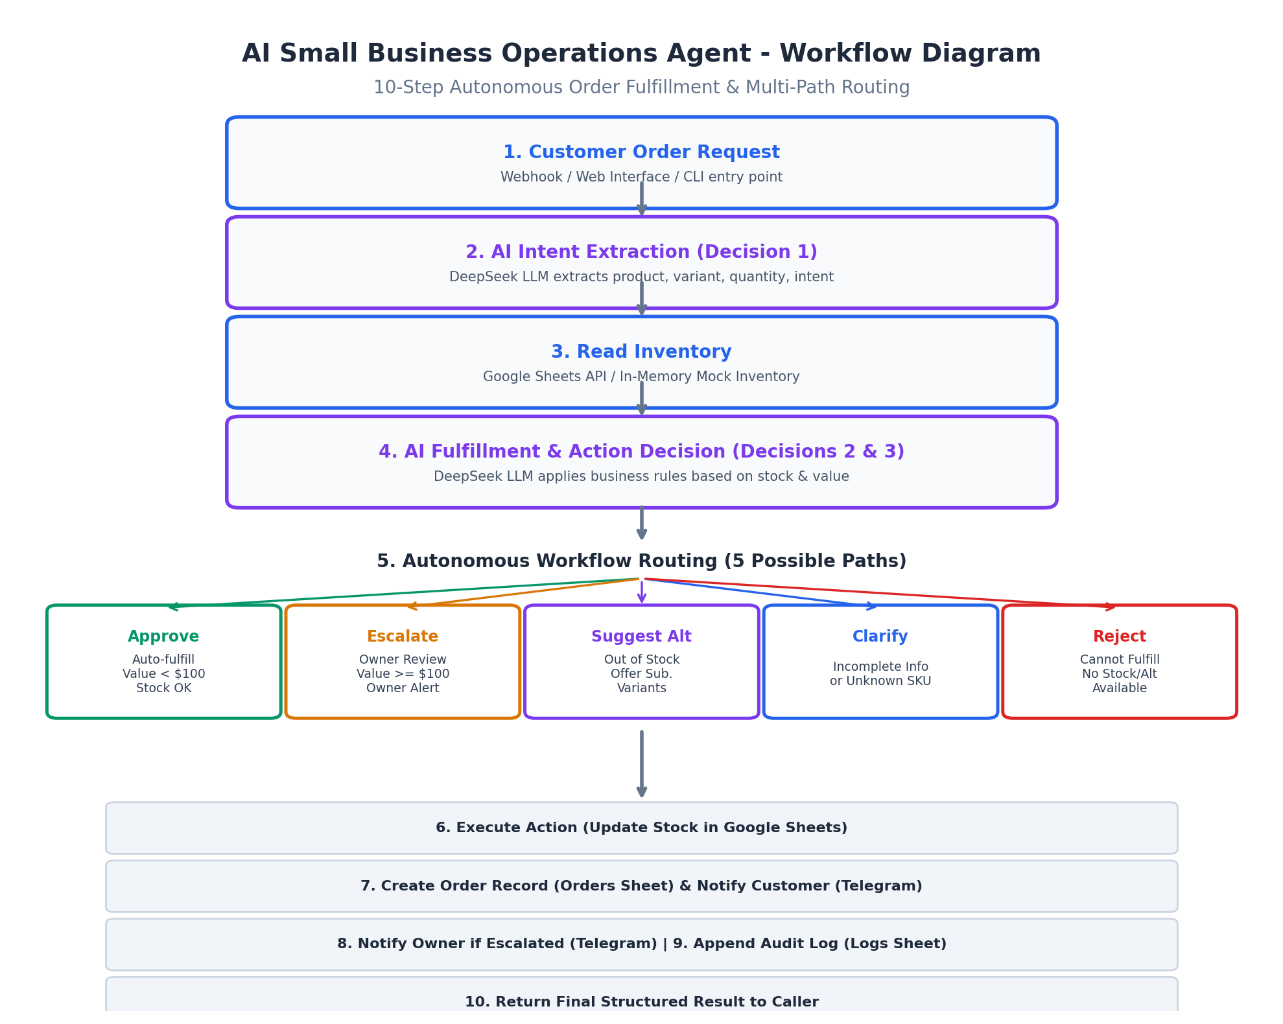
Figure 1: End-to-End 10-Step AI Operations Workflow Diagram
Step # | Action Stage | Component / Tool | Description
1 | Receive Request | Webhook / Web / CLI | Customer message enters system asynchronously.
2 | Extract Order Intent | DeepSeek LLM (Decision 1) | AI parses product name, variant, requested quantity, and intent.
3 | Check Inventory | Google Sheets API | Reads real-time stock levels, unit pricing, and thresholds.
4 | Evaluate Fulfillment | DeepSeek LLM (Decision 2 & 3) | Compares requested quantity against stock and checks business thresholds.
5 | Route Workflow | Autonomous Router | Dynamically routes to 1 of 5 paths: approve, escalate, suggest, clarify, reject.
6 | Execute Inventory Action | Google Sheets API | Deducts stock on approval; holds changes on escalation or suggestion.
7 | Record Order | Google Sheets (Orders Sheet) | Logs order ID, customer name, SKU, price, timestamp, and status.
8 | Notify Customer | Telegram Bot API | Transmits formatted HTML order confirmation or alternative proposals to customer.
9 | Alert Business Owner | Telegram Bot API | Transmits urgent escalation message with details if order >= $100.
10 | Append Audit Trail | Google Sheets (Logs Sheet) | Appends complete trace (inputs, decisions, notifications) to Logs tab.

4. System Architecture
The system follows a modular, decoupled architecture where the central Python Agent Core (agent.py) orchestrates data flow between external LLM reasoning APIs, live spreadsheet databases, and instant messaging bots. An alternative n8n workflow engine orchestration is also provided via importable JSON workflow templates.
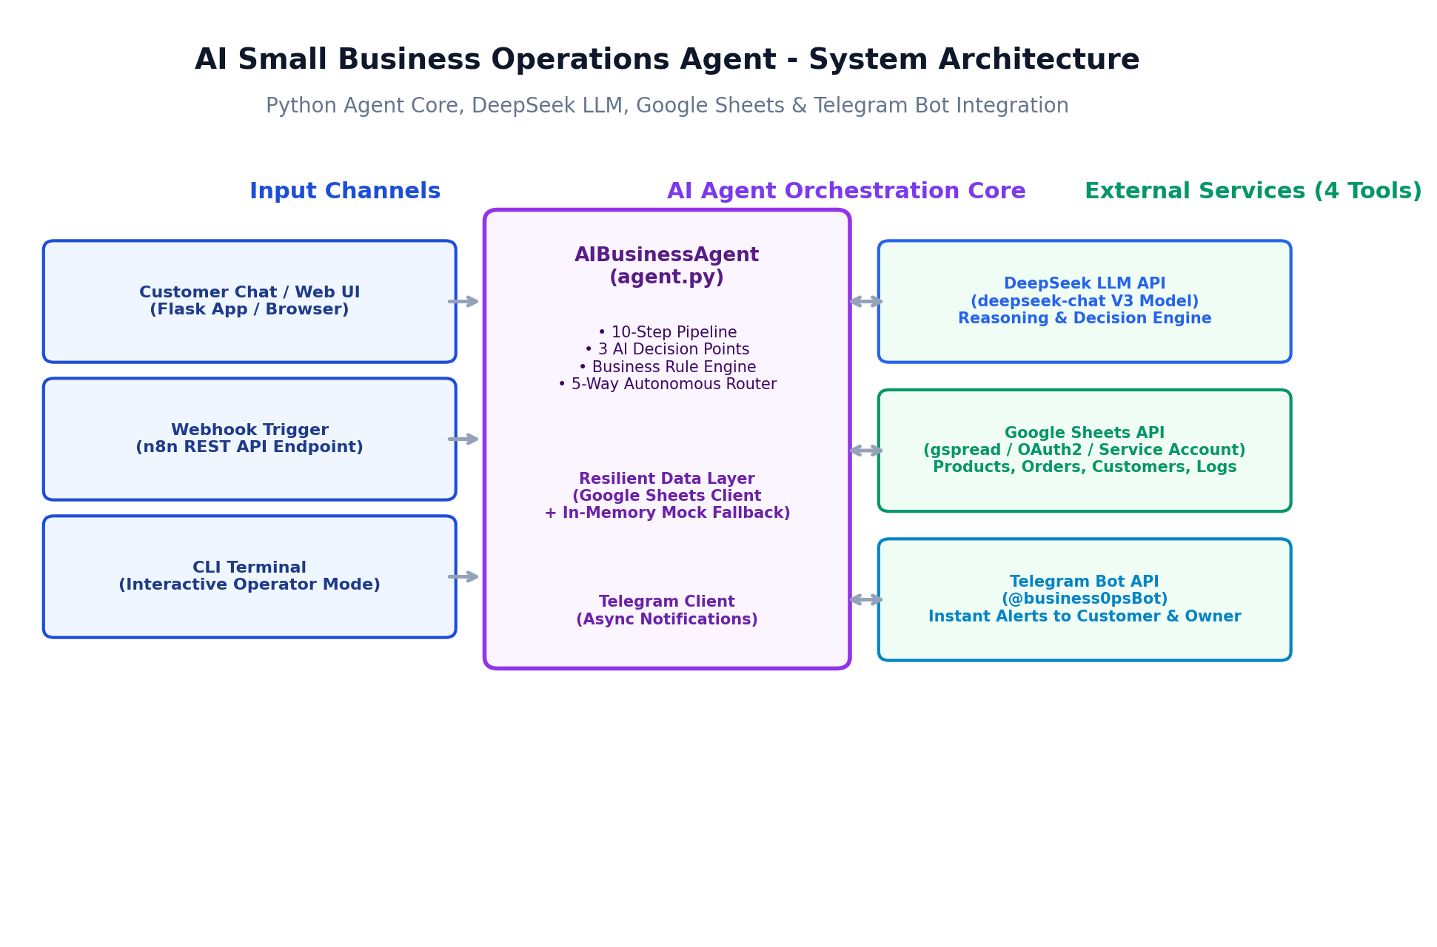
Figure 2: Modular System Architecture & Service Integration Diagram
Tier / Component | Technology Stack | Role & Functional Responsibility
Client Entry Points | Flask Web UI / CLI / Webhook | Accepts natural language customer messages from browser, terminal, or API.
Agent Core & Router | Python 3.10+ (agent.py) | Coordinates 10-step pipeline, maintains state, applies business rules, and routes.
Reasoning & Decision Tier | DeepSeek API (deepseek-chat) | OpenAI-compatible LLM endpoint executing intent extraction and fulfillment logic.
Data Persistence Tier | Google Sheets API (gspread) | Multi-sheet relational database (Products, Orders, Customers, Logs).
Resilient Fallback | In-Memory Mock Database | Provides zero-downtime offline execution if Google Cloud credentials are unavailable.
Notification Tier | Telegram Bot API (@business0psBot) | Dispatches instant alerts and proposals to customer and owner chat IDs.

5. AI Tools, Models, and External Services Used
To satisfy the assignment requirement of integrating at least two external services, the agent integrates four external tools and services, coordinated by an LLM reasoning engine:
Service Name | Category | Model / Protocol | Detailed Role in Solution
DeepSeek API | LLM Reasoning | deepseek-chat (V3) | Performs structured intent extraction and decision reasoning using temperature=0.1.
Google Sheets API | Database / Storage | REST / gspread / OAuth2 | Provides persistent tables for Products, Orders, Customers, and Logs.
Telegram Bot API | Messaging / Alerts | HTTP Bot API (@business0psBot) | Delivers real-time customer confirmations and escalation alerts to owner chat.
n8n Orchestration | Workflow Engine | v2.8.4 Node Graph | Visual node-based workflow alternative for enterprise automation environments.
Flask Web Framework | Web Interface | WSGI / HTML5 / JS | Lightweight browser interface providing live status indicators and test buttons.

AI Decision Points & Autonomous Branching Details:
• Decision Point 1 (Intent Parsing): LLM extracts product, variant, quantity, and intent with confidence scoring.
• Decision Point 2 (Fulfillment Evaluation): LLM checks requested quantity against inventory stock.
• Decision Point 3 (Action Selection): LLM evaluates business rules to autonomously trigger 1 of 5 distinct actions:
Rule ID | Rule Name | Condition Logic | Autonomous Action | Priority
R001 | Auto-approve low value | total_value < $100 AND stock >= quantity | approve | Priority 1
R002 | Escalate high value | total_value >= $100 AND stock sufficient | escalate | Priority 2
R003 | Suggest alternative | stock < quantity AND alternative variant exists | suggest_alternative | Priority 3
R004 | Reject unavailable | stock < quantity AND no alternative exists | reject | Priority 4
R005 | Clarify missing info | product not found OR quantity ambiguous | clarify | Priority 5

6. Implementation Screenshots
Below are screenshots capturing the live execution of the AI Operations Agent across multiple scenarios, illustrating system health status, order entry, AI reasoning, and multi-path autonomous routing:
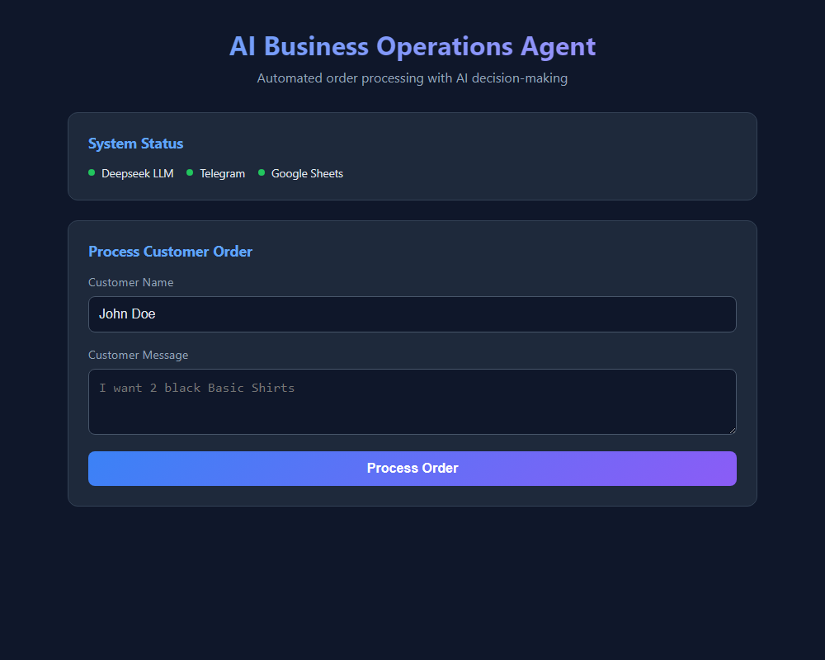
Figure 3: Web Dashboard with live DeepSeek, Telegram, and Sheets health indicators
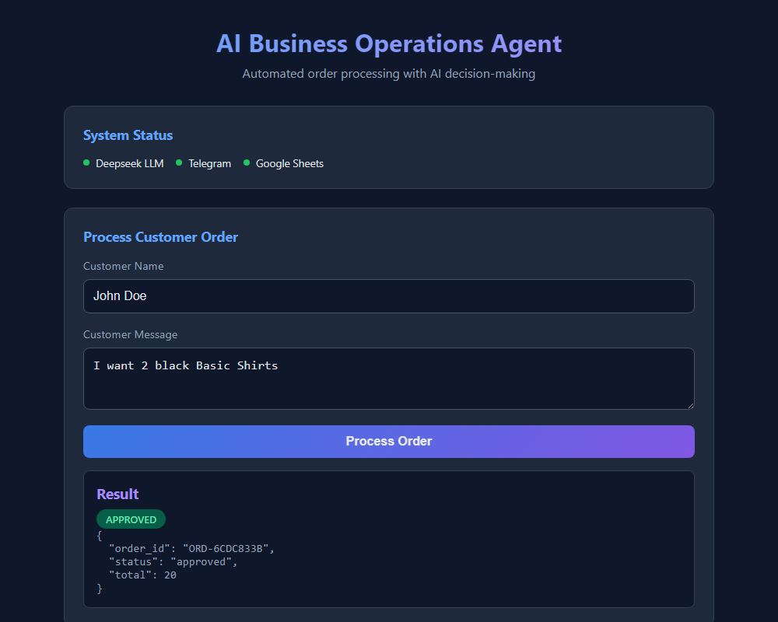
Figure 4: Scenario 1 — Auto-Approval for order under $100 with stock deduction
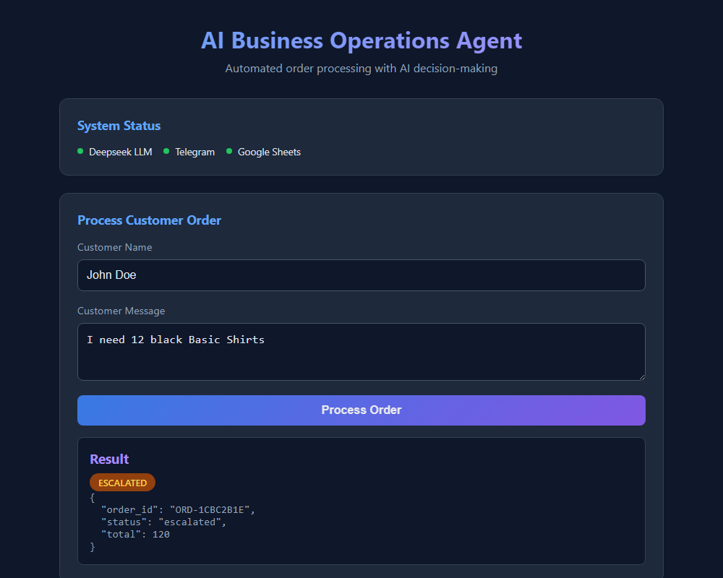
Figure 5: Scenario 2 — Autonomous Escalation to Owner for high-value order ($120 >= $100)
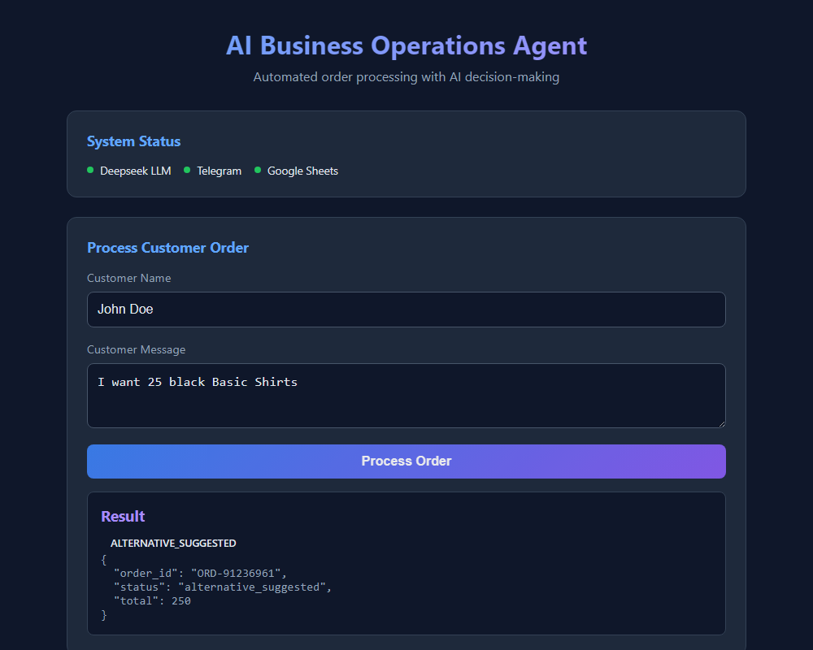
Figure 6: Scenario 3 — Autonomous Suggestion of alternative variants on low stock
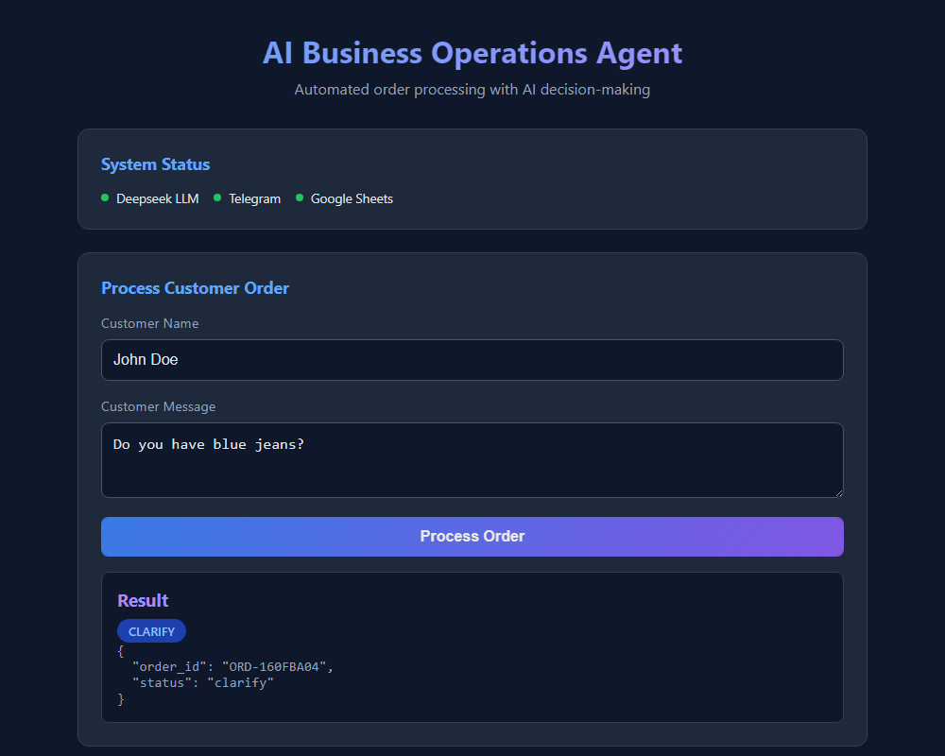
Figure 7: Scenario 4 — Clarification Request triggered when an item is not found
Customization Opportunity
Tip for Submission: You can also paste screenshots of your phone/Telegram chat receiving the alerts from @business0psBot or your Google Sheets spreadsheet right here in this Word document before exporting to PDF.

7. Sample Execution (Input and Output)
The AI Agent was evaluated across four comprehensive end-to-end customer scenarios. Below are the exact inputs, step-by-step AI reasoning stages, and generated outputs:

Scenario 1: Normal Order (Auto-Approve Flow)
Customer: John Doe | Input Message: "I want 2 black Basic Shirts"
Step 1 (Intent Extraction):
Product: Basic Shirts | Variant: black | Quantity: 2 | Intent: order | Confidence: 0.95
Step 2 (Inventory Check):
Found: Basic Shirt (Black) | Stock: 20 | Price: $10
Step 3 (AI Action Decision):
Action: "approve"
Reason: Total value is $20 (< $100) and stock (20) is sufficient for requested quantity (2).
Step 4 (Execution & Output):
Stock updated: 20 -> 18 | Order recorded: ORD-B94D74AD | Customer Telegram Sent
Output JSON: {"status": "approved", "order_id": "ORD-B94D74AD", "total": 20}

Scenario 2: Large Order (Autonomous Escalation Flow)
Customer: Jane Smith | Input Message: "I need 12 black Basic Shirts"
Step 1 (Intent Extraction):
Product: Basic Shirts | Variant: black | Quantity: 12 | Intent: order | Confidence: 0.95
Step 2 (Inventory Check):
Found: Basic Shirt (Black) | Stock: 18 | Price: $10
Step 3 (AI Action Decision):
Action: "escalate"
Reason: Total order value is $120, which is >= $100, and stock is sufficient (18 >= 12).
Per business rules, orders with total value >= $100 require owner approval.
Step 4 (Execution & Output):
Owner notified via Telegram alert with order breakdown | Status set to pending
Output JSON: {"status": "escalated", "order_id": "ORD-1434B6E7", "total": 120}

Scenario 3: Insufficient Stock (Autonomous Suggestion Flow)
Customer: Bob Wilson | Input Message: "I want 25 black Basic Shirts"
Step 1 (Intent Extraction):
Product: Basic Shirts | Variant: black | Quantity: 25 | Intent: order | Confidence: 0.95
Step 2 (Inventory Check):
Found: Basic Shirt (Black) | Stock: 18 | Price: $10 (Insufficient for 25 units)
Step 3 (AI Action Decision):
Action: "suggest_alternative"
Reason: Requested quantity (25) exceeds available stock (18) for Basic Shirt in Black.
Alternative variants available: White (18 in stock) and Red (15 in stock).
Step 4 (Execution & Output):
Proposes breakdown: 18 Black Basic Shirts + 7 White Basic Shirts ($250 total)
Customer notified via Telegram with confirmation prompt
Output JSON: {"status": "alternative_suggested", "order_id": "ORD-02692FB9", "total": 250}

Scenario 4: Unknown Product (Clarification Flow)
Customer: Alice Brown | Input Message: "Do you have blue jeans?"
Step 1 (Intent Extraction):
Product: jeans | Variant: blue | Quantity: None | Intent: inquiry | Confidence: 0.90
Step 2 (Inventory Check):
Query 'jeans' not matched in inventory catalogue.
Step 3 (AI Action Decision):
Action: "clarify"
Reason: Product 'blue jeans' was not found in active inventory.
Step 4 (Execution & Output):
Polite message sent to customer requesting SKU clarification or alternative inquiry.
Output JSON: {"status": "clarify", "order_id": "ORD-82D6DABA"}

8. Video Demo Link
A comprehensive video walkthrough demonstrating the live agent processing order requests, triggering AI decisions, and sending real-time Telegram alerts has been recorded and uploaded for evaluation:
Public Video Demo Link (Clickable)
Public Video URL: [PASTE YOUR PUBLIC VIDEO LINK HERE - e.g., YouTube Unlisted, Loom, or Google Drive URL]
Demo Content Covered in Video:
1. Overview of the problem and architecture.
2. Live execution in Web UI (http://localhost:5000) and CLI (python agent.py).
3. Live Telegram bot (@business0psBot) alerts popping up for both Customer and Owner.
4. Demonstration of autonomous branching: Auto-approval (<$100), Escalation (>=$100), Alternative suggestion, and Clarification.
5. Inspection of Google Sheets records (Products, Orders, Customers, and audit Logs).

9. Link to Your Project
The project source code, workflows, schemas, and demo suite are publicly accessible on GitHub:
Project Link & Source Code
GitHub Public Repository:
https://github.com/mengchheanglong/business-operations-agent
Repository Structure:
• agent.py - Main autonomous AI operations agent with DeepSeek & Telegram integration
• web_app.py & templates/index.html - Interactive browser testing dashboard
• demo.py & demo/demo-results.json - Multi-path test suite and recorded outputs
• workflows/order-agent-workflow.json - 17-node n8n orchestration workflow template
• workflows/setup-sheets-workflow.json - Google Sheets automated initialization template
• docs/ - Full report, credentials guide, and technical specs
• requirements.txt & .env.example - Dependency management and environment templates

Quick Start Instructions for Evaluators:
# 1. Clone repository
git clone https://github.com/mengchheanglong/business-operations-agent.git
cd business-operations-agent
# 2. Install dependencies
pip install -r requirements.txt
# 3. Configure API keys (DeepSeek, Telegram, Google Sheets in .env)
cp .env.example .env
# 4. Run interactive web dashboard
python web_app.py
# Open http://localhost:5000 in your browser
# 5. Or execute automated demo suite across all 4 scenarios
python demo.py

10. Requirements Verification Matrix
The table below verifies full compliance with all criteria from the assignment specification:
Criterion | Assignment Minimum | Implemented in This Project | Compliance
Problem Scope | Clearly defined real-world problem | Small business retail order & inventory management | MET (100%)
LLM Reasoning | Required for decisions | DeepSeek LLM (deepseek-chat) for intent & action reasoning | MET (100%)
External Tools | >= 2 external tools/services | 4 services: Google Sheets, Telegram Bot, DeepSeek, n8n | EXCEEDED (4 tools)
Workflow Steps | >= 5 steps | 10 sequential operational steps | EXCEEDED (10 steps)
AI Decision Points | >= 2 decision points | 3 decision points (Intent, Stock fulfillment, Action routing) | EXCEEDED (3 decisions)
Autonomous Decision | >= 1 workflow-changing decision | 5-way autonomous branching (approve, escalate, suggest, clarify, reject) | EXCEEDED (5 paths)
Deliverables Format | One PDF with sections 1 to 9 | All 9 sections structured with embedded diagrams & screenshots | READY

