KIRIROM INSTITUTE OF TECHNOLOGY
Department of Software Engineering
BLOCKCHAIN-BASED DIGITAL CERTIFICATE ISSUING PLATFORM
Final Project Submission Report — Citadel Platform Architecture & Implementation
Student / Author | Long Mengchheang
Institution | Kirirom Institute of Technology (KIT)
Team Arrangement | Individual Project (100% Technical Contribution)
GitHub Repository | https://github.com/mengchheanglong/citadel-blockchain-certificates
Public Demo Video | Available on Google Drive / YouTube (Public Link)
Submission Date | October 2026

1. System Overview
1.1 The Credentialing Dilemma
Educational institutions and professional certifying organizations face growing challenges with traditional credential authenticity:
- Vulnerability to Forgery: Static PDF certificates and paper diplomas can easily be altered using graphic editing software or AI tools to modify recipient names, degree titles, or graduation years without visual detection.
- Operational Bottlenecks: Employers and university registrars must conduct manual verification via phone calls or email, typically requiring two to four weeks per verification.
- Centralized Database Risks: Centralized academic databases represent single points of failure susceptible to administrative corruption, insider tampering, and catastrophic data loss.
1.2 The Citadel Platform Solution
Citadel is a decentralized web application engineered to modernize credential issuing using Ethereum blockchain technology:
- Cryptographic Immutability: When a certificate is issued, a unique SHA-256 cryptographic fingerprint is permanently recorded on an Ethereum smart contract. Any alteration to student data alters the hash, immediately exposing the forgery.
- Instant Zero-Gas Verification: Verifiers authenticate credentials in seconds without requiring cryptocurrency, a Web3 wallet, or a platform account via free on-chain view queries.
- Automated Issuance & Delivery: The platform generates high-resolution vector PDF diplomas with embedded verification QR codes and dispatches them automatically to student inboxes via SMTP.
- Lifecycle Governance: Issuing bodies can assign validity periods (Lifetime, 1 Year, 2 Years) and revoke compromised certificates on-chain with mandatory audit justification logging.
2. System Architecture
Citadel utilizes a clean four-tier architectural separation of concerns designed for enterprise reliability, high throughput, and data privacy:
- 1. Presentation Layer (Frontend): Next.js 14 App Router, TypeScript, and Tailwind CSS. Provides an administrative operations portal and a clean public verification engine.
- 2. Application & API Layer (Backend): Next.js Server Route Handlers and Server Actions. Enforces Zod schema validation, computes deterministic SHA-256 digests, renders vector diplomas with jsPDF, and coordinates SMTP delivery via Nodemailer.
- 3. Persistence Layer (Database): PostgreSQL managed via Prisma ORM 5.18. Stores recipient metadata, degree titles, and institution profiles off-chain to ensure GDPR/FERPA compliance.
- 4. Decentralized Ledger Layer (Blockchain): Solidity 0.8.24 smart contract (CertificateRegistry.sol) deployed on the Ethereum EVM (Sepolia Testnet / Hardhat). Serves as the immutable registry for 32-byte credential hashes.
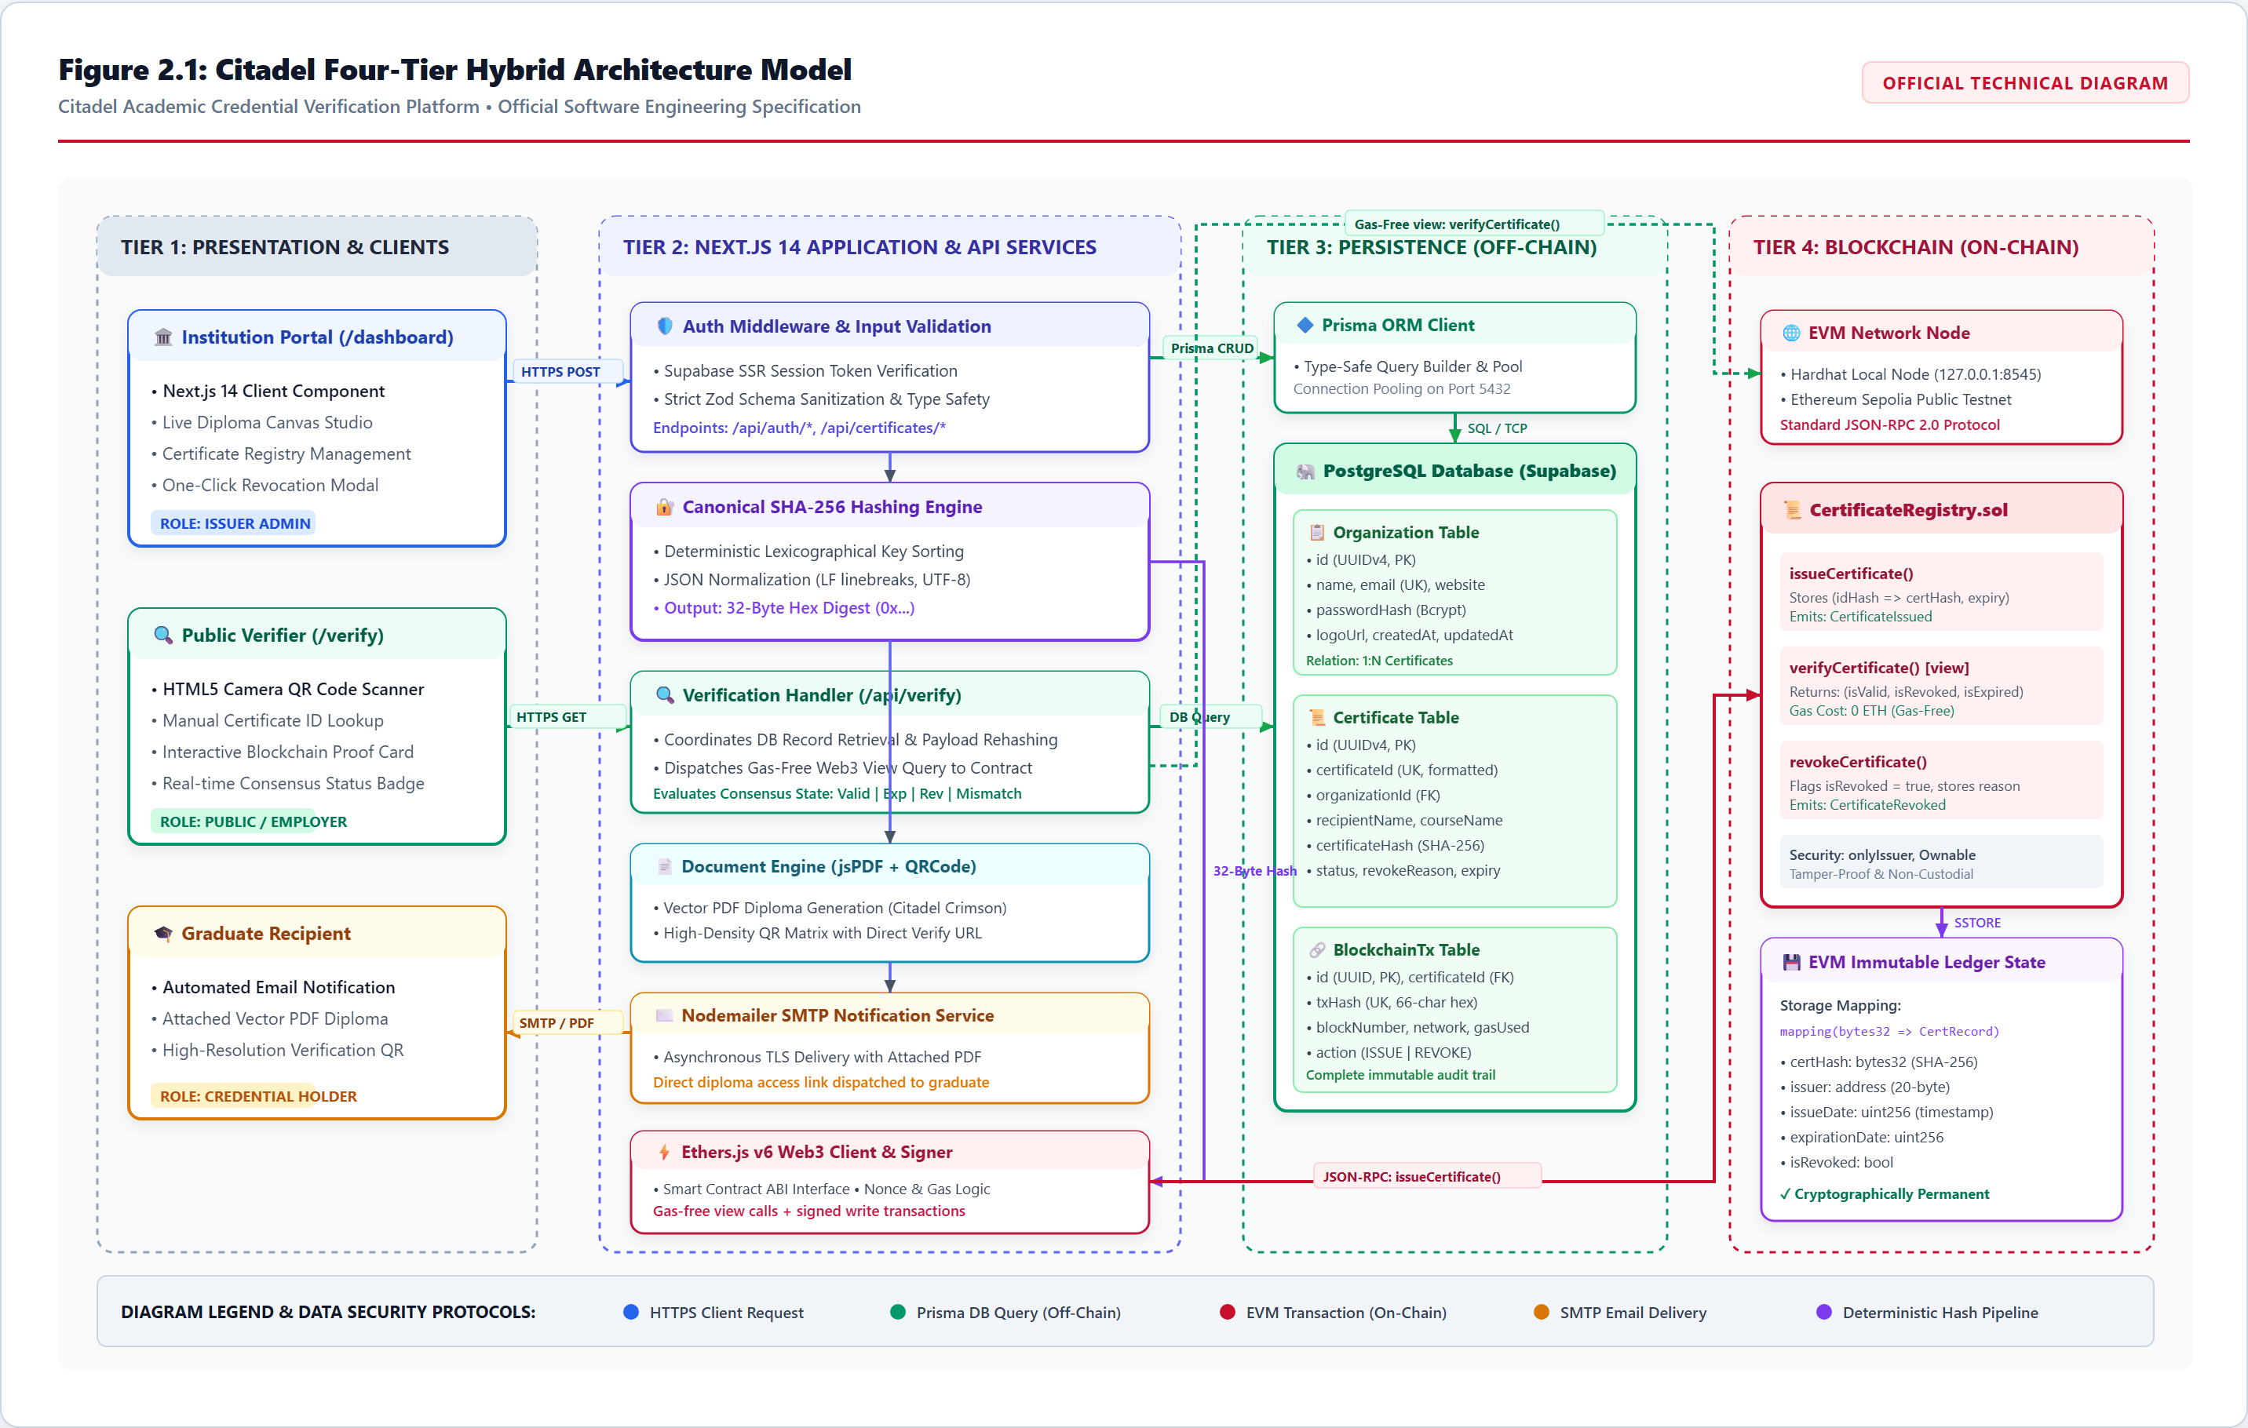
Figure 1: Citadel four-tier system architecture model.
3. User Flow / System Flow
The platform coordinates two primary workflows: the Organization Issuance Pipeline and the Public Verification Pipeline:
- Organization Issuance Flow: The accredited institution logs into the dashboard and accesses the Issue Studio. As the administrator inputs graduate information, an interactive vector diploma canvas updates in real time. Upon submission, the server computes a canonical SHA-256 fingerprint, calls issueCertificate on the smart contract, stores metadata in PostgreSQL, and generates an official PDF diploma emailed to the graduate.
- Public Verification Flow: An employer or admissions officer navigates to /verify and provides the credential via camera QR scan, image drop, PDF upload, or manual ID entry. The system retrieves the record, re-computes the hash, executes a zero-gas view call on the smart contract, and renders an official cryptographic proof badge (Valid, Expired, or Revoked).
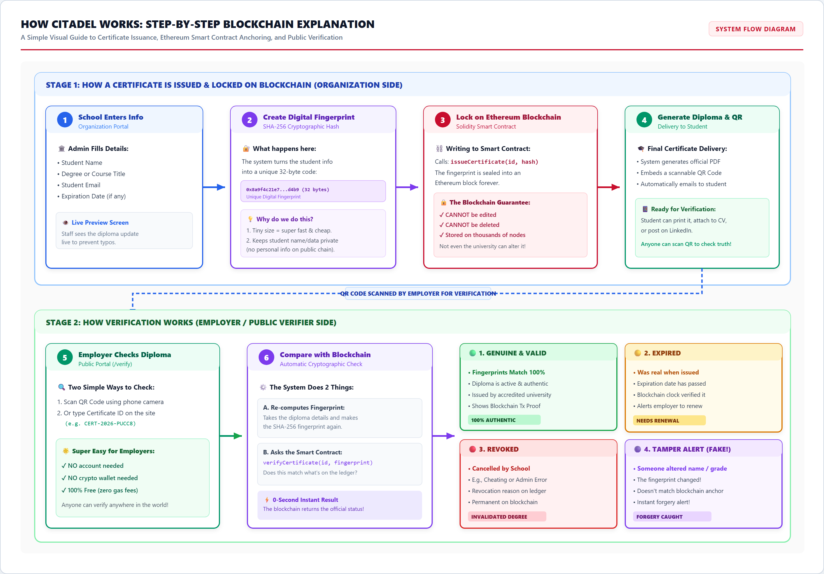
Figure 2: End-to-end credential lifecycle: Stage 1 Issuance Pipeline and Stage 2 Public Verification Pipeline.
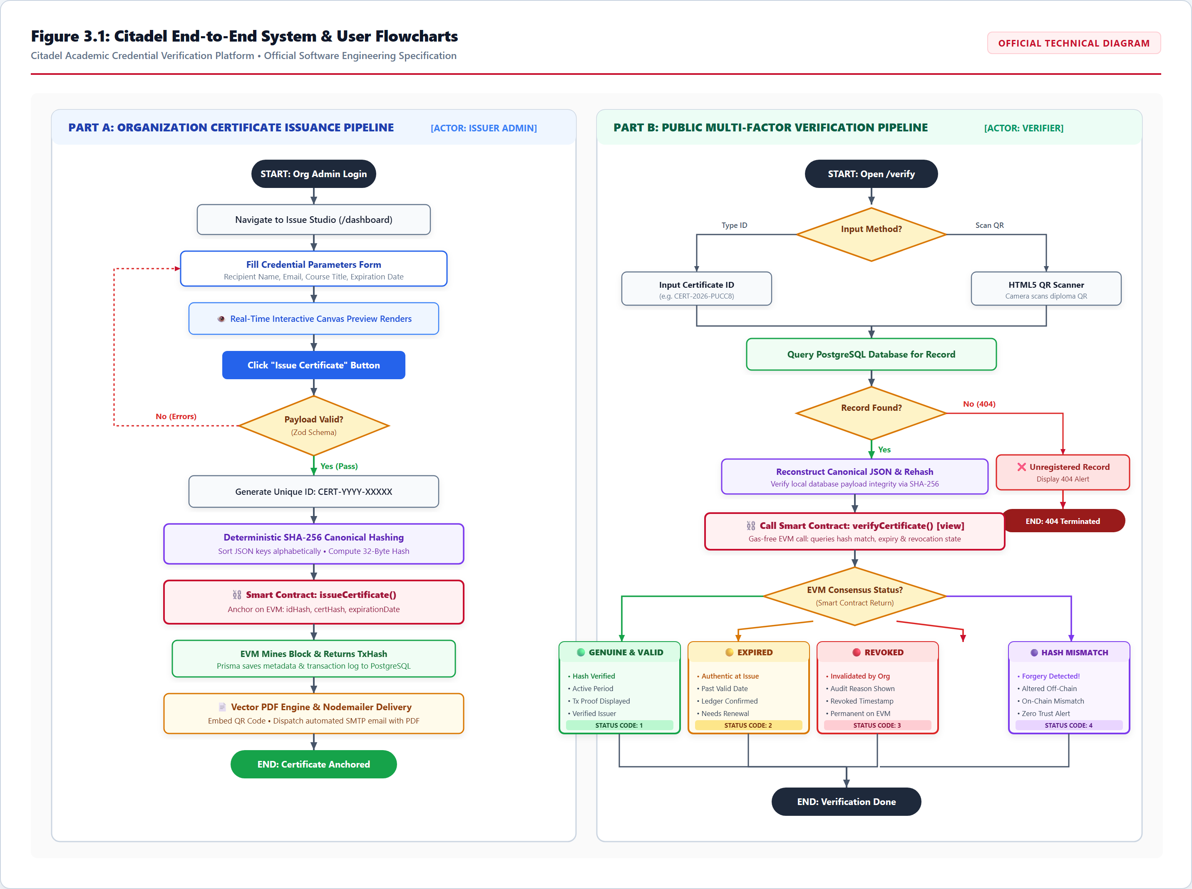
Figure 3: Technical sequence diagram illustrating interactions across User, Web Application, EVM Smart Contract, Database, and Recipient.
4. Database Design (ER Diagram)
To protect student privacy and minimize gas expenditure, detailed textual data is stored off-chain in PostgreSQL, with relational foreign keys connecting to on-chain transaction hashes:
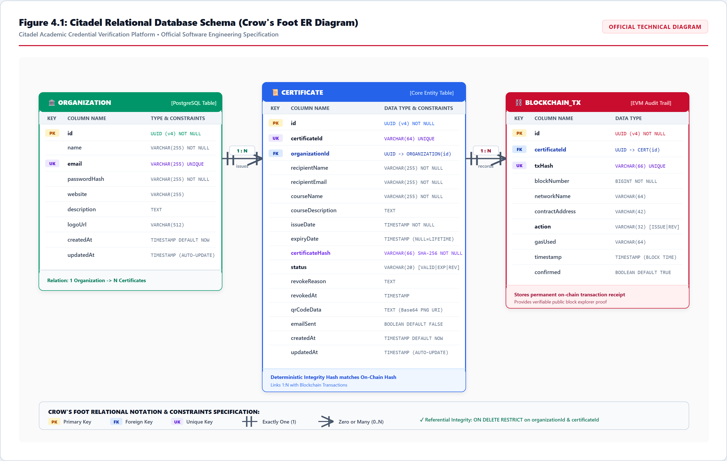
Figure 4: Entity-Relationship model representing Organization, Certificate, and BlockchainTransaction entities.
Table | Key Attributes & Constraints | Architectural Purpose
Organization | id (PK UUID), name, email (UK), website, description, createdAt | Stores verified institution profile and issuer credentials.
Certificate | id (PK UUID), certificateId (UK), recipientName, recipientEmail, courseName, issueDate, expiryDate, status, certHash, organizationId (FK) | Maintains academic records, expiration timestamps, and canonical SHA-256 digests.
BlockchainTransaction | id (PK UUID), certificateId (FK), txHash (UK), blockNumber, networkName, contractAddress, action, timestamp, confirmed | Audit log of on-chain Ethereum transaction receipts and block confirmations.

5. Blockchain Architecture
5.1 Hybrid On-Chain / Off-Chain Philosophy
Storing complete academic transcripts and personal identities directly on Ethereum is cost-prohibitive and violates privacy laws (GDPR Right to be Forgotten, FERPA student privacy). Citadel stores metadata in PostgreSQL while anchoring only a 32-byte cryptographic hash on-chain.
5.2 Deterministic Canonical Hashing Protocol
To prevent JSON key-ordering discrepancies across different programming platforms, Citadel sorts object keys lexicographically before calculating the SHA-256 digest:
Mathematical Cryptographic Specification: Canonical Payload = JSON.stringify(sortKeys({ certId, recipientName, courseName, issueDate, organizationId }))
certHash = SHA-256(Canonical Payload)
certIdHash = keccak256(certId)

Due to the avalanche effect of SHA-256, changing even a single byte in the graduate's name or course title produces a completely different hash, immediately causing on-chain verification to fail.
6. Smart Contract Design
The CertificateRegistry.sol smart contract is written in Solidity 0.8.24 and compiled with Hardhat:
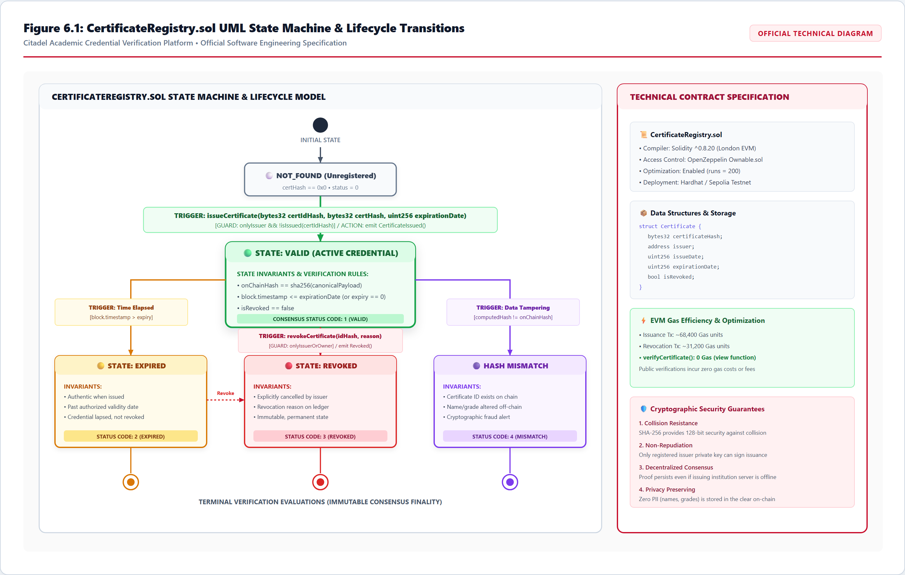
Figure 5: CertificateRegistry.sol Smart Contract Architecture: State Machine Lifecycle, Modifiers, and Cryptographic Invariance.
6.1 State Machine Lifecycle
- Valid (1): Credential exists on-chain, hash matches, and block.timestamp is before expirationDate.
- Expired (2): Credential is authentic, but the validity window has elapsed.
- Revoked (3): Formally invalidated on-chain by the issuing institution with recorded audit reason.
- HashMismatch (4): Certificate ID exists, but the presented data payload produces a mismatched hash.
- NotFound (0): Certificate ID has never been registered on-chain.
6.2 Key Smart Contract Functions
- issueCertificate(bytes32 certIdHash, bytes32 certHash, uint256 expirationDate): Enforces authorized issuer role, checks that the ID has not been used, verifies future expiry, and commits the certificate to the blockchain. Emits CertificateIssued.
- verifyCertificate(bytes32 certIdHash, bytes32 certHash): Free view function (zero gas). Compares the presented hash against the on-chain ledger and dynamically computes expiration.
- revokeCertificate(bytes32 certIdHash, string reason): Only the original issuing institution or contract administrator can revoke an active certificate. Emits CertificateRevoked.
7. User Interface Design or Screenshots
Below are the high-resolution screenshots demonstrating all required features across the Organization Portal and Certificate Verification Engine:
7.1 Organization Portal Interface
The Organization Portal provides accredited institutions with complete administrative control:
- 1. Organization Login: Secure authentication with input validation and session routing.
- 2. Certificate Issuance: Interactive split-screen studio where entered data renders a vector diploma canvas in real time.
- 3. Downloadable PDF Diplomas: Automatic PDF creation with embedded QR code and SMTP email dispatch.
- 4. Blockchain Commitment: Mined transaction confirmations with Tx Hash and Block Number on Ethereum Sepolia.
- 5. Issued Certificate Management: Comprehensive registry table with status filters (All, Valid, Expired, Revoked) and CSV audit export.
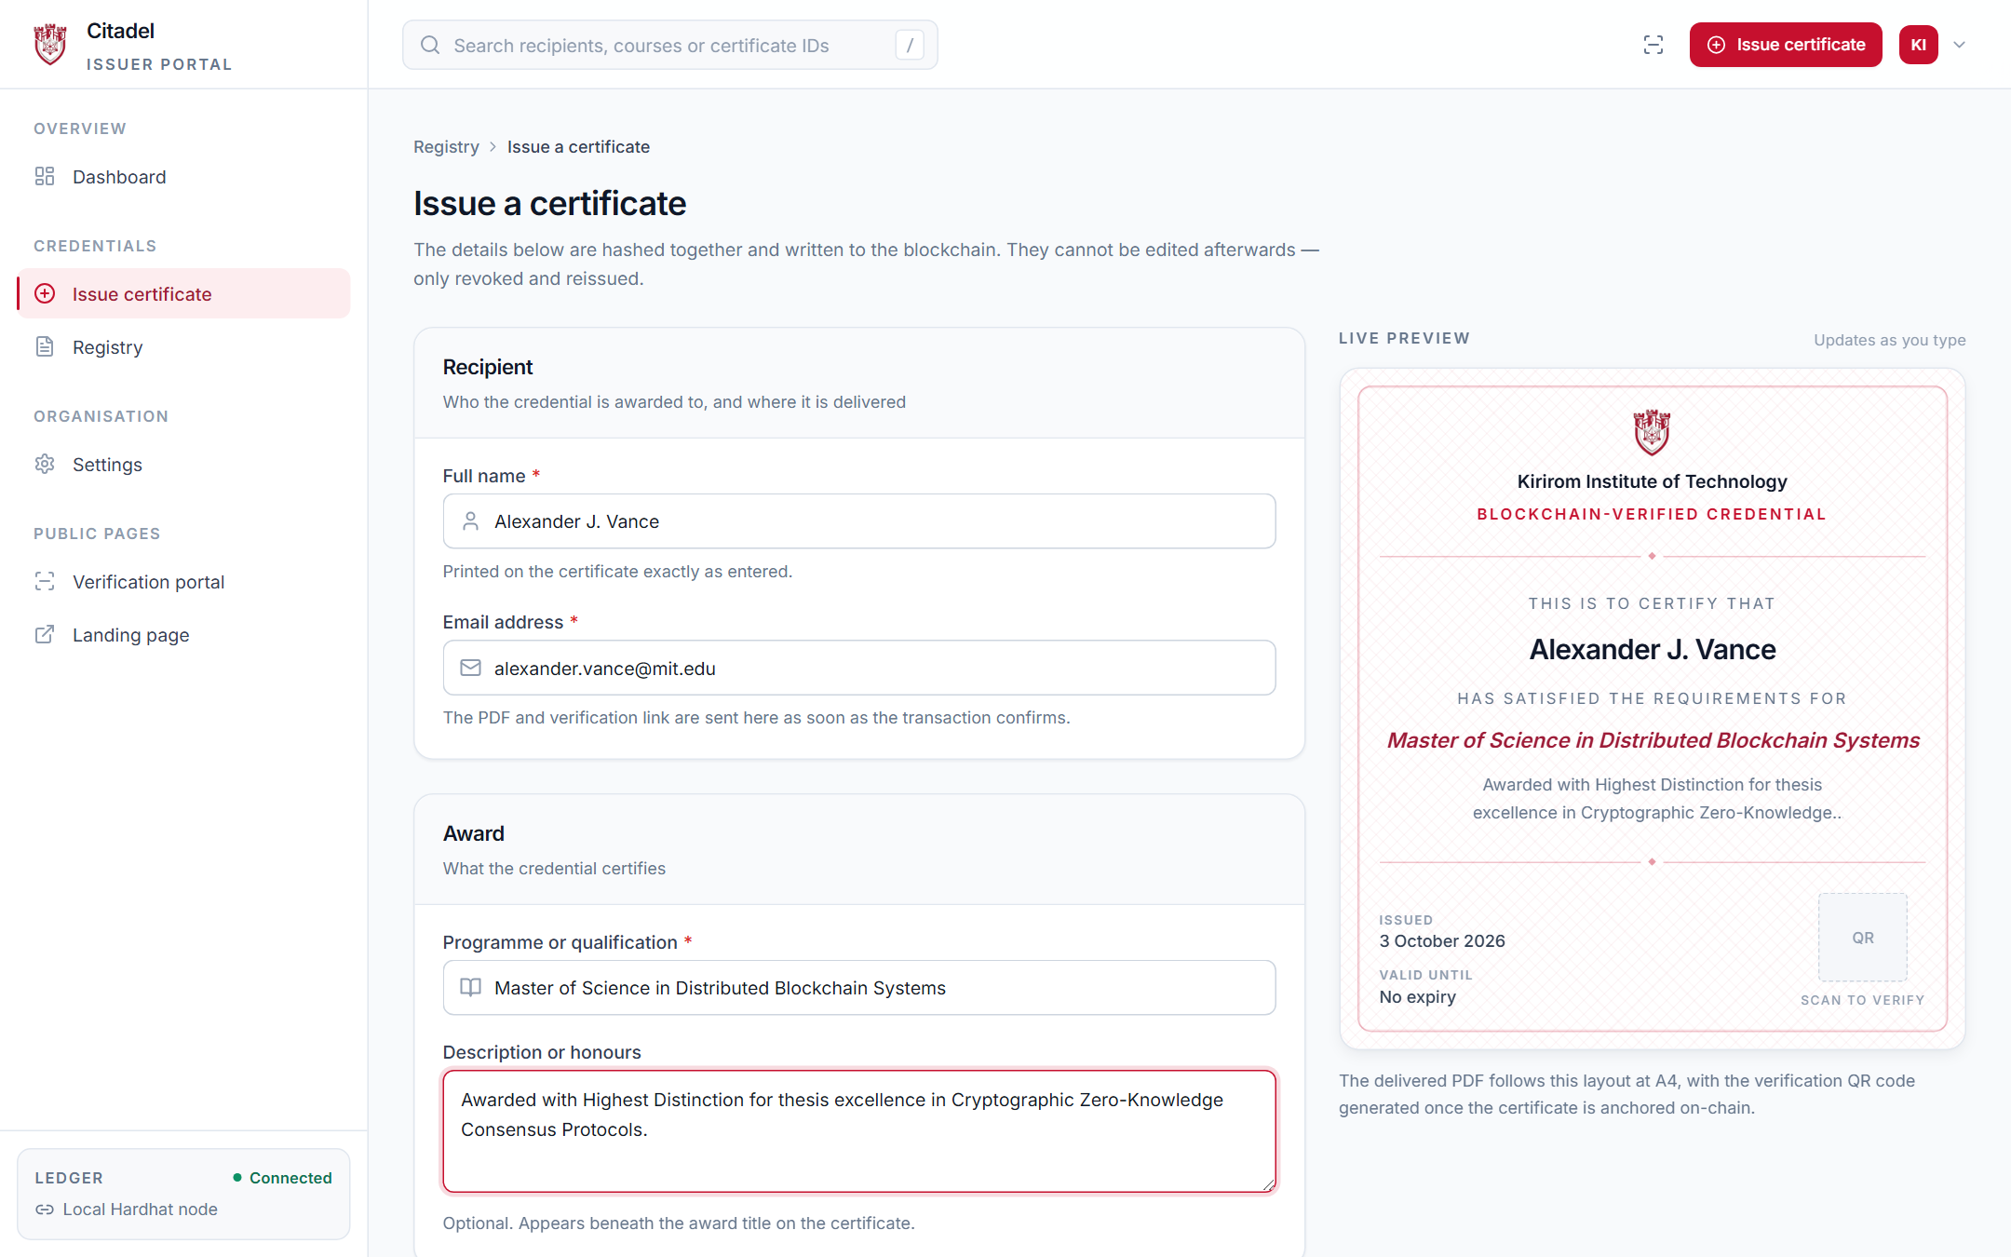
Figure 6: Split-screen Issue Studio: form fields on left and real-time vector diploma preview on right.
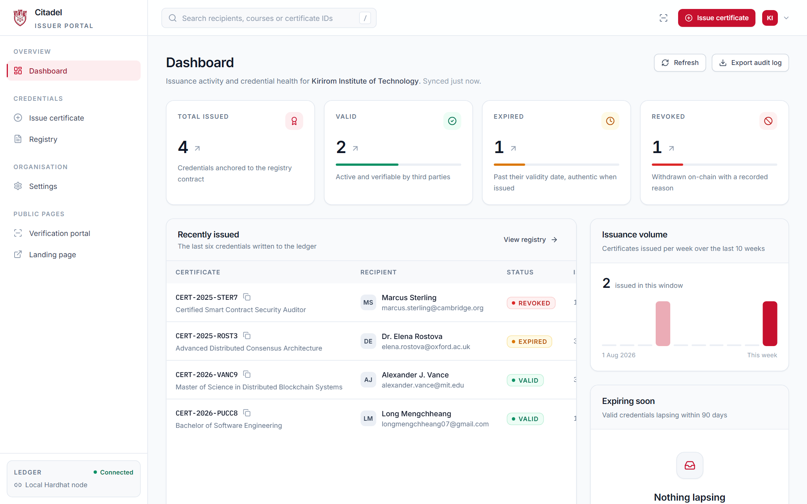
Figure 7: Organization Executive Dashboard showing live metrics, issuance trends, and recent records.
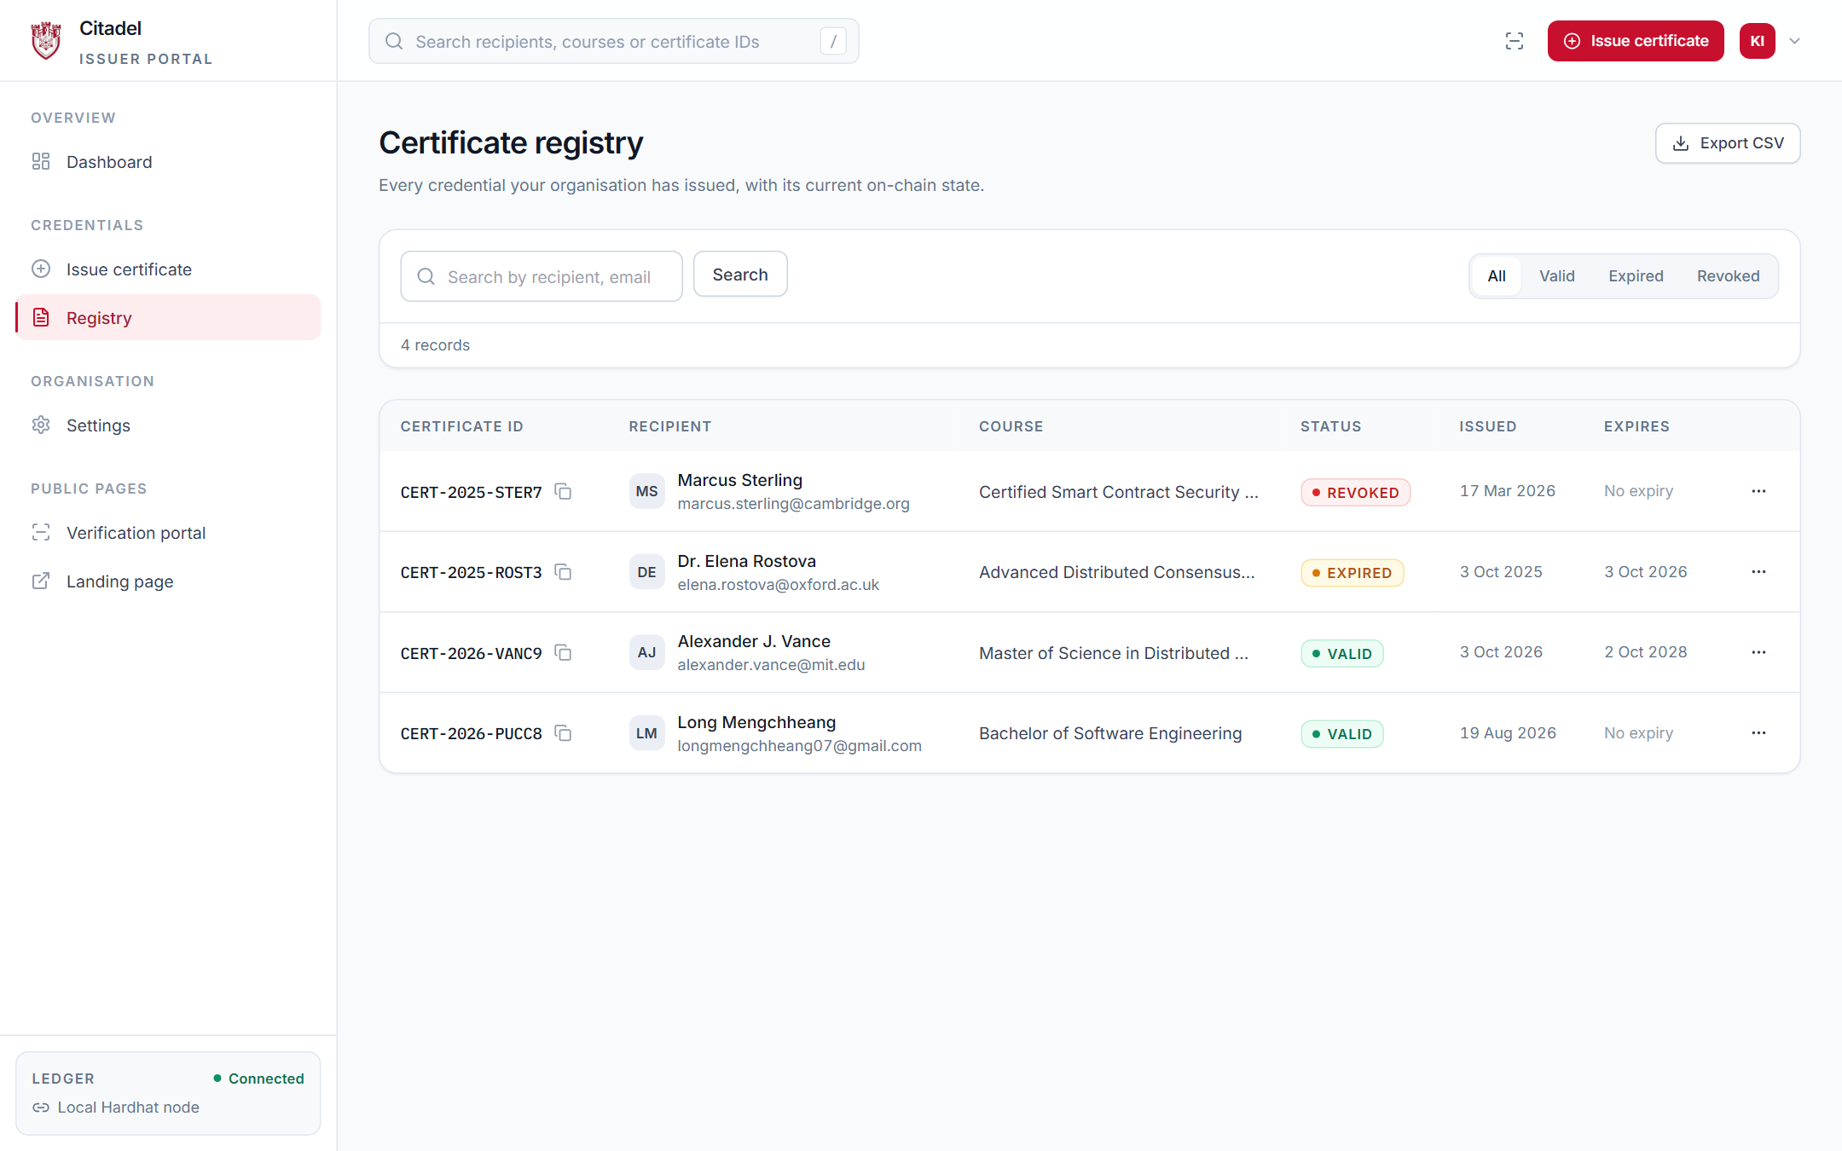
Figure 8: Certificate Registry table with status filter tabs and client-side CSV spreadsheet export.
7.2 Certificate Verification Interface
Public users verify credentials without accounts, gas, or Web3 wallets:
- 1. Multi-Modal Verification: Public users can verify via Certificate ID, camera QR scan, image drop, or PDF upload.
- 2. Certificate Metadata Display: Displays student name, degree title, issue date, and issuing accredited institution.
- 3. Blockchain Transaction Proof: Displays on-chain transaction hash, block number, contract address, and Etherscan link.
- 4. Three Lifecycle Statuses: Evaluates state across all three required statuses: Valid (Green), Expired (Yellow), and Revoked (Red).
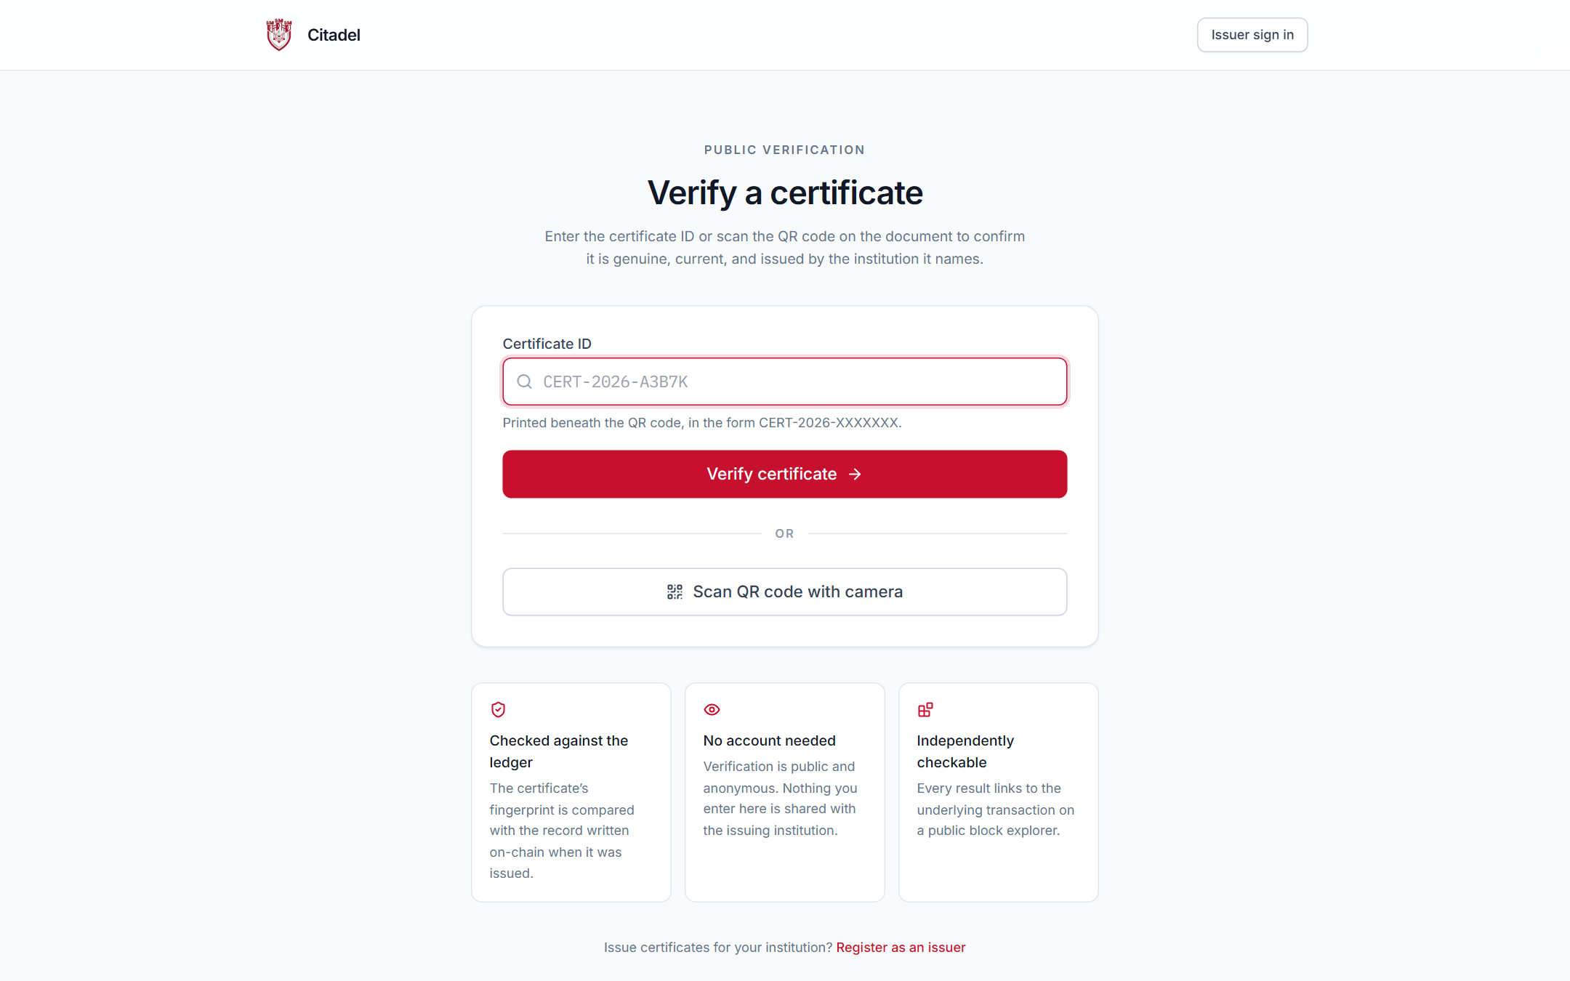
Figure 9: Public verification portal supporting manual ID search, camera scanning, and file upload.
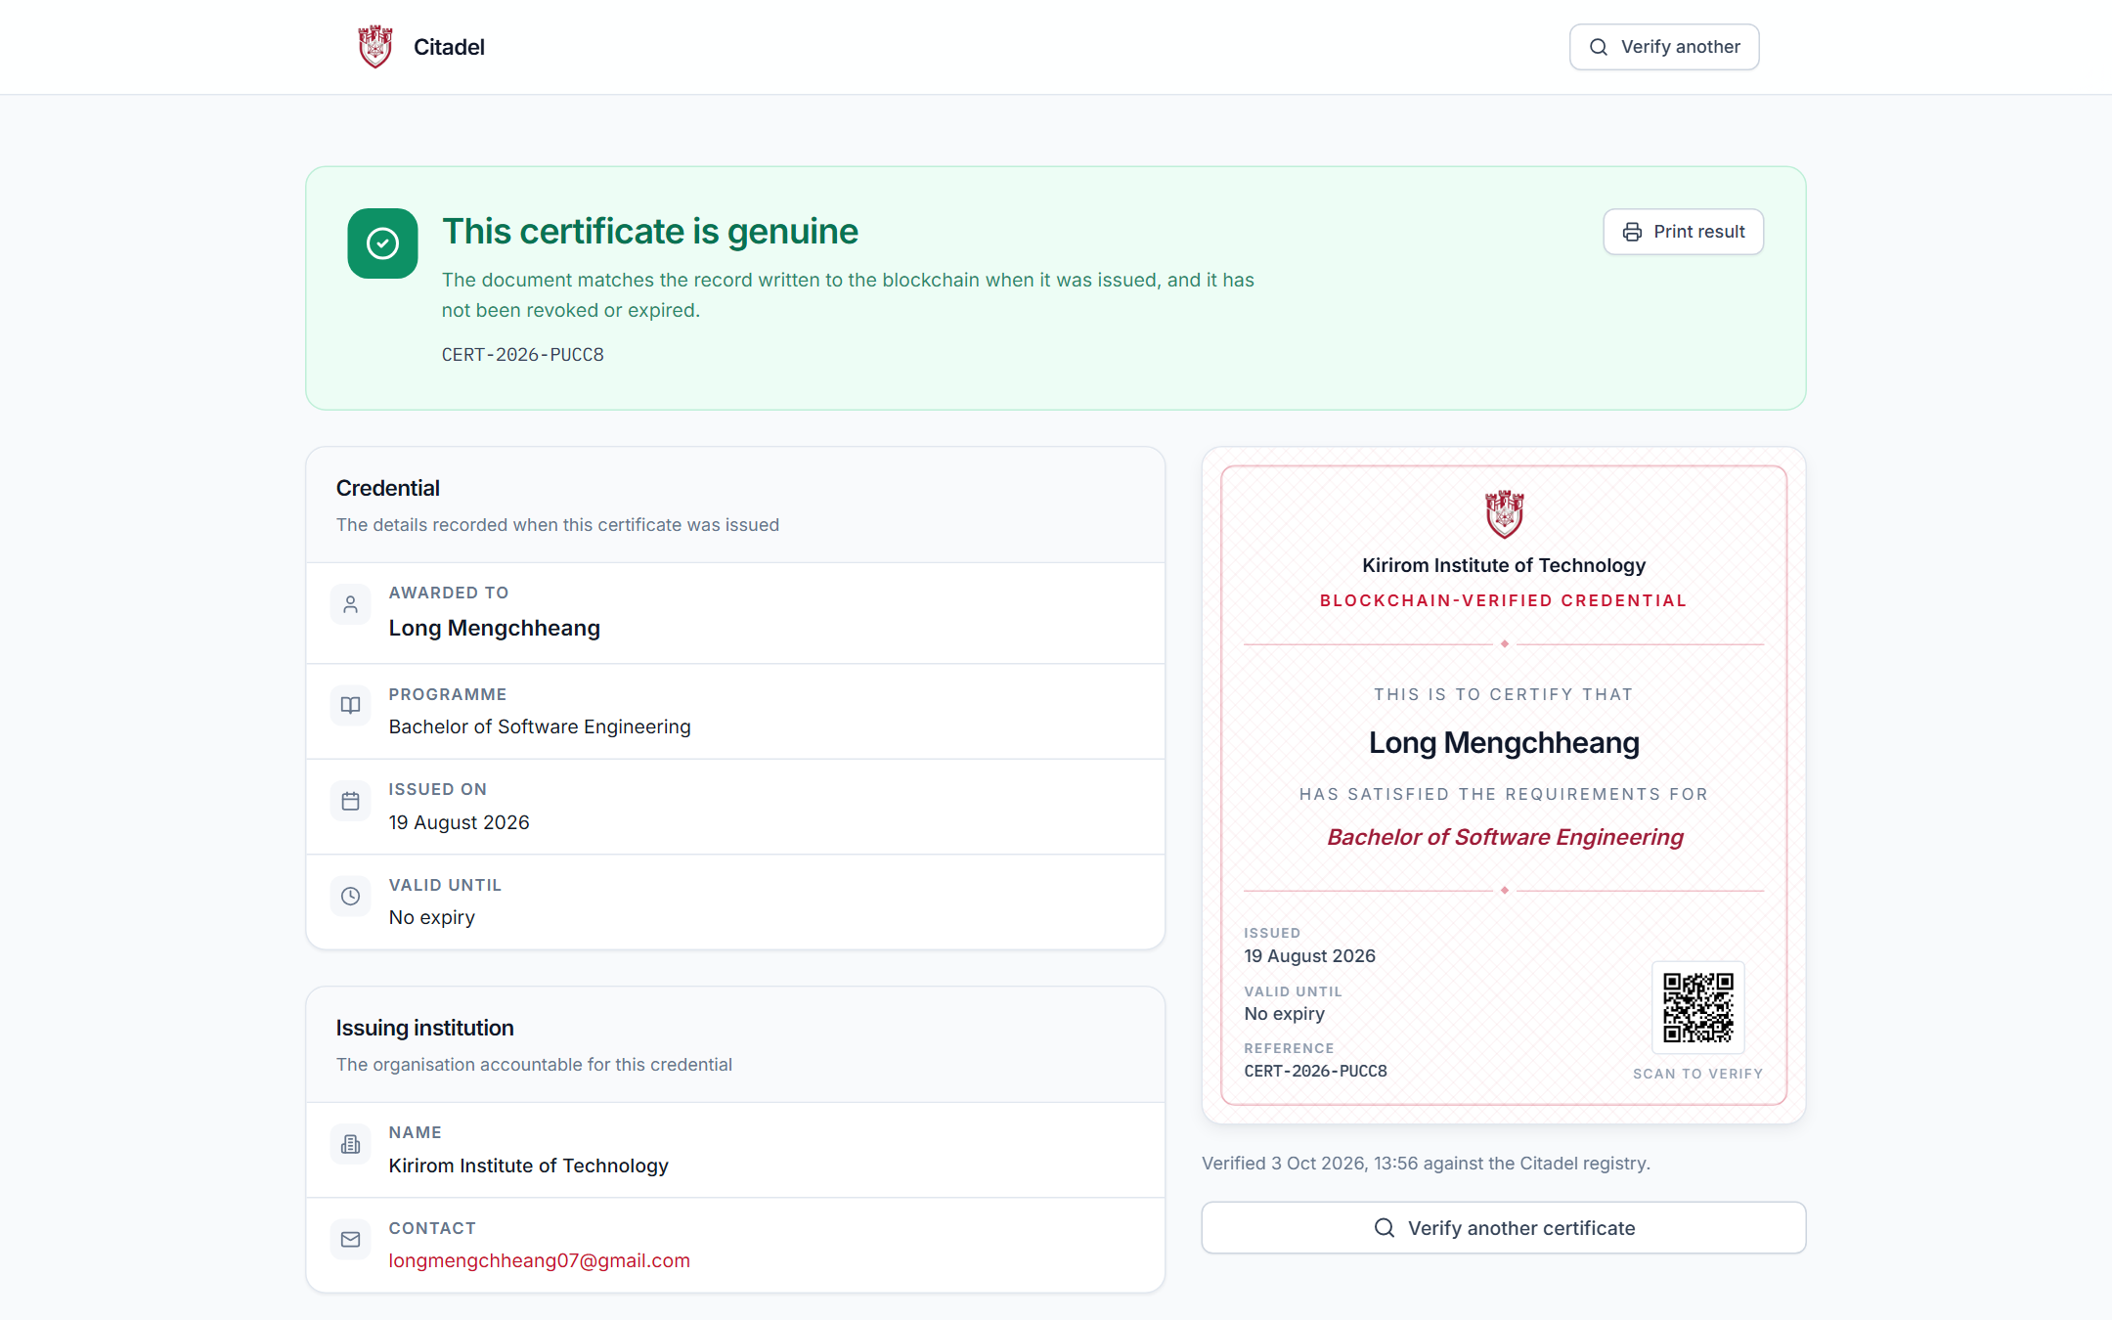
Figure 10: Cryptographic proof result: Valid status with on-chain Ethereum transaction confirmation.
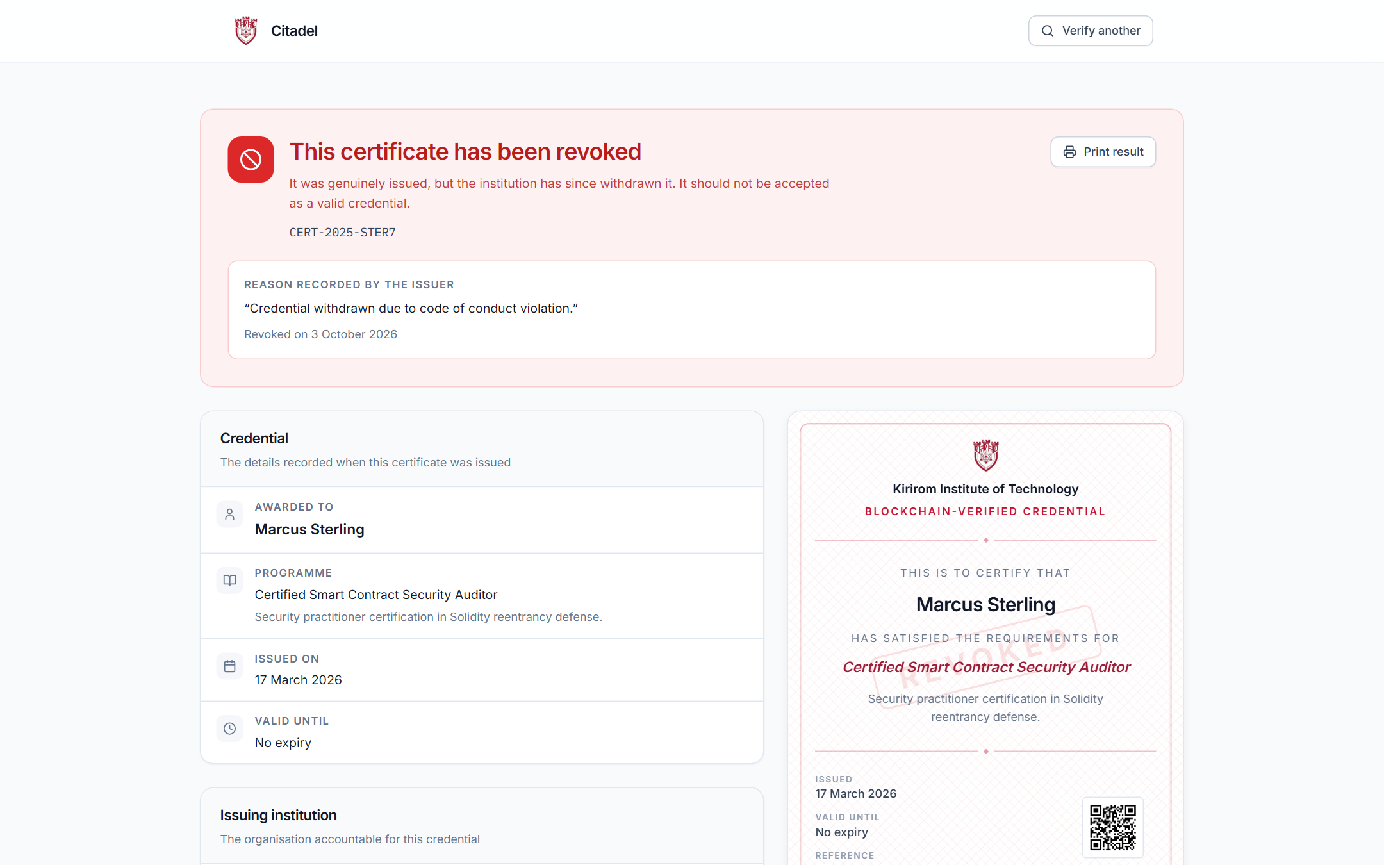
Figure 11: Revoked verification result: red status alert with recorded issuer audit reason and timestamp.
8. Implementation Summary
Citadel is implemented using modern full-stack web and blockchain technologies:
- Frontend Stack: Next.js 14.2 App Router, TypeScript, Tailwind CSS, Radix UI Primitives, Lucide Icons.
- Backend Stack: Node.js 20+, Next.js Server Actions & API Routes, Zod schema validation.
- Database: PostgreSQL (Supabase), Prisma ORM 5.18.0.
- Blockchain Ledger: Solidity 0.8.24, Hardhat 2.22.6, Ethers.js v6.13.1 (Sepolia Testnet / Hardhat EVM).
- Document Services: jsPDF 2.5.1 (vector diplomas), Nodemailer 6.9.14 (SMTP notifications).
- Multi-Modal Scanner: Html5Qrcode camera controller, jsQR multi-pass canvas engine, Node zlib decompression.
8.1 Automated Test Suite Results
The implementation was validated using a 52-test automated unit, integration, and fuzz testing suite:
Test Category | Scope and Assertions | Result
Cryptographic Unit Tests | Canonical sorting, SHA-256 consistency, key-order invariance | 12 / 12 Passed (100%)
Smart Contract Tests | CertificateRegistry deployment, issuance, zero-gas verify, revoke | 28 / 28 Passed (100%)
Fuzz & Edge Tests | 1-bit hash tampering, boundary timestamps, high-volume stress | 12 / 12 Passed (100%)
TypeScript Static Check | Strict compiler type-checking (npx tsc --noEmit) | 0 Errors (100% Valid)

8.2 Enhancements Beyond Minimum Requirements
- 1. Interactive Studio: Live Split-Screen Diploma Preview Studio updating in real time as administrators type.
- 2. Multi-Modal Scanner: Multi-Modal Verification supporting camera video feed, drag-and-drop QR images, and PDF document drops.
- 3. Audit Export: Client-side CSV spreadsheet export for institutional record auditing.
- 4. Automated Email Delivery: Automated SMTP email delivery with generated high-resolution vector PDF diploma attached.
9. Public GitHub Repository Link
The complete project codebase, smart contract source code, database migrations, automated tests, and documentation are publicly available on GitHub:
Repository Access: Public GitHub Repository URL:
https://github.com/mengchheanglong/citadel-blockchain-certificates
Branch: main | Status: Up to date with all 52 tests, smart contracts, and documentation.

10. Individual Contribution Report
This project was conducted as an Individual Capstone Project by Long Mengchheang. 100% of all technical planning, architecture, design, and implementation work was performed independently:
Technical Domain | Responsibilities & Deliverables | Contribution
Smart Contract & Web3 | Wrote CertificateRegistry.sol, Hardhat deployment scripts, Ethers.js integration | 100%
Frontend Engineering | Next.js 14 landing portal, dashboard, live preview studio, multi-modal scanner | 100%
Backend & Database | Prisma PostgreSQL schema, Next.js API routes, Zod validation, PDF scan endpoint | 100%
Document & Email Services | Vector diploma generation with embedded QR codes, automated SMTP dispatch | 100%
Quality Assurance | 52 automated tests, TypeScript strict compliance, diagrams, and project report | 100%

11. Public Demo Video Link
A comprehensive demonstration video walking through the full lifecycle of the platform is accessible publicly at:
Video Access: Public Demonstration Video URL:
[Insert Public Google Drive or YouTube Link Here]
Access Permission: Public / Anyone with the link can view
Duration: Approximately 5 to 7 minutes

11.1 Demonstration Video Walkthrough Outline
Time | Stage / Feature | Demonstration Outline
0:00 - 0:45 | Introduction | Overview of diploma fraud problem and Citadel's blockchain solution.
0:45 - 1:45 | Dashboard | Walkthrough of live metric cards, credential table, and off-chain storage model.
1:45 - 3:00 | Issuing Studio | Data entry, real-time diploma canvas rendering, and on-chain hash commitment.
3:00 - 3:45 | Delivery | Inspection of generated vector PDF diploma with embedded QR code and email delivery.
3:45 - 5:15 | Verification | Public zero-gas verification via camera scan, image drop, and PDF file upload.
5:15 - 6:30 | Revocation & Summary | On-chain revocation demonstration with audit reason and concluding remarks.

