Appendix 3. Technical Basis for Benthic Biomass Spreadsheet Tool
This is an updated version of Appendix 3 to the 2005 CA NNE document.
This memorandum provides technical background information on the development of the CA NNE Benthic Biomass Tool. The tool is a Microsoft Excel spreadsheet, and is intended to be a simple but effective means for estimating in-stream benthic algal density and other metrics in response to a number of inputs. The tool calculates algal density as ash free dry weight (g/m²) and benthic chlorophyll a
The maximum algal contribution to dissolved oxygen deficit is also calculated. Lastly, the tool allows the user to supply a target (either algal density or benthic chlorophyll a), select a calculation method, and the tool will display a graph of allowable TN and TP to meet the target.
A User’s Guide for application of the Benthic Biomass Tool and the BATHTUB Lake Response Tool is provided in a separate document.
Several basic methods of calculation are included in the tool: Dodds’ 1997 empirical method (Dodds et al., 1997), Dodds 2002 empirical method (Dodds et al., 2002; revised 2006), and two varieties of a parametric method based on the representation of benthic algal growth in the QUAL2K model (Chapra and Pelletier, 2003).

Stream Criteria for Periphyton – Empirical Approaches

The Dodds Empirical Approach to Stream Criteria
Dodds et al. (1997) developed nutrient concentration targets to address nuisance growth of benthic algae in the Clark Fork River (Montana), which have been widely cited. This proposed limiting total nitrogen concentrations to 275 µg/L and total phosphorus concentrations to 38 µg/L or less to maintain maximum benthic chlorophyll a concentrations of 100 mg/m² or less. The concentration targets were developed based on empirical regression relationships between benthic chlorophyll a and nutrient concentrations. While some site-specific data from the Clark Fork River are included, it is important to realize that the analysis is based primarily on a compilation of data from 205 sites throughout North America and New Zealand. In addition, the regressions rely on seasonal mean data, not point-in-time observations.
The best predictive regressions identified by Dodds et al. (1997) were nonlinear log-log regressions, in which the log (base 10) of mean benthic chlorophyll a and maximum benthic chlorophyll a were predicted from log (TN), the square of log (TN), and log (TP). Total Nitrogen (TN) and Total Phosphorus (TP) were found to be better regressors than inorganic Nitrogen (N) and inorganic Phosphorus (P).
The relationships that were identified were relatively weak, with a maximum adjusted R² value of 0.430 in log space for prediction of benthic chlorophyll a from total nitrogen.

Biggs (2000) found a similar degree of fit for New Zealand data, with a best reported R² of 0.325 for log-log regressions based on nutrient concentrations only. However, he was able to increase the R² value to 0.741 by including days of accrual in the relationship. It is likely that incorporating days of accrual into the Dodds et al. dataset might result in a similar improvement in predictive ability.
The two regression relationships recommended by Dodds et al. (1997) are:
log(mean Chl a) = -3.22360 + 2.82630 log(TN) – 0.431247 (log(TN))² + 0.25464 log(TP), R² = 0.430
and
log(max Chl a) = -2.70217 + 2.78572 log(TN) – 0.43340 (log(TN))² + 0.30568 log(TP), R² = 0.354.
The nutrient criteria recommendations given by Dodds et al. (1997) were created by fixing the N:P ratio at the Redfield ratio (N:P of 7.23 by mass) and solving the regression equation for appropriate concentrations of TN and TP to meet a benthic algae density target. This yields a central estimate in which approximately half of the observed sites would be expected to have an algal density greater than the target and the prescribed nutrient concentration value. Because the regression relationship is relatively weak and in log space, a high level of uncertainty is associated with the estimated nutrient target values. For instance, to obtain a target maximum chlorophyll a concentration of 100 mg/m², Dodds et al.’s regression analysis yields a target nitrogen concentration of 275 µg/L – but predictions associated with this TN concentration have a 95 percent confidence interval on maximum chlorophyll a of 7.8 to 407 mg/m². Dodds et al. therefore buttressed their arguments with a weight of evidence approach, noting (1) that the observed data indicate that when mean TN concentrations remained at or below 500 µg/L, mean benthic chlorophyll a densities exceeded 150 mg/m² in only 5 percent of cases, and (2) concentrations in an unimpaired reference station were similar.
Dodds et al.’s Redfield ratio analysis yields a TP target of 38 µg/L. Final recommendations for the Clark Fork were adjusted to 350 µg/L TN and 30 µg/L TP “to allow for some external input of TN.”
In addition to hydraulic effects, the observations used by Dodds et al. (1997) will be affected by light availability. No data on percent available light or canopy closure are provided with the data set. However, because they relied on well-studied periphyton sites it seems likely that the data set is biased toward streams in which light sufficient to promote ample periphyton growth is present.
Dodds et al. (1998) extended the analysis of the same data set used in the earlier work. In this second paper the authors appear to have abandoned the regression approach. Instead, they proposed trophic classification boundaries based on a simple division of the cumulative frequencies in the observed data into thirds, yielding the values summarized in .
Table 1. Boundaries for Stream Trophic Classifications Proposed by Dodds et al. (1998)
Variable | Oligotrophic-Mesotrophic Boundary | Mesotrophic-Eutrophic Boundary
Mean benthic chlorophyll a (mg/m²) | 20 | 70
Maximum benthic chlorophyll a (mg/m²) | 60 | 200
TN (µg/L) | 700 | 1,500
TP (µg/L) | 25 | 75

The values shown in are less than satisfactory for use as nutrient criteria for two reasons. First, they represent a naïve statistical tabulation into equal thirds that are not tied to actual evidence of impairment. Second, they do not account for regional differences in nutrient background levels, light, or temperature. A somewhat better (but still naïve) use of these data might be made as follows: Rather than pick breakpoints at arbitrary thirds of the distribution, determine the percentile of a desired chlorophyll target, then associate the corresponding percentile of the N and P distributions. For instance, a mean benthic chlorophyll a of 100 mg/m² appears to occur at about the 87th percentile of the frequency distribution based on the cumulative frequency distribution plots in Dodds et al. (1998). This frequency percentile appears to correspond to TP of about 250 µg/L and TN of about 2,500 µg/L.
Dodds et al. (2002) further expanded the literature data set used in their earlier analyses and also examined the USGS National Stream Water Quality Monitoring Network stream data. Correlation analysis confirmed a positive relationship between mean and maximum benthic chlorophyll a and TN and TP concentrations. The authors also examined correlations to stream gradient, water temperature, and latitude – but not shading. They report a negative correlation of benthic chlorophyll a to gradient, consistent with Biggs (2000) work on scour/accrual effects. However, stream gradient was available for only a small subset of the data, and thus could not be included in the regressions.
Dodds et al. (2002, Table 5) provided new linear log-log regression models for mean and maximum benthic chlorophyll a in the augmented literature data set. These vary significantly from those reported in Dodds et al. (1997); however, it is not clear if the 2002 work evaluated (but rejected as not significant) the non-linear term (the square of log (TN)) as a potential variable or simply omitted it because of theoretical objections to the resulting hyperbolic form, which predicts declining algal concentrations at high TN concentrations. The new best-fit regressions for the literature data set reported by Dodds et al. (2002) were:
log(mean Chl a) = 0.155 + 0.236 log(TN) + 0.443 log(TP), R² = 0.40
and
log(max Chl a) = 0.714 + 0.372 log(TN) +0.223 log(TP), R² = 0.31.
For both models, the reported R² values were slightly less than the best-fit models in Dodds et al. (1997).
Dodds et al. (2006) subsequently published an erratum to the 2002 results, noting that some of the chlorophyll a data has been incorrectly entered or did not meet quality control criteria for inclusion in the analysis. The final form of the regression equations appear as follows and are incorporated into the current version of the spreadsheet tool:
log(mean Chl a) = -0.408 + 0.593 log(TN) + 0.204 log(TP), R² = 0.38
and
log(max Chl a) = 0.722 + 0.349 log(TN) +0.256 log(TP), R² = 0.32.

Dodds et al. (2002, 2006) also developed regression models, for mean chlorophyll a only, in the USGS stream data set. The fit of these models was, however, uniformly poor, with the best reported R² equal to 0.18. It appears that this data set had fewer samples per site than the literature data set, and thus more uncertainty in the evaluation of means, which may account for the poorer performance. In addition, the USGS data set may include more sites where stream shading is a significant uncontrolled covariate relative to the literature data set, as noted above. This fits with Dodds et al.’s comment that no observations in this dataset exceeded 100 mg/m². If this interpretation is correct, the regression against the literature data set should provide an approximate upper bound on the USGS data.
Although not done by Dodds et al. (2002, 2006), the proposed new regression models can be analyzed for criteria recommendations in a manner analogous to that in Dodds et al. (1997), using the N:P Redfield ratio of 7.23. Obtaining 100 mg/m² maximum benthic chlorophyll a with the new (2006) equations corresponds to TN of 300 µg/L and TP of 41.5 µg/L, both slightly higher than the amounts (275 and 38) estimated with the earlier regression.

Application to California Data
No data sets within California have been identified on which an approach similar to that employed by Dodds et al. can be developed at this time – although data collected by SWAMP over the last few years should soon fill this gap. At the time the NNE report was initially develop d in 2005 there were only a few California data sets that do provide measures of benthic biomass, but these generally have only a few measurements per site and thus cannot be used to estimate maximum chlorophyll a or even to obtain good estimates of mean chlorophyll a. In addition, most of these sites do not have long runs of nutrient data, so nutrient concentrations must also be estimated from a few data points.
There was thus not a reasonable prospect of recreating a Dodds-type analysis, which is based on data from a wide range of sites throughout temperate zones of the world, with California data only. What could be done, however, is to compare these datasets to the Dodds et al. results and check for approximate consistency. In making this comparison, we expected to find the following results if the relationships are valid:
- Dodds’ equation for mean chlorophyll a should approximate the center of the distribution of observed data (in log space) for those sites at which strong light limitation or frequent scour is not a major confounding factor.
- Based on the comparison of the literature data set and USGS data in Dodds et al. (2002), the equation for mean chlorophyll a should generally lie above the center of the data for a mixture of sites where light and scour limitations are important.
- Dodds’ equation for maximum chlorophyll a should approximate the upper bound envelope on the observed data.
Two relatively large data sets were identified in California on which this comparison could be made for the 2005 report. These were provisional RWQCB 6 data and EMAP data.

Provisional RWQCB 6 Data
California Regional Water Quality Control Board 6 has collected periphyton chlorophyll a for numerous streams since 2000. Provisional data for 2000 through 2002, which were still undergoing quality review, were provided to us on the condition that the numerical data not be released or attributed to specific geographic sites. Between 30 and 35 sites were sampled per year, and there are a total of 93 valid data points with both benthic chlorophyll a and nutrient data. These represent point measurements, rather than seasonal averages. Unfortunately, no data are available on stream hydrologic regime or light availability.
andFigure 2 plot the RWQCB 6 benthic chlorophyll a observations against TN and TP, respectively. There appears to be a positive correlation with Total Nitrogen in the lower concentration range, but a potential negative correlation for TN concentrations above 1 mg/L. Less of a correlation is evident to TP, and nitrogen appears to be the limiting nutrient in many cases.
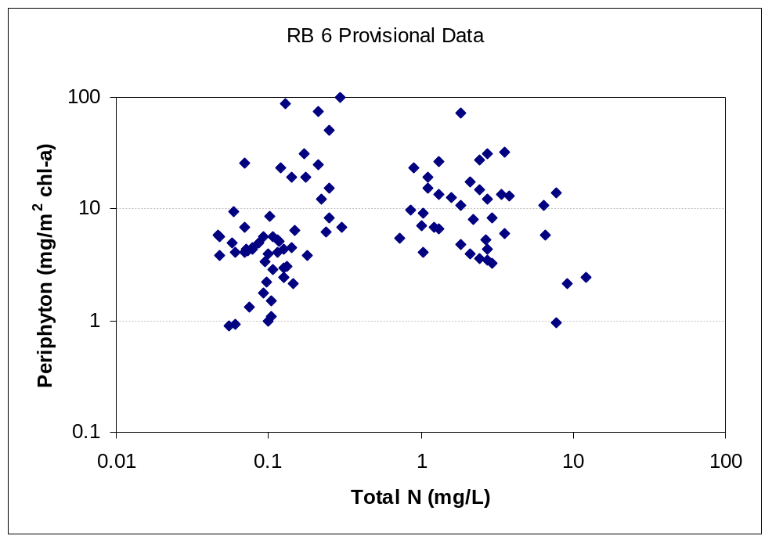
Figure 1. Provisional RWQCB 6 Benthic Chlorophyll a Observations vs. Total Nitrogen

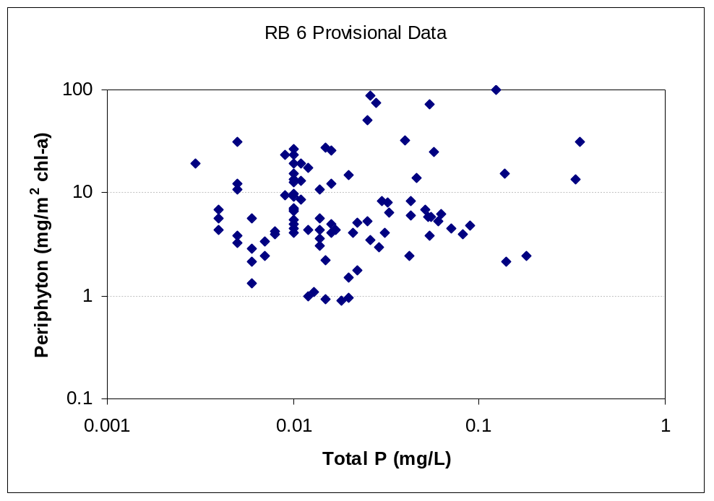
Figure 2. Provisional RWQCB 6 Benthic Chlorophyll a Observations vs. Total Phosphorus
None of the observations in the data set exceeded 100 mg/m² benthic chlorophyll a despite TP concentrations well in excess of the criteria recommended by Dodds.
We developed a nonlinear log-log regression equation for the RWQCB 6 data as a function of TN and TP. Because of the apparent hyperbolic relationship to TN, a nonlinear term on [log(TN)]² was included, as in the Dodds et al. (1997) work. The resulting regression equation is
log(mean Chl a) = -3.20 + 2.94 log(TN) – 0.512 (log(TN))² + 0.0914 log(TP),
with an R² of 0.20. This low R² is similar to the results found by Dodds et al. (2002) in working with the USGS data. The coefficients on TN in this relationship are similar to those in the Dodds et al. (1997) model for mean chlorophyll a, but the coefficient on log (TP) is much lower – perhaps reflecting a situation in which phosphorus is not often limiting. Chlorophyll a density predicted by this equation is lower than the result of the various Dodds equations based on the literature data set. As noted above, this is the expected result because of the small sample size and the fact that many of these sites are likely subject to limitation by shading and scour.
In , the RWQCB 6 data are plotted against TN, with the results of three regression equations (which also depend on TP) superimposed. The regression lines shown are the RWQCB 6 data regression and the two equations from Dodds (2002; rev. 2006); results of the Dodds (1997) equations aretsimilar. The power regression against the RWQCB data is lower than both the Dodds equations. The Dodds equation for the mean is within the data, while the Dodds equation for the maximum lies above all but one of the data points, consistent with expectations.
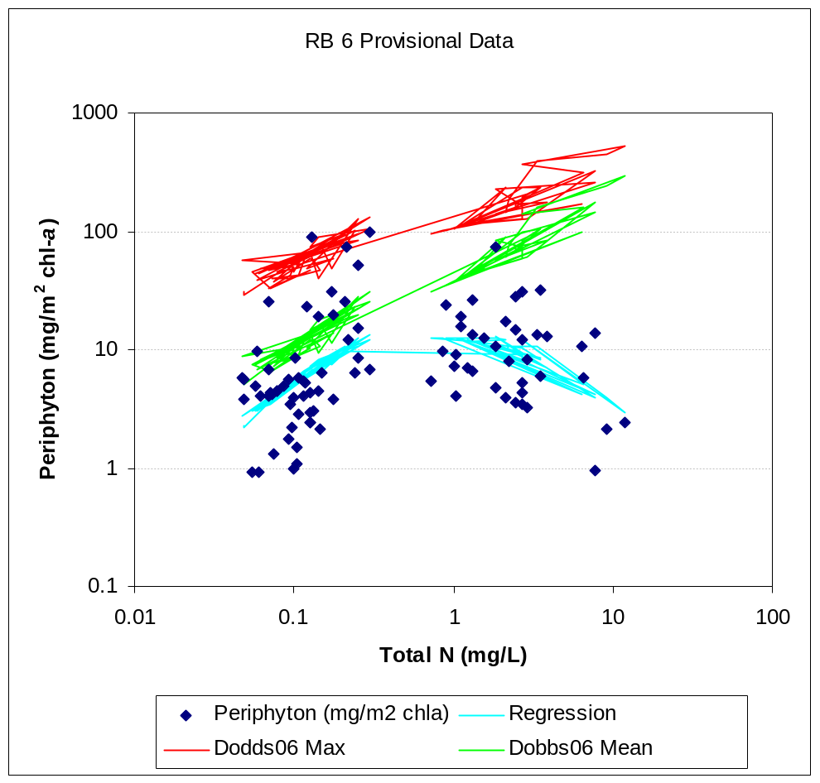
Figure 3. RWQCB 6 Periphyton Chlorophyll a Compared to Various Regression Equations
The relation of the RWQCB 6 data to the Dodds et al. (2002, rev. 2006) equation for mean chlorophyll a is further explored in , which shows the deviations of the data from the predicted mean, plotted against the observed value. Within the lower range of observed values, the deviations (predicted minus observed) are consistently greater than or equal to zero, consistent with the assumptions above. In the higher range, the deviations become negative, presumably representing cases in which the point-in-time algal response is greater than the seasonal mean.
compares the data to the maximum benthic algal regression from Dodds et al. (2002, rev. 2006). In all but one case, the predictions are greater than the observations, suggesting that the Dodds equation does indeed provide a reasonabln upper bound.
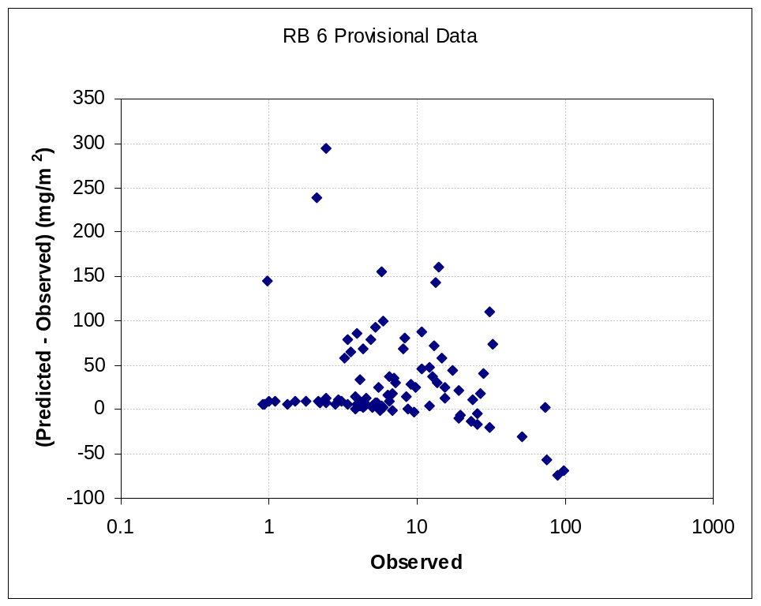
Figure 4. Deviations of RWQCB 6 Provisional Benthic Chlorophyll a Data (mg/m²) from Mean Predictions using Dodds et al. (2002)
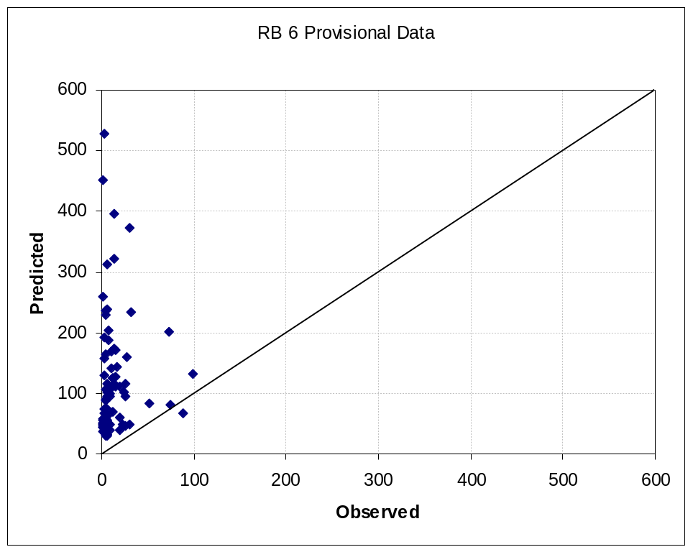
Figure 5. RWQCB 6 Provisional Data for Benthic Chlorophyll a Compared to Maximum Concentrations Predicted by Dodds et al. (2002) Regression

Provisional EMAP Data
Another useful data set was collected by EMAP. This contains 103 data points with both nutrients and benthic chlorophyll a, from sites throughout California in 2000-2002. These data are also in provisional form at the time of this writing, and a complete description of the individual site characteristics is not yet available.
andFigure 7 plot the California EMAP benthic chlorophyll a data against TN and TP respectively. As with the RWQCB 6 data, there is an evident positive correlation to TN below concentrations of 1 mg/L (1,000 µg/L), while the relationship to TP appears much weaker.
As was done with the RWQCB data, the benthic chlorophyll a results, plotted against TN, are shown with the Dodds et al. (2002, rev. 2006) mean and maximum predictions superimposed in , while deviations relative to the mean prediction are shown inFigure 9. Once again, the data lie near the mean prediction, while the maximum prediction appears to establish a reasonable upper bound. The plot of deviations against the mean shows that the difference between predicted and observed is greater than or equal to 0 at low observed concentrations (reflecting other limiting factors), and tends to be less than zero at high observed concentrations (where the observations are likely to more closely approach their maximum potential).
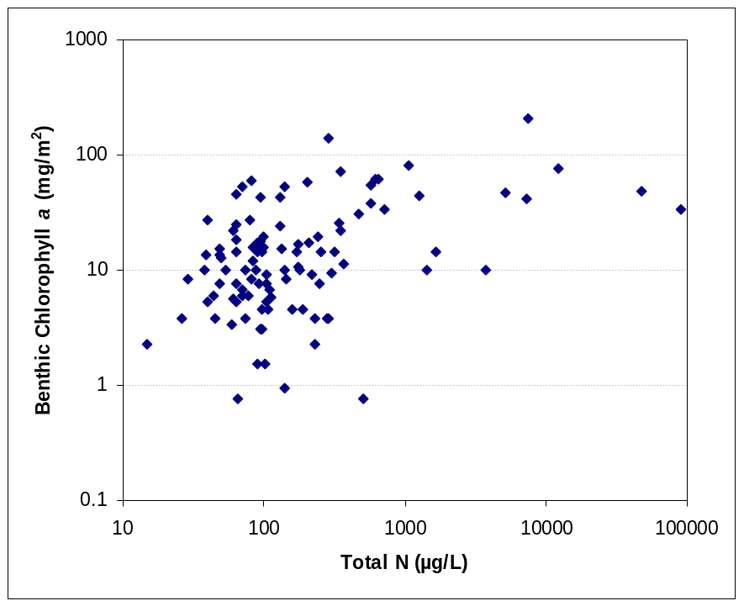
Figure 6. EMAP California Benthic Chlorophyll a Observations vs. Total Nitrogen
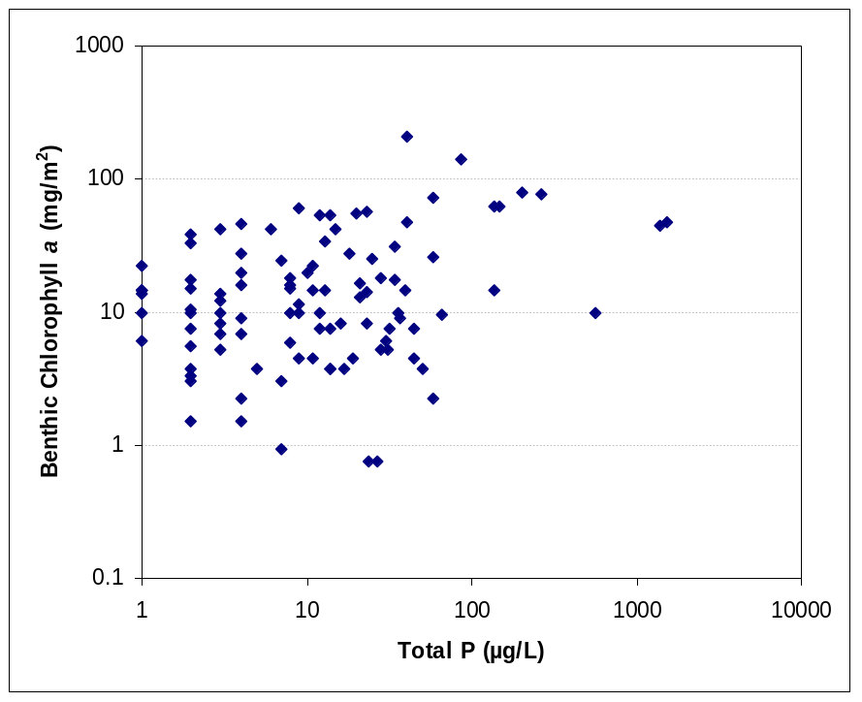
Figure 7. EMAP California Benthic Chlorophyll a Observations vs. Total Phosphorus

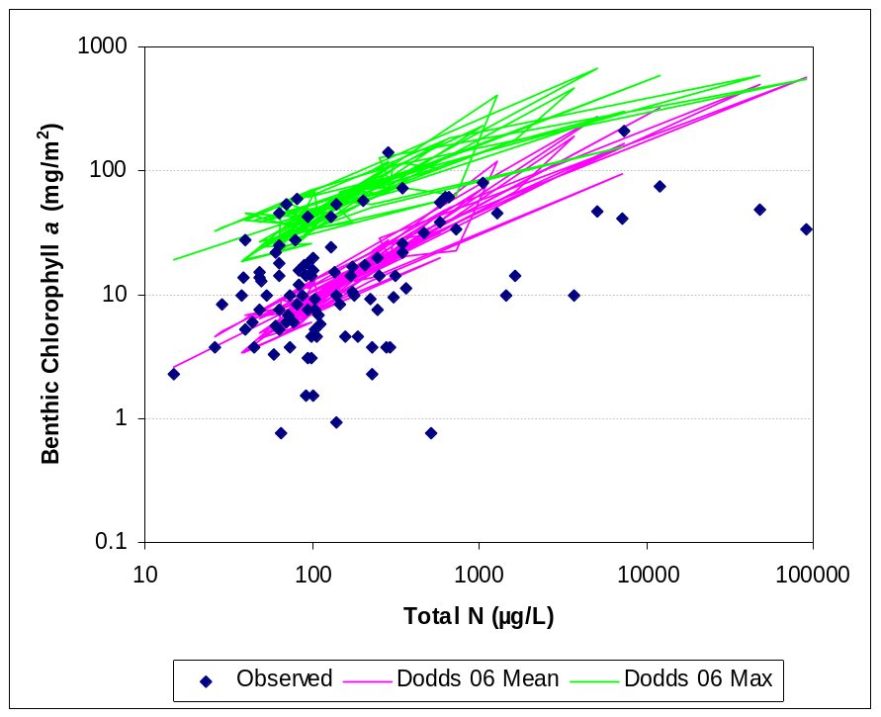
Figure 8. EMAP California Periphyton Chlorophyll a Compared to Various Regression Equations

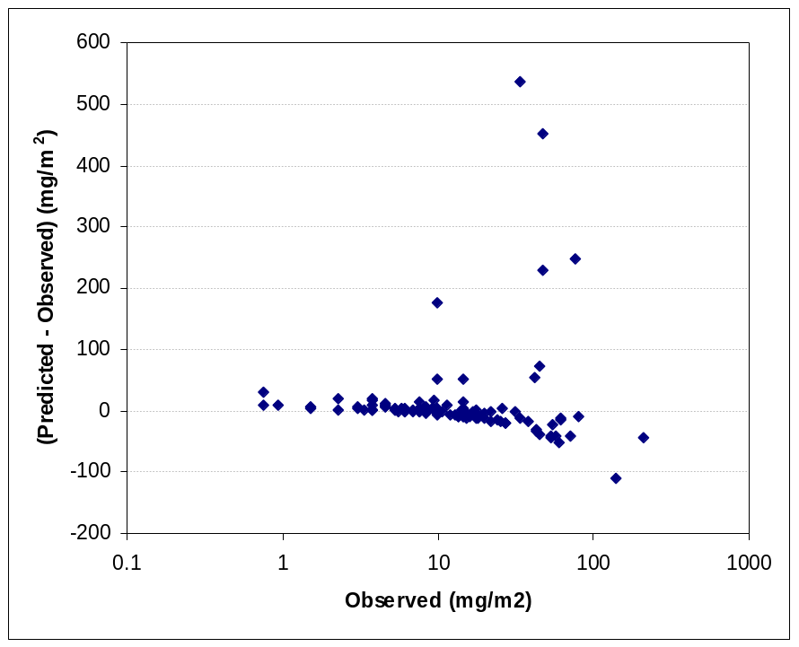
Figure 9. Deviations of EMAP California Benthic Chlorophyll a Data (mg/m²) from Mean Predictions using Dodds et al. (2002, rev. 2006)

Discussion
Comparison to the RWQCB 6 and EMAP data suggests that the equations proposed by Dodds et al. are qualitatively reasonable for predicting mean and maximum potential growth of benthic algae in California streams in the absence of severe light or scour limitation. It should be noted, however, that the Dodds statistical relationships are quite weak, with R² values uniformly less than 50 percent. This is believed to reflect the fact that light and scour limitation play important roles in observed chlorophyll a. For New Zealand, Biggs (2000) demonstrated that the predictive ability of empirical regression equations could be substantially improved (from an R² of less than 40 to an R² greater than 70) by inclusion of a measure of average days of accrual. Presumably, inclusion of a measure of canopy closure might further improve results.
It would be of interest to re-evaluate Dodds’ data set with inclusion of information on average days of accrual, but it may not be possible to obtain the data. Otherwise, the results reported above suggest it is desirable to go to a simple parametric model of benthic algal response. Such a model should be calibrated to be in reasonable agreement with the Dodds regression results. In particular, the Dodds maximum should generally agree with model predictions under conditions of minimal light limitation.

Simulation Modeling of Periphyton in Streams
Simulation modeling provides one line of evidence for the estimation of benthic algal or periphyton growth potential in streams. While a variety of models have been developed to simulate periphyton, the majority are too complex or too site-specific to be useful for initial scoping. Recently, a benthic algal component has been incorporated into a revised version of the QUAL2E water quality model, known as QUAL2K (Chapra and Pelletier, 2003; with an updated version in Chapra et al., 2006). This simple parametric representation can be adapted to provide initial estimates of benthic algal responses to availability of light and nutrients, and can be adjusted to achieve general agreement with the empirical relationships developed by Dodds et al. (1997, 2002, 2006). More sophisticated models may be needed to achieve accurate predictions of benthic algal density, but the simple method incorporated into QUAL2K shows promise as a scoping tool. The following sections lay out the details and proposed fine-tuning of this approach.

Parametric Representation of Benthic Algal Growth Potential – QUAL2K version 1
Following the original QUAL2K development (Chapra and Pelletier, 2003), if B is the concentration of benthic algal biomass (mass per area as AFDM), then
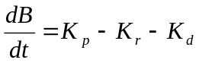.
where, 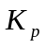 is the rate of photosynthesis, 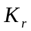is the rate of algal respiration, and 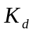is the rate of algal death (all in dry weight mass per time per unit area).

Photosynthesis
is defined by the product of the maximum photosynthesis rate (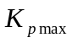, g DW/m²-d), the benthic algae nutrient attenuation factor (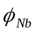), and the benthic algae light attenuation factor (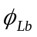). and are dimensionless factors ranging from 0 to 1.
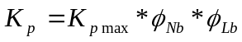.
Note that in QUAL2K K_{pmax} is defined as a fixed number, rather than as a rate (per day) multiplied times concentration. This helps reflect self-limiting factors on periphyton growth. The maximum photosynthetic rate is temperature dependent, and temperature effects on rate are specified with the Arrhenius relationship to the maximum photosynthetic rate at a reference temperature of 20°C (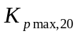):
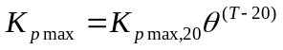.
The benthic algae nutrient attenuation factor () is represented by the Michaelis-Menten nutrient limitation equation for inorganic nitrogen and phosphorus:
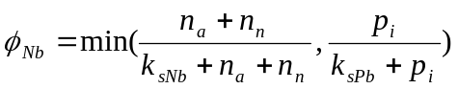.
Where 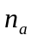is the ammonia concentration in the above water (mg-N/L), 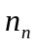is the nitrate plus nitrite concentration in the overlying water (mg-N/L), 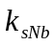is the nitrogen half-saturation constant (mg-N/L), 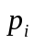is the inorganic phosphorus in the overlying water, and 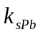 is the phosphorus half-saturation constant (mg-P/L). All concentrations are in terms of total nutrients (dissolved plus sorbed).
For benthic algae, light limitation depends on the amount of photosynthetically active radiation () reaching the bottom of the water column, which is defined by the Beer-Lambert law:
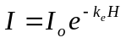.
Where 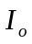is the solar radiation at the water surface (cal/cm²/d), 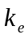is the light extinction coefficient (m⁻¹), and is the water depth (m).
The half-saturation light model defines the light limitation factor with a benthic algae light parameter (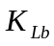) so that
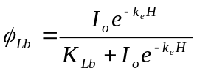.

Respiration and Death
Benthic algae respiration is a first-order rate defined as
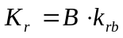,
where  is benthic algae (g/m²) and 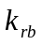is the temperature-dependent bottom algae respiration rate (d⁻¹).
Benthic algae death is also a first-order rate defined as
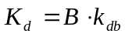,
where is benthic algae (g/m²) and 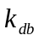is the temperature-dependent bottom algae death rate (d⁻¹). The prediction of biomass uses only the sum of respiration and death, so model fitting exercises cannot distinguish these components independently.

Steady State Benthic Algal Biomass
Under steady-state conditions, dB/dt goes to zero, and the steady-state maximum benthic algal biomass (g/m²) may be calculated as
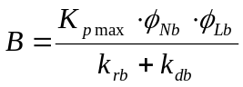.

Kinetic Parameter Values
The steady-state estimate of biomass is very sensitive to the sum of the loss rates, k_{rb} + k_{db}. These values are highly variable and not well documented for benthic algae. Respiration rates for benthic algae used in modeling are typically around 0.1 per day (Bowie et al., 1985), while the recommended value for planktonic algae is 0.125 per day (Wool et al., 2003), which seems a reasonable first cut estimate for simulation. The death rate used for simulation of benthic algae is often inflated above a natural death rate to account for grazing pressure and scour. We consider scour separately below. Accounting for grazing within the “natural” death rate is problematic in general, as grazers may remove from 6 to 97 percent of algal biomass (Welch and Jacoby, 2004), depending on grazer density, types of algae and grazer(s), and so on. This problem is largely avoided when the intention is to predict the maximum concentration that would be present under minimal grazer pressure. For those conditions, it is assumed that the typical death rate for planktonic algae (0.02 per day; Wool et al., 2003) is a reasonable representation of the benthic algal death rate in the absence of scour. Estimates of K_{p max}, K_{sNb}, K_{sPb}, and K_{Lb} were set to QUAL2K defaults for the initial analysis. The initial kinetic parameter values are summarized in .
Table 2. QUAL2K Version 1 Default Kinetic Parameters for Benthic Algae
Parameter | Default Value | Units
(maximum photosynthetic rate) | 60 | g/m²-d
(Arrhenius temperature constant) | 1.07 | Unitless
(respiration rate) | 0.125 | 1/d
(natural death rate) | 0.02 | 1/d
(total inorganic nitrogen half-saturation constant) | 0.015 | mg-N/L
(total inorganic phosphorus half-saturation constant) | 0.002 | mg-P/L
(light half-saturation constant) | 50 | cal/cm²/d

Relationship to Biomass as Chlorophyll a
The QUAL2K model (2003 version 1) predicts as a state variable benthic algal biomass as grams of ash-free dry mass (AFDM) per square meter. The bulk of the literature values on benthic algal biomass and targets are reported as milligrams of chlorophyll a per square meter. Unfortunately, the chlorophyll content of benthic biomass is highly variable, depending on species, detrital biomass including microbes and fungi, and light conditions, rendering a conversion difficult, and many different values are reported in the literature.
The EMAP data for California reports both ash-free dry mass and chlorophyll a for periphyton, along with their ratio. The ratio of chlorophyll a density (mg/m²) to ash-free dry mass (g/m²) on 173 California EMAP samples ranged from 0.06 to 6.73, with an average of 1.673 and a median of 1.14. Most of the values lie between 0.6 and 2.1 (interquartile range). Numbers in this range are not representative of benthic algae. Typical stoichiometry of algae would be a carbon to AFDM ratio of about 0.45 and a carbon to chlorophyll a ratio typically in the range of 25 to 100 but possibly as high as 275 (Bowie et al., 1985). The typical range implies that the ratio of chlorophyll a density (mg/m²) to ash free dry weight (g/m²) for autotrophic benthic algae should be at least 4.5 and possibly as high as 18, while the highest reported value of carbon to chlorophyll ratios in periphytic algae (for dinoflagellates) would lead to a ratio of 1.64. The low ratios at the EMAP sites suggest that the periphyton communities were likely dominated by heterotrophic fungi and bacteria whose growth is based on allochthonous carbon sources (e.g., terrestrial detritus or wastewater) as well as photosynthetic production. Heterotroph biomass usually dominates the surficial biofilm in shaded, fast-flowing, shallow first- to third-order streams in forests (Welch and Jacoby, 2004).
The QUAL2K approach directly predicts the accumulation of phototrophic algal biomass only. However, it is the total periphyton biomass that leads to nuisance conditions and the impairment of uses. Further complications arise because (1) some algae exhibit mixotrophy, in which they are able to assimilate energy from fixed carbon compounds as well as by photosynthesis, (2) algae die as the biofilm accumulates and succession affects species composition so large portions of the algal mat may be detrital, and (3) exudates of benthic phototrophic algae may support bacterial and fungal heterotrophic populations, thus tying the heterotroph density indirectly to photosynthetic production. Both heterotroph and algal exudates can contribute to nuisance conditions for recreation relative to the slipperiness of substrates
For comparison to the Dodds method, an appropriate ratio of chlorophyll a to AFDM must be selected. (The choice of a ratio does not, however, affect the quality of an optimized fit of the QUAL2K model to the Dodds results as both the ratio and K_{p,max} are linear multipliers on the predicted chlorophyll a density; thus, an over-estimate of one value may be compensated for by a downward adjustment in the optimized value of the other parameter.) As noted above, a wide range of values are available. Various authors (cited in Welch and Jacob, 2004) have noted that the autotrophic index (defined as the ratio of AFDM to chlorophyll a) is a useful indicator of the influence of organic wastewater on periphyton communities. Collins and Weber (1978) suggested that an autotrophic index of 400 defines the upper limit of clean water conditions, and use of this boundary has been verified by observations of Biggs (1989). Because the primary use of the model in connection with nutrient criteria is to predict periphyton and chlorophyll a density for “clean water” or supporting conditions, where appropriate nutrient limits can be determined, it is appropriate to use the autotrophic index value of 400 (which corresponds to a ratio of 2.5 mg/m² chlorophyll a to 1 g/m² AFDM) for comparison of QUAL2K to the empirical regression models of Dodds et al. (1997, 2002).

Parametric Representation of Benthic Algal Growth Potential – QUAL2K version 2
The previous section provides an analysis of simulation modeling of maximum periphyton density in streams based on a steady-state limit approximation of the benthic algae simulation contained in the QUAL2K model (v. 1; Chapra and Pelletier, 2003). A subsequent release of QUAL2K (v. 2; Chapra et al., 2006; 2008) included significant modifications to the simulation of benthic algae. This revised method was also evaluated for CA NNE.
One obvious difference is that version 2 simulates periphyton density in terms of chlorophyll a rather than dry mass. While this removes the necessity of converting between chlorophyll a and ash-free dry mass (AFDM) it has the implicit effect of assuming that the chlorophyll a:AFDM ratio is constant – the same as was done in the CA NNE analysis – so this does not really constitute an advantage. Heterotrophic growth is not addressed. The general equation for the concentration of benthic algal biomass (A, as chlorophyll a per unit area) is then
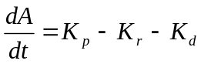.
Where, is the rate of photosynthesis, is the rate of algal respiration, and is the rate of algal death (all now in units of mass as chlorophyll a per time per unit area).
The definitions of and are unchanged from the previous version, except for the units and an option to attenuate respiration under low oxygen conditions, and are defined by rate constants k_{r} and k_{d}.
QUAL2K (v2) allows two options for photosynthetic growth. The first is a zero-order case, similar to that in the previous version. The second is a first-order model, which adds a space limitation factor. We consider only the zero-order model here. The general definition of for the zero-order case is also unchanged from the previous version of QUAL2K except for the units:
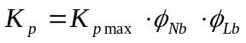.
where is the maximum photosynthetic rage (now in units of mg chl-a/m²-d), is the nutrient limitation factor, and is the light attenuation factor.
The major changes come in the definition of the nutrient limitation factor, which is now based on the Droop (1974) model, in which the nutrient limitation factor is described as:
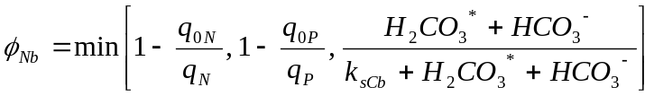
This factor is also apparently constrained to be greater than or equal to zero. The three terms here represent limitation by availability of nitrogen, phosphorus, and inorganic carbon, respectively (for this analysis, we assume that inorganic carbon limitation is not significant in what follows). The nitrogen and phosphorus limitations have been rewritten in terms of cell quotas (mg of nutrient per mg of chlorophyll a), with q_{0N} and q_{0P} representing the minimum cell quotas for photosynthesis, while q_{N} and q_{P} are the actual cell quotas. The quota values are expressed as ratios of the intracellular nutrient concentration to cell biomass:
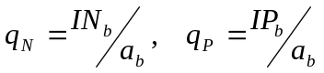
and the changes in the intracellular nutrient concentrations are expressed as
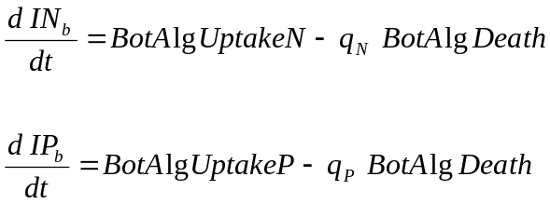
The uptake rates are then expressed as a function of both external and intracellular nutrients (following Rhee, 1973), with
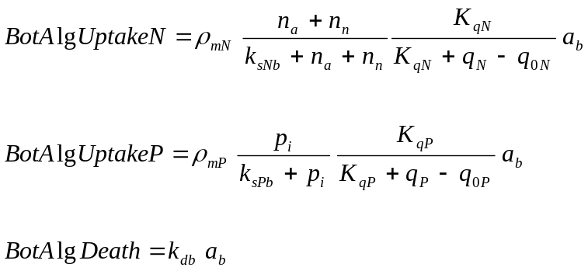
where ρ_{mN} and ρ_{mP} are the maximum uptake rates for nitrogen and phosphorus, k_{sNb} and k_{sPb} are the half-saturation constants for external nutrients, K_{qN} and K_{qP} are the half-saturation constants for intracellular nutrient concentrations, and n_{a}, n_{n}, and p_{i} are the ambient concentrations (mg/L) of ammonia nitrogen (as N), nitrate+nitrite nitrogen (as N) and inorganic phosphorus (as P), respectively. The right hand sides of the uptake formulae contain the variable for cell quota, rendering the steady-state solution much more complex.
At steady state, dIN_{b}/dt = dIP_{b}/dt = 0, and a_{b} is assumed constant. With these assumptions solutions can be written for q_{N} and q_{P} using the positive root of the quadratic formula, and these can subsequently be used to determine steady-state values of and A. This procedure yields the following steady state limits:
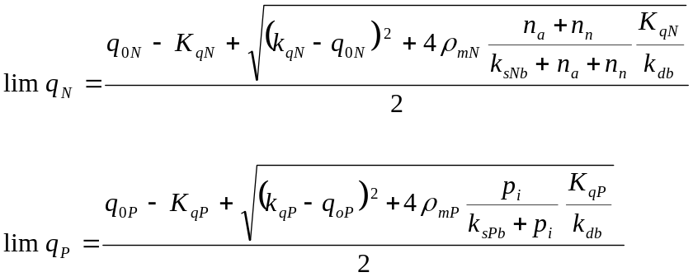
While this approach is presumably more flexible than the Monod kinetics proposed in the earlier version of QUAL2K, it introduces the problem of having to estimate many more parameters. The manuals (Chapra et al., 2006; 2008) offer no table of default values, and the steady-state solution is very sensitive to small changes in these parameters.
Despite its apparently greater flexibility, the steady-state solution derived from version 2 of QUAL2K does not lend itself to improving the agreement between predictions based on the model solution and Dodds et al.’s (2002, rev. 2006) empirical model. When inorganic nutrient concentrations are calculated from constant ratios on total nutrients, the best fit is similar in quality to that obtained from the earlier solution, with a somewhat greater divergence at higher algal concentrations.
In sum, version 2 of QUAL2K offers a more complex representation of benthic algal nutrient limitation, but does not offer guidance on appropriate ranges for the many new parameters. With appropriate parameter values, the version 2 method will approximate the simpler approach contained in version 1. For our specific purposes of obtaining general agreement with the Dodds method for maximum benthic algal biomass at the steady state limit, version 2 of QUAL2K does not seem to offer any compelling advantages, while also introducing considerable additional complexity. Therefore, the simplified NNE tools incorporate only the approach contained in version 1 of QUAL2K.

Maximum Benthic Algal Growth Potential – Default Parameters
This section discusses the implications of the default kinetic parameters for benthic algae in QUAL2K version 1. The maximum benthic algal biomass potential is assessed under typical summer conditions with no shading and no additional algal loss due to scour or grazing. This yields a theoretical upper bound on expected average biomass as a function of nutrient concentration.

Algal growth is affected by both temperature and light. For this theoretical simulation, temperature is assumed to be 20° C – thus requiring no Arrhenius correction.
For light, insolation at the water surface, I₀, depends on latitude, time of year, and sky conditions. For initial comparisons regarding maximum potential benthic algal growth it is appropriate to use cloudless insolation for summer conditions. At the summer maximum (June), variation with latitude in the northern hemisphere is small and the insolation at the outer edge of the atmosphere over California is approximately 975 cal/cm²/d. Even without clouds, this amount is reduced by transmission through the air mass. Without shading (or urban smog), the atmospheric transmission factor is about 0.71 (Black et al., 1954), yielding a value of insolation at the land surface for cloudless summer skies of approximately 690 cal/cm²/d. This is further reduced by reflection at the water surface (albedo), which, for high solar altitude, is approximately 0.05, yielding a value of I₀ of 658 cal/cm²/d. This value is used to establish a baseline of potential benthic algal biomass.
Canopy cover on a stream will further reduce the value of I₀. Estimates in USACE (1956) show that a forest canopy density of 20 percent (percentage of surface area covered by a horizontal projection of the vegetation canopy) reduces surface insolation to 45 percent of that on an unshaded stream, a 40 percent canopy density reduces insolation to about 25 percent, and an 80 percent canopy density reduces it to about 10 percent. Streams in steep topography will have further reductions due to topographic shading depending on aspect.
The simulation also depends on light penetration to the stream bottom, which varies with the product k_{e}H, the extinction coefficient multiplied by the average depth. For the initial simulations, this product is assumed to have a value of 0.5 (e.g., a depth of 0.5 m with an extinction coefficient of 1 m⁻¹, typical of a moderately low turbidity stream.)
The California Ecoregion 6 Nutrient Criteria Pilot Study (Tetra Tech, 2003) lists ranges of nutrient concentrations found in California streams ranging from minimally impacted to impaired. summarizes these concentrations, which can be used to assess the sensitivity of maximum benthic algal density to a range of inorganic nitrogen and phosphorus concentrations in the water column.
Table 3. Ranges of Nutrient Concentrations Reported in Ecoregion 6 Streams
Nutrient | Minimum 1st Quartile Reported (mg/L) | Maximum 4th Quartile Reported (mg/L) | Average Concentration for Impaired Stream (mg/L)
Ammonia (as N) | 0.00 | 16.30 | 0.36
Nitrite (as N) | 0.00 | 2.50 | 0.15
Nitrate (as N) | 0.03 | 42.45 | 5.05
Total Kjeldahl Nitrogen | 0.08 | 8.60 | 0.81
Phosphate (as P) | 0.01 | 12.55 | 0.42
Total Phosphorus | 0.10 | 4.42 | 0.29

andFigure 11 plot the predicted potential biomass of benthic algae as g/m² AF-d under nitrogen and phosphorus limitation, respectively, with the other nutrient and light at maximum (non-limiting) levels. Inorganic nitrogen and phosphorus concentrations range from zero to maximum reported (Table 3).
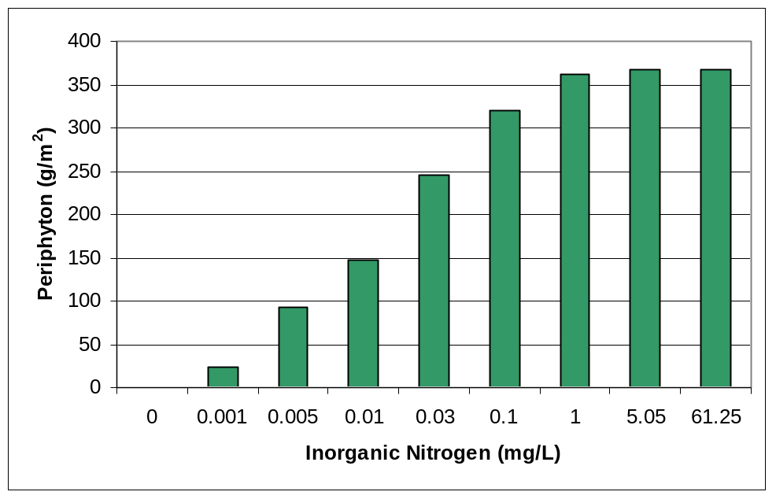
Figure 10. Predicted Steady-State Maximum Benthic Algal Biomass (AFDM) under Nitrogen Limitation with QUAL2K Default Parameters
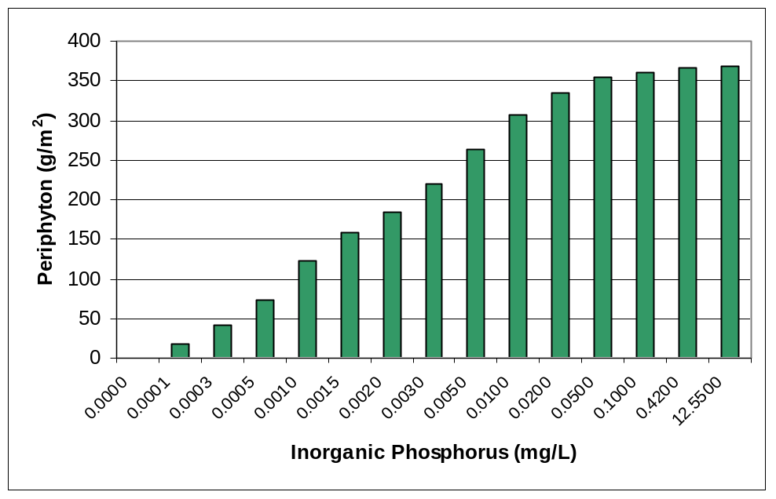
Figure 11. Predicted Steady-State Maximum Benthic Algal Biomass (AFDM) under Phosphorus Limitation with Default QUAL2K Parameters
The maximum predicted periphyton biomass is about 360 g/m² AFDM, which would be equivalent to about 900 mg/m² chlorophyll a using the ratio of 2.5. This is a biomass with no nutrient limitation, little light limitation (June clear sky insolation with relatively high water column transmission) and no losses to scour or heavy grazing.
A response surface of the steady-state periphyton biomass versus inorganic nitrogen and inorganic phosphorus concentrations predicted by the model using default parameters is shown in Figure 12 (the inflection line closely approximates the Redfield ratio.
Two targets often cited for benthic chlorophyll a are 100 and 200 mg/m², which translate toWAFDM biomass of 40 and 80 g/m² (using the 2.5 ratio). The results with initial default QUAL2K parameters shown inFigure 12 suggest that to achieve the 100 mg/m² chlorophyll a target under conditions of no shading and no scour it would be necessary to hold inorganic phosphorus below 0.24 µg/L or inorganic nitrogen less than 1.8 µg/L, while to achieve the 200 mg/m² benthic chlorophyll a target it would be necessary to hold inorganic phosphorus below 0.56 µg/L or inorganic nitrogen below 4.2 µg/L. The default model thus yields extremely low, and likely unrealistic target values. These values are not consistent with the targets recommended by Dodds et al. (1997), but are based on poorly constrained default parameter values that are not very meaningful for criteria in real streams. Nevertheless, the evidence is strong that very low soluble P concentrations can support extensive growth of periphytic algae. Soluble reactive P (SRP) concentrations that saturate growth rates are on the order of 1 – 2 µg/L, while SRP concentrations on the order ut 10 - 20 µgLt saturate periphytic biomass accrual at levels of 600 to 1,000 mg chlorophyll/m² in laboratory channels (Welch and Jacoby, 2004). Higher concentrations are required to maximize biomass due to mat-diffusion limitations.
As will be shown below, significantly higher criteria appear to be appropriate for California applications. Note that these results are for full light and no scour, and also that the magnitude of the results will be sensitive to the specification of the periphyton respiration and natural death rates.

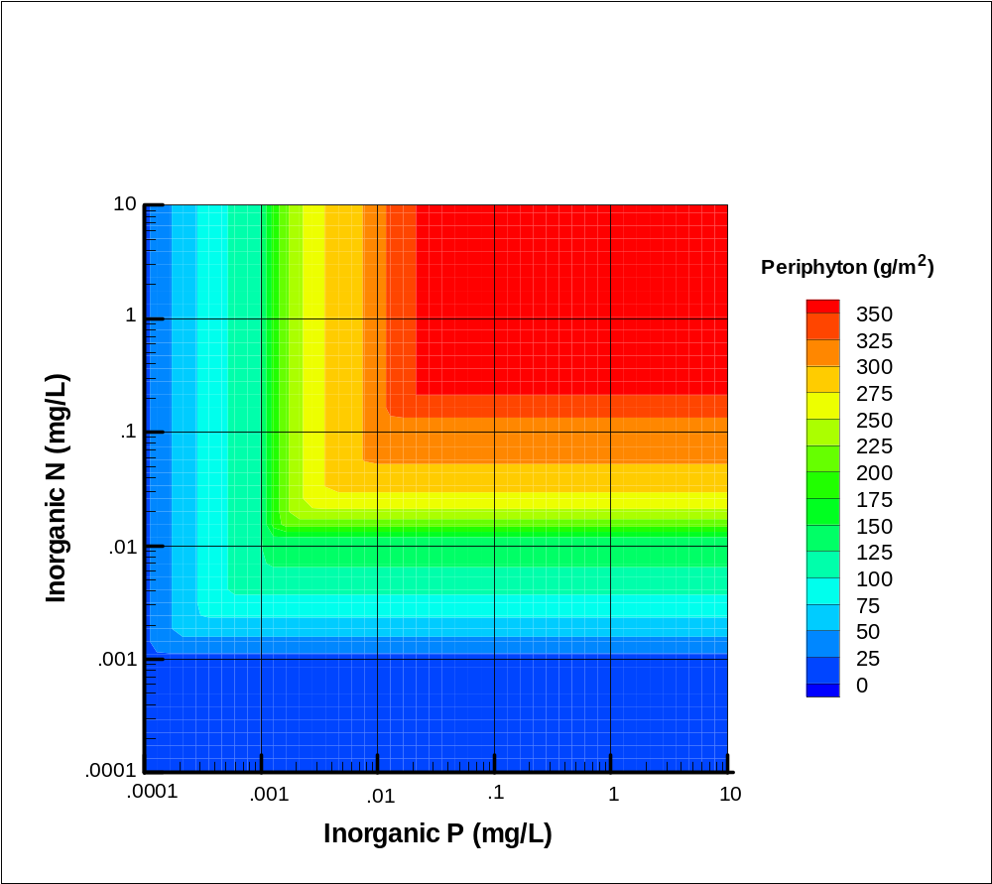
Figure 12. Response Surface for Maximum Periphyton Biomass (AFDM) versus Inorganic Nitrogen and Phosphorus Concentrations, QUAL2K Equations with Default Parameters

Effects of Light Limitation
In most streams, light limitation reduces growth of periphyton below the theoretical maximum. This light limitation may be caused by cloudy or foggy skies, topographic shading, turbidity in the water column, or riparian canopy closure.
A number of sophisticated tools have been developed to evaluate stream shading, light, and heat exchanges (e.g., Shade from Washington Department of Ecology and Heat Source from Oregon Department of Environmental Quality) these approaches are data intensive and complex. In the spirit of developing scoping-level tools that are readily applied, we use a simplified relationship to calculate a transmission factor that approximates the effect of forest cover in depleting solar radiation (WMO, 1994). The transmission factor, K_{f} is calculated as
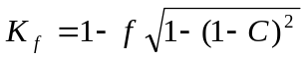
where C is the canopy density or percent closure and f is the portion of solar radiation that is withheld by forest with 100 percent canopy density, usually assumed to be 0.9.
Going from zero to 80 percent canopy closure reduces light by 90 percent and is predicted to reduce periphyton biomass (in the absence of nutrient limitation) by about 50 percent (). Other factors that reduce average light availability (including time of year) will have similar effects. However, the results predicted by the model will depend on the value assigned to the light half-saturation constant.
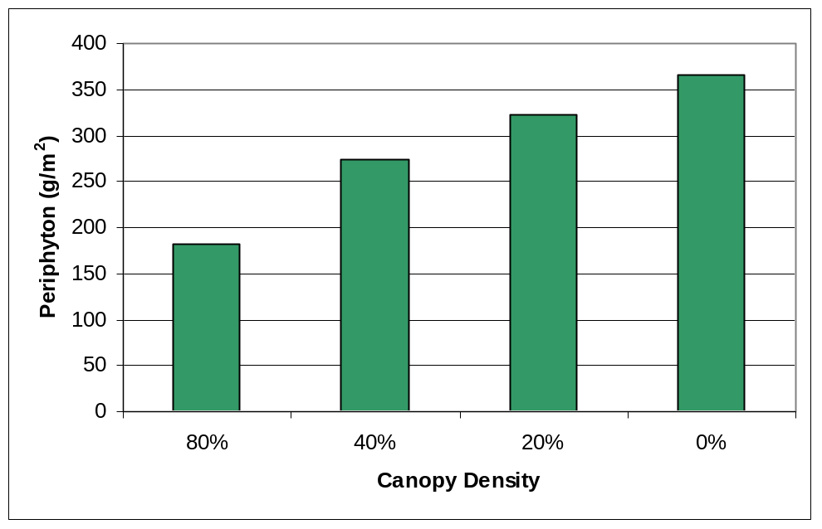
Figure 13. Steady State Benthic Algal Density Response to Canopy Closure without Nutrient Limitation (QUAL2K Version 1 Default Parameters)

Reconciling QUAL2K and Dodds’ Estimates – Direct Fit
The discussions in the previous sections relied on default kinetic parameters for QUAL2K (version 1). Many of these parameters are not well constrained or documented, and may not be appropriate for application in California.
As discussed in Section 1.1, Dodds et al. (1997, 2002, 2006) developed regression relationships on international datasets to predict average and maximum benthic chlorophyll a concentrations in streams as a function of total nitrogen and total phosphorus concentrations. In theory, the maximum predicted using the Dodds equation should correspond to the steady-state QUAL2K (version 1) prediction, without light limitation below the local theoretical maximum, converted from AFDM to chlorophyll a.
As QUAL2K is set up to work with soluble inorganic fractions rather than total nitrogen and phosphorus, as used by Dodds, it is necessary to translate between total and inorganic concentrations to compare the estimates. These numbers vary widely in ecoregion 6 streams. For nitrogen, a plot of the inorganic fraction versus total nitrogen concentration shows a positive correlation (). However, the correlation seems to be absent below about 1 mg/L total nitrogen. Presumably, the higher concentrations represent effluent dominated situations impacted by WWTPs with high inorganic N loads.

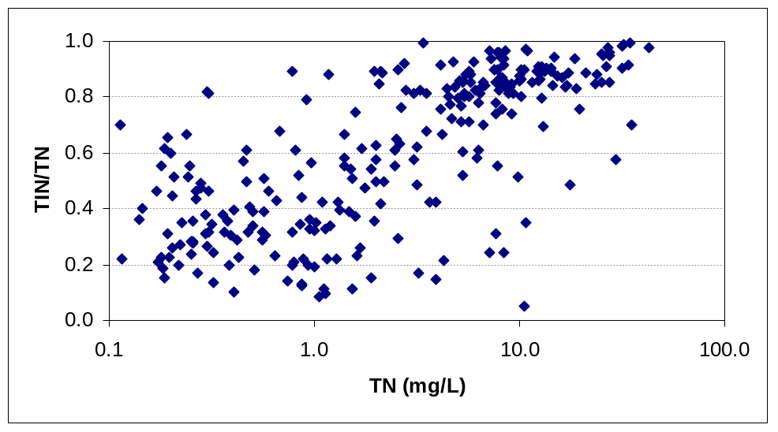
Figure 14. Inorganic Nitrogen Fraction vs. Total Nitrogen in Ecoregion 6 Streams
For phosphorus, there is no evident correlation between inorganic fraction and total phosphorus concentration (), and observed values range from 0 to greater than 1 (not shown), reflecting dubious laboratory precision.
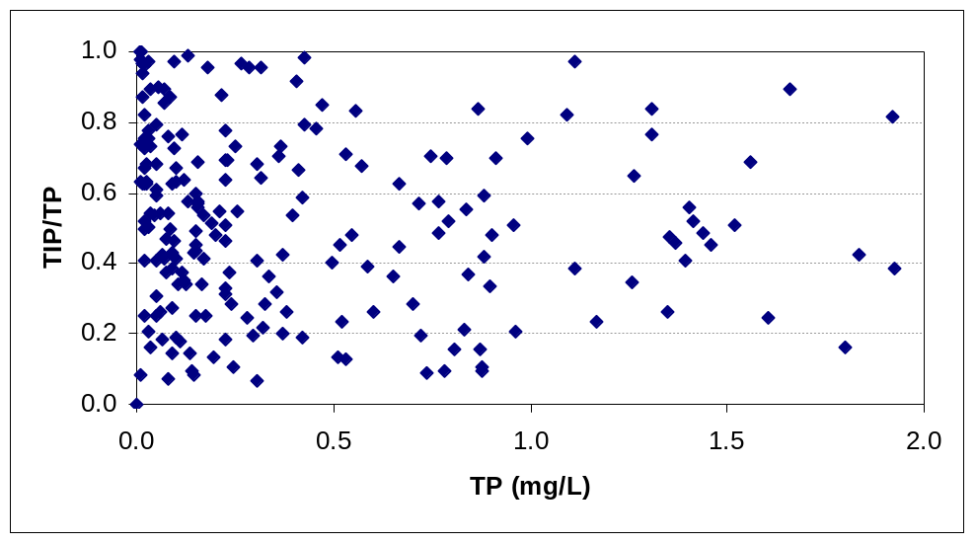
Figure 15. Inorganic Phosphorus Fraction vs. Total Phosphorus in Ecoregion 6 Streams
For the purpose of the initial analysis, it was assumed that the inorganic fraction for nitrogen could be represented as the median from sites with TN concentrations less than 1 (35 percent inorganic), while the inorganic fraction of phosphorus could be represented as the median from sites with TP concentrations less than 0.5 mg/L (63 percent inorganic). However, the large variability in actual fractions limits the applicability of a generic approach to setting total nutrient criteria based on simulation with inorganic nutrient fractions.

When these assumptions are applied, the QUAL2K (version 1) predictions with default parameters deviate markedly from the Dodds et al. equation predictions (Figure 16). The QUAL2K predictions are considerably higher than those predicted by the Dodds model and not linearly related to those predictions.
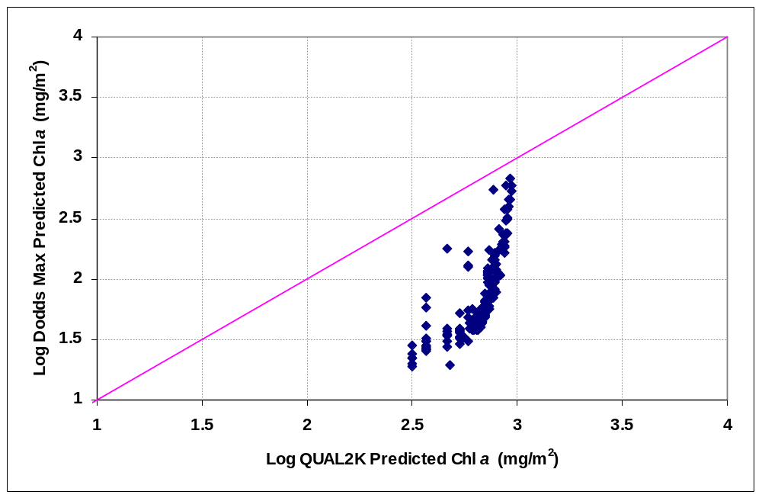
Figure 16. Comparison of QUAL2K (version 1) Steady-State Predictions with Default Parameters to Dodds (2002) Equation for Maximum Periphyton Chlorophyll a
An approximate fit between the QUAL2K (version 1) steady-state results and the Dodds (2002, rev. 2006) equation for maximum chlorophyll a density (as applied to sample pairs of nutrient concentrations drawn from the EMAP and RB3 nutrient data) was obtained by adjusting the kinetic parameters to minimize the squared difference in log space, using numerical optimization on the death rate and the half-saturation constants. (Note that the steady-state solution depends on the ratio K_{p max}/(k_{rb} + k_{db}), so it is not necessary to optimize the maximum photosynthetic rate separately.) The resulting fit is shown in and the corresponding parameter values inTable 4.
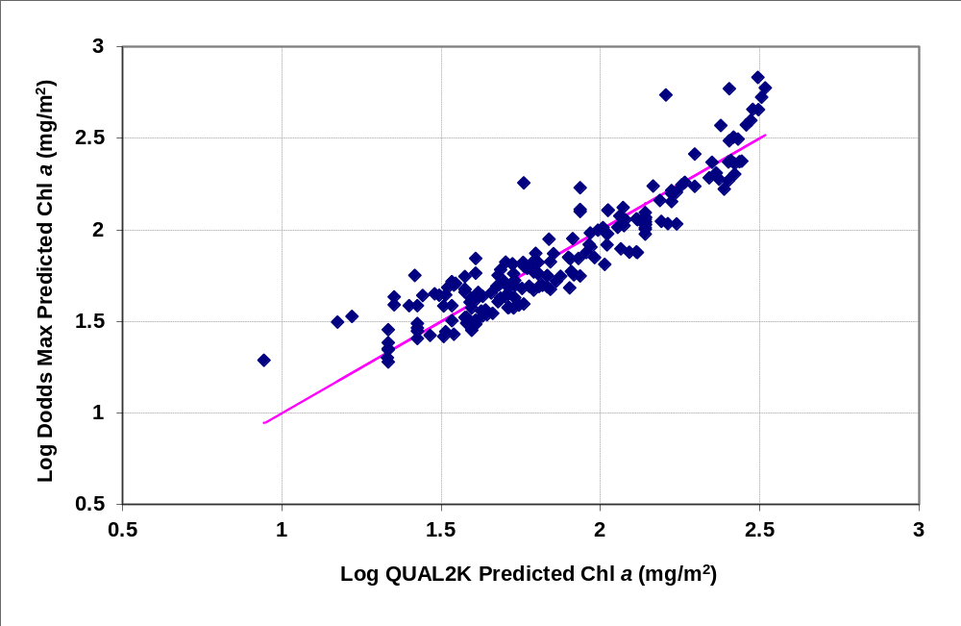
Figure 17. Optimized Reconciliation of QUAL2K (Version 1) Steady-State Predictions to Dodds (2002, rev. 2006) Equation for Maximum Periphyton Chlorophyll a
Note: Individual points represent observed nutrient pairs from the RB6 and EMAP California data sets.

Table 4. QUAL2K (Version 1) Kinetic Parameters for Benthic Algae Adjusted to Approximate Dodds’ (2002, rev. 2006) Results at Steady State
Parameter | Default Value | Optimized Value | Units
(maximum photosynthetic rate) | 60 | 60 | g/m²-d
(respiration rate) | 0.125 | 0.125 | 1/d
(natural death rate) | 0.02 | 0.273 | 1/d
(inorganic nitrogen half-saturation constant) | 0.015 | 0.203 | mg-N/L
(inorganic phosphorus half-saturation constant) | 0.002 | 0.00954 | mg-P/L

Fitting the model requires an elevated natural death rate, which appears potentially unrealistic. The estimated inorganic nutrient half-saturation constants are higher in the adjusted model than specified in the default parameters. This likely reflects the model assumption that the water column is completely mixed, whereas there is likely to be a vertical gradient, particularly in the presence of an active periphyton community, with lower concentrations near the sediment-water interface. The half-saturation point relative to the averaged water column concentration will thus be higher than the true half-saturation constant relative to the water layer just above the sediment bed. The effect of this parameter change is to delay response until higher concentrations are reached.
The model fit yields a maximum density of about 139 g/m² AFDM (348 mg/m² chlorophyll a) in the absence of nutrient or light limitation. This is much lower than the estimate with default parameters (360 g/m² AFDM or 900 mg/m² chlorophyll a) because of the increase in the natural death rate relative to the default parameters, and lower than values observed in many streams). The QUAL2K and Dodds predictions diverge for higher concentrations, with the Dodds equation predicting much greater biomass for the same nutrient concentrations above about 250 g/m² AFDW. Thus, the direct fit of QUAL2K to the Dodds equation appears unsuitable for high nutrient concentrations.
Using the chlorophyll a to AFDM ratio of 2.5 and the dissolved fractions of TN and TP cited above, concentrations corresponding to different benthic chlorophyll a targets may be generated, as shown in . Two sets of numbers are given for inorganic phosphorus. The first is obtained directly from the model (with nitrogen not limiting), while the second represents a Redfield ratio interpretation of the total inorganic nitrogen target. The Dodds model has a high degree of uncertainty, and many of these streams appear to be nitrogen limited. Assuming that the fit to nitrogen is thus more reliable than the fit to phosphorus and following the arguments of Dodds et al. (1997), it may be more appropriate to select joint nitrogen and phosphorus targets consistent with the Redfield ratio. The resulting targets for both TN and TP are lower than those proposed in Dodds et al. (1997) of 297 and 35 µg/L, respectively, to achieve a maximum chlorophyll a density of 100 mg/m².. However, the Dodds recommendations are based on the logarithm of the arithmetic mean concentration, while the QUAL2K fit more properly reflects the geometric mean or median concentration, which is typically lower than the mean for log-normally distributed environmental variables. The P targets are in line with the findings of Sosiak (2002) on the Bow River who associated a maximum periphytic chlorophyll a density of 150 mg/m² with a median soluble reactive phosphorus concentration of 7 µg/L, and with Biggs (2000), who found that 30 days of accrual at 10 µg/L soluble reactive phosphorus produced a biomass of 200 mg/m² chlorophyll a in a group of New Zealand streams. It should be cautioned that the nutrient targets derived in this way ignore the availability of nutrients from sediment and the role of luxury storage and nutrient recycling in the periphyton mat. They also depend on the assumption of chlorophyll a toWAFDM ratio, and use of a lower ratio would yield higher targets. Finally, it should be noted that, even if quantitatively correct, the target concentrations derived from the QUAL2K formulation are “either/or” rather than “and” constraints. That is, the maximum chlorophyll a target is predicted to be met if either the N or P target is met.
Table 5. Nutrient Concentrations to Achieve Maximum Benthic Chlorophyll a Targets Estimated by Optimized QUAL2K Equations for Ecoregion 6
Maximum Chlorophyll a (mg/m²) | Corresponding Algal AFDM (g/m²) | Total (and Inorganic) N (µg/L) | Total (and Inorganic) P (µg/L) | Total (and Inorganic) P (µg/L) – Redfield Ratio
100 | 40 | 234 (82) | 6.0 (3.8) | 32.4 (11.3)
150 | 60 | 437 (153) | 11.4 (7.2) | 60.4 (21.2)
200 | 80 | 783 (274) | 20.5 (12.9) | 104 (37.9)

There is a difference in how use of the Redfield ratio works out with the Dodds empirical approach and the QUAL2K parametric approach. The Dodds equations depend on both nitrogen and phosphorus, and thus always represent some degree of co-limitation. QUAL2K, on the other hand, follows a most-limiting-nutrient approach. For QUAL2K, the target can be obtained by limiting either nitrogen or phosphorus. The Dodds approach always yields a curve of values meeting the target that depends on both nitrogen and phosphorus equations. Imposing a Redfield ratio target on phosphorus on the Dodds equation could be viewed as acknowledgment that the simulated behavior of co-limitation by N and P is not realistic when one nutrient is strongly limiting.
It should be noted that the spreadsheet tool does not use the Redfield ratio approach. Adjustment by the Redfield ratio approach is a potential post facto analysis that may or may not be appropriate.

Reconciling QUAL2K and Dodds’ Estimates – Revised Model
While a general agreement can be obtained between Dodds et al.’s (2006) equation for maximum chlorophyll a and predictions using the QUAL2K equations by optimizing parameter values, the two solutions diverge at high concentrations, with the optimized QUAL2K underestimating the results of the Dodds solution. Somewhat less obvious, the linear fit for QUAL2K tends to overestimate the Dodds results in the mid range. The combined effect is to underestimate the nutrient concentrations required to meet maximum chlorophyll a targets less than 200 mg/m², while at the same time potentially underestimating the impacts that may occur in connection with higher nutrient concentrations.
These observations led to a reconsideration and revision of the approach used in QUAL2K.
The QUAL2K model (version 1) represents benthic algal growth in a manner analogous to planktonic algal growth using a Monod formulation. This assumes that limitations on growth are directly determined by ambient water quality concentrations (C) of nutrients, characterized by a Michaelis-Menten half-saturation constant (K), such that the fraction of potential growth is given by C/(C+K).
The Monod formulation rests on the assumption that measured ambient concentrations are representative of actual nutrient availability to growing cells, and also that K is a constant. Unlike planktonic algae, benthic algae are not fully exposed to the water column. The assumption may be reasonable at low periphyton densities, but becomes less appropriate at higher densities, resulting in a divergence from the Dodds solution. Assuming that the empirical relationship developed by Dodds is correct, the divergence could be explained by a combination of some of the following factors: (1) inappropriate assumptions regarding inorganic nutrient fractions, particularly at higher periphyton densities where the periphyton may deplete inorganic nutrients from the water column, (2) development of a concentration gradient in the water column under conditions of high periphyton nutrient demand and low mixing intensity such that ambient water column samples are not representative of the concentrations available at the stream bottom, (3) “luxury” nutrient storage, either directly by algae or by heterotrophs in the periphyton mat, and (4) diffusion limitations on nutrient penetration into the periphyton mat.
Difficulties in obtaining reliable measurements of the inorganic nutrient fraction available to periphyton suggest that it may be advantageous to base the model on total nutrient concentrations. Similarly, Dodds et al. (1997, 2002, 2006) found that empirical models based on TN and TP provided better fits than models based on inorganic N and P.
Shifting to a total nutrient basis alone does not solve the discrepancy between the methods. Indeed, the model optimization in the previous section was developed using constant inorganic fractions, and so is directly proportional to a fit to total nutrients. A much better agreement between the QUAL2K and Dodds results can be obtained if nutrient availability (as a fraction of total nutrient concentration) is assumed to vary as a function of periphyton density. Mathematically, this is equivalent to assuming that the Michaelis-Menten half-saturation parameter (on total nutrient concentration) varies with density, with a factor equal to the inverse of the availability factor.
Somewhat counter-intuitively, an improved match between the two predictions across the entire range of concentrations, with growth and death rates closer to literature defaults, can be obtained if nutrient availability is assumed to decline with increasing concentration (or the half-saturation constant increases with increasing nutrient concentration). Here, nutrient concentration is a surrogate for the thickness of the periphyton mat. As mat thickness increases, higher rates of detrital sloughing may be anticipated, resulting in higher particulate nutrient concentrations in the water column. Decrease in availability with increasing concentration (such as might occur due to diffusion limitation) means that the QUAL2K model can be fit with a lower death rate, resulting in higher predicted benthic algal densities at high nutrient concentrations, while maintaining or improving fit at lower concentrations.
We investigated several adjustments to obtain better agreement between QUAL2K and Dodds, and eventually settled on a scaled logistic model to represent the fraction of nutrient concentration that is not available. The logistic model is an approximation of the cumulative normal distribution and exhibits a characteristic s-curve shape. Availability is expressed as the complement of the unavailable fraction, resulting in the following representation:
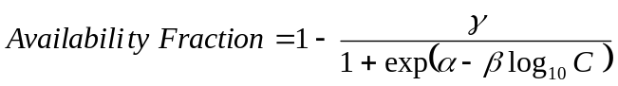,
where γ is a shift parameter that establishes a non-zero lower bound for availability and α and β are scaling parameters. This representation ensures that as C goes toward zero availability goes to 1, and as C becomes large availability goes to 1 – γ. The typical shape of this representation is shown in .
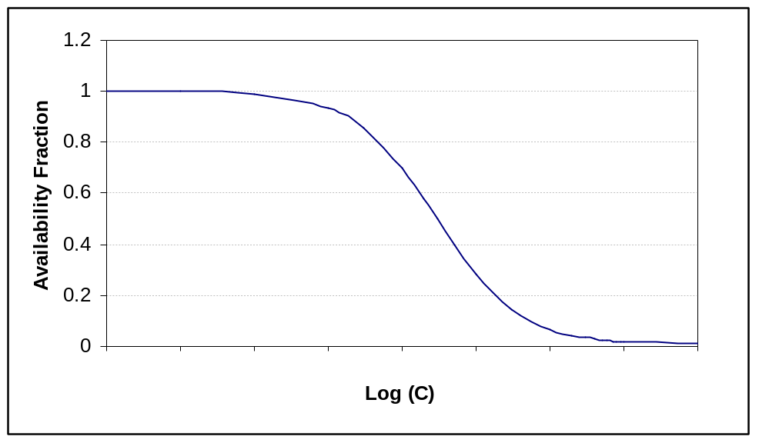
Figure 18. Logistic Representation of Total Nutrient Availability Fraction
Availability here represents more than just the inorganic fraction of nutrients, as it may also reflect factors such as mat thickness, vertical gradients in the water column, and temporal variability in the inorganic fraction.
Interestingly, the total effect on the Monod growth limitation can be equivalently expressed as an effect on nutrient availability or as an inverse effect on the half saturation constant:
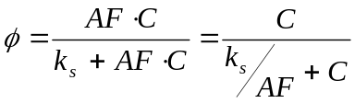,
in which AF, the available fraction, is a function of total nutrient concentration, C.
Using this representation, an approximately unbiased agreement between the revised QUAL2K and Dodds estimates can be obtained across the entire range of data (). The maximum potential biomass predicted by the revised model under the assumed light conditions (280 g/m²WAFDM or 700 mg/m² chlorophyll a) is similar to that predicted by the QUAL2K model in Section 2.5); however, the relationship to the Dodds predictions is in better agreement across the entire range.

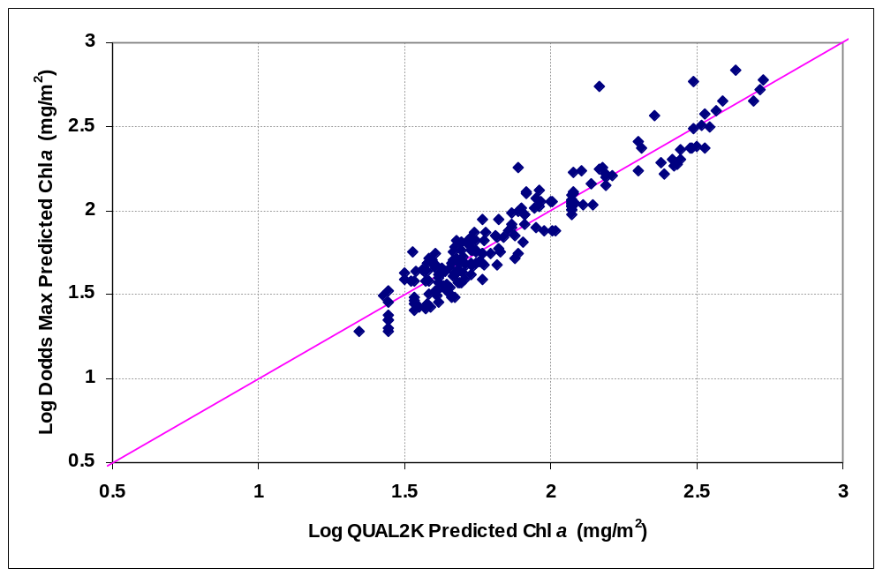
Figure 19. Optimized Reconciliation of Revised QUAL2K Steady-State Predictions to Dodds et al.’s (2002, rev. 2006) Equation for Maximum Periphyton Chlorophyll a

Optimized parameter values for the revised QUAL2K model are shown in . The maximum photosynthetic rate and natural death rate aretcloser to literature values and QUAL2K defaults. Half-saturation constants are not directly comparable to the previous model – first because they are in terms of total nutrient concentration rather than the inorganic fraction, and second because they may be thought of as varying as a function of concentration (as the inverse of availability). Values are shown at zero and at the average concentration of each nutrient. The optimized logistic model parameters result in a wide variability in availability (or in effective half-saturation constant) for TN, with a much smaller range of variation for TP.
Table 6. Kinetic Parameters for Revised QUAL2K Model of Benthic Algae Adjusted to Dodds’ (2002, rev. 2006) Results
Parameter | Optimized Value |  | Units
(maximum photosynthetic rate) | 54.95 |  | g/m²-d
(respiration rate) | 0.125 |  | 1/d
(natural death rate) | 0.0667 |  | 1/d
(total nitrogen half-saturation constant) | 0.0202 at 0 mg/L TN  2.41 at 1.622 mg/L TN |  | mg-N/L
(total phosphorus half-saturation constant) | 0.0223 at 0 mg/L TP  0.045 at 0.046 mg/L TP |  | mg-P/L
Logistic Availability Model | Total N | Total P
α | -0.956 | 82.082 | for concentrations in µg/L
β | 1.889 | 10.362 | for concentrations in µg/L
γ | 0.993 | 0.531 | for concentrations in µg/L

Concentrations predicted to achieve various target levels by control of one nutrient only are shown in . The phosphorus targets remain quite low. However, in this model, potential nitrogen co-limitation persists to a much higher concentration, due to the assumption of nitrogen availability varying with concentration, and the total phosphorus targets calculated from the Redfield ratio to total N are more consistent with the targets derived from Dodds et al. 22006) of 300 µg/L TN and 42 µg/L TP to achieve a maximum periphytic algal biomass of 100 mg/m² chlorophyll a, which also relied on the Redfield ratio. The directly calculated targets for total phosphorus are, however, in line with the findings of Sosiak (2002), studying the effects of removal of phosphorus and nitrogen from sewage effluent in the Bow River, Calgary, Alberta, who developed a regression equation predicting a maximum periphytic chlorophyll a density of 150 mg/m² in response to a median concentration of 18 µg/L total phosphorus.
Table 7. Nutrient Concentrations to Achieve Maximum Benthic Chlorophyll a Targets
Estimated from Revised QUAL2K Model for Ecoregion 6
Maximum Chlorophyll a (mg/m²) | Corresponding Algal Biomass (g/m²) | Total N (µg/L) | Total P (µg/L) | Total P – Redfield Ratio (µg/L)
100 | 40 | 344 | 4.1 | 48
150 | 60 | 645 | 13.5 | 92
200 | 80 | 1021 | 20.0 | 147

Commenters have suggested that it is desirable to use a model solution that is based on inorganic, rather than total nutrient concentrations. Like the standard QUAL2K implementation, the revised QUAL2K method is “tuned” to agree with Dodds’ empirical solution for maximum benthic chlorophyll a as applied to the CA EMAP and RB6 data. While the standard approach uses inorganic nutrient concentrations and the revised approach uses total nutrient concentrations as a starting point, both are evaluated from an interpretation of the data that assumes constant inorganic nutrient fractions. This means that the revised QUAL2K method, with minor modifications, may be equivalently assumed to be a solution based on inorganic nutrient concentrations. Specifically, if the inorganic fraction of total nutrient is assumed to be ξ, the same parameters may be applied to inorganic nutrient concentrations if the total nutrient half-saturation constant is adjusted by 1/ξ. Such a modification could readily be added to the spreadsheet, or the spreadsheet may be simply applied with organic nutrient concentrations set to zero and the half-saturation constants adjusted as indicated above.

Effects of Grazing
As noted above, grazing likely accounts for much of the variation in observed relationships between nutrient concentrations and periphyton biomass (Walton et al., 1995; Anderson et al., 1999). Effects of grazing, however, depend on the density of grazers (which may vary dramatically over time) and the type of algae that are present. In some cases, grazers may accomplish nearly complete removal of diatoms, while there is generally little or no effect on Cladophora. Where the approach to nutrient criteria is based on maximum potential periphyton density, it may generally be appropriate to ignore the influence of grazers. It is possible to include the effect of grazing through the death rate of benthic algae in the QUAL2K model. However, assigning realistic rates will require site-specific information.

Effects of Hydraulic Regime (Accrual Adjustment)
In higher-gradient natural streams, periphyton is periodically scoured out by high flow events. Variability in flow may also suppress periphyton growth relative to steady flowing streams in other ways, for instance by periodic drying of much of the wetted perimeter. Unlike grazing, hydraulic scour can be considered as a relatively consistent feature of many streams that is less dependent on biology. Therefore, it may be appropriate to include scour effects as a co-factor in the analysis of likely maximum benthic algal density in streams.
Flow volume is a useful surrogate for velocity, and changes in flow volume correlate with changes in velocity. Sudden increase in velocity (e.g., by a factor of two to three) can result in the scour of a constant-velocity adapted biomass. Periphyton can adapt to growth in high velocity conditions (up to about 70 cm/s), but periphyton mats that develop under such conditions are still susceptible to scour when velocity increases (Horner et al., 1990). Therefore, the frequency of sudden increases in velocity (or flow) is a useful indicator of the role of scour impacts.
In extensive work in New Zealand, Biggs (2000) determined that a simple, but useful statistical representation of the effects on biomass of hydrologic regime can be created based on an analysis of the mean number of days available for biomass accrual (d_{a}), which he defined as the average time between flood events greater than 3 times the median flow. Note that days of accrual are calculated as [1/(mean frequency of events per year >3x median flow) x 365 d], and the measure is not the same as an actual count of average days between flood events. Biggs found that the frequency of high-biomass events increases greatly in response to nutrients when the average accrual period exceeds about 50 days.
Biggs’ best fit regression for maximum monthly density of benthic algal biomass (mg/m² chlorophyll a) was written in terms of days of accrual and soluble inorganic nitrogen (SIN) concentration, although the parameters on d_{a} are similar for regressions on accrual only and on accrual and soluble reactive phosphorus. This has the form:
Figure 3 in Biggs (2000) shows that the response to d_{a} flattens out by 200 days and may be taken as an estimate of the maximum response in the absence of scour, B_{max}. Because the equation is in logarithmic form, computing the ratio of B at a specified value of d_{a} to the value of B_{max} results in cancellation of the constant and SIN terms. This yields an expression for the reduction in maximum monthly biomass as a function of days of accrual:
This results in a factor on the maximum potential periphytic algal biomass as a function of days of accrual as shown in .
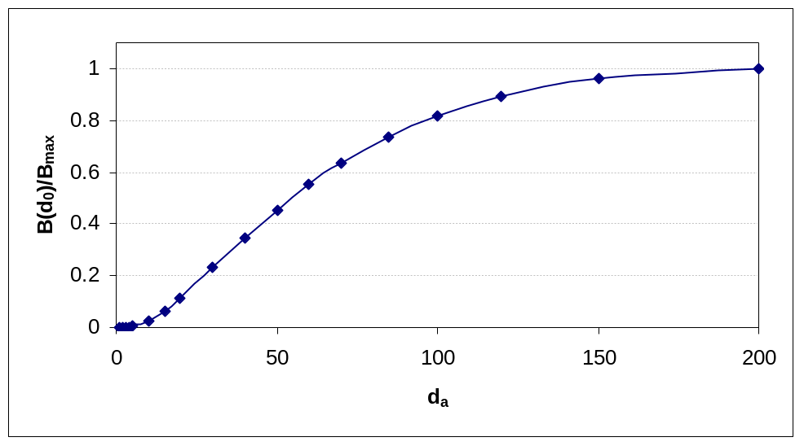
Figure 20. Fraction of Potential Maximum Periphyton Biomass Expected as a Function of
Days of Accrual
The exact parameter values for this relationship are specific to the New Zealand streams studied by Biggs, and may not be applicable to California. However, data are not available to develop a similar analysis for periphyton response in California streams, and it is reasonable to expect that a similar relationship exists. Note that a 50-day or less accrual period is sufficient to reduce the density by more than half (using Biggs’ regression).
Variability in the hydraulic regime is likely to have a large effect on whether a particular biomass target is attained. For example 30 or less days of accrual would reduce the average monthly maximum biomass to 23 percent of the theoretical maximum, using the Biggs (2000) equation. Under these conditions, the biomass would not be predicted to exceed a 100 mg/m² chlorophyll a target using the default QUAL2K parameters.
The Mediterranean climate of southern California experiences long dry periods during the summer. Intuitively, this would suggest that the value of d_{a} should be large for streams in this area, and the effects on biomass small. This is not, however, necessarily the case, as d_{a} is defined on the basis of frequency relative to the median flow, and the California climate also suppresses the median flow value. In fact, d_{a} should be thought of as a measure of flow variability rather than as a direct index of flood frequency. This can be seen through an example application to the 1969-1994 flow record for the upper Santa Margarita River at Temecula, CA (USGS gage 11044000).
Flow in the Santa Margarita at this site is flashy, but is perennial in character, being supported by groundwater discharge (). Like most California rivers, flows in the Santa Margarita are also affected by upstream impoundments, return flow from irrigation using imported water, and wastewater discharges.
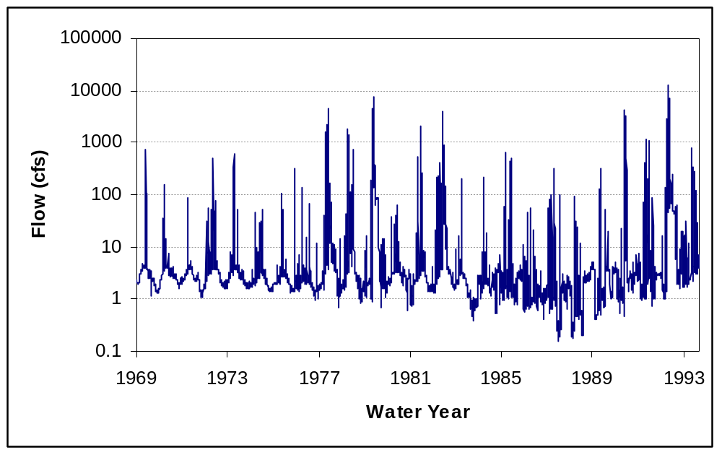
Figure 21. Daily Flows in the Santa Margarita River at Temecula, CA
Large flows in the Santa Margarita typically occur for brief periods in the winter rainy season and are uncommon in the summer. For example, flows of 100 cfs or greater occur on less than 3 percent of days, and there are often greater than 200 days between flows of this magnitude. However, this does not mean that the value of d_{a} is large.
The median flow in the Santa Margarita is 2.5 cfs, and 3 times the median flow is only 7.5 cfs, so flows greater than 3 times the median are actually fairly common. Over the period of record, 12.3 percent of flows exceeded 7.5 cfs. The value of d_{a} calculated as recommended by Biggs is thus only 8.13 days. This estimate is, however, strongly influenced by the flow regime in a few wet years. If, alternatively, the value of d_{a} is calculated for each individual year and then averaged the estimate is 22.7 days.
In either case, the Santa Margarita example shows that the estimate of Biggs’ accrual index, d_{a}, may be quite low for California streams – not because large floods occur frequently but because of variability about a naturally low median flow. If the Biggs relationship is valid for these types of streams, this would imply a significant reduction in the maximum potential algal biomass as a function of flow variability. Another possibility is that d_{a} should be redefined as a higher multiple of median flow for the California climate than is appropriate for New Zealand. Testing of the relationship is needed for California streams, but is not possible with the data currently available.
If a low value is set for the days of accrual (d_{a}), then the estimated maximum benthic algal density will be reduced to a fraction of what otherwise would be predicted. This in turn would lead to an estimate of a high assimilative capacity for nutrients, which would not be justified if scour does not actually occur. A solution is to define d_{a} not on the basis of a multiple of the median flow but instead on the frequency of reaching a flow/velocity threshold sufficient to induce scour (which, for some streams such as the Santa Margarita, may be much greater than three times the median flow). Unfortunately, data to establish such a threshold are sparse, and complicated by the fact that different types of benthic algae are adapted to different hydraulic conditions. One possibility (that would address cases such as the Santa Margarita) would be to define d_{a} based on the larger of 3 times the median flow and a flow corresponding to some fraction of the channel forming or bankfull flow (e.g., some fraction of the 1.5-year recurrence flow). Further research would be needed to explore this option.

DO Deficit Contribution of Benthic Algae
In addition to direct impacts, extensive growths of benthic algae are of concern due to their ability to cause significant diurnal fluctuations in dissolved oxygen concentration. To evaluate this component as an endpoint for analysis, the portion of the DO balance due to benthic algae can be separated from the overall DO balance.
The components of DO deficit are superposable (additive). Consider the portion due only to fixed (benthic) algae. Respiration and daily average photosynthesis by fixed algae can be described by a net, distributed source-sink term:
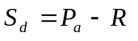,
where 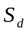 is the net source-sink term (M/L³-T), 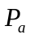 is the daily average oxygen production rate due to photosynthesis, and  is the respiration rate.
The DO equation for these sources is described in Thomann and Mueller (1987, p. 320):
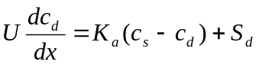,
where U is the water velocity, x is the travel distance,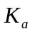is the reaeration rate, 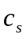is the saturation concentration, and 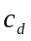is the DO concentration. The DO deficit equation (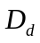) for benthic algae is then:
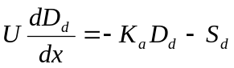.
This is a first-order, ordinary-linear, non-homogeneous differential equation with solution
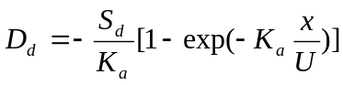.
As 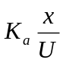 becomes larger, 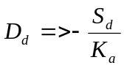, which gives the maximum possible daily average deficit associated with benthic algae. The maximum is reached more quickly in streams that are shallow and rapidly moving, as opposed to deeper, slower moving streams.
Work of DiToro (1975a) and Erdmann (1979), as cited in Thomann and Mueller (1987, p. 290), shows that the diurnal range in deficit can be approximated by 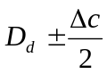, where
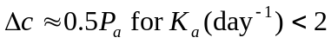, and
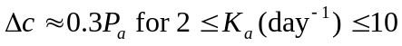.
For an approximate analysis in flowing streams, use the O’Connor and Dobbins (1958) method for reaeration:
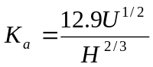,
where is the reaeration rate (day⁻¹),  is the velocity in ft/s, and is the depth in ft (note the non-SI units).
Outputs of the QUAL2K equations, bottom algae photosynthesis () and respiration (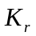) are in g DW/m²-d (g DW = grams dry weight) as a daily average. From stoichiometry, photosynthesis (using NH₄) creates 32 mg O₂ per 12 mg C (creates more when NO₃ is used, so use NH₄ for conservative estimate). Respiration similarly uses 32 mg O₂ per 12 mg C. In addition, assume that DW = 40% C (QUAL2K default).
Given and from QUAL2K equations, along with water depth (H),
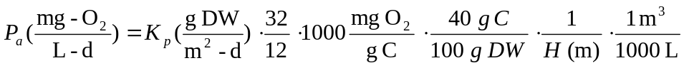,
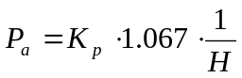.
Similarly, direct respiration is estimated as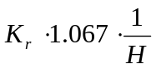. Assume that algal death also represents a direct oxygen demand and can be included with respiration, then
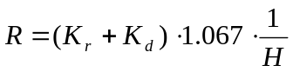.
Combining, the daily average DO deficit impact of benthic algae is estimated as
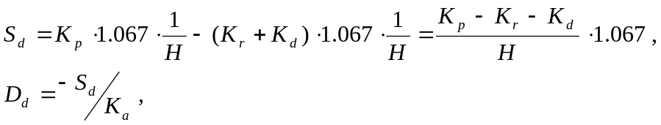
At steady-state conditions (as in the benthic biomass calculation), (K_{p}-K_{r}-K_{d}) is, by definition, equal to zero. Deleterious impacts of benthic algae on the DO balance occur, however, under unsteady conditions of a biomass die-off, when production is less than respiration plus death. In the benthic biomass predictor, a reasonable estimate of relative risk can be obtained by evaluating K_{r} and K_{d} at the expected maximum benthic algal concentration associated with ambient conditions, while evaluating K_{p} at the user-specified minima of daily average insolation and nutrient concentrations to establish the maximum expected daily average deficit.
The diurnal range in DO deficit is 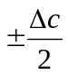as given above, and is added to the daily average deficit to estimate the maximum instantaneous DO deficit. This approach is incorporated into the benthic biomass predictor spreadsheet to provide scoping analyses of the maximum DO deficit, or the range of DO fluctuation, that is expected from nutrient-induced growth of benthic algae.

References
Anderson, E.L., E.B. Welch, J.M. Jacoby, G.M. Schimek, and R.R. Horner. 1999. Periphyton removal related to phosphorus and grazer biomass level. Freshwater Biology, 41: 633-651.
Biggs, B,J.F. 1989. Biomonitoring of organic pollution using periphyton, South Branch, Canterbury, New Zealand. New Zealond Journal of Marine and Freshwater Research, 23: 263-274.
Biggs, B.J.F. 2000. Eutrophication of streams and rivers: dissolved nutrient-chlorophyll relationships for benthic algae. Journal of the North American Benthological Society, 19(1): 17-31.
Black, J.N., C.W. Bonython, and J.A. Prescott. 1954. Solar radiation and the duration of sunshine. Quarterly Journal of the Royal Meteorological Society. 80: 231-235.
Bowie, G.L., W.B. Mills, D.B. Porcella, C.L. Campbell, J.R. Pagenkopf, G.L. Rupp, K.M. Johnson, P.W.H. Chan, S.A. Gherini, and C.E. Chamberlin. 1985. Rates, Constants, and Kinetic Formulations in Surface Water Quality Modeling (Second Edition). EPA/600/3/-85/040. Environmental Research Laboratory, U.S. Environmental Protection Agency, Athens, GA.
Chapra, S. and G. Pelletier. 2003. QUAL2K: A Modeling Framework for Simulation River and Stream Water Quality: Documentation and Users Manual. Civil and Environmental Engineering Dept., Tufts University, Medford, MA.
Chapra, S., G. Pelletier, and H. Tao. 2006. QUAL2K: A Modeling Framework for Simulating River and Stream Water Quality (Version 2.04): Documentation and Users Manual. Civil and Environmental Engineering Dept., Tufts University, Medford, MA.
Chapra, S.C., G.J. Pelletier, and H. Tao. 2008. QUAL2K: A Modeling Framework for Simulating River and Stream Water Quality, Version 2.11: Documentation and Users Manual. Civil and Environmental Engineering Dept., Tufts University, Medford, MA.
Collins, G.B. and C.I. Weber. 1978. Phycoperiphyton (algae) as indicators of water quality. Trans. Am. Microscop. Soc., 97: 36-43.
DiToro, D.M. 1975. Algae and Dissolved Oxygen. Summer Institute in Water Pollution. Manhattan College, Bronx, NY.
Dodds, W.K., V.H. Smith, and B. Zander. 1997. Developing nutrient targets to control benthic chlorophyll levels in streams: A case study of the Clark Fork River. Water Research, 31(7): 1738-1750.
Dodds, W.K., J.R. Jones, and E.B. Welch. 1998. Suggested classification of stream trophic state distributions of temperate stream types by chlorophyll, total nitrogen, and phosphorus. Water Research, 32(5): 1455-1462.
Dodds, W.K., V.H. Smith, and K. Lohman. 2002. Nitrogen and phosphorus relationships to benthic algal biomass in temperate streams. Canadian Journal of Fisheries and Aquatic Sciences, 59: 865-874.
Dodds, W.K., V.H. Smith, and K. Lohman. 2006. Erratum: Nitrogen and phosphorus relationships to benthic algal biomass in temperate streams. Canadian Journal of Fisheries and Aquatic Sciences, 63: 2290-1191.
Droop, M.R. 1974. The nutrient status of algal cells in continuous culture. J. Mar. Biol. Assoc. UK, 54: 825-855.
Erdmann, J.B. 1979. Systematic diurnal curve analysis. J. Water Poll. Contr. Fed, 51(1): 78-86.
Horner, R.R., E.B.Welch, M.R. Seeley, and J.M. Jacoby. 1990. Responses of periphhyton to changes in current velocity, suspended sediment and phosphorus concentration. Freshwater Biology, 24: 215-232.
O’Connor, D.J. and W.E. Dobbins. 1958. Mechanism of reaeration in natural streams, Trans. ASCE, Vol. 123, pp 641-684.
Rhee, G. -Y. 1973. A continuous culture study of phosphate uptake, growth rate and polyphosphate in Scenedesmus sp. J. Phycol., 9: 495–506
Sosiak., A. 2002. Long-term response of periphyton and macrophytes to reduced municipal nutrient loading to the Bow River (Alberta, Canada). Can. J. Fish. Aquat. Sci., 59: 987-1001.
Tetra Tech. 2003. 2003 Progress Report, Ecoregion 6 (Southern and Central California Oak and Chaparral Woodlands) Pilot Study for the Development of Nutrient Criteria. Prepared for US EPA Region IX Regional Technical Advisory Group and CA SWRCB State Regional Board Advisory Group. Tetra Tech, Inc., Lafayette, CA.
Thomann, R.V. and J.A. Mueller. 1987. Principles of Surface Water Quality Modeling and Control. Harper & Row, NY.
USACE. 1956. Snow Hydrology. U.S. Army Corps of Engineers, North Pacific Division.
Walton, S.P., E.B. Welch and R.R. Horner. 1995. Stream periphyton responses to grazing and changes in phosphorus concentrations. Hydrobiologia, 302: 31-46.
Welch, E.B. and J.M. Jacoby. 2004. Pollutant Effects in Freshwater, Applied Limnology, 3rd Edition. Spon Press, London.
WMO. 1994. Guide to Hydrological Practices, Fifth Edition. WMO-No. 168. World Meteorological Organization, Geneva.
Wool, T.A., R.B. Ambrose, J.L. Martin, and E.A. Comer. 2003. Water Quality Analysis Simulation Program (WASP), Version 6.0, Draft: User’s Manual. U.S. Environmental Protection Agency – Region 4, Atlanta, GA.

