编号 | B001-008
机构 | ProjectSyndicate（Project Syndicate）
类型/日期 | news_science ｜ 2026-08-28
英文原题 | China’s Super-Dam Is Becoming an Upstream Water Bomb
原文链接 | https://www.project-syndicate.org/commentary/china-himalayan-super-dam-dangerous-and-plan-lacks-transparency-by-brahma-chellaney-2026-08
简报期次 | B001（2026-08-28 归档）
本库文件 | B001-008-Project syndicate -chinas-super-dam-is-becoming-an-upstream-water-b-202608.md

China’s Super-Dam Is Becoming an Upstream Water Bomb
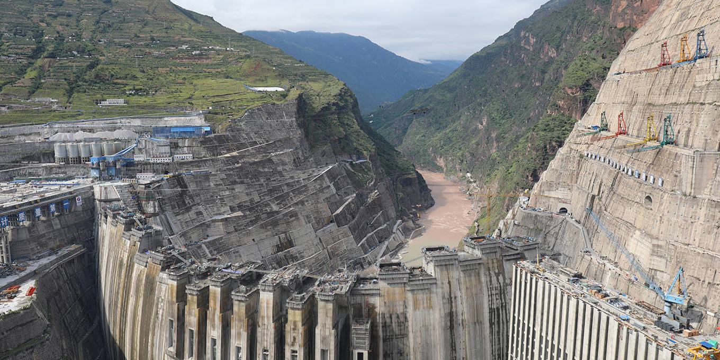
图1 Image for China’s Super-Dam Is Becoming an Upstream Water Bomb
The latest evidence suggests that the Chinese scientific establishment understands the dangers of a planned Himalayan dam—the world's largest—more clearly than its political leadership is willing to acknowledge. With the livelihoods of two billion people at stake, the international community needs to weigh in.
Your browser does not support the audio element. Listen to this commentary Please log in to listen to this commentary 0:00 / 0:00 1x Audio unavailable NEW DELHI—The world’s largest dam is rising in one of the world’s most geopolitically treacherous and seismically unstable regions. Just a few kilometers from the heavily militarized border with India, China is constructing an unprecedented hydropower project in Tibet on the Yarlung Tsangpo, the world’s highest-altitude major river, better known internationally as the Brahmaputra.
The super-dam will dwarf China’s Three Gorges Dam, currently the world’s largest, in power-generating capacity. Its reservoir will impound a gargantuan volume of water above millions of people downstream in India’s northeast and deltaic Bangladesh, much of which lies barely above sea level.
Now the most troubling warning is coming not from foreign critics but from China’s own scientists. A recent paper published in the state-linked, Mandarin-language journal Sedimentary Geology and Tethyan Geology identifies serious geological hazards at the construction site. The geologists conclude that the terrain has a “loose structure and weak cohesion” and warn that fault movement or an earthquake could easily trigger large-scale instability, threatening both the reservoir and surrounding infrastructure. The authors recommend reinforcing the reservoir slopes, installing retaining structures, and redesigning key elements to reduce the risk of catastrophe.
When scientists working under a communist regime issue such warnings, the international community must pay attention.
The new dam is rising at the Great Bend of the Brahmaputra, where the river plunges steeply through the world’s deepest and longest canyon before entering India. It also sits squarely within the Himalayan seismic belt, created by the slow-motion collision of the Indian and Eurasian tectonic plates. This is among Earth’s most earthquake-prone regions, with a record of producing devastating temblors.
, PS Politics Every Wednesday in PS Politics, we share a curated selection of original analysis on the latest events and most pressing issues related to global politics and international relations.
By signing up, you agree to our privacy policy and terms of service.
Make your inbox smarter. Select Newsletters
The danger is not simply that an earthquake might damage a dam. A gigantic reservoir could itself trigger a quake by intensifying geological stresses. Reservoir-triggered seismicity, or RTS, has been documented for decades.

图2 Image for Sharpen your perspective
Sharpen your perspective
A PS Digital subscription brings you cutting-edge analysis of the forces shaping markets, politics, and power. This back-to-school season, give one to a student in your life, or claim one for yourself, for only $50 for your first year.
the precise relationship, influential research concluded that the immense weight of water stored in the reservoir of the new Zipingpu Dam may have increased pressure along an underlying fault, potentially advancing the earthquake by decades or even centuries.
Instead of facing up to that scientific possibility, China has embarked on a vastly larger dam project in an even more fragile geological setting. But the Himalayan fault system does not respect national borders; nor would the consequences of a major dam failure. The powerful 2025 Myanmar earthquake demonstrated how interconnected this seismic zone is, with tremors traveling far enough to trigger the collapse of a high-rise building in Bangkok, some 1,000 kilometers away.
The Brahmaputra is the lifeline of northeastern India, irrigating farms, sustaining fisheries, replenishing wetlands, and supporting millions of livelihoods before flowing into Bangladesh, where it is the single largest source of freshwater. Like China’s giant dams on the Mekong, the super-dam threatens to alter cross-border river flows and reduce the downstream transport of nutrient-rich sediment essential to the river’s ecology and riparian countries’ agriculture.
Worse, a catastrophic structural failure—or even an emergency release of impounded water following seismic damage—could unleash devastating floods across densely populated downstream plains with little warning. What begins as an engineering failure in Tibet could become a humanitarian catastrophe extending all the way to Bangladesh, the world’s most densely populated country outside microstates and mini-states.
The geological danger is only part of the story. China is increasingly transforming its control of the Tibetan Plateau—the source of most of Asia’s major rivers—into strategic leverage. It has built cascades of dams on transboundary rivers, withheld hydrological data during periods of tension, and resisted entering any water-sharing treaty with downstream states. Water has become another instrument of coercive statecraft.
The sheer scale of what China calls “the project of the century” will inevitably give it unprecedented control over river flows. Even routine reservoir operations can affect downstream ecosystems, agriculture, sediment transport, and flood patterns.
Yet the project remains shrouded in secrecy, with the Chinese government releasing remarkably little technical information despite the enormous transboundary implications. There has been no meaningful environmental transparency, no independent geological review, and no credible consultation with the countries facing the greatest downstream risks.
International law has long recognized that states sharing transboundary rivers bear responsibilities toward one another, including preventing significant cross-border harm, exchanging relevant information, and consulting on projects that could materially affect downstream neighbors. Adherence to these principles is essential to safeguard shared resources. China’s continuing opacity undermines them.
The Himalayan watershed is often called Asia’s water tower because its rivers sustain nearly two billion people across multiple countries. When the largest dam ever attempted is introduced into this fragile ecosystem, secrecy becomes a regional security risk.
Given the extraordinary stakes, China should immediately invite an independent panel of international seismologists, geologists, and dam-safety experts to inspect the site, review the project’s geological assumptions, and assess whether the recommended design modifications are sufficient. China should also institutionalize year-round, real-time hydrological data-sharing and emergency notification mechanisms with India and Bangladesh, and commit to ongoing transboundary consultation on major design changes.
Ironically, the latest evidence suggests that the Chinese scientific establishment understands the dangers more clearly than its political leadership appears willing to acknowledge. Now that China’s own geologists have raised the alarm, policymakers must embrace transparency and accept transboundary responsibilities before a potential water bomb is fully assembled upstream.
Featured

The Epstein Class Was Made Offshore
Jul 22, 2026 Brooke Harrington

America Is Closing the Door on Opportunity—and Talent
Jul 22, 2026 Pinelopi Koujianou Goldberg

Yes, the Hong Kong of Old Is Over
Jul 23, 2026 Stephen S. Roach

What Ukraine’s Success Means for the West
Jul 24, 2026 Chrystia Freeland

Large Language Models for Small Language Communities
Jul 22, 2026 Vivek Badrinath

Licensing
0 Contact Us Licensing https://prosyn.org/XIpwCSV It appears that you have not yet updated your first and last name. If you would like to update your name, please do so here.
Pin comment to this paragraph After posting your comment, you’ll have a ten-minute window to make any edits. Please note that we moderate comments to ensure the conversation remains topically relevant. We appreciate well-informed comments and welcome your criticism and insight. Please be civil and avoid name-calling and ad hominem remarks.
Hide Cancel Post Comment Save edit Your name First Name Last Name

