编号 | B001-013
机构 | Bruegel（Bruegel - Publications）
类型/日期 | think_tank ｜ 2026-08-27
英文原题 | Why the EU right to consent to personal data processing doesn't work
原文链接 | https://www.bruegel.org/working-paper/why-eu-right-consent-personal-data-processing-doesnt-work
简报期次 | B001（2026-08-28 归档）
本库文件 | B001-013-Bruegel - publications -why-the-eu-right-to-consent-to-personal-data-pro-202608.md

Why the EU right to consent to personal data processing doesn't work
Search: Search Suggested keywords:
decarbonisation
energy
climate change
monetary policy
This paper argues that consent banners for the collection of personal data under the European Union’s General Data Protection Regulation (GDPR) are, in practice, a legal and technical fiction. While the GDPR requires consent to be freely given, specific, informed and unambiguous, it prescribes no technical standards for consent tools. Publishers and advertisers design their own tools. They often exploit pervasive consent fatigue and use ‘dark patterns’ to nudge data subjects towards acceptance of personal data sharing. Few consent tools are fully GDPR-compliant.
More fundamentally, even a perfectly transparent, unbiased consent tool cannot tell data subjects how sharing their data will affect their welfare, since data controllers aggregate and analyse data in ways individuals cannot foresee or evaluate. This makes ‘informed’ consent impossible. Beyond private costs, reduced data sharing under the GDPR has social costs too: reduced market transparency, greater concentration among data brokers, app market exits and higher prices, though data externalities can cut either way for welfare. Policy responses so far, such as proposed EU browser-level opt-out signals and browser extensions that automate consent responses, reduce consent costs but do not improve information for data subjects. The paper closes by speculating that artificial-intelligence agents acting on behalf of data subjects could shift bargaining away from attention-based advertising towards genuine competition for quality online services, potentially resolving the consent fiction, though only if such agents are genuinely neutral rather than commercially biased.
This paper was written for a Bruegel Annual Meetings 2026 panel debate on the EU General Data Protection Regulation. It builds on, and uses substantive extracts from Mariniello et al (2026). However, the views expressed in this paper are the author’s alone and do not necessarily coincide with the views of co-authors in Mariniello et al (2026).
Authors

图1 headshot
Bertin Martens

图2 LAS VEGAS, USA - JANUARY 06:Nvidia CEO Jensen Huang addresses participants at the keynote of CES 2025 in Las Vegas, Neva
Europe needs a strategy to close the artificial intelligence compute gap
In its bid to compete with the US on AI, Europe could learn from both China and from the classic Airbus industrial policy case Alicia García-Herrero and Bertin Martens 19 May 2026 artificial intelligence industrial policy ... technology digital economy innovation

图3 A man walks by a billboard showing a humanoid robot in the AI ​​section at the Chinese International Supply Chain Expo \
The battle for the AI stack
Europe’s options for AI in the midst of US-China strategic competition Alicia García-Herrero, Bertin Martens, Paul Triolo and Yuyun Zhan 08 July 2026 digital economy artificial intelligence ... industrial policy innovation technology

图4 Alicia Bertin 220626
Stack battles: the US-China artificial-intelligence rivalry is moving beyond chips alone
China is challenging US leadership in both AI hardware and software, with Europe unlikely to catch up Alicia García-Herrero and Bertin Martens 22 June 2026 artificial intelligence innovation ... technology digital economy industrial policy geopolitics
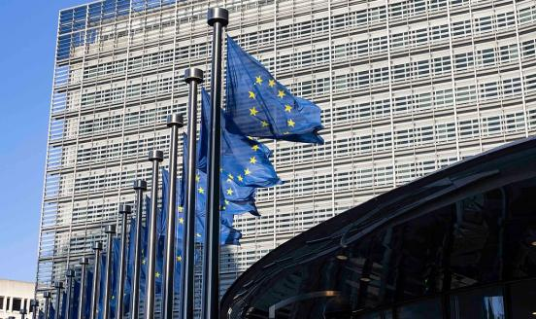
图5 European Commission visual
AI, data and Europe’s quest to simplify
How can the EU adapt its rulebook to meet tomorrow's technology environment?
Rebecca Christie, Mario Mariniello and Bertin Martens 07 January 2026 artificial intelligence digital currencies ... digital economy EU institutions

