编号 | B001-021
机构 | Nikkei（Nikkei Asia - Tech）
类型/日期 | news_science ｜ 2026-08-27
英文原题 | Toyota to roll out near fully autonomous cars from 2028
原文链接 | https://asia.nikkei.com/business/technology/toyota-to-roll-out-near-fully-autonomous-cars-from-2028
简报期次 | B001（2026-08-28 归档）
本库文件 | B001-021-Nikkei asia - tech -toyota-to-roll-out-near-fully-autonomous-cars-fr-202608.md

Toyota to roll out near fully autonomous cars from 2028
Technology

［原图未能获取：https://images.ft.com/v3/image/raw/https%3A%2F%2Fcms-image-bucket-productionv3-ap-northeast-1-a7d2.s］
Competition in self-driving technology is growing in the Japanese market. (Photo by Ryo Asayama)
KOSUKE OKAMOTO, RYO ASAYAMA and SHOTA UEHARA August 28, 2026 00:28 JST Listen English (Original)
NAGOYA, Japan -- Toyota Motor will introduce self-driving technology in passenger vehicles in 2028, the automaker said Thursday, with plans to develop its own Level 2++ system requiring minimal driver input.
Read Next

［原图未能获取：https://images.ft.com/v3/image/raw/https%3A%2F%2Fcms-image-bucket-productionv3-ap-northeast-1-a7d2.s］
Automobiles Nissan, Honda team with self-driving startups to chase US and China rivals
Automobiles Sony to offer drivers cute AI agent for self-driving age

［原图未能获取：https://images.ft.com/v3/image/raw/https%3A%2F%2Fcms-image-bucket-productionv3-ap-northeast-1-a7d2.s］
Automobiles Japan self-driving startup Tier IV to design open-source AI chips
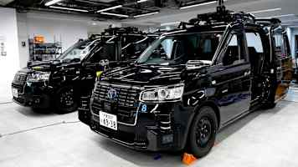
图4 Japan self-driving startup Tier IV to design open-source AI chips
Construction Komatsu teams with US startup on self-driving construction machines
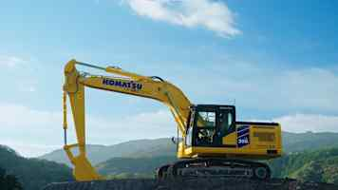
图5 Komatsu teams with US startup on self-driving construction machines
Startups Japanese self-driving truck venture T2 raises $30m
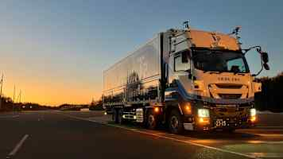
图6 Japanese self-driving truck venture T2 raises $30m
Artificial intelligence Nvidia partners with Toyota's Woven City on physical AI tech

图7 Nvidia partners with Toyota's Woven City on physical AI tech
Transportation Japan eyes network for 10,000 self-driving vehicles by fiscal 2030

［原图未能获取：https://images.ft.com/v3/image/raw/https%3A%2F%2Fcms-image-bucket-productionv3-ap-northeast-1-a7d2.s］
Automobiles Tokyo warehouse district emerges as testing ground for self-driving tech
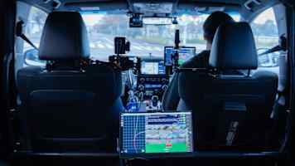
图9 Tokyo warehouse district emerges as testing ground for self-driving tech
Latest on Technology
Technology Meta, Roblox to enhance child-safety measures in Philippines, minister says

［原图未能获取：https://images.ft.com/v3/image/raw/https%3A%2F%2Fcms-image-bucket-productionv3-ap-northeast-1-a7d2.s］
Technology How the Kumamoto earthquake raised the profile of a Japanese drone maker

［原图未能获取：https://images.ft.com/v3/image/raw/https%3A%2F%2Fcms-image-bucket-productionv3-ap-northeast-1-a7d2.s］
Technology Japan's Daikin scales up in Mexico with new plant for data center cooling

［原图未能获取：https://images.ft.com/v3/image/raw/https%3A%2F%2Fcms-image-bucket-productionv3-ap-northeast-1-a7d2.s］
Sponsored Content
About Sponsored ContentThis content was commissioned by Nikkei's Global Business Bureau.

