编号 | B001-022
机构 | ASPI（ASPI - The Strategist）
类型/日期 | think_tank ｜ 2026-08-28
英文原题 | The world needs to take the AI bull by the horns – and fast
原文链接 | https://www.aspistrategist.org.au/the-world-needs-to-take-the-ai-bull-by-the-horns-and-fast/
简报期次 | B001（2026-08-28 归档）
本库文件 | B001-022-Aspi - the strategist -the-world-needs-to-take-the-ai-bull-by-the-horns-202608.md

The world needs to take the AI bull by the horns – and fast
Search:
X (formerly Twitter)X (formerly Twitter)InstagramInstagramYouTubeSubstackSubstackSpotifySpotifyRSS FeedRSS Feed
Search:
SHARE Share to Facebook Share to Twitter Share to LinkedIn Share to Email Print This Post
With ImagesWithout Images
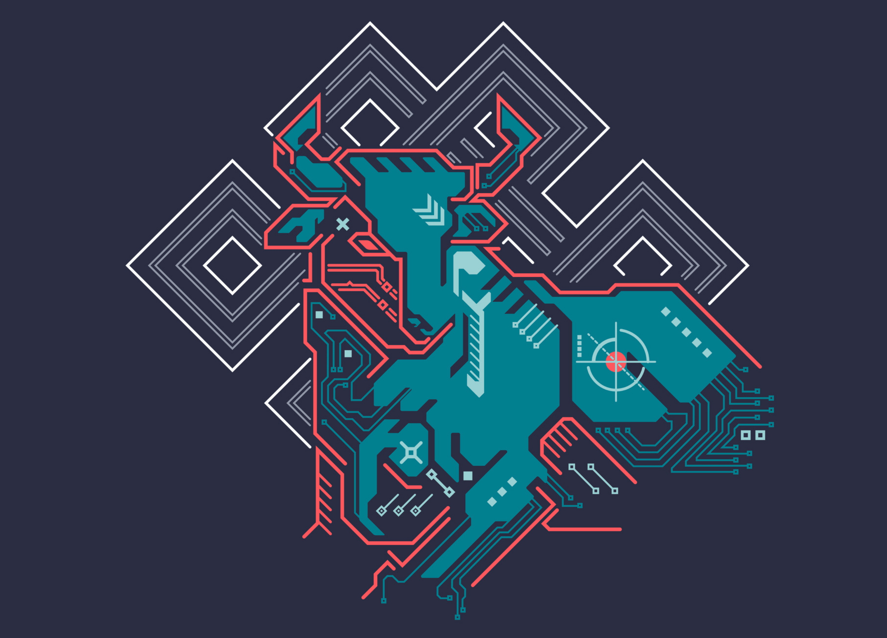
Earth, we have a problem. Artificial intelligence is the world’s biggest, maddest bull in the world’s most overstocked and poorly organised china shop. Global coordination to harness this rampaging beast has never been more urgent, and yet it’s never looked harder. We need to make it happen – starting today.
Australia’s National Cabinet agreement between the prime minister and premiers to develop consistent standards for building artificial intelligence data centres was a small but significant step in the right direction. Bear with me here.
Prime Minister Albanese’s decision not to dig in on renewable energy mandates for data centres is a positive signal that his government recognises the urgency with which Australia needs to push ahead to seize the best opportunity it has to become a globally relevant AI player. It’s one more obstacle cleared.
This matters because countries such as Australia need a say in global AI development. Yes, attracting AI data-centre investment is good for the future of our economy and our strategic options, given the power AI capability will confer on nations. But to reap those benefits, we first need the world to harness the bull and steer it out the right door of the china shop. There are many doors leading to many fates for humanity, and not all of them are good – indeed, some could lead to catastrophe. Embedding ourselves in a form of managed interdependence with the United States on AI development while also creating sovereign AI options will be critical means for Australia to reserve a seat at the table of global AI governance.
Either way, the US and China need to sit down and talk about safeguards immediately as the two frontier nations. But the consequences of untamed AI will affect all 8.3 billion people on earth, and so all nations need a say.
As Bill Gates wrote in his frankly stunning essay on AI, published on Wednesday, ‘we are not preparing adequately for [the AI] transition’. He wrote that it ‘should be the world’s top priority’ and yet ‘there is no plan to ease the entry into the AI era’. AI companies are proposing solutions – just as they’ve led the discussion for years without being taken sufficiently seriously – but it’s not all up to them. We need democratically led processes and international cooperation with new institutions.
The government is right to establish national standards for data-centre construction, not least because strong conditions on the investment can ensure that the infrastructure translates into a slice of the AI value chain. It’s equally right to accept that states have some flexibility on the energy mix to power data centres. This represents a commendable compromise on renewable energy imperatives, which is ironic given global climate efforts represent a near-defeat for international coordination. Most of my adult life I’ve watched the world try to cooperate on climate action and yet we’ve never seemed further away. We can’t repeat that failure on AI.
Climate change is serious and urgent, but AI is advancing by the day. We don’t really know what 2027 looks like, much less 2030. As Gates writes, ‘The world needs a plan.’ Now.
Author David Wroe is a resident senior fellow and head of ASPI’s AI and Security program.
Image: Jackie Niam/Getty Images.
AI contributed no ideas to this article – David Wroe Tags
Australia
artificial intelligence
governance
SHARE Share to Facebook Share to Twitter Share to LinkedIn Share to Email Print This Post
With ImagesWithout Images
The Strategist — The Australian Strategic Policy Institute Blog. Copyright © 2026 Follow Us on X!Follow Us on Instagram!

