编号 | B001-023
机构 | SCSP（SCSP - Special Competitive Studies Project）
类型/日期 | think_tank ｜ 2026-08-27
英文原题 | Quantum States: Exploring America's Quantum Tech Hubs
原文链接 | https://scsp222.substack.com/p/quantum-states-exploring-americas
简报期次 | B001（2026-08-28 归档）
本库文件 | B001-023-Scsp - special competitive studies project -quantum-states-exploring-americas-quantum-tech-h-202608.md

Quantum States: Exploring America's Quantum Tech Hubs

图1 Special Competitive Studies Project


图2 Special Competitive Studies Project
Discover more from Special Competitive Studies Project By subscribing to our newsletter you agree to receive emails from the Special Competitive Studies Project. You can un, and acknowledge its Information Collection Notice and Privacy Policy.
Already have an account? Sign in
Introducing a new limited newsletter series from SCSP
［原图未能获取：https://substackcdn.com/image/fetch/$s_!11pT!,w_36,h_36,c_fill,f_auto,q_auto:good,fl_progressive:ste］
SCSP

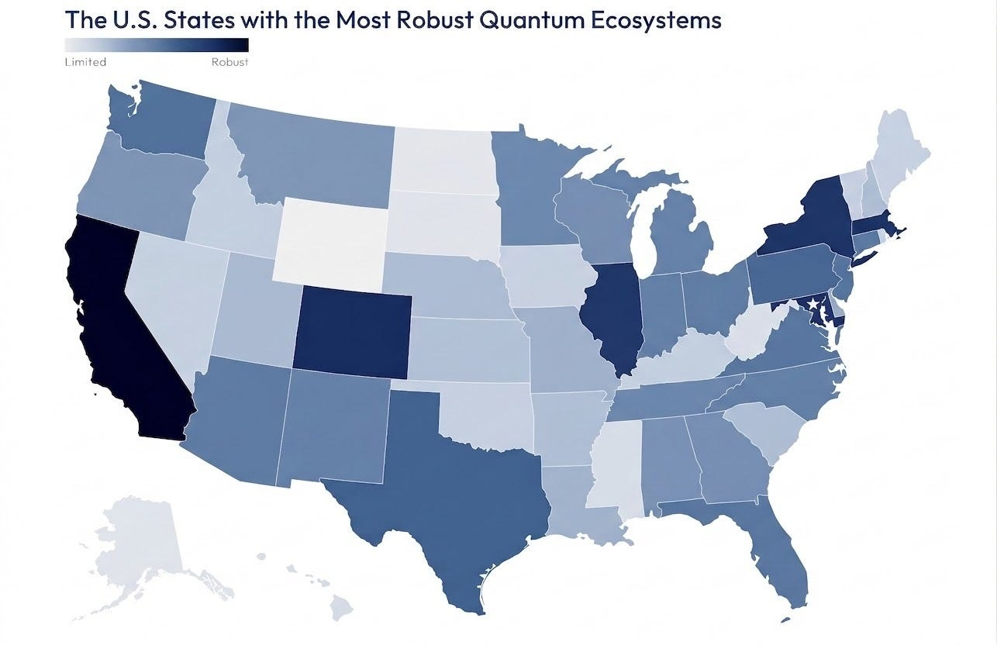
Hello, I’m Ylli Bajraktari, President of the Special Competitive Studies Project. In this edition of our newsletter, SCSP’s Joseph Pontiff and Mackenzie Morante kick off a limited newsletter series, “Quantum States,” that will explore the history, foundation, and future of place-based quantum innovation in America. Over the next several weeks, we will be applying the methodology of our Tech Scorecard at the subnational level, and the team will spotlight what state and local governments are doing to spur the discovery, development, and deployment of quantum information science, engineering, and technologies (QISET).
Quantum information science, engineering, and technologies (QISET) is in its second revolution. It’s rapidly transitioning from a lab-based science to real-world commercial applications, resulting in a vibrant private sector and robust federal government mobilization. The first phase of QISET advancement, known as Quantum 1.0, roughly the first 100 years of quantum mechanics, resulted in the development of lasers and transistors, fundamental building blocks of the technology we encounter every single day. These technologies provided pathways to an ever deeper understanding of the universe, leading to Quantum 2.0: quantum sensing, quantum computing, and quantum networking, the technologies that can shape our future.
QISET is nearing an inflection point. To succeed, it requires state and federal investment across three pillars: academia, industry, and government. While state and federal strategies are being developed, the U.S. ecosystem remains disconnected, with decentralized hubs located in a few leading states. Our challenge, and our opportunity, is to turn decentralization into a flywheel for innovation; not by enforcing top-down control, but by engineering a strategy to synchronize the nation’s regional hubs. While California, Illinois, Colorado, Maryland, Massachusetts, and New York are already established quantum hubs, this newsletter serves to highlight unconventional regional innovators, illuminating models of states that are ready to meet the emergence of Quantum 2.0.
By exploring the history of quantum hubs around the country, we’ll uncover what makes each hub unique. These findings will guide us in engineering a more connected system, linked by strong pathways like neurons in a brain. In each newsletter of the series, we’ll explore a different region of the United States. Our first newsletter will feature the South East and Mid Atlantic, then we will move to the South West, then to Northeast and Midwest, and finally to the Rocky Mountain and Pacific regions. We’ll spotlight exceptional state and local ecosystems within the region, noting successful collaboration between the three pillars of academia, industry, and government. We’ll conclude the newsletter series with policy recommendations Washington should consider at the national level.
Methodology:
In this newsletter, we’ve outlined the quantum ecosystem through five categories: State and Federal Leverage, Market Ecosystem, Talent Pipeline, Industrial Capacity, and Innovation Leadership, using a similar framework to our Quantum Tech Scorecard report.
For each category, we collected data for each U.S. state within these metrics:
Share of top 10% most Cited Research Publications: Keyword search for quantum-adjacent papers, research publications cited globally.
Patents: Keyword search for quantum-defining terms, searching patents over all years with inventor address targeted per state.
Quantum-enabling companies score: A scored category accounting for companies within a state focused on each of the 5 main quantum-enabling technologies: photonics, cryo, interconnects, microelectronics, and specialized materials.
Evaluation of Holistic Full Quantum Stack (Compute, Sensing, Networking): A scored category accounting for the different types of facilities across computing, sensing, and networking within a state.
Number of quantum companies (Major and Startup): A count of quantum-specific companies in a state, from industry leaders to small startups.
Amount of Federal Funding Received: Federal funding attributed to states via DOE, NSF, DoD, Department of Commerce (NIST), NASA, DHS, and NSA.
Number of National Labs and NIST Locations: A scored category accounting for the number of National Labs, National Quantum Information Science Research Centers within the Labs, and NIST locations.
Number of Military Research Facilities: Military research installations with dedicated quantum programs.
Magnitude of State Quantum Initiatives: A scored category accounting for announced state quantum initiatives and quantity of funding follow-through.
Number of PhDs awarded: PhD degrees conferred in Computer Science, Engineering, and Physical Sciences.
Undergraduate Quantum Program Feeders: Universities with devoted quantum computing research groups.
Job Openings: Number of all quantum-related job openings ranging from technicians to PhDs.
Market Ecosystem
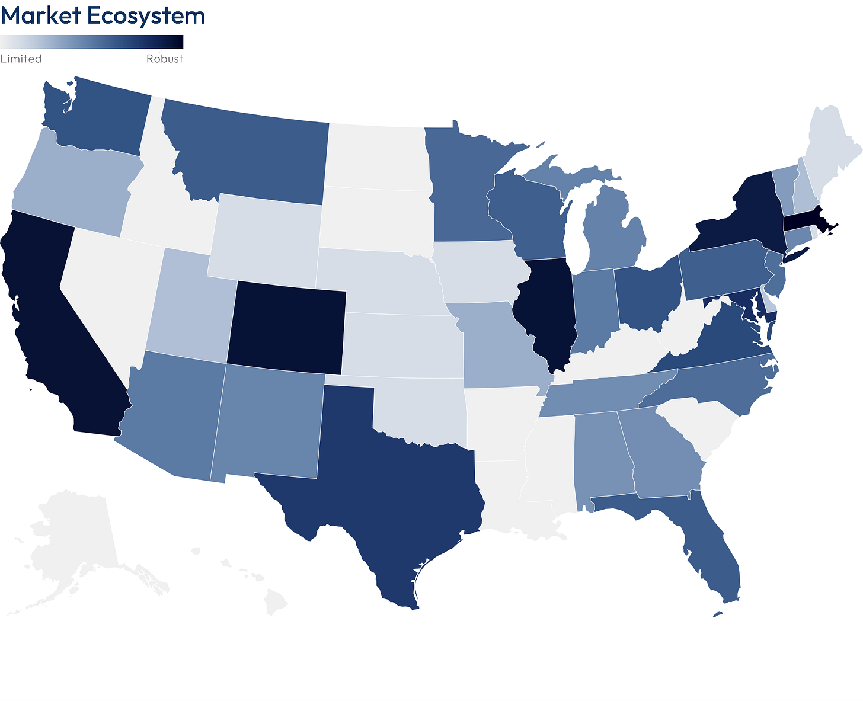
Developing a robust ecosystem of quantum technologies is not a one-size-fits-all approach, in which local leadership is guaranteed by hosting the most companies within a region. Rather, it requires a cohesive, strategic effort leveraging strengths within that state. While quantum technologies fundamentally leverage the same unique quantum phenomena, quantum computing, quantum sensing, and networking each require vastly different footprints. States that are leading in the quantum revolution have a high volume of companies, often housing the majority of facilities, from R&D to fabrication, within their borders. A high score in this metric signals a state’s ability to attract companies, but more importantly, it reflects how effectively its strategies retain and capitalize on them.
When taking stock of the volume of companies and range of their specializations, states like Washington and Montana perform very similarly. Montana has 15 quantum companies that reside within its borders, exemplifying its photonics expertise. This specialization means Montana receives a lower Holistic Full Quantum Stack score, which measures the diversity of quantum industrial expertise. However, the high number of photonics companies makes it a strong regional tech hub for that specific layer of the quantum tech stack. Washington’s commercial approach leverages traditional tech companies such as Microsoft and Amazon, which are headquartered in the state. When it comes to quantum, Microsoft has software, Microsoft Azure quantum cloud, and algorithm development sites, and Amazon houses its Amazon bracket quantum cloud computing service sites. Washington is also home to a 100,000 sq foot IonQ facility, the first dedicated quantum computing manufacturing facility in the United States. Due to these companies and their diverse expertise, Washington has a high full-stack score, but only houses 4-6 quantum companies, much less than Montana.
These states have two very different approaches: one is hyper-specialized, the other, less so, with three different large quantum companies within its borders. Yet both states find themselves with similar market ecosystem scores and quantum impact, highlighting the various state-led approaches taken to build a local quantum ecosystem.
Talent Pipeline
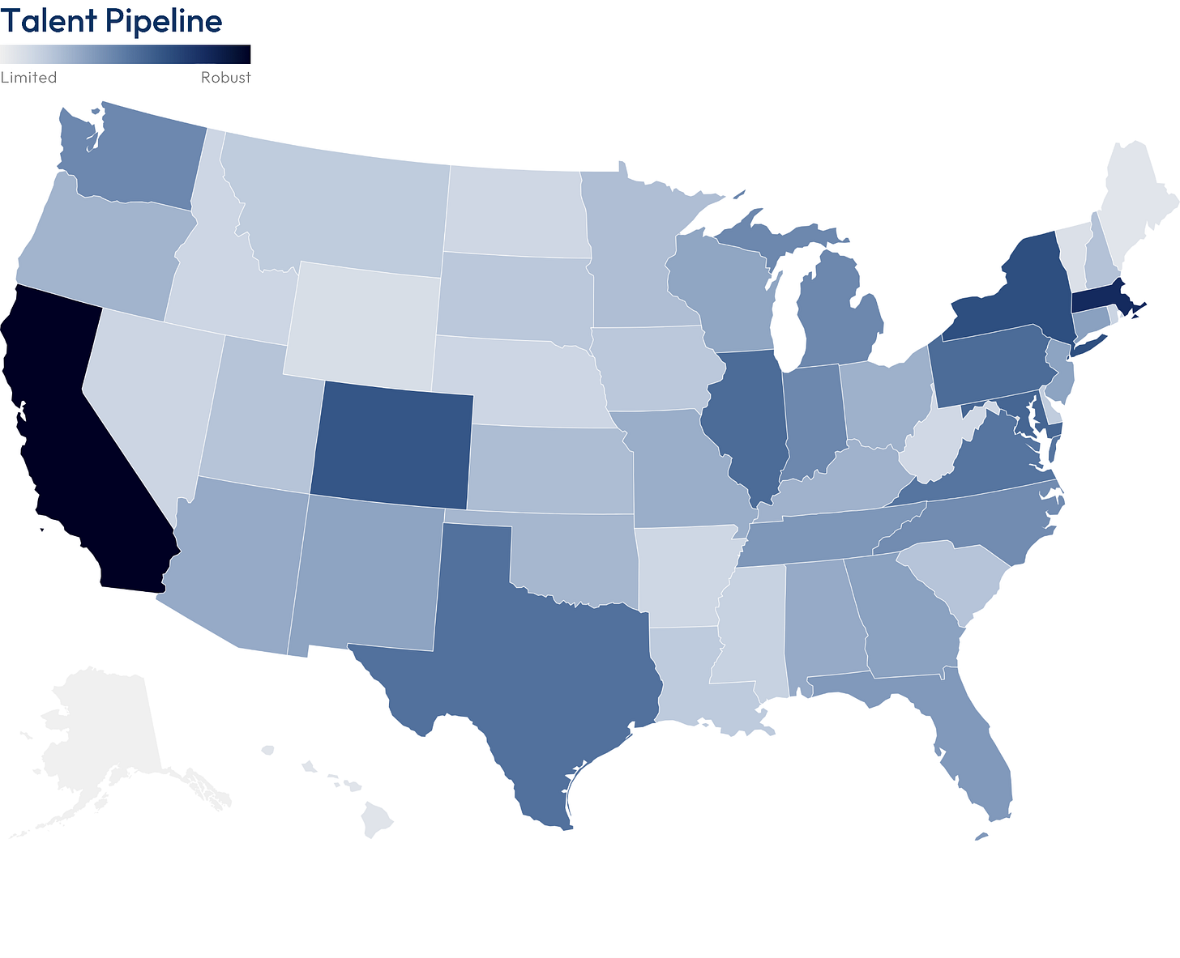
These contributions are developed through America’s innovation engine: its Tier 1 educational institutions.
While traditional academic powerhouses such as Massachusetts and California are bound to have strong scores in this category, this map highlights the untapped potential of other states such as Texas and North Carolina. While these states may not have the highest score in this category, in part because of their lower volume of quantum job openings, they are primed to support the growth of quantum tech through a developed base of talent. Not only do these states award many PhDs, but their academic institutions host Quantum research centers such as the Texas Quantum Institute and the Duke Quantum Center. With a diverse range of quantum research groups within these centers, they provide experiential opportunities for the future generations of quantum mechanics. When fault-tolerant systems arrive at scale, these states, and many others, are poised to accelerate their development.
Industrial Capacity
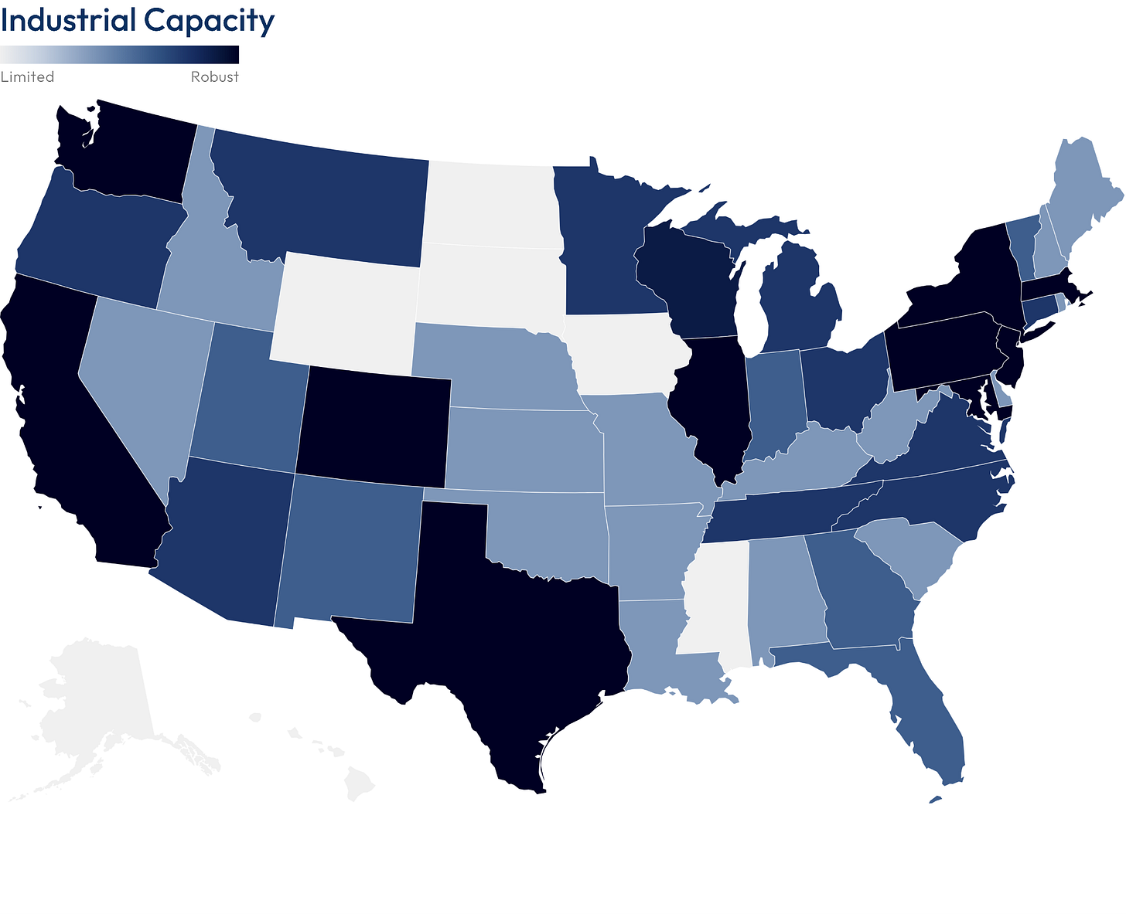
The answer is to measure the diversity and development of a state’s ecosystem of mature supporting technologies. In the quantum realm, these are known as quantum-enabling technologies. Innovations from previous generations of quantum—like the Quantum 1.0 era of lasers, cryostats, and dilution refrigerators— as well as hardware from other industries in the form of specialized materials and microelectronics, these technologies provide the industrial base on which commercial quantum systems can develop and scale.
By measuring the diversity of these companies within a state, we can measure the foundation on which its quantum future rests. Ohio, Wisconsin, and Pennsylvania, with their top-tier research institutions combined with their high industrial capacity, have solid foundations on which to build competitive quantum ecosystems.
Importantly, due to America’s industrial capacity and the prevalence of quantum enabling technologies in many industries, many states have the necessary foundation to industrialize quantum tech. By leveraging this industrial strength, as well as existing infrastructure, in many different states, a high quantum enabling technologies score provides foresight into areas where quantum tech can expand and grow, even if states do not necessarily have a specific quantum company residing within their borders.
Innovation Leadership
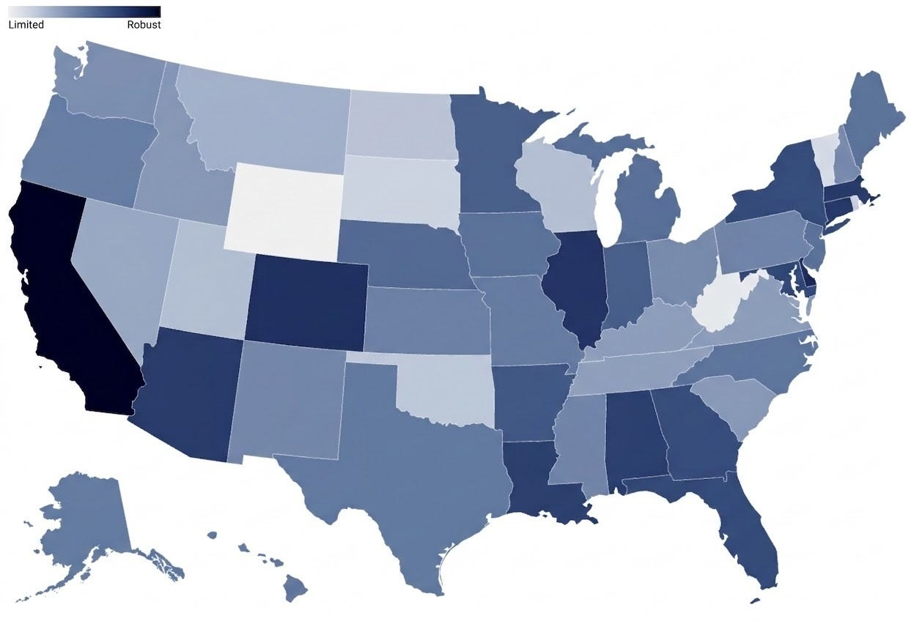
Although a key difference between these two maps, is the innovation strength of a state like Arizona. Here, we see that innovation thrives when industry and governmentset demand signals for universities.
External actors – being government or industry who have a vested interest in quantum applications – should partner with universities to drive innovation and set application goals. Arizona leads in innovation leadership and serves as a cornerstone model of defense as a driver of operational use-cases. In 1995, three Army scientists planned the first-ever Department of Defense workshop on quantum computing and cryptography at the University of Arizona in Tucson; a key event in the timeline of quantum computing development. Sustained government and industry engagement can give universities the funding, test environments, and end-user feedback needed to demonstrate new applications and move promising technologies closer to operational and commercial readiness.
State and Federal Leverage
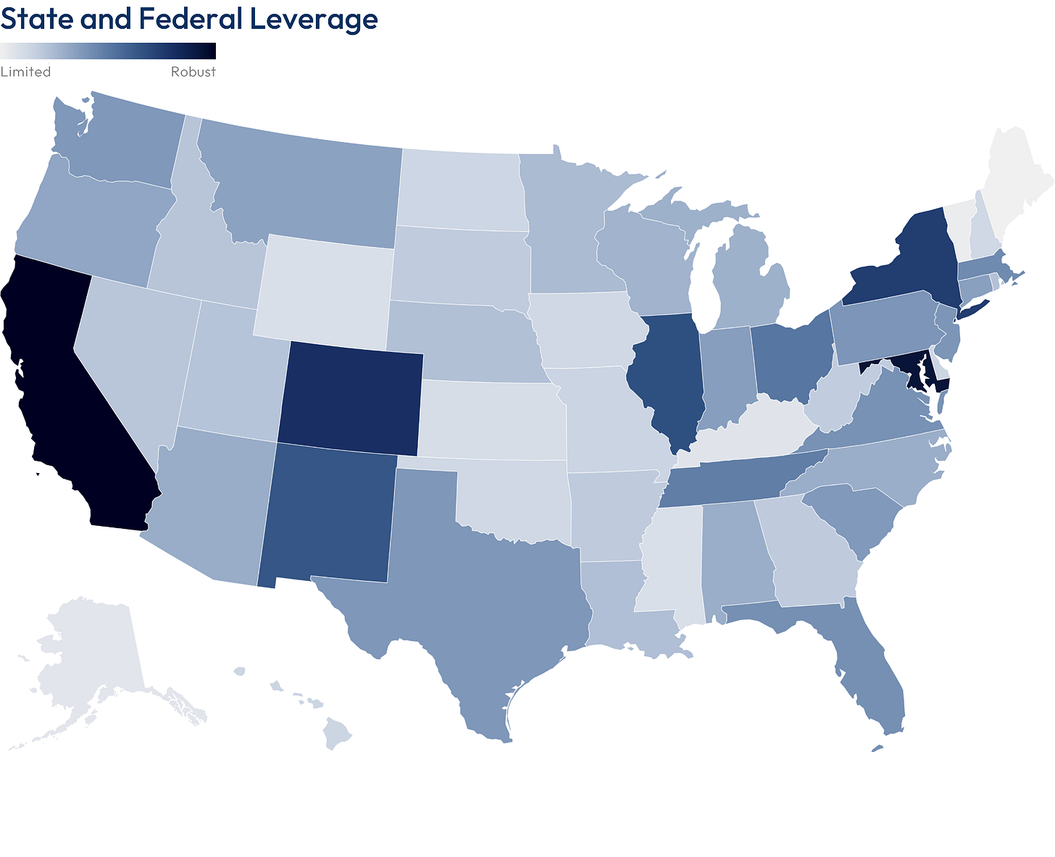
Florida is not yet an established quantum hub, but is an instructive model for state capitalization on infrastructure and a robust university system. The Florida Department of Commerce collaborates with the Florida Alliance for Quantum Technologies (FAQT), a consortium of 15 of Florida’s public and private universities, with the intent of becoming a quantum hub comparable to states like Colorado and Maryland. The Florida Secretary of Commerce has released statements about capitalizing on Florida‘s resilient power grid and strong space industry. Funding must continue to follow this ecosystem management intent.
Vocal support for quantum is a blank check without real capital behind it. States cannot rely solely on federal grants to build their high-tech future. If leaders want to attract talent and capture federal matching dollars, political advocacy must be backed by direct, state-level appropriations.
Quantum-specific funding is best channeled through state economic development councils or departments of commerce, rather than remaining confined to traditional academic or federal research grants. Shifting funds toward these state-level agencies is a strategic measure for states to take because quantum is more than high-level research; it is a broad workforce engine. Beyond software developers, a thriving quantum economy demands skilled trades like cryogenic HVAC technicians. For economic development councils, quantum is a prime vehicle to expand local employment and draw significant private investment.
Engineering the Map of Quantum 2.0
A robust quantum ecosystem starts with innovators in universities, government research facilities, and strategic regional infrastructure. Colorado’s quantum ecosystem was built upon CU-Boulder, its NIST facility, and the partnership that created JILA; California leveraged its semiconductor heritage and deep-tech venture density; and Maryland grew around pioneers like Chris Monroe, who translated his trapped-ion research at the University of Maryland into IonQ. The defining features of the next generation’s quantum hub will be each state’s ability to capitalize on its unique resources.
Turning those assets into regional advantage requires collaboration. The presence of industry, academia, and government is a necessary starting point, but it is not sufficient. True quantum hubs will emerge where these three pillars actively connect, whether through industry shaping university innovation or state government orchestrating regional alignment.
We’ve only scratched the surface of the states’ success stories. In the coming weeks, we’ll take a deep dive into leading and emerging quantum ecosystems across the country and explore the engine driving their growth.
Our concluding edition will leverage these regional insights to deliver nationwide policy recommendations aimed at bridging structural gaps within the currently fragmented quantum landscape.

图11 Sarah Y's avatar
［原图未能获取：https://substackcdn.com/image/fetch/$s_!WHFS!,w_32,h_32,c_fill,f_auto,q_auto:good,fl_progressive:ste］
［原图未能获取：https://substackcdn.com/image/fetch/$s_!M_wT!,w_32,h_32,c_fill,f_auto,q_auto:good,fl_progressive:ste］
25 Likes∙ 1 Restack
Discussion about this post
TopLatestDiscussions AI+ Expo Recap: Spotlight on the Central Stage
Highlights from the Central Stage at the AI+ Expo.
Jul 8, 2025 • SCSP
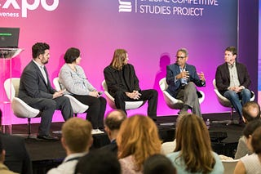
Memo to the President: A Conversation with JP Allain
I’m Ylli Bajraktari, CEO of the Special Competitive Studies Project, back with another edition of Memos to the President.
Jul 9, 2025 • SCSP
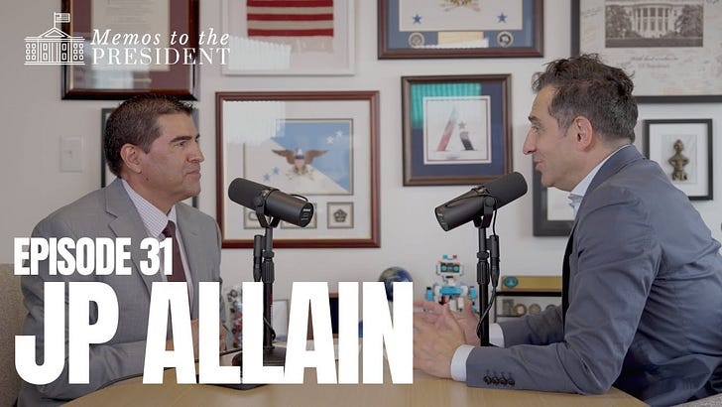
AI+Expo Registration is OPEN! 🇺🇸
Attend for free in Washington, D.C.
Feb 27 • SCSP
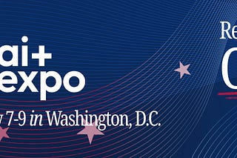
See all
Ready for more?
∙ Terms ∙ Collection notice
Start your SubstackGet the app
Substack is the home for great culture

