编号 | B001-024
机构 | A16Z（a16z (Andreessen Horowitz)）
类型/日期 | news_science ｜ 2026-08-27
英文原题 | You are not a model. Don’t price per token.
原文链接 | https://www.a16z.news/p/you-are-not-a-model-dont-price-per
简报期次 | B001（2026-08-28 归档）
本库文件 | B001-024-A16z (andreessen horowitz) -you-are-not-a-model-dont-price-per-token-202608.md

You are not a model. Don’t price per token.

图1 a16z


图2 a16z
Discover more from a16z It's time to build.
Over 262,000 , and acknowledge its Information Collection Notice and Privacy Policy.
Already have an account? Sign in
Charging per token is becoming the default for AI companies. For most AI applications, it is a mistake.

图3 Tugce Erten's avatar
［原图未能获取：https://substackcdn.com/image/fetch/$s_!HXoY!,w_36,h_36,c_fill,f_auto,q_auto:good,fl_progressive:ste］
Tugce Erten and Sarah Wang

［原图未能获取：https://substackcdn.com/image/fetch/$s_!SU5S!,w_1456,c_limit,f_auto,q_auto:good,fl_progressive:steep］
Token pricing began in the right place: the model layer. When OpenAI launched its API in 2020, charging for the computation a model consumed was a sensible way to meter raw inference. However, ChatGPT’s debut two years later helped spark a wave of applications built on that infrastructure that do much more. These new products combine proprietary data, tools, orchestration, integrations, and workflow logic to complete work on a customer’s behalf.
When an application prices that work in tokens, it imports the model provider’s cost structure into the relationship with the customer and anchors the product’s value to a unit whose cost keeps falling. Based on our work, it’s often a mistake to carry the model layer’s pricing logic into the application layer.
Instead, we believe companies should price at the highest layer of value that they can reliably measure, attribute, and defend.
If you sell model access, price tokens.
If you turn models into useful work, price the recognizable value unit, often through credits.
If you deliver a clear and attributable business result, price the outcome.
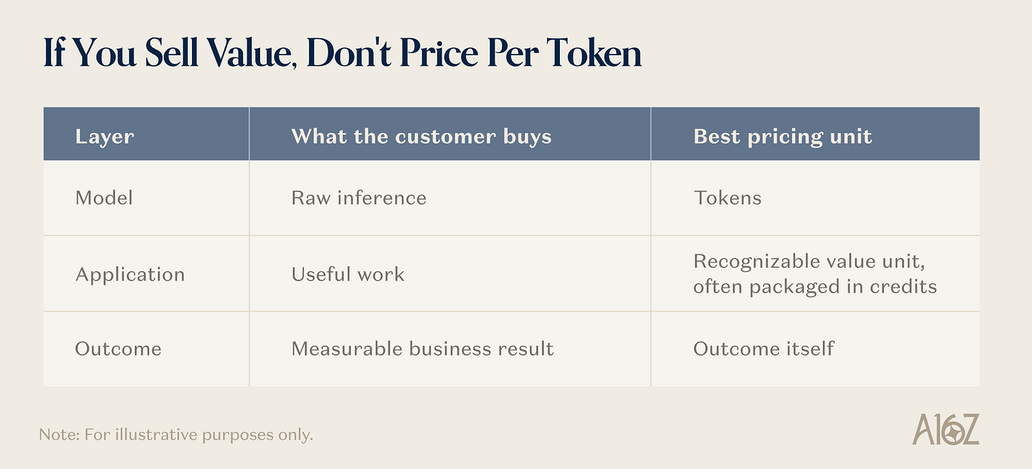
Getting this wrong is difficult to undo. A token-based price trains customers to compare an application with raw compute. It gives away the value of data, workflow, and orchestration; exposes customers to technical complexity they cannot forecast; and can lock the vendor into weak margins. Credits do not solve that problem on their own if they are merely cost-plus tokens; they still meter infrastructure as opposed to value.
Pricing around the recognizable work does the opposite. It makes value legible, spend forecastable, and product improvements economically valuable to both sides. In our survey of 50 technical AI buyers, 27 preferred credits tied to recognizable work, while only 14 preferred tokens.
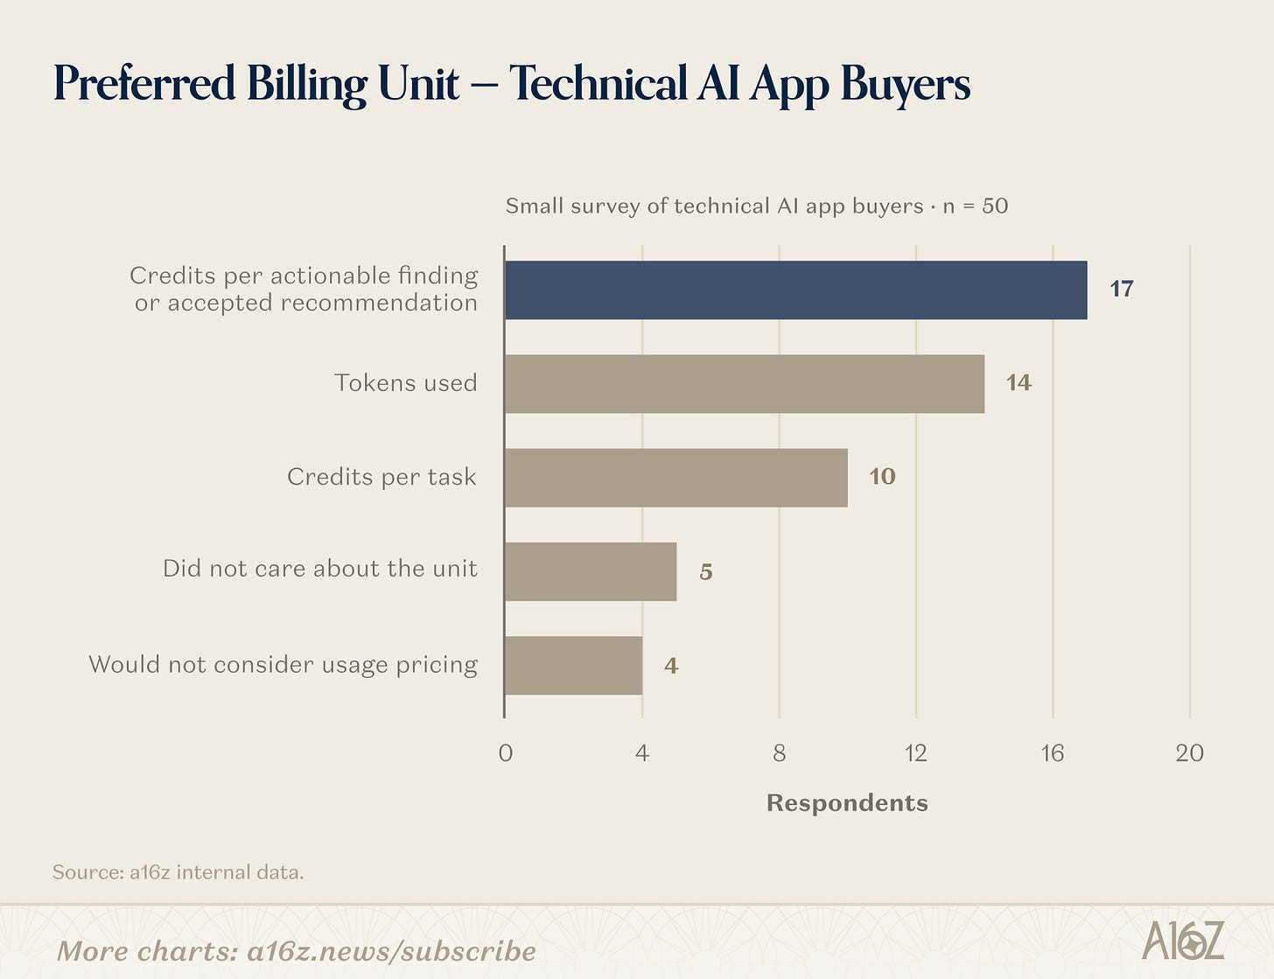
1. Price the Layer You Sell
The two ends of the stack are relatively straightforward. Model providers sell inference, which can be metered in tokens. Some applications deliver outcomes that are observable and attributable enough to price directly.
The middle is harder. That’s where most AI applications live.
For example, an account-research agent is not selling searches and model calls. It is selling a completed account brief. A coding agent is selling an implemented change. A data platform might sell a completed query, pipeline, or agent run. The application’s job is to abstract the complexity beneath that unit of work.
Because every category packages value differently, there is no universal AI application metric. Voice AI may begin with minutes, then move toward conversations resolved. Copilots may begin with seats, then add usage-based pricing as agentic work creates greater variation in cost and value.
The right question is not, “What is the AI pricing metric?” It is: “What unit of value does the customer already understand, and can we measure it consistently?”
2. Customers Want Legibility, Not Tokens
Customers will still ask about tokens. Usually, they are asking for one of two things: comparability or control.
First, buyers want a common benchmark. Tokens appear to let them compare a specialized application with a general-purpose model API or an internal build. But the comparison is usually false precision. Each application combines different models, data, tools, and levels of automation. A token flowing through one product does not produce the same work as a token flowing through another.
Second, buyers want to allocate spend. Finance and IT teams need to trace AI spend to a department, project, client, or invoice, often across a growing portfolio of applications. Requiring them to forecast tokens separately for every product recreates the complexity those products are meant to hide.
Both needs are reasonable. Nonetheless, token pricing often creates more friction than clarity.
A support leader can estimate how many conversations the company handles. It is much harder to predict context length, retrieval volume, retries, reasoning time, or output tokens. What should be a straightforward ROI calculation becomes a separate compute-forecasting exercise for every AI application the company deploys.
The better answer is to expose enough underlying usage detail to build trust without turning that usage into the commercial unit. Show customers what work was completed, where capacity went, and why certain tasks consumed more than others. Give finance and IT the reporting they need for budgets and chargebacks.
Transparency does not require the billing meter and the underlying cost meter to be the same. In highly competitive or technically sophisticated markets, companies may still need to offer token pass-through, particularly for unusually expensive or volatile model usage. But this should be an explicit component of a hybrid model, not the default expression of the product’s value.
3. Credits Should Map Work to Value, Not Hide Tokens
For the broad middle of the AI stack, credits can be an effective way to package variable work. But a credit is a currency, not a value metric. What matters is what the credit buys.
A weak credit system converts token counts into an opaque internal currency. It hides the meter without improving it.
A strong credit system maps to work the customer recognizes. It might use a few intuitive effort bands: a small bug fix costs less than a multi-file feature; summarizing one contract clause costs less than reviewing the full agreement; enriching one record costs less than running a multi-step account research workflow.
The best credit systems do three things:
Abstract infrastructure complexity. Customers buy the work, not the ingredients.
Explain relative effort. Simple work consumes a little; standard work consumes a predictable amount; complex work consumes more.
Create commercial flexibility. One pool can cover several workloads, agents, or automations while procurement manages one contract.
The test is comprehension. Buyers usually know their workload before they know their compute load. If customers cannot understand the credit system in a few sentences, it is too complicated.
4. Credits Can Protect Margins
Credits do more than just make usage understandable. Designed well, they also protect your gross margins.
In traditional SaaS, an additional user often adds little marginal cost. In AI applications, every user can generate inference, retrieval, search, tool calls, third-party data, media generation, retries, and failed runs. Fast growth can hide a weak business if each new dollar of revenue is quickly paid back to model, cloud, or data providers.
The pricing system needs to separate two decisions:
What is the work worth? Customer value, willingness to pay, and competition determine the price of the credit pool
What does the work cost to deliver? Relative cost and complexity determine how many credits each task consumes
This separation enables the vendor to protect margin while preserving the margin upside from model routing, caching, prompt optimization, better infrastructure, and a more diverse (and changing!) mix of proprietary and open-source models. In fact, if underlying model costs fall, the application may even be able to retain part of the benefit because customers are paying for work, not just reimbursing the company for compute.
Clay offers a helpful example and has often been ahead of the curve in how they think about pricing. In a 2026 pricing memo, the company wrote that it had mispriced credits in its Pro segment back in 2022 and operated that segment at a loss for years. Its new model separates Data Credits for third-party data from Actions for orchestration work. Clay keeps fixed pricing for models with predictable costs while passing through the actual token cost of more volatile and expensive reasoning models without a markup. In other words, Clay uses different meters for different layers: Actions for platform value and token pass-through for unpredictable model costs.1
5. Move to Outcomes When Value Is Clear
Credits are most useful when the product performs valuable work but the final business result is not cleanly attributable. Once the outcome becomes observable, attributable, and valuable enough to support a stable price, the meter should move again.
Under those conditions, price the outcome: a resolved support conversation, a qualified lead, a booked meeting, a processed claim, or a recovered dollar.
If the results are not attributable enough, price the unit of work through credits.
If the customer is buying raw model access, price tokens.
Many products will use hybrids: seats for access, credits for variable work, token pass-through for unusually expensive or unpredictable model calls, and outcome fees where attribution is clean. Multiple meters are not the problem, but avoid using the wrong meter for the wrong layer.
Make Value Visible
Token pricing pulls the customer conversation toward a cost curve that keeps falling. This is a poor anchor for a product whose usefulness, reliability, and role in the workflow should keep rising.
The better path is to price at the highest layer of value you can reliably measure, attribute, and defend. Translate variable work into understandable units. Use credits to package those units when flexibility matters. Move toward outcomes as soon as customers can recognize and trust them.

图10 Faking a brand is easy. Making it stop is hard.

图11 Cursor + SpaceXAI: the fastest iterating team wins
](https://substackcdn.com/image/fetch/$s_!SU5S!,f_auto,q_auto:good,fl_progressive:steep/https%3A%2F%2Fsubstack-post-media.s3.amazonaws.com%2Fpublic%2Fimages%2F8c68d5c7-8a95-49ea-9c12-8cf7f5f0f1a1_2920x10.png)
_This newsletter is provided for informational purposes only, and should not be relied upon as legal, business, investment, or tax advice. Furthermore, this content is not investment advice, nor is it intended for use by any investors or prospective investors in any a16z funds. This newsletter may link to other websites or contain other information obtained from third-party sources - a16z has not independently verified nor makes any representations about the current or enduring accuracy of such information. If this content includes third-party advertisements, a16z has not reviewed such advertisements and does not endorse any advertising content or related companies contained therein. Any investments or portfolio companies mentioned, referred to, or described are not representative of all investments in vehicles managed by a16z; visithttps://a16z.com/investment-list/ for a full list of investments. Other important information can be found at a16z.com/disclosures. You’re receiving this newsletter since you opted in earlier; if you would like to opt out of future newsletters you may unhttps://www.clay.com/blog/clay-pricing-memo-internal
, and acknowledge its Information Collection Notice and Privacy Policy.

图12 Alan Cole's avatar
［原图未能获取：https://substackcdn.com/image/fetch/$s_!lHN4!,w_32,h_32,c_fill,f_auto,q_auto:good,fl_progressive:ste］
［原图未能获取：https://substackcdn.com/image/fetch/$s_!-Cor!,w_32,h_32,c_fill,f_auto,q_auto:good,fl_progressive:ste］

图15 Dumebi's avatar

图16 The Melian's avatar
151 Likes∙ 10 Restacks
Discussion about this post
［原图未能获取：https://substackcdn.com/image/fetch/$s_!7Y_7!,w_32,h_32,c_fill,f_auto,q_auto:good,fl_progressive:ste］
Alessandro Alinone
10h
Completely agree with this thesis. At Now4real (a group chat SaaS for websites), we made the deliberate choice to price our AI-based moderation per 1,000 analyzed messages, completely abstracting away the concept of tokens. Our customers care about keeping their communities safe, not about doing the math on our underlying compute costs. By pricing based on the actual unit of value delivered—the message—we eliminate friction, keep our pricing predictable, and ensure we aren't confusing our application's value with an LLM provider's cost structure.
[Like (1)](javascript:void(0))ReplyShare 1 reply
Riccardo Bettio
10h
Interesting, but the example of Github copilot pro must not be forgotten. It may be said that copilot was selling access to models, but if we’re putting it on that way, then every AI app is selling access to models so let’s say they were selling code. Initially they priced per request, i.e. per feature (proxied) that the dev wanted to implement. But that totally backfired because of the unpredictability of the workflow the agent had to do. I believe that the winners will be those who are capable of reducing the marginal cost of each new / unpredicted workflow, and at that point they can price by outcome. Otherwise the customer risks paying a lot of money for nothing (as the vendor must protect from unpredictability), or the vendor will blow up like Github [Like (1)](javascript:void(0))ReplyShare 6 more comments...
TopLatestDiscussions Charts of the Week: SaaSpocalypse Interrupted
Consumer AI: Room to Run; Ads Come for Everything; Trucks Are Busy; Earnings Go Up, Prices Go Down
Apr 3 • a16z New Media
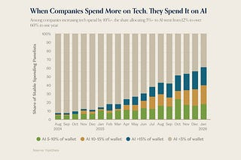
The Palantirization of everything
Pairing enterprise software with high-touch delivery
Jan 16 • Marc Andrusko

Big Ideas 2026: Part 1
The biggest problems builders will tackle in 2026, according to our partners
Dec 9, 2025 • a16z New Media

See all
Ready for more?
∙ Terms ∙ Collection notice
Start your SubstackGet the app
Substack is the home for great culture

