编号 | B001-033
机构 | NASA（NASA - News Releases）
类型/日期 | official ｜ 2026-08-28
英文原题 | NASA Invites Media to Turkey Artemis Accords Signing Ceremony
原文链接 | https://www.nasa.gov/news-release/nasa-invites-media-to-turkey-artemis-accords-signing-ceremony/
简报期次 | B001（2026-08-28 归档）
本库文件 | B001-033-Nasa - news releases -nasa-invites-media-to-turkey-artemis-accords-sig-202608.md

NASA Invites Media to Turkey Artemis Accords Signing Ceremony
Search
Suggested Searches
Climate Change
Artemis
Expedition 64
Mars perseverance
SpaceX Crew-2
International Space Station
View All Topics A-Z
Home
Missions
Humans in Space
Earth
The Solar System
The Universe
Science
Aeronautics
Technology
Learning Resources
About NASA
Español
News & Events
Multimedia
NASA+
Featured
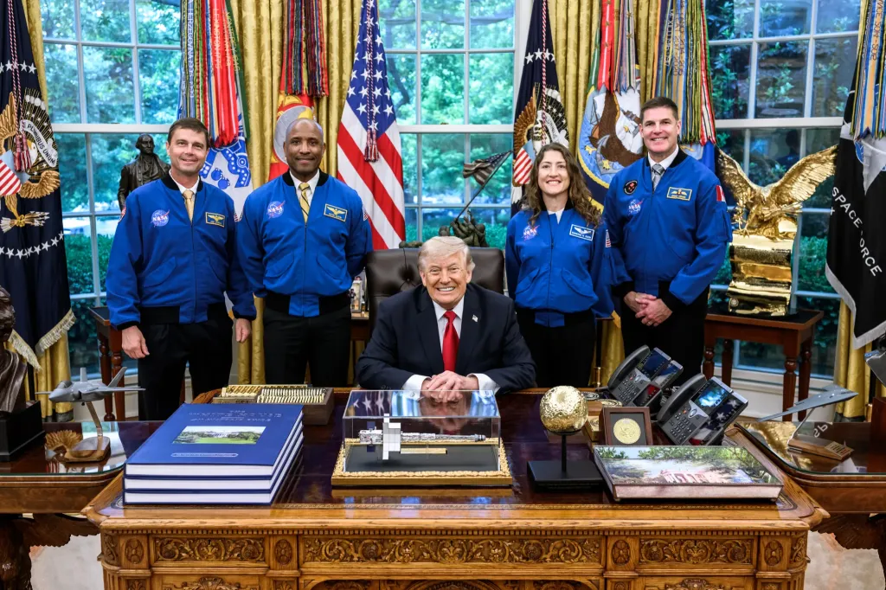
图1 From left, Artemis II crew NASA astronauts Reid Wiseman, Victor Glover, Christina Koch, and CSA \(Canadian Space Agency\

［原图未能获取：https://www.nasa.gov/wp-content/uploads/2026/08/ksc-20260821-ph-ser01-0003large.jpg?w=767］

［原图未能获取：https://assets.science.nasa.gov/dynamicimage/assets/science/cds/ciencia/sistema-solar/2026/eclipse%2］
Back
Missions
Search All NASA Missions
A to Z List of Missions
Upcoming Launches and Landings
Spaceships and Rockets
Communicating with Missions
Artemis
James Webb Space Telescope
Hubble Space Telescope
International Space Station
OSIRIS-Rex
Humans in Space
Why Go to Space
Astronauts
Commercial Space
Destinations
Spaceships and Rockets
Living in Space
Earth
Explore Earth Science
Climate Change
Earth, Our Planet
Earth Science in Action
Earth Multimedia
Earth Data
Earth Science Researchers
The Solar System
The Sun
Mercury
Venus
Earth
The Moon
Mars
Jupiter
Saturn
Uranus
Neptune
Pluto & Dwarf Planets
Asteroids, Comets & Meteors
The Kuiper Belt
The Oort Cloud
Skywatching
The Universe
Exoplanets
The Search for Life in the Universe
Stars
Galaxies
Black Holes
The Big Bang
Dark Energy
Dark Matter
Science
Earth Science
Planetary Science
Astrophysics & Space Science
The Sun & Heliophysics
Biological & Physical Sciences
Lunar Science
Citizen Science
Astromaterials
Aeronautics Research
Human Space Travel Research
Aeronautics
Science in the Air
NASA Aircraft
Flight Research Innovation
Supersonic Flight
Air Traffic Solutions
Green Aviation Tech
Drones & You
Technology
Technology Transfer & Spinoffs
Space Travel
Living in Space
Lunar Surface Technology
Manufacturing and Materials
Robotics
Science Instruments
Computing
Learning Resources
For Kids and Students
For Educators
For Colleges and Universities
For Professionals
Science for Everyone
Requests for Exhibits, Artifacts, Speakers & Flyovers
STEM Engagement at NASA
About NASA
NASA's Impacts
Centers and Facilities
Directorates
Organizations
People of NASA
Careers
Internships
Our History
Doing Business with NASA
Get Involved
Contact
NASA en Español
Ciencia
Aeronáutica
Ciencias Terrestres
Sistema Solar
Universo
News & Events
News Releases
Recently Published
Video Series on NASA+
Podcasts & Audio
Blogs
Newsletters
Social Media
Media Resources
Events
Upcoming Launches & Landings
Virtual Guest Program
Multimedia
NASA+
Images
NASA Live
NASA Apps
Podcasts
Image of the Day
e-Books
3D Resources
Interactives
STEM Multimedia
NASA Brand & Usage Guidelines
Featured

［原图未能获取：https://www.nasa.gov/wp-content/uploads/2026/08/ksc-20260821-ph-ser01-0003large.jpg?w=767］

［原图未能获取：https://assets.science.nasa.gov/dynamicimage/assets/science/missions/pandora/news/2026/Pandora_Artis］

［原图未能获取：https://assets.science.nasa.gov/dynamicimage/assets/science/missions/chandra/2026/galaxies_ngc4631.j］
Highlights

［原图未能获取：https://assets.science.nasa.gov/dynamicimage/assets/science/psd/ares/iss049e035512~orig.jpg?w=1024］

［原图未能获取：https://assets.science.nasa.gov/dynamicimage/assets/science/esd/eo/images/iotd/2026/earthset-from-th］

［原图未能获取：https://www.nasa.gov/wp-content/uploads/2026/06/art002e024603orig.jpg?w=1024］
Highlights

［原图未能获取：https://assets.science.nasa.gov/dynamicimage/assets/science/esd/eo/images/iotd/2026/rare,-widespread］

［原图未能获取：https://www.nasa.gov/wp-content/uploads/2026/08/0202795orig.jpg?w=1024］

［原图未能获取：https://assets.science.nasa.gov/dynamicimage/assets/science/esd/eo/images/iotd/2026/a-changing-world］
Highlights
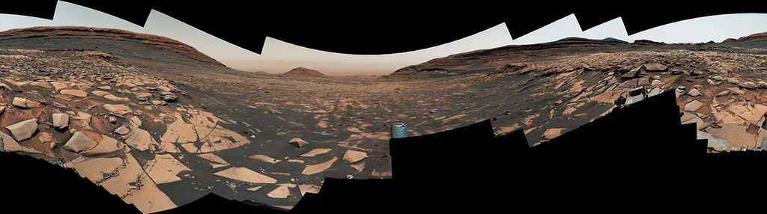
图13 Curiosity Reaches 1-Kilometer Elevation Gain

［原图未能获取：https://www.nasa.gov/wp-content/uploads/2026/08/jsc2026e406812.jpg?w=1024］

［原图未能获取：https://science.nasa.gov/wp-content/uploads/2026/08/shield-heliosphere-shrinking-screenshot.png］
Featured

［原图未能获取：https://science.nasa.gov/wp-content/uploads/2026/08/roman-new.jpg］

［原图未能获取：https://assets.science.nasa.gov/dynamicimage/assets/science/missions/pandora/news/2026/Pandora_Artis］

［原图未能获取：https://assets.science.nasa.gov/dynamicimage/assets/science/missions/chandra/2026/galaxies_ngc4631.j］
Highlights

［原图未能获取：https://science.nasa.gov/wp-content/uploads/2026/03/stockcake-planetary-alignment-art-1265316-standa］

［原图未能获取：https://assets.science.nasa.gov/dynamicimage/assets/science/esd/eo/images/iotd/2026/a-changing-world］

［原图未能获取：https://assets.science.nasa.gov/dynamicimage/assets/science/missions/pandora/news/2026/Pandora_Artis］
Highlights

［原图未能获取：https://www.nasa.gov/wp-content/uploads/2026/08/uli-round-9-awards.jpg?w=1024］

［原图未能获取：https://www.nasa.gov/wp-content/uploads/2026/08/2027-gbs-email-header-cc.png?w=1024］

［原图未能获取：https://www.nasa.gov/wp-content/uploads/2026/08/grc-1956-c-43327-feature-image.jpg?w=1024］
Highlights

［原图未能获取：https://www.nasa.gov/wp-content/uploads/2026/08/1-pia26777-d2026-0824-rl0031661-pano-med.jpg?w=1024］

［原图未能获取：https://assets.science.nasa.gov/dynamicimage/assets/science/cds/svs/a030000/a031300/a031302/high-alt］

［原图未能获取：https://www.nasa.gov/wp-content/uploads/2023/09/copernicus-gtoc.png?w=1024］
Featured

［原图未能获取：https://www.nasa.gov/wp-content/uploads/2023/02/nancy-grace-roman-space-telescope-visualization.jpeg］
Featured

［原图未能获取：https://www.nasa.gov/wp-content/uploads/2026/08/nasa-state-hubs-announcement-aug-19.jpg?w=1024］

图30 NASA’s Artemis II Crew Set to Receive Congressional Space Medal of Honor
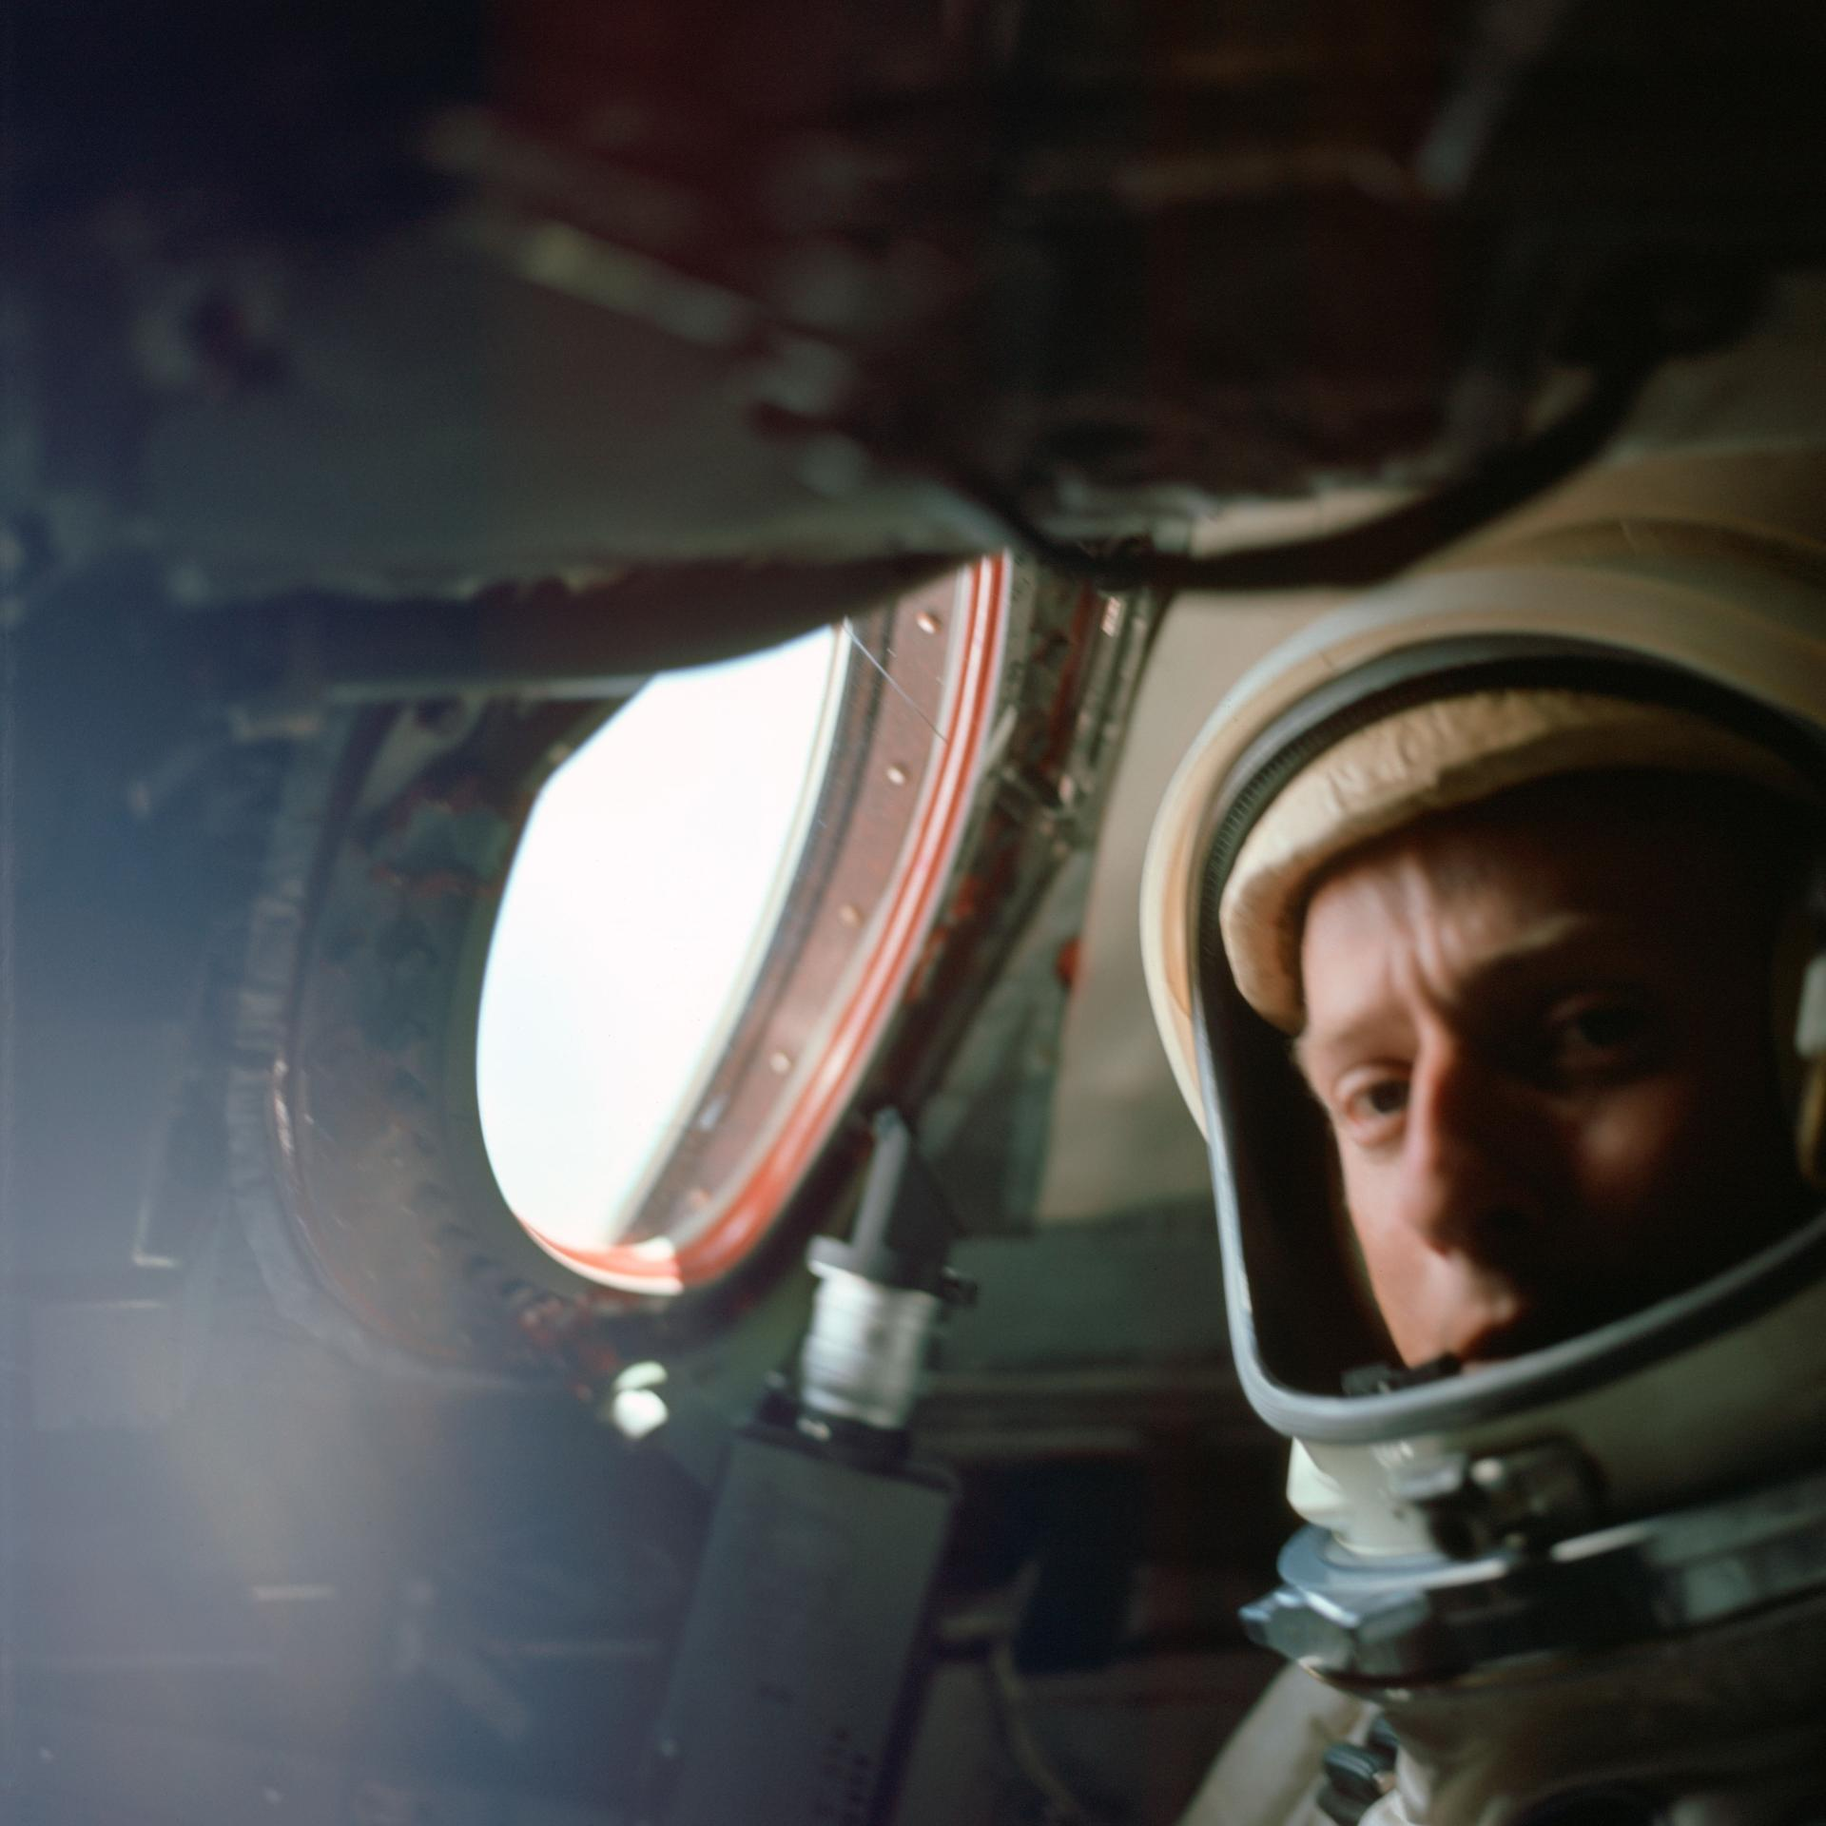
图31 The View from Above: The Gemini Visual Acuity Experiments
Highlights

［原图未能获取：https://www.nasa.gov/wp-content/uploads/2026/03/a2crew-7ff19d.jpg?w=1024］

［原图未能获取：https://www.nasa.gov/wp-content/uploads/2026/03/suit-patch.jpg?w=1024］
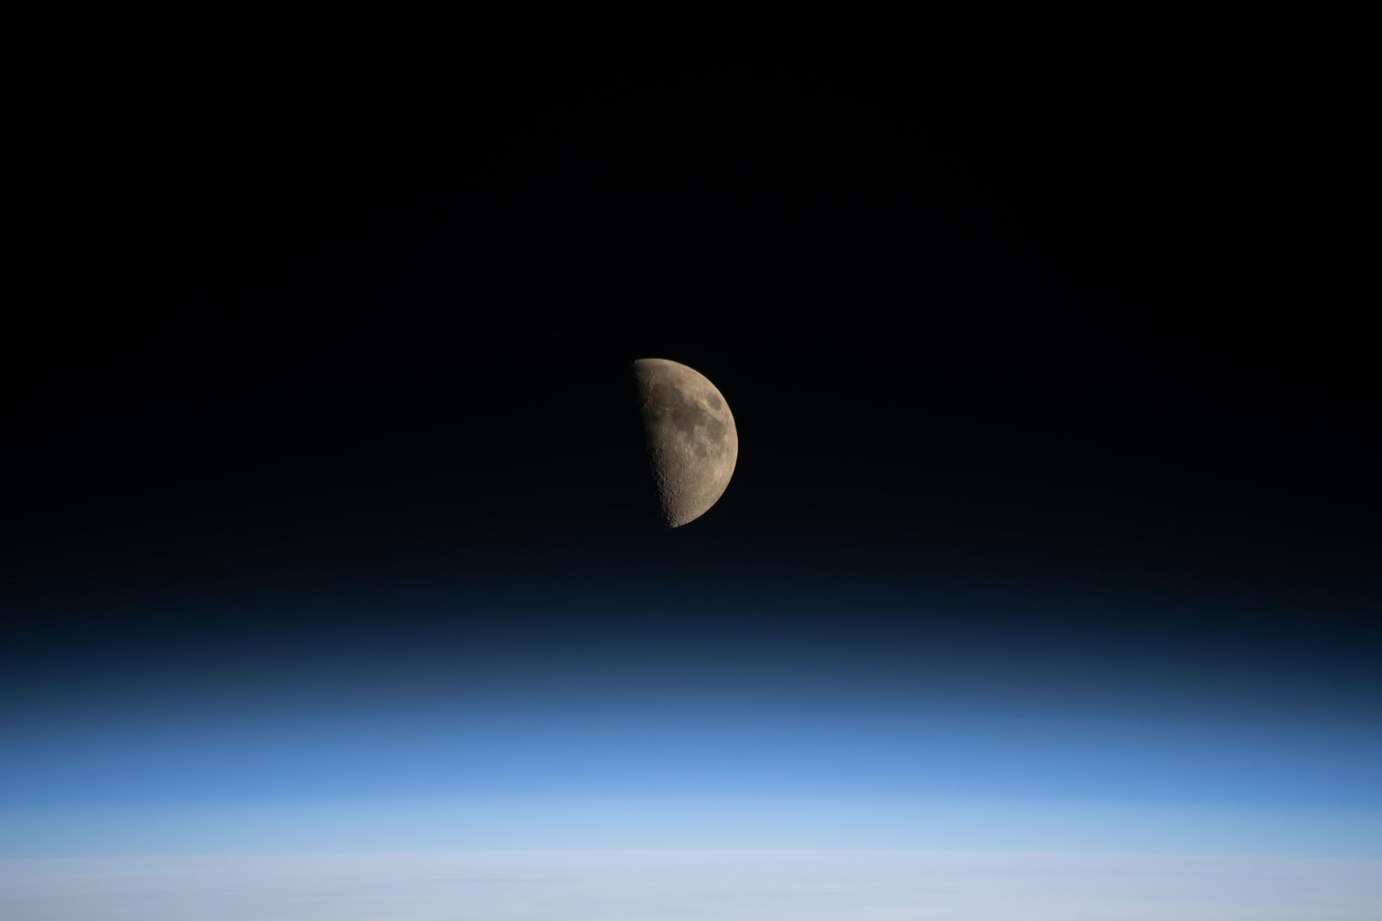
图34 La NASA refuerza Artemis: añade una misión y perfecciona su arquitectura general

［原图未能获取：https://www.nasa.gov/wp-content/uploads/2022/07/cropped-cropped-581097main_STS-1_Dust-it-Off-mp3-ima］
Jennifer M. Dooren Aug 27, 2026 MEDIA ADVISORYM26-065
NASA Headquarters

［原图未能获取：https://www.nasa.gov/wp-content/uploads/2026/06/nasa-meatball-11-black-background.jpg?w=1080］
Credit: NASA Turkey will sign the Artemis Accords during a ceremony at 2:30 p.m. EDT Monday, Aug. 31, at NASA Headquarters in Washington, becoming the 71st country signatory.
NASA Administrator Jared Isaacman will host Turkish Minister of Industry and Technology Mehmet Fatih Kacır for the ceremony, together with U.S. Department of State officials.
This event is in person only. Media interested in attending must RSVP no later than 11 a.m. on Aug. 31, to: hq-media@mail.nasa.gov. NASA’s media accreditation policy is online.
In 2020, during the first Trump Administration, the United States, led by NASA and the State Department, -end- Camille Gallo / Elizabeth Shaw Headquarters, Washington 202-358-1600 camille.m.gallo@nasa.gov / elizabeth.a.shaw@nasa.gov
Share

Details
Last Updated Aug 27, 2026 Editor Jennifer M. Dooren Location NASA Headquarters
Related Terms
Office of International and Interagency Relations (OIIR)
Artemis Accords
Was this page helpful?
Δ Was this page helpful?
Yes No × Notifications

