编号 | B001-035
机构 | NASA（NASA - News Releases）
类型/日期 | official ｜ 2026-08-28
英文原题 | 9 Things to Know About NASA’s Nancy Grace Roman Space Telescope
原文链接 | https://science.nasa.gov/missions/roman-space-telescope/9-things-to-know-about-nasas-nancy-grace-roman-space-telescope/
简报期次 | B001（2026-08-28 归档）
本库文件 | B001-035-Nasa - news releases -9-things-to-know-about-nasas-nancy-grace-roman-s-202608.md

9 Things to Know About NASA’s Nancy Grace Roman Space Telescope
Search
Suggested Searches
Climate Change
Artemis
Expedition 64
Mars perseverance
SpaceX Crew-2
International Space Station
View All Topics A-Z
Home
Missions
Humans in Space
Earth
The Solar System
The Universe
Science
Aeronautics
Technology
Learning Resources
About NASA
Español
News & Events
Multimedia
NASA+
Highlights

图1 NASA’s Artemis II Crew Set to Receive Congressional Space Medal of Honor

［原图未能获取：https://www.nasa.gov/wp-content/uploads/2026/08/ksc-20260821-ph-ser01-0003large.jpg?w=150&h=150&crop］

［原图未能获取：https://assets.science.nasa.gov/dynamicimage/assets/science/cds/ciencia/sistema-solar/2026/eclipse%2］
Back
Missions
Search All NASA Missions
A to Z List of Missions
Upcoming Launches and Landings
Spaceships and Rockets
Communicating with Missions
Artemis
James Webb Space Telescope
Hubble Space Telescope
International Space Station
OSIRIS-REx
Humans in Space
Why Go to Space
Astronauts
Commercial Space
Destinations
Spaceships and Rockets
Living in Space
Earth
Explore Earth Science
Climate Change
Earth, Our Planet
Earth Science in Action
Earth Multimedia
Earth Data
Earth Science Researchers
The Solar System
The Sun
Mercury
Venus
Earth
The Moon
Mars
Jupiter
Saturn
Uranus
Neptune
Pluto & Dwarf Planets
Asteroids, Comets & Meteors
The Kuiper Belt
The Oort Cloud
Skywatching
The Universe
Exoplanets
The Search for Life in the Universe
Stars
Galaxies
Black Holes
The Big Bang
Dark Matter
Dark Energy
Science
Earth Science
Planetary Science
Astrophysics & Space Science
The Sun & Heliophysics
Biological & Physical Sciences
Lunar Science
Citizen Science
Astromaterials
Aeronautics Research
Human Space Travel Research
Aeronautics
Science in the Air
NASA Aircraft
Flight Innovation
Supersonic Flight
Air Traffic Solutions
Green Aviation Tech
Drones & You
Technology
Technology Transfer & Spinoffs
Space Travel Technology
Technology Living in Space
Manufacturing and Materials
Robotics
Science Instruments
Computing
Learning Resources
For Kids and Students
For Educators
For Colleges and Universities
For Professionals
Science for Everyone
Requests for Exhibits, Artifacts, or Speakers
STEM Engagement at NASA
About NASA
NASA's Impacts
Centers and Facilities
Directorates
Organizations
People of NASA
Careers
Internships
Our History
Doing Business with NASA
Get Involved
Contact
NASA en Español
Ciencia
Aeronáutica
Ciencias Terrestres
Sistema Solar
Universo
News & Events
Recently Published
Video Series on NASA+
Podcasts & Audio
Blogs
Newsletters
Social Media
Media Resources
Multimedia
NASA+
Images
NASA Live
NASA Apps
Podcasts
Image of the Day
e-Books
3D Resources
Interactives
STEM Multimedia
NASA Brand & Usage Guidelines
Highlights

［原图未能获取：https://www.nasa.gov/wp-content/uploads/2026/08/ksc-20260821-ph-ser01-0003large.jpg?w=150&h=150&crop］

［原图未能获取：https://assets.science.nasa.gov/dynamicimage/assets/science/missions/pandora/news/2026/Pandora_Artis］

［原图未能获取：https://assets.science.nasa.gov/dynamicimage/assets/science/missions/chandra/2026/galaxies_ngc4631.j］
Highlights

［原图未能获取：https://assets.science.nasa.gov/dynamicimage/assets/science/psd/ares/iss049e035512~orig.jpg?w=1024］

［原图未能获取：https://assets.science.nasa.gov/dynamicimage/assets/science/esd/eo/images/iotd/2026/earthset-from-th］

［原图未能获取：https://www.nasa.gov/wp-content/uploads/2026/06/art002e024603orig.jpg?w=150&h=150&crop=1］
Highlights

［原图未能获取：https://assets.science.nasa.gov/dynamicimage/assets/science/esd/eo/images/iotd/2026/rare,-widespread］

［原图未能获取：https://www.nasa.gov/wp-content/uploads/2026/08/0202795orig.jpg?w=150&h=150&crop=1］

［原图未能获取：https://assets.science.nasa.gov/dynamicimage/assets/science/esd/eo/images/iotd/2026/a-changing-world］
Highlights
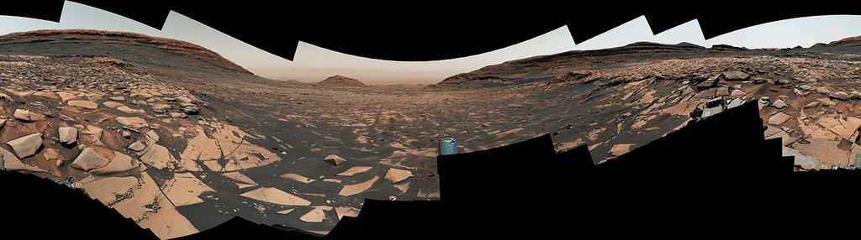
图13 Curiosity Reaches 1-Kilometer Elevation Gain

［原图未能获取：https://www.nasa.gov/wp-content/uploads/2026/08/jsc2026e406812.jpg?w=150&h=150&crop=1］

［原图未能获取：https://science.nasa.gov/wp-content/uploads/2026/08/shield-heliosphere-shrinking-screenshot.png］
Highlights

［原图未能获取：https://science.nasa.gov/wp-content/uploads/2026/08/roman-new.jpg］

［原图未能获取：https://assets.science.nasa.gov/dynamicimage/assets/science/missions/pandora/news/2026/Pandora_Artis］

［原图未能获取：https://assets.science.nasa.gov/dynamicimage/assets/science/missions/chandra/2026/galaxies_ngc4631.j］
Highlights

［原图未能获取：https://science.nasa.gov/wp-content/uploads/2026/03/stockcake-planetary-alignment-art-1265316-standa］

［原图未能获取：https://assets.science.nasa.gov/dynamicimage/assets/science/esd/eo/images/iotd/2026/a-changing-world］

［原图未能获取：https://assets.science.nasa.gov/dynamicimage/assets/science/missions/pandora/news/2026/Pandora_Artis］
Highlights

［原图未能获取：https://www.nasa.gov/wp-content/uploads/2026/08/uli-round-9-awards.jpg?w=150&h=150&crop=1］

［原图未能获取：https://www.nasa.gov/wp-content/uploads/2026/08/2027-gbs-email-header-cc.png?w=150&h=150&crop=1］

［原图未能获取：https://www.nasa.gov/wp-content/uploads/2026/08/grc-1956-c-43327-feature-image.jpg?w=150&h=150&crop=］
Highlights

［原图未能获取：https://www.nasa.gov/wp-content/uploads/2026/08/1-pia26777-d2026-0824-rl0031661-pano-med.jpg?w=150&h］

［原图未能获取：https://assets.science.nasa.gov/dynamicimage/assets/science/cds/svs/a030000/a031300/a031302/high-alt］

［原图未能获取：https://www.nasa.gov/wp-content/uploads/2023/09/copernicus-gtoc.png?w=150&h=150&crop=1］
Highlights

［原图未能获取：https://www.nasa.gov/wp-content/uploads/2023/02/nancy-grace-roman-space-telescope-visualization.jpeg］
Highlights

［原图未能获取：https://www.nasa.gov/wp-content/uploads/2026/08/nasa-state-hubs-announcement-aug-19.jpg?w=150&h=150&］

图30 NASA’s Artemis II Crew Set to Receive Congressional Space Medal of Honor

图31 The View from Above: The Gemini Visual Acuity Experiments
Highlights

［原图未能获取：https://www.nasa.gov/wp-content/uploads/2026/03/a2crew-7ff19d.jpg?w=150&h=150&crop=1］

［原图未能获取：https://www.nasa.gov/wp-content/uploads/2026/03/suit-patch.jpg?w=150&h=150&crop=1］
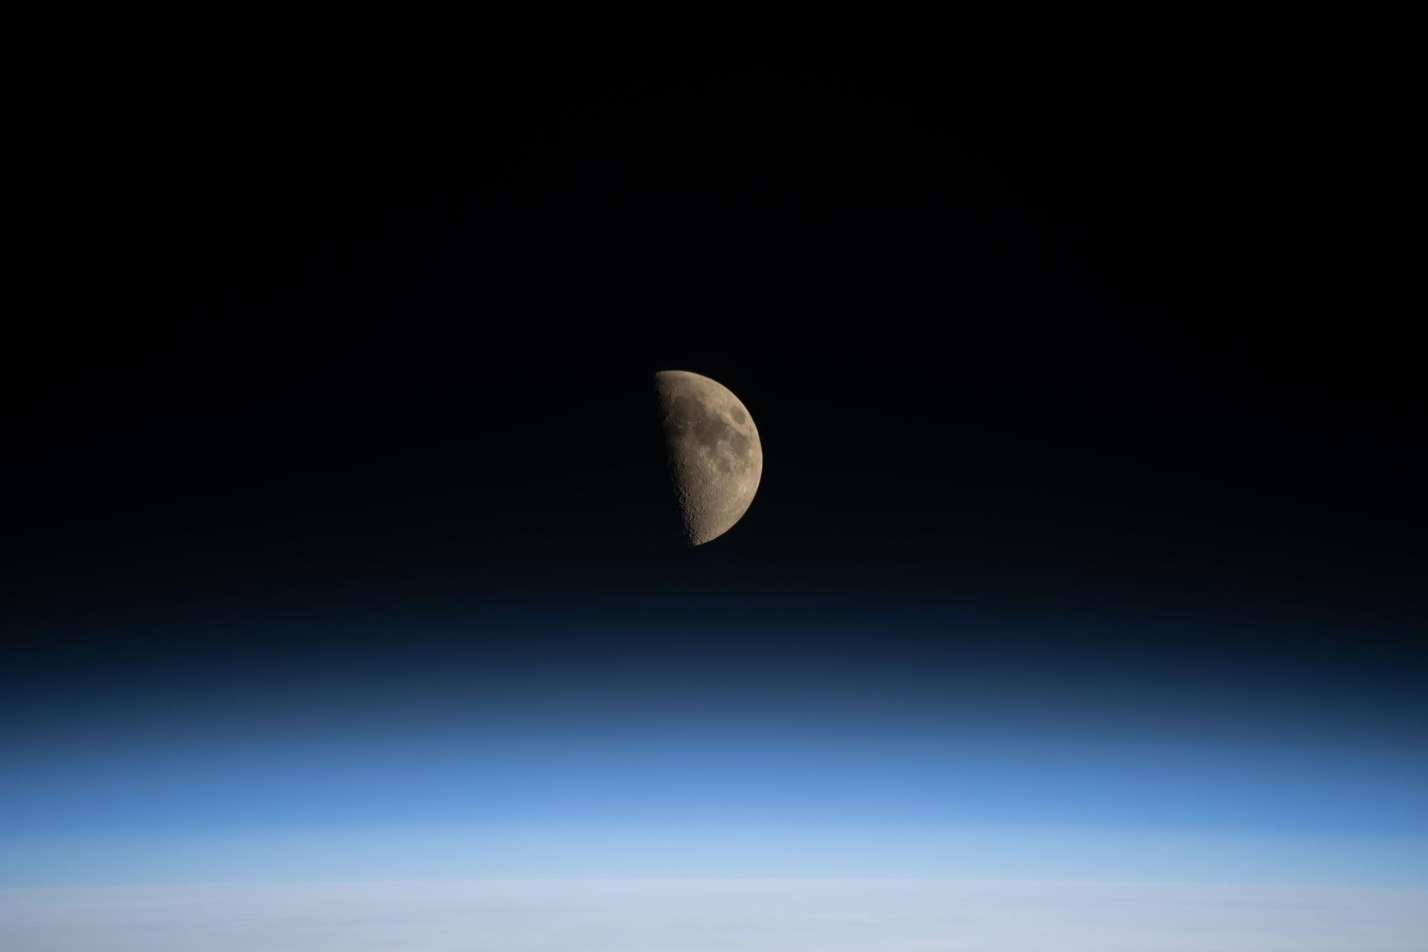
图34 La NASA refuerza Artemis: añade una misión y perfecciona su arquitectura general
Ashley Balzer Aug 27, 2026 Article

NASA’s Nancy Grace Roman Space Telescope is set to launch at 7:26 a.m. EDT on Sunday, Aug. 30. While you wait to watch the launch, brush up on some key facts about this wide-view mission.

［原图未能获取：https://science.nasa.gov/wp-content/uploads/2026/08/encap.jpg?w=1439］
Teams inside the Payload Hazardous Servicing Facility at NASA’s Kennedy Space Center in Florida encapsulate the agency’s Nancy Grace Roman Space Telescope within the payload fairing on Friday, Aug. 21, 2026, ahead of mating to a SpaceX Falcon Heavy rocket. Encapsulation shields the spacecraft during rollout, ascent, and the early phases of flight. Roman will investigate dark energy and dark matter, conduct a statistical census of planetary systems, and enable a broad range of additional astrophysics research. Liftoff from Launch Complex 39A at Kennedy is targeted for no earlier than Sunday, Aug. 30, 2026.
NASA/Sydney Rohde (Rocz)
01
The mission is named after NASA’s first chief astronomer, Dr. Nancy Grace Roman.
Roman is named after Dr. Nancy Grace Roman (1925–2018), NASA’s first chief of astronomy. She championed space-based observatories that could study the universe above Earth’s hazy atmosphere while making their data broadly available to the scientific community.
While she’s known as the “mother” of the Hubble Space Telescope, Roman played an even broader role as the driving force behind NASA’s entire Great Observatories program, which included Hubble along with the Chandra X-ray Observatory and the retired Compton Gamma Ray Observatory and Spitzer Space Telescope.
Her vision and leadership helped establish NASA as a world-class scientific institution and laid the foundation for generations of space telescopes that continue to expand humanity’s understanding of the cosmos.
02
Roman will transform our view of the cosmos by showing us the bigger picture.
Roman will pair a large field of view with crisp infrared vision to scan vast, deep swaths of sky. This flagship mission is designed to help astronomers explore dark matter, dark energy, and planets outside our solar system, called exoplanets.
Since each of Roman’s surveys will sample such a large volume of the cosmos, the mission will also offer practically limitless opportunities for astronomers to conduct a broad range of additional science. From objects in our outer solar system and exploding stars to growing black holes and galaxies by the billions, very little will be beyond Roman’s reach. Roman’s data will be made public as soon as it’s processed, allowing many teams to analyze it simultaneously.
03
**The observatory will journey a million miles to , the same location as NASA’s James Webb Space Telescope. At L2, gravity from the Sun and Earth works together with an object’s motion around the Sun to hold it roughly in place. This balance will give Roman a relatively steady orbit without using much fuel.
Like Webb, Roman will trace out a large orbit around the actual L2 point — much larger than the Moon’s orbit around Earth — and the two will easily be kept far apart.
04
The spacecraft carries the names of more than a million people.
This summer, everyone was invited to submit their name to be added to a memory card attached to a plaque on the Roman spacecraft. More than 1.3 million people did so and will have their names carried all the way to L2.
05
Roman will scan the skies for at least five years.
Roman will have a primary mission lifetime of five years and is designed to support an additional five-year extended mission. Fuel is expected to be the mission’s life-limiting resource, and while NASA does not currently have an ability to service observatories at L2, Roman is designed to be refuelable.
06
Two instruments will enable myriad discoveries.
The observatory’s Wide Field Instrument is a 300-megapixel infrared camera that will give Roman the same sharpness (angular resolution) as Hubble but with a field of view at least 100 times larger. Using this instrument, each Roman image will capture a patch of the sky about 1.5 times bigger than the apparent size of a full Moon.
Roman’s Coronagraph Instrument is designed to demonstrate the most advanced technologies ever flown in space for directly imaging planets around other stars. It will block the glare from stars and make it possible for scientists to see the faint reflected light from planets in orbit around them, revealing giant worlds that are older, colder, and in closer orbits than the hot, young super-Jupiters direct imaging has mainly revealed so far.
07
**Roman mission with key contributions from NASA, will observe a larger area of the sky than Roman, though with less detail. Since their survey areas will overlap, scientists can use Roman’s higher-quality data to apply corrections to Euclid’s, then extend these refinements over Euclid’s much larger area.
Scientists can also pair Roman’s infrared data with visible-light observations from the ground-based Vera C. Rubin Observatory, a National Science Foundation–Department of Energy collaboration. That will allow astronomers to inch closer to achieving Roman-like quality over Rubin’s much greater sky coverage.
By showcasing technology to directly photograph Jupiter-like exoplanets, Roman will also provide a crucial stepping stone for NASA’s Habitable Worlds Observatory concept, a flagship space telescope that would be designed to photograph Earth-like planets in other solar systems for the first time ever.
08
Watch the Roman launch live from anywhere.
NASA will stream this event live through a variety of platforms. Learn where to watch online: nasa.gov/live. The launch broadcast will continue until approximately one hour past launch to follow the first several critical milestones post-launch.
09
NASA expects to share Roman’s first images by early 2027.
The Roman team will complete a carefully orchestrated series of deployments, calibrations, and tests in the three months following launch before the observatory reaches its final orbit. Science operations begin once this commissioning period is completed, starting with the release of Roman’s first science images.
To learn more about the Roman mission, visit:
https://www.nasa.gov/roman
Media contact:
Claire Andreoli NASA’s Goddard Space Flight Center, Greenbelt, Md.
claire.andreoli@nasa.gov 301-286-1940
Share

Details
Last Updated Aug 27, 2026 Editor Ashley Balzer Contact Ashley Balzer ashley.m.balzer@nasa.gov Location NASA Goddard Space Flight Center
Related Terms
Nancy Grace Roman Space Telescope
Black Holes
Dark Energy
Dark Matter
Exoplanets
Galaxies
Stars
The Universe
Explore More

［原图未能获取：https://www.nasa.gov/wp-content/uploads/2025/04/roman-coresurvey-infographic-gbtds.jpg］

［原图未能获取：https://www.nasa.gov/wp-content/uploads/2026/02/roman-lensing-5mb.gif］

［原图未能获取：https://www.nasa.gov/wp-content/uploads/2025/04/roman-coresurvey-infographic-hltds.jpg］
Δ Did you find what you were looking for?(Required)
Yes No Partly What were you looking for?(Required)
What were you hoping to accomplish × Notifications

