编号 | B001-036
机构 | NASA（NASA - News Releases）
类型/日期 | official ｜ 2026-08-27
英文原题 | NASA Astronaut Jonny Kim Departs Agency to Continue Military Service
原文链接 | https://www.nasa.gov/news-release/nasa-astronaut-jonny-kim-departs-agency-to-continue-military-service/
简报期次 | B001（2026-08-28 归档）
本库文件 | B001-036-Nasa - news releases -nasa-astronaut-jonny-kim-departs-agency-to-conti-202608.md

NASA Astronaut Jonny Kim Departs Agency to Continue Military Service
Search
Suggested Searches
Climate Change
Artemis
Expedition 64
Mars perseverance
SpaceX Crew-2
International Space Station
View All Topics A-Z
Home
Missions
Humans in Space
Earth
The Solar System
The Universe
Science
Aeronautics
Technology
Learning Resources
About NASA
Español
News & Events
Multimedia
NASA+
Featured
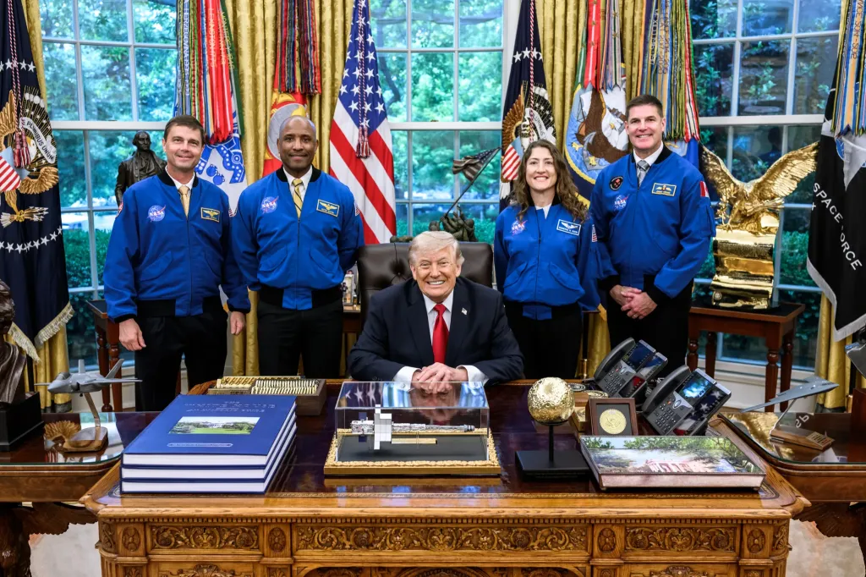
图1 From left, Artemis II crew NASA astronauts Reid Wiseman, Victor Glover, Christina Koch, and CSA \(Canadian Space Agency\

［原图未能获取：https://www.nasa.gov/wp-content/uploads/2026/08/ksc-20260821-ph-ser01-0003large.jpg?w=767］

［原图未能获取：https://assets.science.nasa.gov/dynamicimage/assets/science/cds/ciencia/sistema-solar/2026/eclipse%2］
Back
Missions
Search All NASA Missions
A to Z List of Missions
Upcoming Launches and Landings
Spaceships and Rockets
Communicating with Missions
Artemis
James Webb Space Telescope
Hubble Space Telescope
International Space Station
OSIRIS-Rex
Humans in Space
Why Go to Space
Astronauts
Commercial Space
Destinations
Spaceships and Rockets
Living in Space
Earth
Explore Earth Science
Climate Change
Earth, Our Planet
Earth Science in Action
Earth Multimedia
Earth Data
Earth Science Researchers
The Solar System
The Sun
Mercury
Venus
Earth
The Moon
Mars
Jupiter
Saturn
Uranus
Neptune
Pluto & Dwarf Planets
Asteroids, Comets & Meteors
The Kuiper Belt
The Oort Cloud
Skywatching
The Universe
Exoplanets
The Search for Life in the Universe
Stars
Galaxies
Black Holes
The Big Bang
Dark Energy
Dark Matter
Science
Earth Science
Planetary Science
Astrophysics & Space Science
The Sun & Heliophysics
Biological & Physical Sciences
Lunar Science
Citizen Science
Astromaterials
Aeronautics Research
Human Space Travel Research
Aeronautics
Science in the Air
NASA Aircraft
Flight Research Innovation
Supersonic Flight
Air Traffic Solutions
Green Aviation Tech
Drones & You
Technology
Technology Transfer & Spinoffs
Space Travel
Living in Space
Lunar Surface Technology
Manufacturing and Materials
Robotics
Science Instruments
Computing
Learning Resources
For Kids and Students
For Educators
For Colleges and Universities
For Professionals
Science for Everyone
Requests for Exhibits, Artifacts, Speakers & Flyovers
STEM Engagement at NASA
About NASA
NASA's Impacts
Centers and Facilities
Directorates
Organizations
People of NASA
Careers
Internships
Our History
Doing Business with NASA
Get Involved
Contact
NASA en Español
Ciencia
Aeronáutica
Ciencias Terrestres
Sistema Solar
Universo
News & Events
News Releases
Recently Published
Video Series on NASA+
Podcasts & Audio
Blogs
Newsletters
Social Media
Media Resources
Events
Upcoming Launches & Landings
Virtual Guest Program
Multimedia
NASA+
Images
NASA Live
NASA Apps
Podcasts
Image of the Day
e-Books
3D Resources
Interactives
STEM Multimedia
NASA Brand & Usage Guidelines
Featured

［原图未能获取：https://www.nasa.gov/wp-content/uploads/2026/08/ksc-20260821-ph-ser01-0003large.jpg?w=767］

［原图未能获取：https://assets.science.nasa.gov/dynamicimage/assets/science/missions/pandora/news/2026/Pandora_Artis］

［原图未能获取：https://assets.science.nasa.gov/dynamicimage/assets/science/missions/chandra/2026/galaxies_ngc4631.j］
Highlights

［原图未能获取：https://assets.science.nasa.gov/dynamicimage/assets/science/psd/ares/iss049e035512~orig.jpg?w=1024］

［原图未能获取：https://assets.science.nasa.gov/dynamicimage/assets/science/esd/eo/images/iotd/2026/earthset-from-th］

［原图未能获取：https://www.nasa.gov/wp-content/uploads/2026/06/art002e024603orig.jpg?w=1024］
Highlights

［原图未能获取：https://assets.science.nasa.gov/dynamicimage/assets/science/esd/eo/images/iotd/2026/rare,-widespread］

［原图未能获取：https://www.nasa.gov/wp-content/uploads/2026/08/0202795orig.jpg?w=1024］

［原图未能获取：https://assets.science.nasa.gov/dynamicimage/assets/science/esd/eo/images/iotd/2026/a-changing-world］
Highlights
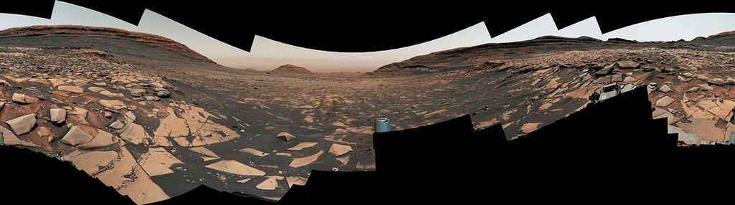
图13 Curiosity Reaches 1-Kilometer Elevation Gain

［原图未能获取：https://www.nasa.gov/wp-content/uploads/2026/08/jsc2026e406812.jpg?w=1024］

［原图未能获取：https://science.nasa.gov/wp-content/uploads/2026/08/shield-heliosphere-shrinking-screenshot.png］
Featured

［原图未能获取：https://science.nasa.gov/wp-content/uploads/2026/08/roman-new.jpg］

［原图未能获取：https://assets.science.nasa.gov/dynamicimage/assets/science/missions/pandora/news/2026/Pandora_Artis］

［原图未能获取：https://assets.science.nasa.gov/dynamicimage/assets/science/missions/chandra/2026/galaxies_ngc4631.j］
Highlights

［原图未能获取：https://science.nasa.gov/wp-content/uploads/2026/03/stockcake-planetary-alignment-art-1265316-standa］

［原图未能获取：https://assets.science.nasa.gov/dynamicimage/assets/science/esd/eo/images/iotd/2026/a-changing-world］

［原图未能获取：https://assets.science.nasa.gov/dynamicimage/assets/science/missions/pandora/news/2026/Pandora_Artis］
Highlights

［原图未能获取：https://www.nasa.gov/wp-content/uploads/2026/08/uli-round-9-awards.jpg?w=1024］

［原图未能获取：https://www.nasa.gov/wp-content/uploads/2026/08/2027-gbs-email-header-cc.png?w=1024］

［原图未能获取：https://www.nasa.gov/wp-content/uploads/2026/08/grc-1956-c-43327-feature-image.jpg?w=1024］
Highlights

［原图未能获取：https://www.nasa.gov/wp-content/uploads/2026/08/1-pia26777-d2026-0824-rl0031661-pano-med.jpg?w=1024］

［原图未能获取：https://assets.science.nasa.gov/dynamicimage/assets/science/cds/svs/a030000/a031300/a031302/high-alt］

［原图未能获取：https://www.nasa.gov/wp-content/uploads/2023/09/copernicus-gtoc.png?w=1024］
Featured

［原图未能获取：https://www.nasa.gov/wp-content/uploads/2023/02/nancy-grace-roman-space-telescope-visualization.jpeg］
Featured

［原图未能获取：https://www.nasa.gov/wp-content/uploads/2026/08/nasa-state-hubs-announcement-aug-19.jpg?w=1024］

图30 NASA’s Artemis II Crew Set to Receive Congressional Space Medal of Honor
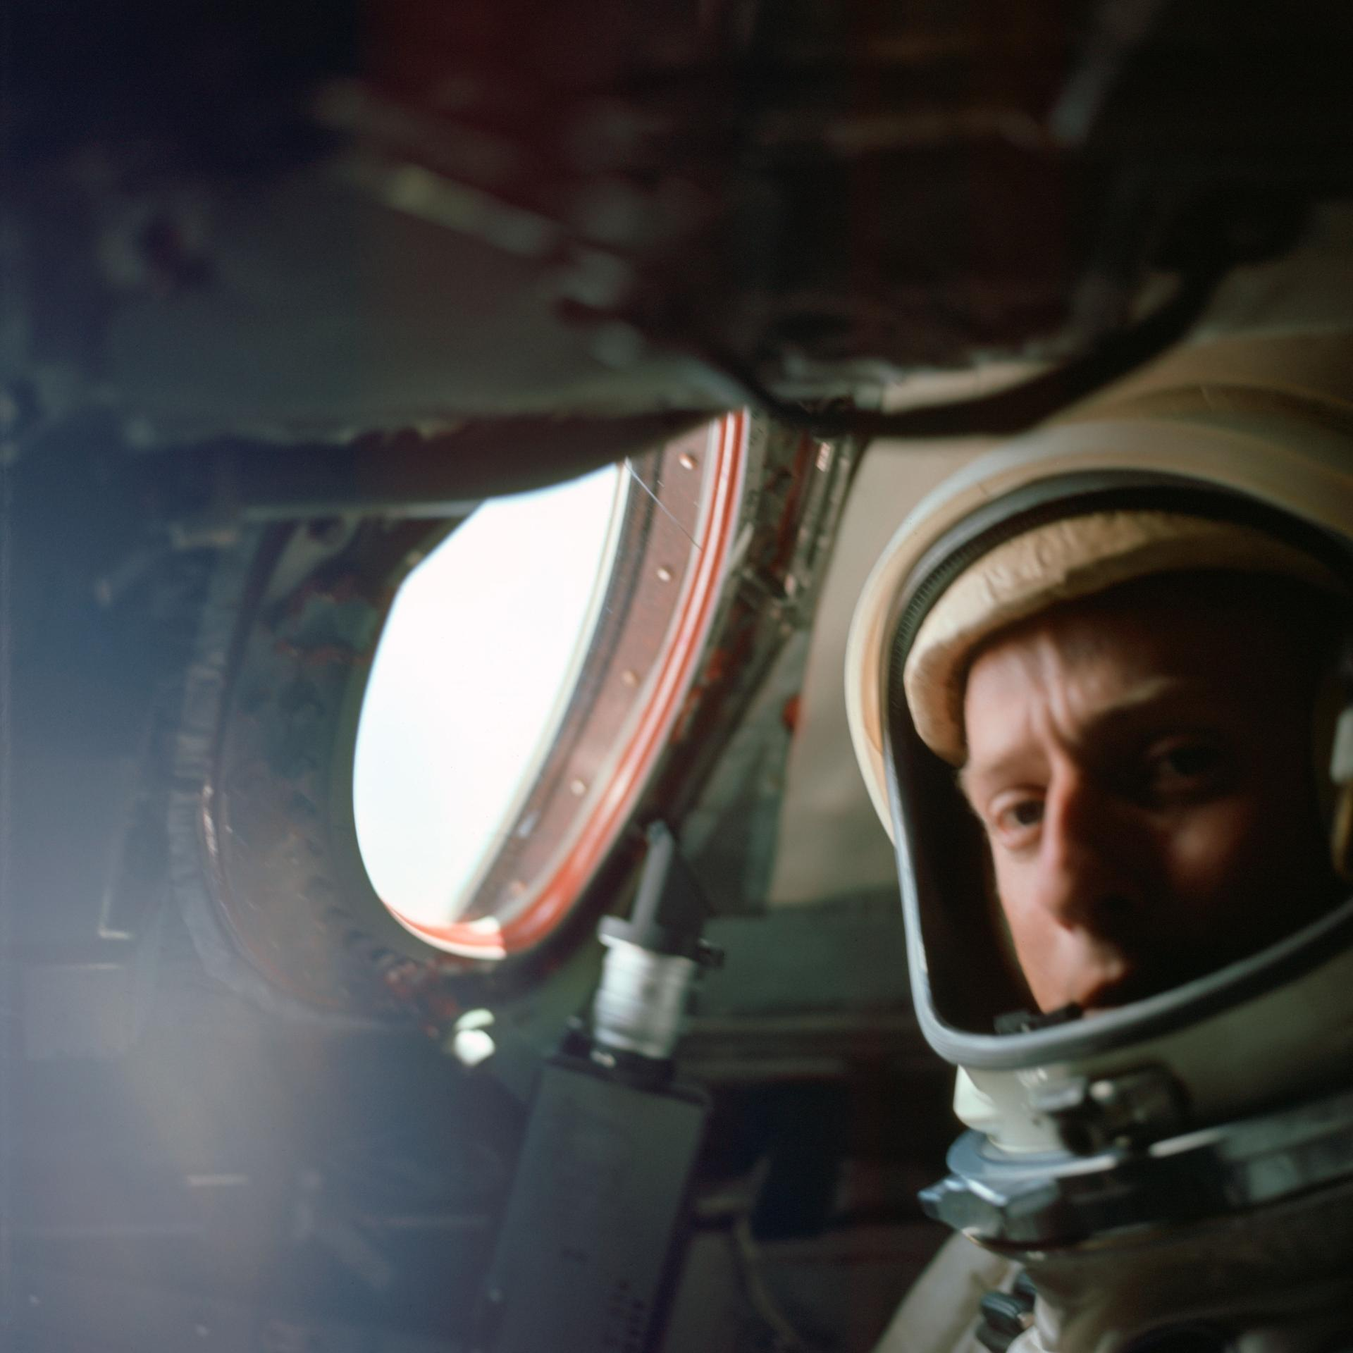
图31 The View from Above: The Gemini Visual Acuity Experiments
Highlights

［原图未能获取：https://www.nasa.gov/wp-content/uploads/2026/03/a2crew-7ff19d.jpg?w=1024］

［原图未能获取：https://www.nasa.gov/wp-content/uploads/2026/03/suit-patch.jpg?w=1024］
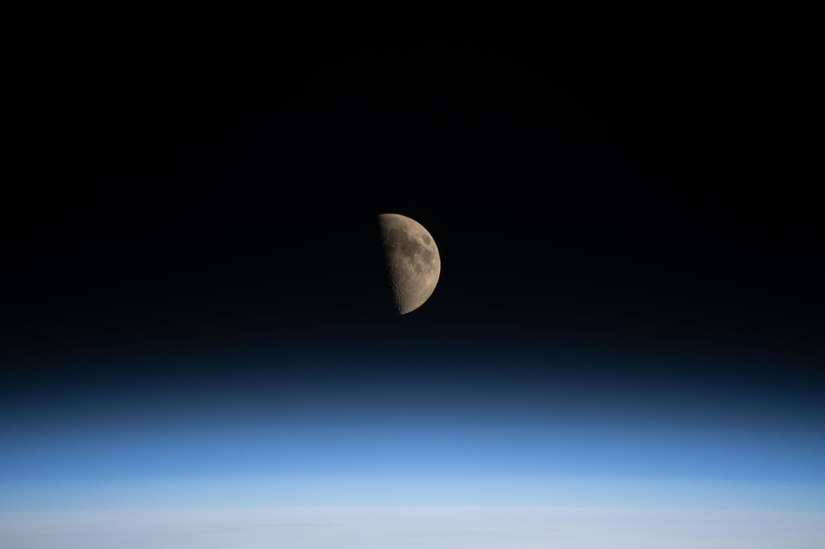
图34 La NASA refuerza Artemis: añade una misión y perfecciona su arquitectura general
Jessica Taveau Aug 27, 2026 RELEASE26-068
NASA Headquarters

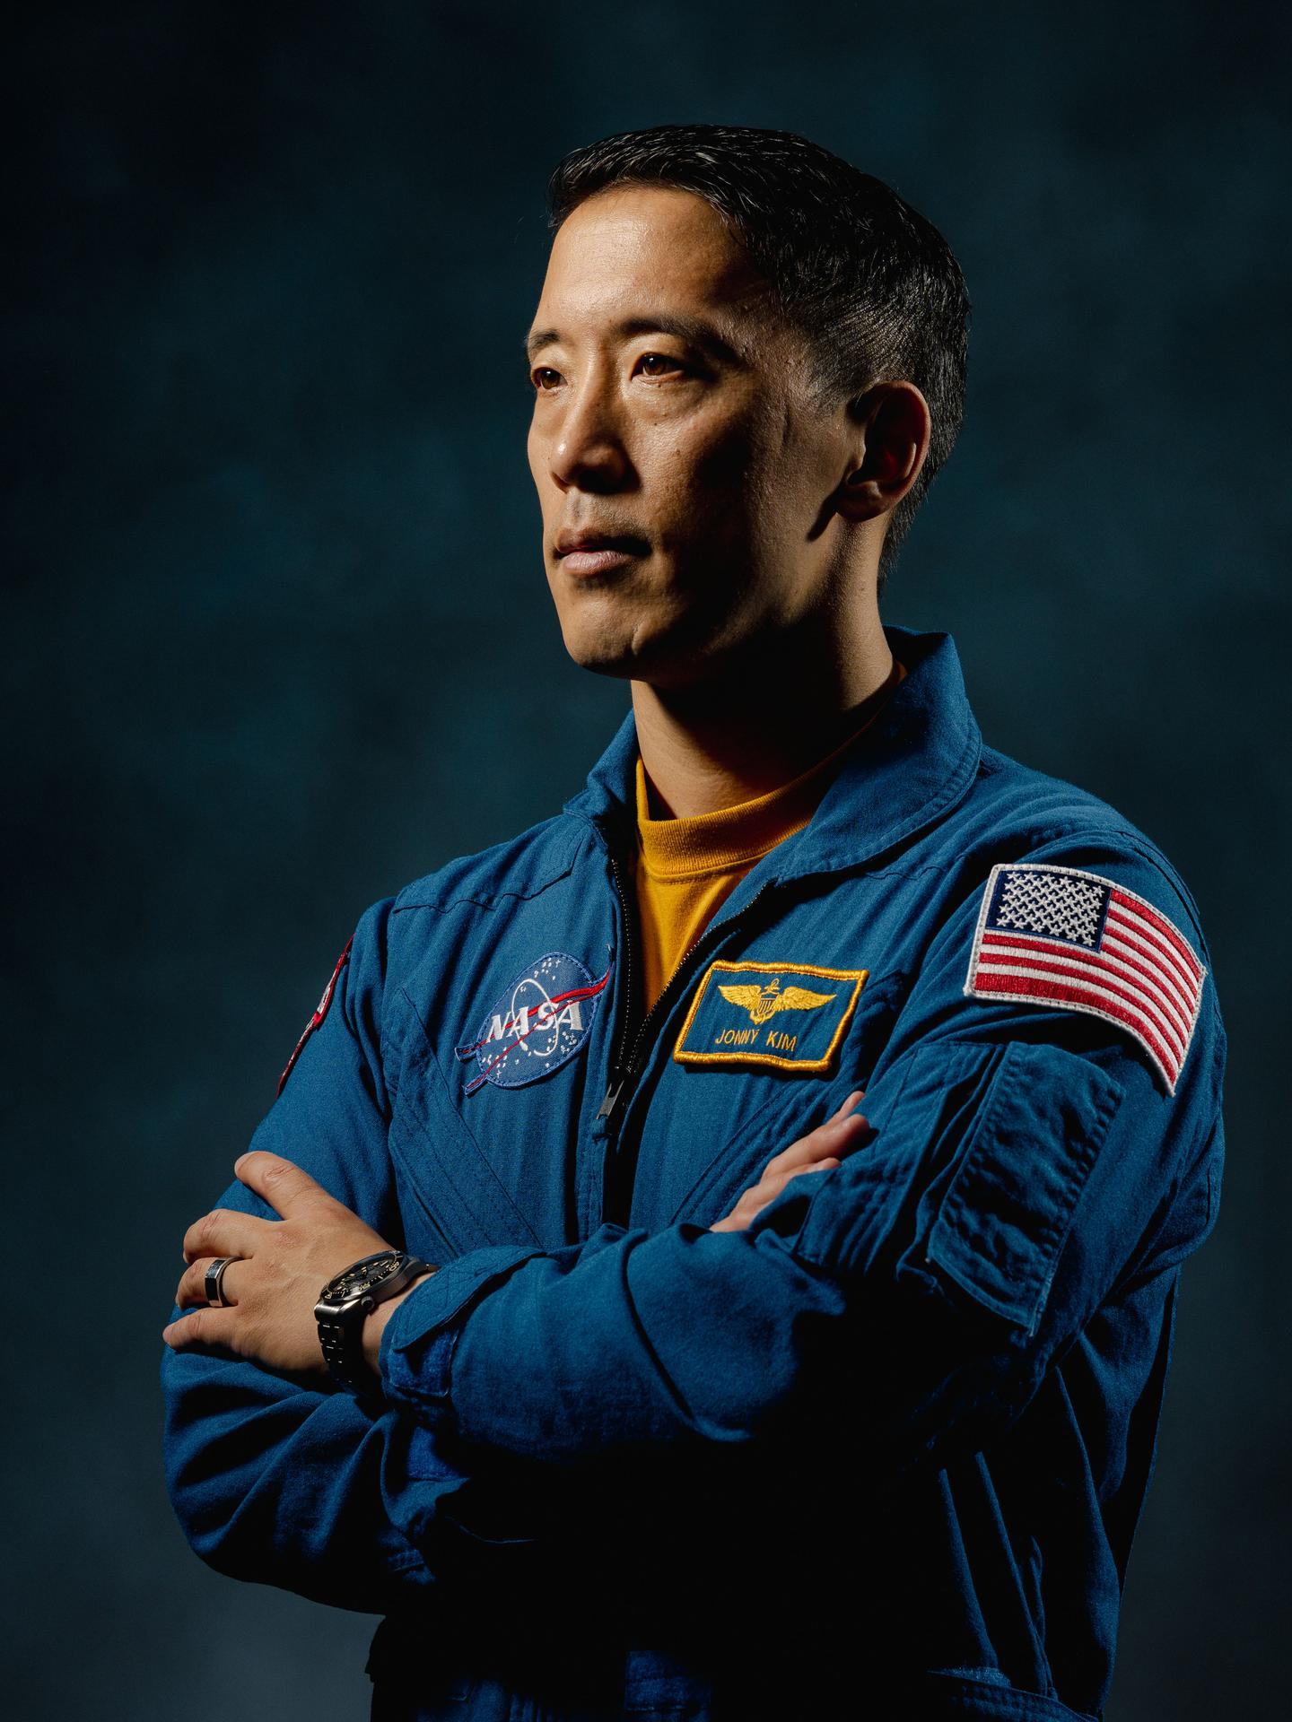
图35 NASA astronaut Jonny Kim poses for a portrait at NASA’s Johnson Space Center in Houston, Texas.
NASA astronaut Jonny Kim poses for a portrait at NASA’s Johnson Space Center in Houston.
Credit: NASA/Josh Valcarcel After nearly a decade of service to NASA, including an eight-month science expedition aboard the International Space Station, astronaut Jonny Kim’s last day at the agency is Thursday. He will continue serving as lieutenant commander in the U.S. Navy.
Kim launched to the space station in April 2025 aboard the Soyuz MS‑27 spacecraft to conduct scientific research as a flight engineer during Expeditions 72/73. During the mission, he orbited Earth 3,920 times, traveled nearly 104 million miles, and contributed to a broad range of scientific investigations spanning technology development, Earth science, biology, and human research critical for future exploration.
“Jonny Kim represents the very best of NASA, a person who continually pushed the boundaries of exploration while inspiring countless others,” said NASA Administrator Jared Isaacman. “His contributions aboard the International Space Station advanced critical science that will shape NASA’s future missions for decades to come. We are grateful for his dedication to our nation and to the pursuit of knowledge, and we wish him success as he continues his service in the U.S. Navy.”
Serving as the U.S. Operating Segment lead for the second half of Expedition 73, Kim oversaw operations across the station’s international modules. During the expedition, the station achieved a historic milestone when every available docking port was occupied for the first time in 25 years. He also commanded the Canadarm2 robotic arm during the first capture of Northrop Grumman’s new Cygnus XL spacecraft, securing 11,000 pounds of supplies for the station. Kim and his Roscosmos crewmates landed safely in Kazakhstan in December 2025.
“Jonny has been an integral part of the agency, and his immeasurable impact will be felt for generations to come,” said Vanessa Wyche, director of NASA’s Johnson Space Center in Houston. “From advancing groundbreaking science to inspiring the next generation, Jonny has been an incredible source of inspiration to our nation. His exceptional talent, determination, and grit will leave a lasting legacy at NASA.”
Kim was selected as a NASA astronaut in 2017 and completed two years of astronaut candidate training, which included instruction in space station systems, Russian language, robotics, T‑38 flight operations, geology, survival training, and spacewalk preparation.
He later supported station operations as a capsule communicator, or capcom, in NASA’s Mission Control Center at Johnson. Kim also contributed to Artemis program development through his work in the astronaut exploration branch, leading the astronaut crew operations branch, and serving as increment lead for Expedition 65. His experiences as a Navy SEAL, physician, and naval aviator provided unique perspectives in mission operations and crew support.
“Jonny approached every assignment with humility, precision, and steadfast commitment to the mission,” said Scott Tingle, chief of the Astronaut Office at NASA Johnson. “His combination of medical training, operational experience, and engineering insight strengthened our team and contributed to advancements in exploration and space station operations.”
Born in Los Angeles, Kim enlisted in the U.S. Navy after graduating high school in 2002. He trained as a hospital corpsman and completed Basic Underwater Demolition/SEAL training before -end- Jimi Russell Headquarters, Washington 202-358-1100 james.j.russell@nasa.gov Anna Schneider Johnson Space Center, Houston 281-483-5111 anna.c.schneider@nasa.gov
Share

Details
Last Updated Aug 27, 2026 Editor Jessica Taveau Location NASA Headquarters
Related Terms
Humans in Space
Astronauts
Johnson Space Center
Jonny Kim
Was this page helpful?
Δ Was this page helpful?
Yes No × Notifications

