编号 | B001-045
机构 | SWF（Secure World Foundation）
类型/日期 | think_tank ｜ 2026-08-20
英文原题 | From Silos to Strategy: Advancing Dialogue Across Nuclear Policy, Space Security, and Commercial Space
原文链接 | https://swfound.org/publications-and-reports/from-silos-to-strategy-insight-august-2026
简报期次 | B001（2026-08-28 归档）
本库文件 | B001-045-Secure world foundation -from-silos-to-strategy-advancing-dialogue-across-202608.md

From Silos to Strategy: Advancing Dialogue Across Nuclear Policy, Space Security, and Commercial Space
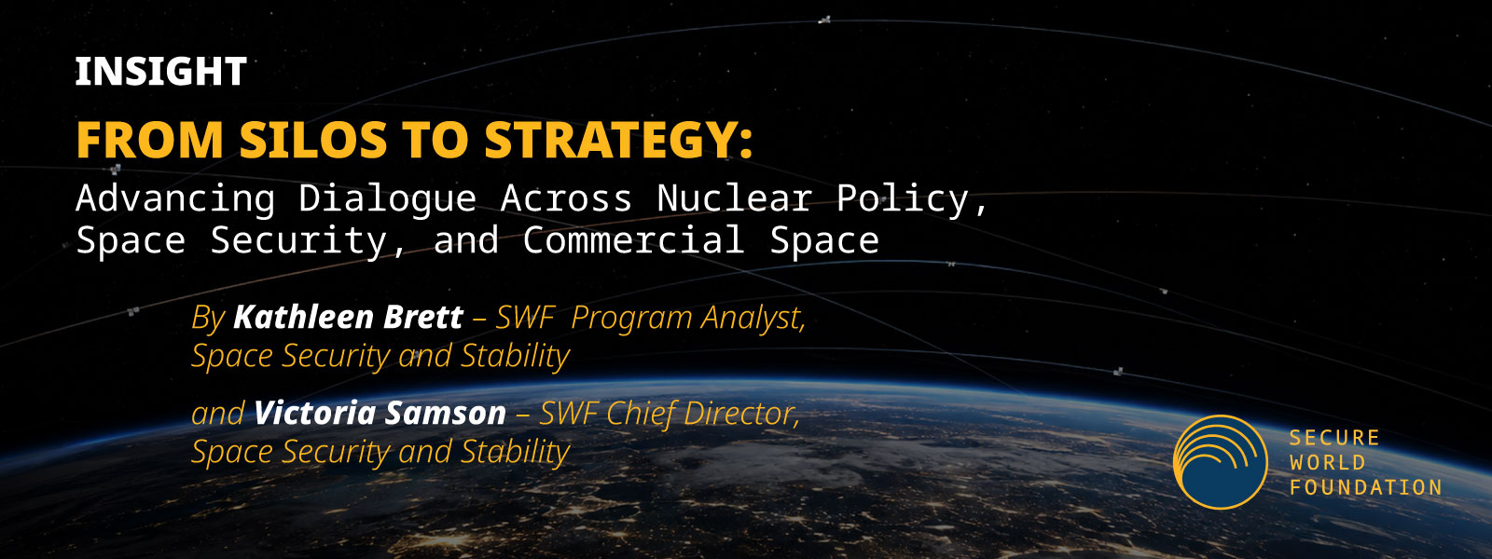
图1 Image 1
by Kathleen Brett & Victoria Samson
Dialogue Background & Purpose
In partnership with the Carnegie Endowment for International Peace, the Secure World Foundation received a grant from the Andrew Carnegie Foundation, formerly known as the Carnegie Corporation of New York, with the purpose of strengthening strategic stability in an era of rising tensions and increasing space activity. This project, "Strengthening Strategic Stability at the Nexus of Space and Nuclear Security," resulted in a dialogue series, which is intended to examine how the increasingly interconnected nature of space security, nuclear policy, and commercial space efforts in low Earth orbit (LEO) have an impact on nuclear risks, especially escalation, and thus impact global security. This dialogue series will take place over two years. The first dialogue took place in January 2026 and brought together, for the first time, experts from the nuclear policy, space security, and commercial space sectors.
Historically, the space-nuclear nexus has been primarily focused on the security of nuclear command and control satellites in geosynchronous orbit (GEO). However, the space environment has drastically changed since the Cold War: there are many more actors, many more satellites offering new capabilities, and a much more complicated threat environment. For example, given that proliferated military satellites in LEO are likely to play an increasingly important role in nuclear command and control, nuclear escalation could, in the future, plausibly be sparked by operations in LEO. Russia's apparent interest in nuclear-armed anti-satellite capability increases the possibility of nuclear use in that orbital regime.
There is a great deal of siloing within nuclear policy, space security, and commercial space sectors. Thus the goal of this first dialogue was to bring experts from these various communities together, to facilitate open, not-for-attribution discussion on the current state of each sector, and to raise awareness of the implications of each sector's work for the others and of how each sector can shape and be shaped by competition and cooperation in space. This column is a shorter version of the dialogue's final report, which will be released shortly.
Key Dialogue Themes
Beginning with space security, the attendees discussed what was considered responsible behavior in space and how understandings of responsible behavior can change when analyzing different space actors or orbits. When introducing the theme of nuclear risks, the attendees analyzed the threats to satellites involved in nuclear command and control, lessons learned from decades of nuclear risk reduction, and considered which solutions might be adapted for space. Finally, while looking at issues facing the commercial space sector, attendees deliberated about how commercial space actors could mitigate risk to their assets, especially when involved in national security missions, along with their ability to evaluate major factors shaping international stability and escalation risks. Each sector-specific discussion further highlighted how each sector impacts the other.
Following the initial sector-specific discussions, the group then focused on two overarching concepts: international stability (ensuring predictability during peacetime) and risk escalation management (preventing further escalation during a crisis or conflict).
International Stability:
The discussion on international stability focused on what behaviors, norms, and regulations should be undertaken to ensure international stability, along with the potential impediments to these actions. The attendees examined how challenges to norm development, including a lack of enforcement mechanisms, differences in what behavior in each sector is deemed acceptable, and the tension between a desire for freedom of action in space and a need for norms of behavior, have the potential to weaken international stability. Transparency and data sharing turned out to be an issue that many felt was a challenge for their sectors.
Risk Escalation Management:
The discussion on escalation management looked at the role of sharing information, with a particular focus on highlighting some of the obstacles. The participants talked about how each sector might be able to contribute to escalation management efforts during times of a crisis. Also discussed was how assumptions about US technological or operational dominance (in all sectors) might create blind spots in crisis scenarios.
Suggested Measures to Strengthen International Stability
Finally, the participants broke up into smaller discussion groups to brainstorm concrete and specific measures that, from a policy perspective, would promote international stability and reduce escalation risks. These included placing beacons on satellites; establishing unilateral policies of minimum separation distances; reducing the benefit of destabilizing initial attacks by minimizing reliance on space; increased redundancy in space-based nuclear command, control, and communications; expanding hardening against radiation beyond traditional military satellites; working with India and China to dissuade Russia from placing a nuclear warhead in orbit; identifying how to share information about military rendezvous and proximity operations; requiring operators to transmit their ITU assignment at regular intervals; tying more accurate orbital descriptions to mission authorizations; inventing and investing in a radiofrequency space catalog; clarifying declaratory policies; and vastly stepping up the amount of SSA information shared, by operators and national actors alike.
Participants agreed that there is a need for reliable communication between governments and operators in order to prevent and address problems quickly, yet, as noted by the participants, the current communication pathways are very underdeveloped. There should also be greater enforcement and accountability across sectors, as there are limited consequences for violations of norms. Also recommended was exploring the implementation of mechanisms such as insurance requirements and increased transparency requirements as possible starting points to combat escalation risks. Some suggested low hanging fruit for future work included working on common terminologies; clarifying peacetime responsibilities; and striving to normalize advanced notifications when possible.
Next Steps
The second dialogue in this series will be held in spring 2027 overseas with a goal of bringing together global nuclear policy, space security, and commercial space sectors in order to better understand international perspectives and opportunities for risk reduction. We aim to facilitate beneficial discussions that will shore up global stability and make connections across the various sectors for years to come.

