编号 | B002-004
机构 | Nature（Nature - Current Issue）
类型/日期 | news_science ｜
英文原题 | What employers are looking for in the age of AI — and four ways to provide it
原文链接 | https://www.nature.com/articles/d41586-026-01913-x
简报期次 | B002（2026-08-28 归档）
本库文件 | B002-004-Nature - current issue -what-employers-are-looking-for-in-the-age-of-ai-202608.md

What employers are looking for in the age of AI — and four ways to provide it

图1 Image 1: He Xiaopeng, co-founder and chairman of Chinese electric vehicle maker Xpeng, pictured on stage in front of a s
The world of artificial intelligence can be intimidating, but researchers have tips on how to get started. Credit: Jade Gao/AFP via Getty
Artificial intelligence is becoming a must-have skill for both employers and funders. Data compiled by the jobs site Indeed show that, in the United States, science jobs listing ‘AI’ as a required skill are rising sharply, whereas the overall number of science jobs has fallen (see ‘AI in demand’).
One example is the Quadram Institute in Norwich, UK, which specializes in food science and gut biology. Despite that core focus, researchers must show some knowledge of machine learning and AI, according to chief executive Daniel Figeys.
“Definitely they should be familiar with it,” he says, adding that a lot of work in Quadram’s field involves machine learning and high-throughput screening, the data from which are often analysed with AI tools. “If they were lacking all those skills, depending on the position, that would be a red flag.”
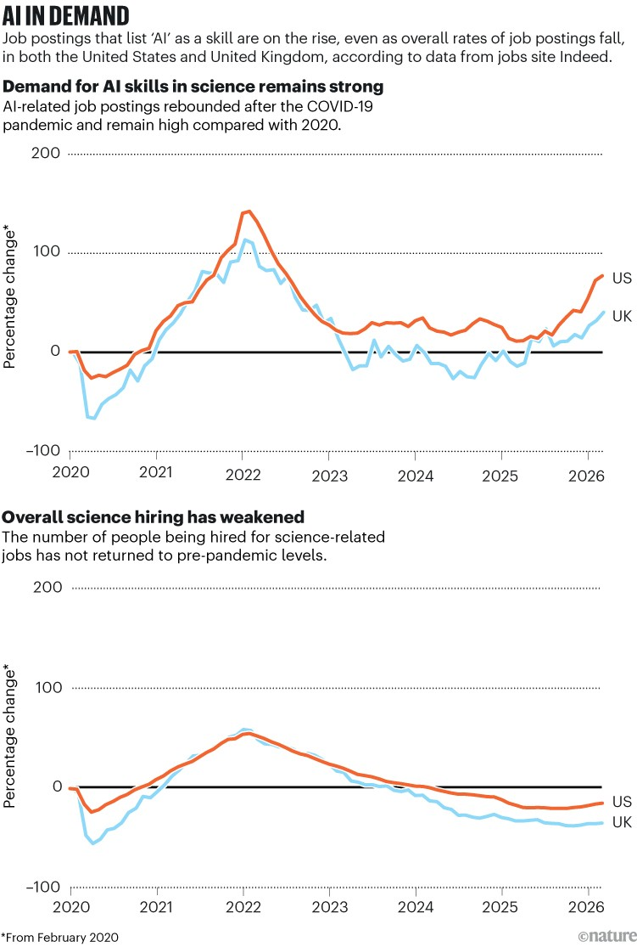
图2 Image 2: AI in demand. Two line charts show trends in science job postings in the United States and United Kingdom since
Source: Indeed
However, instead of worrying that AI systems will be taking science jobs, researchers can get ahead by using and interpreting AI tools to build their understanding. And they don’t need to know everything. Computer scientist Regina Barzilay runs a specialist course at the Massachusetts Institute of Technology (MIT) in Cambridge to teach scientists AI skills. She likens it to cooking: “You don’t need to learn every recipe on Earth to feel comfortable in the kitchen … but you need to have this very basic understanding,” she says, much like “you don’t need to be a computer scientist to use a computer.”
Nature spoke to nine recruiters and researchers to ask them what the most important skills will be for scientists of all kinds in the AI era.
In short
Dos and don’ts to build your AI knowledge:
• Do experiment with AI technologies in your working day.
• Do take a course in AI and machine learning.
• Do ask AI to write code for a project, then take the code apart and learn how it works.
• Don’t propose a project using AI tools without being able to show that you have the skills to back it up.
• Don’t believe everything you get from a chatbot.
• Don’t try to learn everything at once.
Be curious
Recruiters repeatedly told Nature that, rather than specific technical skills, they’re mostly looking for candidates who are curious to learn more about AI and are able to demonstrate that on their CVs.
“It’s the willingness to just roll up your sleeves and get into it, whether it’s informal training, whether it’s just spending some hours on open-source educational content,” explains Vijay Shah, dean of research at the Mayo Clinic in Rochester, Minnesota, which had almost 30 open research positions in May.
This is more important than specific skills, he says, because the field is moving so quickly. If you set a litmus test that requires people to be able to use AI tools such as OpenClaw or AlphaGenome, for instance, it will quickly be outdated, he adds.
It’s a sentiment echoed by Christopher Walsh, chief executive of TileBio, a start-up in Glasgow, UK, which uses AI to analyse medical images. “It’s actually really easy to teach yourself new information using large language models these days, as long as you verify the sources. So I’d recommend just having the curiosity to do that,” says Walsh. “Go and be open to learning new things, I think that’s the first step.”
Many institutions provide training in AI alongside their science curriculum, and online courses are also available, offered by institutions such as MIT and the Royal Society of Chemistry in London. “There are other ways of getting access to that type of training” rather than relying on your institution, Figeys says.
Get to know how AI thinks
One pitfall when using AI tools is putting too much faith in the results that they generate without examining the data critically. “Often it’ll give you results that it thinks you want to see, based on something you’ve said,” says Walsh. “It’s a people pleaser.”
Something that needs careful checking, according to Barzilay, is any percentage likelihood given by AI, because it might not match the observed reality. For instance, if an AI model says that there is an 80% probability that a radiology image depicts cancerous cells, “What you need to do is to say, ‘can I trust this 80%?’”
LINK Should I use AI to help draft my science job application?
This means recognizing whether the probability estimation has been calibrated against current test data to ensure its estimations match the real distributions.
For example, cancer screening models are often benchmarked against historical cases, so when these models are used to analyse new populations, the risk thresholds that they rely on might no longer match reality. In unpublished work, AI specialist Aziz Ayed and his colleagues at MIT found that the AI model MIRAI miscategorized women’s breast-cancer risk, potentially endangering lives by failing to flag some women as eligible for advanced screening.
Engineer Sydney Pham completed the machine-learning course run by Barzilay in 2024. Now working at pharmaceutical company Moderna in Cambridge, Massachusetts, she uses AI to improve manufacturing processes by working out the most promising parameters of an experiment and identifying areas for further investigation.
“Sometimes models can make sense of unexpected observations, which can guide further iterations of studies,” Pham says, but she cautions that she always corroborates AI recommendations through other means. “It’s helpful to understand how the models generate their results.”
It’s really important to get “a sense for the capabilities of the model, but also [to] develop a sense about what that means when it runs on a machine or when it interacts with data sets”, says Dominik Lukeš, a consultant at the AI Competency Centre at the University of Oxford, UK.
Because some people simply try a large language model and get “sort of wonky answers”, Lukeš thinks that it’s worth investing time in trying to understand how AI works. “There are people who’ve spent hundreds of hours learning how to take advantage of it, thinking about the process, rethinking their process and all of a sudden they will say [they] can’t live without it and ‘oh, this is an enormous game changer’.”
Know what you know
In an AI-enabled era, it feels like most research proposals are packed with ideas on how the technology can be used. However, proposal writers often don’t demonstrate that their team has the experience to implement its ideas, say hiring managers. Writing ‘we will use AI to achieve our goals’ isn’t especially credible without detail and experience to back it up.
AI features in many of the proposals that the research funder Cancer Research UK (CRUK) in London receives, says Talisia Quallo, the organization’s head of prevention and early-detection research. She says that funding committees need to see “that you understand these AI approaches and that you detail how you’re going to use them, how that algorithm works and the limitations of it”.
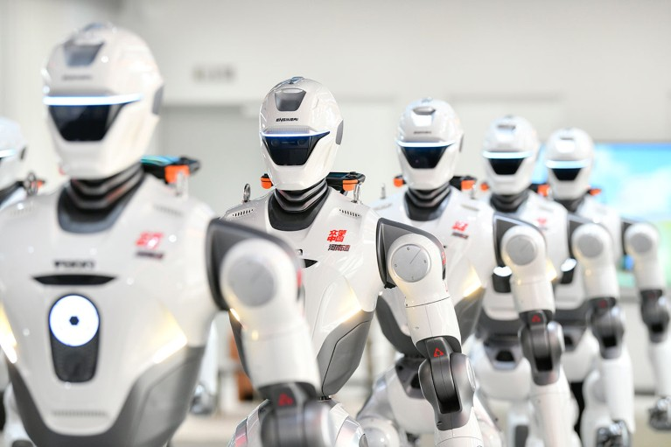
图3 Image 3: A long line of EngineAI T800 humanoid robots after coming off the production line at a manufacturing facility.
The production of effective humanoid robots is one research goal for some scientists working in embodied intelligence. Credit: VCG via Getty
One successful example at CRUK is Ke Yuan’s research group, called AI for Cancer Research. This team previously included Walsh, who did an undergraduate degree in computer science before specializing in cancer for his PhD.
“I was one of the members who brought computer-science knowledge,” says Walsh. Everyone had different responsibilities outlined in the grant — his role was to “translate that pathology knowledge and cell biology knowledge into code”.
Quallo says that the simplest and best way to demonstrate to evaluation committees that you know how to use AI techniques is to have publications in the field. Alternatively, she recommends including members of the project team in the grant proposal who have the relevant expertise, although every person in the team should have some knowledge of AI.

