编号 | B002-007
机构 | Nikkei（Nikkei Asia - Tech）
类型/日期 | news_science ｜ 2026-08-28
英文原题 | India's private capex surges on data centers and renewables
原文链接 | https://asia.nikkei.com/economy/india-s-private-capex-surges-on-data-centers-and-renewables2
简报期次 | B002（2026-08-28 归档）
本库文件 | B002-007-Nikkei asia - tech -indias-private-capex-surges-on-data-centers-and-202608.md

India's private capex surges on data centers and renewables
Economy

［原图未能获取：https://images.ft.com/v3/image/raw/https%3A%2F%2Fcms-image-bucket-productionv3-ap-northeast-1-a7d2.s］
Sectors like data centers and renewables are powering a surge in private capital expenditures in India, reflecting government support for industries seen as key to the country's quest for self-reliance. (Nikkei montage/Source photo by Reuters)
ANANTA AGARWAL August 28, 2026 14:25 JST Listen English (Original)
BENGALURU -- After years of caution that invited national criticism, India's private sector is showing a renewed appetite for investment, with "sunrise industries" like data centers, renewables and electronics powering a surge.
Read Next

［原图未能获取：https://images.ft.com/v3/image/raw/https%3A%2F%2Fcms-image-bucket-productionv3-ap-northeast-1-a7d2.s］
Companies Indian firms' profit growth hits 3-year high despite war shock
Trade ASEAN headlines India's export expansion in April-June quarter

［原图未能获取：https://images.ft.com/v3/image/raw/https%3A%2F%2Fcms-image-bucket-productionv3-ap-northeast-1-a7d2.s］
Politics Modi pitches 7 growth mantras, wants '50 Indian firms in Fortune 500'

图4 Modi pitches 7 growth mantras, wants '50 Indian firms in Fortune 500'
Materials India's battery materials bet races ahead of lithium cell making plans
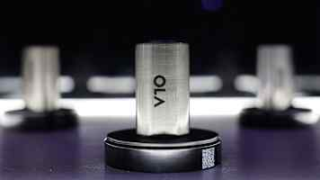
图5 India's battery materials bet races ahead of lithium cell making plans
Economy India's services exports growth highlights limits of manufacturing push

［原图未能获取：https://images.ft.com/v3/image/raw/https%3A%2F%2Fcms-image-bucket-productionv3-ap-northeast-1-a7d2.s］
Trade India's European trade deals revive hopes for textile exporters

［原图未能获取：https://images.ft.com/v3/image/raw/https%3A%2F%2Fcms-image-bucket-productionv3-ap-northeast-1-a7d2.s］
Work India moves to protect $1tn export target from forced labor concerns
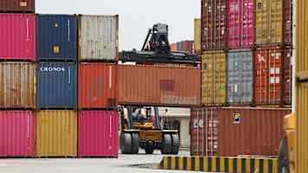
图8 India moves to protect $1tn export target from forced labor concerns
Latest on Economy
Economy Bank of Korea delivers back-to-back rate hikes to cope with inflation

［原图未能获取：https://images.ft.com/v3/image/raw/https%3A%2F%2Fcms-image-bucket-productionv3-ap-northeast-1-a7d2.s］
Economy Sole Bank Indonesia governor candidate outlines 'pro-growth' policies

［原图未能获取：https://images.ft.com/v3/image/raw/https%3A%2F%2Fcms-image-bucket-productionv3-ap-northeast-1-a7d2.s］
Economy Malaysia's strong growth yet to reach households, small businesses

［原图未能获取：https://images.ft.com/v3/image/raw/https%3A%2F%2Fcms-image-bucket-productionv3-ap-northeast-1-a7d2.s］
Sponsored Content
About Sponsored ContentThis content was commissioned by Nikkei's Global Business Bureau.

