编号 | B003-020
机构 | NASA（NASA - News Releases）
类型/日期 | official ｜ 2026-08-29
英文原题 | NASA Awards First Prize in Phase 2 of Agency’s LunaRecycle Challenge
原文链接 | https://www.nasa.gov/directorates/stmd/prizes-challenges-crowdsourcing-program/centennial-challenges/nasa-awards-first-prize-in-phase-2-of-agencys-lunarecycle-challenge/
简报期次 | B003（2026-08-29 归档）
本库文件 | B003-020-Nasa - news releases -nasa-awards-first-prize-in-phase-2-of-agencys-lu-202608.md

NASA Awards First Prize in Phase 2 of Agency’s LunaRecycle Challenge
Search
Suggested Searches
Climate Change
Artemis
Expedition 64
Mars perseverance
SpaceX Crew-2
International Space Station
View All Topics A-Z
Home
Missions
Humans in Space
Earth
The Solar System
The Universe
Science
Aeronautics
Technology
Learning Resources
About NASA
Español
News & Events
Multimedia
NASA+
Featured

［原图未能获取：https://www.nasa.gov/wp-content/uploads/2026/08/ksc-20260821-ph-ser01-0003large.jpg?w=767］

［原图未能获取：https://www.nasa.gov/wp-content/uploads/2026/08/congressional-space-medal-of-honor-ceremony-1.jpg?w=］

［原图未能获取：https://www.nasa.gov/wp-content/uploads/2026/08/eo-1.png?w=1024］
Back
Missions
Search All NASA Missions
A to Z List of Missions
Upcoming Launches and Landings
Spaceships and Rockets
Communicating with Missions
Artemis
James Webb Space Telescope
Hubble Space Telescope
International Space Station
OSIRIS-Rex
Humans in Space
Why Go to Space
Astronauts
Commercial Space
Destinations
Spaceships and Rockets
Living in Space
Earth
Explore Earth Science
Climate Change
Earth, Our Planet
Earth Science in Action
Earth Multimedia
Earth Data
Earth Science Researchers
The Solar System
The Sun
Mercury
Venus
Earth
The Moon
Mars
Jupiter
Saturn
Uranus
Neptune
Pluto & Dwarf Planets
Asteroids, Comets & Meteors
The Kuiper Belt
The Oort Cloud
Skywatching
The Universe
Exoplanets
The Search for Life in the Universe
Stars
Galaxies
Black Holes
The Big Bang
Dark Energy
Dark Matter
Science
Earth Science
Planetary Science
Astrophysics & Space Science
The Sun & Heliophysics
Biological & Physical Sciences
Lunar Science
Citizen Science
Astromaterials
Aeronautics Research
Human Space Travel Research
Aeronautics
Science in the Air
NASA Aircraft
Flight Research Innovation
Supersonic Flight
Air Traffic Solutions
Green Aviation Tech
Drones & You
Technology
Technology Transfer & Spinoffs
Space Travel
Living in Space
Lunar Surface Technology
Manufacturing and Materials
Robotics
Science Instruments
Computing
Learning Resources
For Kids and Students
For Educators
For Colleges and Universities
For Professionals
Science for Everyone
Requests for Exhibits, Artifacts, Speakers & Flyovers
STEM Engagement at NASA
About NASA
NASA's Impacts
Centers and Facilities
Directorates
Organizations
People of NASA
Careers
Internships
Our History
Doing Business with NASA
Get Involved
Contact
NASA en Español
Ciencia
Aeronáutica
Ciencias Terrestres
Sistema Solar
Universo
News & Events
News Releases
Recently Published
Video Series on NASA+
Podcasts & Audio
Blogs
Newsletters
Social Media
Media Resources
Events
Upcoming Launches & Landings
Virtual Guest Program
Multimedia
NASA+
Images
NASA Live
NASA Apps
Podcasts
Image of the Day
e-Books
3D Resources
Interactives
STEM Multimedia
NASA Brand & Usage Guidelines
Featured

［原图未能获取：https://www.nasa.gov/wp-content/uploads/2026/08/ksc-20260821-ph-ser01-0003large.jpg?w=767］

［原图未能获取：https://www.nasa.gov/wp-content/uploads/2026/08/congressional-space-medal-of-honor-ceremony-1.jpg?w=］
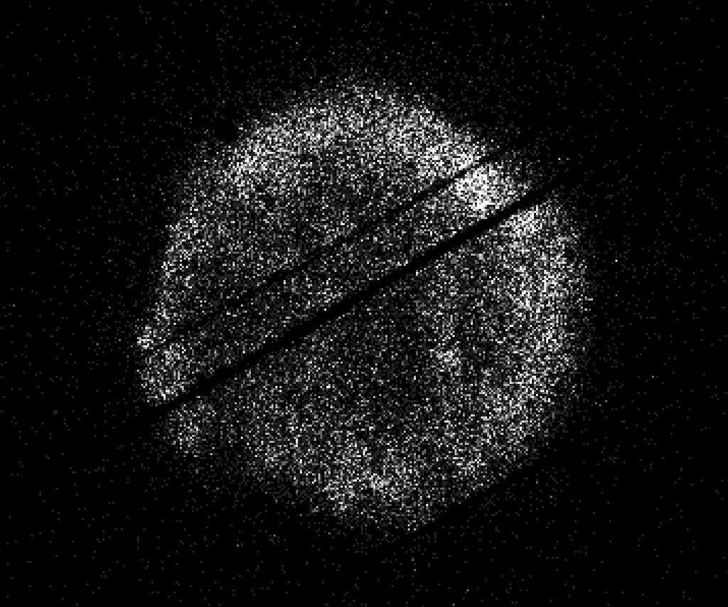
图6 NASA’s Swift Restarts Science Observations
Highlights

［原图未能获取：https://assets.science.nasa.gov/dynamicimage/assets/science/psd/ares/iss049e035512~orig.jpg?w=1024］

［原图未能获取：https://assets.science.nasa.gov/dynamicimage/assets/science/esd/eo/images/iotd/2026/earthset-from-th］

［原图未能获取：https://www.nasa.gov/wp-content/uploads/2026/06/art002e024603orig.jpg?w=1024］
Highlights

［原图未能获取：https://assets.science.nasa.gov/dynamicimage/assets/science/esd/eo/images/iotd/2026/the-forested-flo］

［原图未能获取：https://assets.science.nasa.gov/dynamicimage/assets/science/esd/eo/images/iotd/2026/rare,-widespread］

［原图未能获取：https://www.nasa.gov/wp-content/uploads/2026/08/0202795orig.jpg?w=1024］
Highlights
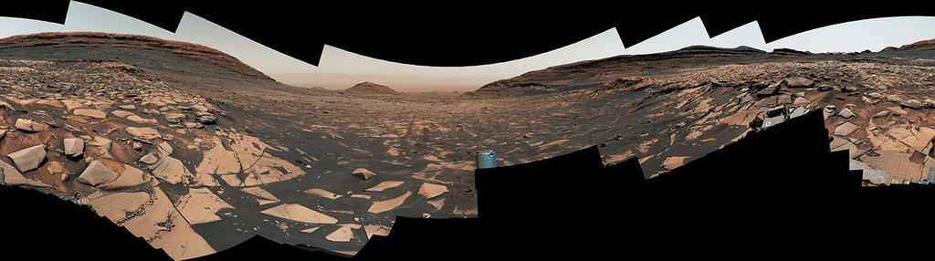
图13 Curiosity Reaches 1-Kilometer Elevation Gain

［原图未能获取：https://www.nasa.gov/wp-content/uploads/2026/08/jsc2026e406812.jpg?w=1024］

［原图未能获取：https://science.nasa.gov/wp-content/uploads/2026/08/shield-heliosphere-shrinking-screenshot.png］
Featured

［原图未能获取：https://science.nasa.gov/wp-content/uploads/2026/08/roman-new.jpg］

［原图未能获取：https://assets.science.nasa.gov/dynamicimage/assets/science/missions/pandora/news/2026/Pandora_Artis］

［原图未能获取：https://assets.science.nasa.gov/dynamicimage/assets/science/missions/chandra/2026/galaxies_ngc4631.j］
Highlights

［原图未能获取：https://assets.science.nasa.gov/dynamicimage/assets/science/cds/soma/apsmex26/APSMEX25-image.jpg?w=1］

［原图未能获取：https://science.nasa.gov/wp-content/uploads/2026/03/stockcake-planetary-alignment-art-1265316-standa］

［原图未能获取：https://assets.science.nasa.gov/dynamicimage/assets/science/esd/eo/images/iotd/2026/a-changing-world］
Highlights

［原图未能获取：https://www.nasa.gov/wp-content/uploads/2026/08/jsc2026e406812.jpg?w=1024］

［原图未能获取：https://www.nasa.gov/wp-content/uploads/2026/08/uli-round-9-awards.jpg?w=1024］

［原图未能获取：https://www.nasa.gov/wp-content/uploads/2026/08/2027-gbs-email-header-cc.png?w=1024］
Highlights

［原图未能获取：https://www.nasa.gov/wp-content/uploads/2026/08/1-pia26777-d2026-0824-rl0031661-pano-med.jpg?w=1024］

［原图未能获取：https://assets.science.nasa.gov/dynamicimage/assets/science/cds/svs/a030000/a031300/a031302/high-alt］

［原图未能获取：https://www.nasa.gov/wp-content/uploads/2023/09/copernicus-gtoc.png?w=1024］
Featured

［原图未能获取：https://www.nasa.gov/wp-content/uploads/2023/02/nancy-grace-roman-space-telescope-visualization.jpeg］
Featured

［原图未能获取：https://www.nasa.gov/wp-content/uploads/2026/08/ksc-20260821-ph-ser01-0003large.jpg?w=767］

［原图未能获取：https://www.nasa.gov/wp-content/uploads/2026/08/congressional-space-medal-of-honor-ceremony-1.jpg?w=］
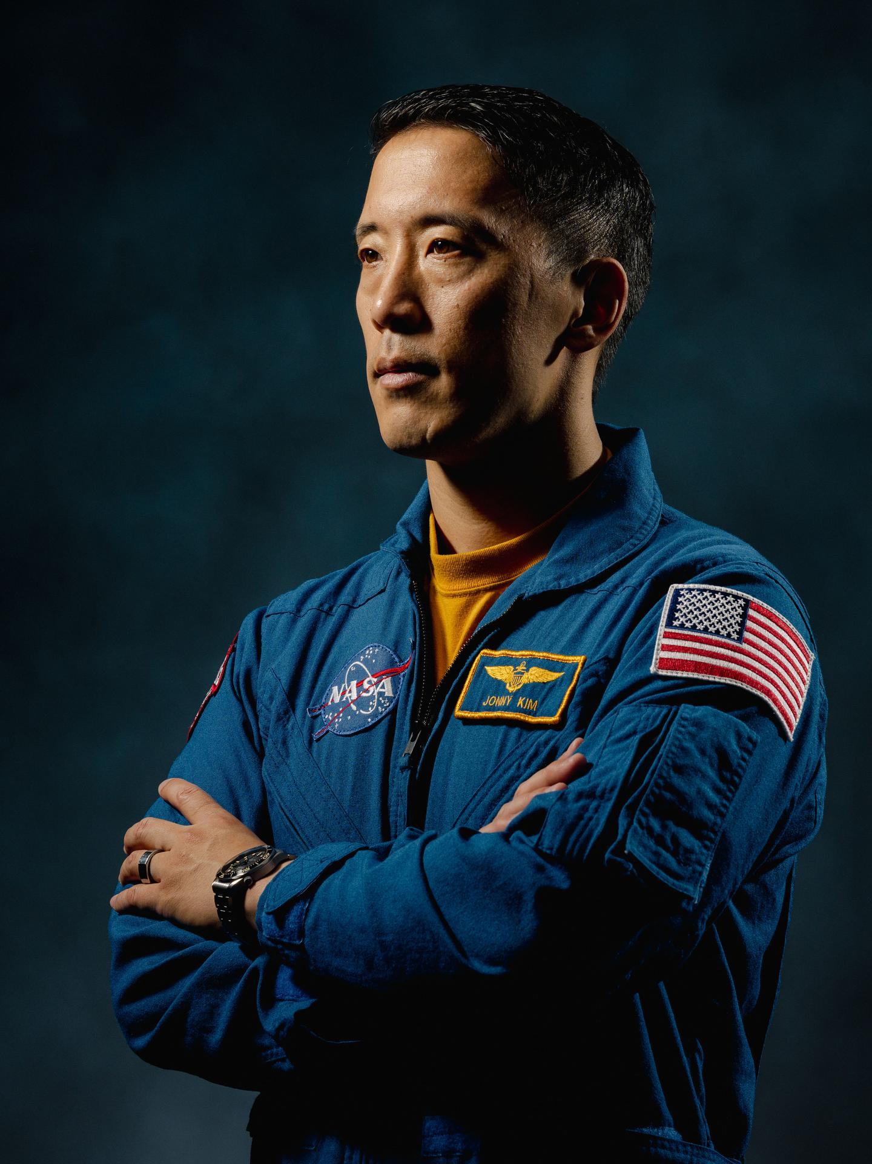
图31 NASA Astronaut Jonny Kim Departs Agency to Continue Military Service
Highlights

［原图未能获取：https://www.nasa.gov/wp-content/uploads/2026/03/a2crew-7ff19d.jpg?w=1024］

［原图未能获取：https://www.nasa.gov/wp-content/uploads/2026/03/suit-patch.jpg?w=1024］
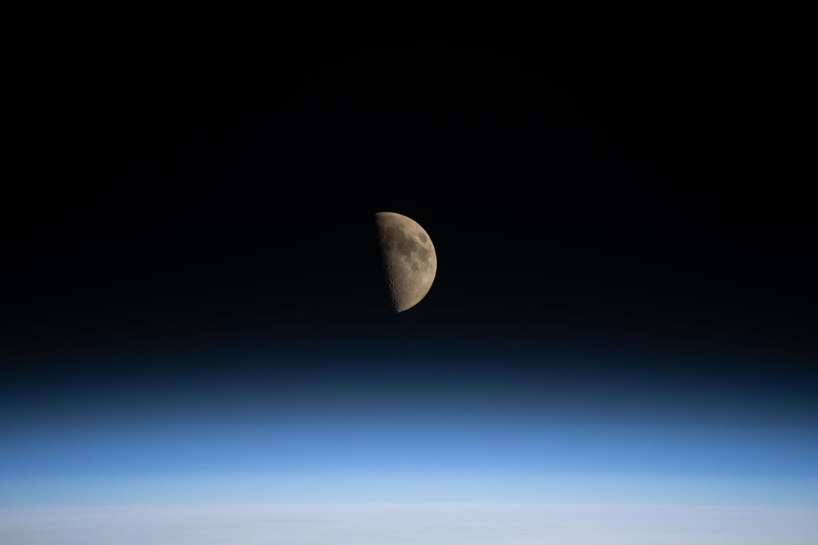
图34 La NASA refuerza Artemis: añade una misión y perfecciona su arquitectura general

［原图未能获取：https://www.nasa.gov/wp-content/uploads/2023/12/nasainsigniargb150px.png］
Bailey G. Light Aug 28, 2026 Article

［原图未能获取：https://www.nasa.gov/wp-content/uploads/2026/08/cerberuz-lunarecycle-winners.jpg?w=2048］
The Massachusetts Institute of Technology team won NASA’s LunaRecycle Challenge competition for their project, Composites for Extraterrestrial Recycling By Engineering the Reuse and Upcycling of Zotek (CERBERUZ).
Credit: NASA/Savannah Bullard NASA named a team from the Massachusetts Institute of Technology (MIT) as the first prize winner for Phase 2 of the agency’s LunaRecycle Challenge, which focused on developing solutions for reducing waste during missions to the Moon or deep space by recycling common materials, like fabrics, plastics, foam, and metals.
The Composites for Extraterrestrial Recycling By Engineering the Reuse and Upcycling of Zotek (CERBERUZ) team, comprised of undergraduate, graduate, and doctoral students at MIT, received a total of $775,000 in awards.
The technology grinds mixed trash into a fine powder, repurposing materials such as Zotek foam as reinforcement rather than treating it as contamination that needs to be sorted out. The powder becomes feed for use as injection-mold finished parts or 3D-printing filament. The MIT team won in both the competition’s prototype development track and in the track focused on developing virtual models, known as “digital twins,” of recycling systems.
“The LunaRecycle Challenge finale is the culmination of two years of innovation spurred by this competition,” said Jennifer Edmunson, program manager for Centennial Challenges at NASA’s Marshall Space Flight Center in Huntsville, Alabama. “It’s incredible to see these technologies go from concept to prototype and digital twin demonstrations in that time. Driving rapid and creative innovation is what NASA challenges are all about.”
LunaRecycle is a $3 million, two-phase competition in partnership with The University of Alabama Lee J. Styslinger Jr. College of Engineering. Phase 2 of the competition required U.S. teams to submit a prototype, with an optional digital twin serving as a virtual model of it.
For Phase 2, 14 finalist teams from across the United States gathered at The University of Alabama’s Lee J. Styslinger Jr. College of Engineering, in Tuscaloosa, from Aug. 24 to Aug. 28 to demonstrate their technology prototypes. The digital twin models submitted by some teams were also presented alongside their respective prototypes.
The competitors’ backgrounds ranged from university students and faculty to entrepreneurs and space technology enthusiasts. Teams were encouraged to envision solutions that not only addressed recycling in deep space, but that also could have applications on Earth.
Along with the first prize winner, nine teams received prizes:
Prototype track winners:
Second place overall ($225,000): Terasynth from Orlando, Fla. with Lunar Re-Forge System
Most Innovative ($50,000): RECLAIM from Penn State University with the Resource Extraction and Conversion from Lunar Anthropogenic Inputs with Microwaves (RECLAIM) system
Highest Mass Efficiency ($50,000): Cislune from Rosemead, Calif. with the Carbon Recovery and Feedstock Transformation for Extraterrestrial Reuse (CRAFTER) system
Most Trash Types Recycled ($50,000): Team Lovegrove from Bob Jones University in Greenville, S.C. with LunaBrix
Additional digital twin track winners:
Second place overall ($125,000): Moon Made from Boulder, Co. with Fiber Forge
Most Innovative ($25,000): RECLAIM from Penn State University with the RECLAIM system
Best Visualization ($25,000): Waste Parrot Technologies from New York, N.Y.
People’s choice winner ($25,000):
Terasynth from Orlando, Fla. with Lunar Re-Forge System
“This competition highlights how collaborations can lead to incredible solutions,” said Chris Frangione, who manages the LunaRecycle Challenge in support of NASA Centennial Challenges contracted through Amentum Space Exploration Division. “Between the solver teams, The University of Alabama, and NASA, this finale showcases what can be achieved when we bring together resources and great ideas towards a common goal.”
The Phase 2 awards follow the success of the competition’s Phase 1, which received record-breaking interest from the global innovator community with more than 1,200 registrations – more than any competition in the 20-year history of NASA Centennial Challenges. For Phase 1, which concluded in 2025, participants from around the world could submit designs in either or both of the prototype or digital twin tracks. A panel of 50 judges evaluated nearly 200 Phase 1 submissions, selecting 17 teams representing five countries and nine U.S. states as winners. Phase 2 entries were required to be unrelated to Phase 1.
The LunaRecycle Challenge is managed at NASA’s Marshall Space Flight Center by Centennial Challenges, part of the Prizes, Challenges, and Crowdsourcing program within NASA’s Research and Technology Mission Directorate. NASA’s Centennial Challenges have a legacy of more than 20 years engaging the public to solve complex problems that benefit NASA’s broader initiatives. Past challenges have spurred advances in robotics, additive manufacturing, power and energy, textiles, chemistry, and biology.
LunaRecycle is also supported by subject matter experts at NASA’s Kennedy Space Center in Florida, NASA’s Ames Research Center in California’s Silicon Valley, and NASA’s Langley Research Center, in Hampton, Virginia.
To learn more about LunaRecycle, visit:
www.nasa.gov/lunarecycle
Was this page helpful?
Δ Was this page helpful?
Yes No × Notifications

