编号 | B003-021
机构 | NASA（NASA - News Releases）
类型/日期 | official ｜ 2026-08-29
英文原题 | President Honors NASA’s Artemis II Crew with Highest US Space Award
原文链接 | https://www.nasa.gov/news-release/president-honors-nasas-artemis-ii-crew-with-highest-us-space-award/
简报期次 | B003（2026-08-29 归档）
本库文件 | B003-021-Nasa - news releases -president-honors-nasas-artemis-ii-crew-with-high-202608.md

President Honors NASA’s Artemis II Crew with Highest US Space Award
Search
Suggested Searches
Climate Change
Artemis
Expedition 64
Mars perseverance
SpaceX Crew-2
International Space Station
View All Topics A-Z
Home
Missions
Humans in Space
Earth
The Solar System
The Universe
Science
Aeronautics
Technology
Learning Resources
About NASA
Español
News & Events
Multimedia
NASA+
Featured

［原图未能获取：https://www.nasa.gov/wp-content/uploads/2026/08/ksc-20260821-ph-ser01-0003large.jpg?w=767］

［原图未能获取：https://www.nasa.gov/wp-content/uploads/2026/08/congressional-space-medal-of-honor-ceremony-1.jpg?w=］

［原图未能获取：https://www.nasa.gov/wp-content/uploads/2026/08/eo-1.png?w=1024］
Back
Missions
Search All NASA Missions
A to Z List of Missions
Upcoming Launches and Landings
Spaceships and Rockets
Communicating with Missions
Artemis
James Webb Space Telescope
Hubble Space Telescope
International Space Station
OSIRIS-Rex
Humans in Space
Why Go to Space
Astronauts
Commercial Space
Destinations
Spaceships and Rockets
Living in Space
Earth
Explore Earth Science
Climate Change
Earth, Our Planet
Earth Science in Action
Earth Multimedia
Earth Data
Earth Science Researchers
The Solar System
The Sun
Mercury
Venus
Earth
The Moon
Mars
Jupiter
Saturn
Uranus
Neptune
Pluto & Dwarf Planets
Asteroids, Comets & Meteors
The Kuiper Belt
The Oort Cloud
Skywatching
The Universe
Exoplanets
The Search for Life in the Universe
Stars
Galaxies
Black Holes
The Big Bang
Dark Energy
Dark Matter
Science
Earth Science
Planetary Science
Astrophysics & Space Science
The Sun & Heliophysics
Biological & Physical Sciences
Lunar Science
Citizen Science
Astromaterials
Aeronautics Research
Human Space Travel Research
Aeronautics
Science in the Air
NASA Aircraft
Flight Research Innovation
Supersonic Flight
Air Traffic Solutions
Green Aviation Tech
Drones & You
Technology
Technology Transfer & Spinoffs
Space Travel
Living in Space
Lunar Surface Technology
Manufacturing and Materials
Robotics
Science Instruments
Computing
Learning Resources
For Kids and Students
For Educators
For Colleges and Universities
For Professionals
Science for Everyone
Requests for Exhibits, Artifacts, Speakers & Flyovers
STEM Engagement at NASA
About NASA
NASA's Impacts
Centers and Facilities
Directorates
Organizations
People of NASA
Careers
Internships
Our History
Doing Business with NASA
Get Involved
Contact
NASA en Español
Ciencia
Aeronáutica
Ciencias Terrestres
Sistema Solar
Universo
News & Events
News Releases
Recently Published
Video Series on NASA+
Podcasts & Audio
Blogs
Newsletters
Social Media
Media Resources
Events
Upcoming Launches & Landings
Virtual Guest Program
Multimedia
NASA+
Images
NASA Live
NASA Apps
Podcasts
Image of the Day
e-Books
3D Resources
Interactives
STEM Multimedia
NASA Brand & Usage Guidelines
Featured

［原图未能获取：https://www.nasa.gov/wp-content/uploads/2026/08/ksc-20260821-ph-ser01-0003large.jpg?w=767］

［原图未能获取：https://www.nasa.gov/wp-content/uploads/2026/08/congressional-space-medal-of-honor-ceremony-1.jpg?w=］
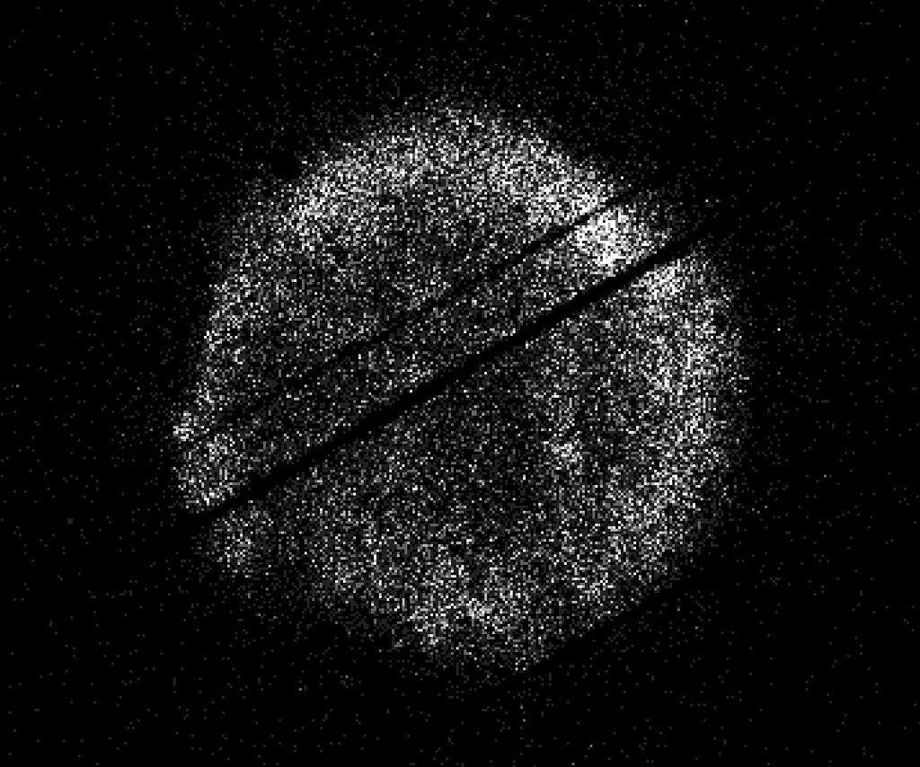
图6 NASA’s Swift Restarts Science Observations
Highlights

［原图未能获取：https://assets.science.nasa.gov/dynamicimage/assets/science/psd/ares/iss049e035512~orig.jpg?w=1024］

［原图未能获取：https://assets.science.nasa.gov/dynamicimage/assets/science/esd/eo/images/iotd/2026/earthset-from-th］

［原图未能获取：https://www.nasa.gov/wp-content/uploads/2026/06/art002e024603orig.jpg?w=1024］
Highlights

［原图未能获取：https://assets.science.nasa.gov/dynamicimage/assets/science/esd/eo/images/iotd/2026/the-forested-flo］

［原图未能获取：https://assets.science.nasa.gov/dynamicimage/assets/science/esd/eo/images/iotd/2026/rare,-widespread］

［原图未能获取：https://www.nasa.gov/wp-content/uploads/2026/08/0202795orig.jpg?w=1024］
Highlights
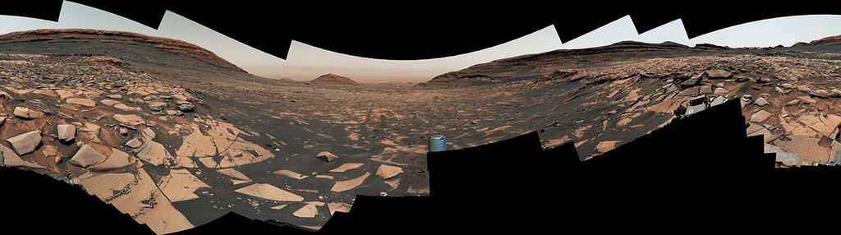
图13 Curiosity Reaches 1-Kilometer Elevation Gain

［原图未能获取：https://www.nasa.gov/wp-content/uploads/2026/08/jsc2026e406812.jpg?w=1024］

［原图未能获取：https://science.nasa.gov/wp-content/uploads/2026/08/shield-heliosphere-shrinking-screenshot.png］
Featured

［原图未能获取：https://science.nasa.gov/wp-content/uploads/2026/08/roman-new.jpg］

［原图未能获取：https://assets.science.nasa.gov/dynamicimage/assets/science/missions/pandora/news/2026/Pandora_Artis］

［原图未能获取：https://assets.science.nasa.gov/dynamicimage/assets/science/missions/chandra/2026/galaxies_ngc4631.j］
Highlights

［原图未能获取：https://assets.science.nasa.gov/dynamicimage/assets/science/cds/soma/apsmex26/APSMEX25-image.jpg?w=1］

［原图未能获取：https://science.nasa.gov/wp-content/uploads/2026/03/stockcake-planetary-alignment-art-1265316-standa］

［原图未能获取：https://assets.science.nasa.gov/dynamicimage/assets/science/esd/eo/images/iotd/2026/a-changing-world］
Highlights

［原图未能获取：https://www.nasa.gov/wp-content/uploads/2026/08/jsc2026e406812.jpg?w=1024］

［原图未能获取：https://www.nasa.gov/wp-content/uploads/2026/08/uli-round-9-awards.jpg?w=1024］

［原图未能获取：https://www.nasa.gov/wp-content/uploads/2026/08/2027-gbs-email-header-cc.png?w=1024］
Highlights

［原图未能获取：https://www.nasa.gov/wp-content/uploads/2026/08/1-pia26777-d2026-0824-rl0031661-pano-med.jpg?w=1024］

［原图未能获取：https://assets.science.nasa.gov/dynamicimage/assets/science/cds/svs/a030000/a031300/a031302/high-alt］

［原图未能获取：https://www.nasa.gov/wp-content/uploads/2023/09/copernicus-gtoc.png?w=1024］
Featured

［原图未能获取：https://www.nasa.gov/wp-content/uploads/2023/02/nancy-grace-roman-space-telescope-visualization.jpeg］
Featured

［原图未能获取：https://www.nasa.gov/wp-content/uploads/2026/08/ksc-20260821-ph-ser01-0003large.jpg?w=767］

［原图未能获取：https://www.nasa.gov/wp-content/uploads/2026/08/congressional-space-medal-of-honor-ceremony-1.jpg?w=］
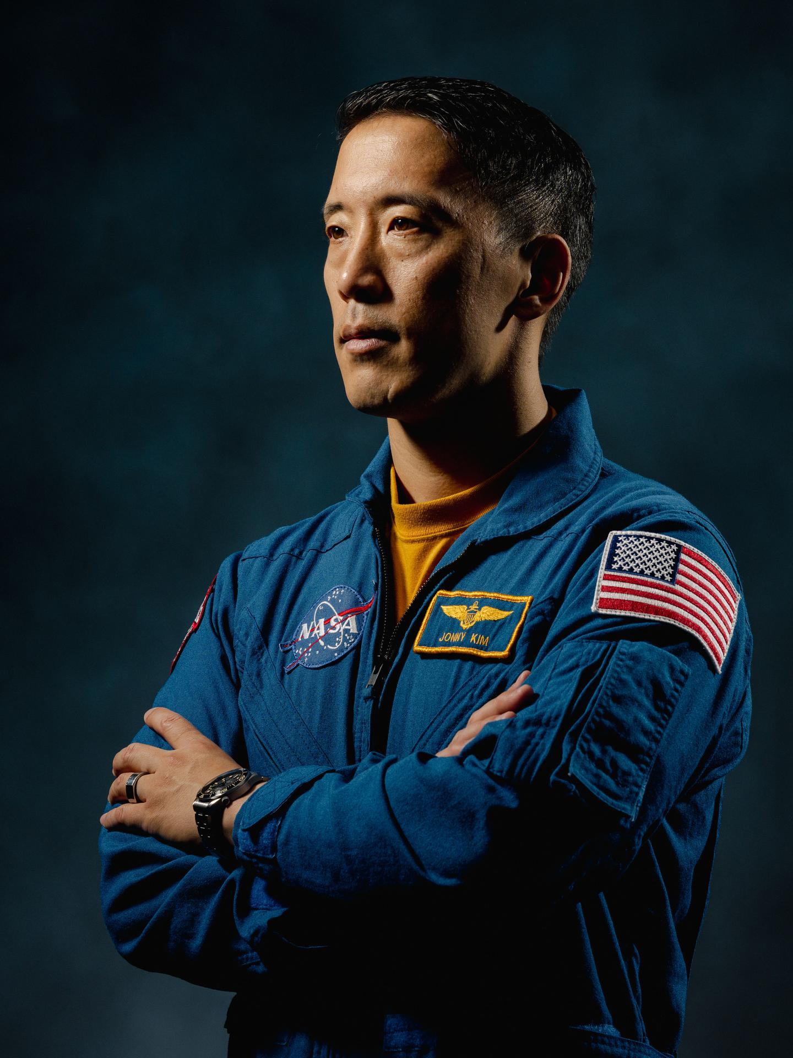
图31 NASA Astronaut Jonny Kim Departs Agency to Continue Military Service
Highlights

［原图未能获取：https://www.nasa.gov/wp-content/uploads/2026/03/a2crew-7ff19d.jpg?w=1024］

［原图未能获取：https://www.nasa.gov/wp-content/uploads/2026/03/suit-patch.jpg?w=1024］
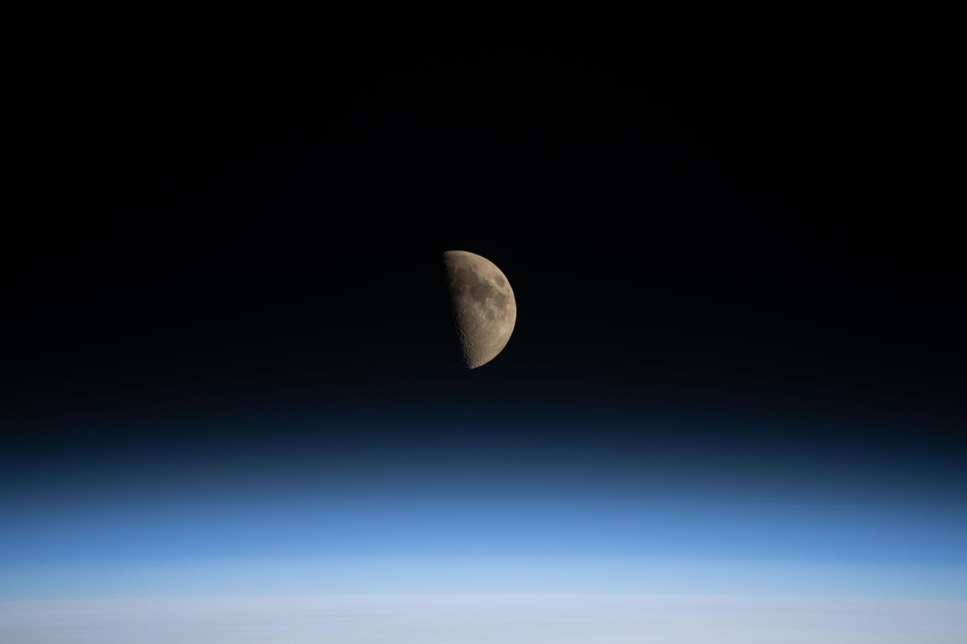
图34 La NASA refuerza Artemis: añade una misión y perfecciona su arquitectura general
Jessica Taveau Aug 28, 2026 RELEASE26-070
NASA Headquarters
Johnson Space Center

［原图未能获取：https://www.nasa.gov/wp-content/uploads/2026/08/congressional-space-medal-of-honor-ceremony-1.jpg?w=］
President Donald J. Trump awarded NASA astronauts Reid Wiseman, Victor Glover, and Christina Koch, and CSA (Canadian Space Agency) astronaut Jeremy Hansen with the Congressional Space Medal of Honor on Aug. 28, 2026, at NASA’s Johnson Space Center in Houston.
Credit: NASA President Donald J. Trump awarded NASA astronauts Reid Wiseman, Victor Glover, and Christina Koch, and CSA (Canadian Space Agency) astronaut Jeremy Hansen with the Congressional Space Medal of Honor Friday for their service during the Artemis II mission. He presented the awards during a ceremony at NASA’s Johnson Space Center in Houston, honoring the first medal recipients since 2023.
NASA’s historic Artemis II mission launched on April 1, and splashed down safely in the Pacific Ocean on April 10. The crew members were the first astronauts to launch on the agency’s SLS (Space Launch System) rocket, flying aboard NASA’s Orion spacecraft, which the crew named Integrity. During their record-setting mission, the astronauts traveled 252,756 miles from Earth, farther than any humans have traveled before, surpassing a previous record set by Apollo 13 astronauts in 1970. In total, they flew 695,081 miles, including a lunar flyby.
“We gather on these historic grounds to celebrate the immense courage of four intrepid space heroes whose sense of daring and adventure led them further from Earth than anyone has ever traveled ever before,” said President Trump. “Today we’re proudly awarding the Congressional Space Medal of Honor to the remarkable crew of Artemis II. These astronauts did not do it alone. I want to salute all of the engineers, and scientists, launch and landing specialists, everyone at NASA who helped make this mission a great success.”
The Congressional Space Medal of Honor was authorized by Congress in 1969 to recognize an astronaut who in the performance of duties has distinguished himself or herself by exceptionally brave and meritorious efforts, and contributions to the welfare of the nation and humanity. There now are 34 recipients of the award since the beginning of the space program, including the crews of Apollo 1, Challenger, and Columbia who received the award posthumously.
“President Trump’s leadership has put America back on a path to lead the world in space, from creating the Artemis program to giving NASA the resources and mandate to win this new space race,” said NASA Administrator Jared Isaacman. “The Artemis II crew answered that call with extraordinary skill and courage, showing the world the Moon again and what American leadership and exploration look like at their best. Their achievement was made possible by the exceptional NASA workforce, alongside our industry and international partners, who showed once again what can be accomplished when we commit to big, bold endeavors. We will build on this success as we return to the lunar surface and establish an enduring presence on the Moon.”
The first crewed mission under NASA’s Artemis program paved the way for the 2027 Artemis III test flight in low Earth orbit to demonstrate rendezvous and docking capabilities between Orion and commercial human landing systems, and the Artemis IV mission in 2028, which will return American astronauts to the lunar surface.
“It was the honor of my lifetime to fly on Integrity around the Moon with Victor, Christina, and Jeremy. Having President Trump here at the agency’s Johnson Space Center to honor NASA and my crew underscores the significance of what our teams accomplished,” said Wiseman, who served as commander of the mission. “I can’t wait to see my friends continue this legacy on Artemis III.”
Glover served as pilot of the Orion spacecraft.
“Piloting Orion for the first time in space was a profound honor, made possible because of the years of hard work, dedication, and expertise by countless individuals dedicating their time and talents to the mission,” said Glover. “We share this recognition with the thousands of people who launched us around the Moon and brought us safely back to Earth.”
Koch served as a mission specialist.
“The response to our mission here on Earth was beyond anything we ever imagined and all we ever hoped for. We are grateful every time we hear from people who followed along with our journey. As team members on this shared mission, we accept this award to honor those who made it happen, from factory floors to clean rooms and mission control rooms,” said Koch.
Hansen also served as a mission specialist.
“It is a privilege to receive the Congressional Space Medal of Honor alongside my Artemis II crewmates,” said Hansen. “I share this recognition with the dedicated teams in Canada, the United States, and our international partners who made the mission possible. Artemis II showed what we can accomplish for humanity when we set ambitious goals and work together. For Canada, the mission and the Artemis program as a whole are about much more than just going back to the Moon. It is about the pursuit of excellence and collaboration.”
As part of a Golden Age of innovation and exploration, NASA will send Artemis astronauts on a series of challenging missions to explore more of the Moon and establish a Moon Base on the lunar surface for long-term exploration. These missions will set the stage for sending the first astronauts — Americans — to Mars. Learn more:
https://www.nasa.gov/artemis
-end- Bethany Stevens / Cheryl Warner Headquarters, Washington 202-358-1600 bethany.c.stevens@nasa.gov / cheryl.m.warner@nasa.gov Brandi Dean / Chelsey Ballarte Johnson Space Center, Houston 281-483-5111 brandi.k.dean@nasa.gov / chelsey.n.ballarte@nasa.gov
Share

Details
Last Updated Aug 28, 2026 Editor Jessica Taveau Location NASA Headquarters
Related Terms
Humans in Space
Was this page helpful?
Δ Was this page helpful?
Yes No × Notifications

