编号 | B003-022
机构 | NASA（NASA - News Releases）
类型/日期 | official ｜ 2026-08-29
英文原题 | President Trump Signs Executive Order to Create US Space Academy
原文链接 | https://www.nasa.gov/news-release/president-trump-signs-executive-order-to-create-us-space-academy/
简报期次 | B003（2026-08-29 归档）
本库文件 | B003-022-Nasa - news releases -president-trump-signs-executive-order-to-create-202608.md

President Trump Signs Executive Order to Create US Space Academy
Search
Suggested Searches
Climate Change
Artemis
Expedition 64
Mars perseverance
SpaceX Crew-2
International Space Station
View All Topics A-Z
Home
Missions
Humans in Space
Earth
The Solar System
The Universe
Science
Aeronautics
Technology
Learning Resources
About NASA
Español
News & Events
Multimedia
NASA+
Featured

［原图未能获取：https://www.nasa.gov/wp-content/uploads/2026/08/ksc-20260821-ph-ser01-0003large.jpg?w=767］

［原图未能获取：https://www.nasa.gov/wp-content/uploads/2026/08/congressional-space-medal-of-honor-ceremony-1.jpg?w=］

［原图未能获取：https://www.nasa.gov/wp-content/uploads/2026/08/eo-1.png?w=1024］
Back
Missions
Search All NASA Missions
A to Z List of Missions
Upcoming Launches and Landings
Spaceships and Rockets
Communicating with Missions
Artemis
James Webb Space Telescope
Hubble Space Telescope
International Space Station
OSIRIS-Rex
Humans in Space
Why Go to Space
Astronauts
Commercial Space
Destinations
Spaceships and Rockets
Living in Space
Earth
Explore Earth Science
Climate Change
Earth, Our Planet
Earth Science in Action
Earth Multimedia
Earth Data
Earth Science Researchers
The Solar System
The Sun
Mercury
Venus
Earth
The Moon
Mars
Jupiter
Saturn
Uranus
Neptune
Pluto & Dwarf Planets
Asteroids, Comets & Meteors
The Kuiper Belt
The Oort Cloud
Skywatching
The Universe
Exoplanets
The Search for Life in the Universe
Stars
Galaxies
Black Holes
The Big Bang
Dark Energy
Dark Matter
Science
Earth Science
Planetary Science
Astrophysics & Space Science
The Sun & Heliophysics
Biological & Physical Sciences
Lunar Science
Citizen Science
Astromaterials
Aeronautics Research
Human Space Travel Research
Aeronautics
Science in the Air
NASA Aircraft
Flight Research Innovation
Supersonic Flight
Air Traffic Solutions
Green Aviation Tech
Drones & You
Technology
Technology Transfer & Spinoffs
Space Travel
Living in Space
Lunar Surface Technology
Manufacturing and Materials
Robotics
Science Instruments
Computing
Learning Resources
For Kids and Students
For Educators
For Colleges and Universities
For Professionals
Science for Everyone
Requests for Exhibits, Artifacts, Speakers & Flyovers
STEM Engagement at NASA
About NASA
NASA's Impacts
Centers and Facilities
Directorates
Organizations
People of NASA
Careers
Internships
Our History
Doing Business with NASA
Get Involved
Contact
NASA en Español
Ciencia
Aeronáutica
Ciencias Terrestres
Sistema Solar
Universo
News & Events
News Releases
Recently Published
Video Series on NASA+
Podcasts & Audio
Blogs
Newsletters
Social Media
Media Resources
Events
Upcoming Launches & Landings
Virtual Guest Program
Multimedia
NASA+
Images
NASA Live
NASA Apps
Podcasts
Image of the Day
e-Books
3D Resources
Interactives
STEM Multimedia
NASA Brand & Usage Guidelines
Featured

［原图未能获取：https://www.nasa.gov/wp-content/uploads/2026/08/ksc-20260821-ph-ser01-0003large.jpg?w=767］

［原图未能获取：https://www.nasa.gov/wp-content/uploads/2026/08/congressional-space-medal-of-honor-ceremony-1.jpg?w=］
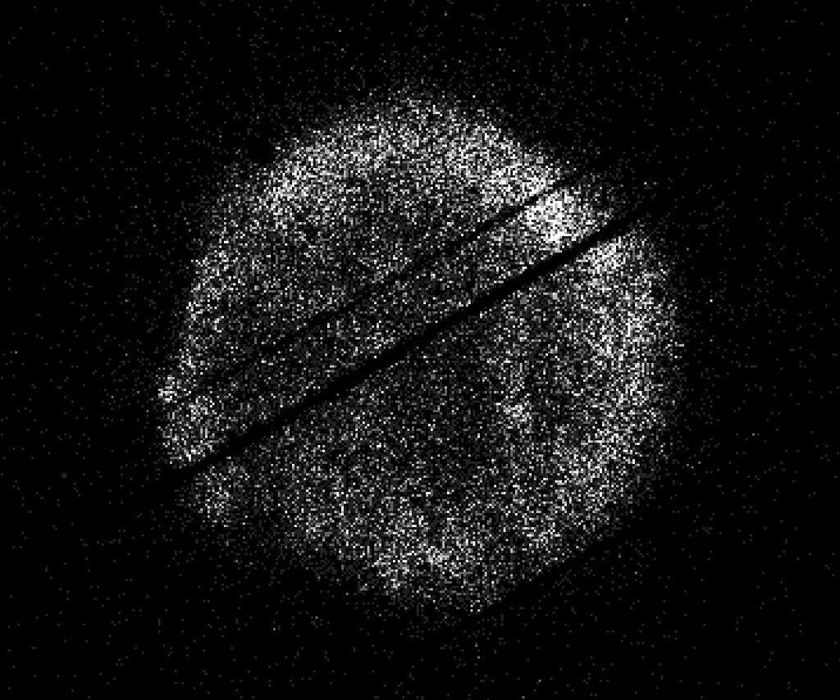
图6 NASA’s Swift Restarts Science Observations
Highlights

［原图未能获取：https://assets.science.nasa.gov/dynamicimage/assets/science/psd/ares/iss049e035512~orig.jpg?w=1024］

［原图未能获取：https://assets.science.nasa.gov/dynamicimage/assets/science/esd/eo/images/iotd/2026/earthset-from-th］

［原图未能获取：https://www.nasa.gov/wp-content/uploads/2026/06/art002e024603orig.jpg?w=1024］
Highlights

［原图未能获取：https://assets.science.nasa.gov/dynamicimage/assets/science/esd/eo/images/iotd/2026/the-forested-flo］

［原图未能获取：https://assets.science.nasa.gov/dynamicimage/assets/science/esd/eo/images/iotd/2026/rare,-widespread］

［原图未能获取：https://www.nasa.gov/wp-content/uploads/2026/08/0202795orig.jpg?w=1024］
Highlights
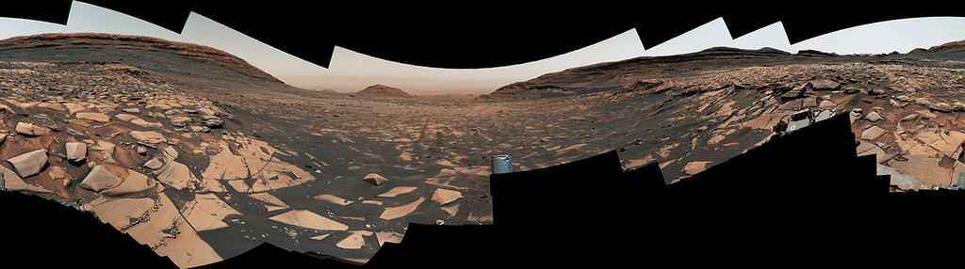
图13 Curiosity Reaches 1-Kilometer Elevation Gain

［原图未能获取：https://www.nasa.gov/wp-content/uploads/2026/08/jsc2026e406812.jpg?w=1024］

［原图未能获取：https://science.nasa.gov/wp-content/uploads/2026/08/shield-heliosphere-shrinking-screenshot.png］
Featured

［原图未能获取：https://science.nasa.gov/wp-content/uploads/2026/08/roman-new.jpg］

［原图未能获取：https://assets.science.nasa.gov/dynamicimage/assets/science/missions/pandora/news/2026/Pandora_Artis］

［原图未能获取：https://assets.science.nasa.gov/dynamicimage/assets/science/missions/chandra/2026/galaxies_ngc4631.j］
Highlights

［原图未能获取：https://assets.science.nasa.gov/dynamicimage/assets/science/cds/soma/apsmex26/APSMEX25-image.jpg?w=1］

［原图未能获取：https://science.nasa.gov/wp-content/uploads/2026/03/stockcake-planetary-alignment-art-1265316-standa］

［原图未能获取：https://assets.science.nasa.gov/dynamicimage/assets/science/esd/eo/images/iotd/2026/a-changing-world］
Highlights

［原图未能获取：https://www.nasa.gov/wp-content/uploads/2026/08/jsc2026e406812.jpg?w=1024］

［原图未能获取：https://www.nasa.gov/wp-content/uploads/2026/08/uli-round-9-awards.jpg?w=1024］

［原图未能获取：https://www.nasa.gov/wp-content/uploads/2026/08/2027-gbs-email-header-cc.png?w=1024］
Highlights

［原图未能获取：https://www.nasa.gov/wp-content/uploads/2026/08/1-pia26777-d2026-0824-rl0031661-pano-med.jpg?w=1024］

［原图未能获取：https://assets.science.nasa.gov/dynamicimage/assets/science/cds/svs/a030000/a031300/a031302/high-alt］

［原图未能获取：https://www.nasa.gov/wp-content/uploads/2023/09/copernicus-gtoc.png?w=1024］
Featured

［原图未能获取：https://www.nasa.gov/wp-content/uploads/2023/02/nancy-grace-roman-space-telescope-visualization.jpeg］
Featured

［原图未能获取：https://www.nasa.gov/wp-content/uploads/2026/08/ksc-20260821-ph-ser01-0003large.jpg?w=767］

［原图未能获取：https://www.nasa.gov/wp-content/uploads/2026/08/congressional-space-medal-of-honor-ceremony-1.jpg?w=］
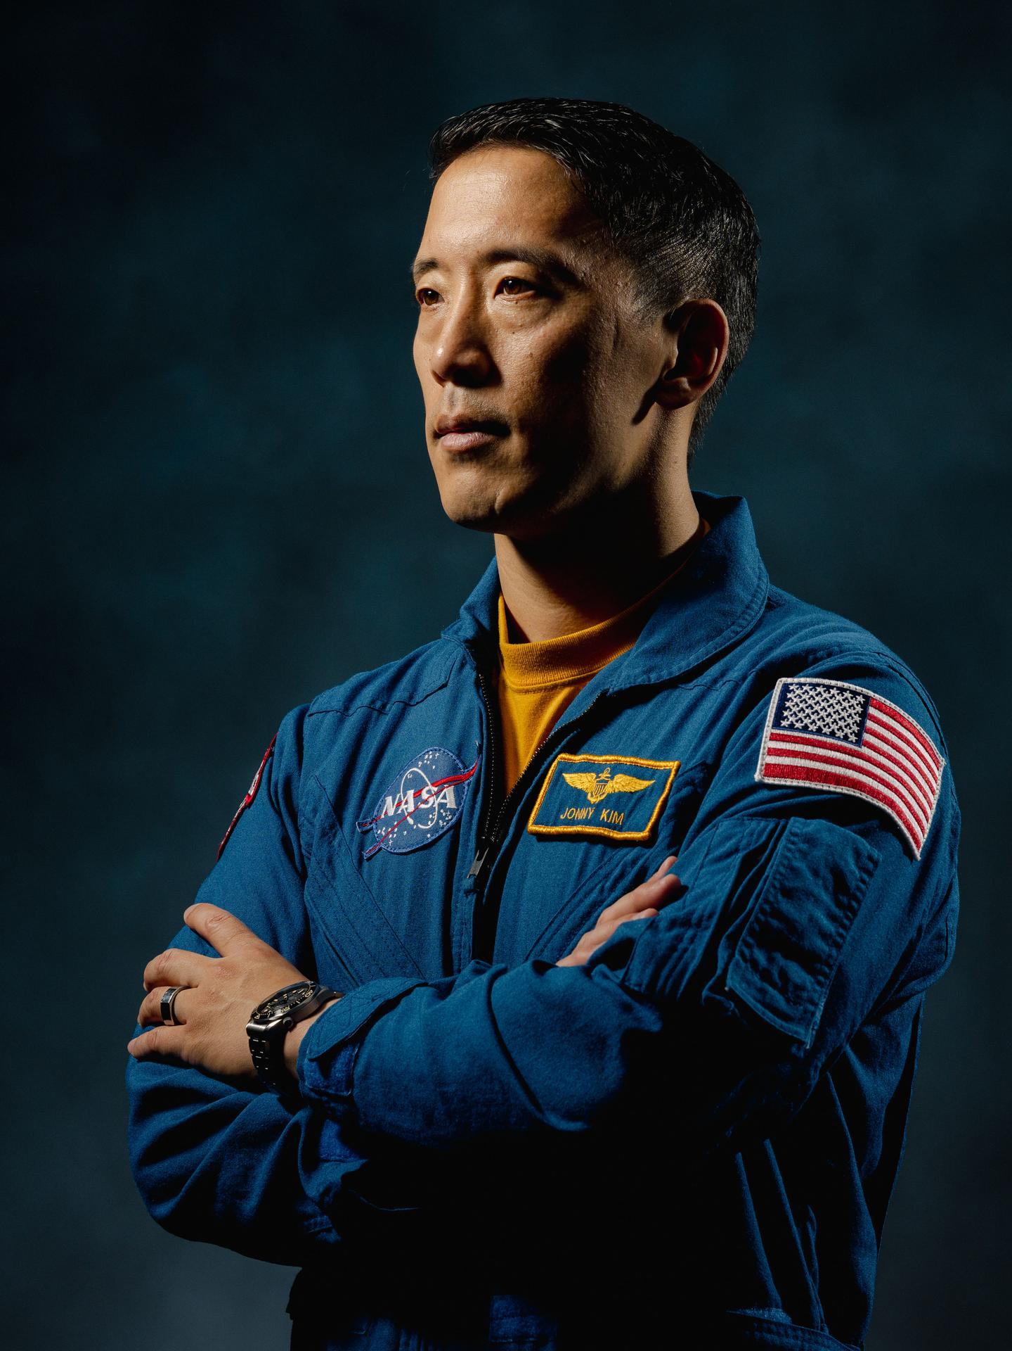
图31 NASA Astronaut Jonny Kim Departs Agency to Continue Military Service
Highlights

［原图未能获取：https://www.nasa.gov/wp-content/uploads/2026/03/a2crew-7ff19d.jpg?w=1024］

［原图未能获取：https://www.nasa.gov/wp-content/uploads/2026/03/suit-patch.jpg?w=1024］
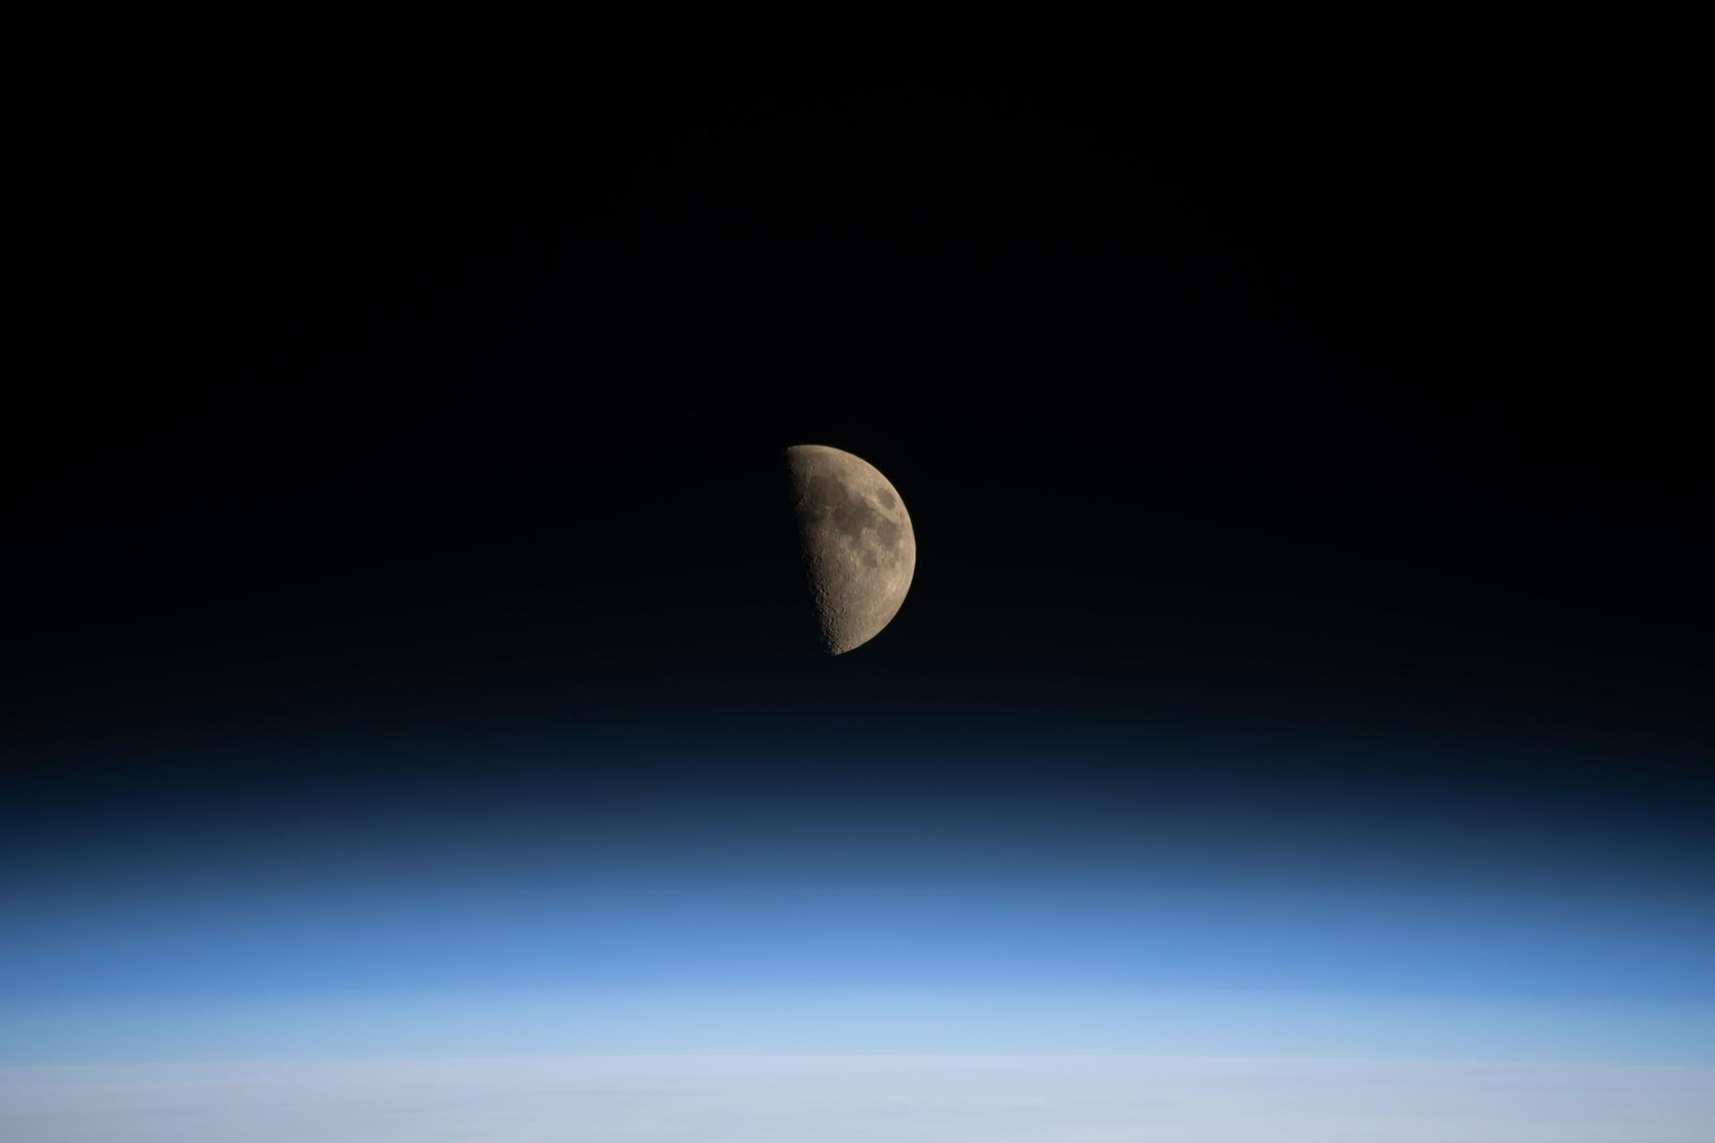
图34 La NASA refuerza Artemis: añade una misión y perfecciona su arquitectura general
Jessica Taveau Aug 28, 2026 RELEASE26-069
NASA Headquarters

［原图未能获取：https://www.nasa.gov/wp-content/uploads/2026/08/eo-1.png?w=1320］
President Donald J. Trump signed an Executive Order on Aug. 28, 2026, to establish the nation’s first U.S. Space Academy at NASA’s Johnson Space Center in Houston.
Credit: NASA To strengthen the nation’s space workforce and develop the next generation of space leaders, President Donald J. Trump signed an Executive Order on Friday to establish the nation’s first U.S. Space Academy.
The order highlights how space is a critical domain for American national security, economic growth, scientific discovery, and technological innovation. The proposed academy would focus technical education with leadership development, discipline, and a commitment to public service, helping ultimately advance U.S. interests in space.
“Given the rapid growth of the U.S. Space Force and commercial space industry, and the expansion of our ambitions to the Moon and far beyond the Moon, it’s clear we will need to educate and train an entire generation of skilled service members, engineers, and civil operators,” said President Trump. “That’s why I will sign an Executive Order to begin the process of creating a new a national academy called the U.S. Space Academy.”
The order also calls on NASA Administrator Jared Isaacman to serve as the chair of a new Presidential Commission on the United States Space Academy, and NASA Deputy Administrator Matt Anderson to serve as the executive director. They will work with vice chairs — Assistant to the President for Science and Technology, Michael Kratsios, and Assistant to the President for Economic Policy, Kevin Hassett — and other representatives from the White House and the interagency on the commission.
“President Trump’s vision for a new academy is a transformational step to educate the engineers, scientists, technicians, operators and even the astronauts who will be necessary for the inspiring future we are pursuing in space. In the years ahead, we will return NASA astronauts to the lunar surface, build the Moon Base, get underway on nuclear power, ignite the orbital economy and launch more missions of science and discovery,” said Isaacman. “I have no doubt that so much of the future talent that will graduate and contribute to these exciting endeavors will be educated at the United States Space Academy.”
A report from the commission to the President is due within 120 days of the signing with recommendations on governance framework, service obligations for graduates, physical location of the academy, legislative requirements, and more.
The signing of “Establishing the United States Space Academy Executive Order,” took place at NASA’s Johnson Space Center in Houston where the President also presented the Artemis II crew members with the Congressional Space Medal of Honor.
The Executive Order is the latest from President Trump that demonstrates his commitment to maintaining U.S. leadership in space and advancing NASA’s Golden Age exploration and innovation. In December 2025, he signed the Ensuring American Space Superiority, and recently, a new National Space Transportation Policy memorandum on Aug. 20.
Read the full Executive Order on The White House website:
https://www.whitehouse.gov/presidential-actions/2026/08/establishing-the-united-states-space-academy
-end- Bethany Stevens / Cheryl Warner Headquarters, Washington 202-358-1600 bethany.c.stevens@nasa.gov / cheryl.m.warner@nasa.gov
Share

Details
Last Updated Aug 28, 2026 Editor Jennifer M. Dooren Location NASA Headquarters
Related Terms
NASA Headquarters
Was this page helpful?
Δ Was this page helpful?
Yes No × Notifications

