编号 | B004-010
机构 | NASA（NASA - News Releases）
类型/日期 | official ｜ 2026-08-29
英文原题 | NASA’s Artemis II Crew Receives Congressional Space Medal of Honor
原文链接 | https://www.nasa.gov/image-article/nasas-artemis-ii-crew-receives-congressional-space-medal-of-honor/
简报期次 | B004（2026-08-29 归档）
本库文件 | B004-010-Nasa - news releases -nasas-artemis-ii-crew-receives-congressional-spa-202608.md

NASA’s Artemis II Crew Receives Congressional Space Medal of Honor
Search
Suggested Searches
Climate Change
Artemis
Expedition 64
Mars perseverance
SpaceX Crew-2
International Space Station
View All Topics A-Z
Home
Missions
Humans in Space
Earth
The Solar System
The Universe
Science
Aeronautics
Technology
Learning Resources
About NASA
Español
News & Events
Multimedia
NASA+
Featured

［原图未能获取：https://www.nasa.gov/wp-content/uploads/2026/08/ksc-20260821-ph-ser01-0003large.jpg?w=767］

［原图未能获取：https://www.nasa.gov/wp-content/uploads/2026/08/congressional-space-medal-of-honor-ceremony-1.jpg?w=］

［原图未能获取：https://www.nasa.gov/wp-content/uploads/2026/08/eo-1.png?w=1024］
Back
Missions
Search All NASA Missions
A to Z List of Missions
Upcoming Launches and Landings
Spaceships and Rockets
Communicating with Missions
Artemis
James Webb Space Telescope
Hubble Space Telescope
International Space Station
OSIRIS-Rex
Humans in Space
Why Go to Space
Astronauts
Commercial Space
Destinations
Spaceships and Rockets
Living in Space
Earth
Explore Earth Science
Climate Change
Earth, Our Planet
Earth Science in Action
Earth Multimedia
Earth Data
Earth Science Researchers
The Solar System
The Sun
Mercury
Venus
Earth
The Moon
Mars
Jupiter
Saturn
Uranus
Neptune
Pluto & Dwarf Planets
Asteroids, Comets & Meteors
The Kuiper Belt
The Oort Cloud
Skywatching
The Universe
Exoplanets
The Search for Life in the Universe
Stars
Galaxies
Black Holes
The Big Bang
Dark Energy
Dark Matter
Science
Earth Science
Planetary Science
Astrophysics & Space Science
The Sun & Heliophysics
Biological & Physical Sciences
Lunar Science
Citizen Science
Astromaterials
Aeronautics Research
Human Space Travel Research
Aeronautics
Science in the Air
NASA Aircraft
Flight Research Innovation
Supersonic Flight
Air Traffic Solutions
Green Aviation Tech
Drones & You
Technology
Technology Transfer & Spinoffs
Space Travel
Living in Space
Lunar Surface Technology
Manufacturing and Materials
Robotics
Science Instruments
Computing
Learning Resources
For Kids and Students
For Educators
For Colleges and Universities
For Professionals
Science for Everyone
Requests for Exhibits, Artifacts, Speakers & Flyovers
STEM Engagement at NASA
About NASA
NASA's Impacts
Centers and Facilities
Directorates
Organizations
People of NASA
Careers
Internships
Our History
Doing Business with NASA
Get Involved
Contact
NASA en Español
Ciencia
Aeronáutica
Ciencias Terrestres
Sistema Solar
Universo
News & Events
News Releases
Recently Published
Video Series on NASA+
Podcasts & Audio
Blogs
Newsletters
Social Media
Media Resources
Events
Upcoming Launches & Landings
Virtual Guest Program
Multimedia
NASA+
Images
NASA Live
NASA Apps
Podcasts
Image of the Day
e-Books
3D Resources
Interactives
STEM Multimedia
NASA Brand & Usage Guidelines
Featured

［原图未能获取：https://www.nasa.gov/wp-content/uploads/2026/08/ksc-20260821-ph-ser01-0003large.jpg?w=767］

［原图未能获取：https://www.nasa.gov/wp-content/uploads/2026/08/congressional-space-medal-of-honor-ceremony-1.jpg?w=］
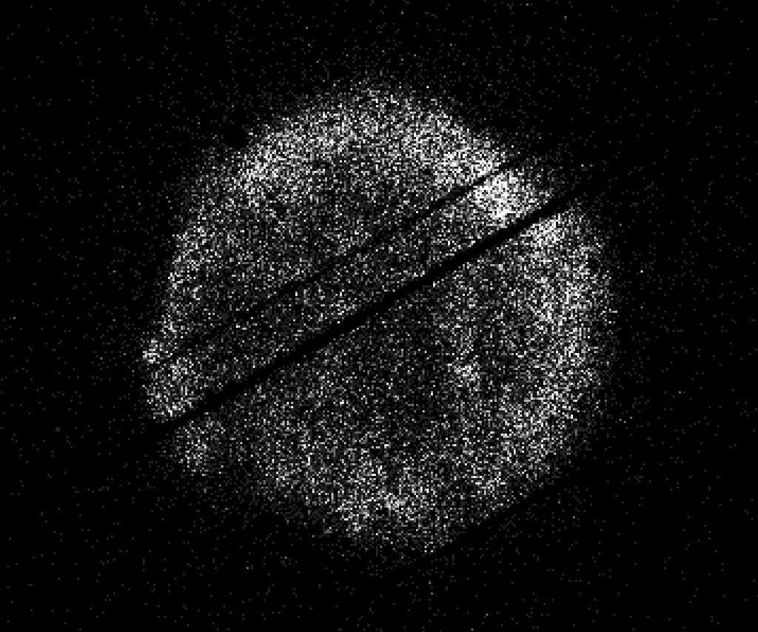
图6 NASA’s Swift Restarts Science Observations
Highlights

［原图未能获取：https://assets.science.nasa.gov/dynamicimage/assets/science/psd/ares/iss049e035512~orig.jpg?w=1024］

［原图未能获取：https://assets.science.nasa.gov/dynamicimage/assets/science/esd/eo/images/iotd/2026/earthset-from-th］

［原图未能获取：https://www.nasa.gov/wp-content/uploads/2026/06/art002e024603orig.jpg?w=1024］
Highlights

［原图未能获取：https://assets.science.nasa.gov/dynamicimage/assets/science/esd/eo/images/iotd/2026/the-forested-flo］

［原图未能获取：https://assets.science.nasa.gov/dynamicimage/assets/science/esd/eo/images/iotd/2026/rare,-widespread］

［原图未能获取：https://www.nasa.gov/wp-content/uploads/2026/08/0202795orig.jpg?w=1024］
Highlights
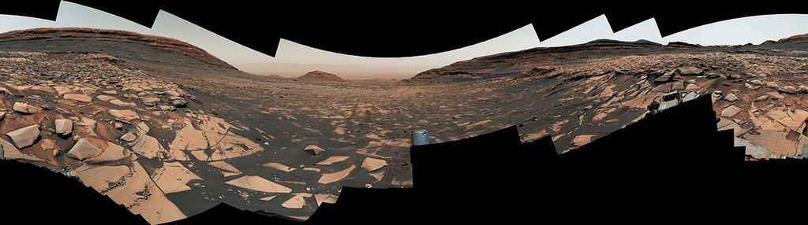
图13 Curiosity Reaches 1-Kilometer Elevation Gain

［原图未能获取：https://www.nasa.gov/wp-content/uploads/2026/08/jsc2026e406812.jpg?w=1024］

［原图未能获取：https://science.nasa.gov/wp-content/uploads/2026/08/shield-heliosphere-shrinking-screenshot.png］
Featured

［原图未能获取：https://science.nasa.gov/wp-content/uploads/2026/08/roman-new.jpg］

［原图未能获取：https://assets.science.nasa.gov/dynamicimage/assets/science/missions/pandora/news/2026/Pandora_Artis］

［原图未能获取：https://assets.science.nasa.gov/dynamicimage/assets/science/missions/chandra/2026/galaxies_ngc4631.j］
Highlights

［原图未能获取：https://assets.science.nasa.gov/dynamicimage/assets/science/cds/soma/apsmex26/APSMEX25-image.jpg?w=1］

［原图未能获取：https://science.nasa.gov/wp-content/uploads/2026/03/stockcake-planetary-alignment-art-1265316-standa］

［原图未能获取：https://assets.science.nasa.gov/dynamicimage/assets/science/esd/eo/images/iotd/2026/a-changing-world］
Highlights

［原图未能获取：https://www.nasa.gov/wp-content/uploads/2026/08/jsc2026e406812.jpg?w=1024］

［原图未能获取：https://www.nasa.gov/wp-content/uploads/2026/08/uli-round-9-awards.jpg?w=1024］

［原图未能获取：https://www.nasa.gov/wp-content/uploads/2026/08/2027-gbs-email-header-cc.png?w=1024］
Highlights

［原图未能获取：https://www.nasa.gov/wp-content/uploads/2026/08/1-pia26777-d2026-0824-rl0031661-pano-med.jpg?w=1024］

［原图未能获取：https://assets.science.nasa.gov/dynamicimage/assets/science/cds/svs/a030000/a031300/a031302/high-alt］

［原图未能获取：https://www.nasa.gov/wp-content/uploads/2023/09/copernicus-gtoc.png?w=1024］
Featured

［原图未能获取：https://www.nasa.gov/wp-content/uploads/2023/02/nancy-grace-roman-space-telescope-visualization.jpeg］
Featured

［原图未能获取：https://www.nasa.gov/wp-content/uploads/2026/08/ksc-20260821-ph-ser01-0003large.jpg?w=767］

［原图未能获取：https://www.nasa.gov/wp-content/uploads/2026/08/congressional-space-medal-of-honor-ceremony-1.jpg?w=］
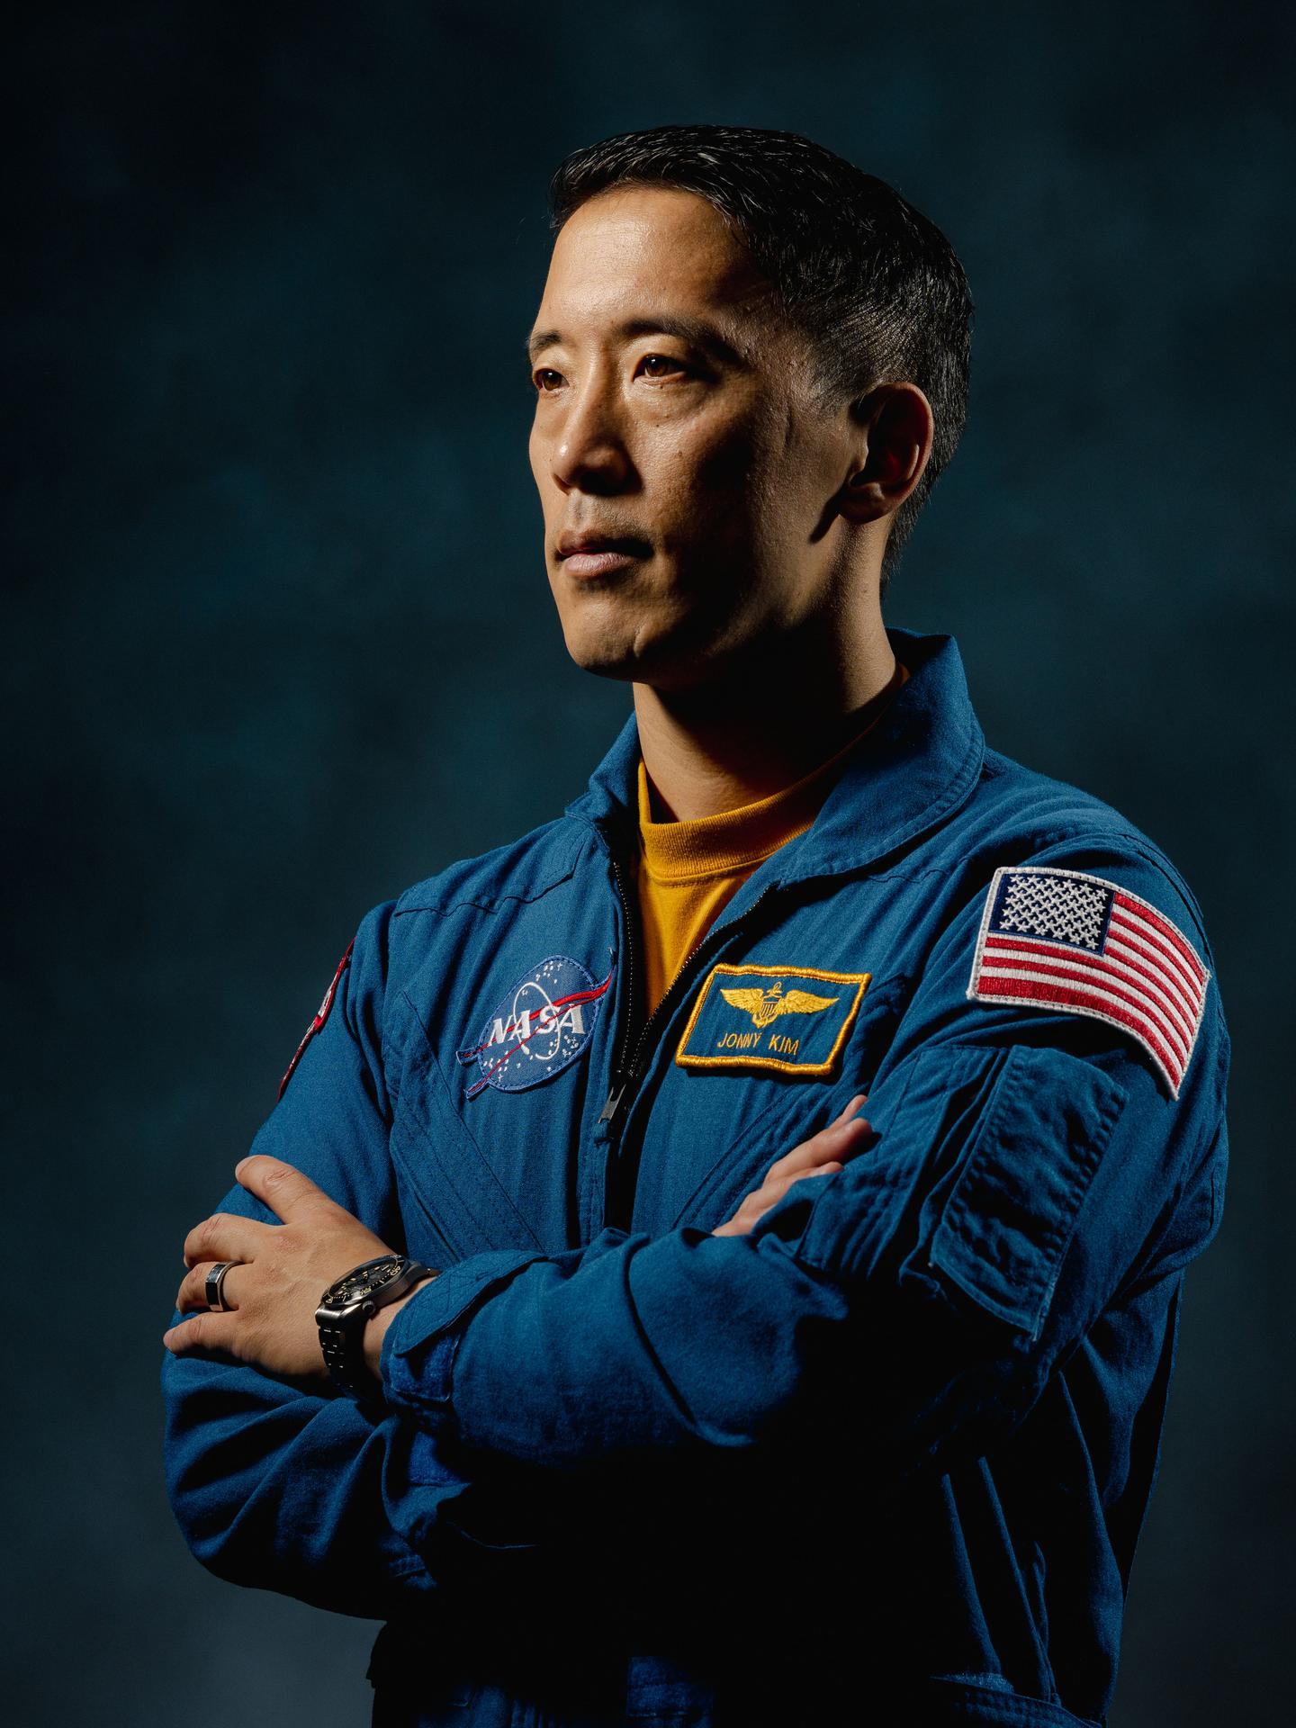
图31 NASA Astronaut Jonny Kim Departs Agency to Continue Military Service
Highlights

［原图未能获取：https://www.nasa.gov/wp-content/uploads/2026/03/a2crew-7ff19d.jpg?w=1024］

［原图未能获取：https://www.nasa.gov/wp-content/uploads/2026/03/suit-patch.jpg?w=1024］
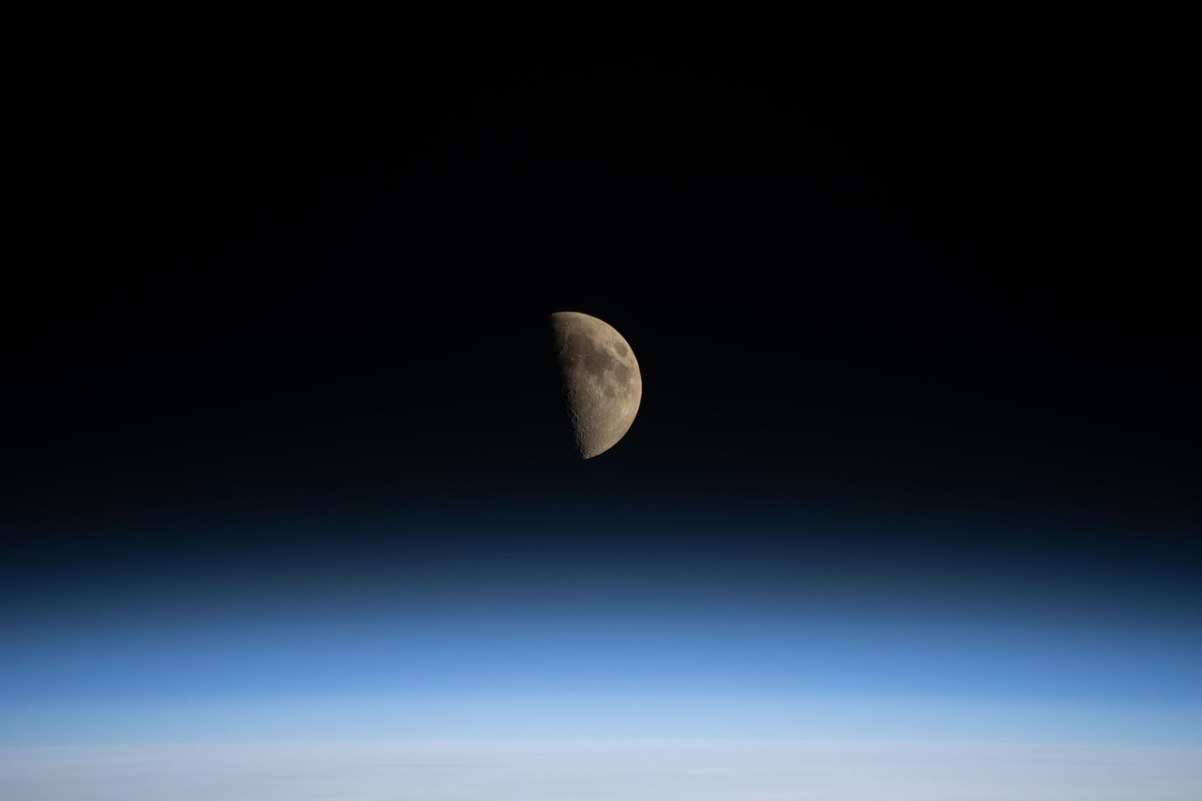
图34 La NASA refuerza Artemis: añade una misión y perfecciona su arquitectura general
HQ Web Team Aug 28, 2026 Image Article

［原图未能获取：https://www.nasa.gov/wp-content/uploads/2026/08/20260828-120552-jk1-3999-1.jpg?w=2048］
President Donald J. Trump awarded NASA astronauts Victor Glover and Christina Koch, CSA (Canadian Space Agency) astronaut Jeremy Hansen, and NASA astronaut Reid Wiseman with the Congressional Space Medal of Honor on Aug. 28, 2026, at NASA’s Johnson Space Center in Houston.
NASA/John Kraus From left to right: NASA astronauts Victor Glover and Christina Koch, CSA (Canadian Space Agency) astronaut Jeremy Hansen, and NASA astronaut Reid Wiseman receive the Congressional Space Medal of Honor from President Donald J. Trump on Aug. 28, 2026, for their service during the Artemis II mission.
The Congressional Space Medal of Honor was authorized by Congress in 1969 to recognize an astronaut who in the performance of duties has distinguished himself or herself by exceptionally brave and meritorious efforts, and contributions to the welfare of the nation and humanity. There now are 34 recipients of the award since the beginning of the space program, including the crews of Apollo 1, Challenger, and Columbia who received the award posthumously.
Image credit: NASA/John Kraus
Was this page helpful?
Δ Was this page helpful?
Yes No × Notifications

