编号 | B005-004
机构 | CEPR（CEPR - Discussion Papers）
类型/日期 | news_science ｜ 2026-08-29
英文原题 | DP21888 When the Middle Class Undermines Progress: The Political Economy of AI Regulation
原文链接 | https://cepr.org/publications/dp21888
简报期次 | B005（2026-08-30 归档）
本库文件 | B005-004-Cepr - discussion papers -dp21888-when-the-middle-class-undermines-progres-202608.md

DP21888 When the Middle Class Undermines Progress: The Political Economy of AI Regulation
Search the site Search English Français Deutsch Italiano 中文 More The classic literature argues that a large middle class is a prerequisite for economic development. Is this true when AI progress threatens to disrupt the labor market? On the one hand, uncertainty about the consequences can impede the passage of AI-friendly regulation: voters fear the prospect of losing when the uncertainty is resolved. On the other, granular information about reform consequences may reduce political support as well. In our model, a larger middle class hampers reform, compensatory redistribution is most politically effective when its welfare justification is weakest, and AI regulatory sandboxes encounter resistance because new information undermines reform coalitions.
Translation created by Artificial Intelligence (LLM)
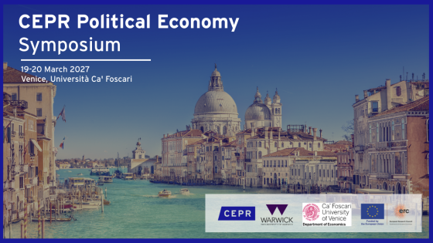
Conference The Political Economy Programme Meeting
CEPR Political Economy Symposium 2027
19 Mar 2027 - 20 Mar 2027 in Venice, Italy
Political Economy
Closes 14 Sep 2026 at 08:00

图2 Paris Symposium 2024 image
Conference CEPR Paris Symposium
CEPR Paris Symposium 2026
3 Dec 2026 - 8 Dec 2026 in Paris, France
Ageing and Longevity
Artificial Intelligence
Competition Policy
European Economic Policy
European Financial Architecture
Fintech and Digital Currencies
Geoeconomics and Security
Growth, Innovation and Social Model in Europe
Household Finance
Media Plurality
Political Economy of Migration
Preventing Conflict: Policies for Peace
Asset Pricing
Banking and Corporate Finance
Climate Change and the Environment
Development Economics
Economic History
Industrial Organization
International Macroeconomics and Finance
International Trade and Regional Economics
Labour Economics
Macroeconomics and Growth
Monetary Economics and Fluctuations
Organizational Economics
Political Economy
Public Economics
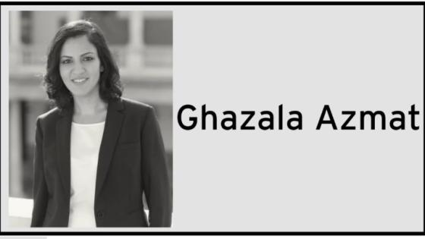
图3 Ghazala Azmat
Conference
Ghazala Azmat Award 2026
3 Dec 2026 - 8 Dec 2026 in Paris, France
Inequality and the Role of Firms
Organizational Economics
Labour Economics
Public Economics
Political Economy
Closes 31 Aug 2026 at 00:00
Español Ελληνικά 日本語 Português Türkçe

