编号 | B005-005
机构 | Nikkei（Nikkei Asia - Tech）
类型/日期 | news_science ｜ 2026-08-30
英文原题 | AI robots and drones to assist in Fukushima nuclear plant cleanup
原文链接 | https://asia.nikkei.com/business/technology/artificial-intelligence/ai-robots-and-drones-to-assist-in-fukushima-nuclear-plant-cleanup
简报期次 | B005（2026-08-30 归档）
本库文件 | B005-005-Nikkei asia - tech -ai-robots-and-drones-to-assist-in-fukushima-nucl-202608.md

AI robots and drones to assist in Fukushima nuclear plant cleanup
Artificial intelligence

［原图未能获取：https://images.ft.com/v3/image/raw/https%3A%2F%2Fcms-image-bucket-productionv3-ap-northeast-1-a7d2.s］
Three reactors at the Fukushima Daiichi nuclear plant contain 880 tons of debris. (Photo by Akitoshi Sugiura)
MASATOSHI IDA August 30, 2026 06:07 JST Listen English (Original)
TOKYO -- AI robots and drones will assist in the removal of radioactive debris from the Fukushima Daiichi nuclear plant, with the Japanese government and Tokyo Electric Power Co. Holdings expected to launch a consortium addressing those plans as soon as this fiscal year.
Read Next

［原图未能获取：https://images.ft.com/v3/image/raw/https%3A%2F%2Fcms-image-bucket-productionv3-ap-northeast-1-a7d2.s］
Environment Fukushima plant's treated water stores fall just 7% despite sea releases
Energy TEPCO resumes commercial operations at world's largest nuclear plant

［原图未能获取：https://images.ft.com/v3/image/raw/https%3A%2F%2Fcms-image-bucket-productionv3-ap-northeast-1-a7d2.s］
Big in Asia Japan's nuclear power revival triggers Fukushima foreboding

图4 Japan's nuclear power revival triggers Fukushima foreboding
Technology Japan left behind by US and China in AI era patent race

［原图未能获取：https://images.ft.com/v3/image/raw/https%3A%2F%2Fcms-image-bucket-productionv3-ap-northeast-1-a7d2.s］
Artificial intelligence Hyundai bets on physical AI to evolve beyond automobiles

［原图未能获取：https://images.ft.com/v3/image/raw/https%3A%2F%2Fcms-image-bucket-productionv3-ap-northeast-1-a7d2.s］
Artificial intelligence Japanese university startups develop AI robot arms for delicate tasks
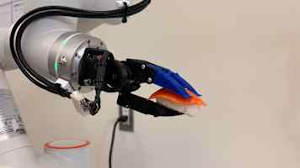
图7 Japanese university startups develop AI robot arms for delicate tasks
Artificial intelligence Japan eyes AI-powered comeback in factory robot race with China, Europe
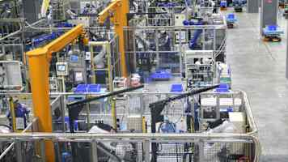
图8 Japan eyes AI-powered comeback in factory robot race with China, Europe
Latest on Artificial intelligence
Artificial intelligence Japan's top banks regain access to Anthropic's Mythos AI after US freeze

［原图未能获取：https://images.ft.com/v3/image/raw/https%3A%2F%2Fcms-image-bucket-productionv3-ap-northeast-1-a7d2.s］
Artificial intelligence SK Hynix starts construction of first HBM chip packaging plant in US

［原图未能获取：https://images.ft.com/v3/image/raw/https%3A%2F%2Fcms-image-bucket-productionv3-ap-northeast-1-a7d2.s］
Artificial intelligence Komatsu to triple size of US maintenance hub amid AI copper rush

［原图未能获取：https://images.ft.com/v3/image/raw/https%3A%2F%2Fcms-image-bucket-productionv3-ap-northeast-1-a7d2.s］
Sponsored Content
About Sponsored ContentThis content was commissioned by Nikkei's Global Business Bureau.

