编号 | B006-005
机构 | Hoover（Hoover Institution - China Program）
类型/日期 | think_tank ｜ 2026-08-30
英文原题 | Articles On: Global South, Trade, Taiwan, Military Ties, Chinese Investment, and U.S.-China Relations
原文链接 | https://cms.hoover.org/research/articles-global-south-trade-taiwan-military-ties-chinese-investment-and-us-china-relations
简报期次 | B006（2026-08-31 归档）
本库文件 | B006-005-Hoover institution - china program -a-hrefhttpscmshooverorgresearcharticles-global-s-202608.md

Articles On: Global South, Trade, Taiwan, Military Ties, Chinese Investment, and U.S.-China Relations
Articles The section describes how the Chinese Communist Party employs its foreign infrastructure and development program to further its strategic interests abroad and in international institutions.
Sunday, August 30, 2026 1 min read

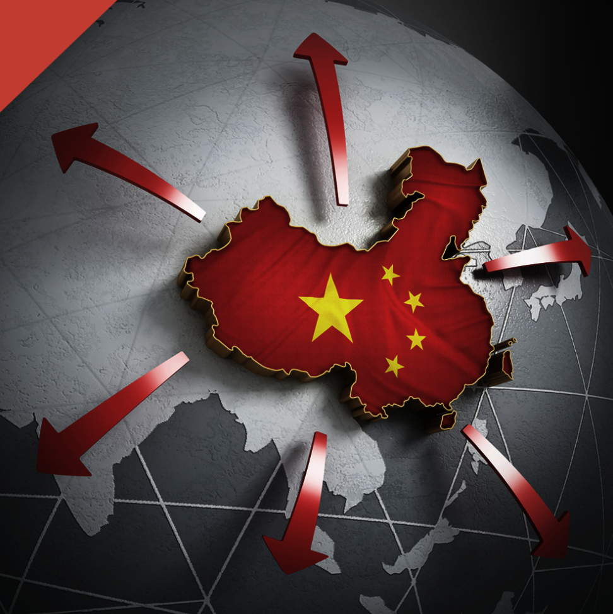
图1 csgp beltroad image

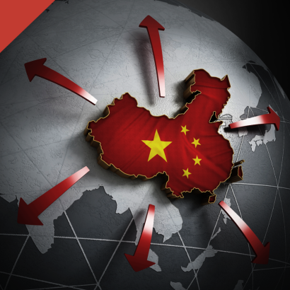
图2 csgp beltroad image
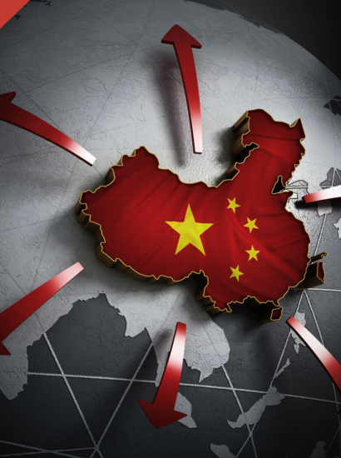
图3 csgp beltroad image
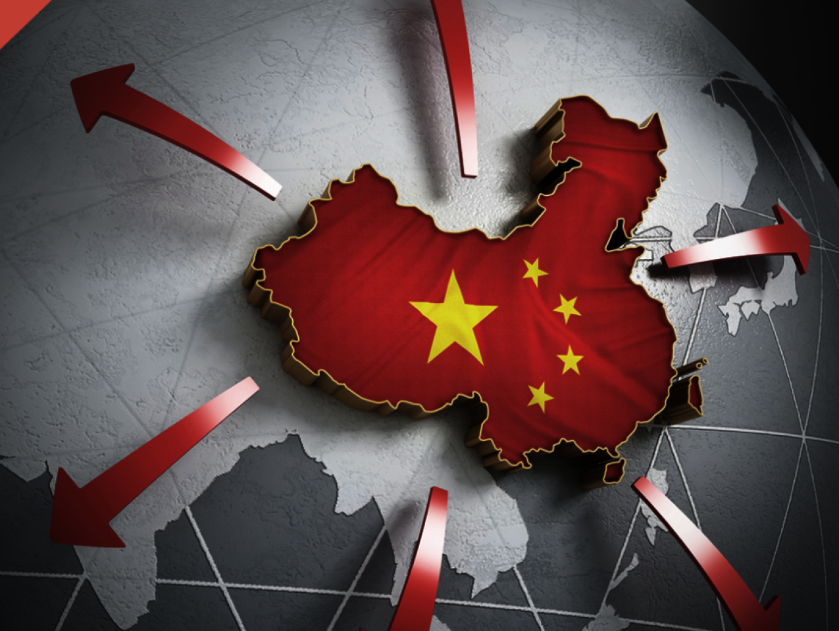
图4 csgp beltroad image
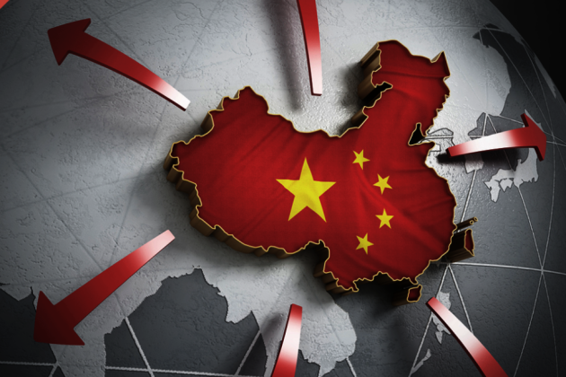
图5 csgp beltroad image
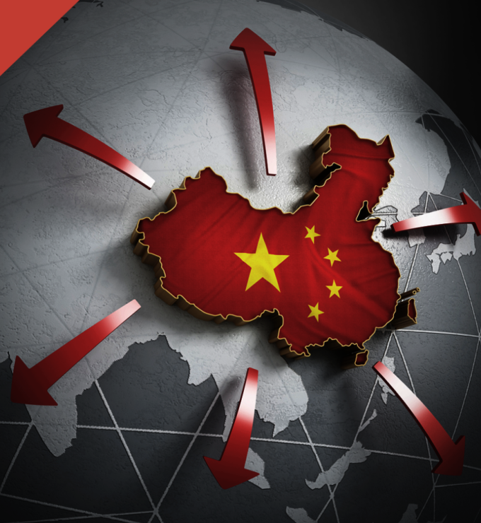
图6 csgp beltroad image
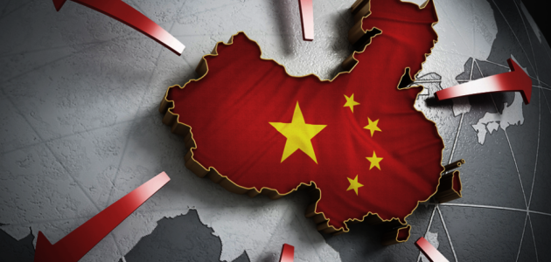
图7 csgp beltroad image
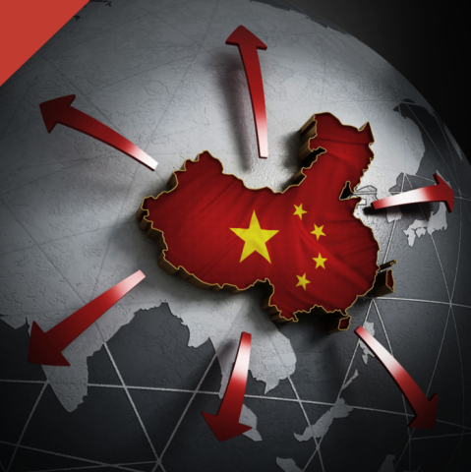
图8 csgp beltroad image
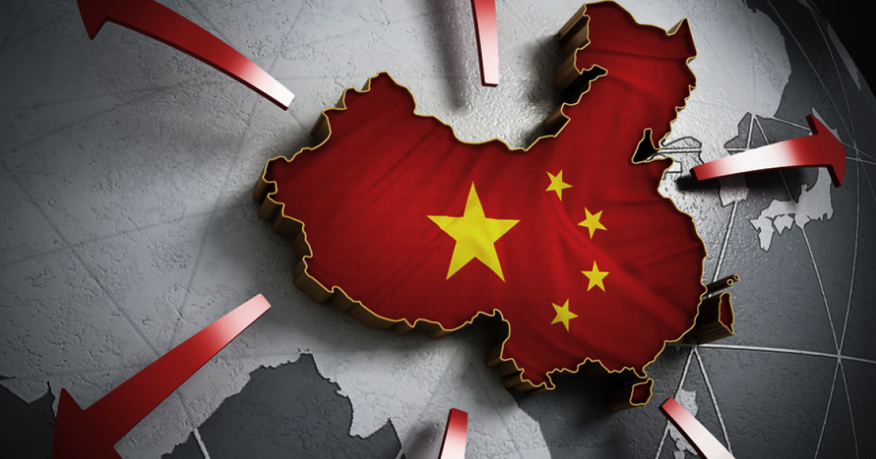
图9 csgp beltroad image
China's Global Sharp Power Weekly Alert
2026 Issue 32
Honduras industrial chief calls for resumption of trade ties with Taiwan via Taiwan News on August 25, 2026 Brazil presidential debate zeroes in on Chinese investment and US tariffs via South China Morning Post on August 24, 2026 China, Indonesia agree to boost military ties, work closer on minerals, energy and tech by Stanley Widianto via Reuters on August 21, 2026 US-China proxy battle at the canal turns into a $3.5bn nightmare for Panama via BNE IntelliNews on August 25, 2026 A Top Trump Ally Turns to China by Catherine Osborn via Foreign Policy on August 21, 2026 The Global South: the 21st century’s great utopia via Engelsberg Ideas on August 21, 2026 Ecuador Courts Chinese Money While Teaming Up with US Military by Stephan Kueffner via Bloomberg on August 19, 2026
# COMMENTS POLICY
While the Hoover Institution welcomes comments from readers, we exercise the right to monitor the comments we receive. We will delete comments that include obscenities, swear-words and vulgarisms; ad hominem attacks; racist expression; rudeness or discourtesy; violations of copyright; or any other transgression of taste or civility that the editors deem unpublishable on a Hoover Institution Web site. The editors recommend that commenters use their real names when posting. If commenters post under a screen name, we reserve the right to delete the comment. We reserve the right, also, to close down comments on a particular essay if the editors believe we have reached "saturation" point.

图10 footer

［原图未能获取：https://cms.hoover.org/research/articles-global-south-trade-taiwan-military-ties-chinese-investment-］
Copy link ✓ 感谢分享 Find any service AddToAny
更多…

