编号 | B006-006
机构 | ChathamHouse（Chatham House - What's New）
类型/日期 | news_science ｜ 2026-08-27
英文原题 | What the Burnham government should do in its foreign policy The new government must avoid its predecessors’ habit of trying to do everything. Priorities should include advancing the UK–EU reset talks, defending the Euro-Atlantic area, and working with the EU to address Chinese economic competition.
原文链接 | https://www.chathamhouse.org/2026/08/what-burnham-government-should-do-its-foreign-policy
简报期次 | B006（2026-08-31 归档）
本库文件 | B006-006-Chatham house - what's new -what-the-burnham-government-should-do-in-its-for-202608.md

What the Burnham government should do in its foreign policy The new government must avoid its predecessors’ habit of trying to do everything. Priorities should include advancing the UK–EU reset talks, defending the Euro-Atlantic area, and working with the EU to address Chinese economic competition.
[ Explore policy in a shifting geopolitical order. alert
What the Burnham government should do in its foreign policy
Policy paper Published 27 August 2026 ISBN: 978 1 78413 690 1 Image — The UK’s prime minister, Andy Burnham, shakes hands with the Ukrainian president, Volodymyr Zelenskyy, at a naval base in Portsmouth, UK, 27 July 2026. Copyright © Simon Jones-WPA Pool/Getty Images.
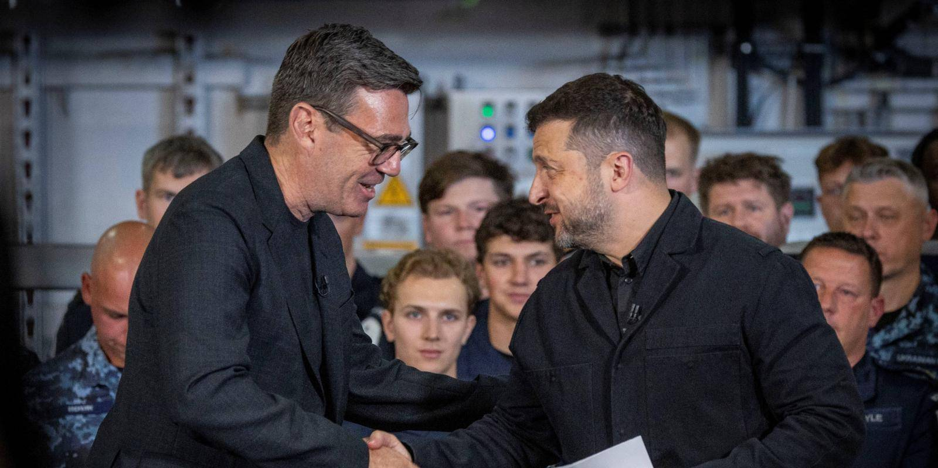
图1 Photo of Andy Burnham meeting Volodymyr Zelenskyy, 27 July 2026
View more authors This paper sets out a proposed foreign policy agenda for the government of Andy Burnham, the UK’s new prime minister. Given the extent to which the UK’s fiscal and military resources are stretched, the government must identify a relatively narrow set of priorities and stick to them. These priorities should be confined, we argue, to national security, the economy and boosting the UK’s global influence.
On Europe, a first task is to complete several nearly concluded technical agreements with the EU. But there is also scope to deepen the defence and security relationship, and to coordinate policy responses regarding the Chinese competitive threat to European industries. In dealing with an unpredictable US, the UK should maintain cordial cooperation but be prepared to diverge with US positions that clash with UK interests or values.
Boosting cooperation among ‘middle powers’ should be a focus of the UK’s G20 presidency next year. On defence, there is an urgent need for the government to clarify how it plans to finance raising core spending to 3.5 per cent of GDP by 2035.
DOI: 10.55317/9781784136901
Summary
What the Burnham government should do in its foreign policy
Hide contents
Summary
What the Burnham government should do in its foreign policy

［原图未能获取：https://www.chathamhouse.org/themes/custom/numiko/dist/img/spinner.gif］
Summary
Andy Burnham’s new government faces the same dilemmas as its predecessor in responding with limited resources to a volatile world. Foreign policy should be derived from clear national goals and interests, which now are security , the economy and strengthening the UK’s g****lobal position.
The UK must depart from the practice of trying to do too much. The priority now is to prioritize.
The government should acknowledge the limitations of being a mid-sized power and use this to the UK’s advantage. US–China rivalry injects new value into Britain’s role as a ‘strategic middle power’ making common cause with countries seeking a path between the demands of the superpowers. Advancing this agenda – including combating climate change and promoting governance of AI and digital services – should be a pre-eminent UK foreign policy goal; it should inform the hosting of next year’s G20.
Europe has prime claim on the government’s energies because of its importance to the UK for economy and defence. By the end of 2026, the UK government should aim to complete its ‘agreements to agree’ with the EU on food and animal products trade, emissions trading and youth experience. Defence collaboration should be pursued as a goal in its own right, not as a bargaining chip for negotiating better trading terms.
Burnham’s influence with the EU will be stronger if his top team reaches an early decision on whether the next Labour Party manifesto will commit the UK to Next chapter

