编号 | B006-010
机构 | Lawfare（Lawfare - Cybersecurity & Tech）
类型/日期 | think_tank ｜ 2026-08-28
英文原题 | Scaling Laws: Is Meta's Oversight Board a Model for AI Governance?
原文链接 | https://www.lawfaremedia.org/article/scaling-laws--is-meta's-oversight-board-a-model-for-ai-governance
简报期次 | B006（2026-08-31 归档）
本库文件 | B006-010-Lawfare - cybersecurity & tech -scaling-laws-is-metas-oversight-board-a-model-fo-202608.md

Scaling Laws: Is Meta's Oversight Board a Model for AI Governance?
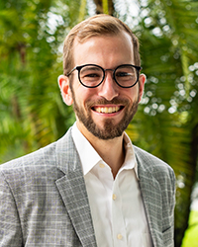
图1 Kevin Frazier
Kevin Frazier
@kevintfrazier
kevintfrazier.bsky.social
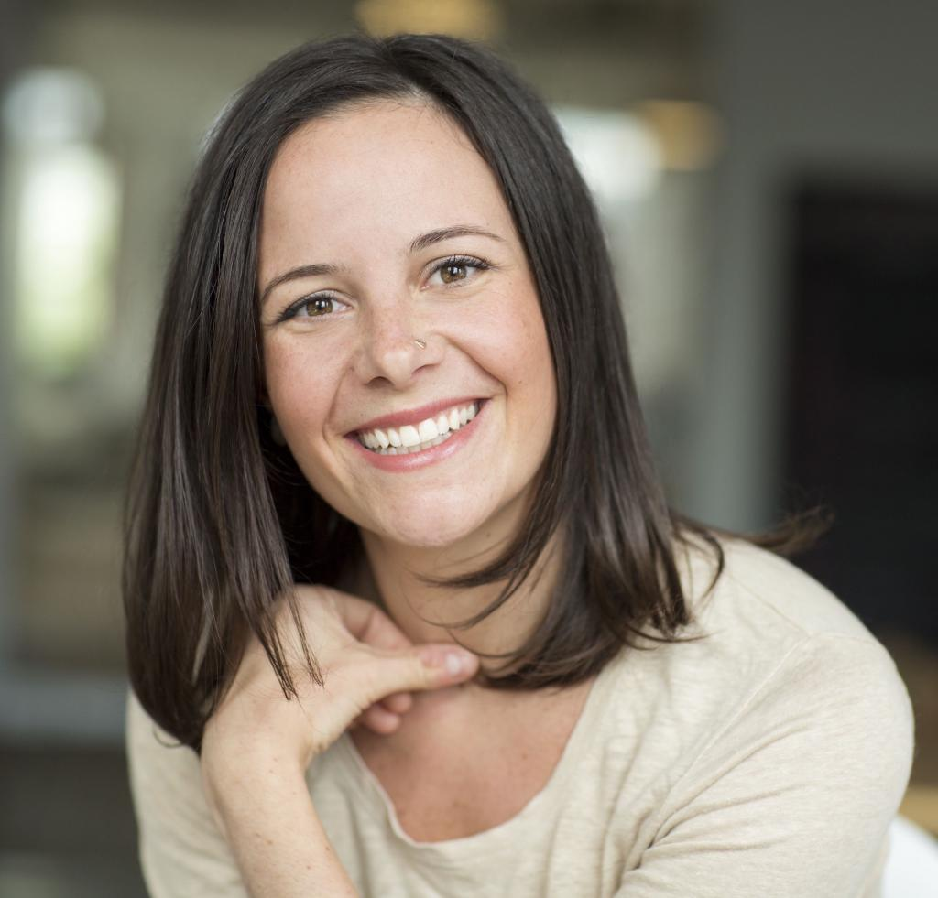
图2 Kate Klonick
Kate Klonick

图3 Kenji Yoshino
Kenji Yoshino
Meet The Authors
Kenji Yoshino, Chief Justice Earl Warren Professor of Constitutional Law at New York University School of Law and a member of Meta’s Oversight Board, with fellow Board member Ronaldo Lemos arguing that meaningful AI oversight should feature independent and representative overseers, external standards, and transparent, reasoned decisions.
The trio tests that proposal against some of the hardest questions raised by the Oversight Board’s own experience. Can a selective, precedent-setting institution provide meaningful oversight at AI scale? What gives a privately created board legitimacy to constrain decisions with global consequences? What powers would an AI oversight body actually need? And when does private oversight complement democratic regulation—and when might it merely give corporate power a new source of legitimacy?
Find Scaling Laws on the Lawfare website, and to never miss an episode.
To receive ad-free podcasts, become a Lawfare Material Supporter at www.patreon.com/lawfare. You can also support Lawfare by making a one-time donation at https://givebutter.com/lawfare-institute.
Click the button below to view a transcript of this podcast. Please note that the transcript was auto-generated and may contain errors.
Transcript
[Intro]
Alan Rozenshtein: It's the Lawfare Podcast. I'm Alan Rozenshtein, associate professor of law at the University of Minnesota and a senior editor and research director at Lawfare. Today, we're bringing you something a little different, an episode from our new podcast series, Scaling Laws. It's a creation of Lawfare and the University of Texas School of Law, where we're tackling the most important AI and policy questions, from new legislation on Capitol Hill to the latest breakthroughs that are happening in the labs. We cut through the hype to get you up to speed on the rules, standards, and ideas shaping the future of this pivotal technology. If you enjoy this episode, you can find and Back to Top

图4 Kevin Frazier
Kevin FrazierKevin Frazier is a senior editor at Lawfare and the Director of the AI Innovation and Law Program at the University of Texas School of Law.

图5 Kate Klonick
Kate Klonick
Read More
Kate Klonick is an Associate Professor at St. John’s University Law School, a fellow at the Brookings Institution, Yale Law School’s Information Society Project, Harvard Berkman Klein Center and a Distinguished Scholar at the Institute for Humane Studies. Her writing on online speech, freedom of expression, and private internet platform governance has appeared in the Harvard Law Review, Yale Law Journal, The New Yorker, the New York Times, The Atlantic, the Washington Post and numerous other publications. For the 2023-2024 academic year, she was a Fulbright Schuman Innovation Scholar in the European Union where she was a Visiting Professor at SciencesPo and University of Amsterdam researching and writing about the Digital Services Act and Digital Markets Act.

图6 Kenji Yoshino
Kenji Yoshino
Read More
Kenji Yoshino is the Chief Justice Earl Warren Professor of Constitutional Law at New York University School of Law and a member of Meta’s Oversight Board.
}
More Articles
［原图未能获取：https://www.lawfaremedia.org/article/scaling-laws--is-meta's-oversight-board-a-model-for-ai-governan］
Invisible Source Skew
Kate Klonick Renée DiResta
Aug 28, 2026 Our information flows aren’t just threatened by slop or foreign actors. They're being reshaped by invisible decisions from AI companies.
［原图未能获取：https://www.lawfaremedia.org/article/scaling-laws--is-meta's-oversight-board-a-model-for-ai-governan］
U.K. Supreme Court Opens Door for Spyware Victims to Sue Foreign States
Siena Anstis Natalia Krapiva Kate Pundyk
Aug 28, 2026 The Kingdom of Bahrain cannot claim immunity from a suit by exiled dissidents over harm caused by spyware surveillance on U.K. soil.
［原图未能获取：https://www.lawfaremedia.org/article/scaling-laws--is-meta's-oversight-board-a-model-for-ai-governan］
Scaling Laws, Founders & Founders: Brandon Mitchell of WriteSea
Kevin Frazier Brandon Mitchell
Aug 28, 2026
Other Topics
［原图未能获取：https://www.lawfaremedia.org/ResourcePackages/Talon/assets/dist/images/right-arrow.png］
［原图未能获取：https://www.lawfaremedia.org/ResourcePackages/Talon/assets/dist/images/right-arrow.png］
［原图未能获取：https://www.lawfaremedia.org/ResourcePackages/Talon/assets/dist/images/right-arrow.png］
［原图未能获取：https://www.lawfaremedia.org/ResourcePackages/Talon/assets/dist/images/right-arrow.png］
［原图未能获取：https://www.lawfaremedia.org/ResourcePackages/Talon/assets/dist/images/right-arrow.png］
［原图未能获取：https://www.lawfaremedia.org/ResourcePackages/Talon/assets/dist/images/right-arrow.png］
［原图未能获取：https://www.lawfaremedia.org/ResourcePackages/Talon/assets/dist/images/right-arrow.png］
［原图未能获取：https://www.lawfaremedia.org/ResourcePackages/Talon/assets/dist/images/right-arrow.png］
［原图未能获取：https://www.lawfaremedia.org/ResourcePackages/Talon/assets/dist/images/right-arrow.png］
［原图未能获取：https://www.lawfaremedia.org/ResourcePackages/Talon/assets/dist/images/right-arrow.png］
［原图未能获取：https://www.lawfaremedia.org/ResourcePackages/Talon/assets/dist/images/right-arrow.png］
［原图未能获取：https://www.lawfaremedia.org/ResourcePackages/Talon/assets/dist/images/right-arrow.png］

