编号 | B006-023
机构 | NASA（NASA - News Releases）
类型/日期 | official ｜ 2026-08-30
英文原题 | Panorama Showcasing the 34-Meter Antennas of the DSN’s Goldstone Complex
原文链接 | https://science.nasa.gov/photojournal/panorama-showcasing-the-34-meter-antennas-of-the-dsns-goldstone-complex/
简报期次 | B006（2026-08-31 归档）
本库文件 | B006-023-Nasa - news releases -panorama-showcasing-the-34-meter-antennas-of-the-202608.md

Panorama Showcasing the 34-Meter Antennas of the DSN’s Goldstone Complex
Search
Suggested Searches
Climate Change
Artemis
Expedition 64
Mars perseverance
SpaceX Crew-2
International Space Station
View All Topics A-Z
Home
Missions
Humans in Space
Earth
The Solar System
The Universe
Science
Aeronautics
Technology
Learning Resources
About NASA
Español
News & Events
Multimedia
NASA+
Highlights

［原图未能获取：https://www.nasa.gov/wp-content/uploads/2026/08/ksc-20260821-ph-ser01-0003large.jpg?w=150&h=150&crop］

［原图未能获取：https://www.nasa.gov/wp-content/uploads/2026/08/congressional-space-medal-of-honor-ceremony-1.jpg?w=］

［原图未能获取：https://www.nasa.gov/wp-content/uploads/2026/08/eo-1.png?w=150&h=150&crop=1］
Back
Missions
Search All NASA Missions
A to Z List of Missions
Upcoming Launches and Landings
Spaceships and Rockets
Communicating with Missions
Artemis
James Webb Space Telescope
Hubble Space Telescope
International Space Station
OSIRIS-REx
Humans in Space
Why Go to Space
Astronauts
Commercial Space
Destinations
Spaceships and Rockets
Living in Space
Earth
Explore Earth Science
Climate Change
Earth, Our Planet
Earth Science in Action
Earth Multimedia
Earth Data
Earth Science Researchers
The Solar System
The Sun
Mercury
Venus
Earth
The Moon
Mars
Jupiter
Saturn
Uranus
Neptune
Pluto & Dwarf Planets
Asteroids, Comets & Meteors
The Kuiper Belt
The Oort Cloud
Skywatching
The Universe
Exoplanets
The Search for Life in the Universe
Stars
Galaxies
Black Holes
The Big Bang
Dark Matter
Dark Energy
Science
Earth Science
Planetary Science
Astrophysics & Space Science
The Sun & Heliophysics
Biological & Physical Sciences
Lunar Science
Citizen Science
Astromaterials
Aeronautics Research
Human Space Travel Research
Aeronautics
Science in the Air
NASA Aircraft
Flight Innovation
Supersonic Flight
Air Traffic Solutions
Green Aviation Tech
Drones & You
Technology
Technology Transfer & Spinoffs
Space Travel Technology
Technology Living in Space
Manufacturing and Materials
Robotics
Science Instruments
Computing
Learning Resources
For Kids and Students
For Educators
For Colleges and Universities
For Professionals
Science for Everyone
Requests for Exhibits, Artifacts, or Speakers
STEM Engagement at NASA
About NASA
NASA's Impacts
Centers and Facilities
Directorates
Organizations
People of NASA
Careers
Internships
Our History
Doing Business with NASA
Get Involved
Contact
NASA en Español
Ciencia
Aeronáutica
Ciencias Terrestres
Sistema Solar
Universo
News & Events
Recently Published
Video Series on NASA+
Podcasts & Audio
Blogs
Newsletters
Social Media
Media Resources
Multimedia
NASA+
Images
NASA Live
NASA Apps
Podcasts
Image of the Day
e-Books
3D Resources
Interactives
STEM Multimedia
NASA Brand & Usage Guidelines
Highlights

［原图未能获取：https://www.nasa.gov/wp-content/uploads/2026/08/ksc-20260821-ph-ser01-0003large.jpg?w=150&h=150&crop］

［原图未能获取：https://www.nasa.gov/wp-content/uploads/2026/08/congressional-space-medal-of-honor-ceremony-1.jpg?w=］
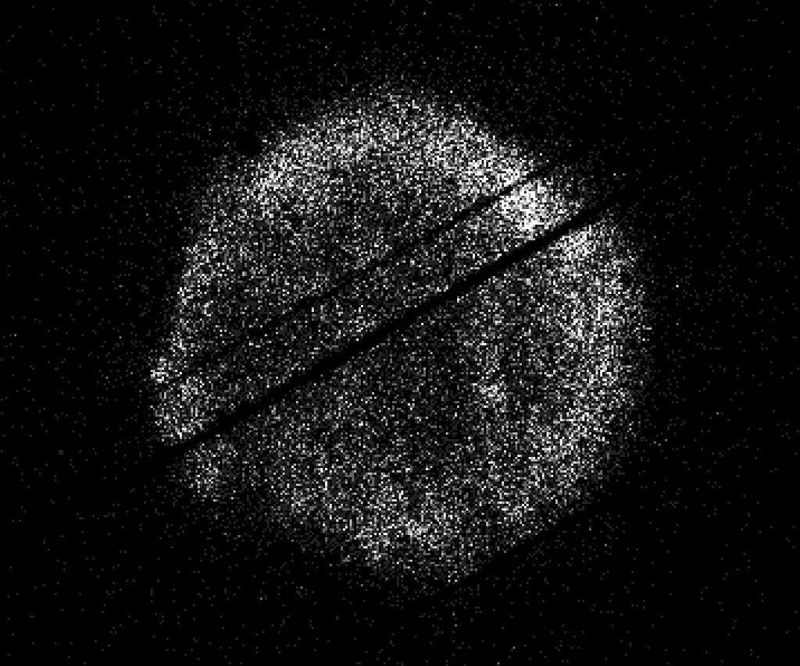
图6 NASA’s Swift Restarts Science Observations
Highlights

［原图未能获取：https://assets.science.nasa.gov/dynamicimage/assets/science/psd/ares/iss049e035512~orig.jpg?w=1024］

［原图未能获取：https://assets.science.nasa.gov/dynamicimage/assets/science/esd/eo/images/iotd/2026/earthset-from-th］

［原图未能获取：https://www.nasa.gov/wp-content/uploads/2026/06/art002e024603orig.jpg?w=150&h=150&crop=1］
Highlights

［原图未能获取：https://assets.science.nasa.gov/dynamicimage/assets/science/esd/eo/images/iotd/2026/the-forested-flo］

［原图未能获取：https://assets.science.nasa.gov/dynamicimage/assets/science/esd/eo/images/iotd/2026/rare,-widespread］

［原图未能获取：https://www.nasa.gov/wp-content/uploads/2026/08/0202795orig.jpg?w=150&h=150&crop=1］
Highlights
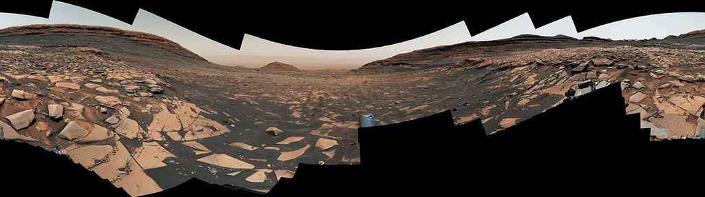
图13 Curiosity Reaches 1-Kilometer Elevation Gain

［原图未能获取：https://www.nasa.gov/wp-content/uploads/2026/08/jsc2026e406812.jpg?w=150&h=150&crop=1］

［原图未能获取：https://science.nasa.gov/wp-content/uploads/2026/08/shield-heliosphere-shrinking-screenshot.png］
Highlights

［原图未能获取：https://science.nasa.gov/wp-content/uploads/2026/08/roman-new.jpg］

［原图未能获取：https://assets.science.nasa.gov/dynamicimage/assets/science/missions/pandora/news/2026/Pandora_Artis］

［原图未能获取：https://assets.science.nasa.gov/dynamicimage/assets/science/missions/chandra/2026/galaxies_ngc4631.j］
Highlights

［原图未能获取：https://assets.science.nasa.gov/dynamicimage/assets/science/cds/soma/apsmex26/APSMEX25-image.jpg?w=1］

［原图未能获取：https://science.nasa.gov/wp-content/uploads/2026/03/stockcake-planetary-alignment-art-1265316-standa］

［原图未能获取：https://assets.science.nasa.gov/dynamicimage/assets/science/esd/eo/images/iotd/2026/a-changing-world］
Highlights

［原图未能获取：https://www.nasa.gov/wp-content/uploads/2026/08/jsc2026e406812.jpg?w=150&h=150&crop=1］

［原图未能获取：https://www.nasa.gov/wp-content/uploads/2026/08/uli-round-9-awards.jpg?w=150&h=150&crop=1］

［原图未能获取：https://www.nasa.gov/wp-content/uploads/2026/08/2027-gbs-email-header-cc.png?w=150&h=150&crop=1］
Highlights

［原图未能获取：https://assets.science.nasa.gov/dynamicimage/assets/science/psd/photojournal/pia/pia26/pia26779/PIA2］

［原图未能获取：https://assets.science.nasa.gov/dynamicimage/assets/science/psd/photojournal/pia/pia26/pia26778/PIA2］

［原图未能获取：https://assets.science.nasa.gov/dynamicimage/assets/science/psd/photojournal/pia/pia26/pia26777/PIA2］
Highlights

［原图未能获取：https://www.nasa.gov/wp-content/uploads/2023/02/nancy-grace-roman-space-telescope-visualization.jpeg］
Highlights

［原图未能获取：https://www.nasa.gov/wp-content/uploads/2026/08/ksc-20260821-ph-ser01-0003large.jpg?w=150&h=150&crop］

［原图未能获取：https://www.nasa.gov/wp-content/uploads/2026/08/congressional-space-medal-of-honor-ceremony-1.jpg?w=］

图31 NASA Astronaut Jonny Kim Departs Agency to Continue Military Service
Highlights

［原图未能获取：https://www.nasa.gov/wp-content/uploads/2026/03/a2crew-7ff19d.jpg?w=150&h=150&crop=1］

［原图未能获取：https://www.nasa.gov/wp-content/uploads/2026/03/suit-patch.jpg?w=150&h=150&crop=1］
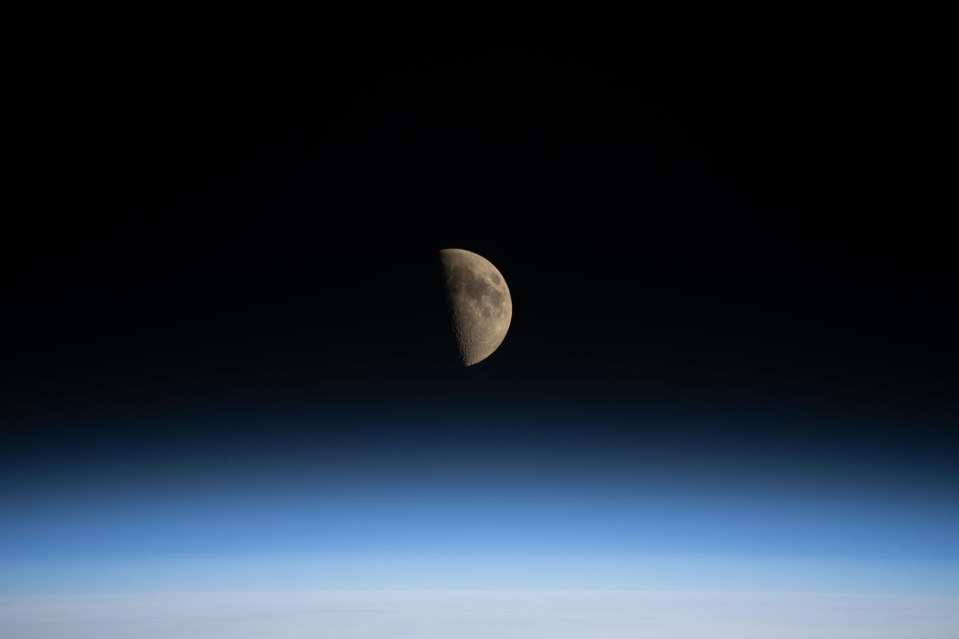
图34 La NASA refuerza Artemis: añade una misión y perfecciona su arquitectura general

［原图未能获取：https://assets.science.nasa.gov/dynamicimage/assets/science/psd/photojournal/pia/pia26/pia26777/PIA2］
PIA26777 Credits: NASA/JPL-Caltech Image Addition Date:08/25/2026
Downloads

［原图未能获取：https://assets.science.nasa.gov/dynamicimage/assets/science/psd/photojournal/pia/pia26/pia26777/PIA2］
JPEG (853.58 KB)
Description
Five antennas soak in the summer sun at the Deep Space Network’s Goldstone complex near Barstow, California, in August 2026. The recently completed Deep Space Station 23, a 34-meter (114-foot) beam-waveguide antenna, can be seen to the right of the frame in the foreground. The other three 34-meter antennas are, from left, DSS-26, DSS-25, and DSS-24. At farthest right is a smaller 26-meter (85-foot) antenna, the retired “Apollo Antenna” that was built in 1967 as part of the Manned Space Flight Network and earned its nickname for providing tracking for the Apollo Program.
NASA leadership and personnel as well as dignitaries gathered at the complete DSS-23 antenna for a ceremonial ribbon-cutting on Aug. 25, 2026. It’s the latest antenna to be added as part of the Deep Space Network’s Aperture Enhancement Project, which began in 2009 to upgrade and expand the network by adding six new 34-meter multifrequency beam-waveguide antennas. These versatile Deep Space Network (DSN) dishes can enhance many missions operating over different radio frequencies.
The DSN allows missions to track, send commands to, and receive scientific data from faraway spacecraft. It is managed by NASA’s Jet Propulsion Laboratory in Southern California, a division of Caltech, for the agency’s Space Communications and Navigation (SCaN) Program, which is located at NASA Headquarters within the Research and Technology Mission Directorate.
For more information about the DSN, visit:
https://www.nasa.gov/communicating-with-missions/dsn/ Keep Exploring
Discover More Topics From Photojournal

［原图未能获取：https://assets.science.nasa.gov/dynamicimage/assets/science/psd/photojournal/pia/pia22/pia22567/PIA2］

［原图未能获取：https://assets.science.nasa.gov/dynamicimage/assets/science/psd/photojournal/pia/pia25/pia25729/PIA2］

［原图未能获取：https://assets.science.nasa.gov/dynamicimage/assets/science/psd/photojournal/pia/pia24/pia24543/PIA2］

［原图未能获取：https://assets.science.nasa.gov/dynamicimage/assets/science/psd/photojournal/pia/pia25/pia25691/PIA2］
Δ Did you find what you were looking for?(Required)
Yes No Partly What were you looking for?(Required)
What were you hoping to accomplish × Notifications

