编号 | B006-024
机构 | NASA（NASA - News Releases）
类型/日期 | official ｜ 2026-08-30
英文原题 | NASA’s Dark Universe-Seeking Nancy Grace Roman Space Telescope Launches
原文链接 | https://www.nasa.gov/news-release/nasas-dark-universe-seeking-nancy-grace-roman-space-telescope-launches/
简报期次 | B006（2026-08-31 归档）
本库文件 | B006-024-Nasa - news releases -nasas-dark-universe-seeking-nancy-grace-roman-sp-202608.md

NASA’s Dark Universe-Seeking Nancy Grace Roman Space Telescope Launches
Search
Suggested Searches
Climate Change
Artemis
Expedition 64
Mars perseverance
SpaceX Crew-2
International Space Station
View All Topics A-Z
Home
Missions
Humans in Space
Earth
The Solar System
The Universe
Science
Aeronautics
Technology
Learning Resources
About NASA
Español
News & Events
Multimedia
NASA+
Featured

［原图未能获取：https://www.nasa.gov/wp-content/uploads/2026/08/ksc-20260821-ph-ser01-0003large.jpg?w=767］

［原图未能获取：https://www.nasa.gov/wp-content/uploads/2026/08/congressional-space-medal-of-honor-ceremony-1.jpg?w=］

［原图未能获取：https://www.nasa.gov/wp-content/uploads/2026/08/eo-1.png?w=1024］
Back
Missions
Search All NASA Missions
A to Z List of Missions
Upcoming Launches and Landings
Spaceships and Rockets
Communicating with Missions
Artemis
James Webb Space Telescope
Hubble Space Telescope
International Space Station
OSIRIS-Rex
Humans in Space
Why Go to Space
Astronauts
Commercial Space
Destinations
Spaceships and Rockets
Living in Space
Earth
Explore Earth Science
Climate Change
Earth, Our Planet
Earth Science in Action
Earth Multimedia
Earth Data
Earth Science Researchers
The Solar System
The Sun
Mercury
Venus
Earth
The Moon
Mars
Jupiter
Saturn
Uranus
Neptune
Pluto & Dwarf Planets
Asteroids, Comets & Meteors
The Kuiper Belt
The Oort Cloud
Skywatching
The Universe
Exoplanets
The Search for Life in the Universe
Stars
Galaxies
Black Holes
The Big Bang
Dark Energy
Dark Matter
Science
Earth Science
Planetary Science
Astrophysics & Space Science
The Sun & Heliophysics
Biological & Physical Sciences
Lunar Science
Citizen Science
Astromaterials
Aeronautics Research
Human Space Travel Research
Aeronautics
Science in the Air
NASA Aircraft
Flight Research Innovation
Supersonic Flight
Air Traffic Solutions
Green Aviation Tech
Drones & You
Technology
Technology Transfer & Spinoffs
Space Travel
Living in Space
Lunar Surface Technology
Manufacturing and Materials
Robotics
Science Instruments
Computing
Learning Resources
For Kids and Students
For Educators
For Colleges and Universities
For Professionals
Science for Everyone
Requests for Exhibits, Artifacts, Speakers & Flyovers
STEM Engagement at NASA
About NASA
NASA's Impacts
Centers and Facilities
Directorates
Organizations
People of NASA
Careers
Internships
Our History
Doing Business with NASA
Get Involved
Contact
NASA en Español
Ciencia
Aeronáutica
Ciencias Terrestres
Sistema Solar
Universo
News & Events
News Releases
Recently Published
Video Series on NASA+
Podcasts & Audio
Blogs
Newsletters
Social Media
Media Resources
Events
Upcoming Launches & Landings
Virtual Guest Program
Multimedia
NASA+
Images
NASA Live
NASA Apps
Podcasts
Image of the Day
e-Books
3D Resources
Interactives
STEM Multimedia
NASA Brand & Usage Guidelines
Featured

［原图未能获取：https://www.nasa.gov/wp-content/uploads/2026/08/ksc-20260821-ph-ser01-0003large.jpg?w=767］

［原图未能获取：https://www.nasa.gov/wp-content/uploads/2026/08/congressional-space-medal-of-honor-ceremony-1.jpg?w=］
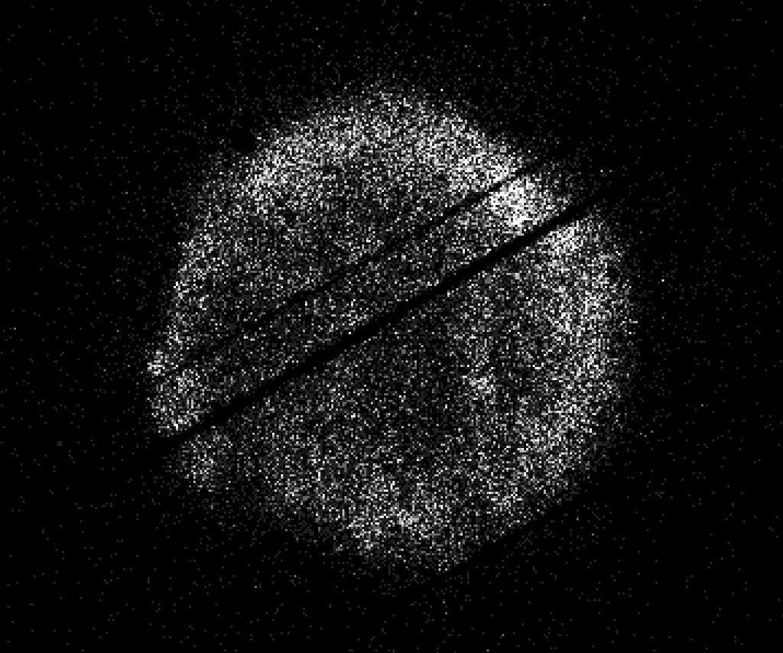
图6 NASA’s Swift Restarts Science Observations
Highlights

［原图未能获取：https://assets.science.nasa.gov/dynamicimage/assets/science/psd/ares/iss049e035512~orig.jpg?w=1024］

［原图未能获取：https://assets.science.nasa.gov/dynamicimage/assets/science/esd/eo/images/iotd/2026/earthset-from-th］

［原图未能获取：https://www.nasa.gov/wp-content/uploads/2026/06/art002e024603orig.jpg?w=1024］
Highlights

［原图未能获取：https://assets.science.nasa.gov/dynamicimage/assets/science/esd/eo/images/iotd/2026/the-forested-flo］

［原图未能获取：https://assets.science.nasa.gov/dynamicimage/assets/science/esd/eo/images/iotd/2026/rare,-widespread］

［原图未能获取：https://www.nasa.gov/wp-content/uploads/2026/08/0202795orig.jpg?w=1024］
Highlights
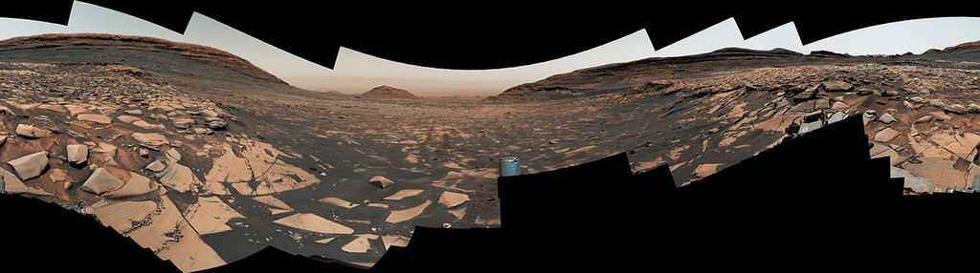
图13 Curiosity Reaches 1-Kilometer Elevation Gain

［原图未能获取：https://www.nasa.gov/wp-content/uploads/2026/08/jsc2026e406812.jpg?w=1024］

［原图未能获取：https://science.nasa.gov/wp-content/uploads/2026/08/shield-heliosphere-shrinking-screenshot.png］
Featured

［原图未能获取：https://science.nasa.gov/wp-content/uploads/2026/08/roman-new.jpg］

［原图未能获取：https://assets.science.nasa.gov/dynamicimage/assets/science/missions/pandora/news/2026/Pandora_Artis］

［原图未能获取：https://assets.science.nasa.gov/dynamicimage/assets/science/missions/chandra/2026/galaxies_ngc4631.j］
Highlights

［原图未能获取：https://assets.science.nasa.gov/dynamicimage/assets/science/cds/soma/apsmex26/APSMEX25-image.jpg?w=1］

［原图未能获取：https://science.nasa.gov/wp-content/uploads/2026/03/stockcake-planetary-alignment-art-1265316-standa］

［原图未能获取：https://assets.science.nasa.gov/dynamicimage/assets/science/esd/eo/images/iotd/2026/a-changing-world］
Highlights

［原图未能获取：https://www.nasa.gov/wp-content/uploads/2026/08/jsc2026e406812.jpg?w=1024］

［原图未能获取：https://www.nasa.gov/wp-content/uploads/2026/08/uli-round-9-awards.jpg?w=1024］

［原图未能获取：https://www.nasa.gov/wp-content/uploads/2026/08/2027-gbs-email-header-cc.png?w=1024］
Highlights

［原图未能获取：https://assets.science.nasa.gov/dynamicimage/assets/science/psd/photojournal/pia/pia26/pia26779/PIA2］

［原图未能获取：https://assets.science.nasa.gov/dynamicimage/assets/science/psd/photojournal/pia/pia26/pia26778/PIA2］

［原图未能获取：https://assets.science.nasa.gov/dynamicimage/assets/science/psd/photojournal/pia/pia26/pia26777/PIA2］
Featured

［原图未能获取：https://www.nasa.gov/wp-content/uploads/2023/02/nancy-grace-roman-space-telescope-visualization.jpeg］
Featured

［原图未能获取：https://www.nasa.gov/wp-content/uploads/2026/08/ksc-20260821-ph-ser01-0003large.jpg?w=767］

［原图未能获取：https://www.nasa.gov/wp-content/uploads/2026/08/congressional-space-medal-of-honor-ceremony-1.jpg?w=］
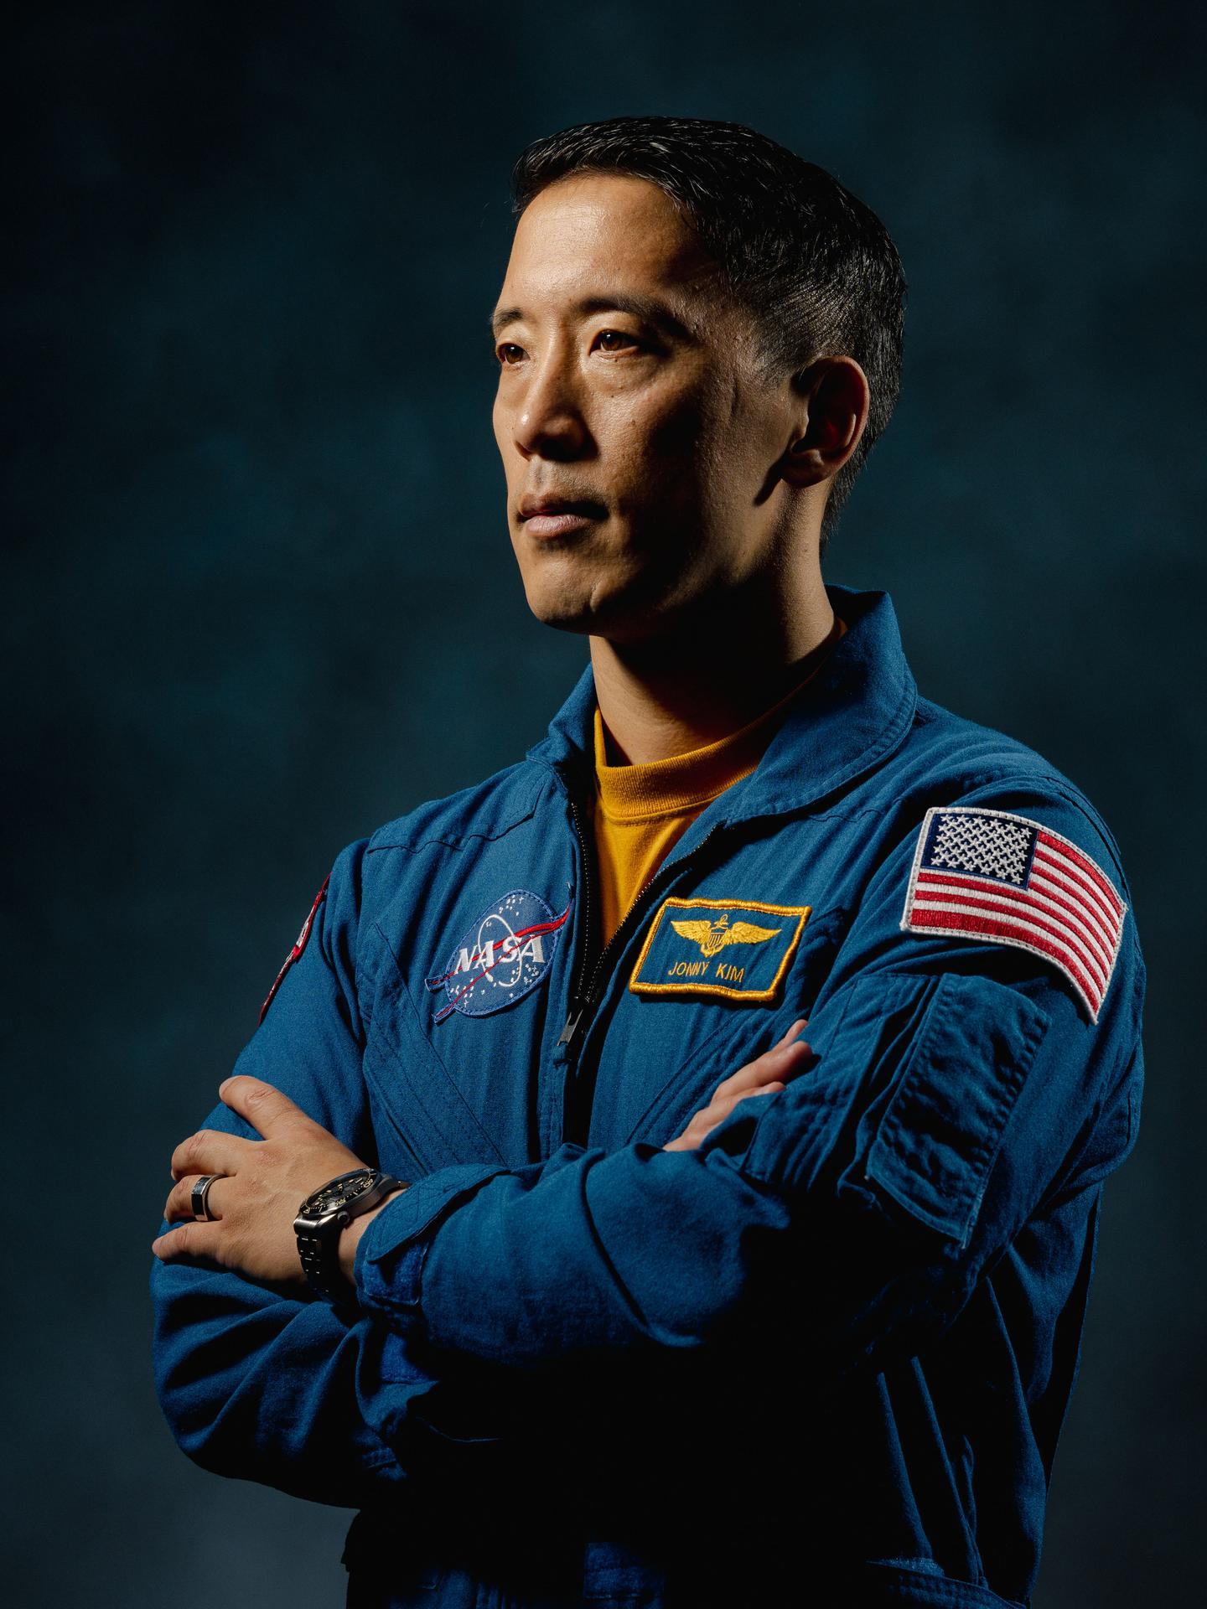
图31 NASA Astronaut Jonny Kim Departs Agency to Continue Military Service
Highlights

［原图未能获取：https://www.nasa.gov/wp-content/uploads/2026/03/a2crew-7ff19d.jpg?w=1024］

［原图未能获取：https://www.nasa.gov/wp-content/uploads/2026/03/suit-patch.jpg?w=1024］
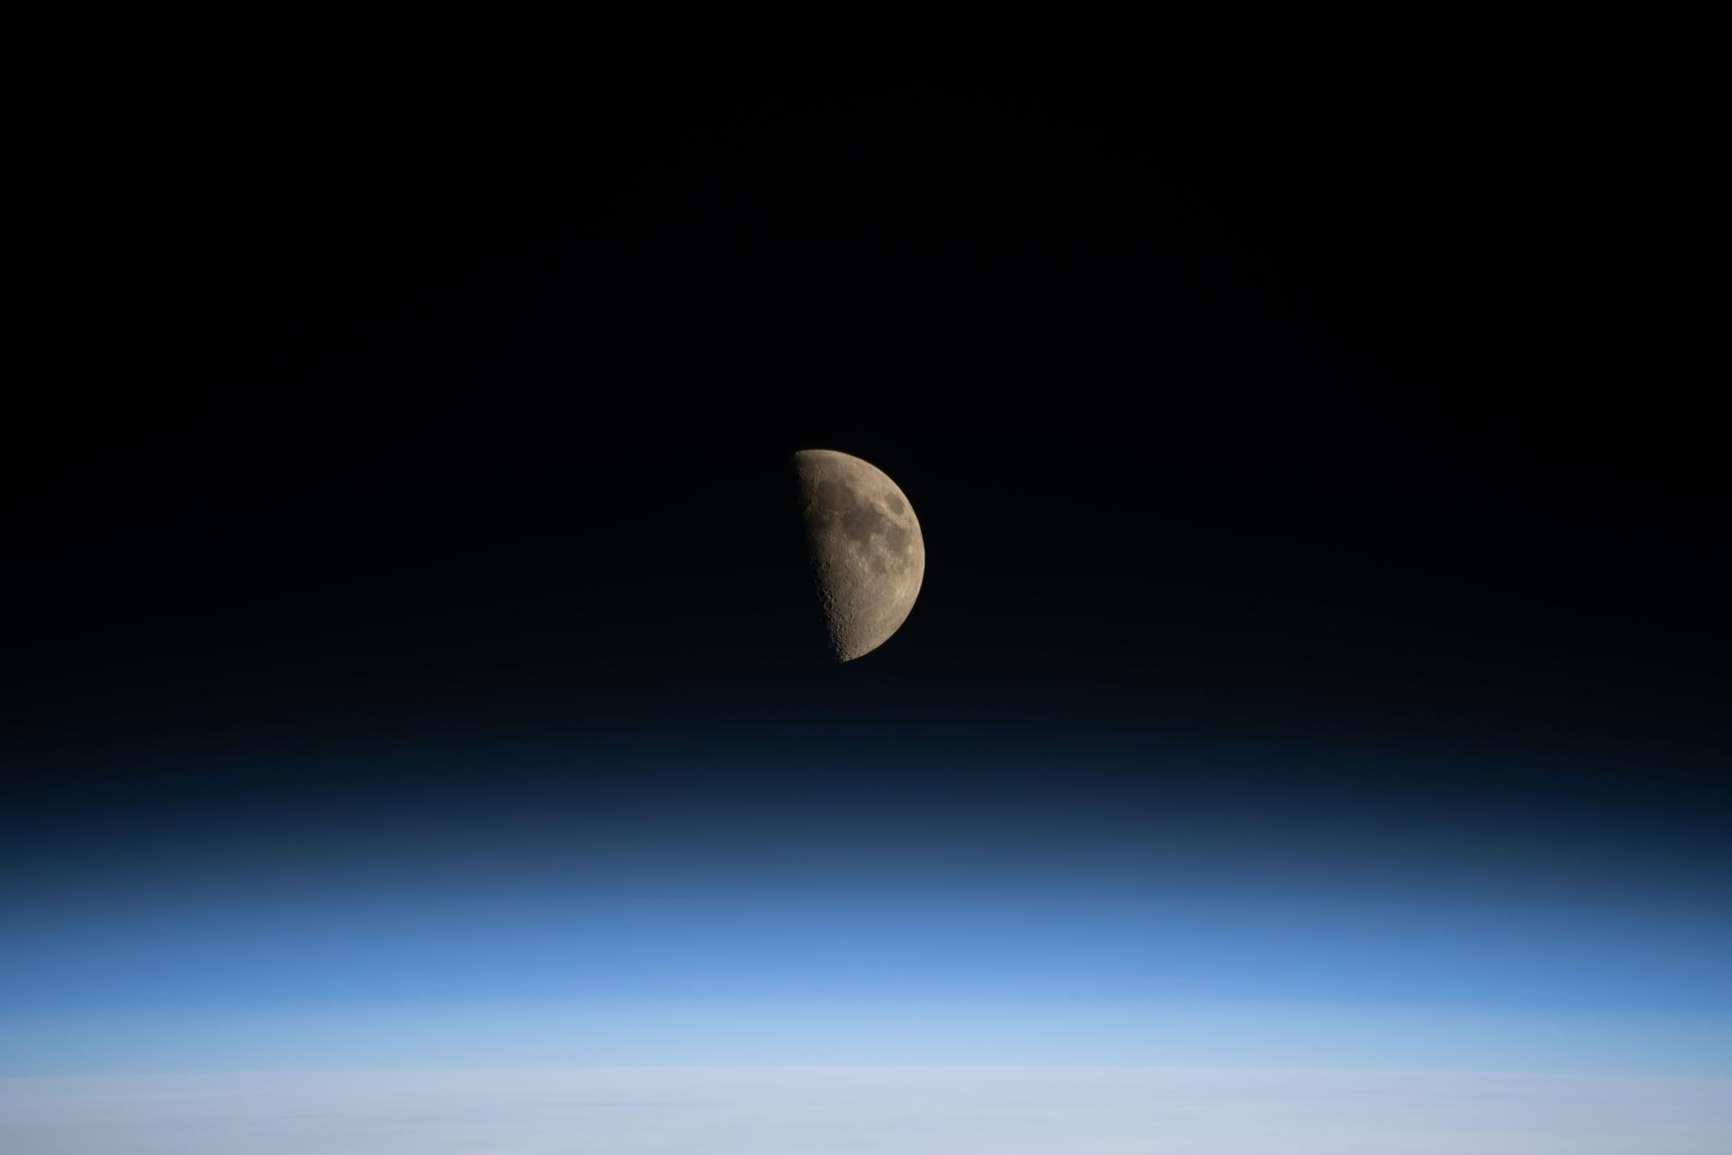
图34 La NASA refuerza Artemis: añade una misión y perfecciona su arquitectura general

［原图未能获取：https://www.nasa.gov/wp-content/uploads/2022/07/cropped-cropped-581097main_STS-1_Dust-it-Off-mp3-ima］
Jennifer M. Dooren Aug 30, 2026 RELEASE26-071
NASA Headquarters

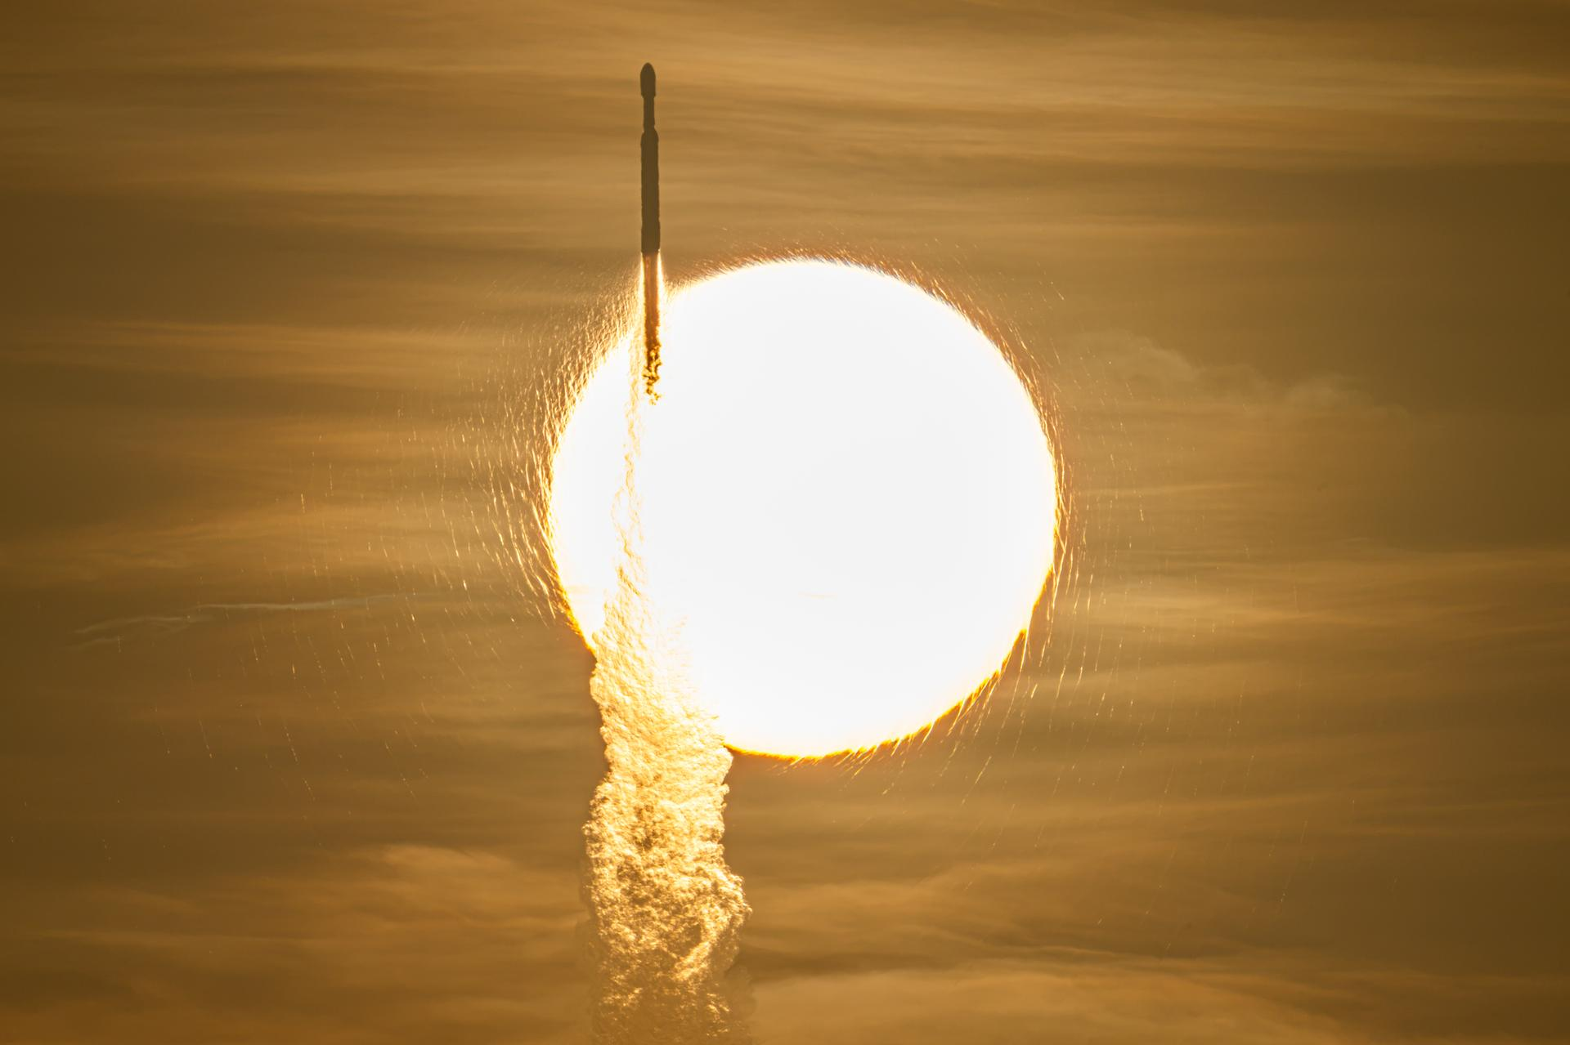
A SpaceX Falcon Heavy rocket with NASA’s Nancy Grace Roman Telescope on board is seen transiting the sun during launch from Launch Complex 39A, Sunday, Aug. 30, 2026, at NASA’s Kennedy Space Center in Florida.
NASA/John Kraus Now on a three-month, million-mile journey to its final orbit, NASA’s Nancy Grace Roman Space Telescope will soon reveal the universe’s darkest secrets. The mission launched at 7:26 a.m. EDT Sunday aboard a SpaceX Falcon Heavy rocket from Launch Complex 39A at the agency’s Kennedy Space Center in Florida.
Roman pairs a large field of view with crisp infrared vision to explore vast swaths of the sky and probe deeply into cosmic history. This flagship mission will help astronomers explore dark matter, dark energy, and worlds outside of our solar system, known as exoplanets. Its surveys will support a broad range of research extending far beyond the mission’s main science goals.
“Roman is exactly the kind of success story we want to see across NASA,” said NASA Administrator Jared Isaacman. “Delivered ahead of schedule and on budget, this mission reflects more than a decade of dedication from the NASA workforce and our industry partners. Now, Roman will give us a new atlas of the universe, push the boundaries of discovery, and demonstrate what is possible when America’s space program pairs bold ambition with disciplined execution.”
The ground control team at NASA’s Goddard Space Flight Center in Greenbelt, Maryland, began receiving telemetry data from Roman seven minutes after launch. The Falcon Heavy rocket performed as expected, separating from the observatory 31 minutes into the flight. After separating from the center core, the rocket’s boosters safely returned to the launch site for refurbishment.
“Roman will be a discovery machine that will bring us closer than ever before to answering humanity’s most profound questions about our cosmic history,” said Nicky Fox, associate administrator for the Science Mission Directorate at NASA Headquarters in Washington. “With its large field of view and fast survey speeds, Roman will usher us into a new era of discovery and make the invisible visible, setting the foundation for humanity’s search for life beyond our solar system.”
During launch and early orbit, Roman uses the Near Space Network’s ground stations and relay satellites to exchange tracking, telemetry, and command data with ground controllers. About 70 minutes after launch, the Deep Space Network takes over communications and guides Roman toward the second Sun-Earth Lagrange point, or L2, about one million miles from Earth. Roman connects to that network through the Canberra Deep Space Communication Complex in Australia first. Approximately six hours later it will transfer to the Madrid Deep Space Communication Complex in Spain and then to the Goldstone Deep Space Communication Complex in California, ensuring continuous contact with Roman throughout its journey.
The Roman team also confirmed successful deployment of the observatory’s solar panels and lower instrument sun shade an hour and 23 minutes after launch. Within the upcoming days, Roman’s high-gain antenna and visor-like deployable aperture cover will deploy, ground controllers will initiate the first of two-mid-course corrections, and the Coronagraph Instrument will power on. This instrument will demonstrate the technology that future missions like NASA’s Habitable Worlds Observatory concept could use to image Earth-like planets in the search for life in the universe. Roman’s Coronagraph will take a giant step in that direction by snapping pictures of Jupiter-like planets.
A few weeks into Roman’s voyage, its primary instrument, the Wide Field Instrument, will activate. This 300-megapixel infrared camera has 18 4K detectors, each about the size of a saltine cracker. These detectors collect photons of light that will be decoded into crisp cosmic panoramas. Thanks to the observatory’s rigid design and stable optical performance, it will rapidly scan the sky without needing substantial time between separate observations. The Roman telescope is designed to survey the universe a thousand times faster than NASA’s Hubble Space Telescope.
Throughout the rest of Roman’s three-month commissioning period, scientists will run the instruments through a series of calibrations and tests. NASA anticipates releasing Roman’s first images by early 2027.
Roman will send back 1.4 terabytes of data every day, the highest data rate of any NASA astrophysics mission, so far. Machine learning, artificial intelligence, and citizen scientists will help sift through it and flag significant findings, which astronomers can then study.
“We’ve never been able to view the universe with eyes like Roman’s before,” said Julie McEnery, Roman’s senior project scientist at NASA Goddard. “There’s no telling what more we’ll know and have seen by this time next year.”
Roman is the fourth primary mission NASA has launched on a Falcon Heavy rocket. Earlier this year, the agency’s Launch Services Program worked with SpaceX to accelerate the launch date to accommodate the space telescope’s early completion.
The telescope is managed at NASA Goddard with participation by the agency’s Jet Propulsion Laboratory in Southern California; Caltech/IPAC in Pasadena, California; the Space Telescope Science Institute in Baltimore; and a team of scientists from various research institutions. The primary industrial partners are BAE Systems Inc., L3Harris Technologies, and Teledyne Scientific & Imaging. Contributions to Roman also are made by ESA, JAXA, the French space agency CNES (Centre National d’Études Spatiales), and the Max Planck Institute for Astronomy in Germany.
To learn more about the Roman mission, visit:
https://www.nasa.gov/roman
-end- George Alderman / Alise Fisher Headquarters, Washington 202-358-1600 george.a.alderman@nasa.gov / alise.m.fisher@nasa.gov Claire Andreoli Goddard Space Flight Center, Greenbelt, Md.
202-286-1940 claire.andreoli@nasa.gov
Share

Details
Last Updated Aug 30, 2026 Editor Jennifer M. Dooren Location NASA Headquarters
Related Terms
Missions
Astrophysics
Goddard Space Flight Center
Jet Propulsion Laboratory
Kennedy Space Center
Nancy Grace Roman Space Telescope
Science Mission Directorate
Was this page helpful?
Δ Was this page helpful?
Yes No × Notifications

