编号 | B007-011
机构 | NASA（NASA - News Releases）
类型/日期 | official ｜ 2026-08-31
英文原题 | APOD: 2026 August 31 – Launch of the Roman Space Telescope
原文链接 | https://science.nasa.gov/image-article/apod-2026-august-31-launch-of-the-roman-space-telescope/
简报期次 | B007（2026-08-31 归档）
本库文件 | B007-011-Nasa - news releases -apod-2026-august-31-launch-of-the-roman-space-te-202608.md

APOD: 2026 August 31 – Launch of the Roman Space Telescope
Search
Suggested Searches
Climate Change
Artemis
Expedition 64
Mars perseverance
SpaceX Crew-2
International Space Station
View All Topics A-Z
Home
Missions
Humans in Space
Earth
The Solar System
The Universe
Science
Aeronautics
Technology
Learning Resources
About NASA
Español
News & Events
Multimedia
NASA+
Highlights

［原图未能获取：https://www.nasa.gov/wp-content/uploads/2026/08/ksc-20260821-ph-ser01-0003large.jpg?w=150&h=150&crop］

［原图未能获取：https://www.nasa.gov/wp-content/uploads/2026/08/congressional-space-medal-of-honor-ceremony-1.jpg?w=］

［原图未能获取：https://www.nasa.gov/wp-content/uploads/2026/08/eo-1.png?w=150&h=150&crop=1］
Back
Missions
Search All NASA Missions
A to Z List of Missions
Upcoming Launches and Landings
Spaceships and Rockets
Communicating with Missions
Artemis
James Webb Space Telescope
Hubble Space Telescope
International Space Station
OSIRIS-REx
Humans in Space
Why Go to Space
Astronauts
Commercial Space
Destinations
Spaceships and Rockets
Living in Space
Earth
Explore Earth Science
Climate Change
Earth, Our Planet
Earth Science in Action
Earth Multimedia
Earth Data
Earth Science Researchers
The Solar System
The Sun
Mercury
Venus
Earth
The Moon
Mars
Jupiter
Saturn
Uranus
Neptune
Pluto & Dwarf Planets
Asteroids, Comets & Meteors
The Kuiper Belt
The Oort Cloud
Skywatching
The Universe
Exoplanets
The Search for Life in the Universe
Stars
Galaxies
Black Holes
The Big Bang
Dark Matter
Dark Energy
Science
Earth Science
Planetary Science
Astrophysics & Space Science
The Sun & Heliophysics
Biological & Physical Sciences
Lunar Science
Citizen Science
Astromaterials
Aeronautics Research
Human Space Travel Research
Aeronautics
Science in the Air
NASA Aircraft
Flight Innovation
Supersonic Flight
Air Traffic Solutions
Green Aviation Tech
Drones & You
Technology
Technology Transfer & Spinoffs
Space Travel Technology
Technology Living in Space
Manufacturing and Materials
Robotics
Science Instruments
Computing
Learning Resources
For Kids and Students
For Educators
For Colleges and Universities
For Professionals
Science for Everyone
Requests for Exhibits, Artifacts, or Speakers
STEM Engagement at NASA
About NASA
NASA's Impacts
Centers and Facilities
Directorates
Organizations
People of NASA
Careers
Internships
Our History
Doing Business with NASA
Get Involved
Contact
NASA en Español
Ciencia
Aeronáutica
Ciencias Terrestres
Sistema Solar
Universo
News & Events
Recently Published
Video Series on NASA+
Podcasts & Audio
Blogs
Newsletters
Social Media
Media Resources
Multimedia
NASA+
Images
NASA Live
NASA Apps
Podcasts
Image of the Day
e-Books
3D Resources
Interactives
STEM Multimedia
NASA Brand & Usage Guidelines
Highlights

［原图未能获取：https://www.nasa.gov/wp-content/uploads/2026/08/ksc-20260821-ph-ser01-0003large.jpg?w=150&h=150&crop］

［原图未能获取：https://www.nasa.gov/wp-content/uploads/2026/08/congressional-space-medal-of-honor-ceremony-1.jpg?w=］
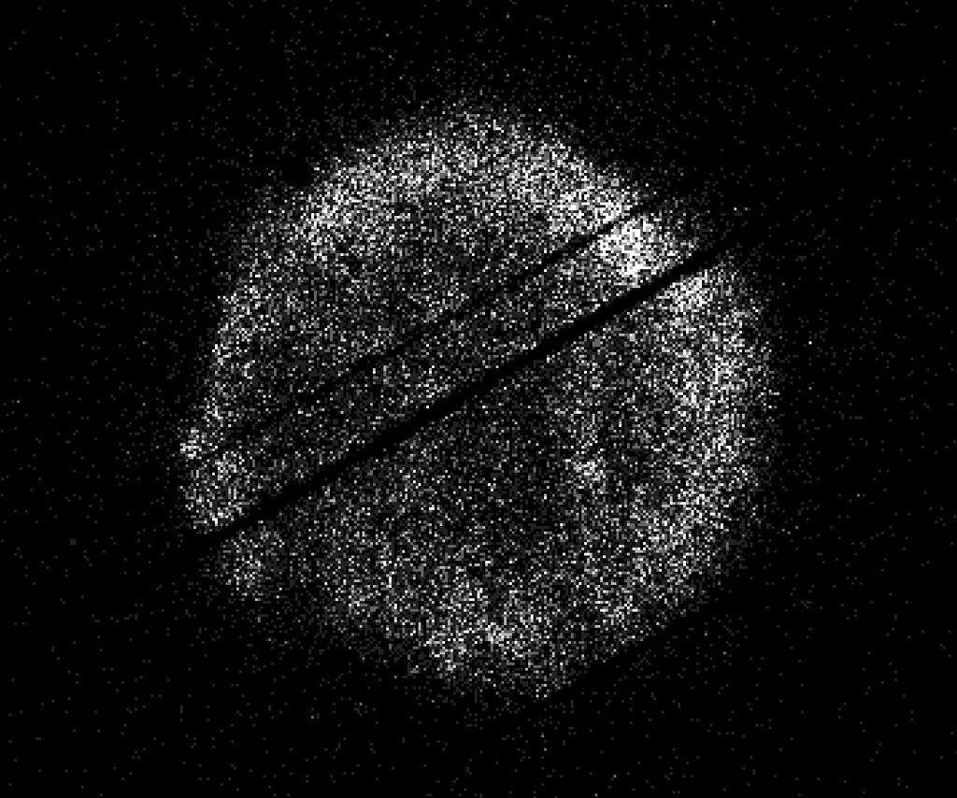
图6 NASA’s Swift Restarts Science Observations
Highlights

［原图未能获取：https://assets.science.nasa.gov/dynamicimage/assets/science/psd/ares/iss049e035512~orig.jpg?w=1024］

［原图未能获取：https://assets.science.nasa.gov/dynamicimage/assets/science/esd/eo/images/iotd/2026/earthset-from-th］

［原图未能获取：https://www.nasa.gov/wp-content/uploads/2026/06/art002e024603orig.jpg?w=150&h=150&crop=1］
Highlights

［原图未能获取：https://assets.science.nasa.gov/dynamicimage/assets/science/esd/eo/images/iotd/2026/the-forested-flo］

［原图未能获取：https://assets.science.nasa.gov/dynamicimage/assets/science/esd/eo/images/iotd/2026/rare,-widespread］

［原图未能获取：https://www.nasa.gov/wp-content/uploads/2026/08/0202795orig.jpg?w=150&h=150&crop=1］
Highlights
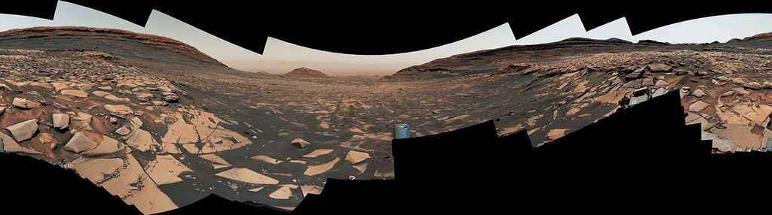
图13 Curiosity Reaches 1-Kilometer Elevation Gain

［原图未能获取：https://www.nasa.gov/wp-content/uploads/2026/08/jsc2026e406812.jpg?w=150&h=150&crop=1］

［原图未能获取：https://science.nasa.gov/wp-content/uploads/2026/08/shield-heliosphere-shrinking-screenshot.png］
Highlights

［原图未能获取：https://science.nasa.gov/wp-content/uploads/2026/08/roman-new.jpg］

［原图未能获取：https://assets.science.nasa.gov/dynamicimage/assets/science/missions/pandora/news/2026/Pandora_Artis］

［原图未能获取：https://assets.science.nasa.gov/dynamicimage/assets/science/missions/chandra/2026/galaxies_ngc4631.j］
Highlights

［原图未能获取：https://assets.science.nasa.gov/dynamicimage/assets/science/cds/soma/apsmex26/APSMEX25-image.jpg?w=1］

［原图未能获取：https://science.nasa.gov/wp-content/uploads/2026/03/stockcake-planetary-alignment-art-1265316-standa］

［原图未能获取：https://assets.science.nasa.gov/dynamicimage/assets/science/esd/eo/images/iotd/2026/a-changing-world］
Highlights

［原图未能获取：https://www.nasa.gov/wp-content/uploads/2026/08/jsc2026e406812.jpg?w=150&h=150&crop=1］

［原图未能获取：https://www.nasa.gov/wp-content/uploads/2026/08/uli-round-9-awards.jpg?w=150&h=150&crop=1］

［原图未能获取：https://www.nasa.gov/wp-content/uploads/2026/08/2027-gbs-email-header-cc.png?w=150&h=150&crop=1］
Highlights

［原图未能获取：https://assets.science.nasa.gov/dynamicimage/assets/science/psd/photojournal/pia/pia26/pia26779/PIA2］

［原图未能获取：https://assets.science.nasa.gov/dynamicimage/assets/science/psd/photojournal/pia/pia26/pia26778/PIA2］

［原图未能获取：https://assets.science.nasa.gov/dynamicimage/assets/science/psd/photojournal/pia/pia26/pia26777/PIA2］
Highlights

［原图未能获取：https://www.nasa.gov/wp-content/uploads/2023/02/nancy-grace-roman-space-telescope-visualization.jpeg］
Highlights

［原图未能获取：https://www.nasa.gov/wp-content/uploads/2026/08/ksc-20260821-ph-ser01-0003large.jpg?w=150&h=150&crop］

［原图未能获取：https://www.nasa.gov/wp-content/uploads/2026/08/congressional-space-medal-of-honor-ceremony-1.jpg?w=］

图31 NASA Astronaut Jonny Kim Departs Agency to Continue Military Service
Highlights

［原图未能获取：https://www.nasa.gov/wp-content/uploads/2026/03/a2crew-7ff19d.jpg?w=150&h=150&crop=1］

［原图未能获取：https://www.nasa.gov/wp-content/uploads/2026/03/suit-patch.jpg?w=150&h=150&crop=1］
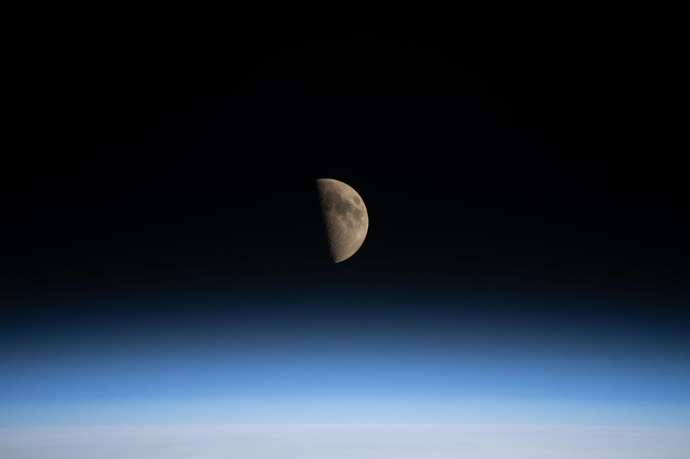
图34 La NASA refuerza Artemis: añade una misión y perfecciona su arquitectura general
APOD APOD Astronomy Picture of the Day Discover the cosmos! Each day a different image or photograph of our fascinating universe is featured, along with a brief explanation written by a professional astronomer.
To view this video please enable JavaScript, and consider upgrading to a web browser that supports HTML5 video
Launch of the Roman Space Telescope
Explanation: A new telescope has been launched into space to study the universe. The Nancy Grace Roman Space Telescope (RST) has the same size main mirror as the Hubble Space Telescope (HST) but sees 100 times more sky during each snapshot. This is possible because when compared to HST, RST's main mirror is more curved, its secondary mirror is closer, and its main camera is larger. The result is that RST can inspect more of the sky more quickly, likely allowing, among other capabilities, the discovery of many more supernovas which tell us more about the expansion rate and composition of our universe, and many more planets orbiting other stars that tell us more about the possibilities for life elsewhere in the universe. RST will orbit the Sun, not the Earth, like the James Webb Space Telescope. The featured video shows Roman being launched yesterday from Kennedy Space Center, Florida, USA aboard a SpaceX Falcon Heavy rocket.
APOD's main NASA site ismoving: From apod.nasa.gov to science.nasa.gov/apod
Tomorrow's picture: eclipse flight
DateAugust 31, 2026
Credit: | NASA
Authors & editors: | Robert Nemiroff, Jerry Bonnell, Cecilia Chirenti, Keighley Rockcliffe
A service of: | ASD at NASA / GSFC,
NASA Science Activation & Michigan Tech. U. | Random APOD Generator

Yesterday's Image APOD: 2026 August 30 – M74: A Grand Design Spiral Tomorrow's Image
Δ Did you find what you were looking for?(Required)
Yes No Partly What were you looking for?(Required)
What were you hoping to accomplish × Notifications

