**well come to c++**

1. **Logic operators**

**#include<iostream>**

**using namespace std;**

**int main() {**

**bool result;**

**result = (3 != 5) && (3 < 5); // true**

**cout << "(6 != 8) && (3 < 5) is " << result << endl;**

**result = (3 == 5) && (3 < 5); // false**

**cout << "(3 == 5) && (3 < 5) is " << result << endl;**

**result = (3 == 5) && (3 > 5); // false**

**cout << "(3 == 5) && (3 > 5) is " << result << endl;**

**result = (3 != 5) || (3 < 5); // true**

**cout << "(3 != 5) || (3 < 5) is " << result << endl;**

**result = (3 != 5) || (3 > 5); // true**

**cout << "(3 != 5) || (3 > 5) is " << result << endl;**

**result = (3 == 5) || (3 > 5); // false**

**cout << "(3 == 5) || (3 > 5) is " << result << endl;**

**result = !(5 == 2); // true**

**cout << "!(5 == 2) is " << result << endl;**

**result = !(5 == 5); // false**

**cout << "!(5 == 5) is " << result << endl;**

**return 0;**

**}**

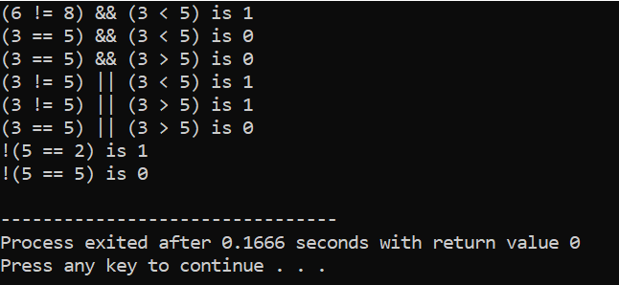

1. **Arithematic operators**

**#inlcude<iostream>**

**using namespace std;**

**int main() {**

**int a, b;**

**a = 20;**

**b = 18;**

**// printing the sum of a and b**

**cout << "a + b = " << (a + b) << endl;**

**// printing the difference of a and b**

**cout << "a - b = " << (a - b) << endl;**

**// printing the product of a and b**

**cout << "a * b = " << (a * b) << endl;**

**// printing the division of a by b**

**cout << "a / b = " << (a / b) << endl;**

**// printing the modulo of a by b**

**cout << "a % b = " << (a % b) << endl;**

**return 0;**

**}**

**using namespace std;**

**int main() {**

**int a, b;**

**a = 20;**

**b = 18;**

**// printing the sum of a and b**

**cout << "a + b = " << (a + b) << endl;**

**// printing the difference of a and b**

**cout << "a - b = " << (a - b) << endl;**

**// printing the product of a and b**

**cout << "a * b = " << (a * b) << endl;**

**// printing the division of a by b**

**cout << "a / b = " << (a / b) << endl;**

**// printing the modulo of a by b**

**cout << "a % b = " << (a % b) << endl;**

**return 0;**

**}**

**Output**

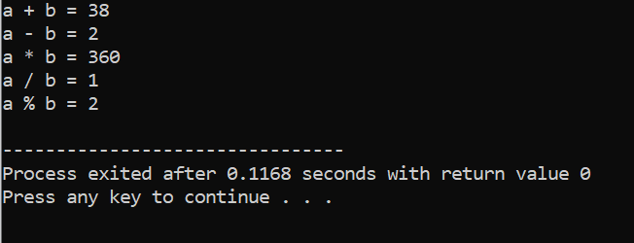

1. **relational operators**

**#include <iostream>**

**using namespace std;**

**int main() {**

**int a, b;**

**a = 11;**

**b = 19;**

**bool result;**

**result = (a == b); // false**

**cout << "11 == 19 is " << result << endl;**

**result = (a != b); // true**

**cout << "11 != 19 is " << result << endl;**

**result = a > b; // false**

**cout << "11> 19 is " << result << endl;**

**result = a < b; // true**

**cout << "11 < 19 is " << result << endl;**

**result = a >= b; // false**

**cout << "11 >= 19 is " << result << endl;**

**result = a <= b; // true**

**cout << "11 <= 19 is " << result << endl;**

**return 0;**

**}**

**Output**

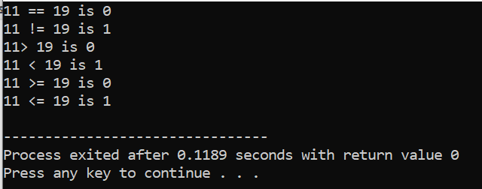

1. **bitwise shift right and left**

**#include <iostream>**

**using namespace std;**

**int main() {**

**// declaring two integer variables**

**int num = 212, i;**

**// Shift Right Operation**

**cout << "Shift Right:" << endl;**

**// Using for loop for shifting num right from 0 bit to 3 bits**

**for (i = 0; i < 4; i++) {**

**cout << "212 >> " << i << " = " << (212 >> i) << endl;**

**}**

**// Shift Left Operation**

**cout << "\nShift Left:" << endl;**

**// Using for loop for shifting num left from 0 bit to 3 bits**

**for (i = 0; i < 4; i++) {**

**cout << "212 << " << i << " = " << (212 << i) << endl;**

**}**

**return 0;**

**}**

**Output**

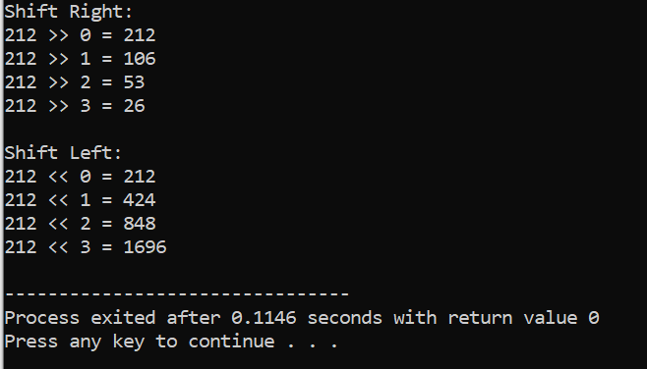

1. **bitwise AND**

**#include<iostream>**

**Using namespace std;**

**int main(){**

**//declare variabke**

**int c=5,d=6;**

**cout<<"c="<<d<<endl;**

**cout<<"d="<<d<<endl;**

**cout<<"c&d="<<(c&d)<<endl;**

**return 0;**

**}**

**Output**

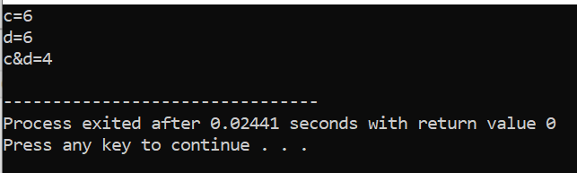

1. bitws OR

#include<iostream>

using namespace std;

int main(){

int c=5,d=6;

cout<<"c="<<c<<endl;

cout<<"d="<<d<<endl;

cout<<"c|d="<<(c|d)<<endl;

return 0;

}

Output

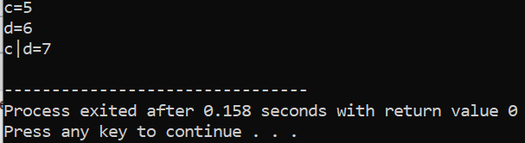

1. ASSIGNIMENT OPERATORS

#include<iostream>

Using namspace std;

int main(){

int c,d;

// 4 is assignde to c

c=4;

// d is assigned to 8

d=8;

cout<<"c="<<c<<endl;

cout<<"d="<<d<<endl;

cout<<"\nAfter c+=d"<<endl;

//assigning the sum of c and d to a

c+=d;//c=c+d

cout<<"c="<<c<<endl;

return 0;

}

Output

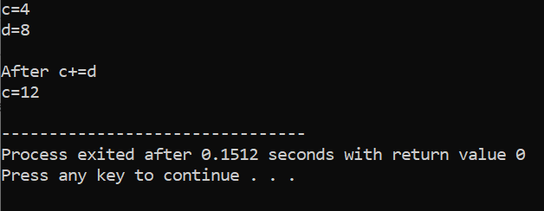

1. Increament and decreament

#include <iostream>

Using namespace std;

int main(){

int a=20,b=100,result_a,result_b;

// increament a by 2 and storing the result in result a

result_a=++a;

cout<<"result_a="<<result_a<<endl;

//decreamenting b by 2 and storing the result in result b

result_b=-b;

cout<<"result_b="<<result_b<<endl;

return 0;

}

Output

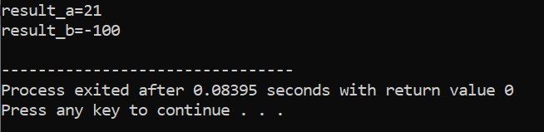

**9.ASCII NUMBER**

**#include <iostream>**

**using namespace std;**

**int main(){**

**char c;**

**cout<<"enter my character";**

**cin>>c;**

**cout<<"\nthe ASCII value character["<<c<<"] is "<<int(c)<<"\n";**

**return 0;**

**}**

**output**

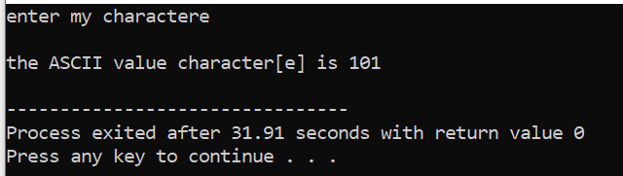

Chapter 2 Exercise

Question num1Write statement or comment

to accomplish each of the following:

#include <iostream>

using namespace std;

int main() {

int x = 7, y = 4, z = 9, product;

product = x * y * z;

cout << "The product of " << x << ", " << y << ", and " << z << " is " << product << endl;

return 0;

}

1. write a program that accept two intigers and display the sum,diffrence,product and divison of two numbers and the program should also state the greater and smaller value.

#include <iostream>

using namespace std;

int main() {

int a, b;

a = 20;

b = 18;

// printing the sum of a and b

cout << "a + b = " << (a + b) << endl;

// printing the difference of a and b

cout << "a - b = " << (a - b) << endl;

// printing the product of a and b

cout << "a * b = " << (a * b) << endl;

// printing the division of a by b

cout << "a / b = " << (a / b) << endl;

// printing the modulo of a by b

cout << "a % b = " << (a % b) << endl;{

int num1, num2;

cout << "Enter first number: ";

cin >> num1;

cout << "Enter second number: ";

cin >> num2;

if (num1 > num2) {

cout << num1 << " is greater than " << num2 << endl;

} else if (num1 < num2) {

cout << num1 << " is smaller than " << num2 << endl;

} else {

cout << num1 << " and " << num2 << " are equal" << endl;

}

return 0;

}

1. write a program the calculate and display the circumfrence of a circle.

#include<iostream>

using namespace std;

int(){

double c,r;

const double pi=3.14;

cout<<"enter the radius of the circle"<<endl;

cin>>r;

c=2*pi*r,

cout<<"the circumfrense of the circle is ="<<c;

return 0; }

1. write a program to solve a quadratic equation.

#include<iostream>

using namespace std;

int main(){

float a,b,c,x1,x2,determinant,realpart,imaginarypart;

cout<<"enter coefcient a";

cin>>a;

cout<<"\nenter coefcient b";

cin>>b;

cout<<"\nenter coefcient c";

cin>>c;

determinant=b*b-4*a*c;

if (determinant>0)

{

x1=(-b+bsqrt(determinant)) /(2*a);

x2=(-b-bsqrt(determinant)) /(2*a);

cout<<"\nRoots are real and diffrent"<<endl;

cout<<"\nx1="<<x1<<endl;

cout<<"\nx2="<<x2<<endl;

}

else if(determinant==0)

{

cout<<"\nRoots are real and same "<<endl;

x1=(-b+bsqrt(determinant)) /(2*a);

cout<<"\nx1=x2="<<x1<<endl;

}

else

{

realpart=-b/(2*a);

imaginarypart=sqrt(-determinant)) /(2*a);

cout<<"\nRoots are complex and diffrent"<<endl;

cout<<"\nx1="<<realpart<<"+"<<imaginarypart<<"i"<<endl;

cout"\nx2="<<realpart<<"-"<<maginarypart<<"i"<<endl;

}

return 0;

}

Chapter 3 demo

**One way or if statement**

#include<iostream>

Using namespace std;

int m;

cout<<"write a number";

cin>>m;

// check the number is even

if (m%2==0){

cout<<" write an even number"<<m<<endl;

}

return 0;

}

**Two way or if else statement**

**using namespace std;**

**int main()**

**{**

**int m;**

**cout<<"enter intger";**

**cin>>m;**

**if(m<=0){**

**cout<<"enter negative number"<<m<<endl;**

**}**

**else{cout<<"enter positive"<<m<<endl;**

**}**

**return 0;**

**}**

**multi way if-else statement**

#include <iostream>

using namespace std;

int main() {

int number;

cout << "Enter an integer: ";

cin >> number;

if (number > 0) {

cout << "You entered a positive integer: " << number << endl;

}

else if (number < 0) {

cout << "You entered a negative integer: " << number << endl;

}

else {

cout << "You entered 0." << endl;

}

return 0;

}

BY: MENGISTU GEBRE