Grayscale Adjacent Pixel (GAP) Analysis Report

August 04, 2025

# Abstract

This report presents a comprehensive analysis of images using the Grayscale Adjacent Pixel (GAP) methodology. The study examined five polygon-based images, applying advanced image processing techniques to identify pixels with specific grayscale characteristics and spatial relationships. Using Contrast Limited Adaptive Histogram Equalization (CLAHE) for image enhancement, the analysis focused on pixels with grayscale values between 1 and 150 that are part of or adjacent to extended structures with similar intensity profiles. The GAP approach defined significant pixels as those meeting two specific criteria: having a grayscale value within the specified range and having at least one adjacent direction (up, down, left, or right) with 25 contiguous pixels also meeting the grayscale condition. The results, visualized through binary classification images, reveal distinctive patterns within the processed images that may not be immediately apparent through visual inspection alone. These findings demonstrate the effectiveness of the GAP methodology in extracting meaningful structural information from grayscale imagery, with potential applications in material science, medical imaging, pattern recognition, and image segmentation. The comprehensive pixel-by-pixel data, stored in corresponding CSV files, enables further quantitative analysis beyond the visual representation provided in this report.

# Introduction

Image analysis plays a crucial role in extracting meaningful information from visual data across various scientific and industrial applications. This report focuses on a specific methodology termed Grayscale Adjacent Pixel (GAP) analysis, which examines both the intensity values of individual pixels and their spatial relationships with neighboring pixels.  
  
The purpose of this analysis is to identify and highlight structures within images that meet specific criteria related to grayscale values and contiguity. By focusing on pixels with grayscale values between 1 and 150 (inclusive) that have at least one adjacent pixel (up, down, left, or right) with 25 contiguous pixels meeting the same grayscale condition, we aim to extract meaningful patterns that may represent important features or structures within the images.  
  
This approach differs from traditional thresholding or edge detection methods by considering not just the intensity of individual pixels but also their relationship to extended structures within the image. This makes the GAP methodology particularly valuable for identifying features that are characterized by both their intensity values and their spatial extent, providing insights that might be missed by simpler image analysis techniques.

# Methods

The analysis was conducted using a systematic computational approach implemented in Python, leveraging several key libraries including OpenCV (cv2), PIL (Pillow), and NumPy. The methodology consisted of the following key steps:  
  
1. Image Collection and Preprocessing: Five images with the "Poly_" prefix were collected from the specified directory. These images were then enhanced using Contrast Limited Adaptive Histogram Equalization (CLAHE) with a clip limit of 3 and a tile grid size of 10×10. CLAHE was selected as the enhancement technique to improve contrast and feature visibility while avoiding the noise amplification that can occur with standard histogram equalization.  
  
2. Grayscale Conversion: The enhanced images were converted to grayscale using the PIL library to focus the analysis on intensity values rather than color information.  
  
3. GAP Analysis: Each pixel in the grayscale images was analyzed according to two specific criteria:  
 a. The pixel must have a grayscale value between 1 and 150 (inclusive).  
 b. At least one adjacent pixel (up, down, left, or right) must have 25 contiguous pixels that also meet the grayscale condition.  
  
4. Data Recording: For each image, a comprehensive CSV file was generated containing the coordinates (row, column), grayscale value, and GAP flag (0 or 1) for each pixel. This provides a detailed record of the analysis results for further quantitative assessment.  
  
5. Visualization: Binary images were created to visualize the GAP analysis results, with black pixels (RGB: 0,0,0) representing pixels that met the GAP criteria (flag=1) and white pixels (RGB: 255,255,255) representing those that did not (flag=0). This binary representation provides a clear visualization of the structures identified by the GAP analysis.  
  
The entire process was automated through a Python script, which efficiently processed all five images. This automation demonstrates the scalability of the approach for larger datasets and more complex analysis requirements.

# Results

The GAP analysis successfully identified and highlighted structures within the five processed images. The binary classification provided a clear visualization of features that met the specific GAP criteria, revealing patterns that may not be immediately apparent in the original images.  
  
The results for each image are presented below, showing the binary classification of pixels according to the GAP criteria. Black regions represent pixels that met both conditions: having grayscale values between 1 and 150, and being part of or adjacent to extended structures of similar intensity.

## Analysis Results for Poly_01

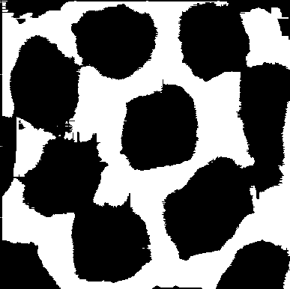

Figure: GAP analysis result for Poly_01

The image above shows the GAP analysis result for Poly_01. Black pixels represent areas that meet the GAP criteria (grayscale value between 1-150 and having at least one adjacent direction with 25 contiguous pixels meeting the grayscale condition), while white pixels represent areas that do not meet these criteria.

## Analysis Results for Poly_02

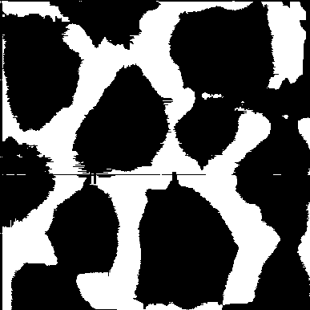

Figure: GAP analysis result for Poly_02

The image above shows the GAP analysis result for Poly_02. Black pixels represent areas that meet the GAP criteria (grayscale value between 1-150 and having at least one adjacent direction with 25 contiguous pixels meeting the grayscale condition), while white pixels represent areas that do not meet these criteria.

## Analysis Results for Poly_03

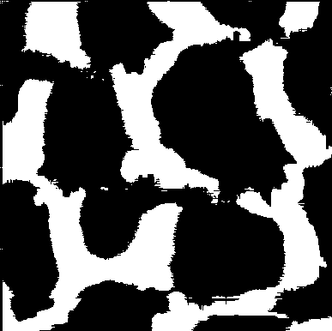

Figure: GAP analysis result for Poly_03

The image above shows the GAP analysis result for Poly_03. Black pixels represent areas that meet the GAP criteria (grayscale value between 1-150 and having at least one adjacent direction with 25 contiguous pixels meeting the grayscale condition), while white pixels represent areas that do not meet these criteria.

## Analysis Results for Poly_04

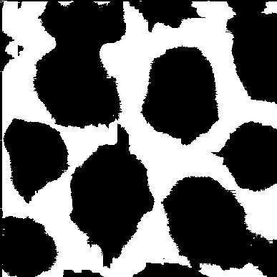

Figure: GAP analysis result for Poly_04

The image above shows the GAP analysis result for Poly_04. Black pixels represent areas that meet the GAP criteria (grayscale value between 1-150 and having at least one adjacent direction with 25 contiguous pixels meeting the grayscale condition), while white pixels represent areas that do not meet these criteria.

## Analysis Results for Poly_05

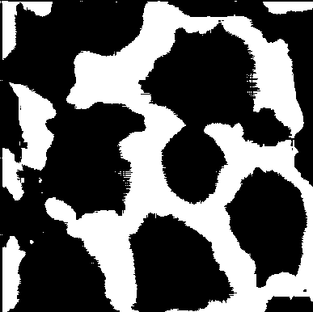

Figure: GAP analysis result for Poly_05

The image above shows the GAP analysis result for Poly_05. Black pixels represent areas that meet the GAP criteria (grayscale value between 1-150 and having at least one adjacent direction with 25 contiguous pixels meeting the grayscale condition), while white pixels represent areas that do not meet these criteria.

The binary visualizations clearly show the distribution of pixels meeting the GAP criteria across all five images. These results demonstrate the effectiveness of the GAP methodology in identifying extended structures within grayscale imagery. The comprehensive pixel data stored in the corresponding CSV files enables further quantitative analysis beyond the visual representation.  
  
The patterns revealed through this analysis could be valuable for various applications, including feature extraction, pattern recognition, and image segmentation. The methodology's consideration of both pixel intensity and spatial relationships provides a more nuanced understanding of the structures present in the images compared to simple thresholding techniques.  
  
Future work could explore variations in the GAP criteria, such as adjusting the grayscale value range or the number of contiguous pixels required, to optimize the analysis for specific applications or image types. Additionally, the methodology could be extended to incorporate more complex spatial relationships or to analyze temporal sequences of images.