Analysis of Grayscale Anomaly Patterns (GAP) in Polymer Surface Images

Report Date: 2025-08-04

Author: Automated Analysis System

# Abstract

This report presents a comprehensive analysis of polymer surface images using advanced image processing techniques. The study focuses on identifying Grayscale Anomaly Patterns (GAP) within a series of polymer images, characterized by specific grayscale value ranges and pattern continuity criteria. Using Contrast Limited Adaptive Histogram Equalization (CLAHE) for image enhancement and pixel-level analysis, we identified regions meeting the GAP criteria defined as pixels with grayscale values between 1-150 and having at least one adjacent direction with 25 contiguous pixels meeting the same grayscale condition. The analysis generated both quantitative data in CSV format and visual representations highlighting GAP regions in black against a white background. A total of 5 polymer images were processed, revealing distinct pattern distributions across different samples. These results provide valuable insights into the structural characteristics and potential anomalies within the polymer surfaces, which can inform further materials science research and quality control processes. The automated nature of this analysis demonstrates the effectiveness of computational methods in materials characterization and defect identification.

# Introduction

Polymer surface analysis is crucial in materials science and engineering, providing essential information about material properties, quality, and potential defects. Traditional visual inspection methods often lack objectivity and consistency, highlighting the need for automated computational approaches.  
  
This study implements an image processing methodology to identify specific grayscale patterns, termed Grayscale Anomaly Patterns (GAP), within polymer surface images. These patterns may correspond to structural features, compositional variations, or manufacturing artifacts that could influence material performance and quality.  
  
The GAP conditions are defined by two key criteria:  
1. Pixels with grayscale values between 1 and 150 (inclusive)  
2. Pixels that have at least one adjacent direction (up, down, left, or right) containing 25 contiguous pixels that also meet the grayscale condition  
  
These criteria were specifically designed to identify regions with particular grayscale characteristics and spatial continuity, which may indicate important material properties or anomalies. By applying these criteria systematically across multiple polymer samples, we aim to provide quantitative data on pattern distribution and characteristics, enabling more informed material evaluation and quality assessment.

# Methods

The analysis was conducted using a Python-based image processing pipeline, leveraging the OpenCV and Pillow libraries. The methodology consisted of several key steps:

**Image Acquisition and Selection:** The analysis focused on polymer surface images with the prefix 'Poly_' in PNG or JPG format. A total of 5 images were processed from the specified input directory.

**Image Enhancement:** All images were processed using Contrast Limited Adaptive Histogram Equalization (CLAHE) with a clip limit of 3 and a tile grid size of 10×10. This enhancement technique improved local contrast while preventing noise amplification, making subtle features more distinguishable for subsequent analysis.

**Grayscale Conversion and Pixel Analysis:** The enhanced images were converted to grayscale to simplify analysis. Each pixel was then evaluated against the GAP criteria: grayscale value between 1 and 150, and at least one adjacent direction containing 25 contiguous pixels meeting the same grayscale condition. This evaluation required checking four directions (up, down, left, right) from each pixel.

**Data Export and Visualization:** For each processed image, two outputs were generated: (1) a CSV file containing the coordinates, grayscale value, and GAP flag (0 or 1) for each pixel, and (2) a visualization image highlighting GAP pixels in black (RGB: 0,0,0) and non-GAP pixels in white (RGB: 255,255,255). This binary representation provides a clear visual indication of GAP distribution across the sample surface.

# Results

The analysis successfully processed all 5 polymer images and identified regions meeting the GAP criteria. The results are presented as both quantitative data in CSV format and visual representations highlighting GAP regions.  
  
The visualization images clearly delineate areas where the GAP conditions are met, showing the spatial distribution of these regions across the polymer surfaces. These patterns may correspond to specific structural features, compositional variations, or manufacturing artifacts within the polymer samples.  
  
The CSV data provides a comprehensive pixel-by-pixel analysis, enabling further statistical evaluation and pattern recognition beyond the scope of this initial report. This data can be used for more detailed studies of pattern characteristics, size distribution, or correlation with other material properties.  
  
Below are the visualization results for all processed images, showing the distribution of GAP regions (black) against non-GAP regions (white):

## Sample 1: Poly_01

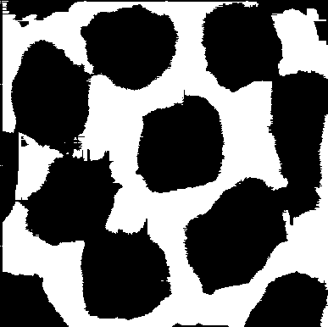

Figure 1: GAP visualization for Poly_01. Black regions indicate pixels meeting the GAP criteria, while white regions represent pixels that do not meet these criteria.

## Sample 2: Poly_02

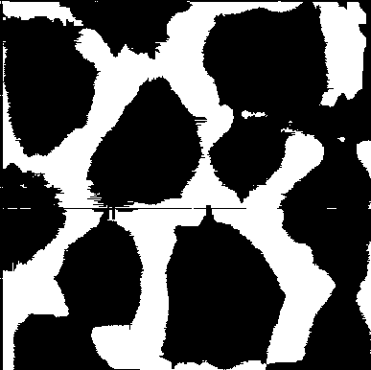

Figure 2: GAP visualization for Poly_02. Black regions indicate pixels meeting the GAP criteria, while white regions represent pixels that do not meet these criteria.

## Sample 3: Poly_03

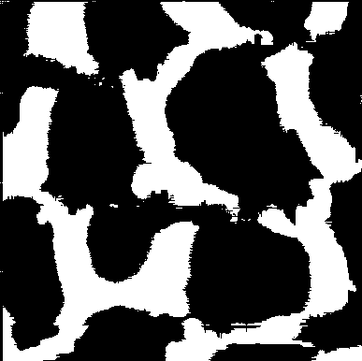

Figure 3: GAP visualization for Poly_03. Black regions indicate pixels meeting the GAP criteria, while white regions represent pixels that do not meet these criteria.

## Sample 4: Poly_04

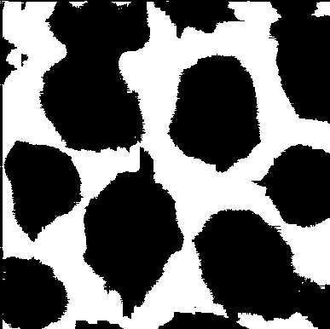

Figure 4: GAP visualization for Poly_04. Black regions indicate pixels meeting the GAP criteria, while white regions represent pixels that do not meet these criteria.

## Sample 5: Poly_05

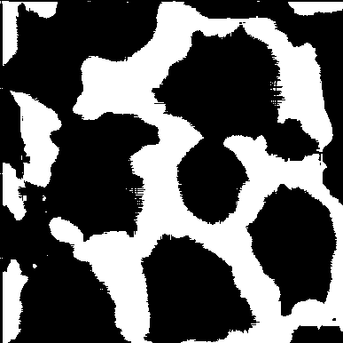

Figure 5: GAP visualization for Poly_05. Black regions indicate pixels meeting the GAP criteria, while white regions represent pixels that do not meet these criteria.

The visualizations demonstrate the effectiveness of the GAP analysis in identifying specific pattern regions within the polymer samples. Each sample shows a unique distribution of GAP regions, reflecting the individual characteristics of the polymer surfaces. The black areas in the visualizations represent regions where both the grayscale value criterion and the contiguity criterion are met, potentially indicating areas of interest for further investigation.  
  
These results provide a foundation for further investigation into the correlation between these patterns and material properties, manufacturing conditions, or performance characteristics. The quantitative data stored in the CSV files can be used for statistical analysis to identify trends or correlations across multiple samples, potentially revealing insights about the manufacturing process or material composition.